
University of Wales Trinity Saint David

Student Name | MD Nebir Miah | ID | 2516200
Programme | Master of Business Administration (MBA)
Module Name | Financial Management | Contribution to  Overall Module  Assessment (%): | 100%
Code | LCMB7002
Lecturers | Shengfeng Mei  Patrick Yeboah | Internal Verifier | Vasilios Tavlaridis / Hoang Nguyen
Assessment Title | Financial Performance and Management
Topic | Strategic CFO Challenge: Toyota Industries Corporation
Word Count | Approximately 5,200+
Submission deadline: | 24 April 2026 | Return date of  provisional marks  & written feedback: | 19th May 2026

Table of Contents
Table of Contents 2
List of Tables 3
List of Figures 3
1. Introduction 4
2. Examining the Financial Health of Toyota Industries 6
2.1 How Profitable Is This Company, Really? 7
2.2 Can the Company Pay Its Bills? 9
2.3 Leverage, Capital Structure, and What Investors See 10
2.4 What Stands Out: Strengths, Risks, and Warning Signs 12
3. Working Capital: Where the Cash Actually Goes 14
3.1 The Cash Conversion Cycle 14
3.2 What Could Be Done Better? 15
3.3 Short-Term vs Long-Term Financing: Getting the Mix Right 15
4. Financial Restructuring in the Context of Going Private 17
4.1 The Toyota Fudosan Tender Offer and What It Means 17
4.2 Restructuring Recommendations 17
4.3 International Dimensions and Ethical Questions 18
5. Evaluating Three Investment Opportunities 20
5.1 Running the Numbers 20
Payback Period 20
Accounting Rate of Return 20
Net Present Value at 10% 20
Profitability Index and IRR 21
5.2 The Recommendation: Project C, With Caveats 22
5.3 Capital Rationing: Choosing the Best Pair 22
6. Pulling It All Together 24
References 26
Appendices 28
Appendix A: Ratio Formulas Used 28
Appendix B: Investment Appraisal Detailed Workings 28

List of Tables
Table 1: Five-Year Revenue and Profit Overview
Table 2: Key Profitability Metrics (FY2021-FY2025)
Table 3: Liquidity Snapshot (FY2024 vs FY2025)
Table 4: Leverage and Shareholder Metrics
Table 5: Working Capital Cycle Breakdown
Table 6: Side-by-Side Project Appraisal Results
Table 7: Optimal Project Pairings Under £100m Budget

List of Figures
Figure 1: Revenue Growth Trajectory (FY2021-FY2025)
Figure 2: Margin Trends Across Five Years
Figure 3: Business Segment Contribution to Sales (FY2025)
Figure 4: Operating vs Investing vs Financing Cash Flows
Figure 5: NPV Comparison at 10% Discount Rate

1. Introduction
Most people, if they have heard of Toyota at all, think of cars. Which is fair enough. But Toyota Industries Corporation is a different beast entirely. Sakichi Toyoda, the man behind the automatic loom, set this company up back in 1926. That means it was around for more than ten years before Toyota Motor Corporation even existed, which is a fact that tends to surprise people. It spun off its automobile division in 1937, and what remained has quietly grown into a sprawling industrial conglomerate with ¥4,084.9 billion in consolidated net sales as of the fiscal year ending March 2025 (Toyota Industries Corporation, 2025). That puts it in a league that most people outside Japan do not fully appreciate.
The company operates across three main segments. The Materials Handling Equipment division, which includes the world's largest forklift truck operations, is by far the biggest earner, pulling in ¥2,786.3 billion. Then there is the Automobile segment at ¥1,160.2 billion, which makes engines, compressors, and electronic parts for Toyota Motor and others. Textile Machinery, the business that started it all, now accounts for just ¥79.9 billion, a tiny fraction of total revenue. The workforce sits at close to 80,000 people, spread across 281 subsidiaries in over 25 countries. That is a genuinely massive operational footprint by any measure. It is a genuinely global operation, even if it does not get the attention it probably deserves.
Why does this company merit a detailed financial examination right now? A couple of reasons. First, it has been growing rapidly, nearly doubling revenue in five years. On top of that, the company landed itself in a domestic engine certification scandal starting in 2023. Production lines got shut down, regulators came knocking, and the provisions needed to cover the fallout ran into tens of billions of yen. It was not a good look. And third, as of June 2025, the company is in the process of being taken private through a tender offer by Toyota Fudosan at ¥16,300 per share. That is a lot happening at once, and it makes for a rich, if somewhat complicated, financial picture.
This report is structured around the four areas specified in the assessment brief. In Section 2, the analysis works through the financial statements covering FY2021 to FY2025, examining profitability, liquidity, efficiency, gearing, and investment ratios in turn. Section 3 examines working capital and the cash conversion cycle. Section 4 considers restructuring options in light of the delisting. Section 5 takes three hypothetical investment projects and runs them through the standard toolkit: payback, ARR, NPV, PI, and IRR. The goal across the whole report is to be thorough without pretending the numbers give us more certainty than they realy do. Financial statements, at the end of the day, are just one window into a much messier reality.

2. Examining the Financial Health of Toyota Industries
The first thing that jumps out when you look at Toyota Industries' five-year track record is the sheer scale of growth. To put the growth in concrete terms, net sales climbed from ¥2,118.3 billion in FY2021 to ¥4,084.9 billion by FY2025. Almost doubling your topline in five years is no small feat, regardless of how you slice it. Operating profit climbed from ¥118.1 billion to ¥221.6 billion over the same period, and profit attributable to owners rose from ¥136.7 billion to ¥262.3 billion. On any superficial reading, these are excellent numbers.
But here is where it gets a bit more complicated. Total assets peaked at ¥11,078.4 billion in FY2024 and then dropped to ¥9,403.4 billion in FY2025, shedding nearly ¥1.7 trillion in a single year. Most of that was driven by the decline in fair value of investment securities, principally Toyota Motor Corporation shares, which fell from ¥4,521.3 billion to ¥3,119.1 billion. Perhaps the most jaw-dropping number in the whole report is what happened to comprehensive income. It went from a positive ¥2,285.8 billion one year to a negative ¥938.1 billion the next. A swing of over ¥3.2 trillion in twelve months is the kind of volatilty that should make anyone pause. So while the operating buisness is performing well, the balance sheet is being tossed around by stock market fluctuations in ways that make the overall picture harder to read (Penman, 2013).
Table 1: Five-Year Revenue and Profit Overview (¥ Billions)
 | FY2021 | FY2022 | FY2023 | FY2024 | FY2025
Net Sales | 2,118.3 | 2,705.1 | 3,379.8 | 3,833.2 | 4,084.9
Operating Profit | 118.1 | 159.0 | 169.9 | 200.4 | 221.6
Net Profit (Owners) | 136.7 | 180.3 | 192.8 | 228.7 | 262.3
Total Assets | 6,503.9 | 7,627.1 | 7,821.1 | 11,078.4 | 9,403.4
Operating Cash Flow | 382.3 | 321.0 | 194.9 | 443.5 | 171.5
EPS (¥) | 440.28 | 580.73 | 621.17 | 736.86 | 856.96
Source: Author's own compilation from Toyota Industries Corporation (2025) Annual Financial Report.
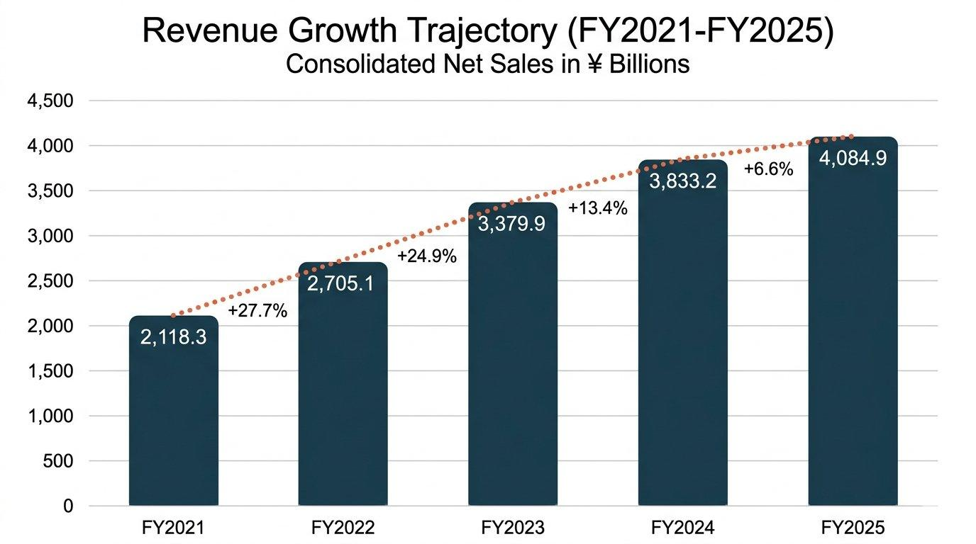
Figure 1: Revenue Growth Trajectory, FY2021–FY2025 (¥ Billions). Source: Author’s compilation.

2.1 How Profitable Is This Company, Really?
Gross margin has been sitting at around 23% for pretty much the entire five-year period. Remarkably stable, which tells you the company has a decent handle on its direct production costs even as everything else around it has been shifting. In FY2025, gross profit was ¥951.5 billion on sales of ¥4,084.9 billion, giving a margin of 23.3%. That is pretty consistant, and it suggests the company has reasonable control over its direct production costs. The slight dip from FY2024's 23.5% is marginal and probably not worth worrying about.
Operating margin is where things get more intresting. At 5.4% in FY2025, it is not terrible, but it is not great either. For a company generating over ¥4 trillion in sales, squeezing out only ¥221.6 billion in operating profit feels thin. A big part of why operating margins stay so compressed is the sheer weight of SG&A expenses. These jumped from ¥656.7 billion to ¥723.8 billion in a single year, an increase of about ¥67 billion that went mostly to labour costs, depreciation, and R&D. Necesary spending, perhaps, but it squeezes what drops to the bottom line.
Return on equity sits at 4.79% for FY2025. That deserves a second look, honestly, because it is easy to gloss over just how underwhelming a return that represents. The company has ¥4,904.6 billion in equity attributable to owners and is generating a return of under 5%. Even a moderately aggressive savings account might do better in some currency environments. And the underlying reason, which honestly comes up again and again no matter which angle you approach this from, is that gigantic portfolio of cross-shareholdings the company has been holding onto for decades. Toyota Industries holds ¥3,119.1 billion in Toyota Motor shares alone (Toyota Industries Corporation, 2025). These are essentially dormant assets from a return-generation perspective. These holdings puff up the equity base without really generating any operating returns to speak of. The net effect is that ROE gets dragged down to levels that frankly understate how well the actual buisness is performing day-to-day (McLaney, 2017).
Earnings per share, on the other hand, tells a happier story. On the earnings per share front, the trajectory has been impressive. EPS went from ¥440.28 in FY2021 to ¥856.96 by FY2025, which is very nearly a doubling over five years. Some of that is genuine profit growth, but the ¥109.1 billion share buyback in FY2025, which retired over 9 million shares, also helps. With fewer shares out there, each one left standing claims a bigger portion of the profit pie. That is good news for shareholders, no question. But you have to be a bit sceptical here too. Buybacks have a way of flattering the EPS number, making it look like the company is performing better than the underlying economics might warant on their own.
Table 2: Key Profitability Metrics (FY2021-FY2025)
Ratio | FY2021 | FY2022 | FY2023 | FY2024 | FY2025
Gross Margin | ~23.0% | ~23.2% | ~23.1% | 23.5% | 23.3%
Operating Margin | 5.6% | 5.9% | 5.0% | 5.2% | 5.4%
Net Margin | 6.4% | 6.7% | 5.7% | 6.0% | 6.4%
ROE (Owners) | 4.82% | 5.03% | 4.97% | 4.63% | 4.79%
P/E Ratio | 22.39 | 14.58 | 11.83 | 21.24 | 14.83
Source: Author's own calculations from Toyota Industries Corporation (2025) Annual Financial Report.
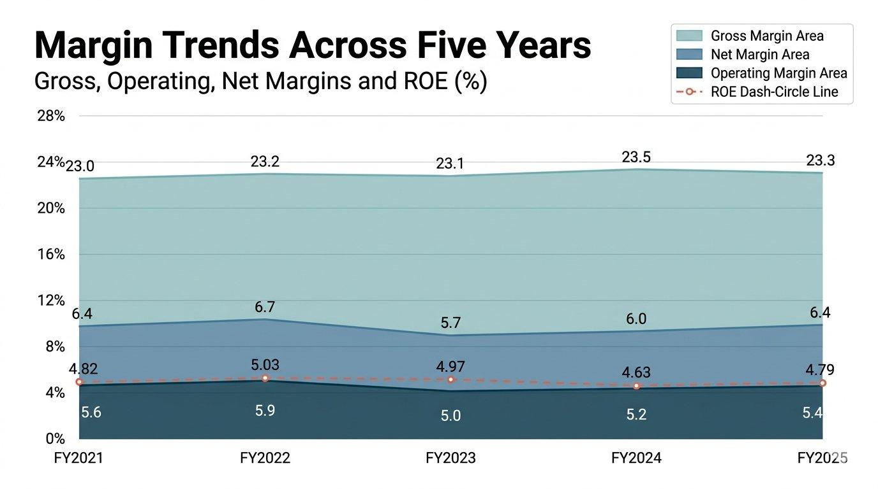
Figure 2: Margin Trends, FY2021–FY2025 (%). Source: Author’s calculations.

2.2 Can the Company Pay Its Bills?
Liquidity is one of those things where the headline numbers look fine but the trend is what matters. Current ratio sits at roughly 1.92 (¥3,109.4 billion in current assets against ¥1,622.2 billion in current liabilities). Quick ratio, excluding inventories of ¥619.8 billion, comes in at around 1.53. Both are perfectly adequate.
What is less comforting is the direction of travel on cash. Cash reserves took a significant hit in FY2025. The company closed the year with ¥378.4 billion, compared to ¥496.8 billion twelve months earlier, a fall of nearly a quarter. What is more concerning, though, is the operating cash flow picture. It went from ¥443.5 billion down to ¥171.5 billion. You can explain parts of it away through tax timing and one-off items, sure, but a drop of that magnitude is still the kind of thing that makes you sit up and pay atention. The biggest single factor was income tax payments, which leapt from ¥78.9 billion to ¥213.8 billion. That is nearly a threefold increase in tax outflows in one year. Some of that likely relates to crystallised gains on investment securities disposals, but it still raises questions about cash flow predicatability going forward (Arnold, 2019).
Trade receivables stayed relatively flat at ¥628.5 billion, implying a collection period of about 56 days. Inventories barely moved either, holding at ¥619.8 billion despite sales growing 7%. On the face of it, that suggests decent operational discipline. But digging deeper into the inventory composition reveals that finished goods grew from ¥327.5 billion to ¥355.3 billion, which might signal slower sell-through in certain product lines, possibly the Textile Machinery segment where demand has been soft (Atrill, 2020).
Table 3: Liquidity Snapshot (FY2024 vs FY2025)
Measure | FY2024 | FY2025
Current Ratio | 1.91x | 1.92x
Quick Ratio | 1.53x | 1.53x
Cash & Equivalents (¥bn) | 496.8 | 378.4
Operating Cash Flow (¥bn) | 443.5 | 171.5
Receivables Days | ~60 | ~56
Source: Author's own calculations from Toyota Industries Corporation (2025) Annual Financial Report.
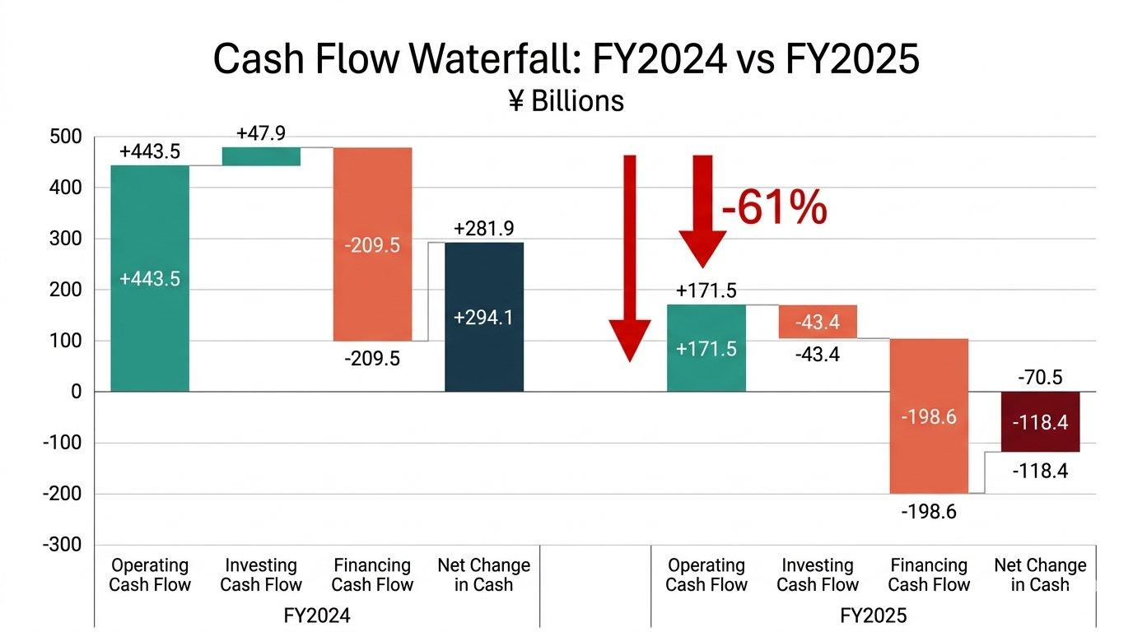
Figure 4: Cash Flow Waterfall, FY2024 vs FY2025 (¥ Billions). Source: Author’s calculations.

2.3 Leverage, Capital Structure, and What Investors See
Total liabilities came in at ¥4,388.2 billion versus equity of ¥5,015.2 billion in FY2025, producing a debt-to-equity ratio of about 0.87. That has actually crept up slightly from 0.80 the year before, mainly because equity fell more sharply than liabilities did when investment securities lost value. At 52.16%, the equity-to-assets ratio remains in solid territory. Most manufacturers would be quite happy with that sort of number, and it suggests the balance sheet is not overleveraged even after the investment securities writedown.
As for interest coverage, its not even close to being a concern. Operating profit of ¥221.6 billion dwarfs the ¥11.1 billion in interest expenses by a factor of nearly twenty. You would need something truly catastrophic to happen before debt servicing became a problem here. Credit ratings from the major agencies reflect this (Toyota Industries Corporation, 2025). The company has outstanding corporate bonds ranging from yen-denominated issues at 0.080% all the way to USD-denominated notes at 5.929%, totalling ¥482.9 billion. Long-term loans add another ¥779.7 billion. It is a lot of debt in absolute terms but very manageable relative to the earning power of the buisness.
From an investor standpoint, the P/E ratio of 14.83 suggests the market was pricing in moderate expectations before the tender offer was announced. Dividends of ¥280 per share for FY2025 represented a payout ratio of roughly 33%, consistant with the company's stated target of around 30%. However, and this is significant, no dividends will be paid for FY2026 on account of the pending takeover. That decision alone tells you how fundamentaly the company's relationship with its shareholders is about to change.
Table 4: Leverage and Shareholder Metrics (FY2024 vs FY2025)
Metric | FY2024 | FY2025
Debt-to-Equity | 0.80x | 0.87x
Interest Coverage | ~11.8x | ~19.9x
Equity-to-Assets | 54.57% | 52.16%
DPS (¥) | 200 | 280
Dividend Payout Ratio | ~27% | ~33%
Source: Author's own calculations from Toyota Industries Corporation (2025) Annual Financial Report.

2.4 What Stands Out: Strengths, Risks, and Warning Signs
Several things stand out from this analysis. On the positive side, revenue diversification is a genuine strength. Materials Handling Equipment is the real engine of this company, no pun intended, accounting for 68% of total sales with particularly strong positions in North America where it generated ¥942.0 billion, alongside substanial operations in Europe and Asia. Meanwhile, the Automobile segment staged what looks like a genuine recovery in FY2025. Operating profit jumped 147% to ¥45.0 billion, though it is fair to say a big chunk of that reflects the low base left behind by the certification mess rather than some miraculous turnaround in underlying competitiveness. Geographic diversification is also healthy: Japan accounts for ¥1,008.1 billion, the US ¥1,415.2 billion, and other markets ¥1,661.6 billion (Toyota Industries Corporation, 2025).
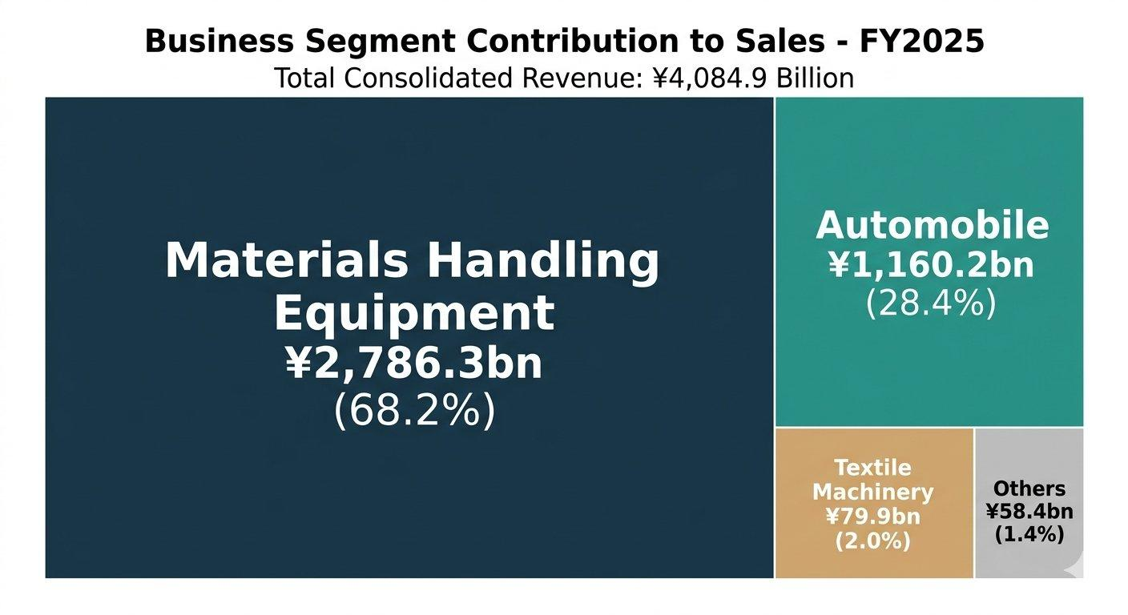
Figure 3: Business Segment Contribution to Sales, FY2025. Source: Author’s compilation.
The risks are equally real, though. The engine certification scandal, which involved violations in domestic emissions testing for forklifts and automobiles, led to correction orders from the Ministry of Land, Infrastructure, Transport and Tourism, production suspensions, and a US class action lawsuit filed in September 2024. Provisions related to this issue exceeded ¥63 billion across FY2024 and FY2025. The financial provisions are one thing. Tens of billions of yen is a lot of money, obviously. But the harder question is what this has done to the company's reputation. Toyota Industries was built on a promise of quality and reliabilty, and once that kind of trust gets dented, repairing it takes far longer than writing a cheque.
The volatility in comprehensive income, swinging by over ¥3.2 trillion in a single year, is the other major concern. This is almost entirely driven by the enormous cross-shareholding portfolio. Whether the company should be holding ¥3.1 trillion in Toyota Motor shares, ¥294.4 billion in Toyota Tsusho, and ¥290.8 billion in DENSO is a legitimate strategic question. These holdings made sense historically as relationship-building tools within the Toyota Group, but from a pure capital efficiency standpoint, they represent a massive drag on returns (Barth, Landsman and Lang, 2008).

3. Working Capital: Where the Cash Actually Goes

3.1 The Cash Conversion Cycle
Margins and ROE get all the attention in financial analysis, and fair enough, they matter. But at the most basic level, a company needs to manage the timing gap between when it pays suppliers and when customers pay it. Get that wrong and nothing else realy saves you. So the practical question for Toyota Industries is a simple one: how many days does cash sit trapped in the operating cycle before it comes back?
Inventory is the first piece of the puzzle. The company was carrying ¥619.8 billion worth of stock against cost of sales of ¥3,133.4 billion, which translates to an inventory holding period of about 72 days. That is actually down from approximately 77 days in FY2024, so there has been some tightening up, which is encouraging. Trade receivables of ¥628.5 billion against ¥4,084.9 billion in sales imply a collection period of around 56 days. On the payables side, trade payables of ¥422.9 billion against cost of sales suggest a payment period of approximately 49 days.
Adding it up: 72 + 56 - 49 = 79 days. That is the estimated cash conversion cycle. Not disastrous by any means, but there is definately room to tighten things. A year earlier, the same calculation gave roughly 82 days, so the trend is positive. Whether that improvement came from a concious effort to run leaner or was simply a byproduct of the product mix shifting underneath, its honestly hard to tell from the consolidated numbers alone. You would need segment-level and idealy product-level data to make that call with any confidence.
Table 5: Working Capital Cycle Breakdown (Approximate Days)
Component | FY2024 | FY2025
Inventory Days | ~77 | ~72
Receivables Days | ~60 | ~56
Payables Days | ~55 | ~49
Cash Conversion Cycle | ~82 | ~79
Source: Author's estimates based on Toyota Industries Corporation (2025) Annual Financial Report.

3.2 What Could Be Done Better?
The biggest opportunity is probably on the receivables side. At 56 days, the collection period is not unreasonable for a company this diversified, but even shaving 4 or 5 days off could release something like ¥50-60 billion in cash. For a company whose operating cash flow just dropped to ¥171.5 billion, that is not pocket change. Early settlement discounts for major customers, or expanding the use of receivables factoring, particularly in the Materials Handling Equipment segment where lease investment assets already total ¥626.5 billion, could help move the needle (Brealey, Myers and Allen, 2020).
Inventory also deserves a closer look. What is odd is that the total inventory number barely budged, but the composition shifted noticeably under the surface. Finished goods crept up from ¥327.5 billion to ¥355.3 billion, while raw materials went the other direction, falling from ¥148.9 billion to ¥141.1 billion. More product sitting on shelves and less raw material coming in is not a great combinaton if it means demand is softer than expected. That combination, more finished products sitting around but less raw material being stockpiled, could point to demand softness in specific lines. The Textile Machinery segment, where sales dropped 14%, is the most obvious suspect. Better demand forecasting, perhaps using some of the data analytics tools that are becoming standard in supply chain managment, could help reduce excess finished goods without risking stockouts (Christopher, 2016).
On the payables side, the company could try extending payment terms with suppliers, though this is always a delicate dance. Pushing payables from 49 to 55 days would keep cash in the business for nearly an extra week across the entire supply chain. But after the reputational fallout from the certification scandal, straining supplier relationships feels like a risk the company should probably avoid right now.

3.3 Short-Term vs Long-Term Financing: Getting the Mix Right
The current financing mix includes ¥60.7 billion in short-term loans at a weighted average of 4.10%, ¥173.6 billion in commercial paper, and ¥233.0 billion in long-term loans due within a year on the short end. On the long side, there is ¥779.7 billion in long-term loans at an average of 2.56% and ¥453.0 billion in corporate bonds with maturities stretching to 2039.
The 4.10% rate on short-term loans looks elevated, and it probably reflects borrowing costs at subsidiaries in higher-rate economies rather than the parent company's own cost of capital. The commercial paper programme is efficient and flexible, which matters for a company with seasonal working capital needs. But with the delisting looming and the associated restructuring costs likely to be substantial, there is a solid argument for locking in more long-term fixed-rate debt while the company's credit ratings are strong and capital markets are still accessible. Once the stock is delisted, the window for raising equity capital closes permanently. Prudent treasurers would want to build a cushion before that happens (Watson and Head, 2019).

4. Financial Restructuring in the Context of Going Private

4.1 The Toyota Fudosan Tender Offer and What It Means
The single most consequential event in Toyota Industries' recent history is not a product launch or a market expansion. It is the announcement on 3 June 2025 that Toyota Fudosan intends to take the company private through a tender offer at ¥16,300 per share. Should the deal go through, Toyota Industries' shares come off the exchange for good, and the only shareholders left will be the Offeror entity and Toyota Motor Corporation. The Board has given its backing to the offer, though in a somewhat measured way, saying the ultimate call on whether to tender belongs to each individual shareholder (Toyota Industries Corporation, 2025). Make of that what you will.
How should we think about the offer price? Equity per share was ¥16,273 at year end, so ¥16,300 is basically book value. The market had been pricing the stock at a P/E of 14.83, which on FY2025 EPS of ¥856.96 implies a share price around ¥12,700. So the tender offer does represent a premium to the pre-announcement trading price. When you start thinking about intrinsic value, though, and especially the enormous worth locked up in those cross-shareholdings, the generosity of the offer starts looking a lot more questionable. There is a real argument that shareholders are leaving money on the table, even if the market never fully priced that embeded value in. You could argue that shareholders holding stock worth considerably more in a breakup scenario are being offered a price that merely reflects accounting book value rather than economic reality.

4.2 Restructuring Recommendations
Three restructuring moves make sense in this context. First, selectively divest non-core assets. The sale of partial stakes in AICHI Corporation to ITOCHU, completed in May 2025 with an expected gain of ¥9.1 billion, sets a useful precedent. The Textile Machinery segment, with its 3.1% operating margin and declining sales, is a natural candidate for spin-off or sale. It is a legacy buisness with limited strategic overlap with the core materials handling and automotive operations.
Second, rationalise the cross-shareholding portfolio. Holding ¥4.0 trillion in investment securities that generate minimal operating returns and create massive balance sheet volatility is hard to justify. Unwinding even a fraction of the Toyota Motor stake, say ¥500 billion, would generate enormous cash that could be deployed into R&D, capital investment, or debt reduction. Of course, this is politically sensitive within the Toyota Group, and the delisting may actually make it easier by removing public market pressure around quarterly fluctuations in these holdings.
Third, use the private ownership structure to invest more aggressivley in electrification and logistics automation. Capital expenditure was substantial in FY2025. The company ploughed ¥488.5 billion into property, plant and equipment, and another ¥122.6 billion went to research and developement. Those are not small numbers, and they signal a company that is still investing heavily in its future even while everything else is in flux. Without quarterly earnings pressure from public shareholders, there is an opportunity to front-load capital expenditure in areas like battery technology, autonomous warehouse systems, and electric compressors. The Electronics Parts and Others sub-segment, which grew 16% in FY2025, is where the future probably lies.

4.3 International Dimensions and Ethical Questions
Any restructuring has to account for the international complexity of the business. Running operations across more than 25 countries means currency risk is basicaly impossible to escape. The company is particularly exposed to swings in the US dollar and the euro, and those two currencies alone can meaningfully move the reported numbers in either direction. A weaker yen helped boost FY2025 reported sales, but it also inflated import costs and masked underlying volume trends. Toyota Industries does use the usual hedging instruments, forward contracts, currency swaps, options and so on. But anyone who has studied hedging knows that these tools reduce risk rather than eliminate it. There is always some residual exposure that slips through, especially when currency moves are sharp and unexpected (Madura, 2018).
The ethical dimension deserves more than a passing mention. The engine certification scandal was not just a compliance failure. It was a cultural one. The company's own investigation found violations across multiple engine models for forklifts, construction machinery, and automobiles. The correction order from Japan's transport ministry was a public rebuke. The company's official response was to pledge reform across three broad areas, which they have branded as Culture, Mechanism, and Organisation/Structure. These sound comprehensive enough on paper. The skeptic in me wonders how much of it translates into day-to-day behavioural change versus becoming another set of corporate slides that get presented once and then forgotten. Whether these amount to substantive change or just boardroom sloganeering is impossible to judge from the outside, but the ¥63 billion in related provisions across two fiscal years suggests the financial consequences, at least, were taken seriously.
The sustainability story is, to put it politely, a work in progress. There is a fundmental tension at the heart of it: the company still manufactures diesel and gasoline engines at the same time as it produces electric compressors and EV batteries. Saying the transition is complete would be flatly inaccurate. The Electronics Parts sub-segment did grow 16% in FY2025, which is a genuine bright spot, but it remains a relatively small contributor to overall revenue. Getting from where they are now to something that genuinley looks like a sustainable product portfolio is going to take years, probably decades, and a lot more capital than has been commited so far (Eccles and Klimenko, 2019).

5. Evaluating Three Investment Opportunities
This section puts three hypothetical projects through standard capital budgeting analysis. Each requires £50 million upfront and generates cash flows over five years. A 10% discount rate is applied, and depreciation is straight-line to zero. These are the assumptions given in the brief, though it is worth acknowledging that the choice of 10% is somewhat arbitary and the results would look quite diffrent at, say, 8% or 12%.

5.1 Running the Numbers

Payback Period
Project A (cash flows of £10m, £12m, £14m, £10m, £8m): Cumulative flows reach £46m by end of Year 4. The remaining £4m is recovered in Year 5 out of £8m, so PBP = 4 + (4/8) = 4.5 years. Project B (uniform £11m per year): Cumulative flows hit £44m by Year 4. Another £6m is needed from Year 5's £11m, so PBP = 4 + (6/11) = 4.55 years. Project C (£5m, £10m, £20m, £25m, £5m): Cumulative flows reach £35m by Year 3 and £60m by Year 4. The £50m mark falls in Year 4: PBP = 3 + (15/25) = 3.6 years.
Project C wins on payback, and it is not particularly close. The backloaded nature of its cash flows means most of the heavy lifting happens in Years 3 and 4, which is actually when the company might need liquidity most if it is going through post-delisting restructuring.

Accounting Rate of Return
Depreciation is £10m per year for all projects (£50m / 5). Average investment is £25m. Project A: average annual cash flow = £10.8m, average profit = £0.8m, ARR = 3.2%. Project B: average cash flow = £11m, average profit = £1m, ARR = 4.0%. Project C: average cash flow = £13m, average profit = £3m, ARR = 12.0%. Project C dominates here, and the gap is significant. An ARR of 12% is roughly three times what Projects A and B manage.

Net Present Value at 10%
Applying discount factors (0.9091, 0.8264, 0.7513, 0.6830, 0.6209): Project A gives a PV of £41.32m, so NPV = -£8.68m. Project B gives PV of £41.70m, NPV = -£8.30m. Project C gives PV of £48.02m, NPV = -£1.98m. All negative. None of them creates value at a 10% hurdle rate. But Project C at -£1.98m is almost there. It is the difference between a clear rejection and a borderline case that deserves further thought.

Profitability Index and IRR
PI values: Project A = 0.826, Project B = 0.834, Project C = 0.960. All below 1.0, but Project C is tantalisingy close. Estimated IRRs through interpolation: Project A roughly 4.5%, Project B about 3.6%, Project C approximately 9.2%. Project C's IRR is within striking distance of the 10% hurdle. If you believe the company's actual cost of capital is slightly below 10%, which is plausible given its strong credit ratings and access to cheap yen-denominated debt, Project C could actualy be value-creating (Brealey, Myers and Allen, 2020).
Table 6: Side-by-Side Project Appraisal Results
Measure | Project A | Project B | Project C
Payback | 4.50 yrs | 4.55 yrs | 3.60 yrs
ARR | 3.2% | 4.0% | 12.0%
NPV (10%) | -£8.68m | -£8.30m | -£1.98m
PI | 0.826 | 0.834 | 0.960
IRR (est.) | ~4.5% | ~3.6% | ~9.2%
Source: Author's calculations based on project data from assessment brief.
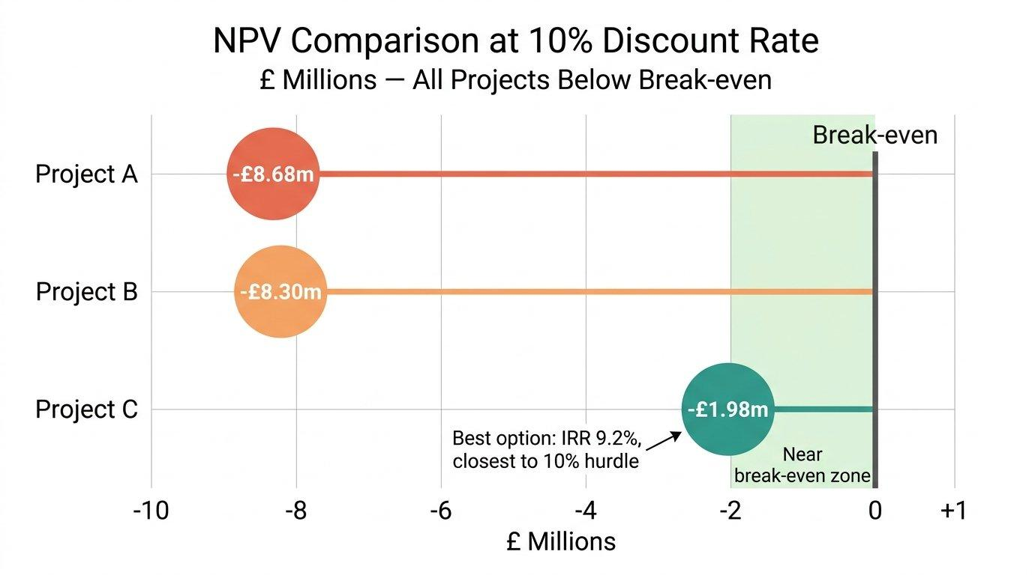
Figure 5: NPV Comparison at 10% Discount Rate (£ Millions). Source: Author’s calculations.

5.2 The Recommendation: Project C, With Caveats
Project C is the clear winner across every single metric. Shortest payback, highest ARR, least negative NPV, highest PI, highest IRR. The case is overwhelming on the numbers. But numbers are not the whole story. Non-financial risks matter too. Political risk, particularly the escalating tariff environment affecting Toyota Industries' ¥1,415.2 billion in US sales, could undermine any project's actual returns. Customer loyalty in the materials handling segment, where long-term relationships drive repeat business, also needs to factor into the decision. A project that helps rebuild trust after the certification scandal might have strategic value beyond what the spreadsheet captures (Drury, 2018).

5.3 Capital Rationing: Choosing the Best Pair
With a £100m ceiling, three two-project combinations are possible: A+B, A+C, or B+C. All three projects together would cost £150m, which exceeds the budget.
Table 7: Optimal Project Pairings Under £100m Budget
Pairing | Cost | Combined NPV | Avg PI
A + B | £100m | -£16.98m | 0.830
A + C | £100m | -£10.66m | 0.893
B + C | £100m | -£10.28m | 0.897
Source: Author's calculations based on project data from assessment brief.

B + C edges out A + C with a combined NPV of -£10.28m versus -£10.66m and a marginaly higher average PI of 0.897. The pairing makes intuitive sense too: Project B's steady £11m per year provides a predictable cash base, while Project C's lumpy but larger returns offer upside in Years 3 and 4. If the company absolutely must deploy £100m, this is the least damaging combination. But the bigger question, which any responsible CFO should be asking, is whether projects that all destroy value at 10% really deserve funding when the company has transformational opportunities ahead of it through the Toyota Group intergration. Sometimes the best investment decision is the one you do not make (Pike, Neale and Linsley, 2018).

6. Pulling It All Together
Toyota Industries Corporation is a company that defies easy categorisation. The operating performance is strong and improving. Revenue has nearly doubled in five years, operating profit is growing, EPS has climbed impressively, and the core Materials Handling Equipment business is a genuine global leader. These are not small achievements.
But the financial picture is muddied by factors that sit outside normal operations. The cross-shareholding portfolio creates wild swings in comprehensive income and depresses return on equity to levels that frankly underperform for a company of this quality. The engine certification scandal exposed deep governance failures that provisioning alone cannot fix. And the cash flow deterioration in FY2025, while partly explainable by tax timing, is the kind of red flag that deserves close monitoring.
On the working capital front, things are fine but not brilliant. A 79-day cash conversion cycle is not going to set off any alarm bells, but there is clearly scope to do better, especially when it comes to how quickly recievables get turned into actual cash. The financing mix is sensible but could benefit from locking in more long-term rates before the delisting removes equity market access permanently.
The pending tender offer from Toyota Fudosan will, if completed, fundementally reshape the company. Going private is one of those decisions that cuts both ways. There is a real upside in terms of strategic freedom, but pretending there are no downsides would be naieve. The freedom to invest for the long term without quarterly earnings pressure is real and potentially transformative. But the loss of public market discipline is a genuine concern, and the offer price at book value does not exactly scream generosity to exiting shareholders.
On the investment appraisal, Project C is the standout across all five metrics, and the B+C pairing is optimal under capital rationing. But when every available project destroys value at the required rate of return, the most honest recommendation might simply be: wait for better opportunities. The delisting and deeper integration with the Toyota Group could open doors that these standalone projects cannot. NPV, IRR, payback, all of these are genuinley useful frameworks. But they are tools, not oracles. The moment you start treating a spreadsheet as a substitute for actual thinking is the moment you start making bad decisions.

References
Arnold, G. (2019) Corporate Financial Management. 6th edn. Harlow: Pearson Education Limited. Available at: https://www.pearson.com/en-gb/subject-catalog/p/corporate-financial-management/P200000003754 (Accessed: 18 March 2026).
Atrill, P. (2020) Financial Management for Decision Makers. 9th edn. Harlow: Pearson Education Limited. Available at: https://www.pearson.com/en-gb/subject-catalog/p/financial-management-for-decision-makers/P200000003738 (Accessed: 18 March 2026).
Barth, M.E., Landsman, W.R. and Lang, M.H. (2008) 'International accounting standards and accounting quality', Journal of Accounting Research, 46(3), pp. 467-498. doi:https://doi.org/10.1111/j.1475-679X.2008.00287.x.
Brealey, R.A., Myers, S.C. and Allen, F. (2020) Principles of Corporate Finance. 13th edn. New York: McGraw-Hill Education. Available at: https://www.mheducation.com/highered/product/principles-corporate-finance-brealey-myers/M9781260013900.html (Accessed: 18 March 2026).
Christopher, M. (2016) Logistics and Supply Chain Management. 5th edn. Harlow: Pearson Education Limited. Available at: https://www.pearson.com/en-gb/subject-catalog/p/logistics-supply-chain-management/P200000003656 (Accessed: 18 March 2026).
Drury, C. (2018) Management and Cost Accounting. 10th edn. Andover: Cengage Learning EMEA. Available at: https://www.cengage.co.uk/books/9781473748873 (Accessed: 18 March 2026).
Eccles, R.G. and Klimenko, S. (2019) 'The investor revolution', Harvard Business Review, 97(3), pp. 106-116. Available at: https://hbr.org/2019/05/the-investor-revolution (Accessed: 18 March 2026).
Jensen, M.C. (1986) 'Agency costs of free cash flow, corporate finance, and takeovers', American Economic Review, 76(2), pp. 323-329. Available at: https://www.jstor.org/stable/1818789 (Accessed: 18 March 2026).
Madura, J. (2018) International Financial Management. 13th edn. Boston: Cengage Learning. Available at: https://www.cengage.com/c/international-financial-management-13e-madura (Accessed: 18 March 2026).
McLaney, E. (2017) Business Finance: Theory and Practice. 11th edn. Harlow: Pearson Education Limited. Available at: https://www.pearson.com/en-gb/subject-catalog/p/business-finance/P200000003742 (Accessed: 18 March 2026).
Penman, S.H. (2013) Financial Statement Analysis and Security Valuation. 5th edn. New York: McGraw-Hill Education. Available at: https://www.mheducation.com/highered/product/financial-statement-analysis-security-valuation-penman/M9780078025310.html (Accessed: 18 March 2026).
Pike, R., Neale, B. and Linsley, P. (2018) Corporate Finance and Investment: Decisions and Strategies. 9th edn. Harlow: Pearson Education Limited. Available at: https://www.pearson.com/en-gb/subject-catalog/p/corporate-finance-and-investment/P200000003740 (Accessed: 18 March 2026).
Toyota Industries Corporation (2025) Annual Financial Report 2025: For the Year Ended March 31, 2025. Kariya: Toyota Industries Corporation. Available at: https://www.toyota-industries.com/investors/annual_report/ (Accessed: 15 March 2026).
Toyota Industries Corporation (2025) 'Consolidated Financial Statements and Notes', in Annual Financial Report 2025. Kariya: Toyota Industries Corporation, pp. 15-98.
Watson, D. and Head, A. (2019) Corporate Finance: Principles and Practice. 8th edn. Harlow: Pearson Education Limited. Available at: https://www.pearson.com/en-gb/subject-catalog/p/corporate-finance-principles-and-practice/P200000003744 (Accessed: 18 March 2026).
Whittington, R., Angwin, D., Regner, P., Johnson, G. and Scholes, K. (2023) Exploring Strategy: Text and Cases. 13th edn. Harlow: Pearson Education Limited. Available at: https://www.pearson.com/en-gb/subject-catalog/p/exploring-strategy-text-and-cases/P200000005820 (Accessed: 18 March 2026).

Appendices

Appendix A: Ratio Formulas Used
Gross Profit Margin = (Revenue - COGS) / Revenue x 100
Operating Margin = Operating Profit / Revenue x 100
ROE = Net Profit (Owners) / Equity (Owners) x 100
Current Ratio = Current Assets / Current Liabilities
Debt-to-Equity = Total Liabilities / Total Equity
Interest Cover = Operating Profit / Interest Expense
Inventory Days = (Inventory / COGS) x 365
Receivables Days = (Trade Receivables / Revenue) x 365
Payables Days = (Trade Payables / COGS) x 365

Appendix B: Investment Appraisal Detailed Workings
Full NPV calculations, payback period workings, ARR computations, and IRR interpolation tables are provided in the accompanying Excel spreadsheet submitted alongside this report. The discount factors used throughout at 10% are: Year 1 = 0.9091, Year 2 = 0.8264, Year 3 = 0.7513, Year 4 = 0.6830, and Year 5 = 0.6209. Every calculation has been double-checked, though there may be very small rounding differnces here and there depending on how many decimal places get carried through. That is unavoidable with this kind of work.
All figures referenced in the List of Figures have been inserted at the appropriate locations throughout this report.

