

LOCATION: Swansea | LLEOLIAD: abertawe
LEVEL 6 | LEFEL 6
EXAMINATION PERIOD | CYFNOD ARHOLIADAU
July 2019 | Gorffennaf 2019

MODULE CODE: M6X02209
ALTERNATIVE POWERTRAIN TECHOLOGY
TIME: 2 HOURS

answer TWO quESTIONS out of tHREE

Equipment or materials required – None
Adnoddau neu ddefnyddiau sydd eu hangen - Dim

ANSWER TWO QUESTIONs OUT OF THREE

QUESTION 1



A national pizza chain are considering replacing their fleet of local delivery vans. The vehicle is expected to work primarily within an urban environment, however they maybe a requirement to venture within a 10 mile radius of Swansea.. They hope to gain the following improvements:
Reduced fuel consumption
Lower emissions
Lower running costs
A greener image
Use diagrams, graphs and basic calculations to support your answers. State any assumptions made where information is missing.

- Analyse alternative electric, hybrid and fuel cell vehicle architectures
(4 marks)
- Investigate and contrast alternative technologies for

- Energy storage
- Re-fuelling
- Drive / electrical machine
(6 marks)
- Develop a brief typical drive cycle and discuss typical vehicle requirements.
(3 marks)
- Recommend a Pizza Urban Delivery Van electric/hybrid solution and demonstrate how it may meet their requirements.
(7 marks)

QUESTION 2



A UPS parcel delivery van has the following characteristics.
Mass 4000kg
Frontal area 4m^2
Coefficient of drag (CD) 0.6
Density of air = 1.2kg/m^3
The rolling (force) resistance of a tyre on asphalt RF(newtons) = 0.016N per applied N of vertical force.

The vehicle is equipped with a mechanical flywheel battery kinetic energy recovery system (KERS). Assume the electrical system is 100% efficient in both directions. The vehicle begins its journey from the Cadogan Building down Mount Pleasant hill with a stationary flywheel.
The vehicle descends through a vertical drop of 30m along 400m of road at a constant speed of 40kph. Assume the vehicle captures all of the available energy and the vehicle friction brakes are not applied.

- How much energy is stored by the flywheel at the bottom of the hill?
(8 marks)

- If the vehicle turns left and continues at the same speed along level ground how far will it travel before the energy in the flywheel has been exhausted?
(4 marks)

- A similar vehicle is equipped with a similar KERS device. The flywheel has been specified to store 500Kj of energy.
The device has a maximum rotational speed of 10,000rpm
Packaging dictates that the disc can be no larger than 0.4 m outer diameter
Calculate the dimensions and mass for a suitable solid (plain section) flywheel?
Density of steel = 7820 kg/m^3
(3 marks)

- Discuss power transmission problems from the road wheels to a flywheel storage device. Suggest and analyse possible solutions to overcome these problems. Use diagram and example calculations to support your discussion.
(5 marks)
QUESTION 3

Many electric hybrid vehicles utilise regenerative braking to capture all or some of the energy used to decelerate a vehicle.

- Explain and contrast the two categories of regenerative braking, series and parallel ?
(5 marks)

- Evaluate which of the series or parallel system would be more appropriate for a 24hr Lemans race car ?
(5 marks)

- A small front engined front wheel drive petrol internal combustion small car has been hybridised with an additional electrically drive rear axle. Analyse the limitations to recovering energy from the rear axle. Use diagrams and numbers to illustrate your answer.
Typical values:
Mass 1200kg Weight distribution 63% front / 37% rear
Wheel base 2.5m
Height of centre of gravity 0.6m above the ground
Rolling radius 0.26m
(10 marks)

Equations

Potential Energy = mass x gravity x height PE = m.g.h

Moment of Inertia = mass x (radius of gyration) ² I = mk²

For a plain disc : radius of gyration k = outer radius x 0.707

Aero dynamic resistance = 0.5 x area x cd x density of air (1.2 kg/m²) x velocity²

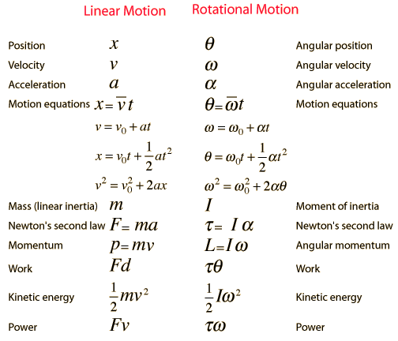

Diwedd/End

