Robert McIntyre
P149064
Web Development
ASP.NET Web Development
Kemi Ademoye

Table of Contents
1 – Introduction 3
2 - Implementation 3
2.1 - Description of the web application 3
2.2 – Features 3
2.3 – Entity Relationship diagram of system 4
2.3 – Screenshots of implemented pages 4
3 – Evaluation 8
3.1 - Functionality and testing 8
3.2 – Current System 9
3.3 – Future Improvements 9
4 - References 9

1 – Introduction
The report consists of a description of the asp.net project for a music store including the features. Also included is an entity relationship diagram to show how the tables within the database are linked together. It shows screenshots of how the website is displayed. There is an evaluation of the successful features and issues that need to be resolved.

2 - Implementation

2.1 - Description of the web application
The Web application provides a store for purchasing musical instruments and their associated accessories including sheet music. The target audience is people who currently play a musical instrument or want to play a musical instrument. The website differentiates the instruments according to who they would be suitable for by specifying level of difficulty for example a beginner. The Instruments are split into different categories so that people can find instruments of a similar type together such as searching for brass instruments. The user will be able to search for sheet music by name and play a sample of the music.

2.2 – Features

Must
- The website must contain a database with relating tables.
- The website must be dynamic.
- There needs to be a password to protect the database.
- The admin should be able to create, edit, delete items from the database.
- There must be at least three tables in the database.
Should
- The website must have form validation when either new accounts or users signing in to the website
- The data from the database should be displayed on the website
- The user should able to search for different instruments/accessories/sheet music
- The search results should be displayed on the website when searched.
- The user should be able to buy an item from the store online.
Could
- There could a button to add item into basket shown under each item.
- There could be a button to play a demo version of the sheet music.

2.3 – Entity Relationship diagram of system
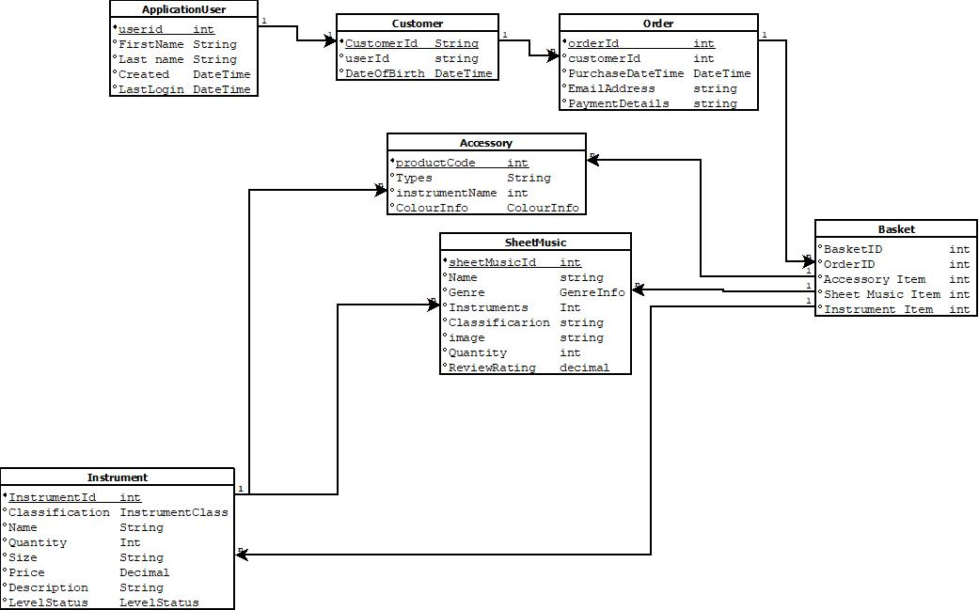
This entity relationship diagram shows how all the tables are related to each other. There are one-one, one-many and many-many relationships. Therefore, the many to many relationship has been broken down into two one-many relationships.

2.3 – Screenshots of implemented pages
Instruments -Index
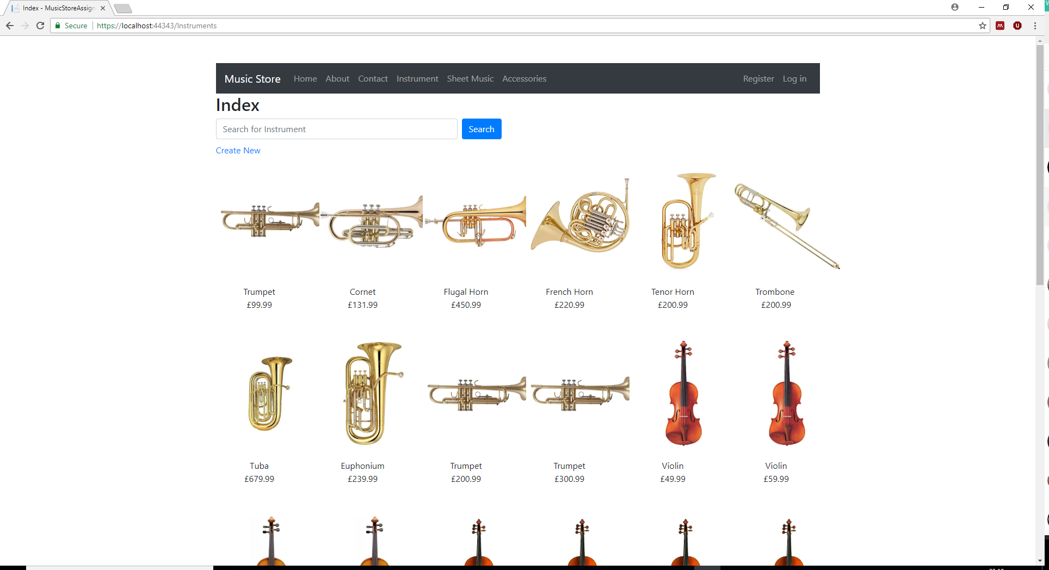
This shows the index page for the instruments grouping by family for example brass/string.

Accessories - Index
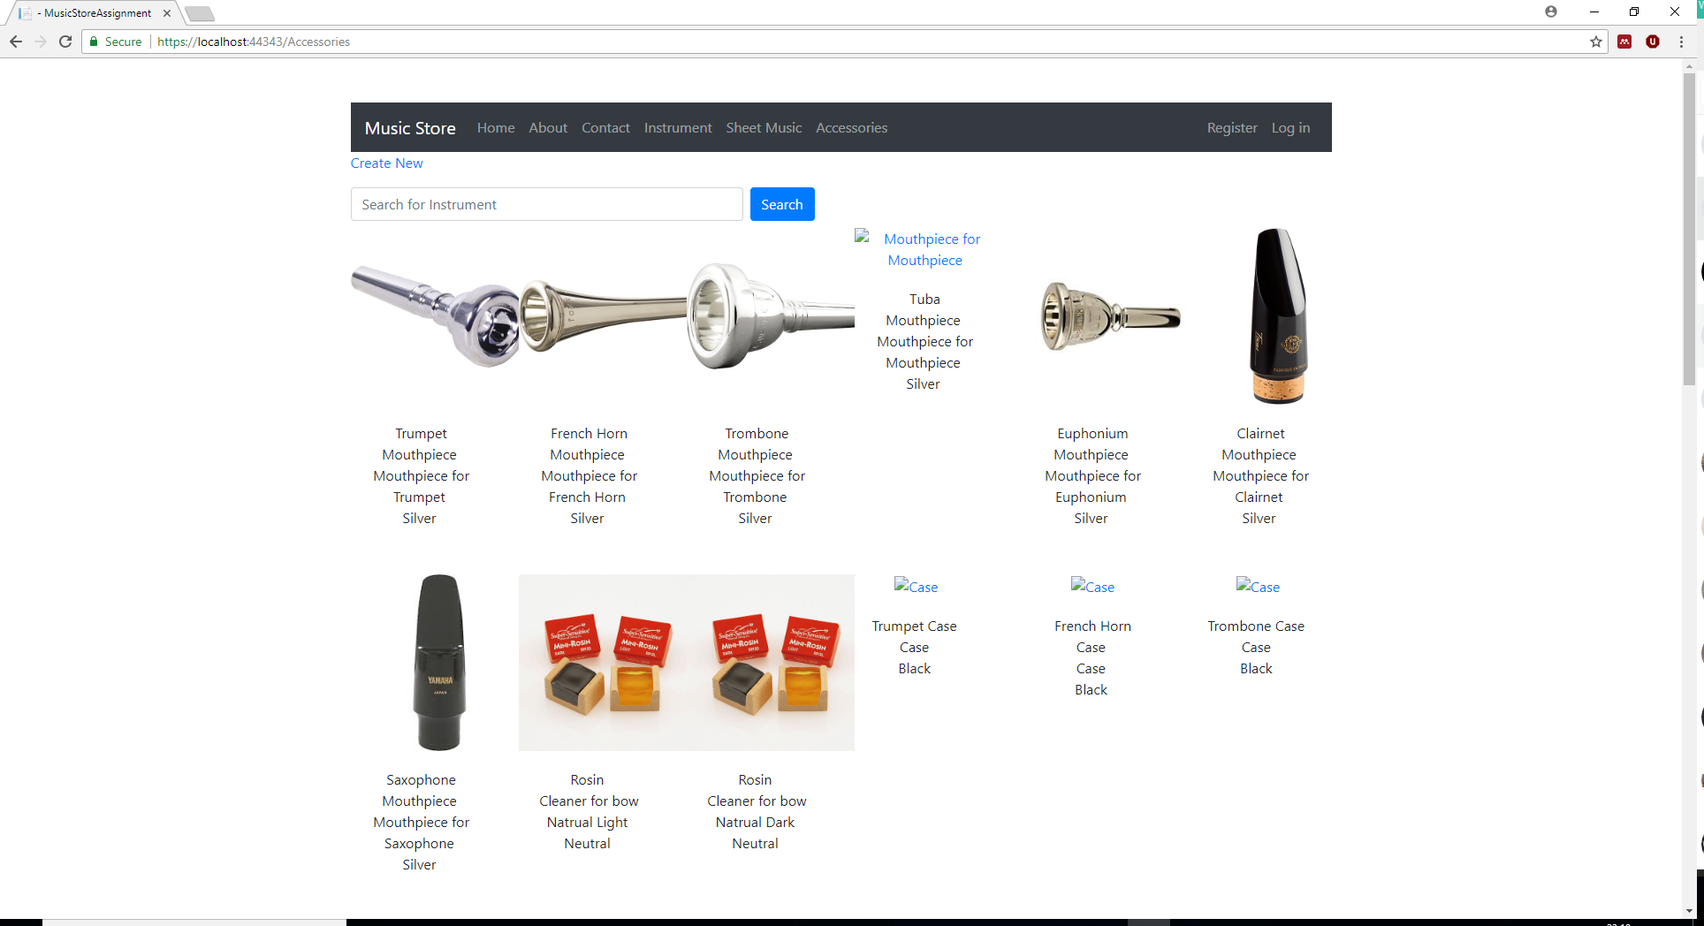
This shows the index page for the Accessories grouped by type for example case/mouthpiece.
Sheet Music - Index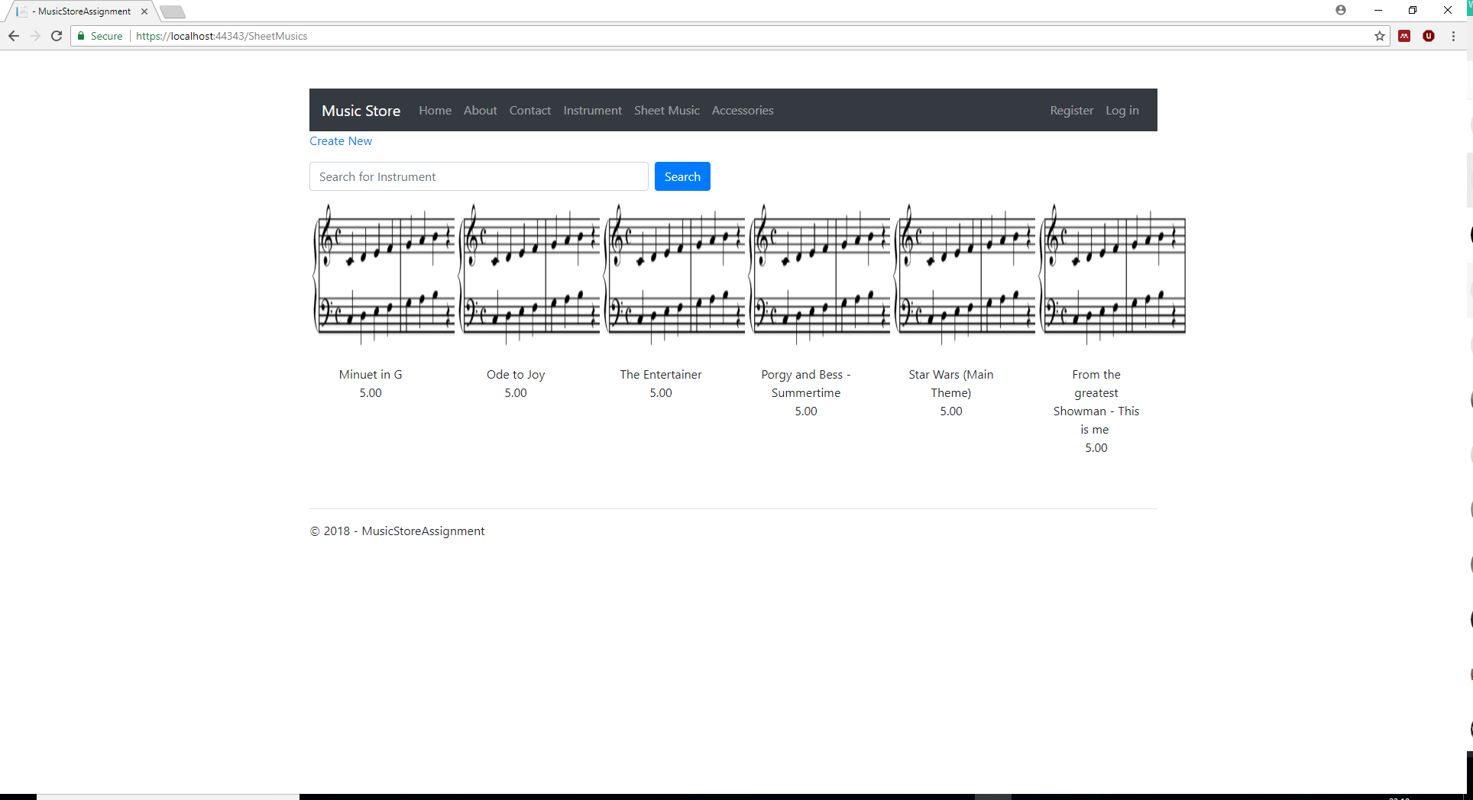
This shows the index page for the Sheet Music grouped by genre for example Classical/Jazz/Pop

Details – Instruments
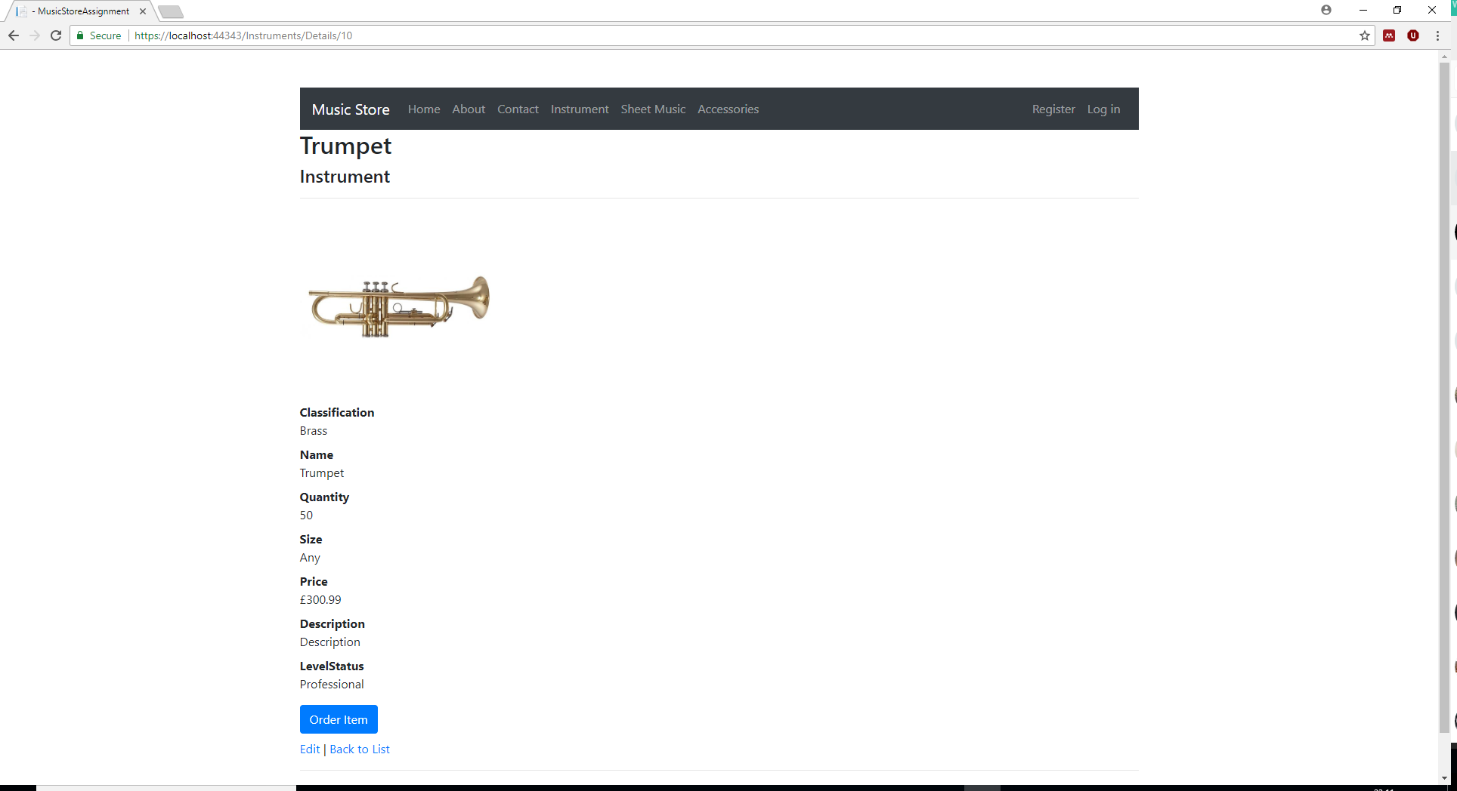
Each item on the index page has an associated page with the instruments details. The is where the instruments will be able to be ordered from the order now button. The admin user can edit the details of each item.
Accessories – Details
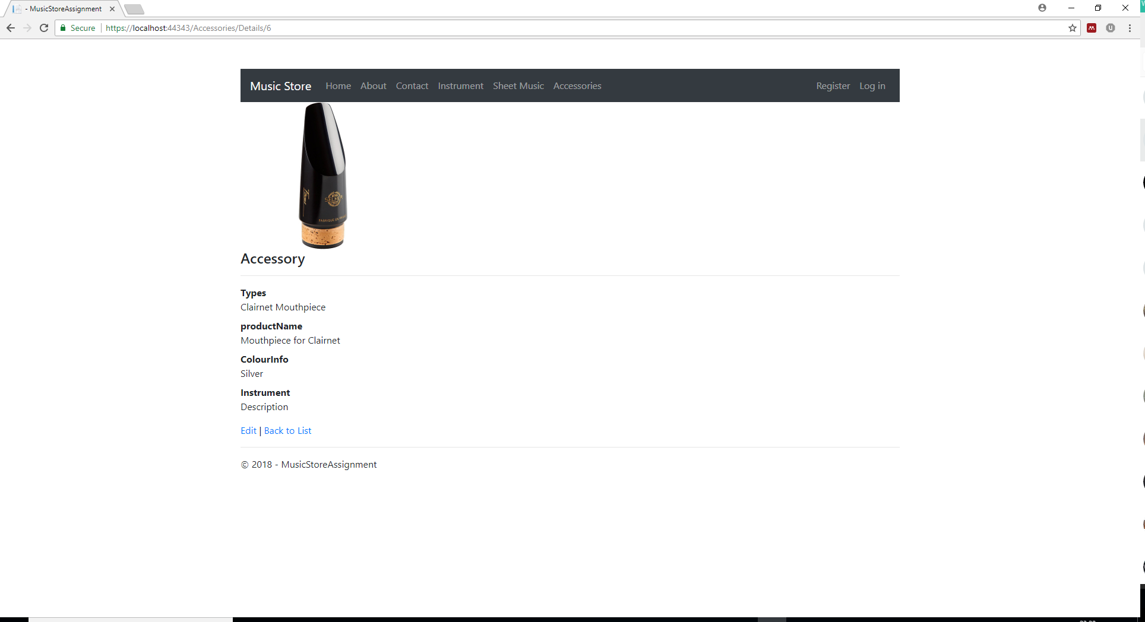
Each item on the index page has an associated page with the Accessory details. The admin user can edit the details of each item.

Details – Sheet Music
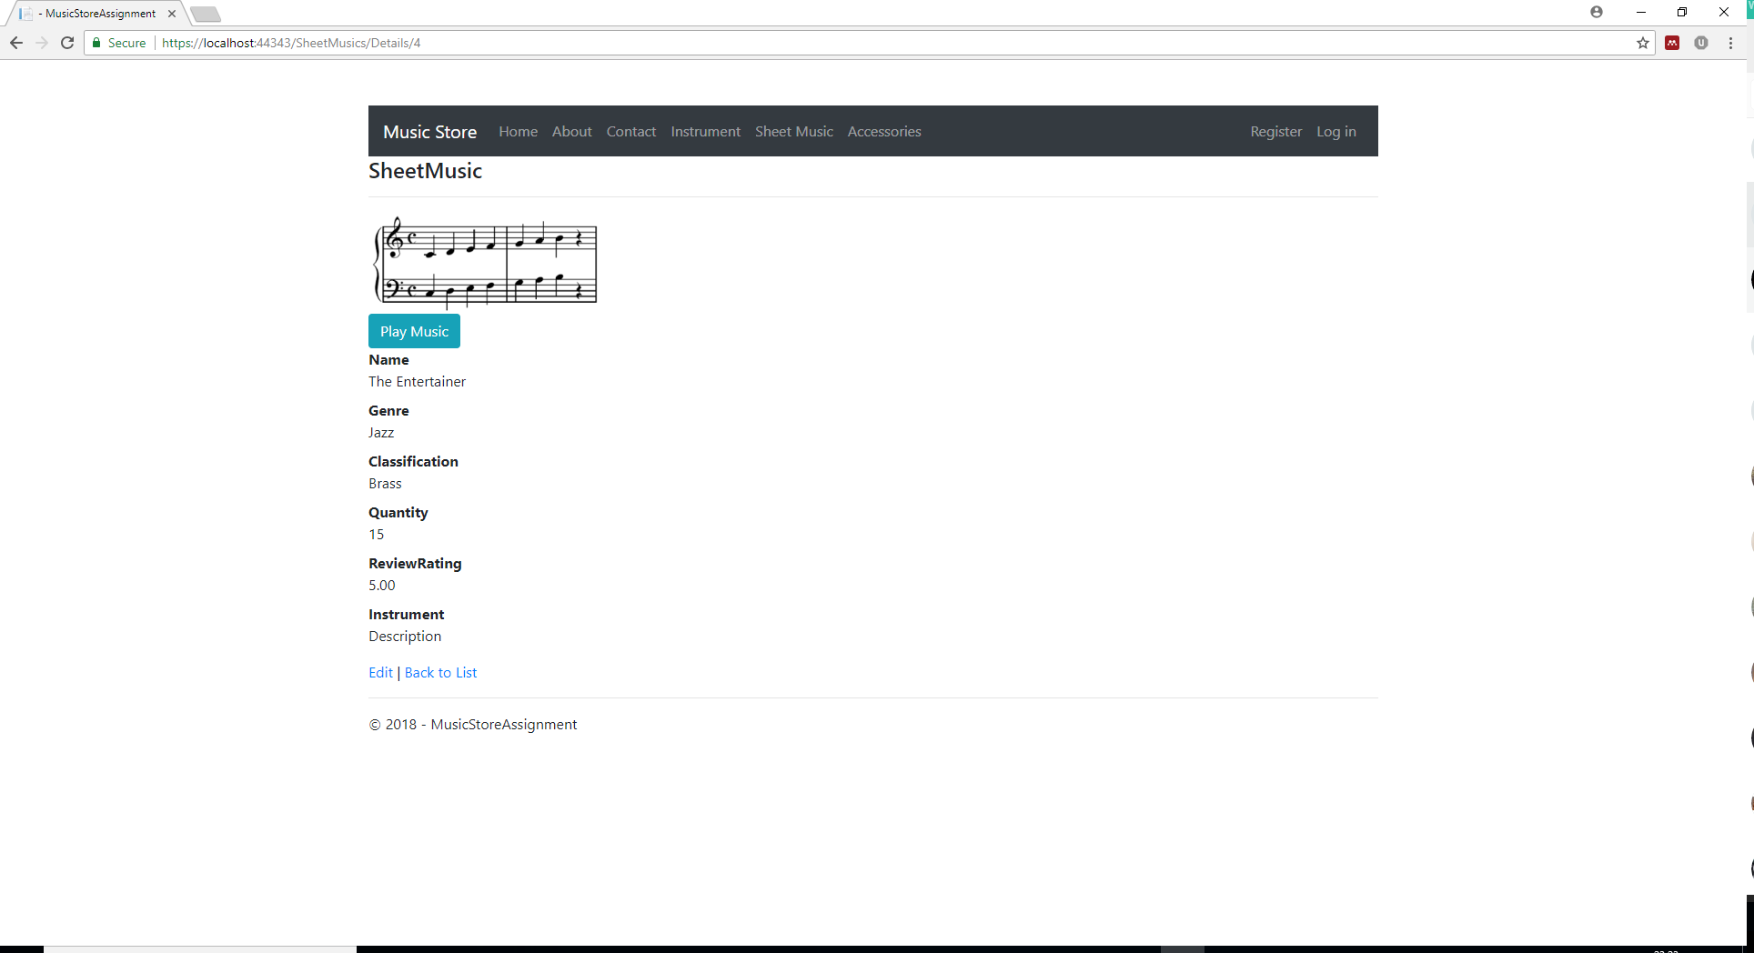
Each item on the index page has an associated page with the sheet music details. The admin user can edit the details of each item. There is a button to listen to a demo of the sheet music listed.

Login In Page
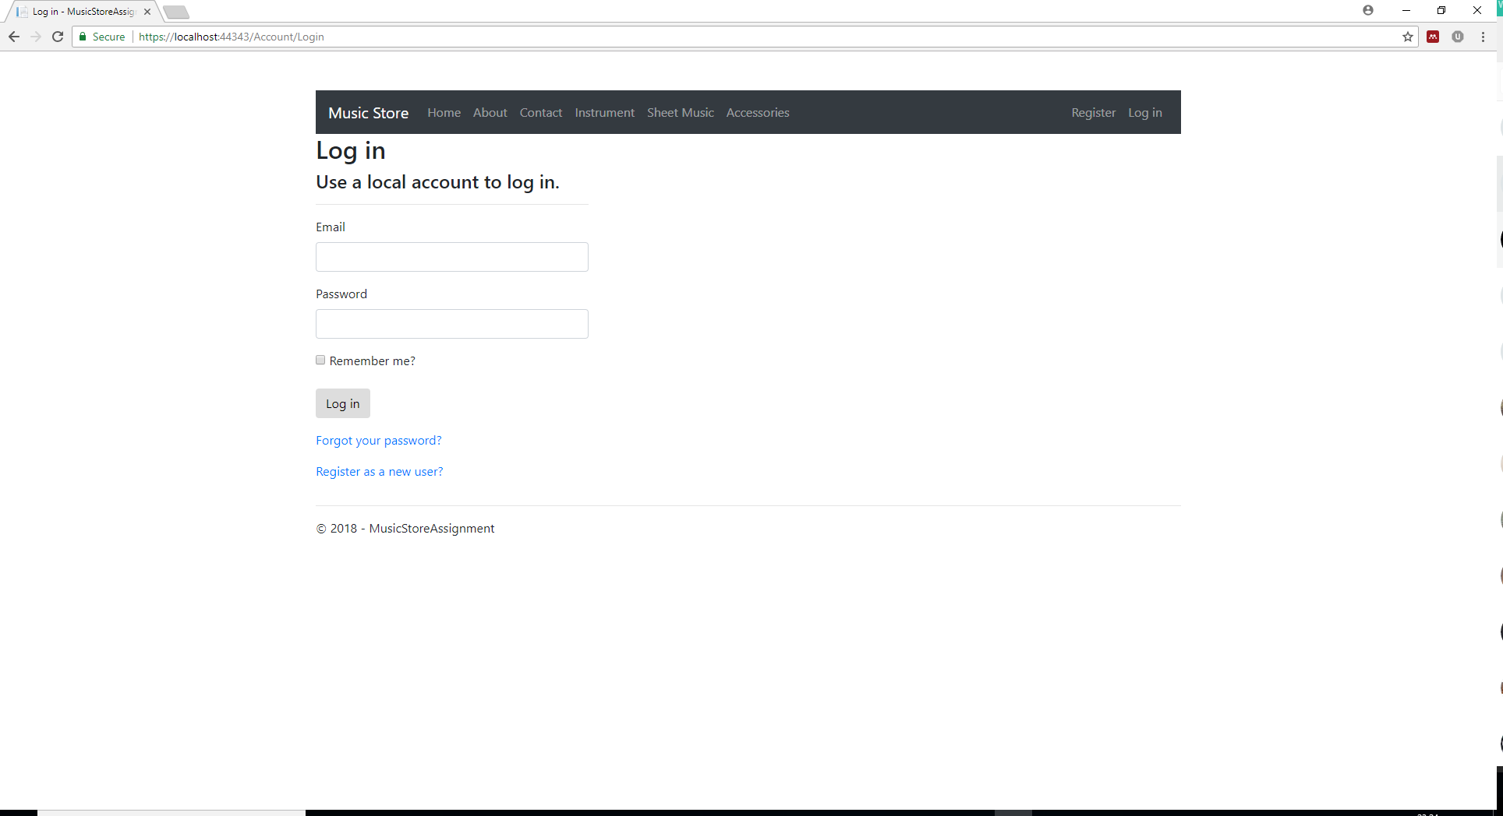
This is a login page for the users and admins. The admin user can log in successfully and is able to edit the details.
Instrument - Search (“Trumpet”)
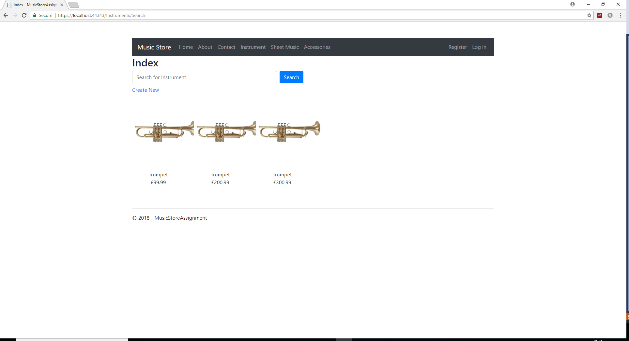
Sheet music – video
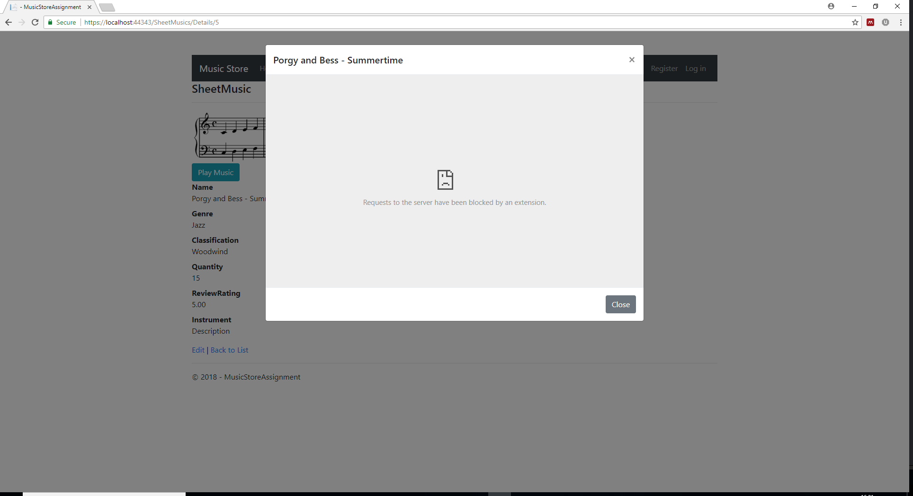
There is an issue with the video playing.

3 – Evaluation

3.1 - Functionality and testing
The database is designed to have an online music shop. Initially there was a problem with migrating the database because a few relationships were incorrect and there was an incorrect version of tools being installed. Once this was corrected the database was migrated successfully to the localDB within Microsoft SQL.
Many tables were created as entity classes to make a dynamic website.[1] The main tables were Instruments, Accessories and Sheet Music with others added to enable different features to be added such as Application User. There is mock data added to the main tables relating to their types with image names and description. Too much data was added to the database resulting in too many items needing to be populated. Not all items have been completely populated due to time constraints for example images missing on some pages. On reflection a smaller database would be easier to manage at the start with additional data added if necessary.
There is a password required to become a member. Only admin users have ability to edit, delete, and create. The user can log into the system without having access to change the database. Initially there was a problem with the user not being able to log into the system. This was fixed using an alternative email address as the database was not updating an initially incorrect entry. The Admin can log into the system and change items. Currently there is an issue with saving the edited data as the enumerated drop-down boxes are not functioning correctly.[2]
The play music button in the Sheet Music page is a YouTube video showing a clip, however, the iframe is not playing on the bootstrap function. Looked at several forums to see if the issue can be fixed. [3] Looked at embedding youtube video with ASP.NET but this did not resolve the issue. The user currently is unable to place an order on all items as the coding is missing behind the button.

3.2 – Current System
It is easy to search for an item on the website. The user can search for items in the main tables by searching the name of the item such as trumpet and it will display the items found in the database. There is a navigational bar at the top of the page for the user to navigate between pages on the site. Each of the detailed pages are functional but could have benefitted from a more varied appearance where the information is spread over the whole page. More description on all the items. There are images to represent what the item might look like and sample music to represent the sheet music.

3.3 – Future Improvements
An improvement to the usability of the website would be to have one search bar to look in all three tables rather than having separate search bars for separate tables. Designing and making a homepage that links the main pages together would make the website more appealing. Implement an order button to add items to a basket. There needs to be more complete descriptions of the items perhaps to include information about the history of the item. There could be suggested items that they might also buy alongside the item chosen. This would further link the tables together as the user might want a case to go with the instruments for instance.

4 - References
[1] R. Peres, “Mastering ASP.NET Core 2.0.” .
[2] P. van der. Westhuizen, Bootstrap for ASP.NET MVC. Packt Publishing, 2014.
[3] M. András, “Embed responsive Youtube video,” 2014. [Online]. Available: https://www.codeproject.com/Tips/810254/Embed-responsive-Youtube-video.

