  Component One: Student Journal (learning log) 750 words +/- 10%  Contribution to Overall Module Assessment: 25% | Student No: | 2225106
 | Module Title: | Hotel Administration and Front Office
 | Module Code: | BMIH4004
 | Lecturer: | Natalie Brailsford,  Dan Payne  Neil Dyer,  Muhammad Cassamo  Scott James
Key Skills Required to Work Within the Hotel Front Office

A front desk employee represents an establishment to the outside world. This individual is always the first encounter that a guest has with an establishment. Undoubtedly this initial meeting is crucial (Bardi, 2011).
Communication: Communication skills, both verbal and written, as well as acute listening ability, should be the primary focus of front office staff members (Tewan, 2009).
Multitasking: A hotel front office staff needs to be accustomed to managing multiple responsibilities at once. Managing several phone lines, having in-person interactions with customers, guests, and staff, as well as administrative tasks, are a few instances (Baum, 2017).
Technical Skills: Proficiency in word processing is essential, but knowledge of Excel, desktop publishing, or industry-specific software like PMS can be advantageous for hotel front desk employees (Bardi, 2011).
Problem Solving: Being able to recognise issues and apply problem-solving techniques to offer solutions is essential for front desk employees. This ability is crucial since it guarantees the continuance of regular operations for the company. A hotel's priceless reputation may frequently be preserved by responding politely and promptly to complaints, which can turn an otherwise negative review into a positive one (Tewan, 2009).
Capacity to remain composed under stress: Staff members might have to sign for a shipment, take credit card payments, answer the phone, and greet guests all at once at any given time (Bardi, 2011).

The Schön Reflective Model
Donald Schon defines this paradigm as the capacity of individuals to think about everything they are carrying out during the time they are actually doing it. He argues that the ability to think creatively and apply prior knowledge to novel situations is essential for navigating the grey areas of professional practise. A capacity for reflection-in-action is required for this (Hébert, 2015). The three stages of this model have been briefly described further with experience.
Knowledge in action: When I was assigned to the front desk, I had plenty of time to reflect about the procedures we normally use. In light of this, I think it is essential to greet guests who come to the front desk with a smile and a friendly gesture resolve or answer to all their problems or queries. Making guests feel at ease and welcome is crucial to building a good first impression and keeping them coming back for more. Therefore, I have resolved to humbly welcome my guests and do my best to ensure they feel at home while solving their issues and answering to queries, no matter how many guests are standing in front (Satariyan and Reynolds, 2016).
Reflection in action: Once after checking out, a guest requested me to breakdown the bill he was charged. As there was a rush of guest, I requested him to allow me to take some time while handling other guests. But it took me several minutes to get back to the specific guest, but at that moment I realized that I kept that guest on hold for too long for which he got upset and left without asking for second time. This situation made me feel bad and anxious as well as broke concentration at work. After a few days, I came to know that the guest gave a negative review on the website of Trip Advisor explaining the whole scenario, which made me more anxious, hampering my productivity (Li et al., 2013).
Reflection on action: When my shift was over, I sat down and was rethinking the whole situation. I realized that I have to be swifter and have to be a prompt multitasker in order to handle all the guests in rush hours which will help me to work more effectively and create memorable experience to my guests (Li et al., 2013).
Conclusion:
To sum up, my time spent working at the Premier Inn hotel East Midlands Airport front desk has been helpful in helping me develop my practical knowledge and abilities in hotel administration. The placement has given me a thorough grasp of customer service, reservations, guest management, and front office operations as a whole. The practical experience has improved professional growth and equipped students for future professions in the hospitality sector by enabling the application of academic knowledge in a real-world situation. The student's exposure to all facets of hotel management has not only enhanced their academic background but also nurtured their personal development, leadership potential, and understanding of the complexities involved in delivering outstanding guest experiences. This internship has really been a life-changing educational experience.

Word Count: 740

References
Bardi, J. (2011) Hotel Front Office Management. Wiley, London
Baum, T. (2017) Skills and training for the hospitality sector: a review of issues. Journal of vocational Education and Training, 54(3), pp.343-364.
Hébert, C. (2015) Knowing and/or experiencing: A critical examination of the reflective models of John Dewey and Donald Schön. Reflective Practice, 16(3), pp.361-371.
Li, L., Gray, D.E., John Lockwood, A. and Buhalis, D. (2013) Learning about managing the business in the hospitality industry. Human Resource Development Quarterly, 24(4), pp.525-559.
Satariyan, A. and Reynolds, B. (2016) A reflective model for action research: An evolving pedagogical trajectory. What is Next in Educational Research? (pp. 21-28). Brill.
Tewan, J. (2009) Hotel Front Office: Operations and Management.
Oxford Higher Education Press.

Component Two
Contribution to Overall Module Assessment: 25%
Trip Advisor Review Response 150 words +/-10%
Dear ali556,
I would like to express my gratitude for the valuable feedback you have provided regarding your experience at Premier Inn East Midlands Airport Hotel. We highly value your review.
I am delighted to ascertain that you fully enjoyed your stay at our establishment, and that the entire crew was successful in delivering a highly satisfactory experience to you. We express our gratitude for the genuine and benevolent sentiments shared.
We value your feedback regarding the accommodations, culinary offerings, and beverage selections. I am particularly pleased that you have acknowledged the attention given to minor elements such as the presence of a shower over the bath and the freshly prepared breakfast options.
I would want to express my regret for the cold breakfast meal provided, and I take appropriate measures to rectify this matter in upcoming events.
I would want to express my gratitude for your kind sentiments, ali556. We greatly appreciated your presence among us. I anticipate the opportunity to extend another invitation to you in the near future

Kind Regards
Selina Akhter Seema
Guest Relation Manager
Premier Inn East Midlands Airport

Screen shot of referenced Trip Advisor review used:
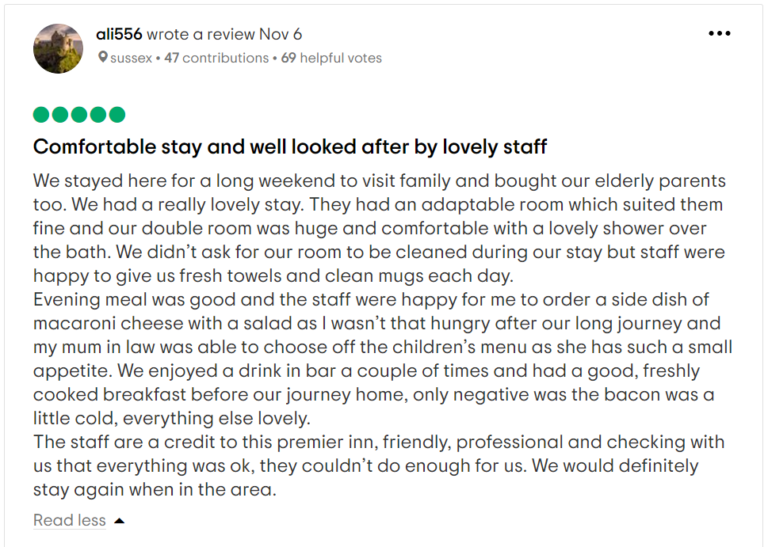
Letter of complaint response 500 words +/- 10-%
Mr Ronald Federick,
17 Trinity court,Swansea
SA1 2AR
November 9, 2023
Dear Mr Ronald Federick,
We have received and analysed the complaint you made about the services and accommodations provided by our hotel. I would like to offer my most sincere apologies for the problems that you encountered during your stay at our hotel. In addition, I would like to show my appreciation to you for informing me about your difficulty, which will be useful in assisting me to rectify the errors and make up for any inconvenience at the appropriate moment.

It was an inevitable situation that caused you to suffer, and I profoundly apologise for that. Please accept my deepest condolences. I am truly sorry that the meal quality was substandard and that it was served to you at a frigid temperature during your recent stay at our hotel. I am really sorry that we were unable to live up to what you were looking for on this particular occasion. We are appreciative of your bringing this matter to our attention. I am really sorry to hear that you were unable to have a good time throughout your experience. To mitigate the likelihood of a future occurrence of this same matter, I intend to have an interaction with the person who manages the kitchen. I respectfully request the opportunity to address and resolve the matter with you, provided you be interested to granting us another chance to do so.
I would want to convey my deep regret upon realising that the cleanliness quality of the property did not exceed the expected standards. Upon being notified of the situation, immediate action was made to promptly provide the necessary instructions to our staff members, with the aim of facilitating a thorough cleaning procedure. you had to experience considerable discomfort, potentially due to both the spatial layout of the environment and the overwhelming occurrence of sound disturbances. The matter has been brought to the attention of the hotel staff, who have swiftly taken steps to discover and implement an improvement.
You will be relieved to find out that the problems you detailed have already been resolved by our team, and that our staff has discussed your concern. This information will bring you some peace of mind. We are sincerely sorry that you had to go through such an unpleasant experience. Even though we put in our best effort to provide the highest possible level of service to our guests, there are times when we fall short. We take measures to ensure that this will not occur again, neither during your stay nor with any other guests, and it is our honest hope that you will notice the improvement and have a pleasant time during your subsequent visit with us.
Once again, we want to express our gratitude for the time you took to address some of our issues. During your stay at our lodging facility, we hope that you will take advantage of the services that we have to offer in future.

Kind Regards
Selina Akhter Seema
Guest Relation Manager
Premier Inn East Midlands Airport

References
Dinnen, R. and Hassanien, A. (2014) Handling customer complaints in the hospitality industry. International Journal of Customer Relationship Marketing and Management (IJCRMM), 2(1), pp.69-91.
Johnston, R Clark, G. Shulver, M. (2012) Service Operations
Management. London
Lewis, R.C. and Morris, S.V. (2017) The positive side of guest complaints. Cornell Hotel and Restaurant Administration Quarterly, 27(4), pp.13-15.
Park, S.Y. and Allen, J.P. (2013) Responding to online reviews: Problem solving and engagement in hotels. Cornell Hospitality Quarterly, 54(1), pp.64-73.
Tesone, D. (2013) Principles of management for the hospitality
industry. London: Routledge

Component Three:
Contribution to Overall Module Assessment: 50% (1000 words +/- 10%)
Writing in essay format

Element 1 – Pre-Arrival

The phase of the guest cycle known as pre-arrival consists of all of the interactions that take place regarding a guest along with a hotel prior to the guest's actual arrival at the hotel. Making a reservation is the single most crucial thing to do before arriving at the destination. During this stage of the process, the guest is responsible for choosing a hotel at which they are going to stay (Suryawanshi, 2020). The guest's decision to book a stay at a particular hotel may be influenced by the convenience with which the reservation was made and the manner in which the reservation agent described the hotel's amenities, such as the room type, the pricing, the recreational opportunities, and the proximity to nearby attractions (Fallon and Rutherford, 2011).
The information gathered during the reservation process is also used for pre-registration tasks, such as providing the guest with the room they requested and determining the room fee that will be applied to their folio throughout their stay (Abed, 2017).
For example, Conrad London St. James streamlines the check-in procedure by sending a comprehensive email to the guest's pre-arrival inbox in order to make this step less difficult for the guest. Not only that, when a guest book a room with them, there is a place for special requests, and this is done in order to ensure they can give the necessary conveniences for every variety of guest (Hilton, 2023).

Element 2 – Arrival

Guest registration and room allocation occur during the arrival phase of the guest life cycle. As soon as they check in, guests begin conducting hotel-related business with the front desk. The hotel's front desk agents are accountable for explaining the guest's financial obligations and keeping tabs on all guest payments. Before registering a guest, the front desk clerk must first ascertain whether or not a room has been reserved for them (Bardi, 2011). Guests who have made reservations may have already completed some form of pre-registration. The front desk staff has a chance to make a sale when walk-in, or impromptu, guests arrive (Wood, 2013). An effective front desk staff necessitates a comprehensive understanding of the hotel's room categories, rates, and visitor amenities, as well as the ability to articulate them favourably. A guest is less inclined to book a room if they have doubts about whether or not they will get what their money is worth. The front desk is unable to operate properly without a registration record that has been filled up either as part of the registration process or at check-in. Guest registration data should include requested payment method, expected duration of stay, and details about any unique requirements the guest may have, which might include a rollaway bed, cot, or preferred guest location. The guest's billing name, address, phone number, and signature are also required. With complete information at check-in, the front desk can better accommodate guests with specific requests, plan for future room use, and settle guest accounts (Tewan, 2009). The registration card guests fill out at check-in is the key document from which we compile information about them. Each guest is given a room category and room tariff based on their registration information by the front desk agent. It also relies on the details of the booking. There are a variety of room types at hotels, from the basic to the extravagant. Even among the identical room type, there could be variations based on the furnishings, facilities, and location on the site. After a guest has decided to book a room, the front desk worker will begin asking about payment options. After confirming the payment method and the departure date, registration is complete. The room key can be given out if necessary. The occupancy phase of the guest life cycle commences when the visitor first enters the room (Dinnen and Hassanien, 2014).
Self-checking in is an option at Conrad London St. James, and they also have a key pick-up counter so that guests can bypass the queue. In addition, they offer a transfer service from the airport to their property in order to make the arrival process as easy as possible for its guests (Hilton, 2023).

Element 3 – Duration of stay

The guest cycle's occupancy stage starts when the visitor arrives at the place of lodging. During the occupancy stage, how the front desk employees portray the hotel is crucial. In its capacity as the primary point of contact for all hotel operations, the front office handles guest demands. One of the people giving the visitors information and materials. In order to reply to guests in a prompt and accurate manner, front desk staff should exercise particular caution. The primary goals of those working at the front desk are to anticipate the needs of their customers and fulfil or beyond their expectations. The guest will be more likely to return to the hotel as a result (Johnston et al., 2012).
A seamless experience is provided to guests of the DoubleTree by Hilton London - West End, by offering a variety of channels via which they can communicate with members of the hotel staff. These channels include telephones in the guest rooms for customers who wants more ease as well as direct contact with the front desk staffs, options for guests. Additionally, premier inn staff members are trained to answer inquiries and resolve issues as soon as possible (Braff, 2023).

Element 4 – Departure

Like all other steps, the checkout procedure must be quick and efficient to ensure that guests do not get frustrated. This is usually the time to gather visitor input and apply it to enhance operations. The guest's excellent experience will be rounded out with no unexpected paperwork or hidden surcharges (Vallen and Jerome, 2014). Upon departing the hotel, the visitor returns the room keys, vacates the room, and receives an exact summary of the cleared bills. The front desk alerts the housekeeping department and updates the room availability status when the guest checks out. Hotels that use property management software automatically update the status of each room. At this point, the front desk furthermore gathers comments regarding the hotel visitor experience by transferring the form of feedbacks (Vallen and Jerome, 2014).
Premier Inn East Midlands Airport Hotel goes out of its way to make its guests feel special by expressing gratitude for their visit, soliciting specific comments, and taking that feedback into consideration (Tripadvisor, 2023).

References

- Abed, M.A.A. (2017) Using the Preregistration Procedures to Minimize the Check-in Duration and To Reflect an Excellent Guest Experience for Regulars and repeaters. International Journal on Recent Trends in Business and Tourism (IJRTBT), 1(4), pp.48-54.
- Bardi, J. (2011) Hotel Front Office Management. Wiley, London.
- Braff, D. (2023) Say goodbye to daily hotel room cleaning. The New York Times. Available at: https://www.nytimes.com/2023/03/24/travel/hotels-end-daily-cleaning.html (Accessed: 09 November 2023).
- Fallon, M. and Rutherford, D. (2011) Hotel Management and
Operations. Wiley, London.
- Hilton (2023) Learn more about Hilton Culture. Available at: https://jobs.hilton.com/us/en/culture (Accessed: 09 November 2023).
- Johnston, R., Clark, G. and Shulver, M. (2012) Service Operations
Management. Pearson, London.
- Suryawanshi, M. (2020) Introduction to guest cycle, Reservation, Pre-Arrival Procedures, Guest Arrival, Guest Stay.
- Tewan, J. (2009) Hotel Front Office: Operations and Management.
Oxford Higher Education Press.
- Tripadvisor (2023) Premier Inn East Midlands airport hotel - updated 2023 prices reviews. Available at: https://www.tripadvisor.com/Hotel_Review-g499575_d1020738_Reviews_Premier_Inn_East_Midlands_Airport_Hotel_Castle_Donington_Leicestershire_England.html (Accessed: 09 November 2023).
- Vallen, G.K. and Jerome J. (2014) Check-in check-out:
managing hotel operations Ninth edition. Pearson new
international.
- Wood, R. (2013) Key Concepts in Hospitality Management. Sage,
London.

