

University of Wales Trinity Saint David
School of Engineering
Conrod Accelerations, Forces, Displacements
Advanced Engine Design
M6X00410
Ainsley Martin
P149894
04/11/2019

Contents
Introduction 4
Engine Information 5
Part A – Peak Gas Forces 6
Part B – Inertia Forces 8
Part C – Maximum Compressive Force 10
Part D – Maximum Tensile Force 12
Part E – Maximum Compressive and Tensile Stress 14
Part F – Nominal Safety Factor 17
Compressive Loads 17
Tensile Loads 18
Part G – Maximum Compression Distance and Stretch 19
Part H – Titanium Conrod Comparison 22
Further Possible Modifications 24
Conclusion 25
Appendix 26
Torque and Power 26
Resolved Forces 27
Maximum Ring Force 27
References 32

Figure 1 - Peak Gas Force Production Engine 6
Figure 2 - Peak Gas Force 0.1m Bore 6
Figure 3 - Peak Gas Force 0.04m Bore 7
Figure 4 - Inertia Forces for Production Engine 8
Figure 5 - Inertia Forces for Modified Engine 8
Figure 6 - Max Compressive Force 10
Figure 7 - Max Compressive Force for Modified Engine 10
Figure 8 - Max Tensile Force 12
Figure 9 - Max Tensile Force for Modified Engine 13
Figure 10 - Max Compressive Stress in Rod Shank 14
Figure 11 - Max Compressive Stress in Rod Shank for a Modified Engine 14
Figure 12 - Maximum Tensile Stress 15
Figure 13 - Maximum Tensile Stress for Modified Engine 15
Figure 14 - Compression Distance 19
Figure 15 - Maximum Compression Distance for Modified Engine 20
Figure 16 - Conrod Stretch 20
Figure 17 - Stretch for Modified Engine 21
Figure 18 - Compression Distance Comparison Between Titanium and Steel 22
Figure 19 - Conrod Stretch Comparison Between Steel and Titanium 22
Figure 20 - Calculated Torque and Power Curve 26
Figure 21 - Actual Torque and Power Curve 26
Figure 22 - Resolved Forces against Crank Angle 27
Figure 23 - Maximum Ring Force 27
Figure 24 - Maximum Ring Friction 28
Figure 25 - Excel Spreadsheet (1) 30
Figure 26- Excel Spreadsheet (2) 31

Introduction
This assignment will look at the forces that occur inside a cylinder and act upon a conrod. At first the forces and stresses will be investigated, and they will be used to see if the current piston is safe enough to withstand the forces.
The engine will then be modified and the conrod will be looked at to see if the new forces and stress will have a detrimental effect on the conrod. A different design or material will have to be considered to overcome the new forces.

Engine Information
The engine used for this assignment is the Ford 1.6GTDI EcoBoost.
Table 1 - Engine Information
Piston mass(g) | Cross Sectional Area(mm) | R(m) | L(m) | μ | Bore (m)
0.3473 | 139.2 | 0.04 | 0.135 | 0.1 | 0.079
(Ferrara, 2016)
To modify the engine the rpm has been increased. This was done using a second order polynomial curve fit. The rpm was increased to see what effect this would have on the conrod.
Table 2 - Table of pressure data used for new rpm
New rpm | rpm used to get pressure data
6500 | 5000
7000 | 4500
7500 | 4000
8000 | 3500
8500 | 3000
9000 | 2000

This method does have some issues as the pressure data will not be exactly, although as the data will always be an assumption it will never be completely accurate.

Part A – Peak Gas Forces
To obtain the peak gas force the following equation is used;
$$Maximum Pressure*\frac{{\left(π*bore\right)}^{2}}{4}$$
Equation 1 - Peak Gas Force
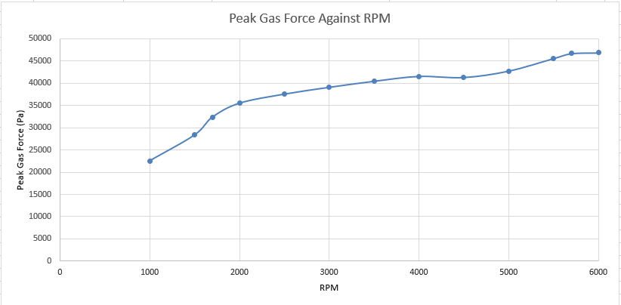
Figure 1 - Peak Gas Force Production Engine

This graph is showing the peak gas forces for each rpm. It can be seen that the peak gas force occurs at 6000rpm.
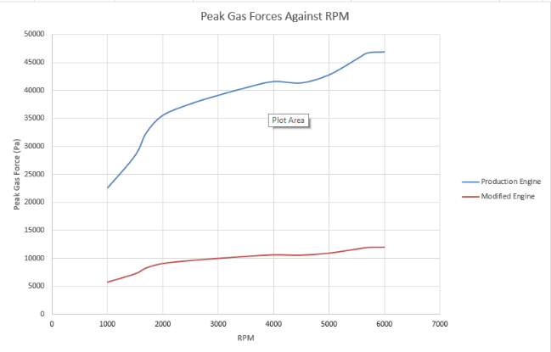

Figure 2 - Peak Gas Force 0.1m Bore

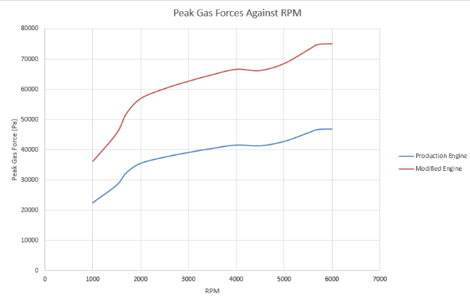

Figure 3 - Peak Gas Force 0.04m Bore

When the bore of the engine is modified the peak gas force changes as expected. If the bore is made smaller the peak gas force decreases and if it is made larger the peak gas force increases. This is why in most motorsport applications an engine will have the biggest bore allowed by the regulations. A larger cylinder size will result in greater stresses due to the temperature inside the cylinder unless the temperature of the gas can be reduced. (Taylor, 1985)

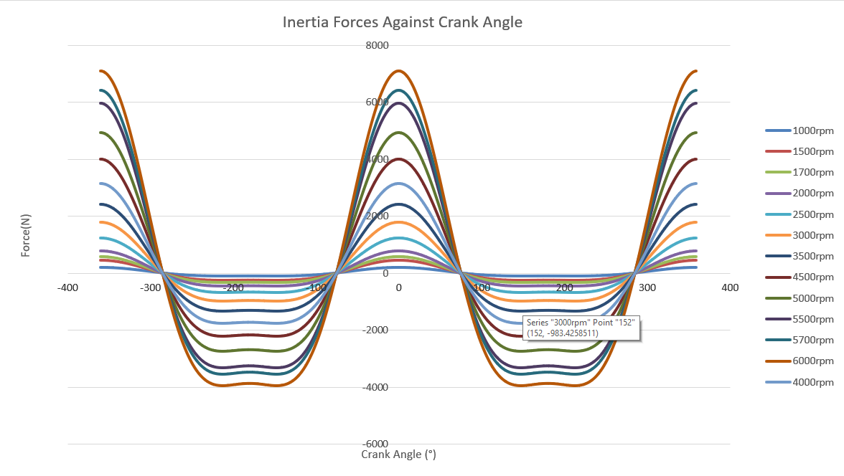
Part B – Inertia Forces
Figure 4 - Inertia Forces for Production Engine
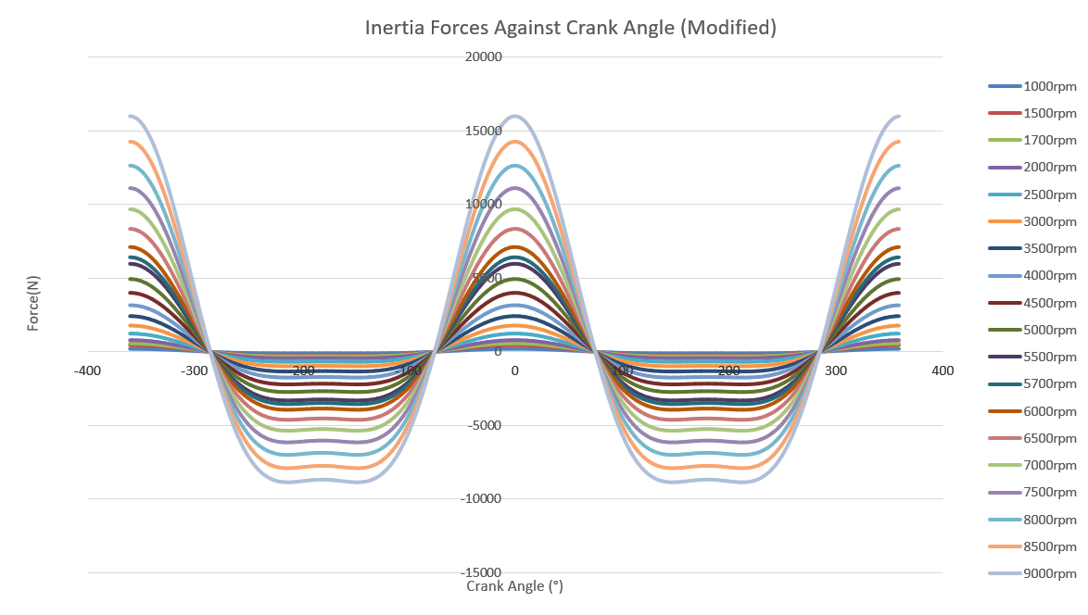
To calculate the inertia force, the following equation is used;
$$\left(R*{\left(2π*\left(\frac{rpm}{60}\right)\right)}^{2}\right)*\cos\left(θ\right)+\frac{R}{L}*{\left(2π*\left(\frac{rpm}{60}\right)\right)}^{2}*cos⁡(2θ)$$
Equation 2 - Inertia Force
Figure 5 - Inertia Forces for Modified Engine
(Macdonald, 2019)
This graph shows that the peak inertia forces occur when the piston is at TDC (-360°, 0° and 360°). This happens as this is where the maximum piston acceleration is occurring and due to newtons 2nd law (F=ma). The greatest inertia forces occur at 6000rpm as it has the largest peak gas force. Between +/-285° and +/-75° the force is negative as it is acting in the opposite direction. When the force is negative it is opposing the gas force. The inertia force causes a resistance to the change or speed or direction (Crouse, 1995)
When the engine is modified the inertia forces continue to increase as the rpm increases, this is because the piston is accelerating quicker with a higher rpm.

Part C – Maximum Compressive Force
The maximum compression force is the maximum value of the net force at each rpm.
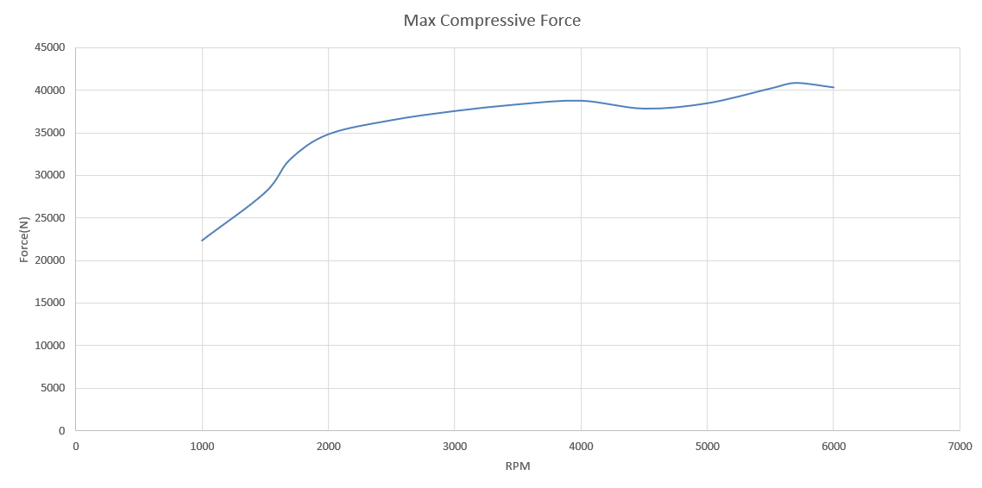
Figure 6 - Max Compressive Force
The max compressive force starts increasing at a steep rate, however after 2000rpm the rate that the force increases by is reduced.
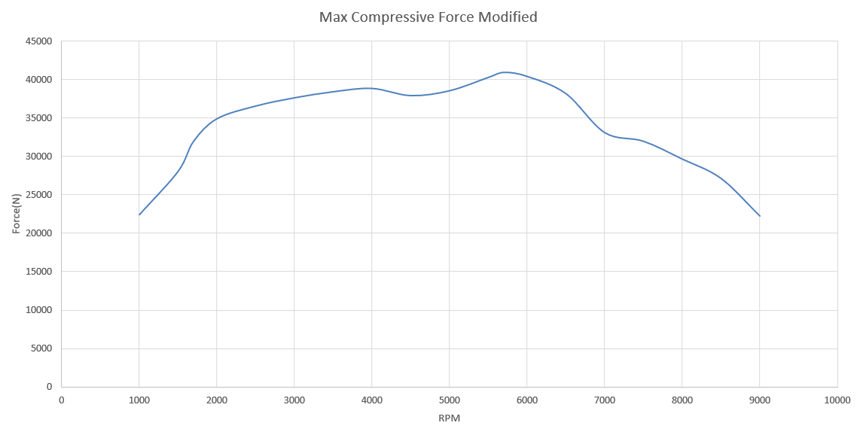
Figure 7 - Max Compressive Force for Modified Engine
When the rpm range is extended it can be seen that the max compressive force starts to decrease after 5700rpm. There is a decrease in pressure after 6000rpm as the engine has not been modified in any way to cope with the higher rpm. As there is a decrease in pressure this causes a decrease in the gas force which will end up reducing the overall compressive force. The drop off could be due to the turbo not being able to pump any more air into the engine as it will only be designed to work up to 6000rpm. If the boost of the turbo was turned up and the turbo was modified to deal with the new forces, the force would then be expected to continue to rise as the rpm of the engine increases. Higher octane fuels are better for turbocharged cars at it allows more air to get into the cylinder and stops the air fuel mixture from pre-detonating (Minnesota Bio Fuels Association, 2016) if the engine is correctly tuned to run on a higher octane fuel.
The compression force through the shank enables it to resist buckling. (Manning, 1988)
A conrod is designed as a strut as they are superior at resisting compressive forces than tensile forces. This is because compressive forces are over 6 times greater than the tensile forces so a conrod needs to be able to withstand the compressive force. (Leela Krishna Vegi, 2013)

Part D – Maximum Tensile Force
The maximum tensile force is the minimum value of the net force as it acts in the opposite direction to the compressive force.
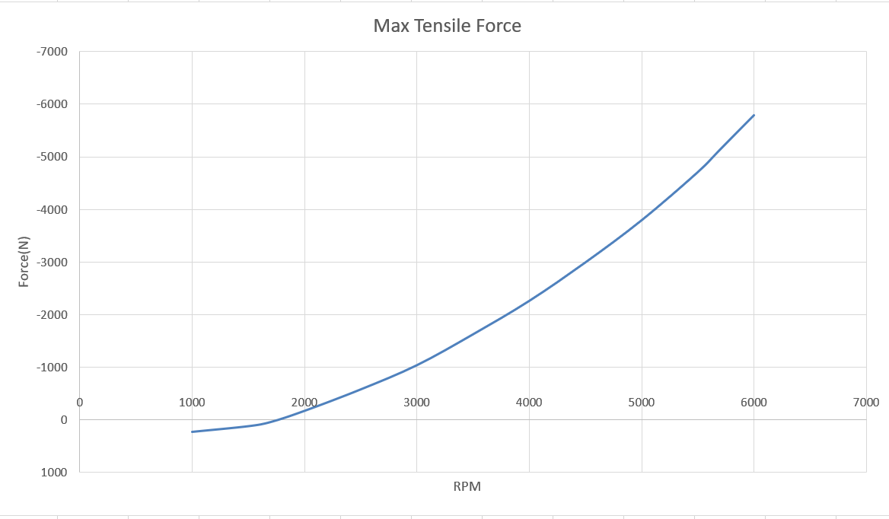
Figure 8 - Max Tensile Force
It can be seen from the graph that after 2000rpm the tensile force increases in a near linear fashion. This is due to the piston acceleration increasing at a linear rate. Before 2000rpm the max force is a positive value. As this engine is turbo charged, before the turbo goes into boost there is some gas force trapped inside the cylinder.
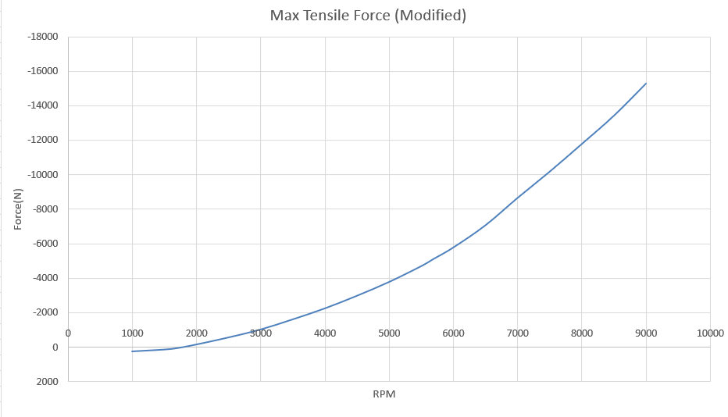
When the engine is modified the force continues to increase at a linear rate.
Figure 9 - Max Tensile Force for Modified Engine

Part E – Maximum Compressive and Tensile Stress
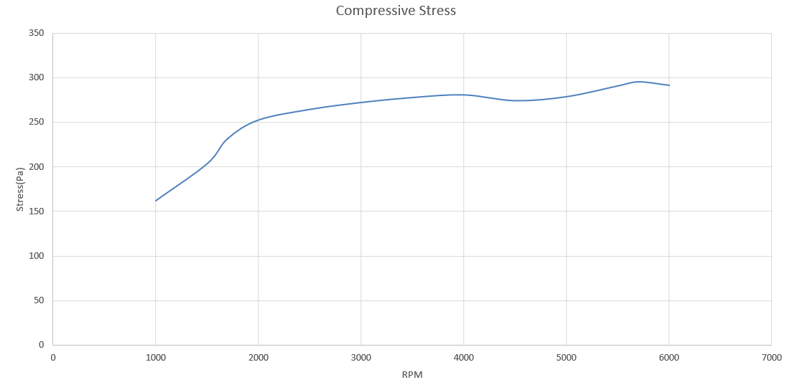
Figure 10 - Max Compressive Stress in Rod Shank
When looking at the compressive stress it can be seen that it follows the same trend as the compressive force (figure 6). This is expected as stress is force divided by area and as the area of the conrod is remaining constant if the force acting on the conrod is increasing the stress will also increase at the same rate.
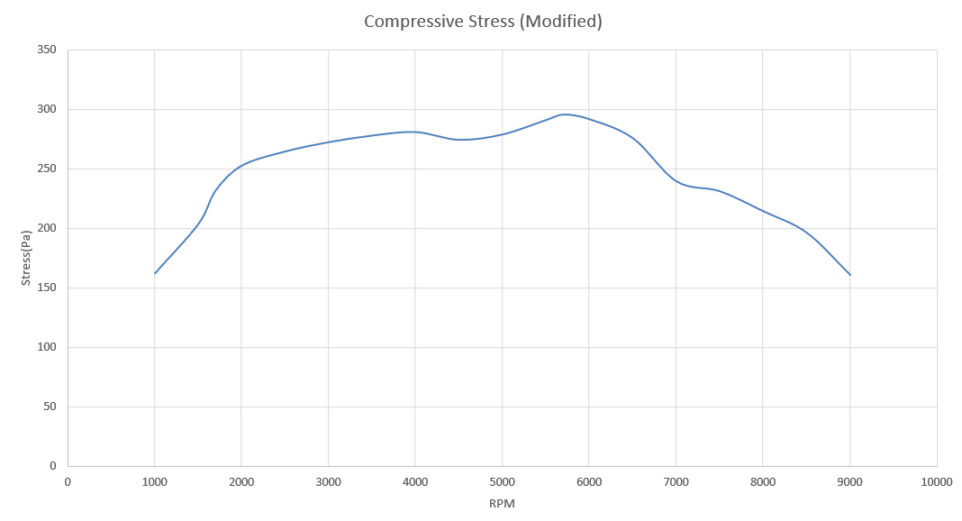
Figure 11 - Max Compressive Stress in Rod Shank for a Modified Engine
When the engine is modified, the stress starts to decrease after 5700rpm. As stated earlier, this is due to the pressure in the engine decreasing and therefore less force is acting on the conrod. If the engine and turbo were correctly modified to deal with the higher rpm, the compressive stress would be expected to continue to increase as the rpm increases.

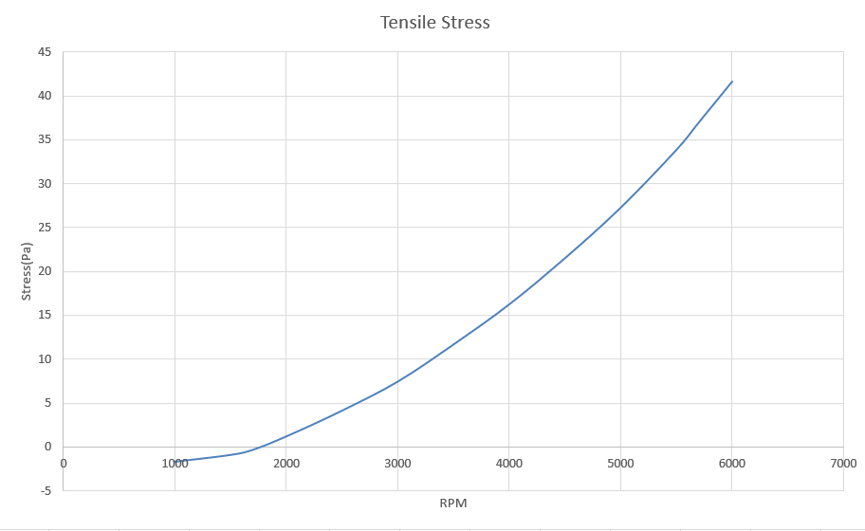
Figure 12 - Maximum Tensile Stress
As with the maximum compressive stress, the tensile stress follows the same trend as the tensile force. Before 2000rpm there is a negative tensile stress acting on the conrod. This is the same as a positive compressive force acting on the conrod, as there is a greater gas force than inertia force acting before 2000rpm.
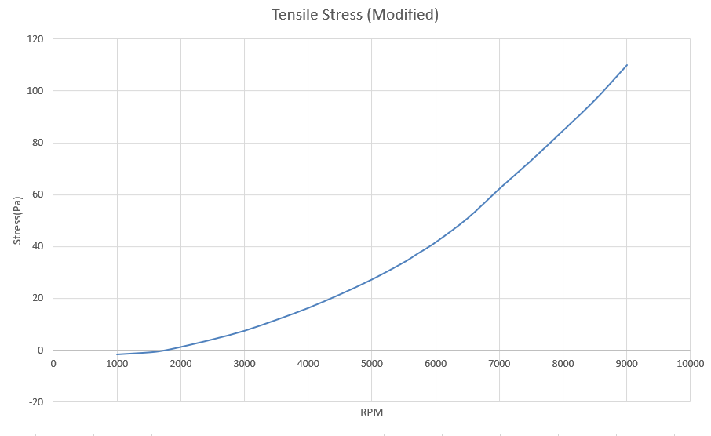
Figure 13 - Maximum Tensile Stress for Modified Engine
When the engine is modified the stress continues to increase at a linear rate as the rpm of the engine increases.

Part F – Nominal Safety Factor

Compressive Loads
The compressive loads safety factors are found the following equation;
$$\frac{UTS}{Compressive Stress}$$
Equation 3 - Safety Factor
RPM | Nominal Safety Factor for Compressive Loads
1000 | 4.805999541
1500 | 3.828324673
1700 | 3.362918489
2000 | 3.086472442
2500 | 2.948159875
3000 | 2.863801634
3500 | 2.806796196
4000 | 2.777058248
4500 | 2.843236375
5000 | 2.797233504
5500 | 2.681031019
5700 | 2.639580908
6000 | 2.675066296
6500 | 2.829245307
7000 | 3.256167519
7500 | 3.373093555
8000 | 3.63713863
8500 | 3.970762679
9000 | 4.84172678

= Modified Engine

From table 1, it can be seen that the minimum safety factor occurs at 5700rpm. This is because the maximum compressive force occurs at 5700rpm. The compressive stress is calculated using the minimum cross sectional area of the conrod, this is where the conrod is weakest and therefore the safety factor is calculated using the minimum cross sectional area.
Different manufacturers calculate their safety factor using differing approaches, so Fords safety factor could be different to Mercedes, but they could potentially withstand the same forces.
It is assumed the safety factor would be acceptable as the conrod will be able to withstand 2.64 times the force that is actually acting on the conrod. These values are taken from ideal conditions, in reality there would be wear on the conrod, there would also be constant fatigue occurring which would cause the conrod to break with less force required compared to a new conrod. This is why the safety factor is in place to make sure it can withstand the forces required for a long time.

Tensile Loads
RPM | Nominal Safety Factor for Tensile Loads
1000 | -462.9823261
1500 | -856.8274999
1700 | -2329.70336
2000 | 656.0422487
2500 | 189.3778712
3000 | 105.0321614
3500 | 66.95753209
4000 | 48.09955774
4500 | 36.31637637
5000 | 28.64027063
5500 | 23.06522434
5700 | 21.12437245
6000 | 18.75375058
6500 | 15.34307421
7000 | 12.53151359
7500 | 10.65918534
8000 | 9.207616902
8500 | 8.082723784
9000 | 7.09670481
Table 3 - Safety Factor for Tensile Load
= Modified Engine

When looking at the safety factor with regards to the tensile loads the values are less useful. As the tensile loads keep increasing with rpm. This does show the conrod would get to a certain rpm and would no longer be able to withstand the tensile forces acting upon it.

Part G – Maximum Compression Distance and Stretch
To find the compression distance equation is used.
$$\frac{Max Frod*L}{Youngs Modulus*Cross Sectional Area}$$
Equation 4 - Compression Distance

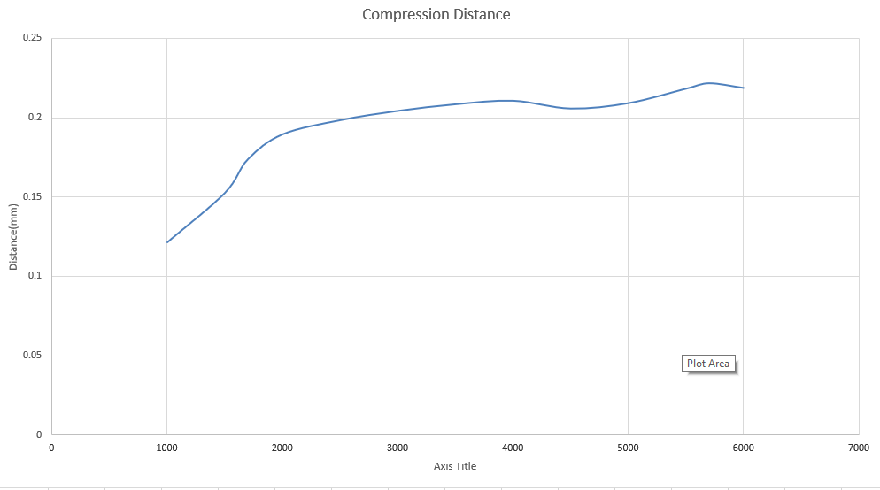
Figure 14 - Compression Distance
The maximum compression occurs at the point where maximum compression load occurs.
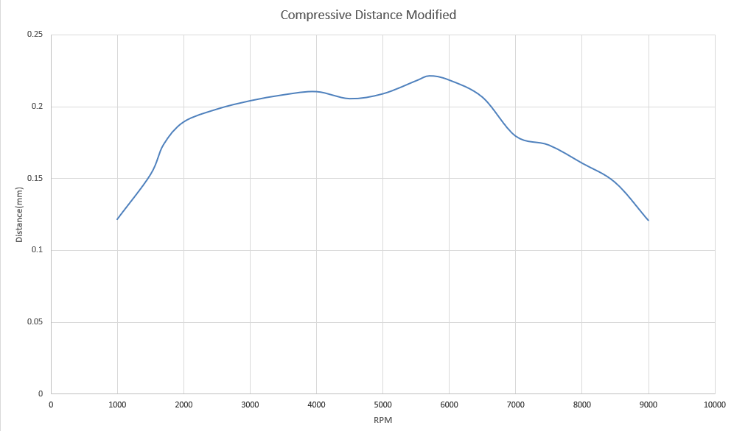
Figure 15 - Maximum Compression Distance for Modified Engine
If the engine was modified to be able to withstand higher rpm it would be expected that the compressive distance would continue to increase. This would mean the safety factor would continue to decrease and therefore the conrod would be at risk of failure. To solve this issue a different material for the conrod might need to be considered.
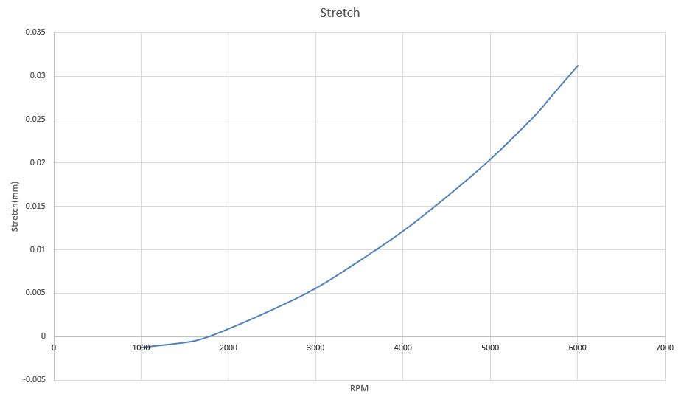
Figure 16 - Conrod Stretch
As the stretch is calculated using the maximum tensile force it follows the same trend. This means as the rpm increases the amount the conrod the is stretched increases. Before 2000rpm the conrod is not being stretched it is being slightly compressed as the stretch is negative.
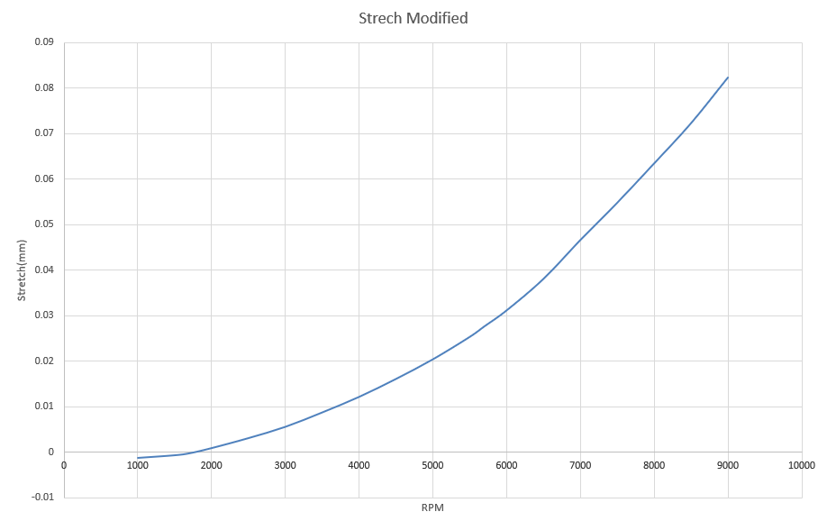
Figure 17 - Stretch for Modified Engine
When looking at the modified engine when the rpm is increased the stretch increases. This would again suggest that the material of the conrod might need to be modified if the rpm of the engine is increased beyond factory settings to a material that can both withstand a greater force acting on but it also more malleable so it can withstand the extra stretch.
If a titanium conrod is being used rather than steel, but the rpm is kept standard, it is assumed the clearance tolerance will fine even with the additional stretch, however if the rpm is being increased it could run into some issues. Most production engines are made with tolerances large enough that the extra stretch as it is a small increase might still be ok but would need to be considered.

Part H – Titanium Conrod Comparison
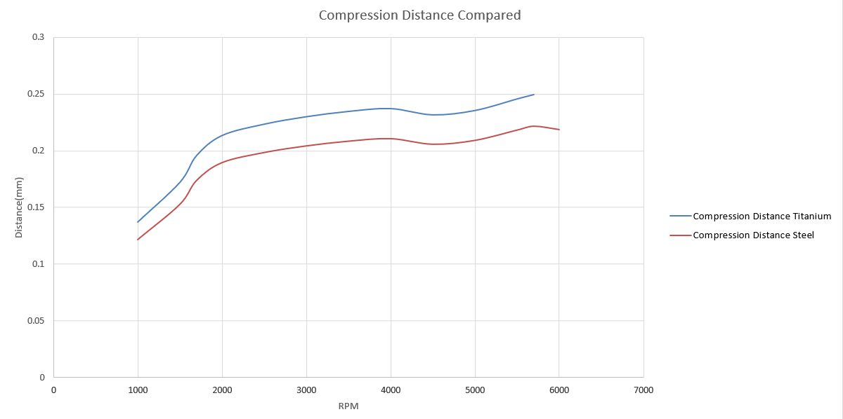
Figure 18 - Compression Distance Comparison Between Titanium and Steel
When the material of the conrod is changed to titanium the compression distance becomes greater but follows the same trend as the steel conrod. This occurs because titanium has a lower young’s modulus, therefore it is more malleable.
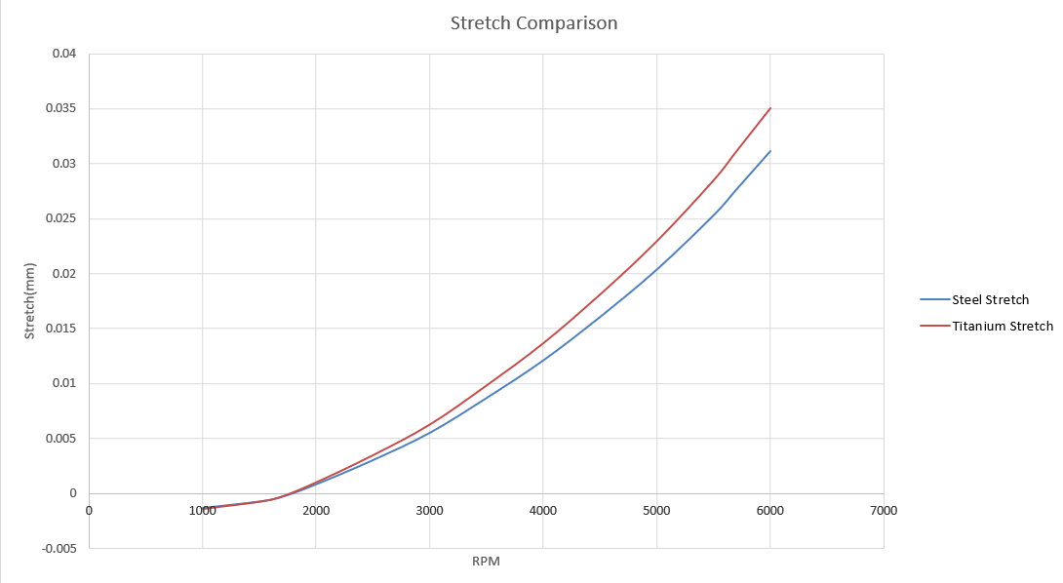
Figure 19 - Conrod Stretch Comparison Between Steel and Titanium
When looking at the comparison of the two differing conrods stretch, they start at a similar value of stretch, but as it is a negative value the conrod is being compressed. The titanium’s stretch increases at a slightly greater rate, this is again due to titanium having a lower young’s modulus.
Titanium has a greater Ultimate Tensile Strength (UTS) than steel, this means it is able to withstand a greater force before breaking. Therefore, if the engine is modified correctly, the forces will continue to rise as the rpm increases. This would mean a new conrod would be required to withstand the new forces. Steel could be used, however it would need to be heavier which will reduce the performance of the engine.
If a titanium conrod is being used, the cross sectional area would have to be increased to compensate for the reduction in mass. This would still make the overall mass of the engine lighter however the cross sectional area of the conrod would be greater. When the engine speeds increase, the forces that cause the change of direction should try to be reduced by using a lighter and stronger material, such as aluminium or titanium. (Heisler, 1999)

Further Possible Modifications
Some possible modifications that could be made to the engine as well as increasing the rpm of the engine could include: -
- Uprating the turbo, this would make the turbo work efficiently past 6000rpm. It would push more air into the cylinders so more fuel can also be also be added this would create more power from the engine. If this is done using higher octane fuel would be advised as it can create more force in the cylinder. If it wasn’t used the extra air fuel mixture might go unburned and be pushed out during the exhaust cycle. If the boost on the turbo is turned up the spark and ignition point would be retarded. This would make the exhaust hotter and the car would run less efficiently but more power would be created.
- Altering the bore or stroke of the engine would be interesting to see how it affects the forces gas forces as it would change the pressures in the cylinder. Currently the engine is under square.

Conclusion
Looking at the results the steel conrod should be able to withstand all the forces acting on it by the standard engine. If the engine was to be modified with a larger turbo or variable vane turbo this would increase the forces acting on the conrod and another material such as titanium would need to be considered.
As many assumptions have been made while manipulating the data the results will need to be verified with actual data and compared before any changes could be made in the real world.
If the material of the conrod was changed other components of the engine such as the piston and bearing would need to be considered to make sure the new conrod would have no negative effects on the overall engine.

Appendix

Torque and Power
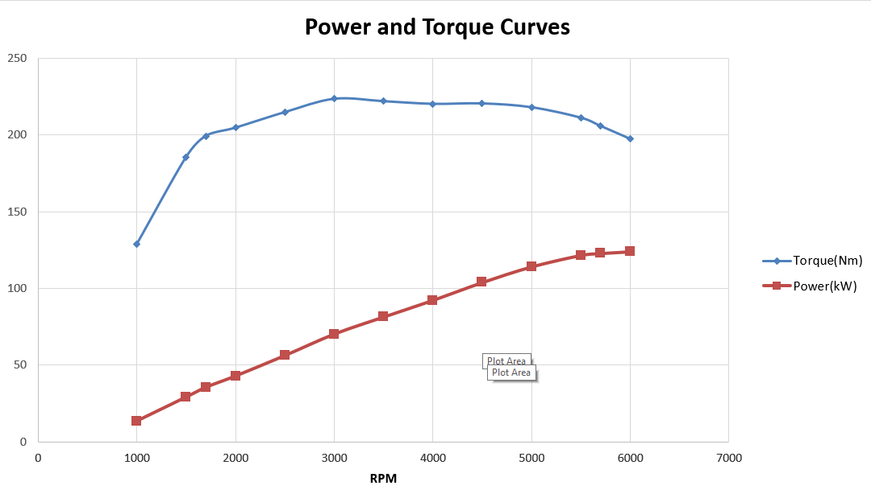
Figure 20 - Calculated Torque and Power Curve
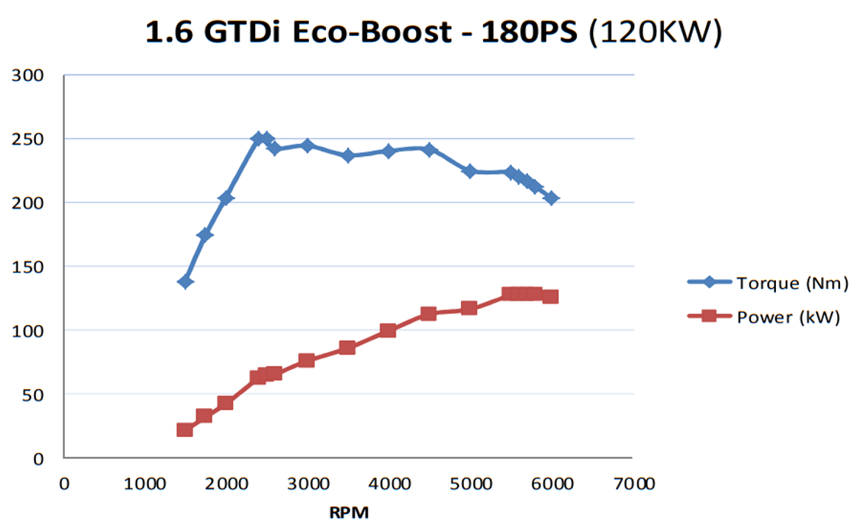
Figure 21 - Actual Torque and Power Curve
As torque is Force x distance the rod angle is calculated using the equation $\sin^{-1}\left(\frac{R}{L}\right)*sin⁡(θ)$ . This can be used to calculate the perpendicular distance to the rod force $r*\sin\left(θ+∅\right)$. This can be multiplied by the inertia force and gas force. The gas torque can be taken away from the inertia torque to find the torque per crank angle. Get an average of these torques and multiply them by the number of cylinders to calculate the max torque for each rpm for each rpm.
To find the power use the equation
$$Torque*\frac{rpm*\left(\frac{2π}{60}\right)}{1000}$$
These graphs show similar trends and have similar values however they are not identical. This is because many assumptions have been made during the calculations.

Resolved Forces
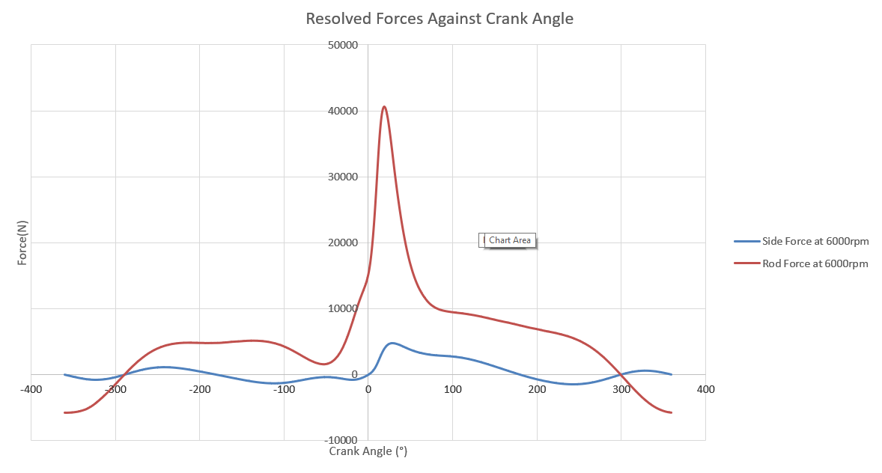
Figure 22 - Resolved Forces against Crank Angle

Maximum Ring Force
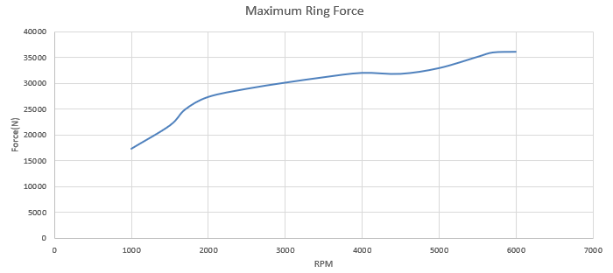
Figure 23 - Maximum Ring Force

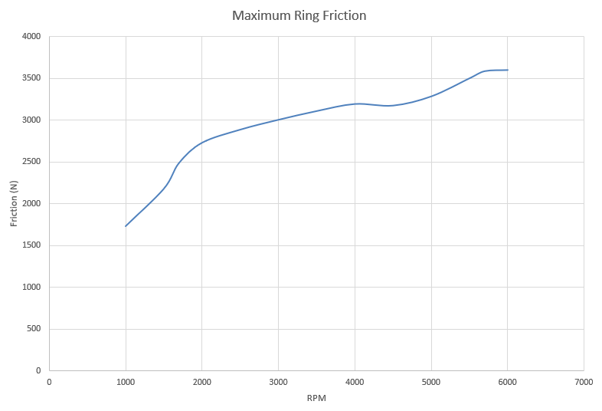
Figure 24 - Maximum Ring Friction

Table 4 - Nominal Safety Factors for Compressive Loads
RPM | Nominal Safety Factor for Compressive Loads (Titanium)
1000 | 6.038307116
1500 | 4.809946384
1700 | 4.225205281
2000 | 3.877875632
2500 | 3.704098304
3000 | 3.598109745
3500 | 3.526487529
4000 | 3.489124466
4500 | 3.572271342
5000 | 3.514472864
5500 | 3.36847487
5700 | 3.316396525
6000 | 3.360980731
6500 | 3.554692822
7000 | 4.091082267
7500 | 4.237989338
8000 | 4.569738278
8500 | 4.988906956
9000 | 6.083195185

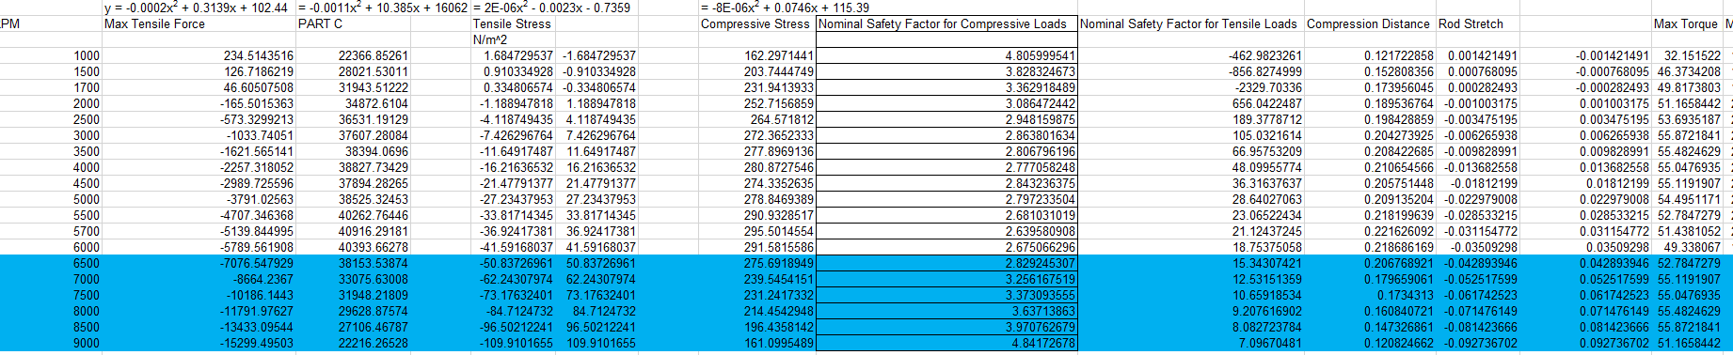
Figure 25 - Excel Spreadsheet (1)

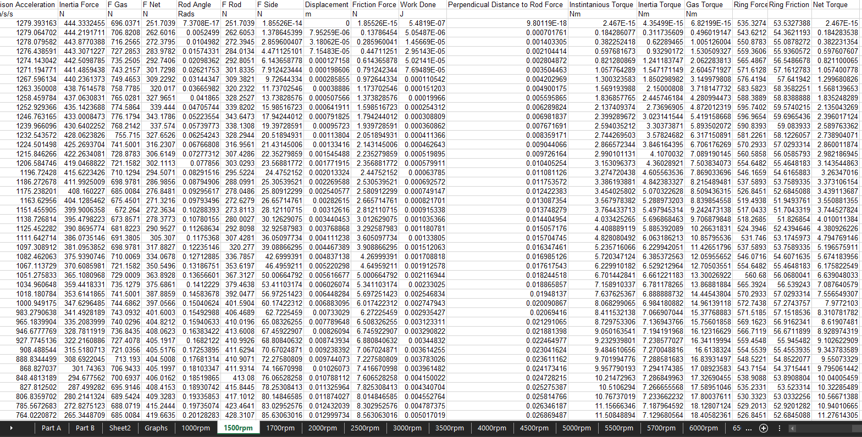
Figure 26- Excel Spreadsheet (2)

References
Bosch, 1996. Automotive Handbook. 4th ed. Stuttgart: Robert Bosch.
Crouse, A., 1995. Automotive Engines. 8th ed. s.l.:McGraw-Hill .
Ferrara, M., 2016. Ford EcoBoost 1.6L Analysis | Turbocharged, Direct-Injection & CCVTC. [Online]
Available at: https://dsportmag.com/the-tech/ford-ecoboost-1-6l-analysis-turbocharged-direct-injection-ccvtc/
[Accessed 18 October 2019].
Ford Motor Company, 2010. Ford 1.6 GTDI EcoBoost. [Online]
Available at: https://www.ford.co.uk/content/dam/guxeu/uk/documents/home/experience-ford/about-ford/ford-component-sales/specification-details-data-sheets/16-ecoboost-np.pdf
[Accessed 15 October 2019].
Heisler, H., 1999. Vehicle and Engine Technology. 2nd ed. London: Arnold Publishers.
Leela Krishna Vegi, V. G. V., 2013. Design And Analysis of Connecting Rod Using Forged steel. International Journal of Scientific & Engineering Research, Volume 4, Issue 6, June-2013, 4(6), pp. 2081-2090.
Macdonald, M., 2019. Adavnced Engine Design. Swansea, University of Wales Trinity Saint David.
Manning, J., 1988. Internal Combustion Engine Design. 1st ed. Croyden: CPI Group.
Minnesota Bio Fuels Association, 2016. ETHANOL AND OCTANE FOR BEGINNERS. [Online]
Available at: https://mnbiofuels.org/media-mba/blog/item/1511-octane-and-ethanol-for-beginners
[Accessed 24 October 2019].
Taylor, C. F., 1985. The Internal Combustion Engine In Theory and Prractice. Volume 1 : Thermodynamics, Fluid Flow, Performance. 2nd ed. Boston: MIT.

