2.4.2023 г.
ASSIGNMENT 1
Marketing Fundamentals
INDIVIDUAL SELECTED BLOG:
TESCO
Name: Yanislav Georgiev
Student ID: 2219323
Module: Marketing Fundamentals
Module code: LCBB4004
Lecturer: Dr.Piyumika Gamage


Table of Contents

History and background of Tesco: 2
Current Segmentation, Targeting, and Positioning (STP) Strategies Of TESCO 2
Segmentation: 3
Targeting: 4
Positioning: 4
Marketing mix strategies of TESCO (4Ps/7Ps) 6
1. Product: 6
2. Price: 7
3. Place: 7
4. Promotion: 7
5. People: 8
6. Process: 8
7. Physical Evidence: 8
References: 9

History and background of Tesco:
Tesco PLC is a British multinational grocery and general merchandise retailer headquartered in Welwyn Garden City, England. The company was founded in 1919 by Jack Cohen as a market stall in Hackney, London. The name "Tesco" was derived from the initials of T.E. Stockwell, a partner in the firm of tea suppliers that Cohen used (Tesco PLC- About us, 2022). The first Tesco store was opened in 1929 in Burnt Oak, Middlesex, and by the 1950s, Tesco had become a leading grocery retailer in the UK. In the 1990s and early 2000s, Tesco embarked on a period of rapid expansion, both in the UK and internationally (Tesco PLC-Our history, 2022). The company diversified its offerings, launching its own-brand products, and expanding into non-food categories, such as clothing and electronics. Tesco also developed a loyalty program, the Tesco Clubcard, which offered discounts and personalized offers to customers (BBC News, 2014).
Tesco faced significant challenges in the late 2000s and early 2010s, including declining sales, increased competition, and accounting scandals. In response, the company launched a turnaround plan, focusing on reducing costs, improving its product offerings, and investing in its online and convenience store operations. Today, Tesco is one of the largest retailers in the world, with operations in 12 countries and over 6,500 stores (Lomax and Haines, 2013). The company's mission statement is "to serve customers a little better every day," reflecting its focus on providing value and quality to its customers. Tesco's history is one of growth, diversification, and resilience in the face of challenges (Choi and Wu, 2009). The company's mission statement emphasizes its commitment to customer satisfaction and continuous improvement, which are reflected in its segmentation, targeting, and positioning strategies (Tesco PLC-Our mission, 2022).

Current Segmentation, Targeting, and Positioning (STP) Strategies Of TESCO

Segmentation:
Tesco employs a variety of segmentation strategies to tailor its products and services to its customers' diverse needs. The company divides its customer base into demographic, psychographic, and behavioral categories.
Demographic segmentation:
Demographic segmentation is the process of dividing the market into different groups based on demographic characteristics such as age, gender, income, and location. This segmentation strategy is particularly useful for companies like Tesco, which sells products and services that cater to the needs of different age groups, genders, and income levels. Tesco uses demographic segmentation to create products and services that appeal to specific customer groups. For example, Tesco has a range of products aimed at families, such as baby and toddler products, while also targeting older customers with products aimed at their specific needs. By using demographic segmentation, Tesco can create targeted marketing campaigns that appeal to specific customer segments (Kotler and Keller, 2016).
Psychographic segmentation:
Psychographic segmentation is the process of dividing the market based on lifestyle, attitudes, values, and personality traits. Tesco uses psychographic segmentation to target customers based on their shopping habits and preferences. For example, customers who purchase organic or sustainable products may receive personalized offers for those products. This type of segmentation allows Tesco to better understand the motivations behind customer purchasing decisions and to tailor its products and services accordingly. By using psychographic segmentation, Tesco can create marketing campaigns that speak to specific customer interests and values (Swift, 2021).
Behavioral segmentation:
Behavioral segmentation is the process of dividing the market based on customer loyalty, usage rate, and purchase history. Tesco uses behavioral segmentation to reward loyal customers through its Clubcard loyalty program, which offers personalized rewards and discounts based on customer spending. This type of segmentation allows Tesco to create incentives for customers to continue shopping with the company and to tailor its products and services to customer preferences. By using behavioral segmentation, Tesco can create targeted marketing campaigns that encourage customers to increase their spending and loyalty to the company (Tesco PLC-Our strategy, 2022).
Tesco tailors its products and services to meet the diverse needs of its customers through a variety of segmentation strategies, including demographic, psychographic, and behavioral segmentation. By understanding the motivations behind customer purchasing decisions and tailoring its marketing campaigns accordingly, Tesco can create a more personalized shopping experience for its customers and increase customer loyalty to the company (Kotler P, 1989).

Targeting:
Tesco targets a broad customer base, including families, students, elderly people, and budget-conscious shoppers. The company's product lines include groceries, clothing, electronics, and financial services.
Tesco's financial services segment targets customers looking for credit cards, insurance, and savings accounts. The company's online grocery shopping service targets customers looking for convenience and flexibility, while its clothing and electronics range targets customers looking for affordable options (Tesco PLC-Tesco sustainability, 2022).
In recent years, Tesco has also focused on targeting younger customers through its Clubcard Plus program, which offers discounts on popular brands and services like Uber and Netflix. Tesco's targeting strategy focuses on providing a broad range of products and services to meet the diverse needs of its customer base, while also tailoring its marketing messages and offers to specific customer segments (Tesco PLC-Tesco Clubcard, 2022).

Positioning:
Tesco positions itself as a customer-focused retailer that provides high-quality goods at reasonable prices. The slogan "Every Little Helps" underpins the company's brand positioning, emphasising its commitment to providing value to customers. Tesco's product positioning focuses on quality and affordability. The company offers a range of own-brand products, including popular Finest and Everyday Value lines, which are positioned as high-quality options at affordable prices. Tesco also offers a range of premium and luxury products, such as its Tesco Finest range, which is positioned as a premium option for customers looking for high-quality products (Tesco PLC-Tesco Finest, 2022).
Tesco has also positioned itself as a leader in sustainability, with a focus on reducing waste and promoting sustainable practices across its operations. This positioning is reflected in its product offerings, such as its range of sustainable and organic products, as well as its packaging and waste reduction initiatives. Tesco's positioning strategy emphasizes its commitment to providing quality, affordability, and sustainability to its customers, while it also distinguishes itself from competitors by offering a diverse range of products. and services and customer-centric approach (Tesco PLC-Tesco sustainability, 2022).
Tesco's segmentation, targeting, and positioning strategies focus on meeting the diverse needs of its customer base while emphasizing its commitment to quality, affordability, and sustainability. The company's use of customer data and personalized offers through its Clubcard loyalty program also helps to build customer loyalty and enhance its targeting strategies. Tesco's focus on sustainability and waste reduction initiatives is also aligned with current consumer trends and helps to position the company as a responsible and forward-thinking retailer (Tesco PLC- Tesco Everyday Value, 2022).

Marketing mix strategies of TESCO (4Ps/7Ps)
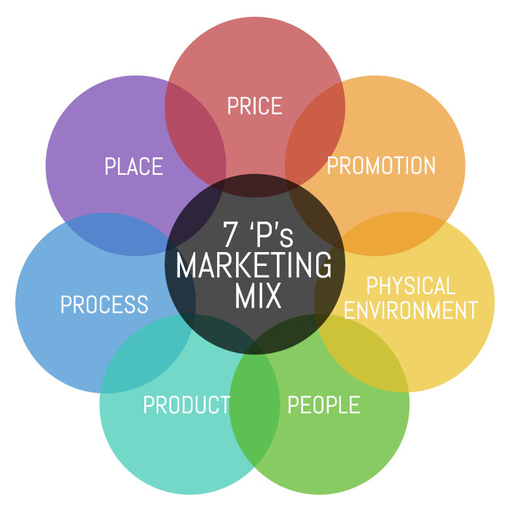

Product:
Tesco has a diverse product offering that includes groceries, clothing, electronics, home appliances, and financial services. Tesco Finest is one of the company's private-label products. Tesco Everyday Value, and Tesco Organic, among others. The products are designed to cater to the needs of different segments of customers, providing them with options to choose from. Tesco has also expanded its product offerings to include non-food items like clothing, electronics, and home appliances, to name a few.
The company ensures that its products are of high quality and meet customer expectations. For instance, Tesco's Tesco Finest range is a premium brand that offers high-quality products made with carefully sourced ingredients. In addition, the company has a dedicated team of product developers who are constantly working on improving the quality of its products and developing new offerings.
Packaging design is an essential aspect of Tesco's product strategy. The company ensures that its products are packaged in an attractive and innovative way that stands out on the shelves. For example, Tesco has recently launched a new range of ready meals packaged in eco-friendly containers made from sustainable materials (Tesco-Our Products, 2022).

2. Price:
Tesco's pricing strategy is focused on providing value to its customers. The company aims to offer competitive prices across its product range while maintaining quality. Tesco uses a range of pricing strategies, including penetration pricing, promotional pricing, and dynamic pricing. For instance, Tesco's Everyday Value range offers affordable products to customers, while the Tesco Finest range is positioned as a premium brand with higher prices (Tesco-Our Prices, 2022).

3. Place:
Tesco's products are available through various channels, including its own retail stores, online platforms, and other third-party sellers. The company operates over 6,500 stores in 12 countries, making it easily accessible to customers worldwide. In addition, Tesco has a well-established online presence through its website and mobile app, providing customers with the option to shop from the comfort of their homes (Tesco-Our Stores, 2022).

4. Promotion:
Tesco uses a combination of promotional strategies to communicate with its target market, advertising, sales promotions, public relations, direct marketing, personal selling, and social media marketing are some examples. The company's advertising campaigns are aimed at promoting its products and brand image. For example, the company's "Food Love Stories" campaign highlights the quality of its products and the importance of food in bringing people together. Tesco also uses sales promotions to attract customers, such as offering discounts on products or providing loyalty program rewards. The company in order to build a positive brand image, the company also engages in public relations activities such as sponsoring community events and charitable initiatives (Tesco, 2022).
Customers are contacted via email and in-store sales representatives using direct marketing and personal selling, respectively (Blythe, 2013). Finally, Tesco's social media marketing efforts include maintaining an active presence on platforms such as Facebook, Twitter, and Instagram, where the company promotes its products and engages with customers. Integrated marketing communications is an essential aspect of Tesco's marketing strategy, as it ensures that the various promotional strategies work together seamlessly to achieve the company's marketing objectives (Kotler et al., 2017).

5. People:
Tesco places great emphasis on its employees and focuses on hiring and training staff to provide excellent customer service. The company encourages employee involvement in decision-making processes and offers flexible working arrangements. Tesco aims to foster a diverse and inclusive work environment (Tesco, 2022).

6. Process:
Tesco ensures efficient and effective processes by implementing technology and streamlining its supply chain management. The company continuously evaluates its processes to ensure that they are customer-focused and cost-efficient (Tesco, 2022).

7. Physical Evidence:
Tesco's physical evidence includes its store layout, store design, and its branding. The company has a consistent store design across all its stores which provides customers with a familiar and comfortable shopping experience. The company's branding is recognizable and is used in all its physical and digital marketing materials (Tesco, 2022).

References:
- Tesco PLC. (2022). About us. Retrieved from https://www.tescoplc.com/about-us/
- Tesco PLC. (2022). Our history. Retrieved from https://www.tescoplc.com/about-us/our-history/
- Tesco PLC. (2022). Our mission. Retrieved from https://www.tescoplc.com/about-us/our-mission/
- BBC News. (2014). Timeline: Tesco's troubles. Retrieved from https://www.bbc.com/news/business-27775327
- Choi, T. Y., & Wu, Z. (2009). Triad partnerships in the global supply chain. Journal of Operations Management, 27(2), 119-138.
- Lomax, W., & Haines, S. (2013). Tesco: The trials and tribulations of a UK retailer in the US. Journal of Business Strategy, 34(3), 32-38.
- Kotler, P. (1989). Marketing management: Analysis, planning, implementation, and control. Prentice Hall.
- Tesco PLC. (2022). Our strategy. Retrieved from https://www.tescoplc.com/strategy/
- Tesco PLC. (2022). Tesco Finest. Retrieved from https://www.tesco.com/groceries/en-GB/shop/fresh-food/tesco-finest
- Tesco PLC. (2022). Tesco Everyday Value. Retrieved from https://www.tesco.com/groceries/en-GB/shop/fresh-food/tesco-everyday-value
- Tesco PLC. (2022). Tesco sustainability. Retrieved from https://www.tescoplc.com/sustainability/
- Tesco plc. (2022). Our customers. Retrieved from https://www.tescoplc.com/sustainability/sustainability-in-our-business/our-customers/
- Kotler, P., & Keller, K. L. (2016). Marketing management (15th ed.). Pearson.
- Swift, C. (2021). Market segmentation examples, definition and types. Retrieved from https://www.crazyegg.com/blog/market-segmentation/
- Blythe, J. (2013). Essentials of marketing. Pearson Education.
- Kotler, P., Armstrong, G., Harris, L. C., & Piercy, N. (2017). Principles of Marketing. Pearson.
- Tesco. (2022). Our Products. Retrieved March 29, 2023, from https://www.tesco.com/groceries/en-GB/shop/
- Tesco. (2022). Our Prices. Retrieved March 29, 2023, from https://www.tesco.com/groceries/en-GB/shop/
- Tesco. (2022). Our Stores. Retrieved March 29, 2023, from https://www.tescoplc.com/about-us/our-stores/
- Tesco. (2022). Our Promotions. Retrieved March 29, 2023, from https://www.tesco.com/groceries/en-GB/offers/
- Tesco. (2022). Our Clubcard. Retrieved March 29, 2023, from https://www.tesco.com/clubcard/
- Tesco. (2022). Our People. Retrieved March 29, 2023, from https://www.tescoplc.com/about-us/our-people/
- Tesco. (2022). Our Environment. Retrieved March 29, 2023, from https://www.tescoplc.com/sustainability/our-environment/

