

BA BUSINESS MANAGEMENT
Module: Marketing Fundamentals
Task1
BLOGGING TO COMMUNICATE IN ADIDAS

- Name: Milena Adzhemova
- University: University of Wales TSD
- Course Title: The Global Business Environment
- Module Code - LCBB4004
- Lecturer: Dr. Nadeem Mirza
- Date: 25.11.2022

Contents
  - Background of the Company 3
  - Adidas Products 5
Products 5
Features 6
Packaging 6
  - Adidas Prices 7
Pricing 7
Free Shipping 8
Free returns and exchanges 8
  - Adidas Place 8
  - Adidas Promotion 9
  - References 11

Background of the Company
Adidas, fully known as Adidas AG, is a German-origin sports shoes, apparel, and other product manufacturer company (Lewis, 2022). The company was established in 1948 by Adolf Dassler (Lewis, 2022). The company name originated from its founder’s name. At the beginning of the 21st century, the company was the largest and second-largest sports goods manufacturer respectively in Europe and the world (Lewis, 2022). Its founder’s family’s operation began with shoe manufacturing after World War I (Lewis, 2022). The company first was recognised publicly during the 1936 Berlin Olympics when the American sports star Jesse Owens won a medal with the gift of shoes from Adolf Dassler (Lewis, 2022). After World War II, the Dassler family resumed its operation. However, due to a conflict of personal interest, Adolf, and Rudolf, two brothers split up the family’s business and created two different brands in 1948 (Lewis, 2022). Rudolf created Puma and Adolf created Adidas (Lewis, 2022).

Figure: Adidas Company Logo (Lewis, 2022)
The Adidas three-stripe trademark has been used since the firm's inception, and it has been included in both the 'trefoil' and mountain logos that the business has released in recent years (Lewis, 2022). As a firm, they believe in the transformative potential of sports. Athletics promote health and mental clarity. They unite and motivate the masses. Furthermore, cutting-edge technology in sports equipment encourages users to achieve their own best. Adidas is dedicated to every possible type of athlete. Those ubiquitous 3-Stripes may be found in just about any place. The company is dedicated to helping creators make better games, have better lives, and make a difference in the world (About Us, 2022). Adidas is a lot more than just athletic clothing. To co-create, the company collaborates with top players in their field. In this way, it provides eco-friendly sports equipment, fashionable apparel, and accessories to die-hard fans who support their favourite teams (About Us, 2022). Adidas wants to make a positive impact on the world.
The company has developed a crystal-clear mission statement. The goal of Adidas is to become the most successful sports brand in the world (About Us, 2022). Because they never accept anything less than their absolute best performance, athletes serve as a source of inspiration for the organisation. The company is extremely motivated to manufacture and market the best sporting goods in the world, as well as provide the best customer service and experience possible, all while acting in an environmentally responsible manner. In addition, the company is extremely motivated to provide the best customer service and experience possible (About Us, 2022). Adidas is under the impression that the only way it can achieve its goal of becoming the best company in the world is if it continues to hold its position as the sustainable industry leader while simultaneously offering the best products and services in its industry (About Us, 2022).
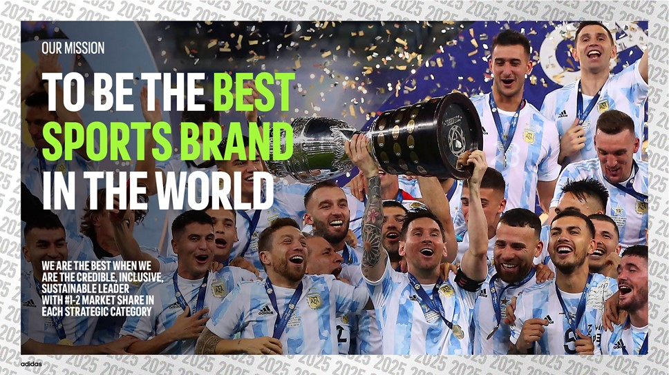
Figure: Adidas Mission (About Us, 2022)

Adidas Products
At Adidas, we are committed to offering you the best sports products, sales, and customer experience. We have products for men women and children in diversified categories.

Products
- Footwear: Shoes were the first thing we ever produced as a business, and as a result, we are quite skilled in the production of footwear. We have a diverse selection of footwear for males, females, and young people. We sell athletic footwear that is appropriate for a wide variety of activities, including basketball, golf, football, and soccer, among others. You can also take a look at our footwear for everyday outdoor activities such as walking, hiking, and gym workouts. In addition to shoes, we also sell sandals, slides, slip-on, and straps, as well as sneakers and comfortable sandals.
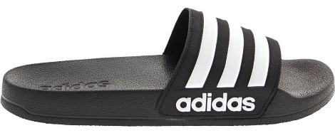
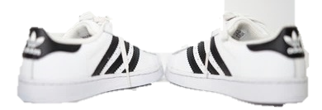
Take Your Pick!

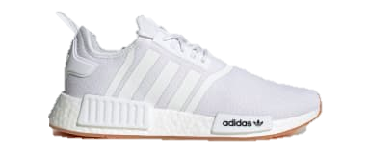
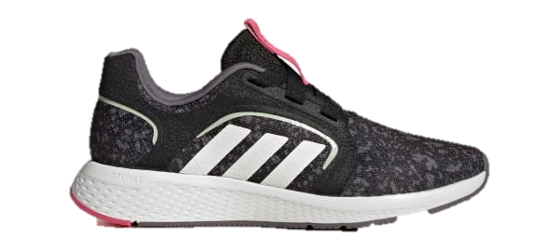

- Apparel: We are able to provide you with a wide variety of sports apparel, such as hoodies, jackets, sweatshirts, T-Shirts, pants, shorts, jerseys, undergarments, and many more items. The previous year, our company's brand was ranked as the fourth largest garment brand in the entire globe, and its brand value was estimated to be close to £15 billion (Tighe, 2022). We stock apparel for a variety of sports, including football, soccer, basketball, golf, softball, and volleyball, amongst others. In addition to that, we have apparel for more casual events, as well as hiking, outdoor, fitness, and gym wear.
Find the ones that match your need!
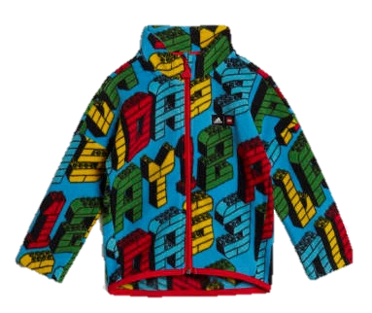
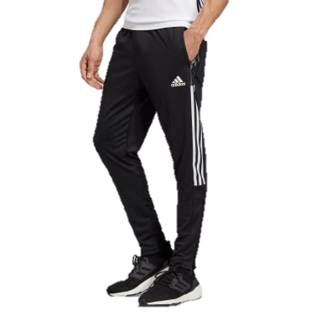
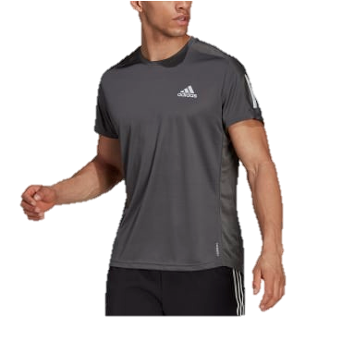
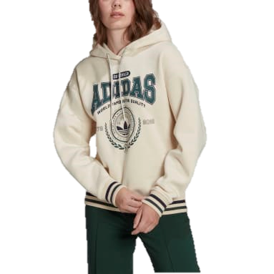

- Accessories: In addition to shoes and other articles of clothing, we also sell a wide variety of accessories, including backpacks, balls, gloves, hats, beanies, headphones, water bottles, shocks, and underwear for adults, adolescents, and children. We are committed to providing you with the highest possible level of customer service as well as the most up-to-date and fashionable sporting goods and accessories. We believe that by doing things in this way, we will become the most successful sports brand in the world.
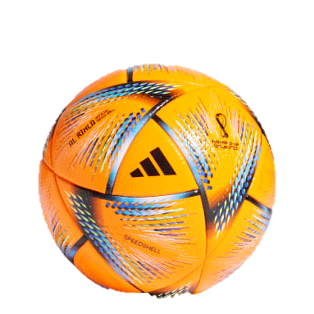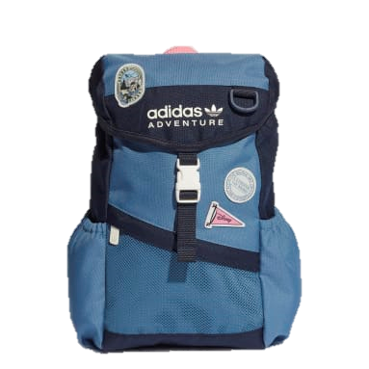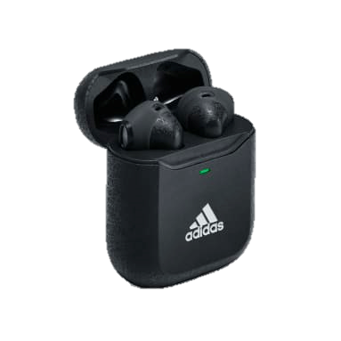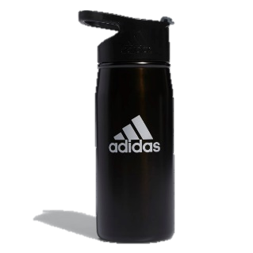
To explore our world-class diversified products and services, click the link below.
https://www.adidas.co.uk

Features
- High Quality: Product and service quality is our ultimate concern. Adidas produces the highest quality products for you. Our footwear and apparels not only are of high quality but also comfortable, and suitable for customers irrespective of their gender and age.
- Diversified product portfolio: Adidas offers different types of shoes and apparel alongside accessories suitable for a wide range of purposes, from sports, outdoors, hiking, and day-to-day use.
- Latest fashioned: our products are designed to keep you up with the latest fashions.

Packaging
Not only our products are of high quality and the latest fashion designs, but you will find our packaging is also attractive and extremely appealing.
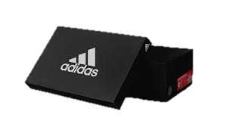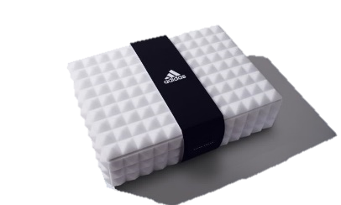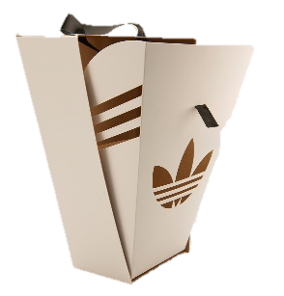

Adidas Prices
Throughout its history, Adidas has adopted either a competitive or a skimming pricing strategy, depending on the market conditions at the time (Edrawsoft, 2022). When compared to those of the company's biggest competitors, such as Nike and Puma, the price points for its typical products are within a competitive range (Edrawsoft, 2022). Skimming pricing is a strategy that is utilised by Adidas whenever the company delivers a breakthrough new product that is much superior to the products that are currently on the market. The average customer of Adidas is wealthy and is prepared to spend more money on quality; hence, the pricing structure of the brand reflects this fact (Edrawsoft, 2022). Due to the exceptional quality of the things being sold, the prices are understandably expensive. However, this premium pricing serves another purpose, which is to mistakenly reassure wealthy customers that they are getting their money's value.

Pricing
At Adidas, we produce the best quality product for the customers. With high quality, the price tag also comes to be expensive. We have products based on different price ranges. We also offer occasional discounts and gifts. Currently, we are offering up to 60% discounts for all types of products available for men women, and children. Browse our products and enjoy the exclusive offers here: https://www.adidas.co.uk
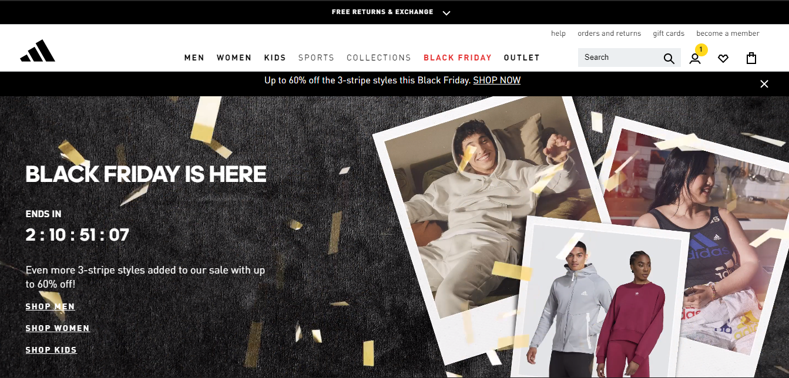

Free Shipping
At Adidas, we are offering you free shipping. spend over £25 and we will ship your product right to your doorsteps.

Free returns and exchanges
You can exchange or return your product within 60 days of your purchase at Adidas. However, products that are customised cannot be returned. for your concern, products that are rarely available must be returned within 14 days.

Adidas Place
When it comes to the distribution of its athletic wear, the brand makes use of both online and offline distribution channels. By maintaining legitimate merchant accounts at Amazon and other e-commerce platforms, Adidas makes it simpler for its global customer base to buy its items online. You can also buy our products directly from the company's official website, where you can also customise your purchases to make them truly one-of-a-kind additions to your wardrobe or thoughtful presents for friends and family. Of course, you can also buy our products directly from our official website. Besides, if you are willing to visit our shops in person and buy our products, you can find our shops near your location on our website. Visit our website here: https://www.adidas.co.uk
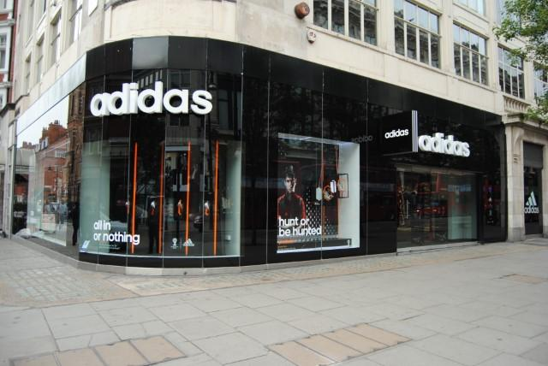
Address: Fouberts Place, Carnaby Street, London.

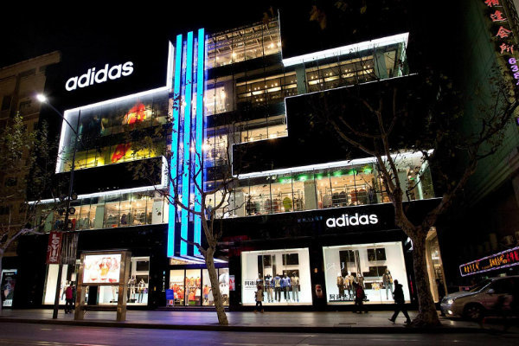
Address: 425 Oxford Street in London West End.

Adidas Promotion
Even though Adidas is now known all across the world, this achievement did not happen suddenly. We are now widely recognised almost immediately as a direct result of the time and attention that was invested in the past into the development and implementation of effective marketing and advertising strategies.
Online and offline marketing: The more traditional types of advertising, such as billboards, television, print publications, and, more recently, online, and social media, take up a significant percentage of our budget. And these methods have proven to be very effective for our company.
Celebrity endorsement: To further spread awareness of the brand among its target demographic, we have also communicated with a large number of well-known individuals, such as Beyonce, Lionel Messi, and Stella McCartney.


Sponsorship: The value of each individual sponsorship agreement is measured in millions of dollars. Its organisation has developed a strong presence in the international market thanks, in part, to our sponsorship of football teams in countries as different as Germany, Mexico, Spain, and Argentina.

References
About Us (2022) Adidas-group.com. Available at: https://www.adidas-group.com/en/about/profile/.
Edrawsoft (2022) Adidas marketing mix (4Ps) analysis, Edrawsoft. Available at: https://www.edrawmind.com/article/adidas-marketing-mix-analysis.html.
Lewis, R. (2022) ‘Adidas’, Encyclopedia Britannica.
Tighe, D. (2022) Adidas - statistics & facts, Statista. Available at: https://www.statista.com/topics/1257/adidas/.

