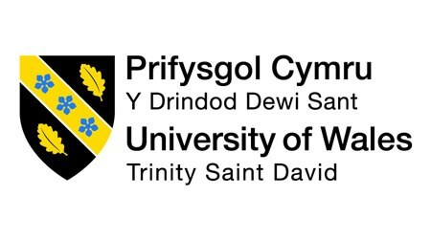

Personnel Resourcing and Development
Name: Alexandru Alin Minea
Code: BMIH5005
LECTURER: HELEN LEE
Research Project Proposal
Analyse the impacts of socioeconomic force on employees’ performance management and monitoring in different work modes: Hospitality HR’s perspective

Student Name
ID

Table of Content
1. Introduction 3
2. PESTEL Analysis of Hyatt Hotels: Socio-Economic Factors 4
Political Factors 4
Economic Factors 5
Social Factors 5
Technological 5
Legal 6
Environmental 6
3. Industry Trends in Hotel Retention and Turnover Rates 7
4. Emergence of Different Work Modes 8
5. Potential Solutions 9
6. Conclusion 10
7. References 12

1. Introduction
The Hyatt Hotel chain has more than 630 hotels spread out across 78 countries and six continents (HospitalityNet, 2021). Based in Chicago, Illinois, the chain's main office has been there since 1957. It is a huge hotel chain with more than 10,000 rooms and 86,000 workers around the world (HospitalityNet, 2021). Through the lens of socioeconomic problems, trends (like retention and turnover rates), and the rise of new ways to work over the last five years, this paper looks at the hospitality business. Because of these social and economic factors, Hyatt needs to really think about whether or not it would be possible to use different ways of working in its business. New venues for the gig economy, flexible schedules, and work from home have opened up new opportunities and risks for the hotel industry. There are pros and cons to working from home. There are benefits, like having more freedom and less overhead. Costs, like making sure everyone is on the same page and keeping an eye on how well workers are doing their jobs. When adopting flexible scheduling, it is just as important to find a good balance between accommodating staff preferences and keeping enough staff on hand to meet guest needs. Integrating tools for the gig economy also brings about new ways of managing employees and the work force. This means that contracts, job reviews, and standards for guest service need to be carefully thought through (Rodrigues, 2021). The proposal's goal is to evaluate into how Hyatt could use different work modes to deal with the challenges and take advantage of the chances that come up because of the current economic situation. The main goal of the report is to demonstrate how these factors affect controlling and managing staff, by considering aspects like how satisfied customers are, how many employees leave, and how much work gets done. As part of the plan, Hyatt wants to learn more about new technologies, best practices, and current trends in order to improve how it manages employee performance in its international workplace (Chuling and Xue, 2022). It is emphasized in the proposal how important it is to know about socioeconomic factors and how they affect Hyatt's and the hospitality industry's ability to manage workers' performance and remain vigilant. With careful research and planning, Hyatt will be able to solve these issues, get the most out of its employees, and give guests moments they will never forget.
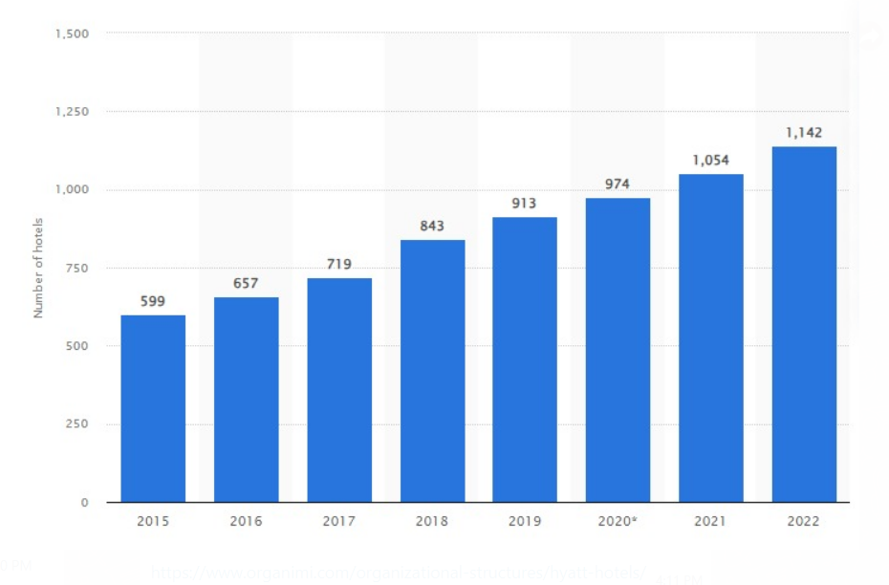
Graph 1 Number of Hyatt Hotels Corporation hotels worldwide from 2015 to 2022 (Kim, 2023)

2. PESTEL Analysis of Hyatt Hotels: Socio-Economic Factors
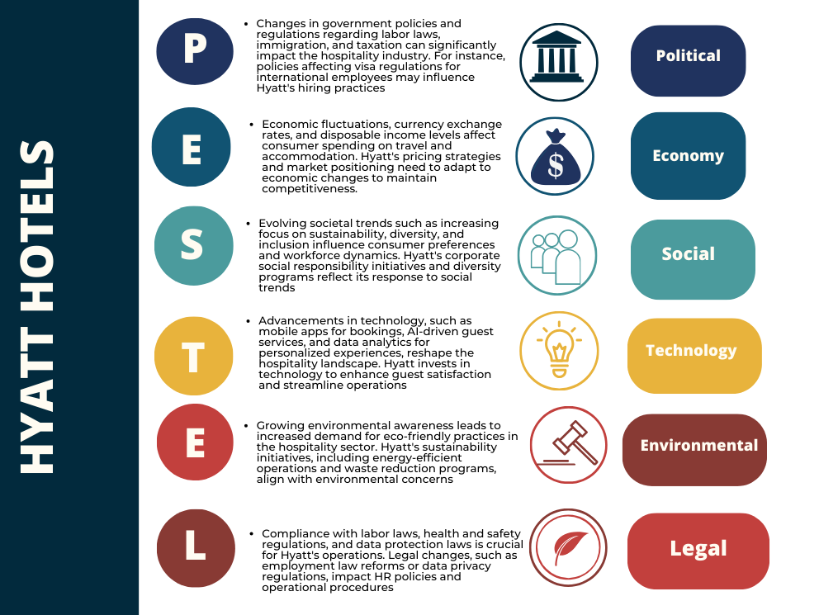
Table 2 (Rodrigues, 2021)

Political Factors
Hyatt Hotels faces various political issues that affect its business strategy and finances. Hyatt's profits are affected by minimum wage and overtime. The recent increase in the US federal minimum wage to $15 an hour by 2025 may raise labor expenses by 5–10%, depending on pay distribution. Staffing strategies may need to be modified (Mohsin et al., 2023). Hyatt relies on immigration regulations to acquire and retain skilled foreign workers to deliver outstanding service, especially in locations with a labor shortage. Hard visa regulations or foreign worker program limits could make Hyatt's hiring harder and operations less efficient.

Economic Factors
As shown in its 2023 Investor Presentation, Hyatt Hotels Corporation uses its wide range of properties in a variety of price ranges to smartly deal with changes in the global economy (Qi, 2023). When the economy is bad, people usually spend less on travel and stay in hotels less. Hyatt's wide range of services helps during these times. This way of doing things lets the company react to different economic situations and stay strong when things get tough. It also takes advantage of people having more money to spend in key areas, as Euromonitor International pointed out in 2023 (Barrantes-Aguilar et al., 2023). As some areas become more prosperous, it opens up possibilities for high-end travel and lodging, which fits with Hyatt's focus on the high-end market. Hyatt is ready to take advantage of people's rising disposable incomes and the demand for high-end experiences by catering to wealthy tourists with high-end services. Hyatt also keeps an eye on how people's buying habits change, knowing that these changes can affect how people want to travel. Travelers on a tight budget may choose to stay somewhere else during times of economic uncertainty, which forces Hyatt to change its tactics. The company also knows that people are increasingly valuing experiences over things, which could mean more money spent on trips. Hyatt changes its products and services to meet changing customer needs and tastes by keeping an eye on how people behave. Hyatt faces economic instability. A 20% decline in worldwide hotel occupancy rates during the 2008 financial crisis shows that global or regional recessions can reduce travel and hotel stays (Fernandes, 2021). This significantly impacts Hyatt's revenue. Currency exchange rates affect Hyatt's global revenue. Exchange rates affect international customers' travel costs, which affects Hyatt's revenue (Qi, 2023).

Social Factors
Social issues affect Hyatt's hotel business due to shifting consumer choices and social trends. Sustainable measures are becoming more significant as customers want eco-friendly procedures in hotels (Roy & Chowdhury, 2021). Investments in trash reduction and energy-efficient technologies have reduced Hyatt's carbon footprint by 15% since 2010 (Chan, 2021). They are environmentally conscious and in accordance with changing social ideals. Diversity and inclusion are key social concerns that affect Hyatt and its workers. The rising emphasis on diversity and inclusion is affecting how people move and what they expect from work. The "We Care" program at Hyatt has led to a 30% increase in women in leadership posts since 2020, demonstrating the company's commitment to an inclusive workplace (Kilson et al., 2023). Social responsibility in the hotel sector includes adopting new technologies. This is why Hyatt has invested in new solutions like 70% guest mobile app uptake (Bharwani and Mathews, 2021).

Technological
Hyatt Hotels is continuously seeking for innovative ways of using technology to boost productivity, client satisfaction, and smooth operations. Automation for cleaning and customer service is a hot topic. Automation can improve efficiency and possibly cut labor costs, but the initial investment and the risk of job loss require careful balance between technical advances and workforce changes (Law et al., 2020).

Legal
Hyatt Hotels must carefully evaluate legal issues to comply, reduce risks, and maintain its reputation. To avoid legal issues and make the workplace pleasant, observe minimum wage, overtime, and employee perks requirements. Strong compliance measures are crucial since labor law infractions can result in large fines and brand damage (Zhong et al., 2021). Hyatt pays close attention to health and safety requirements to protect guests and employees.

Environmental
In its dedication to sustainability, Hyatt Hotels supports environmental measures to reduce its environmental impact. Energy conservation programs use smart thermostats and LED lighting to cut costs and protect the environment. Hyatt's properties have lowered energy use by 10% due to this effort (Ristova, 2020). Hyatt's composting, recycling, and water conservation programs decrease waste, another priority. These projects improve the environment and may cut corporate costs.

3. Industry Trends in Hotel Retention and Turnover Rates
Hospitality companies struggle with high employee turnover, which reduces efficiency, disappoints consumers, and damages business (Liu-Lastres et al., 2024). Before COVID-19, sector change rates were high. The average sector rate was 170%, substantially higher than other sectors (Škare et al., 2021). The epidemic initially lowered revenues since lockdowns prevented people from traveling and working in hotels. Sales soared when travel was allowed again, reaching record highs in certain regions. There are signs that things may be leveling off, but hospitality industries still have significant turnover rates. Several factors exacerbate hospitality's high turnover rate. One issue is that workers in this area generally have demanding schedules and low pay. This drives people to seek better careers. Career progression is scarce in many hotel occupations, which demotivates and makes it tougher to retain staff. Work-life balance issues including long hours, inconsistent schedules, and heavy duties fatigue and turn off employees. After the epidemic, stress, safety concerns, and work habits changed, worsening these issues (Marques Santos et al., 2020).

4. Emergence of Different Work Modes
Numerous studies have examined how COVID-19 affected variables like occupancy rates, sick days taken by employees, and medical expenses. According to all of these studies, these three characteristics are being greatly affected by the epidemic. The CDC was the first organization to investigate how COVID-19 affected occupancy rates (Hu et al., 2021). Since COVID-19 began to spread rapidly throughout North America, there has been a 7% drop in occupancy rates at hotels and motels in key cities across the United States, according to the CDC's weekly surveillance report (Shin et al., 2021). It is also anticipated that occupancy rates will keep falling until the COVID-19 pandemic is over. The gig economy is also affecting hospitality work. Platforms that help find cleaning and event staffing positions provide Hyatt and workers more hiring options. Hyatt has implemented several management practices to ensure that employees perform at the same high level across all work modes (Liaset et al., 2023).
Some hotel chains have adapted swiftly to the changing workplace by meeting employee requirements and embracing new trends. To accommodate changing workplace trends, some hotel brands have launched programs like Marriott's "Work Anywhere" program, which enables administrative and business workers work from home. Wyndham Hotels & Resorts' "FlexPlace" initiative allows workers work from home or the office, depending on their needs. Choice Hotels International's "Work Your Way" marketing allows employees work from home, the office, or a mix. However, Radisson Hotel Group's "Work-Life Harmony" program helps employees balance work and wellness. This program offers wellness resources, flexible schedules, and telecommuting. Finally, Accor's "Smart Flex" initiative lets employees set their own work schedules based on their goals. This promotes personal independence and work-life balance. These programs demonstrate hotel firms' attempts to adapt to changing workplaces and prioritize employees' health, happiness, and productivity.

5. Potential Solutions
- Setting in place strong methods for managing performance that adapt to different ways of working.
- Getting managers all the training and help they need to keep an eye on both remote and on-site workers.
- Setting clear ways for employees to communicate and meet performance standards across all work modes.
- Offering rewards and incentives to workers to keep them motivated and improve their work.
- Performing regular evaluations to find problems and ways to make control of employees better in all work modes.

6. Conclusion
This report from Hyatt Hotels Corporation shows that the hotel business has experienced a lot of changes and problems in the last five years. Different types of work, like working from home, having free hours, and the "gig economy," are becoming more popular. This has caused big changes in how people work and how businesses run in this area. However, Hyatt has also shown that it can be creative and adaptable in how it handles employee work in these different ways. For instance, it uses training, technology, and rules that are focused on workers to push them to do their best work and make the company successful. The fact that more people work from home, which was sped up by the COVID-19 outbreak, shows that the industry can adapt to new problems. Hyatt has changed a lot of workers' plans to better meet their needs. This has also helped the company find the best staffing levels to meet changing demand, which has made the experience better for everyone. Also, Hyatt has added tools for the gig economy. This has helped them hire more people and given workers the chance to make extra money and choose their own hours. Hyatt has a lot of good ways to keep track of how well employees are doing in different kinds of work. A lot has been done by Hyatt to make sure its employees have the tools and help they need. One example is that it gives its workers full training and development programs and uses technology to keep an eye on their progress and stay in touch with them. Hyatt wants its employees to have more fun at work and be more active. A good work-life mix is pushed for, and programs for rewards and recognition are set up to help with this. Last but not least, this work changes more than just how well people work. It changes the company's attitude, the happiness of the workers, and the way guests feel about their stay. It's hard to get ahead in the hotel business. Hyatt can stay ahead for a long time if it is open to new ways of working and takes a more thorough look at how well its employees do their jobs. Work from home tools should get better, and the office should be nice and helpful as long as the company spends money on employee growth. Hyatt can further stand out as a place to work by making these projects a priority. They can also give people from all over the world experiences they can't get anywhere else.

7. References
Barrantes-Aguilar, L.E., Solís-Rivera, L.R. and Villalobos, A., 2023. Global consumers before and during the COVID-19 pandemic: What aspects characterize digital consumer behavior?. ReMark-Revista Brasileira de Marketing, 22(4), pp.1614-1644.
Bharwani, S. and Mathews, D., 2021. Post-pandemic pressures to pivot: tech transformations in luxury hotels. Worldwide Hospitality and Tourism Themes, 13(5), pp.569-583.
Chan, E.S., 2021. Why do hotels find reducing their carbon footprint difficult?. International Journal of Contemporary Hospitality Management, 33(5), pp.1646-1667.
Chuling, C. and Xue, Q., 2022, July. Analysis of the image perception of luxury hotels based on UGC data and customer value theory. In Journal of Physics: Conference Series (Vol. 2301, No. 1, p. 012007). IOP Publishing.
Fernandes, F.S.M.S., 2021. Intercontinental hotels group-time to check-in? analysis of one of the biggest hotel players in times of a global pandemic (Doctoral dissertation).
HospitalityNet.org.com (2021). Hyatt Regency. https://www.hospitalitynet.org/brand/23000085/hyatt-regency.html
Hu, M., Roberts, J.D., Azevedo, G.P. and Milner, D., 2021. The role of built and social environmental factors in Covid-19 transmission: A look at America’s capital city. Sustainable Cities and Society, 65, p.102580.
Kilson, G.A., Calisto, M.D.L. and Peres, R., 2023. An analysis of online employer positioning: insights for a broader employee value proposition construct in the hotel industry. Journal of Human Resources in Hospitality & Tourism, pp.1-28.
Kim, J.J., 2023. Brand personality of global chain hotels, self-congruity, and self-discrepancy on customer responses. International Journal of Hospitality Management, 114, p.103565.
Law, R., Sun, S. and Chan, I.C.C., 2020. Hotel technology: A perspective article. Tourism Review, 75(1), pp.286-289.
Liaset, I.F., Fimland, M.S., Holtermann, A., Mathiassen, S.E. and Redzovic, S., 2023. Can home care work be organized to promote health among the workers while maintaining productivity? An investigation into stakeholders’ perspectives on organizational work redesign concepts based on the Goldilocks Work principles. BMC Health Services Research, 23(1), pp.1-11.
Liu-Lastres, B., Karatepe, O.M. and Okumus, F., 2024. Combating quiet quitting: implications for future research and practices for talent management. International Journal of Contemporary Hospitality Management, 36(1), pp.13-24.
Marques Santos, A., Madrid, C., Haegeman, K. and Rainoldi, A., 2020. Behavioural changes in tourism in times of Covid-19. JRC121262, 22(3), pp.121-147.
Mohsin, A., Brochado, A. and Rodrigues, H., 2023. Mind the gap: a critical reflection on hotel employee turnover. International Journal of Contemporary Hospitality Management, 35(7), pp.2481-2495.
Qi, Y., 2023. Financial Analysis of Hyatt Hotels Corporation. Highlights in Business, Economics and Management, 15, pp.111-116.
Ristova, C., 2020. The environmental impact of hotels: the future is green. SocioBrains, International scientific refereed online journal with impact factor, 66, pp.245-251.
Rodrigues, C.S.F., 2021. Equity research-Hyatt Hotels Corporation (Doctoral dissertation, Instituto Superior de Economia e Gestão).
Roy, M., and Chowdhury, S. (2021). Ecotourism and Hospitality in Bangladesh: The Application of PESTEL Analysis and Determining the Internal Factors. Tourism Products and Services in Bangladesh, 181. https://www.ncbi.nlm.nih.gov/pmc/articles/PMC7972656/
Seruna, A., 2022. Equity research on intercontinental hotels group Plc-enduring the implications of Covid-19 (Doctoral dissertation).
Shin, H., Sharma, A., Nicolau, J.L. and Kang, J., 2021. The impact of hotel CSR for strategic philanthropy on booking behavior and hotel performance during the COVID-19 pandemic. Tourism Management, 85, p.104322.
Tariq, M.I.B., Abdul, A., Khan, M.A., Alderei, A.S., Alteneiji, F.R. and Nobanee, H., Financial analysis of Hyatt Hotels Corporation.
Zhong, L., Sun, S., Law, R. and Li, X., 2021. Tourism crisis management: Evidence from COVID-19. Current Issues in Tourism, 24(19), pp.2671-2682.

