Programme: | MSc Public Health and Social Care in Practice
Module: | Population Health and Digital Health Promotion
Module code: | LCHS7009
Lecturer: | Dr Ping Wu
Assignment Title: | Component 1: 2 Blogs
Student Name: | Md Jewel Ahmad
Student ID: | 2504951

Blog 1 – “Beyond Weight Tracking: Examining MyFitnessPal’s Influence on Global Obesity”

The crisis of the growing waist
In 2022, 1 in 8 people in the world were living with obesity (Janić et al., 2025). The global prevalence of adult overweight increased from 25% in 1990 to 43% in 2022 (McDonough et al., 2021). Among children and adolescents aged 5–19 years, rates have increased fourfold throughout the same time, attaining 20%. The economic burden is anticipated to exceed US $4 trillion per year by 2035 (Salam et al., 2023).
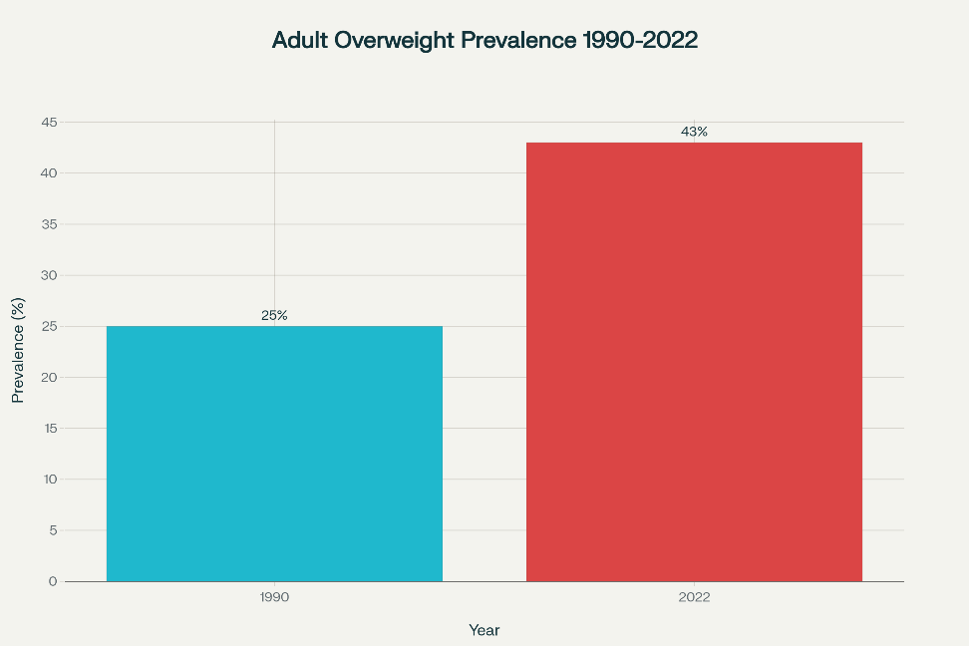
Source: (WHO, 2025)

Why factors leading to obesity?
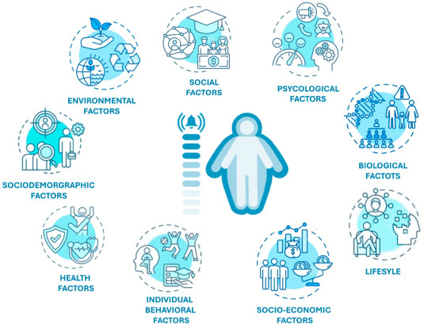
Obesity results from intricate interactions among genetic, behavioural, environmental, and socioeconomic variables, with fast urbanisation and globalisation intensifying the intake of high-calorie foods and promoting sedentary lifestyles.
Source: (Ahmed and Mohammed, 2025)

Introducing MyFitnessPal: a formidable calorie-tracking app
MyFitnessPal (MFP) is a complimentary mobile application established in 2005 that enables users to record their meals, scan barcodes, synchronise wearable devices, and discuss their progress socially. The application has a food database with 14-18 million items and personalised caloric targets, positioning it as a digital self-monitoring tool for weight management (WHO, 2025).
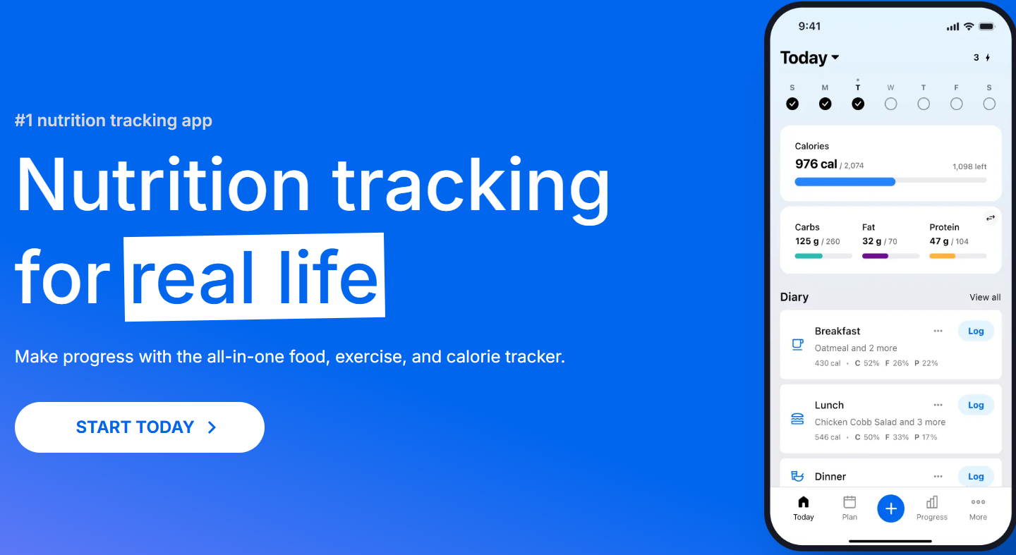
11 Things You’ll Learn Using MyFitnessPal
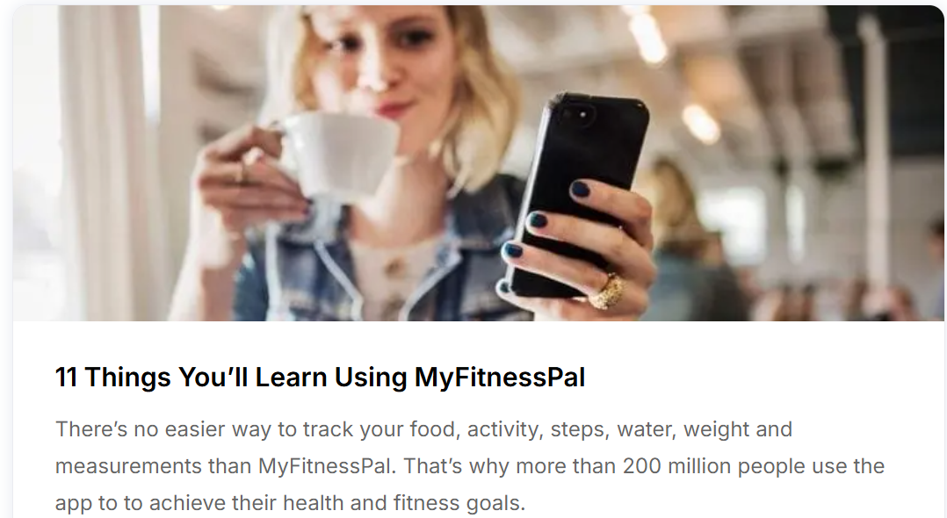

What the app does for obesity
MyFitnessPal promotes obesity prevention via data-driven calorie monitoring, nutritional understanding, and responsibility. It creates a lasting energy deficit by setting daily calorie objectives based on weight, height, and activity level. Users register meals in a vast database and scan barcodes to track consumption versus objectives, promoting weight reduction via mindful eating.
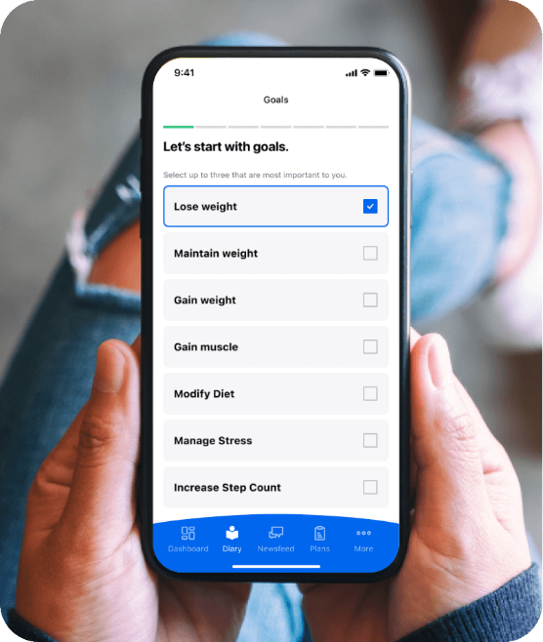

Effectiveness evidence
- According to a 2021 comprehensive review of health-wearable treatments, combining commercial devices with apps (e.g., Fitbit + MFP) resulted in significant BMI reductions (SMD –1.99) (Janić
- A 2016 mobile diabetes-prevention experiment found that an MFP-Fitbit hybrid resulted in 6.2 kg weight reduction over five months, compared to 0.3 kg increase in controls (p <
- Fitbit users in workplace programs increased daily steps by ~1800 and decreased weight by ~1 kg (Salam et al., 2023).

Advantages
Scalability & affordability: freemium model has reached 200 million global downloads with very low extra cost.
Detailed diet feedback: breakdown of micro and macronutrients helps provides personalised advice.
Community support: peer interaction improves adherence; PDA plus tailored feedback achieved 63% weight loss success compared to 46% with paper records (Ringeval et al., 2020).
Interoperability: open API supports integration with wearables, telehealth, and CGM devices.

Limitations & digital gaps
Data accuracy – user-entered food data may miscalculate calories by 7–20%, reducing reliability (McDonough et al., 2021).
Sustainability – progress often slows after 6–12 months due to tracking fatigue; many RCTs show little long-term benefit.
Privacy & monetisation – ads and premium features raise ethical issues about targeting vulnerable users.

Addressing the gaps
- Use image recognition to reduce manual logging and improve accuracy.
- Apply smart reminders that adjust goals during holidays or lockdowns to prevent relapse.
- Design offline-friendly systems with stored food databases for low-internet areas.
- Enable clinical use through EHR-compatible dashboards for remote monitoring and combining lifestyle with medical data.

References
Ahmed, S.K. and Mohammed, R.A. (2025). Obesity: Prevalence, causes, consequences, management, preventive strategies and future research directions. Metabolism Open, [online] 27, p.100375. doi: https://doi.org/10.1016/j.metop.2025.100375.
Janić, M., Janež, A., El-Tanani, M. and Rizzo, M. (2025). Obesity: Recent Advances and Future Perspectives. Biomedicines, [online] 13(2), p.368. doi: https://doi.org/10.3390/biomedicines13020368.
McDonough, D.J., Su, X. and Gao, Z. (2021). Health wearable devices for weight and BMI reduction in individuals with overweight/obesity and chronic comorbidities: systematic review and network meta-analysis. British Journal of Sports Medicine, 55(16), pp.917–925. doi: https://doi.org/10.1136/bjsports-2020-103594.
O’neil, I. (2019). Digital health promotion : a critical introduction. Cambridge, Uk ; Medford, Ma Polity.
Ringeval, M., Wagner, G., Denford, J., Paré, G. and Kitsiou, S. (2020). Fitbit-Based Interventions for Healthy Lifestyle Outcomes: Systematic Review and Meta-Analysis. Journal of Medical Internet Research, [online] 22(10), p.e23954. doi: https://doi.org/10.2196/23954.
Salam, M.M., Yousuf, R., Salam, M.W. and Haque, M. (2023). Obesity and Overweight: A Global Public Health Issue. Advances in Human Biology, [online] 13(1), p.154. doi: https://doi.org/10.4103/aihb.aihb_106_22.
World Health Organization (2025). Obesity and Overweight. [online] World Health Organization. Available at: https://www.who.int/news-room/fact-sheets/detail/obesity-and-overweight.

Blog 2 – “NutriGuide AI: A New Approach to Digital Health Promotion in Obesity Prevention”

The reason why obesity continues to necess
Obesity rates have increased thrice, with forecasts suggesting that by 2035, over 1.9 billion adults about 25% of the global population will be impacted (World Obesity Atlas, 2024). Conventional trackers exhibit suboptimal performance in fostering long-term engagement and adapting to various cultural contexts, leaving several high-risk groups inadequately serviced (Partridge et al., 2024).
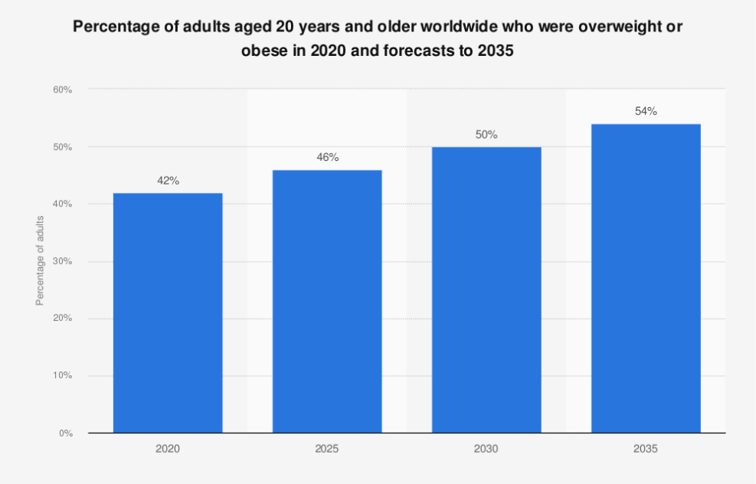
Source: (Statista, 2025)

Introducing NutriGuide AI
The digital platform NutriGuide AI brings together a multilingual chatbot, photo-based meal tracking, and syncing with different wearable devices. The system is built on three main parts:
- Instant food recognition – users take a photo; a smart model estimates portion size and nutrients with about 92% accuracy (Gustafson et al., 2025).
- Adaptive coaching – a chatbot provides evidence-based and culturally relevant advice (e.g., suggesting baked plantain instead of fried in West Africa) (Oh et al., 2021).
- Closed-loop biofeedback – combines heart rate, sleep, and glucose data to adjust daily calorie needs.

Health-promotion pathway
- Outreach by community health workers enables the functionality of smartphones via the application and an inexpensive Bluetooth waist-scale (Irvin et al., 2023).
- Weekly gamified challenges, such as the 5-a-day Quest, establish a societal norm for the eating of fruits and vegetables.
- The Tele-dietitian site recognises users whose weight trends deviate by more than 2 kg from the goal and initiates a series of virtual consultations.

Projected impact
Early simulation using Fitbit and CGM data suggests an average 1.5 kg/m² BMI reduction after 12 months, about twice as effective as basic calorie trackers (Hinchliffe et al., 2022). Personalised algorithms may also lower dropout rates by 30% by making tracking easier and more engaging.

Advantages
Equity-focused design — offline recording option and SMS-based chatbot broaden accessibility to 2G devices.
Holistic measurements extend beyond caloric intake to include sleep deprivation and stress indicators, recognising the multifaceted nature of obesity.
Federated privacy — on-device model training reduces personal data exposure.
The clinical validation loop, an open-science architecture, disseminates anonymised effectiveness dashboards.

Possible disadvantages
Algorithmic bias in food identification may lead to the misclassification of regional foods, perhaps resulting in erroneous recommendations.
Device dependence optional continuous glucose monitors or smartwatches incur additional expenses.
Behavioural overload an excess of notifications may lead to disengagement.

Alleviating challenges
- Collaborate with regional institutions to assemble food picture datasets and enhance model accuracy in under-represented cuisines (Gustafson et al., 2025).
- Implement alert-throttling algorithms that adapt to user preferences to mitigate notification fatigue.
- Offer tiered hardware options: basic (phone only), plus (phone + additional phone), pro (phone + additional phone + wearable) to accommodate various budgets.
- Engage regulators promptly via sandbox pilots collaboratively created with health ministries to facilitate approval (Partridge et al., 2024).

References
Gustafson, D., Rothenberg, E., Steingrimsson, S., Carlsen, H.K., Belloni, F., Eruvuri, N., Knez, R., Olsson, E., Burk, R.D., Cena, H., De Giuseppe, R. and Tognon, G. (2025). Exploring the interplay between diet, obesity, mental health, and the gut microbiota: the MIND-GUT intervention study, study protocol. Frontiers in nutrition, [online] 12, p.1703255. doi: https://doi.org/10.3389/fnut.2025.1703255.
Hinchliffe, N., Capehorn, M.S., Bewick, M. and Feenie, J. (2022). The potential role of digital health in obesity care. Advances in Therapy, 39(10), pp.4397-4412.
Irvin, L., Madden, L.A., Marshall, P. and Vince, R.V. (2023). Digital health solutions for weight loss and obesity: A narrative review. Nutrients, 15(8), p.1858.
Oh, Y.J., Zhang, J., Fang, M.L. and Fukuoka, Y. (2021). A systematic review of artificial intelligence chatbots for promoting physical activity, healthy diet, and weight loss. International Journal of Behavioral Nutrition and Physical Activity, 18(1), p.160.
Partridge, S.R., Knight, A., Todd, A., McGill, B., Wardak, S., Alston, L., Livingstone, K.M., Singleton, A., Thornton, L., Jia, S. and Redfern, J. (2024). Addressing disparities: A systematic review of digital health equity for adolescent obesity prevention and management interventions. Obesity Reviews, 25(12), p.e13821.
Statista (2025). Share of overweight or obese people forecasts worldwide 2035. [online] Statista. Available at: https://www.statista.com/statistics/1386143/percentage-of-overweight-or-obese-people-worldwide-forecasts/.
World Obesity Atlas (2024). World Obesity Atlas 2024: No area of the world is immune from the effects of obesity. [online] World Obesity Federation. Available at: https://www.worldobesity.org/news/world-obesity-atlas-2024.

