Project Management (LCBB5005)
Name : Maiyara M Florian Santana
Lecturer: Essa Bah
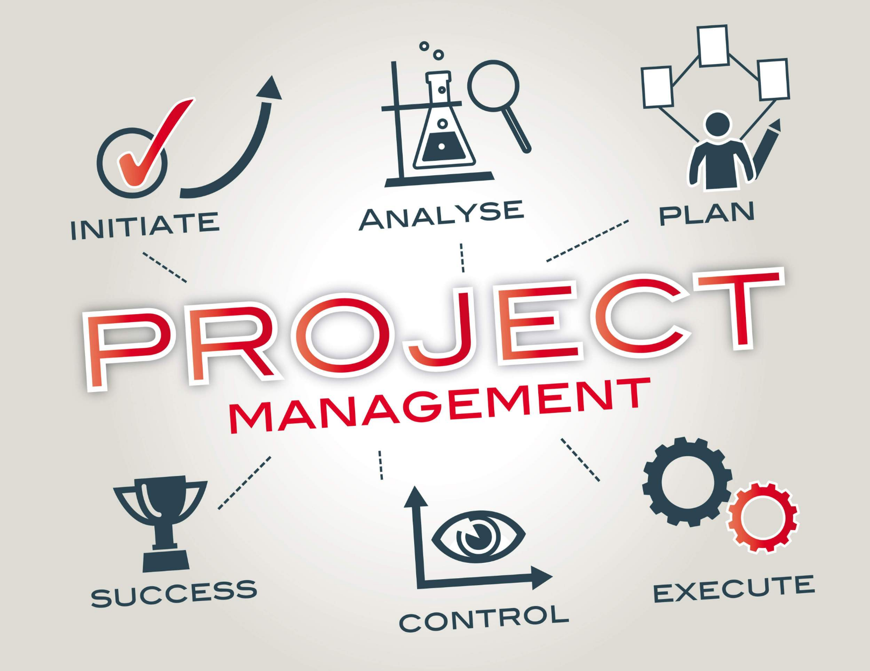

Table of Contents
Introduction 3
2. Aim, Objectives, and Scope 4
2.1 Aim 4
2.2 Objectives 4
2.3 Scope 4
3. Project Outputs and Outcomes 5
3.1 Project Deliverables 5
4.0 Project Tasks and Sub-tasks 6
4.1 Project Initiation and Planning 7
4.2 Medi Vet Connect App Development 7
4.3 Partnership Develop 8
4.4 Marketing and Promotion 8
4.5 Training and Support 8
4.6 Project Monitoring, Evaluation and Reporting 9
5. Deliverables and Milestones 9
6. Resource Requirements 10
6.1 Personnel Requirements 10
5.2 Material Resources 11
5.3 Budget Breakdown 11
Conclusion 12

Introduction
Veterans experience challenges to access healthcare due to various factors such as lack of awareness on the various benefits and services available for them. Many veterans also experience long waiting times, limited mental health support and poor access to the veteran facilities especially in rural areas thus affecting their health outcomes (Board on the Health of Select Populations, Committee on the Assessment of Readjustment Needs of Military Personnel, Veterans and Their Families, 2013.)
Medi Vet Connect is an innovative platform project that seeks to transform how veterans and their families access healthcare services. Technology has transformed nearly every facet of life from education, healthcare, agriculture and business. As new technology continues to revolutionise all sectors, there is a growing opportunity to leverage on emerging digital innovations to improve access to healthcare services (Fortney et al., 2011). As a result, the current project seeks to launch and rollout a mobile application to bridge the gap between veterans and access to specialised healthcare services such as surgical procedures and management of long-term health conditions develop in their active service. Medi Vet Connect offers a user-friendly platform, simplifying how veterans and their families can access healthcare in an increasingly complex healthcare system. With help of the innovative mobile solutions, the application will serve as a central hub for the veterans, enabling them to connect with doctors and healthcare providers, make appointments, and receive clear information on the medical bills.

2. Aim, Objectives, and Scope

2.1 Aim
The Medi Vet Connect project aims to enable veterans especially in rural areas to access care thus expanding their reach in search for specialised healthcare. The process of scheduling appointments is also highly bureaucratic leading to delays in accessing care. The app features streamlined scheduling of appointments thus reducing the waiting time and enhancing delivery of care to the veterans. Additionally, the app will help to improve transparency by providing information on medical costs upfront to enable the veterans and their families to make informed decisions. Finally, Medi Vet Connect will help to create a support network for veterans by linking their families and physicians thus creating holistic care. Therefore, our vision lies in creating a digital platform that simplifies the process of identifying health providers, scheduling points, accessing information on medical costs and delivering their care (Fortney et al., 2011). This will ultimately improve the health outcomes and quality of life for the veterans (Kruse, Bolton, and Freriks, 2015).

2.2 Objectives
- To develop a digital application that allows veterans to browse various specialised medical healthcare services and specialist providers.
- To ensure efficient scheduling of appointments with healthcare providers.
- To provide clear visibility of costs for different surgical procedures.
- To streamline communication between veterans, healthcare providers, and other support services.
- To support effective management of medical records for veterans and their families efficiently.

2.3 Scope
The scope of the project includes the key features and functions of the product. It also includes all activities and tasks required to complete the project.
The digital application
The scope of the Medi Vet Connect covers various key feature and tasks. First, the project will culminate into a digital mobile application platform that allows veterans to browse various medical services and the available specialists. The app is appropriate for both iOS and Android platforms. The app will include functions like user registration, profile management, browsing services, appointment scheduling, cost estimates, and health record management. This will users to find the medical service they need based on their location and preferences. The app also integrates user reviews and rating to support the users in making informed decisions on choosing the best specialists for their treatment.
Scheduling of Appointments
The app will also support a feature that enable users to schedule appointments with health provers. This will enable the users to check availability of the specialists to minimise conflicts when different users schedule their appointments. The application also integrates a notification feature to give appointment reminders and notify of changes or updates.
Cost Transparency and Visibility
The application will also integrate cost information for various procedures and specialists. This will enable users to compare costs for the procedures across the facilities and insurance information for the veterans to understand the packages and make informed decisions.
Streamlined Communication
The application features a secure messaging system allowing users to communicate directly with healthcare providers and specialists. Veterans will be able to communicate with their specialists through messaging and sharing documents, medical records and test results securely through the app for ease of care coordination and planning.
In-app Partnerships
The application will support partnerships with healthcare providers specialising in veteran care. We will negotiate agreement and on-board at least five specialists or facilities specialising in veteran health care.
Training and User Support
The app integrates a support feature including user manuals, in-app tutorials, video guides and FAQs to support users to understand how to use the app. The app will also include a dedicated customer support team to assist users on queries related to using the app.

3. Project Outputs and Outcomes
The Medi Vet Connect project will generate several tangible and intangible outputs and outcomes, enhancing access to healthcare for veterans. The outcomes seek to achieve the project objective in improving access to healthcare and creating value for the veteran community.

3.1 Project Deliverables
Primary Outcomes
Functioning Mobile Application: The key deliverable of the Medi Vet Connect project is a user-friendly mobile application that supports both iOS and Android platforms. The functionalities include user registration and profile management, searching directories and filtering option, appointment scheduling, cost information and streamlined communication through messaging system.
Training and User Support Manual: The application will feature a user guide on various functionalities. This will include in-app tutorials, video tutorials, frequently asked questions (FAQ) and a printable PDF file to support the less tech-savvy users.
Formal Agreements with Partners: After negotiations, we will draft formal contractual agreements with at least five healthcare providers specialising in veteran care. This will include agreements on service level agreements, data sharing protocols, price and cost estimates for services.
Reporting and Analytics: The app will offer monthly reports on various aspects such as the number of active users, successful appointments, booking rates, retention rates and most sought after services. The reports will also show the customer satisfaction scores, provider feedback and cost savings for users.
Secondary Outcomes
Improved access to medical care for veterans. The Medi Vet Connect platform will lead to an increase in the number of veterans accessing the specialised medical care services. The in-app scheduling feature will also result in a reduction in the average waiting time for appointments. Finally, the app will expand the geographical reach for veterans seeking specialised medical care (McInnes et al., 2014).
Improved communication: The app seeks to streamline communication between veterans and healthcare providers supporting seamless exchange of information to support care delivery. This will help to reduce medical errors and improve healthcare outcomes.
Creation of a supportive community: The app also features community support groups for veterans with similar health concerns. This will also create a network of veteran specialist health providers thus supporting for the needy veterans.
Transparency in Medical Billing: The application will also lead to increased transparency in healthcare costs leading to better financial planning for veterans.

4.0 Project Tasks and Sub-tasks
To achieve the desired project outcomes and deliverables, the project will involve various activities. The activities are presented below followed by a work breakdown structure to detail the main tasks and sub-tasks.

4.1 Project Initiation and Planning
Needs Assessment: The initial stage will involve surveying the veteran community to identify their concerns and pain in accessing healthcare. The assessment will also analyse data and reports from the Department of Veteran Affairs and the Department of Defence to understand the unique challenges of veterans.
Developing the project charter and scope statement. This will include a definition of the project goals, objectives, and criteria for success. The project team will also seek approval from various stakeholders.
Developing a project plan: The project plan will include detailing the project schedule and milestones, allocating resources and budget and developing a risk register.
Assembling the project team. The project manager will identify required roles and skills required for appointment to the team and recruit competent members to join the team. Finally, the project manager will on-board members through orientation and kick-off meeting.

4.2 Medi Vet Connect App Development
4.2.1 Identifying and analysing requirements. This will be done through brainstorming groups and interviewing users. After the research, the team will identify and document functional and non-functional requirements and prioritise the features to be integrated based on needs of users.
4.2.2 Designing the app. Here, the team will define the app system architecture and technology stack and come up with a database schema and data flow diagrams to show the sequence and flow of activities within the app.
4.3.3: Design of user interface (UI). This will involve developing wireframes, mock-ups, style and design system. A usability testing will be done with users to understand the ease and challenges in navigating the app to access various functions.
4.3.4: Frontend development- In this stage, the design team will implement the user interface components and screens and integrate them with the with backend APIs to optimise the app for excellent performance and responsiveness.
4.3.5 Backend development- The project team will embark on setting up servers and databases as well as authentication and authorisation systems. The team will also develop the key business logic and APIs to support all backend functions such as user registration and profile management.
4.3.6 Integration of key features. The app developers will work with the project team to integrate key functions such as scheduling appointments, cost module, messaging and communication support.
4.3.7 Testing and quality assurance. After developing the app and integrating all the essential features based on the needs analysis, the project team will carry out testing for each function and test how the app modules integrate. A user acceptance testing will be performed to assess how well the app is usable by the users. Security audits are essential to test the system’s ability to prevent unauthorised penetration and to secure the data of users in compliance with HIPAA.
4.3.8 Deployment. The app will finally be deployed and launched on the Apple App Store and Google Play Store. This will be done while conducting the pre-launch checks and approvals for compliance.

4.3 Partnership Develop
This stage will seek to identify and reach out to various partners to officially negotiate and roll out the services for users. The specific activities include;
- Identifying the partner health providers, their services, location and cost for procedures.
- Negotiating terms of engagement with at least five service providers.
- Formalising the rules of engagement and signing the contracts such as service level agreements.
- On boarding the veteran specialised healthcare providers and integrating their services, location and services. This also includes training the facilities on the app and its functionalities.

4.4 Marketing and Promotion
This activities aim to create awareness about the Medi Vet Connect platform, its services, functionalities and its benefits to the veteran community. The specific activities are presented below;
- Developing the marketing strategy, identifying marketing goals and key performance outcomes.
- Creating marketing materials such as brochures, posters, direct mails.
- Launch a targeted marketing campaign on social media, direct emails, veteran communities, media outreach and organising launch events at VA hospitals and clinics.
- Monitoring and track performance outcomes and comparing with the targets and adjusting the marketing strategy where appropriate to achieve the desired goals.

4.5 Training and Support
This activity will involve empowering users of the app through training to support them in navigating the app and using it effectively to access the services they need. The specific sub-tasks are listed below;
- Develop training materials and materials like manuals, FSQs and video tutorials.
- Training customer support teams on app features.
- Conducting user training after registration.

4.6 Project Monitoring, Evaluation and Reporting
These will be conducted as ongoing efforts to identify how well the app lives to the expectations of users. The specific tasks that will be performed include;
- Tracking performance of the app such as service usage rates and appointments.
- Quality assurance evaluation and customer reviews to ensure the services delivered to users meet the service level agreements
- Generating reports on the project outcomes such as compliance, service usage and providing feedback on issues such as slack time.
4.7 Closure
After successfully launching the project, the project will be handed over to the stakeholder for continuous management. This is essential to ensure that the project meets the specific needs of the stakeholders and users. The specific sub-tasks in this stage include;
- Conducting project post-mortem and reflecting lessons learned session.
- Prepare final project report and presenting to the stakeholders.
- Recognising the project team and the efforts delivered in completion of the project.
- Planning for future iterations and improvements where needed.
Work Breakdown Structure

5. Deliverables and Milestones
Project Phase | Milestone | Key Deliverables | Timeline
Project Initiation and Planning | Project kick-off meeting | Project charter and scope statement | 2 weeks
Medi Vet Connect App Development | -Requirements document approval (week 4)  -UI/UX design completed (week 8)  -Backend development c (week 14)  -Frontend development (week 18)  -App testing (week 22)  -App deployment to app stores (week 24) | Fully Functional Mobile Application | 24 weeks
Partners On-boarding | At least five healthcare providers are on-boarded. | Signed Partnership Agreements | 8 Weeks
Marketing and Promotion | Development of marketing materials and rollout of an integrated marketing campaign. | Official App Launch at veteran healthcare events. | 6 weeks (starts 4 weeks before app deployment).
Training and Support | Completion of a first user training session. | Training materials and a customer support system. | 4 weeks (starts 2 weeks before app deployment)
Project Monitoring, Evaluation and Reporting | First quarterly performance review meeting. | Monthly performance report. | Ongoing from app deployment.
Closure | Project handover to stakeholders | Final project report | 2 weeks (after 3 months of app operation)
Estimated project duration |  |  | 36 Weeks (9 Months)

6. Resource Requirements

6.1 Personnel Requirements
Role | Quantity | Contract Time
Project Manager | 1 | Full-time
Business Analyst | 1 | Full-time
UI/UX Designer | 1 | Full-time
Frontend Developers | 2 | Full-time
Backend Developers | 2 | Full-time
Quality Assurance Specialists | 2 | Full-time
DevOps Engineer | 1 | Full-time
Marketing Specialist | 1 | Full-time
Customer Support Representatives | 3 | Full-time
Legal Advisor | 1 | Part-time

5.2 Material Resources
Besides the human resources, there are various materials resources required to complete the project on time and to meet the scope requirements. These include five workstations to for the project team, mobile phones supporting iOS and Android for performing the testing. The team also requires a cloud-based server platform for hosting the back end of the application, the licenses for development and collaboration software tools, marketing materials to promote the app and budget to support create comprehensive training material to support both the staff and the users. These resources are essential to support the testing, deployment and marketing of Medi Vet Connect application.

5.3 Budget Breakdown
Category | Item | Unit Cost | Total Cost
Personnel | Project Manager |  | £80,000
Personnel | Business Analyst | 1 | £65,000
Personnel | UI/UX Designer | 1 | £60,000
Personnel | Frontend Developers | 1 | £70,000
Personnel | Backend Developers | 2 | £75,000
Personnel | Quality Assurance Specialists | 2 | £55,000
Personnel | DevOps Engineer | 2 | £70,000
Personnel | Marketing Specialist | 1 | £55,000
Personnel | Customer Support Representatives | 1 | £35,000
Personnel | Legal Advisor | 3 | £40,000
Hardware | Workstations for development | 10 | £1,500
Hardware | Smart phones for testing | 10 | £80,000
Software | Cloud infrastructure | 1 | £5,000
Software | Software licenses for development | 10 | £2,000
Software | Licenses for collaborative tools | 15 | £5,000
Marketing | Production of marketing promotion materials | 1 | £30,000
Marketing | Digital marketing campaign | 1 | £50,000
Training | Production of training materials | 1 | £20,000
Miscellaneous | Office supplies & utilities | 1 | £10,000
Miscellaneous | Travel and meetings | 1 | £15,000
Sub-total |  |  | £823,500
Contingency | 10% of the budget |  | £82,350
Total |  |  | £905,850

Based on above estimations, the Medi Vet Connect project cost budget price estimate is £905,850 with 10% contingency of £82,350 below or above the budget. The majority of the expenses will go into covering salaries and compensation for the project team (605,000), hardware (81,500), software (12,000) and marketing expenses (100,000).

Conclusion
Veterans face numerous barriers in accessing specialized health services, which impacts their quality of life and well-being. Medi Vet Connect offers an innovative solution that bridges the gap in access to these essential services. The project seeks to leverage mobile technology to streamline various processes such as locating specialists for various procedures, scheduling appointments and understanding the billing process for medical costs. This will help to improve access to care for veterans by reducing wait times, improving communication and promoting transparency in billing. This project plan has outlined the key activities, milestones, resource requirements, scope, goals and deliverables. With this, the project team is poised to deliver and roll-out a fully functional mobile app that transforms how healthcare is accessed and delivered for veterans, leading to improved health outcomes and quality of life for the individuals who have served their country.

Reference List
- Board on the Health of Select Populations, Committee on the Assessment of Readjustment Needs of Military Personnel, Veterans and Their Families, 2013. Returning Home from Iraq and Afghanistan: Assessment of Readjustment Needs of Veterans, Service Members, and Their Families. Washington (DC): National Academies Press (US). Available at: https://pubmed.ncbi.nlm.nih.gov/24901192/ [Accessed on 29th September, 2024]
- Fortney, J.C., Burgess, J.F., Bosworth, H.B., Booth, B.M. and Kaboli, P.J., 2011. A re-conceptualisation of access for 21st century healthcare. Journal of general internal medicine. Available at: https://pmc.ncbi.nlm.nih.gov/articles/PMC3191218/ [Accessed on 30th September,2024
- Hogan, T.P., Wakefield, B., Nasi, K.M., Houston, T.K. and Weaver, F.M., 2011. Promoting access through complementary eHealth technologies: recommendations for VA's Home Telehealth and personal health record programs. Available at: https://pubmed.ncbi.nlm.nih.gov/21989614/ [Accessed on 1st October,2024]
- Kersner, H., 2017. Project management: a systems approach to planning, scheduling, and controlling. John Wiley & Sons.
- Kruse, C.S., Bolton, K. and Freriks, G., 2015. The effect of patient portals on quality outcomes and its implications to meaningful use: a systematic review. Journal of medical Internet research. Available at: The effect of patient portals on quality outcomes and its implications to meaningful use: a systematic review - PubMed [Accessed on 18th October 2024]
- McInnes, D.K., Petrakis, B.A., Gifford, A.L., Rao, S.R., Houston, T.K., Asch, S.M. and O'Toole, T.P., 2014. Retaining homeless veterans in outpatient care: a pilot study of mobile phone text message appointment reminders. American journal of public health. Available at: https://www.researchgate.net/publication/264643056_Retaining_Homeless_Veterans_in_Outpatient_Care_A_Pilot_Study_of_Mobile_Phone_Text_Message_Appointment_Reminders [Accessed on 30th September]
- Mishuris, R.G., Stewart, M., Fix, G.M., Marcello, T., McInnes, D.K., Hogan, T.P., Boardman, J.B. and Simon, S.R., 2015. Barriers to patient portal access among veterans receiving home‐based primary care: a qualitative study. Health Expectations. Available at: https://pmc.ncbi.nlm.nih.gov/articles/PMC5810689/ [Accessed on 29th September,2024]
- Payne, P.R., Lussier, Y., Foraker, R.E. and Embi, P.J., 2016. Rethinking the role and impact of health information technology: informatics as an interventional discipline. BMC medical informatics and decision making.
- Tsai, J. and Rosenheck, R.A., 2012. Use of the internet and an online personal health record system by US veterans: comparison of Veterans Affairs mental health service users and other veterans nationally. Journal of the American Medical Informatics Association.

