Popovici Alexandru
2322380@student.uwtsd.ac.uk
Scripting and Programming Concepts
CERTHE COMPUTING SKILLS FOR WORKPLACE
ACCA5036
assessment: Attendance System
Attendance-App/Attendance.py at main · popovicialexandru50-afk/Attendance-App

Table of Contents
1. Analysis 2
1.1 Introduction 2
1.2 Requirements Analysis 2
1.3 Non-Functional Considerations 3
2. Software Design and Development 4
2.1 Design 4
a. Flowcharts 4
b. Pseudocode 7
2.2 Implementation Decisions 10
a. Data Structures 10
b. Program Structure and Functions 10
c. Input Validation and Error Handling 10
d. Programming Constructs Used 10
2.3 Source Code 11
3. Testing and Debugging 15
3.1 Functional Testing 15
3.2 Input Validation Testing 19
3.3 Debugging 21
4. Evaluation 21
References 22

Analysis

1.1 Introduction
Bright Minds Academy is a small tutoring centre where tutors currently record student attendance manually. This is usually done using paper registers or simple notes, which can become difficult to manage as the number of students increases. Manual attendance tracking can lead to mistakes, such as missing records or unclear information, and it can also take extra time during lessons.
The aim of this project is to create a simple attendance system using Python that helps tutors record and view student attendance more easily. The system allows tutors to add students, mark them as present or absent for specific dates, and view attendance records when needed. The focus of the system is on basic attendance management rather than advanced features.
This solution is designed to be easy to use and suitable for a small organisation like Bright Minds Academy. It uses a simple text-based menu and does not require any advanced technical knowledge to operate. By using a small program instead of manual records, tutors can manage attendance in a more organised and reliable way.

1.2 Requirements Analysis
The requirements of the attendance system were identified based on the needs of tutors at Bright Minds Academy. The main goal of the system is to provide a simple way to manage student attendance without making the process complicated or time-consuming.
The first requirement of the system is to allow tutors to add new students. When adding a student, the tutor must enter the student’s name and the class group they belong to. This information needs to be stored so that the student can later be selected when recording or viewing attendance.
The second requirement is to record attendance. Tutors must be able to mark a student as present or absent for a specific date. The system should only accept valid input, meaning the date must be entered in the correct format and the attendance status must be either present or absent. This helps reduce errors and keeps the attendance records consistent.
Another requirement is the ability to view attendance records. Tutors should be able to see attendance information for students across different days. In this system, attendance records are viewed by selecting a student, which then displays all recorded dates along with the corresponding attendance status. This approach keeps the system simple while still meeting the needs of the tutors.
Finally, the system must include a search function that allows tutors to quickly find a student by name and view their attendance details. This feature makes it easier to access information without having to manually go through all stored data.

1.3 Non-Functional Considerations
In addition to the main features of the system, some basic non-functional requirements were considered during development. These focus on how the system should behave rather than what it should do.
The system should be easy to use, especially for tutors who may not have strong technical skills. For this reason, the program uses a simple text-based menu that clearly shows the available options and guides the user through each action step by step.
Another important consideration is reliability. The system should handle incorrect input without crashing. For example, if a tutor enters an invalid date, an empty name, or an incorrect attendance status, the system should display a clear error message and ask the user to try again. This helps prevent incorrect data from being stored. [1]
The system should also be lightweight and simple. To keep the program suitable for the task and easy to understand, no external databases or advanced libraries are used. Instead, Python dictionaries are used to store student and attendance information while the program is running.
Overall, these non-functional considerations help ensure that the system is practical, reliable, and appropriate for a small tutoring centre like Bright Minds Academy.

Software Design and Development

Design

Flowcharts

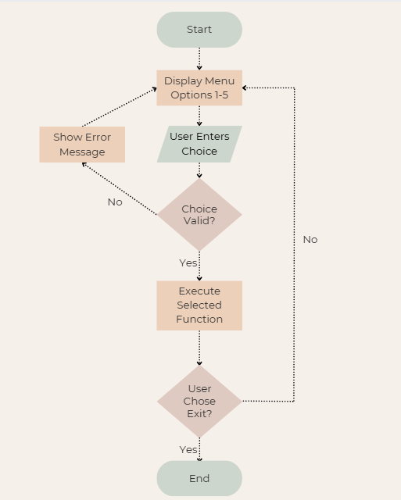
Figure 1. Main Menu Flowchart

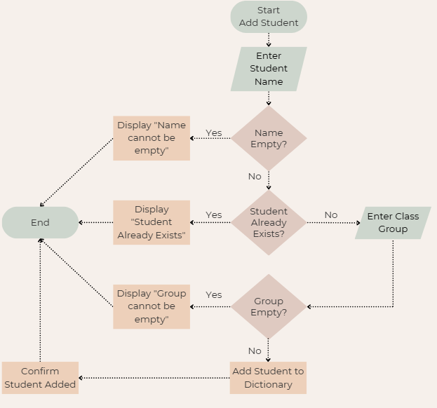
Figure 2. Add Student Flowchart

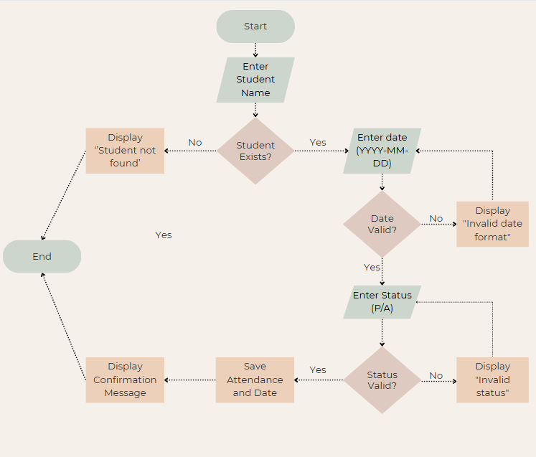
Figure 3. Record Attendance Flowchart

Pseudocode

- Add Student Pseudocode

FUNCTION add_student()
INPUT student_name
IF student_name is empty THEN
DISPLAY "Name cannot be empty"
RETURN
ENDIF

IF student_name exists in students THEN
DISPLAY "Student already exists"
RETURN
ENDIF

INPUT class_group
IF class_group is empty THEN
DISPLAY "Group cannot be empty"
RETURN
ENDIF

students[student_name] = {"group": class_group, "attendance": empty dictionary}
DISPLAY "Student added successfully"
END FUNCTION

- Record Attendance Pseudocode

FUNCTION record_attendance()
INPUT student_name
IF student_name not in students THEN
DISPLAY "Student not found"
RETURN
ENDIF

INPUT date_string (YYYY-MM-DD)
IF date_string is invalid THEN
DISPLAY "Invalid date format"
RETURN
ENDIF

INPUT status (P/A or Present/Absent)
IF status is not valid THEN
DISPLAY "Invalid status"
RETURN
ENDIF

NORMALISE status to "Present" or "Absent"
students[student_name]["attendance"][date_string] = status

DISPLAY "Attendance recorded"
END FUNCTION

- View Attendance Records

FUNCTION view_attendance_by_student()
INPUT student_name
IF student_name not in students THEN
DISPLAY "Student not found"
RETURN
ENDIF

DISPLAY student_name
DISPLAY students[student_name]["group"]

attendance_dict = students[student_name]["attendance"]
IF attendance_dict is empty THEN
DISPLAY "No attendance recorded for this student"
RETURN
ENDIF

FOR each date in attendance_dict sorted ascending
DISPLAY date + " : " + attendance_dict[date]
END FOR
END FUNCTION

Implementation Decisions

Data Structures
Python dictionaries were used as the main data structure to store student information. Each student’s name is used as a key, and the value stores the student’s class group and their attendance records. Attendance records are stored in a nested dictionary, where the date is the key and the attendance status (Present or Absent) is the value.
This approach was chosen because dictionaries allow fast access to data using a key, which makes it easy to find students by name and update their attendance. It also keeps all related information for each student grouped together in a clear and logical way.

Program Structure and Functions
The program was divided into separate functions, such as adding a student, recording attendance, viewing attendance records, and searching for a student. This makes the program easier to read, test, and maintain. Each function is responsible for one specific task, which helps avoid repetition and keeps the code organised.
A main loop was used to display the menu and repeatedly ask the user for input until they choose to exit the program. This allows the system to handle multiple actions in one session without restarting the program. [2]

Input Validation and Error Handling
Input validation was included to prevent incorrect data from being stored and to avoid program crashes. For example, the system checks that student names and class groups are not empty, ensures that dates follow the correct format, and restricts attendance status input to valid options only.
If invalid input is entered, the system displays a clear error message and asks the user to try again. This improves the reliability of the program and makes it easier for tutors to use without technical knowledge. [3]

Programming Constructs Used
The program makes use of basic programming constructs such as if statements for decision-making, while loops for repetition, and functions for modular design. These constructs were chosen because they are suitable for a simple console-based application and are easy to understand. [3]
The datetime module was used to validate date input, ensuring that dates entered by the user follow a consistent and correct format.

Source Code

from datetime import datetime

def get_non_empty(prompt: str) -> str:
while True:
value = input(prompt).strip()
if value:
return value
print("Input cannot be empty. Please try again.")

def get_valid_date(prompt: str) -> str:
while True:
date_str = input(prompt).strip()
try:
datetime.strptime(date_str, "%Y-%m-%d")
return date_str
except ValueError:
print("Invalid date format. Use YYYY-MM-DD (e.g., 2025-12-19).")

def get_valid_status(prompt: str) -> str:
while True:
status = input(prompt).strip().lower()
if status in ("p", "present"):
return "Present"
if status in ("a", "absent"):
return "Absent"
print("Invalid status. Enter P/Present or A/Absent.")

def add_student(students: dict) -> None:
print("\n--- Add New Student ---")
name = get_non_empty("Enter student name: ")

if name in students:
print("Student already exists.")
return

group = get_non_empty("Enter class group: ")
students[name] = {"group": group, "attendance": {}}
print("Student added successfully.")

def record_attendance(students: dict) -> None:
print("\n--- Record Attendance ---")
name = get_non_empty("Enter student name: ")

if name not in students:
print("Student not found. Add the student first.")
return

date_str = get_valid_date("Enter date (YYYY-MM-DD): ")
status = get_valid_status("Enter status (P/A): ")

students[name]["attendance"][date_str] = status
print(f"Attendance recorded: {name} on {date_str} = {status}")

def view_attendance_by_student(students: dict) -> None:
print("\n--- View Attendance (By Student) ---")
name = get_non_empty("Enter student name: ")

if name not in students:
print("Student not found.")
return

group = students[name]["group"]
attendance = students[name]["attendance"]

print(f"\nStudent: {name}")
print(f"Group: {group}")

if not attendance:
print("No attendance records found for this student.")
return

print("\nDate Status")
print("-------------------")
for date_str in sorted(attendance.keys()):
print(f"{date_str} {attendance[date_str]}")

def search_student(students: dict) -> None:
print("\n--- Search Student ---")
view_attendance_by_student(students)

def main() -> None:
students = {}

while True:
print("\n==== Bright Minds Attendance System ====")
print("1) Add new student")
print("2) Record attendance")
print("3) View attendance records (by student)")
print("4) Search student")
print("5) Exit")

choice = input("Choose an option (1-5): ").strip()

if choice == "1":
add_student(students)
elif choice == "2":
record_attendance(students)
elif choice == "3":
view_attendance_by_student(students)
elif choice == "4":
search_student(students)
elif choice == "5":
print("Goodbye.")
break
else:
print("Invalid option. Please enter a number between 1 and 5.")

if __name__ == "__main__":
main()

3. Testing and Debugging

3.1 Functional Testing
Functional testing was used to check that each feature of the system operates correctly.
- Add Student Test
The “Add new student” option was tested by entering a valid student name and class group. The system successfully added the student and displayed a confirmation message. An additional test was carried out by attempting to add the same student again, and the system correctly displayed an error message indicating that the student already exists.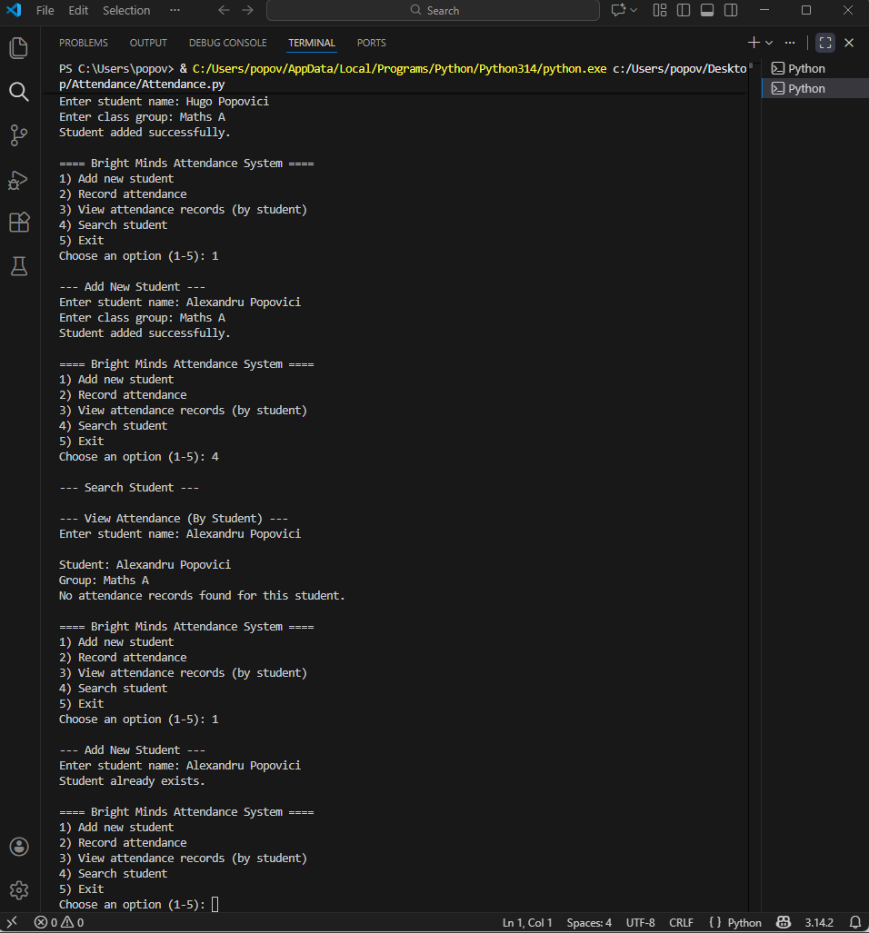
- Record Attendance Test
The “Record attendance” function was tested by selecting an existing student, entering a valid date, and marking the student as present. The system successfully saved the attendance record and displayed a confirmation message.
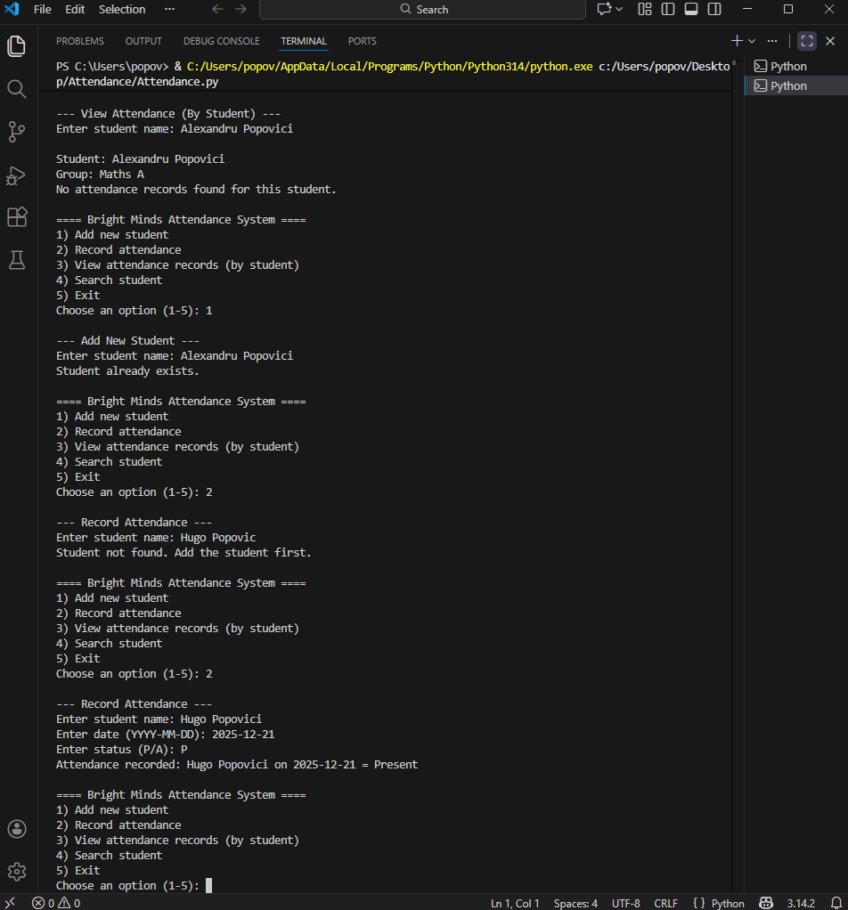

- View Attendance Test
The “View attendance records” option was tested by selecting a student who has attendance records. The system correctly displayed the student’s name, class group, and a list of recorded dates with their attendance status.
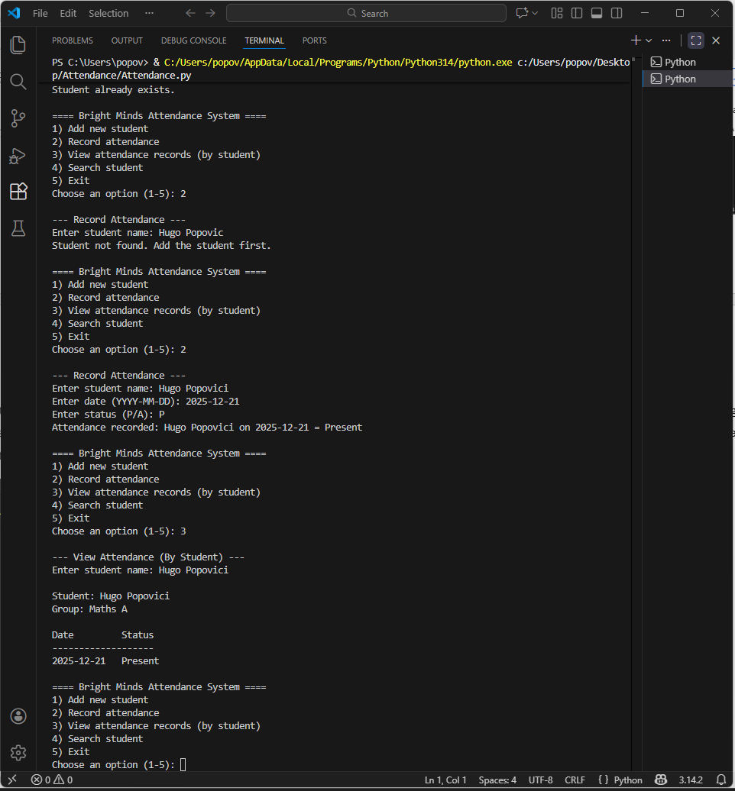

- Search Student Test
The search function was tested by entering the name of an existing student, which correctly displayed their attendance records. The function was also tested using a student name that does not exist, and the system displayed an appropriate error message.
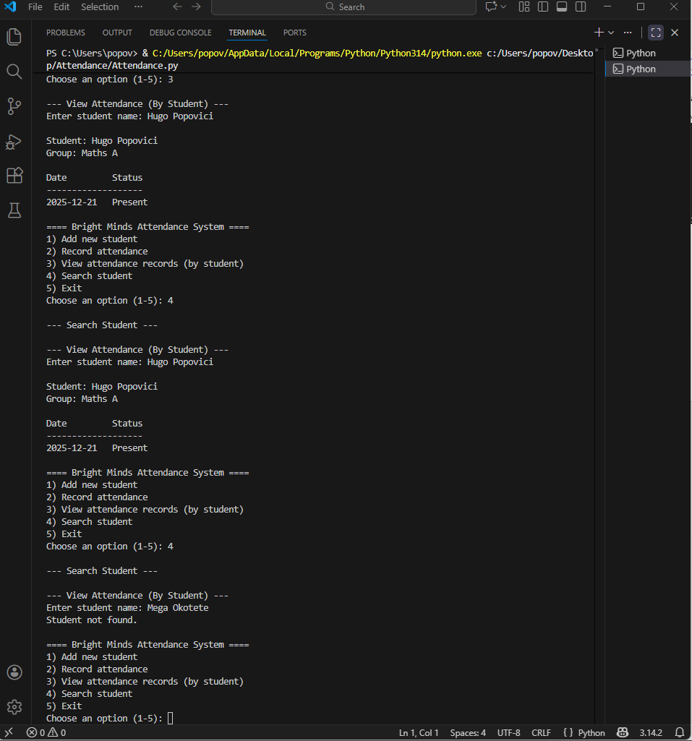

3.2 Input Validation Testing

Input validation testing was carried out to ensure the system handles incorrect input safely.
- Invalid Date Format
When recording attendance, an invalid date format was entered. The system detected the error and displayed a message instructing the user to enter the date in the correct format. The user was then prompted to re-enter the date.
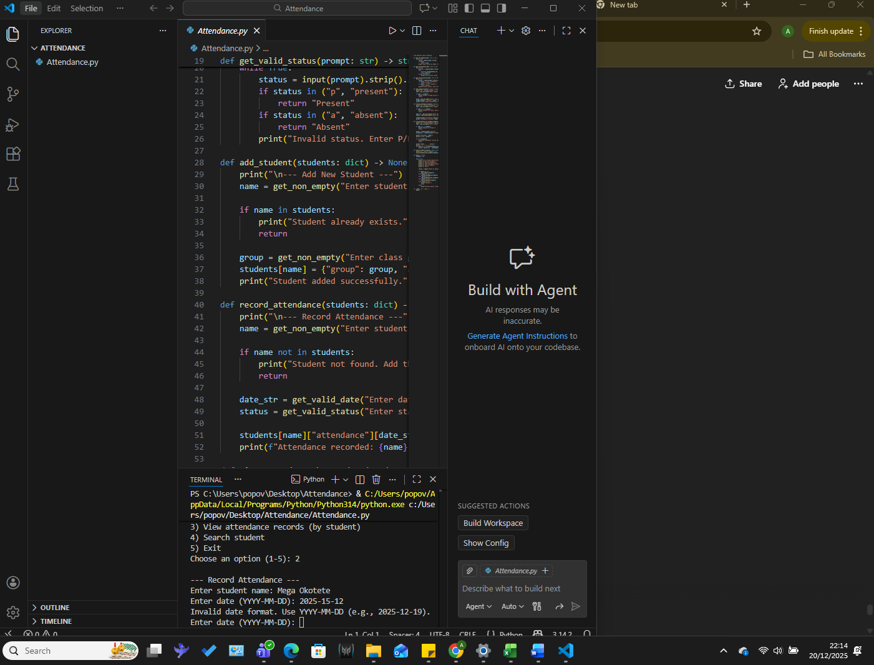

- Invalid Attendance Status
An invalid attendance status was entered when recording attendance. The system rejected the input and displayed an error message asking the user to enter a valid status.
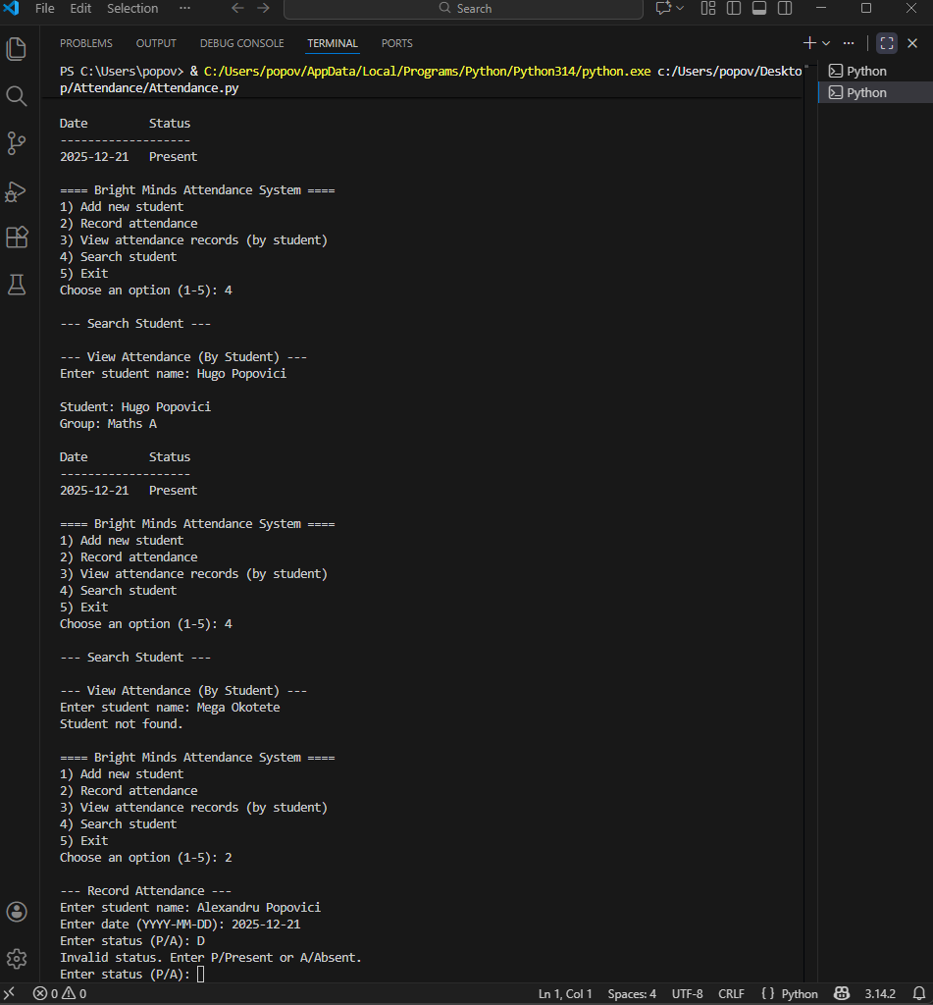

3.3 Debugging

During development, minor issues such as incorrect input handling and formatting errors were identified through testing. These issues were resolved by adding input validation and clear error messages. The use of functions made it easier to isolate and fix problems without affecting other parts of the program.
Overall, testing confirmed that the system meets the functional requirements and behaves reliably when faced with incorrect input.

Evaluation

The attendance system successfully meets the main requirements set out in the project brief. It allows tutors to add students, record attendance for specific dates, view attendance records, and search for students using a simple text-based menu. All core features were implemented and tested, and the system behaves as expected when both valid and invalid input is entered.
One of the main strengths of the system is its simplicity. The menu-driven design makes it easy to use, even for users with limited technical knowledge. Input validation helps prevent errors, such as incorrect date formats or invalid attendance status entries, which improves the reliability of the system. Using functions also made the program easier to understand and maintain.
However, there are some limitations to the current implementation. All data is stored in memory, meaning that student and attendance records are lost when the program is closed. This limits the system’s usefulness for long-term record keeping. In addition, attendance records can only be viewed by student, and there is no option to view attendance by date or generate summary reports.
If the system were to be improved in the future, several enhancements could be made. Data could be saved to a file or database so that records persist between sessions. Additional features such as viewing attendance by date, exporting records, or adding user authentication could also be implemented. A graphical user interface could further improve usability.
Overall, the project provided a useful introduction to designing and implementing a simple software solution. The final system meets the required functionality and demonstrates the use of basic programming concepts such as functions, loops, and input validation.

References

[1] | A. B. Downey, Think Python, O'Reilly Media, 2024.
[2] | A. Warner, Python for Absolute Beginners, Independently published, 2020.
[3] | D. Amos, D. Bader, J. Jablonski and F. Heisler, Python Basics: A Practical Introduction to Python 3, RealPython.com, 2021.

