March 24, 2026
Dayana Balandra Heredia
Student ID: 2442006
University of Wales Trinity Saint David
Database Design and Implementation for MediLink Pharmacy
Introduction to Web and Database Concepts

Introduction

Scenario Analysis

Entity Identification

Entity Relationship Diagram (ERD)

Database Design

Normalisation

Sample Data

Queries

Validation and Testing

Conclusion

References

- Introduction
This report describes the development of a relational database system for MediLink Pharmacy. The purpose of the project is to design a database using Microsoft Access that can manage the pharmacy’s operations, including medicines, suppliers, prescriptions, customers and sales records.
Currently, MediLink Pharmacy manages much of its information manually, which may result in data errors, duplicated records and difficulties when retrieving information. By implementing a structured relational database, the pharmacy will be able to organise data more efficiently, improve accuracy and reduce redundancy.
This report analyses the pharmacy scenario, identifies the main entities within the system and presents an Entity Relationship Diagram (ERD). It also explains the database structure, the normalisation process and example queries used to demonstrate how the system works [1].

Scenario Analysis
MediLink Pharmacy is a local community pharmacy that currently stores and manages its information manually. The pharmacy deals with various types of data such as medicines, suppliers, prescriptions, customer details and sales transactions.
Handling this information without a structured digital system increases the possibility of mistakes, duplicated data and inefficiencies when searching for records. Manual systems also make it more difficult to monitor stock levels and track prescriptions accurately.
For this reason, the management of MediLink Pharmacy plans to implement a relational database using Microsoft Access. The system will help organise information in a structured way, maintain data consistency and improve the efficiency of daily pharmacy operations.

Entity Identification
In a relational database, entities represent the main objects or concepts about which information is stored. Identifying these entities is an important step in database design because it allows data to be organised in a structured and logical way.
Based on the MediLink Pharmacy scenario, the main entities identified are Customers, Medicines, Suppliers, Prescriptions and Sales. Each entity includes attributes that describe the information stored about that object.
3.1 Costumers
The customers entity stores information about the pharmacy’s customers. This entity allows the system to record customer details that may be required when processing prescriptions or sales transactions.
Attributes:
-CustomerID (Primary Key)
-FirstName
-LastName
-PhoneNumber
-Address
-DateOfBirth
3.2 Medicines
The medicines entity stores information about the medicines available in the pharmacy. This includes details such as the medicine name, price and stock quantity. Managing this information helps the pharmacy maintain accurate stock control.
Attributes:
-MedicineID (Primary Key)
-MedicineName
-Description
-Price
-StockQuantity
-SupplierID (Foreign Key)
3.3 Suppliers
The suppliers entity contains information about the companies that supply medicines to the pharmacy. Tracking supplier information helps the pharmacy manage its inventory and maintain relationship with suppliers.
Attributes:
-SupplierID (Primary Key)
-SupplierName
-ContactNumber
-Email
-Address
3.4 Prescriptions
The prescriptions entity records information about prescriptions issued to customers. This allows the pharmacy to track which medicines have been prescribed and dispensed to patients.
Attributes:
-PrescriptionID (Primary Key)
-CustomerID (Foreign Key)
-PrescriptionDate
-Quantity
-DoctorName
3.5 Sales
The sales entity stores information about transactions made in the pharmacy. This includes the medicines sold, the quantity purchased and the date of the transaction.
Attributes:
-SalesID (Primary Key)
-MedicineID (Foreign Key)
-CustomerID (Foreign Key)
-SaleDate
-Quantity
-TotalPrice

Entity Relationship Diagram (ERD)
The Entity Relationship Diagram illustrates the main entities involved in the MediLink Pharmacy database system and the relationships between them. The diagram includes Suppliers, Medicines, Customers, Prescriptions and Sales. Each entity contains attributes, including primary keys and foreign keys, which define the structure of the database and ensure data integrity.
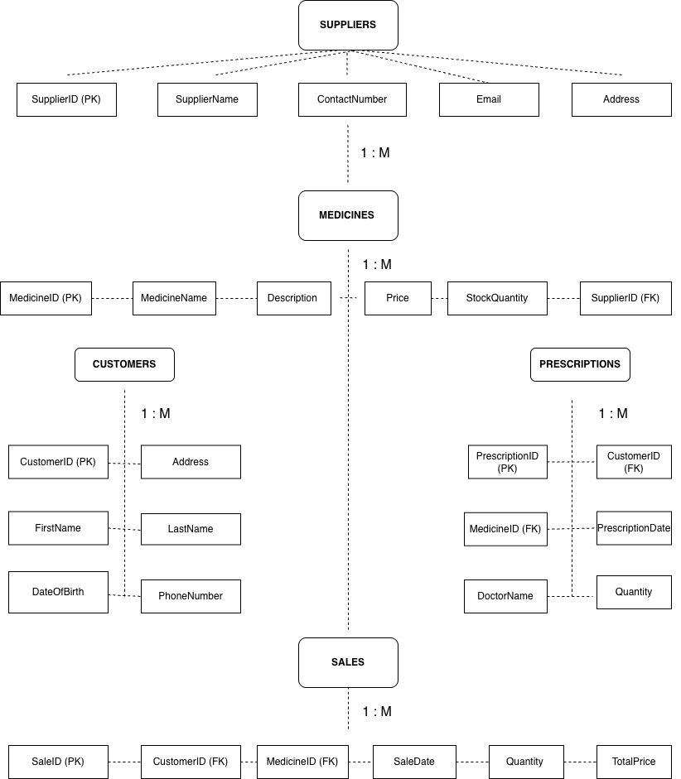
Figure 1: Entity Relationship Diagram for the MediLink Pharmacy Database.

Database Desing
The database design for the MediLink Pharmacy system is based on the entities identified in the Entity Relationship Diagram (ERD). The database is organised into several tables that store information about suppliers, medicines, customers, prescriptions and sales. Each table has a primary key uniquely identify each record, and foreign keys are used to create relationship between the tables.
The Suppliers table store information about the companies that provide medicines to the pharmacy. This table includes the supplier’s name, contact number, email and address. The. Primary key of this table is SupplierID.
The Medicines table stores information about the medicines available in the pharmacy. This includes the medicine the medicine name, description, price and stock quantity. Each medicine is linked to a supplier through the SupplierID foreign key.
The Customers tables store information about the pharmacy’s customers. It includes details such as the customer’s first name, last name, address, phone number and date of birth. The primary key for this table is CustomerID.
The Prescriptions table records prescriptions given to customers. It includes the prescription date, doctor name and the quantity of medicine prescribed. This table also includes foreign keys that connect it to the Customers table and the Medicine table.
The Sales table stores information about sales transactions in the pharmacy. It records which medicine was sold. The customer who purchased it, the date of the sale and quantity sold. The table also includes a total price for each transaction. The Sales table is connected to the Customers table and the Medicines table through foreign keys.
This database design ensures that the pharmacy data is well organised and that relationships between different tables are clearly defined [2].

Normalisation
Normalisation is a method used in database design to organise data and minimise redundancy. The objective of normalisation is to ensure that information is stored efficiently and that relationships between tables are clearly defined.
In this database design, the tables were structured according to the first three normal forms: First Normal Form (1NF), Second Normal Form (2NF) and Third Normal Form (3NF). These stages help ensure that the database structure is logical and that data integrity is maintained.
First Normal Form (1NF) requires that each table has a primary key and that all attributes contain atomic values. This means that each field stores only one value MediLink Pharmacy database, each table has a primary key such as SupplierID, MedicineID, CustomerID, PrescriptionID and SaleID. All attributes store single values, so the database satisfies the requirements of 1NF.
Second Normal Form (2NF) requires that all non-key attributes are fully dependent on the primary key. This means that each attribute in the table must relate directly to the primary key. In the MediLink Pharmacy database, the attributes in each table depend entirely on their respective primary key. For example, medicine details depend on MedicineID, and customer information depends on CustomerID. Therefore, the database structure meets the requirements of 2NF.
Third Normal Form (3NF) requires that there are no transitive dependencies between attributes. This means that non-key attributes should not depend on another non-key attributes. In this database design, related data is separated into different tables such Suppliers, Medicines, Customers, Prescriptions and Sales. This structure removes unnecessary data duplication and ensures that each table stores information about a single entity. As a result, the database design satisfies the requirements of 3NF [3].

Sample Data
Sample data was created to demonstrate how the MediLink Pharmacy database stores and manages information. The data represents realistic examples of suppliers, medicines, customers, prescriptions and sales transactions. This sample data helps illustrate how the tables are popular and how the relationship between the tables works within the database system.
Suppliers
SupplierID | SupplierName | ContactNumber | Email | Address
S001 | HealthCare Ltd | 0201234567 | info@healthcare.com | London
S002 | PharmacySupply | 0209876543 | contact@pharmasupply.com | Manchester
S003 | MedStock Ltd | 0204567891 | sales@medstock.com | Birmingham
Medicines
MedicineID | MedicineName | Description | Price | StockQuantity | SupplierID
M001 | Paracetamol | Pain relief tablets | 2.50 | 100 | S001
M002 | Ibuprofen | Anti-inflammatory medicine | 3.20 | 80 | S002
M003 |  | Antibiotic capsules | 5.50 | 60 | S003
  Amoxicillin
Customers
CustomerID | FirstName | LastName | Address | Phone | DateOfBirth
C001 | Jose | Smith | London | 07123456789 | 1996-05-10
C002 | Emma | Brown | Manchester | 07987654325 | 1990-09-21
C003 | David | Wilson | Birmingham | 07345672947 | 1978-03-14
Prescriptions
PrescriptionID | CustomerID | MedicineID | PrescriptionDate | DoctorName | Quantity
P001 | C001 | M001 | 2026-03-10 | Dr Adams | 2
P002 | C002 | M002 | 2026-03-11 | Dr Patel | 1
P003 | C003 | M003 | 2026-03-12 | Dr Green | 3
Sales
SalesID | CustomerID | MedicineID | SaleDate | Quantity | TotalPrice
S001 | C001 | M001 | 2026-03-10 | 2 | 5.00
S002 | C002 | M002 | 2026-03-11 | 1 | 3.20
S003 | C003 | M003 | 2026-03-12 | 3 | 16.50

Queries
The queries in the MediLink Pharmacy database were created to retrieve useful information from the system. Queries help users search, filter and analyse data stored in the tables. They also support decision-making by showing important information in clear and organised way [4].
One query can be used to display all medicines currently available in stock. This helps the Pharmacy monitor stock levels and identify medicines that may need to be reordered.
Another query can be used to show customers with prescriptions. This allows the Pharmacy to check which customers have been prescribed specific medicines and the quantity prescribed.
A sales query can be used to display sales transactions by customer. This helps staff review customer purchases and track sales activity.
A query can also be used to show medicines supplied by each supplier. This is useful for stock management and helps the pharmacy identify where each medicine comes from.
Finally, a total sales query can be created to calculate the overall value of sales transactions. This helps the pharmacy analyse business performance and monitor income.
8.1 Medicines in Stock Query
This query shows the medicines available in stock, including their names, prices and stock quantities. It is useful for stock control and helps the pharmacy monitor medicine availability.

8.2 Customers with Prescriptions Query
This query displays customers together with their prescriptions and prescribed medicines. It helps staff review prescription records quickly.

8.3 Sales by Customer Query
This query shows sales transactions made by customers. It helps the pharmacy track purchases and analyse customer activity.

8.4 Medicines by Supplier Query
This query lists medicines together with their suppliers. It is useful for inventory management and supplier tracking.

8.5 Total Sales Query
This query calculates the total value of sales transactions. It helps the pharmacy monitor business performance.

Validation and Testing
Validation and testing were carried out to ensure that the MediLink Pharmacy database works correctly and stores accurate information. Validation helps prevent incorrect data from being entered into the system, while testing ensures that the database functions as expected.
Different validation rules can be applied when entering data into the tables. For example, numerical fields such as price, stock quantity and total price should only accept numbers. Date fields such as prescription date and sale date must contain valid dates. These validation rules help reduce data entry errors.
Testing was also performed by entering sample data into the database tables. This allowed the system to demonstrate how the relationships between tables work. For example, customer records were linked to prescriptions and sales transactions using the CustomerID foreign key. Similarly, medicines were connected to suppliers and sales records using the MedicineID and SupplierID fields.
Queries were also tested to ensure that they returned the correct information. For example, queries were used to display medicines above a specific price, show customer prescriptions and analyse sales transactions. The results confirmed that the relationships between tables were functioning correctly, and that the database structure was working as intended.

Conclusion

This report explained the process of designing and implementing a relational database system for MediLink Pharmacy. The aim of the project was to create a structured database capable of storing and managing important pharmacy information such as medicines, suppliers, customers, prescriptions and sales transactions.
The project demonstrated how database concepts such as entity identification, ERD design and normalisation can be applied to organise data efficiently. By using Microsoft Access, the pharmacy can manage its information more effectively and support better operational decision-making.

References

[1] | A. Silberschatz, H. F. Korth and S. Sudarshan, Database System Concepts, New York : McGraw-Hill, 7th.
[2] | R. Elmasri and S. B. Navathe, Fundamentals of Database Systems, Boston: Pearson, 7th.
[3] | T. Connolly and C. Begg, Database Systems: A Practical Approach to Design, Implementation and Management, Harlow: Pearson, 2015.
[4] | Microsoft, “Introduction to Microsoft Access,” 2024. [Online]. Available: https://support.microsoft.com.

