
Programme: BSc Health and Social Care
Module code: BMHP5015
Module: Changemakers: Building your Personal Brand for Sustainable Employment
Lecturer: Olufemi Oluranti
Presented by: Saima Khan (2407142)
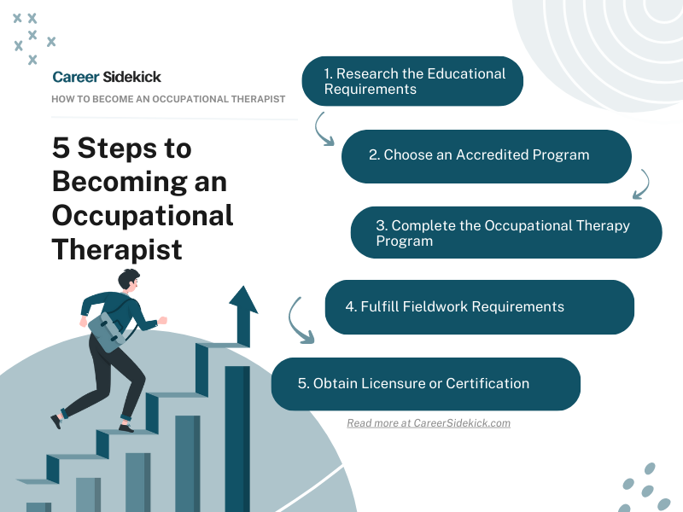
(Google Image Result, 2023) ￼
Table of Contents

Report Writing: Career Development Towards Becoming an Occupational Therapist in the UK 3
1. Introduction 3
2. Analysis of the Job Description and Person Specification 3
3. Analysis of the Employability Skills Required for an Occupational Therapist 4
4. Evaluation of My Skills, Qualifications and Experience 5
5. Building My Personal Brand, Professional Identity and Social Capital 6
6.My Unique Selling Point 6
7. Five-Year Action Plan 7
8. Communicating My Skills to Potential Employers 9
9. Conclusion 9
References: 11
Appendix A: Vacancy Evidence 12
Appendix B: Tailored CV 14

Report Writing: Career Development Towards Becoming an Occupational Therapist in the UK

1. Introduction
This report evaluates my readiness to pursue a career as an Occupational Therapist (OT) within the UK health and social care sector. Occupational Therapists support people of all ages to overcome physical, mental or social challenges, enabling them to participate in meaningful daily activities and improve their independence and wellbeing (Royal College of Occupational Therapists (RCOT), 2021). I selected this profession because I am passionate about helping people achieve a better quality of life through person-centred and evidence-based practice.
The report is based on a current Occupational Therapist vacancy (Appendix A) and analyses the employability skills, qualifications and professional attributes required for the role. It also evaluates my existing knowledge, skills and experience against the job requirements and identifies areas for further development. In addition, the report demonstrates how I intend to build my personal brand, strengthen my professional identity, develop professional networks and communicate my skills effectively to potential employers. Finally, a five-year action plan outlines the steps I will take to achieve my career goal of becoming a HCPC-registered Occupational Therapist.

2. Analysis of the Job Description and Person Specification
The Occupational Therapist vacancy selected for this report (Appendix A) outlines the responsibilities and professional standards expected within the role. The successful applicant is required to assess service users' physical, psychological and social needs, develop person-centred intervention plans, monitor progress and work collaboratively within multidisciplinary teams. The role also involves maintaining accurate clinical records, managing a caseload effectively and contributing to service improvement while complying with HCPC standards and organisational policies (Health and Care Professions Council (HCPC), 2023).
The person specification highlights essential qualities including effective communication, teamwork, organisation, clinical reasoning, problem-solving and the ability to prioritise workloads within a busy healthcare environment. Applicants must demonstrate professionalism, empathy, resilience and a commitment to equality, diversity and inclusion. They are also expected to engage in continuing professional development (CPD), reflective practice and evidence-based decision making to ensure high-quality care.
The vacancy requires an approved Occupational Therapy qualification and HCPC registration. Although I have not yet reached this stage, I have carefully selected this vacancy because it represents my long-term career aspiration. It provides a realistic benchmark against which I can assess my current abilities and identify the knowledge, skills and experience I still need to develop.
This vacancy reflects many of the topics studied during my BSc Health and Social Care programme, including person-centred practice, professionalism, communication, reflective practice and lifelong learning. Analysing a real job advertisement has helped me understand employer expectations and has enabled me to develop a clear plan for progressing towards a career as an Occupational Therapist.

3. Analysis of the Employability Skills Required for an Occupational Therapist
Occupational Therapists require a combination of technical knowledge, professional values and transferable employability skills to provide safe and effective care. One of the most important skills is effective communication, as Occupational Therapists work closely with service users, families and multidisciplinary teams. Clear verbal, written and interpersonal communication supports collaborative decision-making, accurate record keeping and positive therapeutic relationships (HCPC, 2023).
Another essential employability skill is teamwork. Occupational Therapists regularly work alongside physiotherapists, nurses, social workers and other healthcare professionals to coordinate person-centred care. Strong collaborative skills contribute to improved outcomes and ensure that interventions meet the individual's needs.
Problem-solving and clinical reasoning are equally important. Occupational Therapists must assess complex situations, identify barriers to independence and develop appropriate interventions based on evidence and professional judgement. This requires critical thinking, adaptability and the ability to respond effectively to changing circumstances.
The profession also demands excellent organisation and time management. Managing caseloads, prioritising referrals, maintaining clinical documentation and meeting deadlines require practitioners to work efficiently while maintaining high professional standards. Employers also expect Occupational Therapists to demonstrate resilience, emotional intelligence and professionalism when supporting individuals experiencing physical, mental or social challenges.
In addition, Occupational Therapists must embrace reflective practice and continuing professional development to maintain competence and improve the quality of care they provide (HCPC, 2023). Digital literacy has also become increasingly important, as practitioners use electronic patient records, online training and digital communication systems within healthcare settings (NHS England, 2023).
Overall, the vacancy demonstrates that successful Occupational Therapists require not only professional knowledge but also strong transferable skills, ethical practice and a commitment to lifelong learning. These employability skills form the foundation of effective occupational therapy practice and provide a clear framework for my own professional development.

4. Evaluation of My Skills, Qualifications and Experience
Evaluating my current skills against the Occupational Therapist vacancy has enabled me to identify both my strengths and the areas that require further development. Reflecting on my personal and professional experiences has helped me understand how my existing abilities can support my future career while recognising the additional knowledge and qualifications needed to meet the requirements of the profession.
One of my greatest strengths is my reliability and strong work ethic, developed through over thirteen years of employment as a Stock Controller at Tesco. Working in a busy retail environment has enhanced my organisation, time management and problem-solving skills while teaching me to remain calm under pressure and meet deadlines. My role has also strengthened my communication and teamwork skills by working effectively with colleagues, managers and customers from diverse backgrounds. These transferable skills are highly relevant to occupational therapy, where effective communication and collaborative working are essential (Health and Care Professions Council (HCPC), 2023).
Another significant strength is my informal caring experience supporting my mother-in-law. This has developed my empathy, patience and understanding of person-centred care. It has also increased my awareness of the physical, emotional and social challenges that individuals may face, reinforcing the importance of dignity, respect and compassionate care. These experiences have confirmed my motivation to pursue a career that enables people to achieve greater independence and improve their quality of life.
Academically, studying for a BSc Health and Social Care at the University of Wales Trinity Saint David has expanded my knowledge of safeguarding, health promotion, equality, diversity and inclusion, evidence-based practice and professional ethics. Throughout the course I have also developed research, academic writing and critical thinking skills that will support my future professional practice.
Despite these strengths, I recognise that I need to gain direct occupational therapy experience and complete an approved Occupational Therapy qualification leading to HCPC registration. I would also like to continue developing my confidence in presentations and further improve my leadership and clinical decision-making skills. Reflective practice has helped me identify these development needs and has strengthened my commitment to continuous professional development throughout my career.

5. Building My Personal Brand, Professional Identity and Social Capital
Developing a strong personal brand is an important aspect of becoming an Occupational Therapist. My personal brand reflects the values, behaviours and skills that I wish to demonstrate as a future healthcare professional, including compassion, professionalism, integrity and a commitment to person-centred care (HCPC, 2023).
My professional identity has been shaped through my university studies, long-term employment at Tesco and informal caring experience. Together, these experiences have strengthened my communication, resilience, adaptability and ability to work with people from different backgrounds. They have also reinforced the importance of equality, diversity and inclusion when providing health and social care services (NHS England, 2023).
Building social capital through professional relationships is equally important for career development. I intend to develop my network by maintaining positive relationships with university lecturers, placement educators and healthcare professionals. I also plan to attend careers events, participate in professional workshops and become involved with the Royal College of Occupational Therapists. These opportunities will enable me to learn from experienced practitioners, develop professionally and increase my employment opportunities, (Gorbatov et al., 2018).
In addition, I will continue to build a positive digital presence by maintaining an up-to-date LinkedIn profile, participating in online CPD activities and regularly reviewing current occupational therapy research. These actions will strengthen my professional identity and demonstrate my commitment to lifelong learning.

6.My Unique Selling Point
My unique selling point is the combination of extensive employment experience, academic knowledge and genuine compassion for supporting others. Over thirteen years at Tesco have enabled me to develop strong organisational, communication and problem-solving skills while working in a demanding environment. These transferable skills are directly relevant to occupational therapy, where practitioners must prioritise workloads, work collaboratively and adapt to changing situations.
In addition, my informal caring experience has strengthened my empathy, patience and understanding of person-centred care. Combined with the knowledge gained through my BSc Health and Social Care degree, these experiences have provided me with a solid foundation for developing into a competent Occupational Therapist.
I believe I can contribute positively to an organisation by demonstrating professionalism, reliability and a willingness to learn. I am committed to continuous professional development and reflective practice to ensure that I continue improving my knowledge and skills throughout my career. Although I recognise that I have further qualifications and experience to gain, I am highly motivated to achieve my ambition of becoming a compassionate and effective Occupational Therapist.

7. Five-Year Action Plan
Timeframe | Action | Resources Required | Expected Outcome
Year 1 | Complete Level 5 successfully; audit existing certificates; improve academic writing, presentation and digital research skills; create a professional CV and LinkedIn profile; attend occupational therapy webinars and open days | Lecturers, library and academic support; UWTSD careers service; RCOT and HCPC websites; LinkedIn Learning or equivalent. | A verified development portfolio, stronger grades and a credible professional profile.
Year 2 | Complete the current Health and Social Care degree (Level 6); gain relevant experience through volunteering, shadowing, a care or rehabilitation support role, or an Occupational Therapy Assistant post; research and apply to HCPC-approved MSc Occupational Therapy pre-registration programmes. | NHS Jobs, local charities and care providers; occupational therapy departments; university admissions and student finance; references from lecturers and managers. | Direct evidence of person-centred practice and a competitive MSc application.
Year 3 and 4 | Complete the pre-registration MSc and all placements; develop assessment, goal setting, intervention planning, documentation, manual handling, multidisciplinary working and reflective practice; maintain wellbeing and a CPD portfolio. | University teaching, placement educators, supervision, simulation facilities, RCOT student resources and peer support. | Eligibility to apply for HCPC registration and evidence of safe entry-level occupational therapy competence.
Year 4 and 5 | Register with the HCPC; secure a Band 5 Occupational Therapist or rotational post; complete preceptorship; seek rotations or development opportunities in neurology and rehabilitation. | HCPC registration; NHS Jobs; employer preceptorship; clinical supervision; RCOT early-career guidance. | Consolidated autonomous practice at Band 5 and a clearer neurological career direction.
Year 5 and beyond | Build significant neurological and complex-disability experience; complete relevant CPD; contribute to audit, service improvement and supervision; apply for Band 6 posts when the full person specification can be evidenced. | Specialist courses, clinical interest groups, mentorship, audit and quality-improvement projects. | A safe and evidence-based progression towards the selected specialist role rather than premature application.

8. Communicating My Skills to Potential Employers
Communicating my knowledge, skills and experience effectively will be essential when applying for Occupational Therapist positions. I will prepare a professional curriculum vitae (CV) tailored to each job application, ensuring that it reflects the skills and qualities identified within the person specification. My CV will highlight my academic achievements, transferable skills developed through over thirteen years of employment at Tesco and my informal caring experience, demonstrating my commitment to person-centred care and continuous professional development.
Alongside my CV, I will prepare a tailored cover letter explaining my motivation to become an Occupational Therapist and how my experiences align with the organisation's values. I also intend to maintain an up-to-date LinkedIn profile to present a professional online identity, expand my professional network and engage with current developments within occupational therapy. Contemporary technology plays an increasingly important role in recruitment, networking and lifelong learning, making digital professionalism an important aspect of employability (NHS England, 2023).
Finally, I will continue developing my interview skills through university careers support, mock interviews and reflective practice. A copy of my tailored CV is included in Appendix B, while the Occupational Therapist vacancy used throughout this report is provided in Appendix A.

9. Conclusion
This report has analysed the knowledge, skills and professional attributes required to become an Occupational Therapist by evaluating a current UK job vacancy and comparing its requirements with my own abilities, qualifications and experiences. The findings demonstrate that although I already possess valuable transferable skills developed through my university studies, long-term employment at Tesco and informal caring responsibilities, further professional education and practical experience are required before I can achieve HCPC registration.
Completing this evaluation has helped me identify my strengths while recognising the importance of continuous professional development, reflective practice and lifelong learning. It has also reinforced the value of building a strong personal brand, developing professional networks and using contemporary technology to enhance employability within the health and social care sector.
Overall, this report has strengthened my understanding of the Occupational Therapist role and provided a realistic action plan for achieving my long-term career aspiration. By remaining committed to professional development and person-centred practice, I am confident that I can progress towards becoming a compassionate, competent and effective occupational therapist. ￼

References:
Birmingham Community Healthcare NHS Foundation Trust (BCHC) (2026) Band 6 Specialist Neurological Occupational Therapist, vacancy reference 820-8119089-ASR. Available at: https://apps.trac.jobs/job-advert/8119089⁠, (Accessed: 12 July 2026).
Bourdieu, P. (1986) 'The forms of capital', in Richardson, J.G. (ed.) Handbook of Theory and Research for the Sociology of Education. New York: Greenwood Press, pp. 241–258.
Goleman, D. (1998) Working with Emotional Intelligence. London: Bloomsbury.
Gorbatov, S., Khapova, S.N. and Lysova, E.I. (2018) 'Personal branding: Interdisciplinary systematic review and research agenda', Frontiers in Psychology, 9, Article 2238. Available at: https://doi.org/10.3389/fpsyg.2018.02238⁠
Health and Care Professions Council (HCPC) (n.d.) Approved programmes. Available at: https://www.hcpc-uk.org/education/approved-programmes (Accessed: 18 June 2026).
Health and Care Professions Council (HCPC) (2023) Standards of proficiency: Occupational therapists. Available at: https://www.hcpc-uk.org/standards/standards-of-proficiency/occupational-therapists (Accessed: 10 June 2026).
Health and Care Professions Council (HCPC) (2024) Standards of conduct, performance and ethics. Available at: https://www.hcpc-uk.org/standards/standards-of-conduct-performance-and-ethics (Accessed: 9 June 2026).
NHS England (2019) A Digital Framework for Allied Health Professionals. Available at: https://www.england.nhs.uk/wp-content/uploads/2019/04/a-digital-framework-for-allied-health-professionals.pdf⁠ (Accessed: 20 June 2026).
Royal College of Occupational Therapists (RCOT) (2022) Career Development Framework: Guiding Principles for Occupational Therapy. 2nd edn. London: RCOT. Available at: https://www.rcot.co.uk/explore-resources/rcot-publications/career-development⁠ (Accessed: 12 July 2026).
Royal College of Occupational Therapists (RCOT) (n.d.) What is occupational therapy? Available at: https://www.rcot.co.uk/learn-about-occupational-therapy/what-occupational-therapy⁠ (Accessed: 21 June 2026).
Schön, D.A. (1983) The Reflective Practitioner: How Professionals Think in Action. New York: Basic Books.
Yorke, M. (2006) Employability in Higher Education: What It Is – What It Is Not. York: Higher Education Academy.

Appendix A: Vacancy Evidence
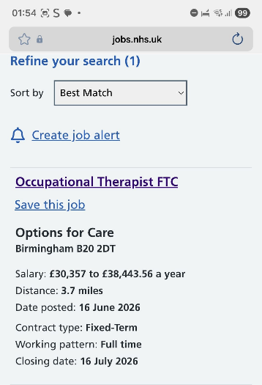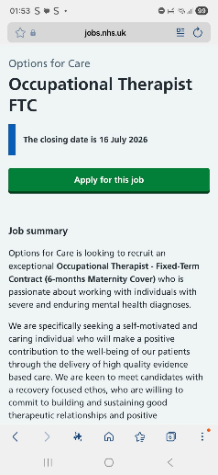
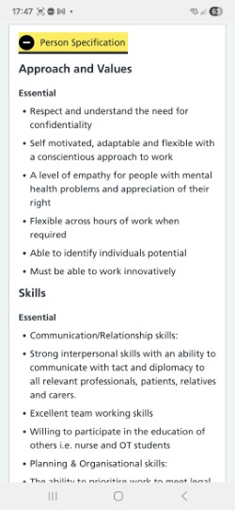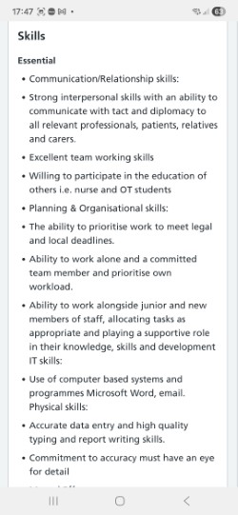
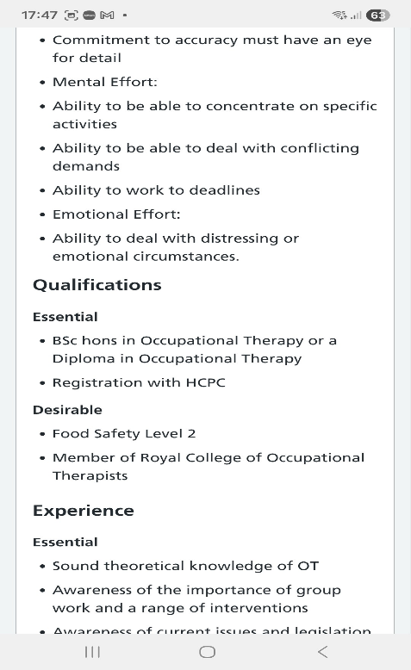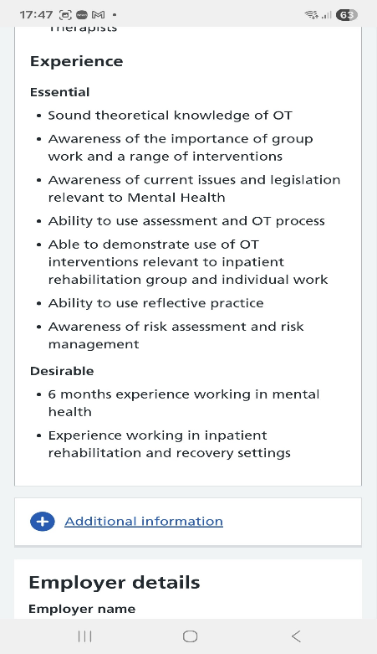

Appendix B: Tailored CV

