Module
PLCs and Control

Project title:
Control Theory

Lecturer:
Dr. Lintao Zhang

Module code:
GOEE5002

Student:
Jairo Fabricio David Sanchez
DAV22868331
07/05/2026

Task 1 (PID Control)
​a) Working principles of PID control within a PLC system
​Into a PLC environment a PID controller is used to maintain a process variable such as temperature or pressure at a specific setpoint. It works by continuously calculating an error signal. Which is the difference between the desired value and the actual measured value.
​There are three components working together as for example:
​Proportional (P): This provides an immediate response to the current error. this mean that Its main purpose is to drive the system towards the setpoint quickly. However on its own, it usually results in a small steady-state error (offset).
​Integral: This component looks at the history of the error by accumulating it over time, this is the primary advantage this mean that it forces the steady state error to zero, ensuring the system eventually hits the exact target.
​Derivative: This part is the in charge to make detecting of rate of change of the error predicting the future, it serves as a dampener or a brake preventing the system from overshooting the target and helping it settle down faster.
​b) Ziegler-Nichols Tuning Methods
​There are 2 principal techniques established by Ziegler and Nichols for finding the optimal controller settings for example:
​The Process Reaction Method (Open Loop): This involves applying a manual "step" change to the system input and recording the output response. It produces an "S-shaped" curve. Applying the measuring the delay (dead time) and the slope of this curve, we can calculate the PID values.
​Suitability: This is best for stable processes that can be tested starting from a resting state for example as large heating tanks.
​The Ultimate Gain Method (Closed Loop): This is the method where Ti and Td are set to zero while Kp is gradually increased until the system reaches a point of sustained oscillation. This specific gain is called the Ultimate Gain (Ku) and the oscillation time is the Ultimate Period (Pu).
​Suitability: This is ideal for systems already in operation because in the moment where we need to find the stability limits without taking the system offline.
​Limitations and Drawbacks:
The principal disadvantage of these methods is that they often result in an aggressive tuning, meaning the system might bounce or oscillate more than desired before stabilising. Additionally the Ultimate Gain method can be risky, as pushing a real industrial machine to the point of constant vibration could potentially cause mechanical damage or trigger safety shutdowns.

C)
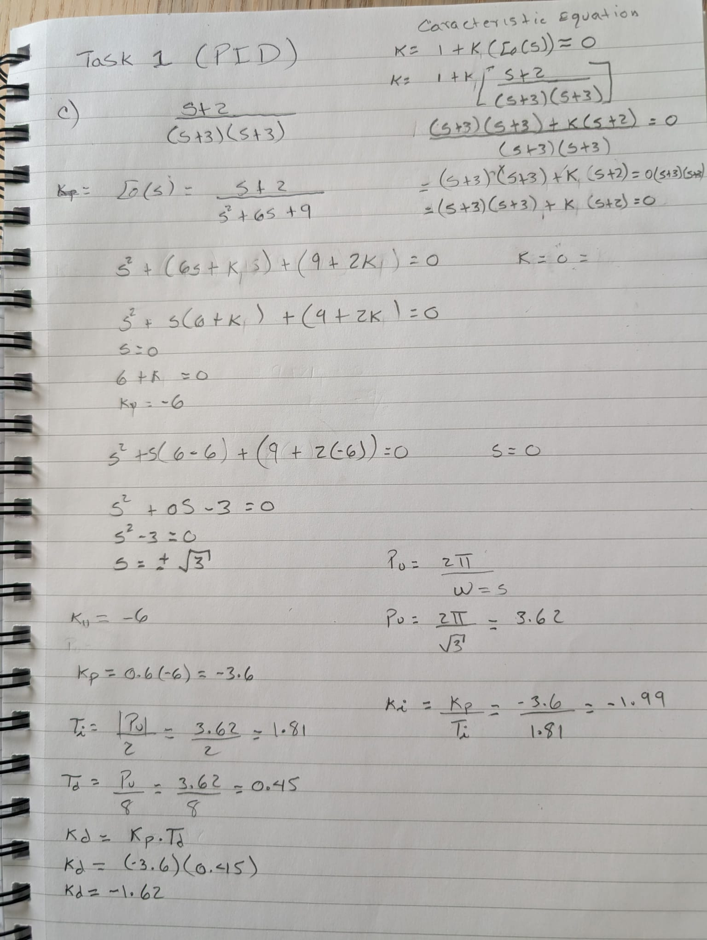

Task 2

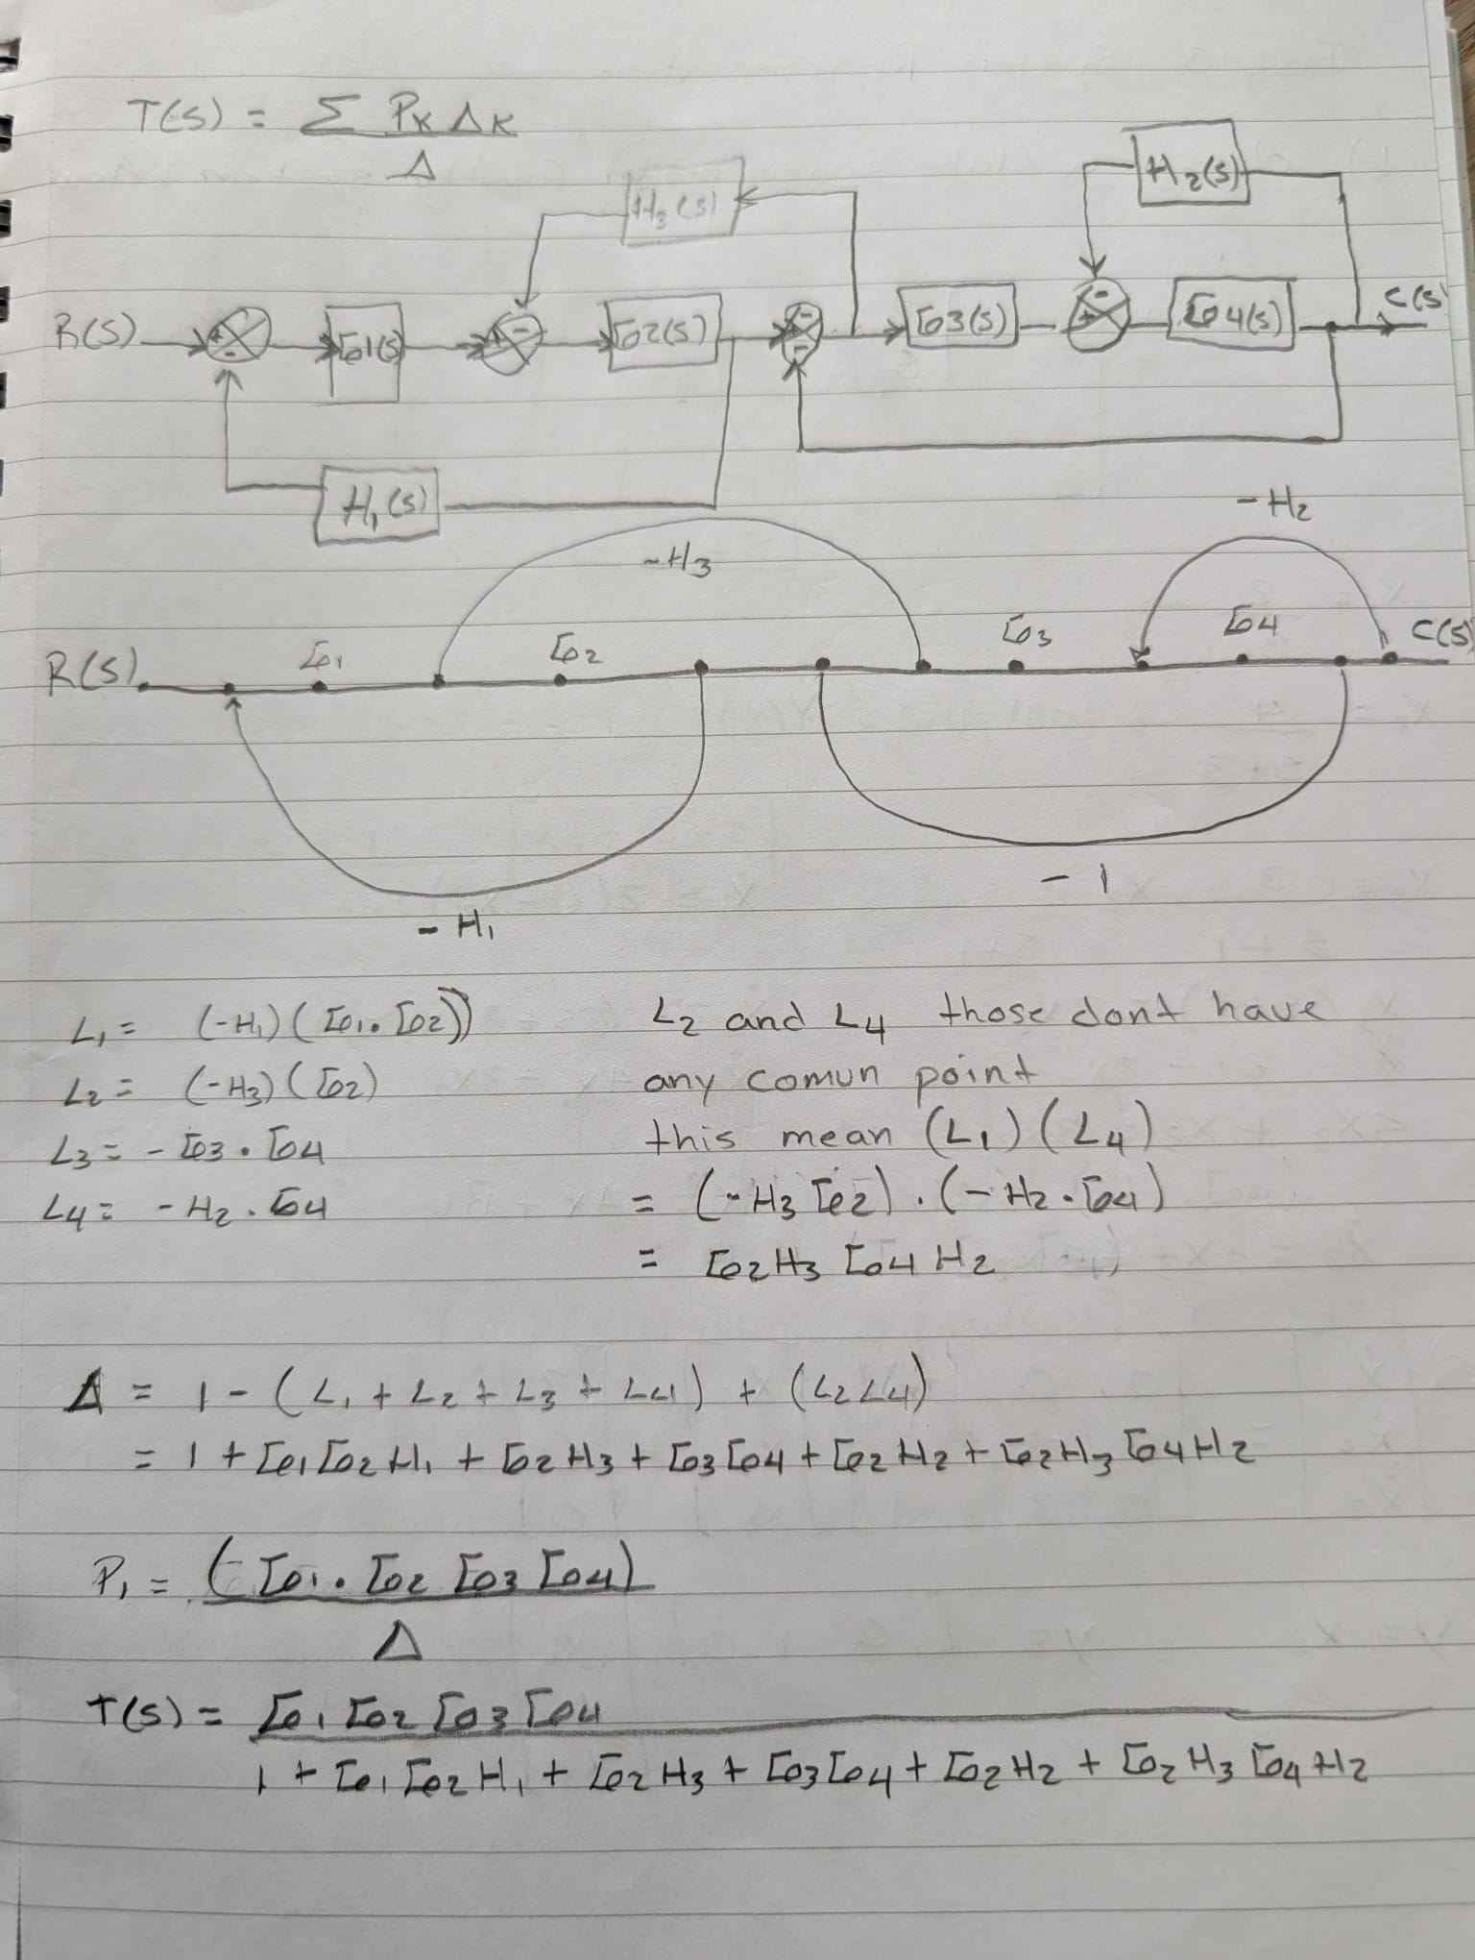

Task 3
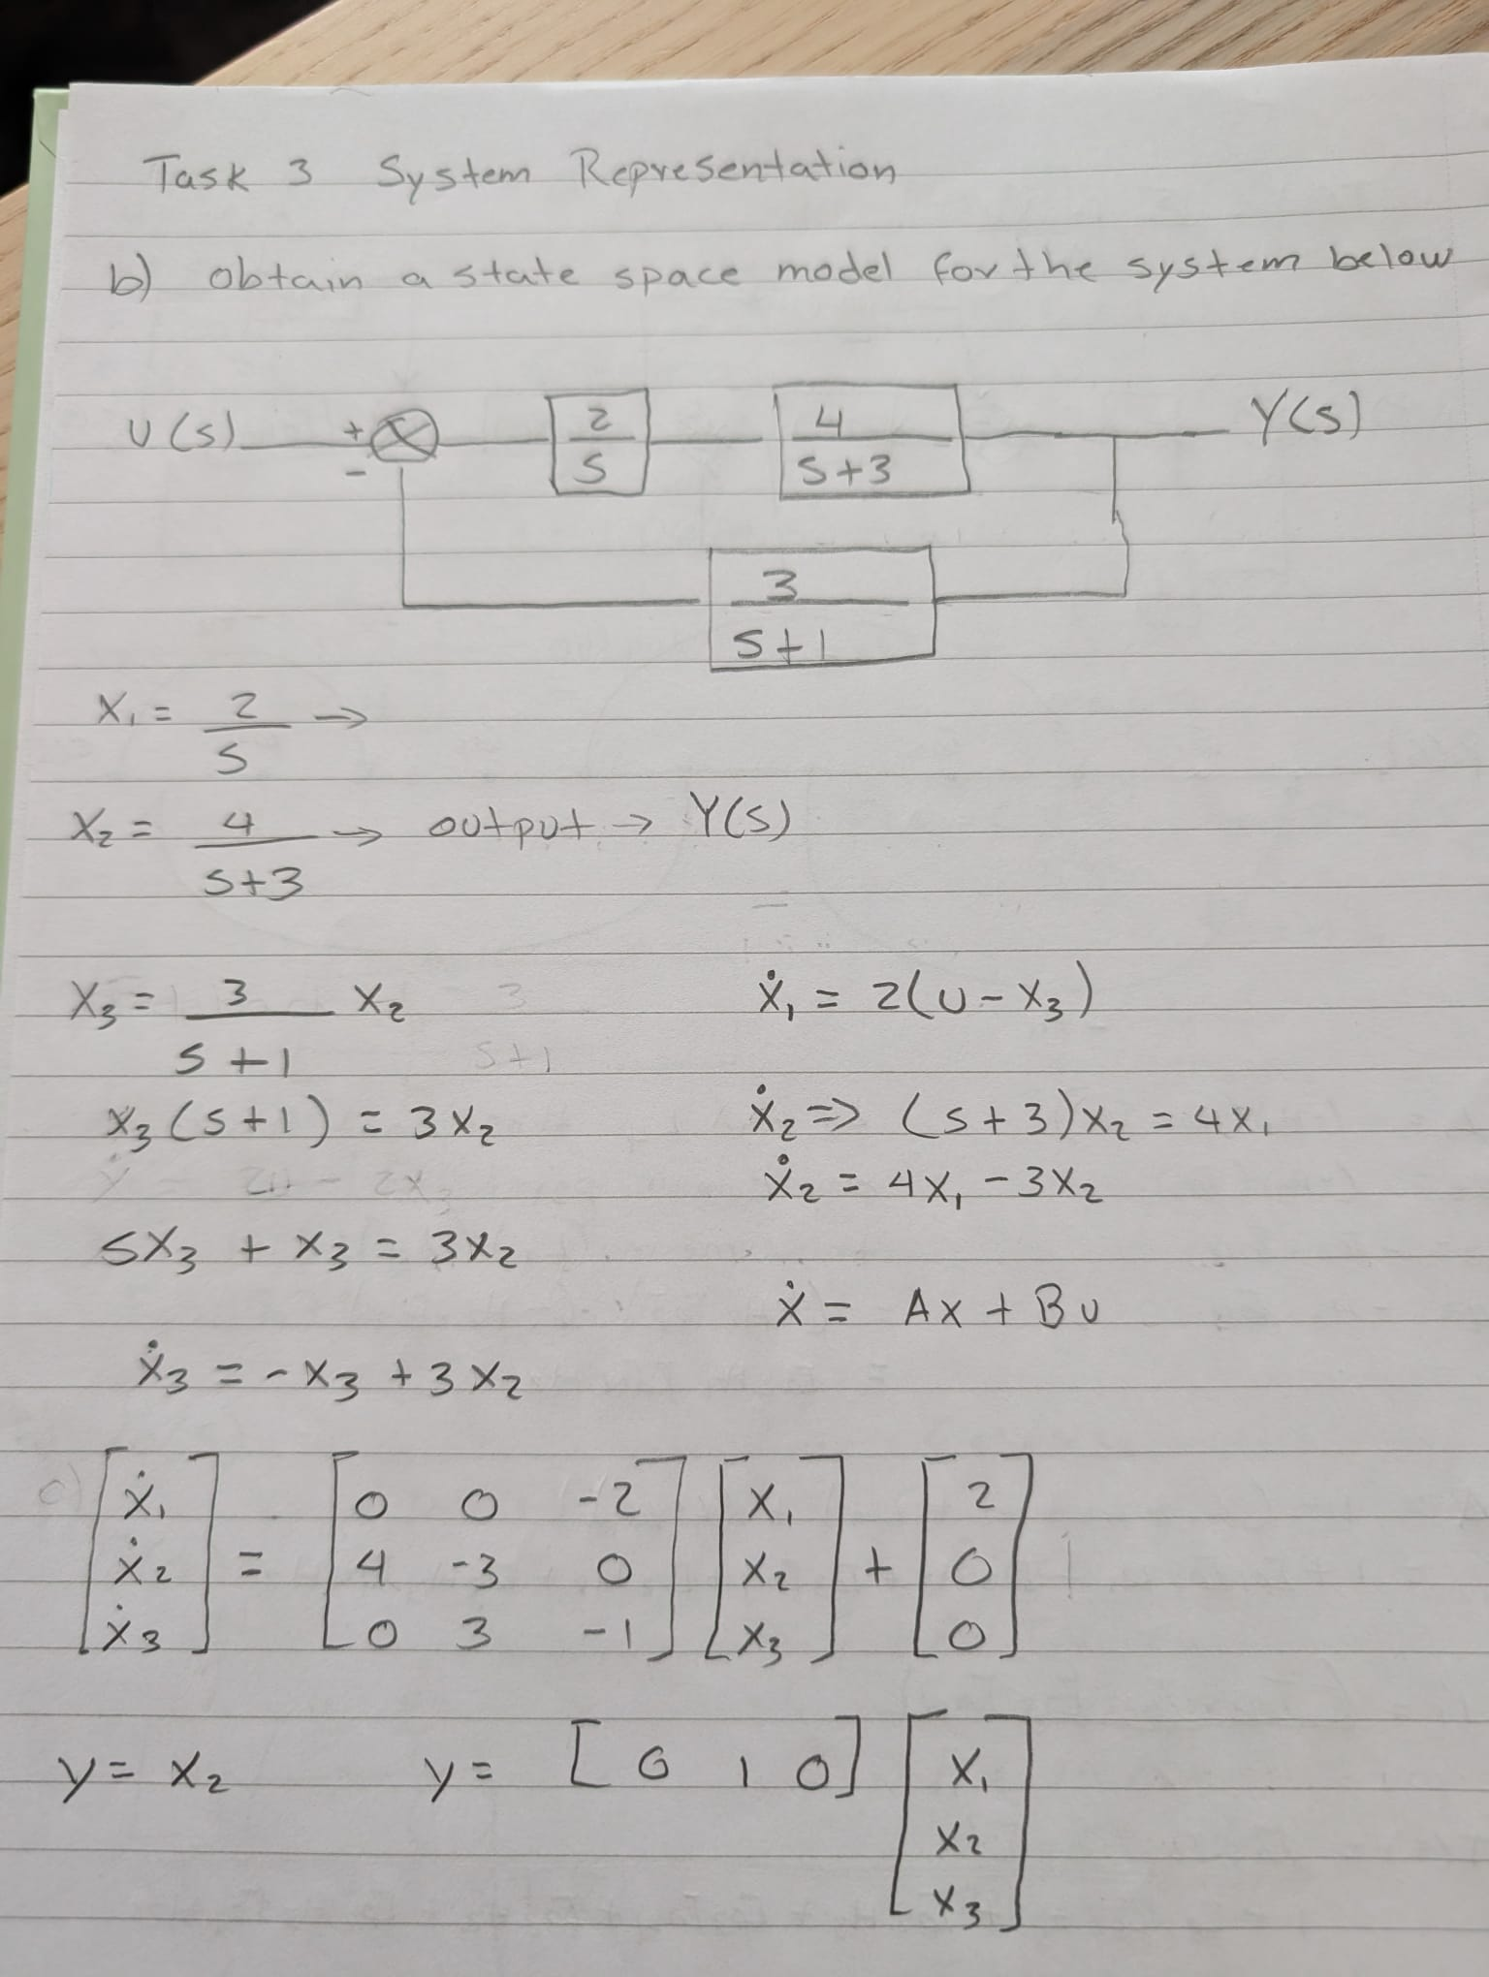

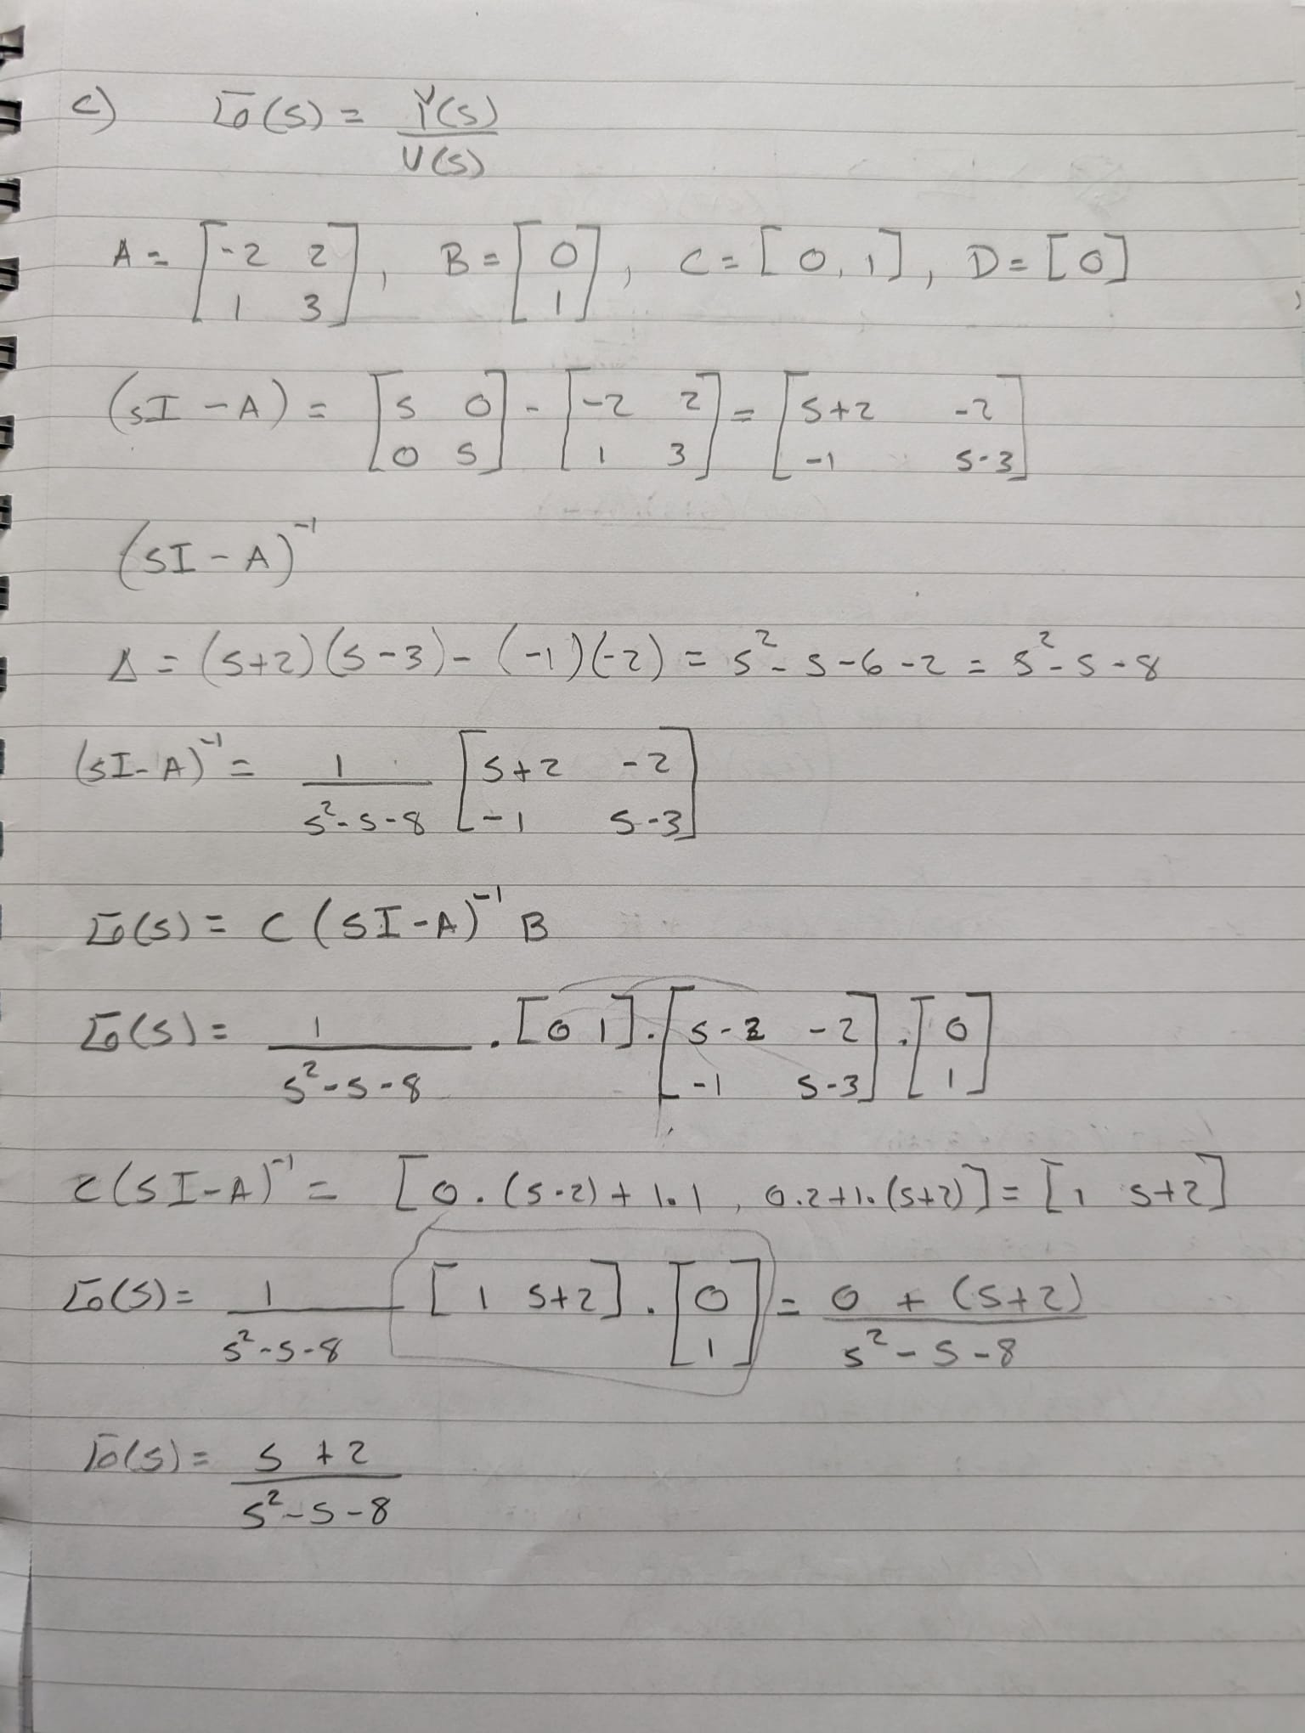

Task 4
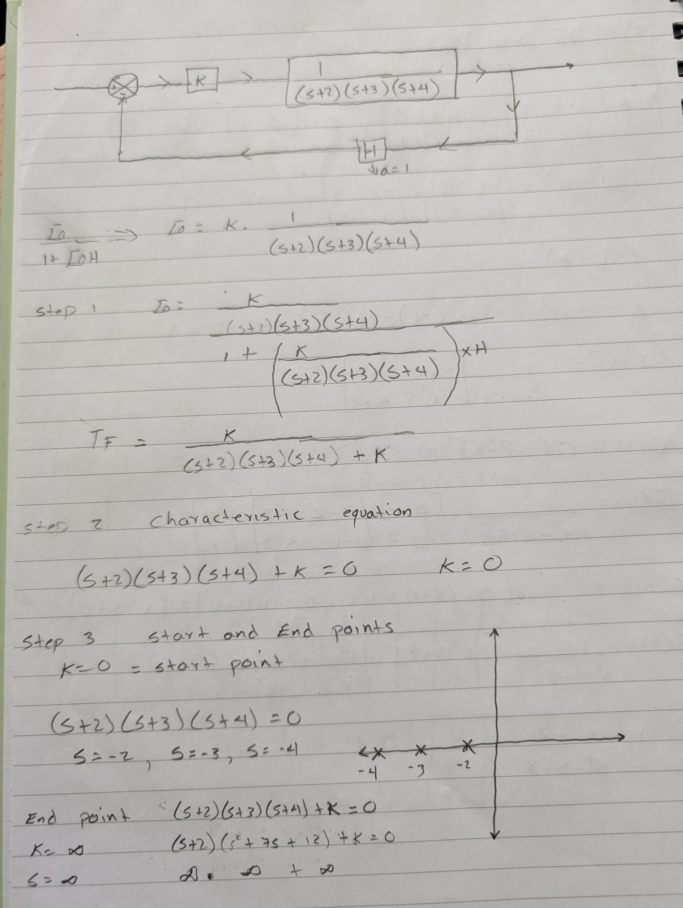
a)

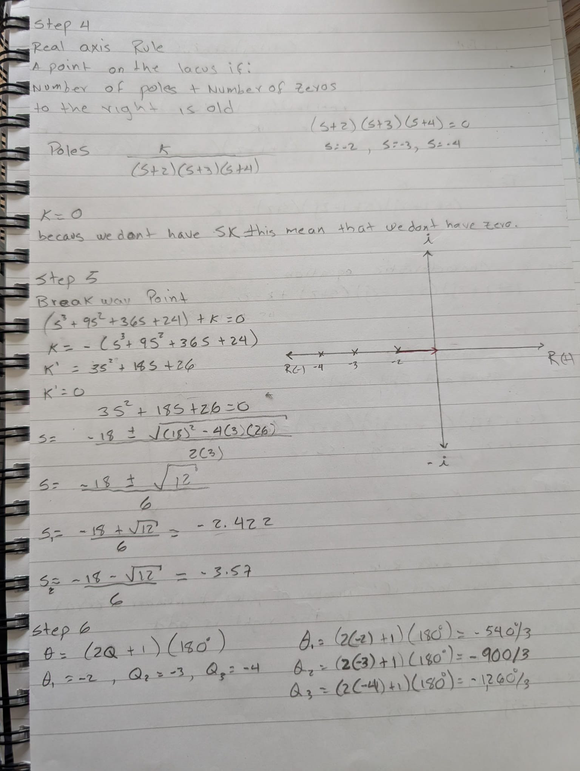

b)
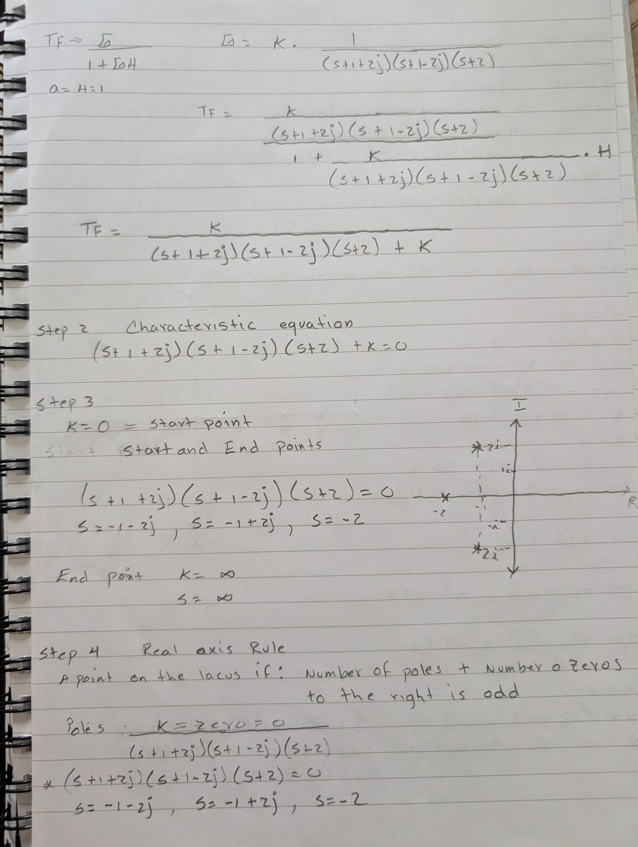

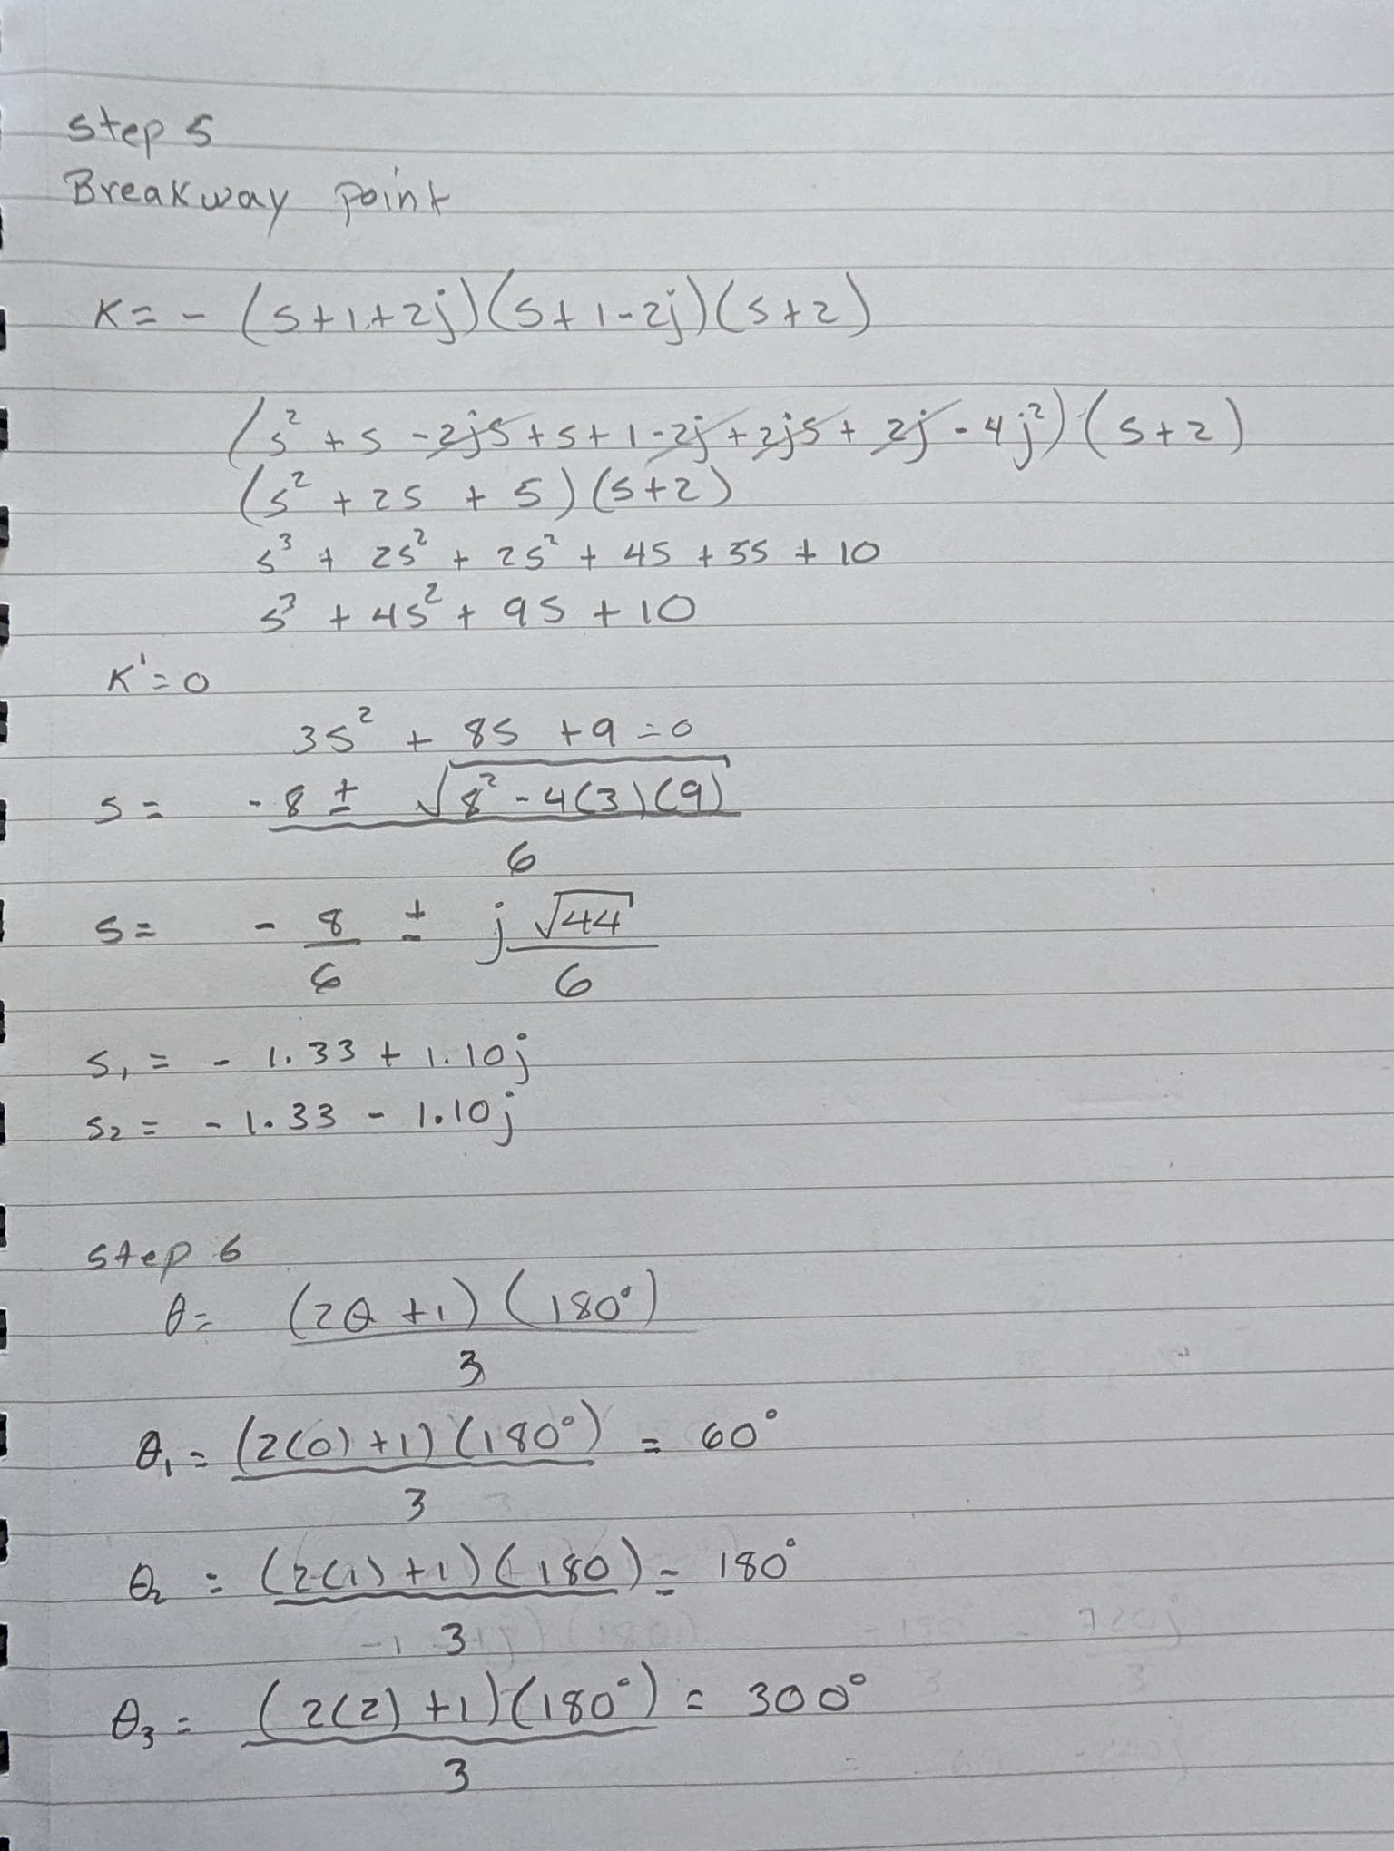

Task 5
Frequency Domain Analysis
Bode Diagram and Nichols Chart
Frequency domain analysis is an important method used in control engineering to evaluate and analysis the behaviour and stability of dynamic systems. There are two of the most widely used graphical techniques are the Bode diagram and the Nichols chart, these methods represent the frequency response of linear time-invariant (LTI) systems and help engineers analyse stability, robustness and system performance.
Bode Diagram
- The Bode diagram is a graphical representation of a system’s frequency response. It consists of two separate logarithmic plots:
- magnitude versus frequency
- phase angle versus frequency
The magnitude plot shows the gain of the system in decibels (dB), whilst the phase plot shows the phase shift in degrees as frequency changes. Frequency is normally represented on a logarithmic scale, making it easier to analyse a wide range of frequencies (Blanco, n.d.).
$$20{log⁡}_{10}∣G(jω)∣$$
The Bode diagram is particularly useful for analysing system stability. Engineers use it to determine the gain margin and phase margin of a control system, these parameters indicate how close the system is to instability and whether oscillations may occur under certain operating conditions (University of Michigan, n.d.).
Bode plots simplify the analysis of transfer functions by allowing complex multiplication operations to be represented as simple additions on logarithmic scales (Patil, n.d.). The technique is commonly used in the design of filters, amplifiers and feedback control systems.

Nichols Chart
The Nichols chart is another frequency domain analysis tool used in control engineering, unlike the Bode diagram, the Nichols chart combines magnitude and phase information into a single graph for example the horizontal axis represents phase shift, whilst the vertical axis represents gain in decibels.
The Nichols chart is especially useful for analysing closed-loop system performance and robustness. Engineers can evaluate stability margins and observe how changes in controller parameters affect system behaviour directly from the chart (MIT OpenCourseWare, n.d.).

one of the most important advantage of the Nichols chart is that it allows the use of constant closed loop magnitude contours, also known as M contours these contours help engineers assess resonant peaks, overshoot and overall frequency response performance more efficiently than separate plots (Engineering LibreTexts, 2023).

Applications of Bode Diagrams and Nichols Charts
Those are 2 of the most important techniques are widely used in control system analysis and design across several engineering fields.
Controller Tuning
Bode diagrams are frequently used to tune PID controllers and compensators for example adjusting gain and phase characteristics, engineers can improve transient response and system stability (Frequency Response, n.d.).
Stability Assessment
The two principals margin are Gain and Phase calculations obtained from Bode plots help determine whether a feedback system is stable or unstable. Nichols charts also provide a visual method for evaluating robustness and closed-loop stability (Massachusetts Institute of Technology, n.d.).
Aerospace Engineering
The frequency domain techniques are used into the aerospace systems to analyse aircraft stability and flight control systems. Accurate frequency response analysis ensures safe and reliable aircraft operation (MIT OpenCourseWare, n.d.).
Automotive Engineering
Bode diagrams are applied in cruise control systems, active suspension systems and engine control applications to improve vehicle performance and comfort (Electronics Tutorials, n.d.).
Process Control
In industrial process control, these methods are used to regulate pressure, temperature and flow systems. The techniques of Frequency response it is used to assist engineers in designing stable controllers capable of handling disturbances effectively (Woolf, n.d.).
On conclusion the Bode diagram and Nichols chart are essential tools in modern control engineering because they provide valuable insight into system stability, robustness and performance in the frequency domain.

References

- Blanco, J. (n.d.) How to Bode plot. Available at: How to Bode Plot

- Swarthmore College (n.d.) Printable collection of Bode Plot Web Pages. Available at
https://lpsa.swarthmore.edu/Bode/BodeAll.html?utm

- Frequency Response (n.d.)
https://ctms.engin.umich.edu/CTMS/index.php?example=Introduction&section=ControlFrequency&utm

- Massachusetts Institute of Technology (n.d.) Frequency Response. Available at: https://ocw.mit.edu/courses/6-003-signals-and-systems-fall-2011/resources/lecture-11-continuous-time-ct-frequency-response-and-bode-plot/?

- MIT OpenCourseWare (n.d.) Control Systems Lectures. Available at:
https://ocw.mit.edu/courses/6-302-feedback-systems-spring-2007/?utm
- Engineering LibreTexts (2023) Frequency Response Plots. Available at: https://eng.libretexts.org/Bookshelves/Industrial_and_Systems_Engineering/Introduction_to_Control_Systems_(Iqbal)/06%3A_Compensator_Design_with_Frequency_Response_Methods/6.01%3A_Frequency_Response_Plots

- University of Michigan (n.d.) Control Systems Tutorials. Available at: https://ctms.engin.umich.edu

- Woolf, A. (n.d.) Process Dynamics and Control. Available at: https://eng.libretexts.org/Bookshelves/Industrial_and_Systems_Engineering

- Patil, M.B. (n.d.) Bode plots. Indian Institute of Technology Bombay. Available at: https://www.ee.iitb.ac.in/~sequel/ee101/mbpbode.pdf?utm

- Electronics Tutorials (n.d.) Bode Plot Tutorial. Available at: https://www.electronics-tutorials.ws/filter/filter_8.html

