SUBMITTED BY : IAVOR STANIMIROV
STUDENT ID : 1921573
INTERNATIONAL FINANCIAL MANAGEMENT ASSESMENT 1

BP PLC COMPANY

TABLE OF CONTENTS
INTRODUCTION……………………………………………………………………………………………………………………..3
INPORTANCE OF INTERNATIONAL FINANSIAL MAMAGEMENT ……………………………………………...3
INTERNATIONAL MARKET CHALLENGES FACED BY BP PLC COMPANY…………………………………….4
INTERNATIONAL FINANCIAL MAMAGEMENT THEORIES…………………………………………………………4
DIVIDEND DISTRIBUTION POLICY OF BP PLC COMPANY………………………………………………………….4
CONCLUSION …………………………………………………………………………………………………………………………6
REFERENCES…………………………………………………………………………………………………………………………..7

Introduction
The multinational corporation that will be selected in international financial management is BP Plc. It is an oil and gas company that has been headquartered in London. The company has been one of the leading companies operating in the UK for a long time. This will include the importance of international financial management and the company's dividend policy and will also be discussed in detail. The efficient market hypothesis theory in context with BP Plc Company will also be considered. Different challenges being faced by BP Plc Company will also be derived.
Importance of International Financial Management-
International Financial Management is a process and method of managing and controlling the financial operations of different international business organizations to ensure that the business activities are effective and will provide effective results to both the organizations and companies (Pons et al. 2021). It is similar to financial management, and the only difference lies in effectively managing the business's operations internationally. It can be determined that international finance management has more business objectives that guide the business firm in the right direction.
Objectives and Application of International Financial Management in BP Plc Company-
Profit Maximization- The first aim of international financial management is to maximize profit by making effective investment decisions in the structure. The promotion of investments is done through such financial management for better utilization of funds. In the case of BP Plc, funds shall be obtained effectively as it will help manage the overall operations effectively (Pons et al. 2021).
Proper Tax Planning- Every country and nation has different tax liabilities and obligations that must be fulfilled. Hence, international financial management helps manage the tax operations and ensures effective tax planning for BP Plc Company to avoid any complexities from the future period to a greater extent. This tax planning will lead to more savings for the company.
Optimum Rate of Interest- Funds that the business organization borrow need to be at an effective and optimum interest rate. Therefore, it can be generated that such financial management enables the business managers of BP Plc to manage their oil and gas debt obligations at a minimum rate of interest for better results. Through such a minimum rate, it will be easy to overcome all the financial problems of the company (Annual Report 2021).
International Market Challenges Faced by BP Plc Company-
- Excessive Barriers to Regulations- The first challenge BP Plc Company might experience in the international financial market is regulations. Every country and nation has its regulations concerning business and its services. Hence, it can be said that it is one of the challenges being highly faced due to the complex requirements (Islam et al. 2021). Therefore, it can be said that BP Plc's operation in more than 140 countries has been reduced accordingly due to complex regulations.
- Exchange rate- Another challenge is fluctuations in the exchange rate. It has been observed that if another country's currency reduces, then the cost of exports will also reduce. Accordingly, there would be an entire effect on the overall payment system of the economy.
- Tax Policies- Different tax policies make it complex and difficult for the business firm of BP Plc to work effectively. It can be observed that the tax policies of the UK are different in comparison to Germany. Therefore, the operations of BP Plc in Germany will have to report tax liability and obligations per the obligations being listed in Germany. Hence, it can be said that it is one of the problems for the business of BP Plc (Islam et al. 2021).
International Financial Management Theories-
There are different theories associated with international financial management theories. Some of them are as follows-
Modern Portfolio Theory- According to this theory, the investors are guided effectively concerning the portfolio concerning the diversification and how the asset's value shall be priced considering its risk accordingly. The risk of the model is returned through the help of the standard deviation model (Thune 2021).
Arbitrage Pricing Theory- According to this theory, the asset's return can be easily predicted and estimated considering the linear relationship of the asset returns and other macroeconomic variables accordingly.
Efficient Market Hypothesis Theory- According to this theory, it can be determined that any changes or fluctuations in the overall price will be considered from the changes in prices. The reasons for the changes are factored into the price of securities.
Dividend Distribution Policy of BP Plc Company-
A dividend is defined as the amount of the business being distributed to the shareholders of the business firm against the capital being invested by these people in the business structure accordingly. The dividend policy of BP Plc Company is constant. One of the dividend policies states that continuous dividends have been paid to the shareholders accordingly every year (Annual Report 2021). Further, under this policy, it can be observed that the company and the business will effectively distribute a specific percentage of the revenue and earnings to the shareholders. The value of dividends can vary with the earnings and revenue of the business firm.
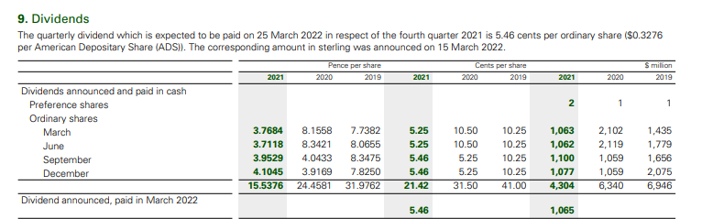
(Source: Annual report)
Based on the above picture, it can be observed that regular dividends have been paid annually from the company's earnings. Therefore, it can be determined that the business of BP Plc has been paying the effective amount of constant dividends to its shareholders to ensure that their interest is being maintained. Accordingly, more shareholders will be attracted to the growth of the business firm (Annual Report 2021). The dividend payment shows the company's ability to maintain its shareholders accordingly and improve its overall obligations in the structure.
Efficient Market Hypotheses Theory in BP Plc-
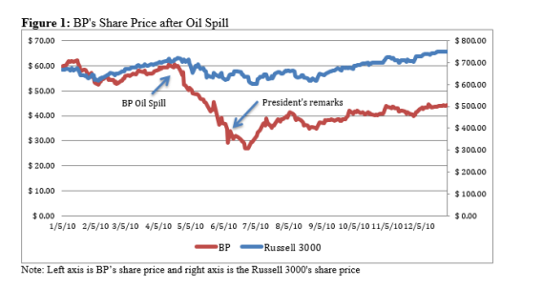
(Source: Koda, 2016).
The above graph depicts the changes in the prices of BP Oil and Gas Company due to the explosion in the oil rig that the company has maintained. Due to this issue, it has been observed that the overflow of oil leak has been there for almost 87 days. This eventually led to a decrease in the share prices of BP Plc Company. Based on this incident, it can be generated that other competitors and industries were also impacted by the same (Thune 2021).
Therefore, considering the efficient market hypothesis theory, it can be said that the oil and gas companies as these companies and business firms are highly connected with oil excavation and production, respectively. Regarding the efficient market theory, it can also be determined that the market took almost 6 weeks to interpret and analyze the data accordingly (Thune 2021). Therefore, it can be concluded that as the information has been interpreted after 6 weeks, it can be determined that the overall decrease in the share prices has been because of such an overflow of oil and gas. Accordingly, the overflow issue has not depicted the same issue as the information received later.
BP Plc Company's Methods of Appraising Projects-
The methods are as follows-
Net Present Value is the difference between the inflow of cash and the outflow of cash of the business accordingly. This is a capital budgeting technique that assists BP Plc Company in generating the level of return of the company based on the investment amount being done to ensure that the returns are positive and high. This is one of the methods through which BP Plc Company appraises the project to avoid any problems (Koda 2016).
The payback period is when the company can determine the amount of return that will be generated. In simpler words, it can be said payback period is the investment budgeting method that determines the exact period in which the company's return will be received accordingly for a better understanding of the results (Koda 2016). This budgeting method is useful for BP Plc Company to understand the level of return and the period the investment will take on an average basis. These two budgeting methods help in appraising the projects.
Conclusion-
From the above essay, it can be derived that the international financial market is significant for the growth of the business firms operating worldwide. In addition, different challenges have also been discussed in the scenario to understand where BP Plc is lacking behind the same. These challenges will get overcome in a future period. Further, different theories of financial management have also been explained, and the theory of efficient market hypothesis theory has also been discussed concerning BP Plc Company effectively. The dividend distribution policy of the company is constant.

References
Annual Report (2021). BP Plc Company (online). Available at: https://www.bp.com/content/dam/bp/business-sites/en/global/corporate/pdfs/investors/bp-annual-report-and-form-20f-2021.pdf Accessed on: 5th July 2022.
Islam, S., Mamun, A., Islam, K.A., Uddin, M.R. and Sultana, T. (2021). Issues and challenges of financial management practices in Islamic financial institutions: empirical evidence from Bangladesh. Indian Journal of Finance and Banking, 5(1), pp.38-55.
Koda, Yuga (2016). "Do Peers Get Punished: Stock Market Effect of BP Oil Spill on Peers," Journal of Environmental and Resource Economics at Colby: Vol. 3 : Iss. 1 , Article 9.
Pons, A., Cristobal-Fransi, E., Vintrò, C., Rius, J., Querol, O. and Vilaplana, J. (2021). An Application of the IFM Method for the Risk Assessment of Financial Instruments. Computational Economics, pp.1-21.
Thune, K. (2021). Efficient Market Hypothesis (EMH) (online) The Balance. Available at: https://www.thebalance.com/efficient-markets-hypothesis-emh-2466619 Accessed on: 5th July 2022.

