Your work has been GRADEMARKed. This means it has been electronically marked.
In order to access your results you need to log into Moodle. You should then go to your results page. Click on the submission you would like to view.
It will then appear in the following format:
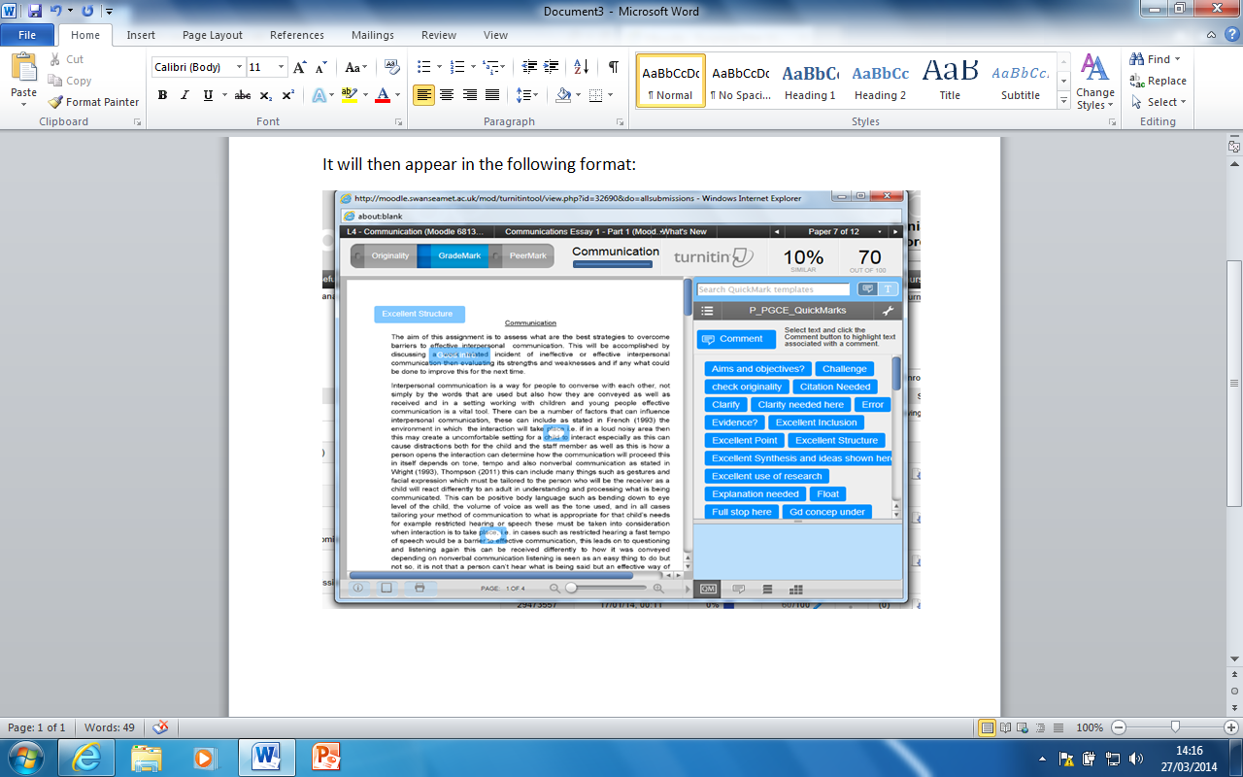

Look again at the top left hand corner. You will see:
Make sure you click ‘GRADEMARK’
You should then be able to access not only your grade, but your comments.
If you cannot see your comments
You should then download and print the document while it is in GRADEMARK mode. It will let you see the comments at the end.
To print and download, click on the following on the bottom left:
Download then print
To check your originality score (or to see how much out of 100% your assignment is NOT your own work)
Click the button NEXT to ‘GRADEMARK’:

