
University of Wales Trinity Saint David
School of Engineering

Design for Manufacture and Assembly : Component Optimisation
Manufacturing design and technology
ACMA5002
Chris Morgan
2512679
11/6/26 – words 5025

Abstract
This report examines the design and optimisation of a mobile phone cover that can be manufactured at high volumes using injection moulding. Design for Manufacture (DFM) and Design for Assembly (DFA) is used to improve cost efficiency, product performance and manufacturability of the chosen product. Autodesk Fusion was used to create the design and explore the injection moulding optimisation using the tools within the programme. Granta was then used to explore material choice for the product, looking at both material cost and performance. Risk failures were then explored using Failure Mode and Effects Analysis (FMEA), and also customer requirements analysed using Quality Function Deployment (QFD). Cost analysis was carried out looking at all aspects using to manufacture the product including tooling, material and design. These tools were utilised to create a final design that demonstrated improved manufacturability, reduced defect risk, improved production efficiency and reduced environmental impact. This report shows the importance of using these tools and simulations in modern manufacturing to improve efficiency and sustainability.

Contents
Abstract
1 Introduction
1.1 Aims
1.2 Objectives
2 Literature Review
2.1 Design for manufacture (DFM)
2.2 Design for Assembly
2.3 Injection moulding process
2.4 Injection moulding defects
2.5 Material Selection for Injection moulding
3. Design Customer Requirements
3.1 Identification of customer requirements
3.2 Quality function Deployment (QFD)
3.3 Failure Mode Effect Analysis (FMEA)
4 Design and Development
4.1 CAD Modelling
4.2 Material Selection
5 Simulation and Validation
5.1 Injection Moulding
5.2 Finite Element Analysis (FEA)
6 Cost calculation analysis
7 Sustainability considerations
7.1 Material recyclability
7.2 Energy efficiency
7.3 Waste reduction
8 Discussion and Recommendations
8.1 Customer requirements
8.2 Design trade-offs
8.3 Further work
9 Conclusion
10 References

1.Introduction
Smartphones have become considerably more popular over the past few decades and this increase in demand has resulted in companies looking for the leanest and most cost efficient manufacturing processes. The mobile phone housings are typically manufactured by using injection moulding, while meeting engineering requirements such as impact and heat resistance, structural integrity, surface finish and all the while aiming to keep production costs as low as possible. Injection moulding of polymers is used due to its repeatability, accuracy and suitability for mass production.
In this report I will used Design for Manufacture (DFM) and Design for Assembly (DFA) principles to optimise the design for the mobile phone casing. The Computer-Aided Design (CAD) programme Autodesk fusion will also be utilised to model the design to the specified dimensions and mould simulations used to optimise the design. The design will focus on high volume production, cost efficiency and defect minimisation while also using the Granta software to assess different material choices.

  - Aims
The aims of this project is to design a mobile phone casing and optimise it using DFM, DFA and FMEA principles, while also using mould tooling and material choice software.

  - Objectives
The objectives of this project are:
- Design a manufacturable mobile phone casing using Autodesk fusion (CAD) software.
- Develop an injection mould suitable for high volume production
- Use Granta software to optimise material selection
- Apply DFM and DFA principles to improve efficiency
- Use FMEA to evaluate and identify and mitigate potential product failures
- Evaluate manufacturing costs and explore product sustainability

2. Literature review
2.1 Design for manufacture
Design for Manufacture (DFM) is the optimisation of product design and manufacture to improve performance and quality while also focusing on being most cost effective (Page, 2026). For injection moulding products DFM is used to reduce sharp corners, optimize wall thickness , minimise undercuts and defects while maintaining the performance of the product (Fuges, 2026). Uniform wall thickness is important in this process as it will ensure consistent cooling across the product, while also minimising shrinkage and warpage defects. Non uniform wall thickness can lead to shrinkage, which can result in warpage defects and sink marks (Erickson, 2025).
Draft angles are another key aspect that have to be considered, as without adequate draft parts may stick to the mould. This could lead potentially to damage of the product and cause defects, while also potentially increasing cycle time. Optimum draft angles make it easier to eject the product from the mould cavity and also help reduce mould wear (Chen, 2026).
The strategic approach of DFM also takes into account gate placement, runner design and cooling channel optimisation in order to make sure the flow and temperature distribution is uniform within the mould (Shinzoft.com, 2025). Any issues with these features could lead to incomplete mould filling or defects which could affect the structural integrity of the product.

2.2 Design for Assembly (DFA)
Design for Assembly (DFA) is a principle that aims to reduce the number of parts required in the product assembly, along with reducing the assembly time and overall cost of the product (Battaïa et al., 2018). The main aims of this principle is to make manufacturing and assembling any product easier and faster by optimising the design and removing or changing any unnecessary complexity. It takes into account fasteners, parts inventory, overall cost, standardising components, easy alignment and joining in order to optimise to the design and manufacture (Battaïa et al., 2018b).
For mobile phone housing snap fit joints would be preferred as an alternative to screws and fasteners, as these are the cheapest and fastest connectors available, helping to reduce assembly time and labour requirements (Amaya, 2026). This feature would allow parts to quickly snap or clip together using flexibility of the material along with a locking mechanism.

2.3 Injection Moulding
Injection moulding is most commonly used in manufacturing for producing high volumes of plastic components, with a high degree of precision and repeatability. As this technology has evolved over the years, products produced by injection moulding are widely used in all industry (Czepiel, Bańkosz and Sobczak-Kupiec, 2023). The process involves melting polymer pellets and then injecting the molten material into a mould cavity under high pressure, where it is then cooled down before solidifying into the required design shape.
The four main stages of injection moulding are filling, packing, cooling and ejection (Jon, 2024). The use of injection moulding for mobile phone housings is very common and has several advantages including high production rates, excellent surface finish, low waste and tight dimensional tolerances (Rosato and Rosato, 2012). In order for this process to be successful other aspects need to be taken into account such as gate location, mould design, cooling channel layout and processing parameters.

2.4 Injection moulding defects
There are numerous defects that can occur in injection moulding components which can have a negative impact on the performance, aesthetics and dimensional accuracy. Common defects that can cause some of these issues include warpage, sink marks, air traps and weld lines (Protolabs, 2024).
- Warpage is caused commonly when the wall thickness is not uniform, and occurs when cooling happens at different rates in different parts of the mould. Regulating cooling conditions and maintaining uniform wall thickness is required to reduce the chance of warpage taking place.
- Sink marks are surface depressions that are primarily caused by shrinkage in thicker sections of the component, that are caused by uneven cooling. Maintaining optimal cooling temperatures and appropriate wall thickness is essential to minimise sink mark formation.
- Air traps are caused when air becomes trapped within the mould, causing incomplete filling of the mould. Inadequate venting as well as poor gate positioning can be the cause of this defect so these conditions need to be optimised using programmes such as CAD Autodesk fusion.
- Weld lines occur when two flow fronts meet in the mould cavity, creating weak bonding areas that can lead to reduced mechanical strength. Again for this defect computer programmes should be used to mitigate the likelihood of these defects (Osswald and Hernández-Ortiz, 2006).

2.5 Material selection for injection moulding
The material choice for use in mobile phone housing is crucial in order to meet performance, cost, manufacturing efficiency and also sustainability. Incorrect material choice potentially can lead to defects and also may not be suitable for the intended use, for example some components will require chemical, water or temperature resistance (Conniff and Audrius Zidonis, 2025). For the mobile phone housing the material choice needs to have sufficient impact strength and also importantly good surface aesthetics. Acrylonitrile Butadiene Styrene (ABS) is one thermoplastic that exhibits these features as well as being easy to process therefore is commonly used in mobile phone housing. Polycarbonate exhibits superior toughness and dimensional stability and can be combined with ABS to utilise the benefits of both materials while keeping material cost down to form PC-ABS (Harper, 2006).
Granta software was used for this decision making process, using filters and selecting desired properties in order to narrow the search down including injection moulding, density, tensile strength and Young’s modulus.
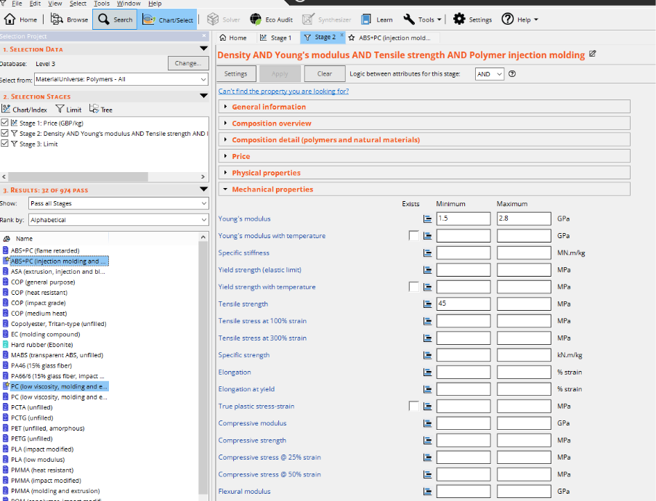
Fig 1 (Morgan , 2026)
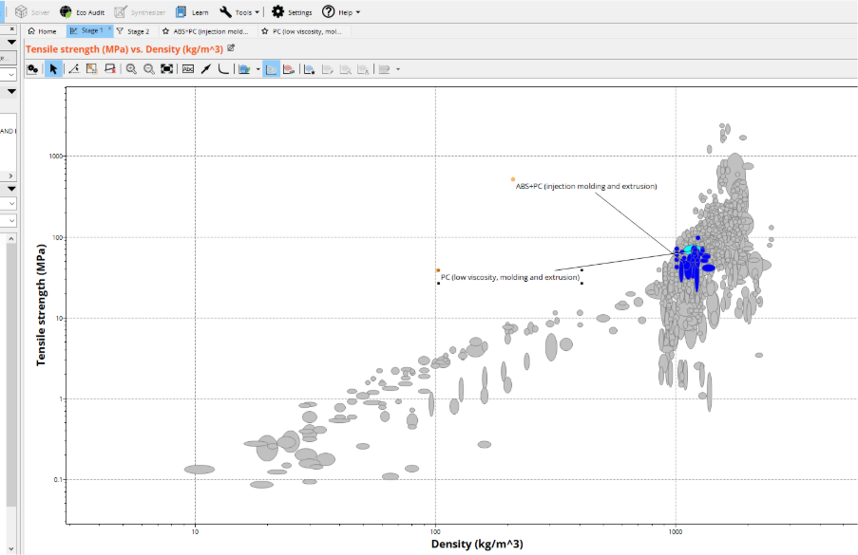
Fig 2 (Morgan , 2026)
This chart (Figure 2) plots material selection showing tensile strength against density for a wide selection of materials, my two materials shortlisted for further comparison. This shows that materials with higher density tend to have greater tensile strength.

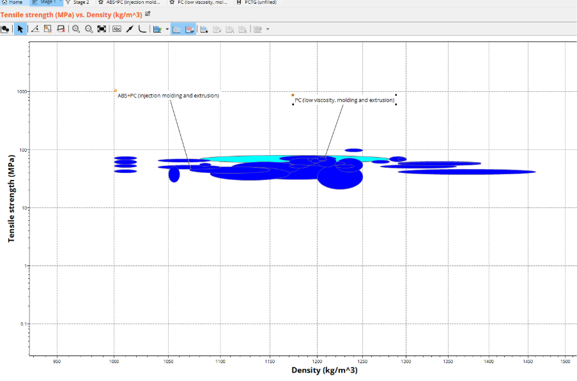
Figure 3 (Morgan, 2026)
A reduced selection is shown in Figure 3 to illustrate the comparison clearer. It shows polycarbonate has higher strength that ABS-PC but higher density, which increases the component weight. ABS on it’s own is lighter but has lower mechanical performance, therefore PC-ABS lies between the two and gives an optimal combination of strength and weight. This material satisfies the criteria required for the mobile phone housing, exhibiting both durability and lightweight performance.
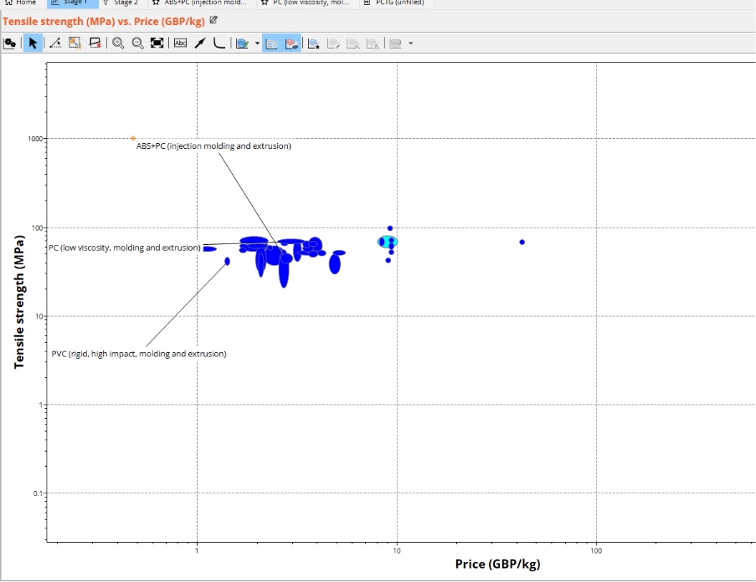
Figure 4 (Morgan , 2026)
Figure 4 shows the relationship between tensile strength and material cost. Polycarbonate shows higher strength but higher costs than ABS-PC, however lower cost materials tend to have lower performance. ABS-PC is positioned in the range that has good balance between strength and cost. For high volume production injection moulding both mechanical performance and cost efficiency are high priorities, making this material very suitable for the component.
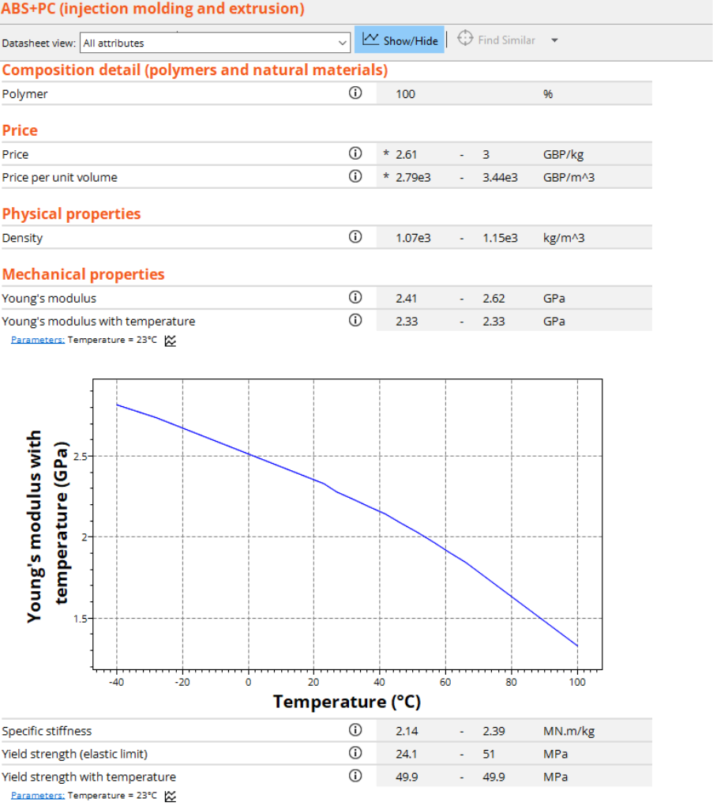
Figure 5 (Morgan , 2026)
Using Granta Figure 5 shows some of the key properties of PC-ABS. This demonstrates that it has a suitable density range and consistent mechanical performance, with Young’s modulus around 2.4-2.6 GPa. These properties enhance the suitability of the material for injection moulding to make mobile phone housing, exhibiting a good balance of strength, stiffness and processability.

3. Customer requirements
3.1 Identification of customer requirements
Customer requirements were identified though research and analysis of modern smartphones in particular the latest iPhone models, taking into account manufacturing constraints, sustainability and performance requirements. The mobile phone casing that is to be produced must meet the manufacturing requirements in order to satisfy customer needs and production efficiency (Ullah and Ali, 2017).
Key customer requirements for this component
- High durability and impact resistance
- Low production costs
- High quality surface finish for aesthetic appearance
- Ease of assembly. Needs met using snap-fit features
- Good dimensional accuracy
- Environmental sustainability
A Quality Function Deployment (QFD) is used to translate these requirements into measurable engineering specifications. This ensures that designers prioritise engineering characteristics in order to meet the customer needs for the product.

3.2 Quality Function Deployment (QFD)
Quality Function Deployment (QFD) is a structured design method that is used to convert customer requirements into technical specifications and parameters that can be measured and optimised during the design. This helps designers and marketers meet the needs of the consumer, prioritising engineering characteristics to achieve these aims (University of Cambridge, 2016).
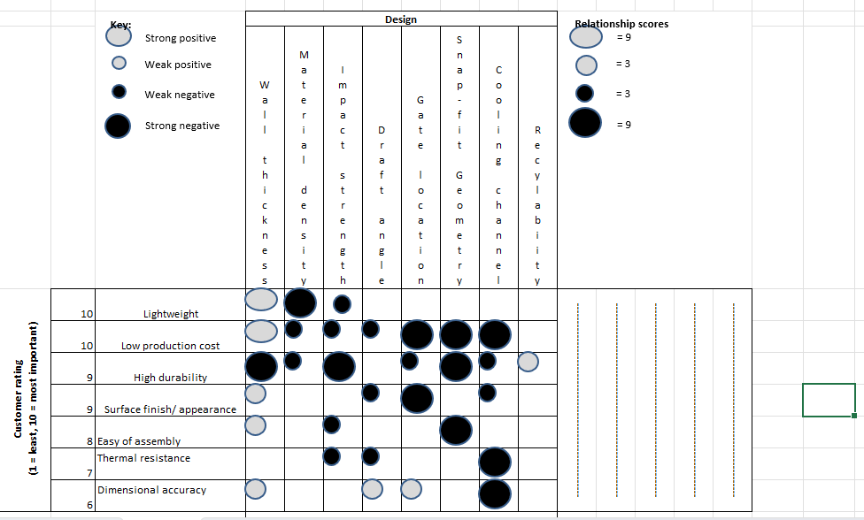
Rank | Design Requirement | Score
1 | Cooling Channel Design | 261
2 | Wall Thickness | 246
3 | Snap-Fit Geometry | 243
4 | Gate Location | 216
5 | Impact Strength | 186
6 | Material Density | 147
7 | Draft Angle | 96
8 | Recyclability | 27
Figure 6 (Morgan , 2026)

In this QFD I have identified wall thickness, material density, impact strength, draft angle, gate location, snap-fit geometry, cooling channel and recyclability as the technical characteristics that are most influential to this design. This QFD analysis is then used to prioritise the most important aspects in order to make further decisions about the CAD design. The QFD analysis identified cooling channel design, wall thickness and snap-fit geometry as the most important features to focus on for the design. During the design stage using fusion CAD and these factors were prioritised in order to make the optimal mobile phone housing. Good snap-fit geometry will make assembly easier and quicker and make the product more robust, while cooling channel design is important to minimise potential defects occurring. For wall thickness there has to be a trade-off to provide a balance between strength and manufacturing costs, with anything too thick and heavy affecting the production time and cost.

3.3 Failure Mode and Effects Analysis (FMEA)
The failure mode and effects analysis (FMEA) is a technique that’s used to identify potential risks associated with design and manufacturing, reducing costs linked to potential defects while also increasing safety (Sartor and Guido Orzes, 2019). This analysis focuses on failures based on severity, occurrence and detection ratings to then calculate the risk priority number (RPN), which is used to prioritise which issue is more critical. The FMEA aims to score the risk before and after controls are put in place, aiming to reduce the risk as much as possible and lower the RPN score (Santos, 2026). The higher scores require more focus and more actions to be taken, therefore warpage represents the highest risk failure in the mobile phone casing FMEA. The table shows that uneven cooling and non-uniform wall thickness are the main cause of this, therefore optimising the cooling channel and maintaining uniform wall thickness would reduce the RPN down to 108. The other main issues that are prevalent from the scoring are air traps and weld lines, which can both be caused by flow issue and potential venting issue would also cause air traps. Again mitigation has been included in the table to bring the scoring down, involving changing the gating and vent designs by using a new design. Snap fits risk of fracture is able to be reduced by including fillets in the design which will help improve manufacturing and the assembly process. This FMEA process is shown in the table below and shows how this structured approach identifies the key issues that need to be prioritised for design and manufacturing improvements.

FAILURE MODE AND EFFECTS ANALYSIS
Item: |  |  |  | Responsibility: |  |  |  |  |  | FMEA number:
Model: | Mobile phone housing |  |  | Prepared by: |  | Chris Morgan |  |  |  | Page : | 1
Core Team: | Design engineer(DE)/ Manufaturing engineer(ME)/ Quality control (QC) |  |  |  |  |  |  |  |  | FMEA Date (Orig): | 03/06/2026 | Rev: |  | 1
Process Function | Potential Failure Mode | Potential Effect(s) of Failure | Sev | Potential Cause(s)/ Mechanism(s) of Failure | Occur | Current  Process  Controls | Detec | RPN | Recommended Action(s) | Responsibility and Target Completion Date | Action Results
 |  |  |  |  |  |  |  |  |  |  | Actions Taken | Sev | Occ | Det | RPN
Injection Moulding | Warpage | Poor fit/ Unable to assemble | 9 | Non uniform wall thickness and no linear cooling | 7 | Basic mould cooling analysis | 5 | 315 | Uniform wall thickness and optimise cooling | DE | Improve cooling system and CAD design | 9 | 4 | 3 | 108
Injection Moulding | Sink Marks | Surface defects | 5 | Issues with wall thickness | 6 | mould flow analysis | 4 | 120 | Optimise packing pressure and reduce wall thickness | DE | Optimise design | 5 | 3 | 3 | 45
Injection Moulding | Weld Lines | Visible marks and weak structure | 7 | Issues with flow and gate placement | 6 | Basic gate design | 5 | 210 | Optimise gate position | ME | Change gate location | 7 | 3 | 4 | 84
Injection Moulding | Air Traps | Voids in component | 6 | Poor venting | 5 | Mould flow simulation | 6 | 180 | Add more vents | DE | Change vent design | 6 | 3 | 3 | 54
Assembly | Snap-Fit fracture | Unable to assemble | 8 | Stress concentration | 4 | Tooling checks, CAD design | 4 | 128 | Add more fillets to design | DE | Change geometry of design | 8 | 3 | 3 | 72
Surface quality | Surface defects | Poor aethetics | 5 | Issues with mould | 3 | Tooling checks | 2 | 30 | Improve mould cleaning and tooling checks | ME/DE | Mould cleaned and further checks complete | 5 | 2 | 2 | 20

Figure 7 (Morgan, 2026)

4.1 CAD modelling
I used Autodesk fusion CAD modelling focusing on design for manufacture (DFM) to create a design that was suitable for high volume injection moulding. Using the snap fits with the design also so ensure the design for assembly (DFA) criteria was being met.
This is the casing designed using Autodesk fusion 360, and includes several design features including camera opening, speaker slots, charging slot and also snap-fit clips for further assembly. This casing will hold the internal components inside and the design suits mass production and has ease of assembly with the snap-fits rather than screws. The casing has uniform wall thickness, as wall thickness was identified as critical in the QFD and FMEA.
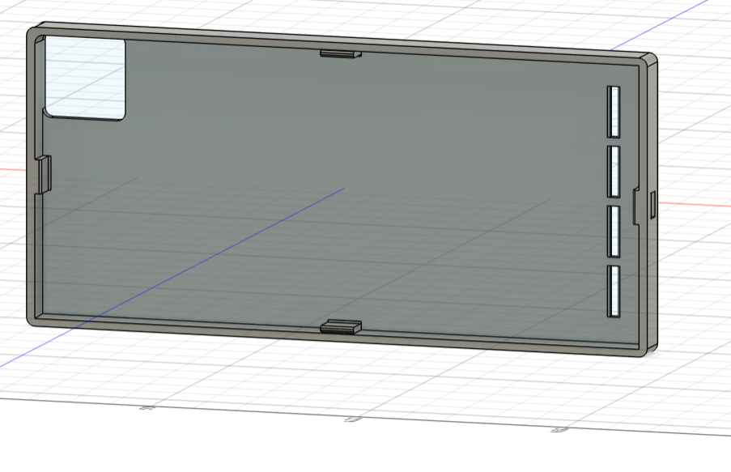
Figure 8 (Morgan , 2026)

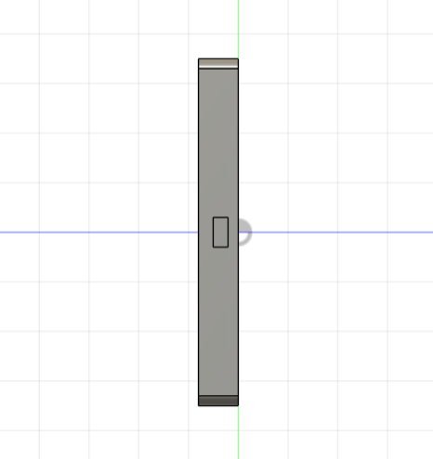
Figure 9 (Morgan , 2026)
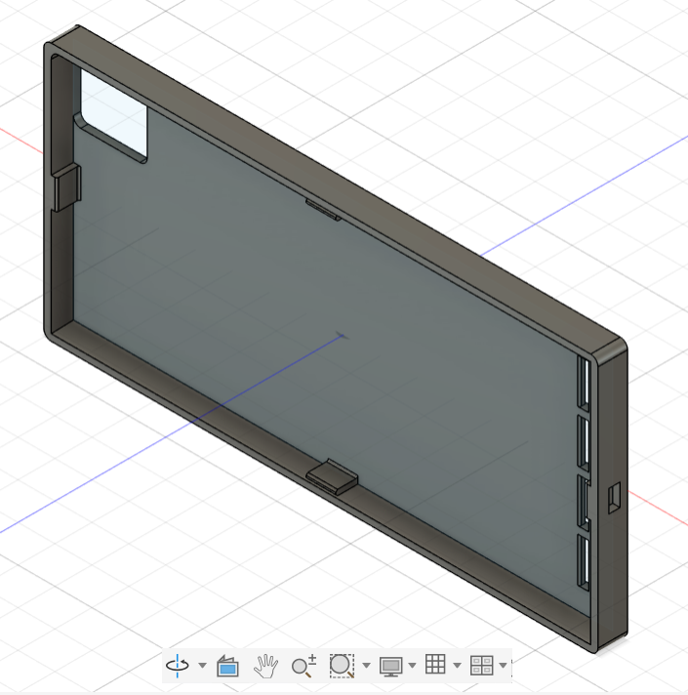
Figure 10 (Morgan, 2026)

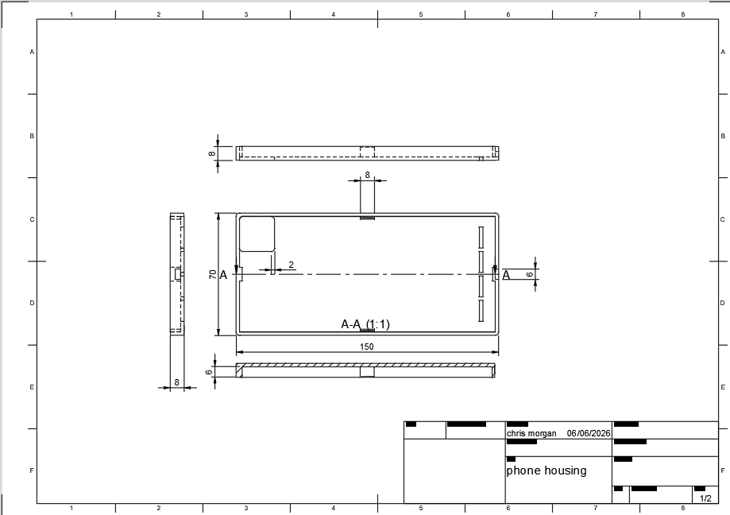
Figure 11 (Morgan, 2026)

This CAD drawing (figure 11) shows the dimensions of the mobile phone casing, as well as the charger hole and snap-fits. You can also see from the drawing the fillet on edges of the casing and around the camera hole, this will help reduce stress concentration and help polymer flow during the injection process.
The camera cut out is a design feature that is integral to mobile phone casing designs and the fillet on this part also helps the mould flow during injection. The charging port is also another key requirement for modern day mobile phone casings. The speaker holes will help amplify the sounds from the mobile phone while also acting as ventilation slots, allowing heat to dissipate from the phone. They have been equally spaced to help with material flow during the injection process, and will also help prevent the risk of weld lines and further defects.
This final design balances the engineering requirements identified in the QFD, with an optimal wall thickness selected as wall thickness improves durability, but increases cost and cooling time if it was too thick.

4.2 Material selection
In order to choose a material for the mobile phone housing Anys Granta EduPack (CES) was used, which has a database of different materials that assesses the material choice based on mechanical performance, cost and environmental impact. Using the QFD materials were identified for the housing taking into consideration impact resistance, density, cost and manufacturability. Acrylonitrile Butadiene Styrene (ABS) and Polycarbonate (PC) were both identified as suitable material while also looking at PC-ABS blend which combines the best out of both properties and keeps the cost down.
ABS satisfies the criteria of having good impact resistance, low cost and is easy to process. It’s negatives are that it has lower heat resistance than other polymers, PC on the other hand has more suitable thermal stability. Polycarbonate also offers greater impact strength but the drawbacks from this material is it is more expensive and more difficult to process. Therefore by using a PC-ABS blend, the best properties from easy polymer can be combined to give a more suitable material to use for the mobile phone case housing (Xiamen Keyuan Plastic Co.,Ltd, 2022). This demonstrates the importance of evaluating and comparing material properties to achieve the required design solution.

5.Simulation and Validation
5.1 Injection moulding
The injection moulding simulation tool was used on fusion to evaluate the manufacturability and performance of the mobile phone housing component that was design on the same software. In order to make injection moulding process suitable I have optimised the design to suit. The mould walls are of uniform thickness and has simple geometry with fillets on the edges, this will promote uniform material flow and make the mould easier to fill. Shown in fig confirms 100% fill using an injection point in the centre of the mould. This also shows that no short-shot defects were found which makes this design suitable for high volume injection moulding.
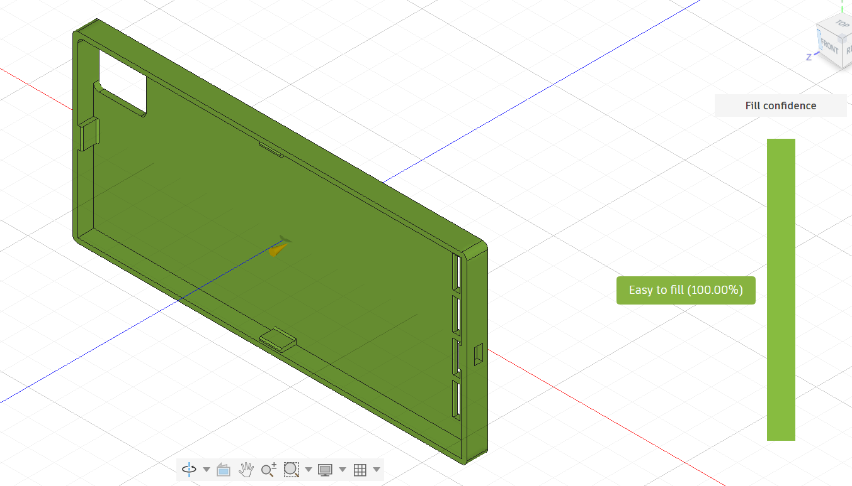
Figure 12 (Morgan, 2026)

The sink mark results (figure 13 ) predict a maximum sink depth of 0.081mm, which is a very shallow surface depression which for this component would be considered acceptable. This level of sink depth has low risk and would not affect the functionality of the component but potentially could affect the aesthetic appearance (Plastic Injection Molding, 2026). The highest values occur where there is a change in geometry which research shows is common (Macher, 2026), for example in this design around the snap fit features. Optimising rib thickness is one improvement that could be made to further reduce sink formation.

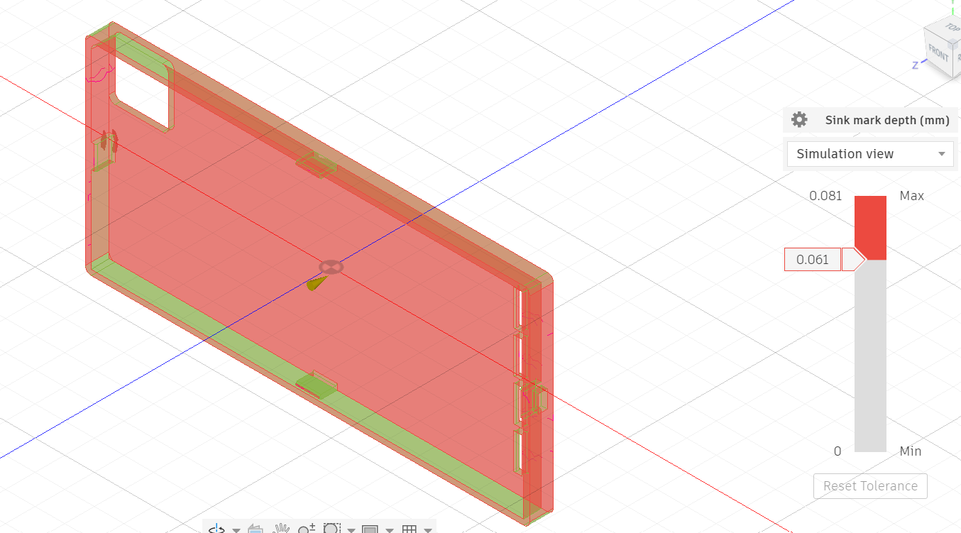
Figure 13 (Morgan, 2026)

With regard to warpage (figure 14 ) the problem areas are concentrated around the side walls and also the corner areas. This defect is potentially caused by differential cooling and material shrinkage during solidification. This value although not optimal would be acceptable for a component like this, however additional cooling channels could be added to lower the deformation here. An alternative injection site was trialled but there was no improvement in the results.

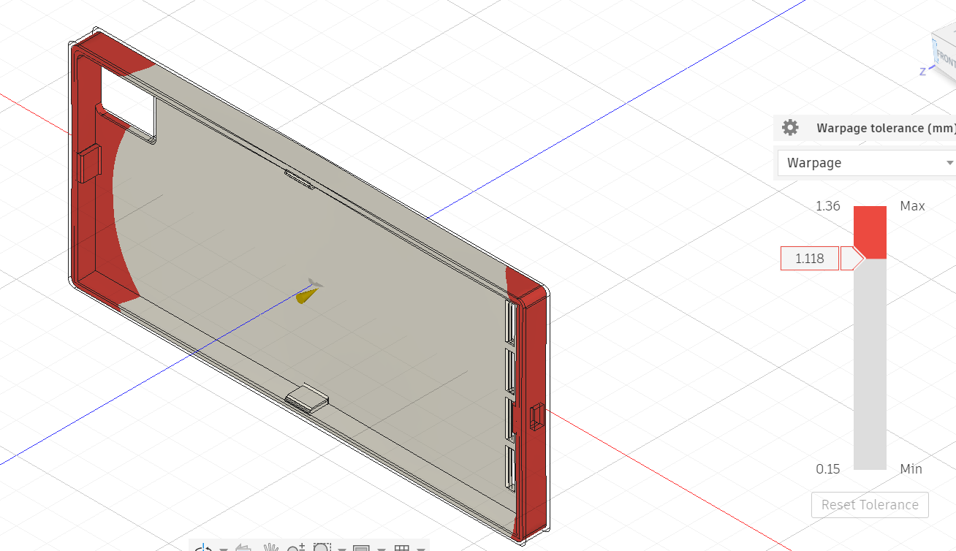
Figure 14 (Morgan, 2026)
5.2 Finite Element Analysis (FEA)
The simulation feature was used in Autodesk Fusion to evaluate the performance of the mobile phone housing, identifying regions on potential stress which can be analysed to further improve the design.
The highest stress areas are expected to occur around snap-fit features, corner regions and also the edges around camera and charging port cut-outs. As expected changes in geometry are the main cause of this increased stress as well as reduced material cross sections. As the snap-fit features will be used to connect other parts during assembly it is particularly important that the stress around these areas is optimized, otherwise potential failures during assembly may occur.
There is already some design improvements that have been worked into the CAD drawing in order to reduce stress concentration. Firstly fillets were added to the corners and also around cut out, this helps distribute stress more evenly across the material. Also the wall thickness is uniform which will help reduce stress and distribute the load evenly. Lastly the snap-fits have been filleted at the base to once again try to reduce stress concentration at those points.
In summary the FEA evaluation shows us that stress concentrations are higher at predicted design features in the housing. The fillets that have been added also help to reduce stress at these potentially problematic areas. The material choice of PC-ABS provides sufficient strength for the component and also due to the materials impact resistance and toughness, make the material suitable for areas under more stress like the snap-fit features. The design therefore taking all results from the simulation into account would be structurally sound and suitable for making this mobile phone housing component under normal operating conditions. These results highlight the value of these simulation tools in predicting manufacturing defects prior to actual production.

6. Cost calculation analysis
Using Granta the material PC-ABS was selected which has the mechanical properties and thermal resistance required. The cost of PC-ABS is higher than standard thermoplastics around £3.50 per kg, due to its enhanced properties. The estimation for the component weight will be 0.08kg based on the CAD model dimensions and material choice. Therefore the material cost per unit will be approximately £0.28. This low cost supports the high production injection moulding model, where machine costs are approximately £50 per hour. From the simulation analysis the cycle time was around 30 seconds per part, which equates to 120 parts per hour. Therefore factoring in the all this the machining costs per unit is £0.42 (Formlabs, 2023). Tooling cost for this set up with maintenance costs have been estimated around £20000, this is slightly higher than for basic tooling as due to the geometry and inclusion of the snap fit feature. This is a high one off initial cost but aside from routine maintenance this set up should be capable of producing mass volume injection moulding phone casing, which then makes it economically viable. With these costs factored in the estimated unit price 0.28 + 0.42 = £0.70.
Break even analysis is carried out to show the volume that needs to be made to justify the investment in tooling and set up. Based on a selling price of £1.50 per unit and a production cost of £0.70 gives a profit of £0.80 per unit. The break even volume is calculated at 20,000/0.80 = 25,000 units. This analysis confirms the economic advantage of injection moulding for high volume mass production.

7. Sustainability considerations
7.1 Material recyclability
In the modern world sustainability has gone from nice to necessary for all businesses, therefore it’s imperative that sustainability is taken into account when assessing manufacturing needs. The worlds consumption of polymers (mainly plastics) has from around 5 million tonnes in 1950 to nearly 100 million tonnes today, therefore with landfill legislation pressures recycling is the best solution (S. et al., 2012). PC-ABS can be recycled mechanically by grinding and remelting, with the waste and rejected parts able to be reused within some manufacturing processes. Also PC-ABS has a circular life cycle as is some instances it can be used in secondary applications (Harper, 2002).
7.2 Energy efficiency
The energy efficiency in injection moulding takes into account factors including cycle time, cooling performance and processing conditions. The design for the mobile phone housing has a uniform wall thickness which will help with consistent cooling throughout the mould which will improves efficiency. Also using filleting on the corners will help the material flow better, meaning injection pressures can be reduced which also leads to reduced machine energy consumption (Feng, Kamat and Pei, 2021). The simulation programme on fusion was used to try and optimise cooling conditions and improve cycle efficiency, this will also assist in reducing energy usage during the production of the phone casing as much as possible.
7.3 Waste reduction
Recycling of plastic waste to use in the construction industry is considered one of the best methods of disposing plastic waste (Proquest.com, 2026). This could be used for the waste produced from this injection moulding process, however it is a low waste manufacturing process. The waste has been further reduced by keeping wall thickness uniform and keeping the geometry simple while keeping the design functional. The simulation shows a very good fill of the mould which again means low waste, any excess waste left can be recycled and reused within the process as it won’t be contaminated with any other material.

8.Discussion and Recommendations
8.1 Customer requirements
After using the QFD analysis to identify the main customer requirements and prioritising durability, low cost, ease of assembly and surface finish, CAD fusion was then used to design the mobile phone casing. The simulations carried out also satisfy the brief, with defects falling within the accepted limits. The mould flow simulation has 100% cavity fill, which shows that the design is suitable to manufacture the product by injection moulding. The warpage and sink mark simulation also fall with accepted limits, which demonstrates that the phone housing surface finish should be of a high standard and it should meet functionality aims. The material choice of PC-ABS selected using Granta meets the material requirements for durability, good impact resistance and acceptable tensile strength. The design also incorporates the snap-fit feature which satisfies the QFD principles for ease of assembly, by eliminating the need for additional screws or fasteners.
8.2 Design trade offs
The main trade off for this product involved balancing the performance of the material with cost. Granta showed that polycarbonate and other polymers offered higher strength than PC-ABS however is was more expensive. Therefore it was more cost effective to go for PC-ABS which offered a lower mechanical spec but at a more cost effective price. This trade off is required for high volume production where it is essential to keep the costs down while still maintaining a fully functional product that meets consumer needs.
Another balancing act is looking at the thickness of the component and weighing up the benefits of having thicker walls in order to making the housing stronger. The negatives to having thicker walls would be higher material costs and also longer cooling times. Potentially there could be a problem with increased surface defects like sink marks and also the mould would be harder to fill. It was determined that a uniform wall thickness would be best to balance these factors, with the fusion simulations confirming that the uniform thickness gives efficient filling and cooling.
Finally the extra features had to be assessed as the more complex the design the higher the potential for issues with material flow and potential for more defects, such as weld lines and air traps. The cut outs for the camera, charging port and ventilation are essential so had to be added to the design, with the edges filleted to help material flow. The snap fit was a feature identified as important due to the ease of assembly requirement, and using the simulation to prove sufficient, this feature was added. These extra features show there is a balance required between functional requirements and manufacturability, with too many features potentially causing cost increases and issues during manufacture.
8.3 Further work
The design satisfies the objectives set out but by looking at the simulations it is clear that improvements could be considered to optimise the design.
- Use of a different material to increase sustainability. Potentially recycled PC-ABS could be used or explore further different recycled polymer properties.
- Multi cavity moulds – This should help to increase the production efficiency.
- Cooling channel design – change this design to reduce warpage further, this would have to be trialled and tested.
- Snap fit geometry – This could be redesigned and optimised further in order improve the ease of assembly while still retaining its other beneficial properties.
- Further simulations – Extra tests such as drop testing or advanced stress testing would further support and validate the performance of the mobile phone housing under real world conditions.

9.Conclusion
In conclusion the report shows the successful implementation and optimisation of a mobile phone housing design using Design for Manufacture (DFM) and Design for Assembly (DFA) principles. FMEA principles were also used to identify the key risks and action was taken to mitigate them. Autodesk fusion 360 was used effectively to design a manufacturable model, incorporating snap-fit assembly, feature cut outs, uniform wall thickness and fillets around edges in order to satisfy customer requirements. These design needs and enhancements were then confirmed to be acceptable for injection moulding by using the simulation programme within fusion 360, looking at how the mould fills as well as sink marks and warpage.
Granta CES was used to filter out materials that did not meet the design brief, with PC-ABS being the preferred choice giving a good balance between cost, weight , strength and manufacturability. The software was used to compare numerous materials through a range of criteria before narrowing it down further for a closer comparison.
Cost analysis was used to calculate the initial set up costs and manufacture costs in order to calculate a selling price. It was found that even though initial tooling costs are high the low unit cost and high production volumes would counteract this initial outlay and make it economical. Sustainability was also considered as modern day manufacturing has to take this important aspect into account in order for the business to survive. The PC-ABS material, and thermoplastics in general, was considered suitable due to its recyclability, efficient material use and reduced waste from the injection moulding manufacturing process.
This concludes that overall the final design meets the criteria and satisfies the key requirements of performance, manufacturability, cost and sustainability. These requirements were found by using tools such as QFD, QFA and FMEA to integrate the design aims and potential issues. These tools were very important to use in order to optimise the design and meet consumer needs. Also the simulations in CAD and material choice through granta show the importance of testing out materials and designs before putting into production. Failed production runs could be very costly to the business so this software is essential to trial and test designs before manufacturing the final component.
10. References
Amaya, J.L. (2026). Shibboleth Authentication Request. [online] Oclc.org. Available at: https://www-sciencedirect-com.uwtsd.idm.oclc.org/science/article/pii/S2212827119309187 [Accessed 2 Jun. 2026].

Battaïa, O., Dolgui, A., Heragu, S.S., Meerkov, S.M. and Tiwari, M.K. (2018a). Design for manufacturing and assembly/disassembly: joint design of products and production systems. International Journal of Production Research, 56(24), pp.7181–7189. doi:https://doi.org/10.1080/00207543.2018.1549795.

Battaïa, O., Dolgui, A., Heragu, S.S., Meerkov, S.M. and Tiwari, M.K. (2018b). Design for manufacturing and assembly/disassembly: joint design of products and production systems. International Journal of Production Research, 56(24), pp.7181–7189. doi:https://doi.org/10.1080/00207543.2018.1549795.

Chen, H.-L. (2026). Sign in to your account. [online] Proquest.com. Available at: https://www.proquest.com/docview/3271052188?accountid=130472&parentSessionId=T9ukrDoCsiCoJalBECUEz%2FVVnJiHoAN03DIN0Gbpb9M%3D&pq-origsite=primo&sourcetype=Scholarly%20Journals [Accessed 1 Jun. 2026].

Conniff, M. and Audrius Zidonis (2025). Injection Molding Material Selection Guide. [online] Xometry.com. Available at: https://www.xometry.com/resources/injection-molding/injection-molding-material-selection-guide/.

Czepiel, M., Bańkosz, M. and Sobczak-Kupiec, A. (2023). Advanced Injection Molding Methods: Review. Materials, [online] 16(17), p.5802. doi:https://doi.org/10.3390/ma16175802.

Erickson, N. (2025). DFM in Injection Molding: Cut Costs, Improve Quality. [online] Aprios.com. Available at: https://www.aprios.com/insights/dfm-principles-optimizing-injection-molding-for-quality-and-efficiency [Accessed 1 Jun. 2026].

Feng, S., Kamat, A.M. and Pei, Y. (2021). Design and fabrication of conformal cooling channels in molds: Review and progress updates. International Journal of Heat and Mass Transfer, 171, p.121082. doi:https://doi.org/10.1016/j.ijheatmasstransfer.2021.121082.

Formlabs (2023). How to Estimate Injection Molding Cost? [online] Formlabs. Available at: https://formlabs.com/uk/blog/injection-molding-cost/.

Fuges, C. (2026). Redirecting. [online] Proquest.com. Available at: https://www.proquest.com/docview/3227079239?accountid=130472&parentSessionId=v5pYdfwb85V2tsqJNWebtBqN9CECNAynFJ6CXKRJ9Qs%3D&pq-origsite=primo&searchKeywords=injection%20moulding%20dfm&sourcetype=Magazines [Accessed 1 Jun. 2026].

Harper, C.A. (2006). Handbook of Plastic Processes. John Wiley & Sons.

Jon (2024). CNC Machining: DFM Principles & Advantages for Efficient Manufacturing. [online] Managed Custom Parts Manufacturing | Jiga. Available at: https://jiga.io/injection-molding/injection-molding-dfm-principles-advantages-for-efficient-manufacturing/ [Accessed 3 Jun. 2026].

Macher, J. (2026). Shibboleth Authentication Request. [online] Oclc.org. Available at: https://www-sciencedirect-com.uwtsd.idm.oclc.org/science/article/pii/S0142941814001469 [Accessed 7 Jun. 2026].

Osswald, T.A. and Hernández-Ortiz, J.P. (2006). Polymer Processing.

Page, T. (2026). Shibboleth Authentication Request. [online] Oclc.org. Available at: https://research-ebsco-com.uwtsd.idm.oclc.org/c/onvpsy/viewer/pdf/saf326ws5z?route=details [Accessed 1 Jun. 2026].

Plastic Injection Molding (2026). Sink Marks in Injection Molding: Design and Process Solutions - Plastic Injection Molding. [online] Plastic Injection Molding. Available at: https://www.injectionmoldingindex.com/sink-marks-in-injection-molding-design-and-process-solutions/ [Accessed 7 Jun. 2026].

Proquest.com. (2026). Polymer Waste Recycling of Injection Molding Purges with Softening for Cutting with Fresnel Solar Collector—A Real Problem Linked to Sustainability and the Circular Economy. [online] Available at: https://www.proquest.com/docview/3037526668?accountid=130472&parentSessionId=5YnrC9TpuOW6iOi7WBdfdTE%2B3czjji0%2FncLls1FfRgk%3D&pq-origsite=primo&sourcetype=Scholarly%20Journals [Accessed 13 Jun. 2026].

Protolabs (2024). Injection Moulding Defects and How to Prevent Them. [online] Protolabs.com. Available at: https://www.protolabs.com/en-gb/resources/blog/injection-moulding-defects-and-how-to-prevent-them/.

S., D., Andriotis, L., A., I., A., D., P., N., Siafaka, P., Tsagkalias, I. and Tsintzou, G. (2012). Recent Advances in the Chemical Recycling of Polymers (PP, PS, LDPE, HDPE, PVC, PC, Nylon, PMMA). Material Recycling - Trends and Perspectives. doi:https://doi.org/10.5772/33457.

Santos, C. (2026). Shibboleth Authentication Request. [online] Oclc.org. Available at: https://www-igi-global-com.uwtsd.idm.oclc.org/gateway/chapter/full-text-html/242802 [Accessed 4 Jun. 2026].

Sartor, M. and Guido Orzes (2019). Quality Management. Emerald Group Publishing.

Shinzoft.com. (2025). Design for Manufacturing (DFM) in Injection Molding: A Practical Guide to Optimize Your Parts - Shinzoft. [online] Available at: https://www.shinzoft.com/design-for-manufacturing-dfm-in-injection-molding-a-practical-guide-to-optimize-your-parts/ [Accessed 1 Jun. 2026].

Ullah, H. and Ali, A. (2017). Design and Development of Mobile Phone Using Quality Function Deployment. International Journal of Engineering Materials and Manufacture, 2(1), pp.1–10. doi:https://doi.org/10.26776/ijemm.02.01.2017.01.

University of Cambridge (2016). Quality Function Deployment. [online] Cam.ac.uk. Available at: https://www.ifm.eng.cam.ac.uk/research/dstools/quality-function-deployment/.

Xiamen Keyuan Plastic Co.,Ltd (2022). How to choose a suitable TPE phone case material - Materials Introduction. [online] Ky-plastics.com. Available at: https://www.ky-plastics.com/info/how-to-choose-a-suitable-tpe-phone-case-materi-77145444.html [Accessed 7 Jun. 2026].

