Assignment 1: Academic skills

Management report: Evaluate whether the voting age should be lowered from 18 to 16?

Submitted By: Harbhajan Sran
1902444

Content page:

1.0: Introduction
1.1: Reasons why the voting age should be lowered to 16.
1.2: Reasons why the voting age should not be lowered to 16.
1.3: Conclusion/ My opinions on the voting age
1.4: References

Evaluate whether the voting age should be lowered?
1.0: This report will look at reasons why the voting age should be lowered and the reasons why voting age shouldn’t be lowered and evaluate what is the best option to receive from the government should the voting age be kept the same or should it reduced and does it have lots of benefits of the voting age being reduced or is it lots disadvantages of doing that. Currently the voting age law in the U.K is 18 to vote in public election. There is a debate whether the voting should be reduced to 16 or not. in this report we will find out what needs to be done for the voting age for example does it need to reconsidered and should there be voting to see how many 16 and 17-year olds who would actually take part in elections.
1.1: There are many reasons why voting age should be lowered because at the age of 16 you can get married, pay taxes, leave home, and can have sex legally. If you can do so many things at the age of 16 then why not allowed to vote. Also, another point that needs to be taken into consideration is that young people under the age of 18 have to follow the same laws as the adults then why not be allowed to vote in elections because they have to act like adults even under age of 18 or otherwise they will face the same consequences as an adult. For example, if you are caught using your phone whilst driving you will get 6 penalty points on your licence and £200 fine and also you might lose your driving licence if the licence isn’t more than 2 years old. This needs to be taken into consideration this law applies on anyone that get caught no matter the age under 18 who have a driver licence or over 18 so therefore allowing the voting age to 16 shouldn’t make any problems because they become responsible adults before the age of 18.
Also, another reason why the voting age should be lowered to 16 is because at this you are allowed to drive cars and some motor cycles (50 cc engine) which are potentially deadly vehicles if used in the wrong way, from the age of 16/17 therefore I think that they can be trusted with a ballot box to put their vote in. There are lots responsibilities that 16/ 17-year olds have such as what their next career move is after finishing year 11(16 years age). So therefore, allowing the age to vote to be lowered 16 would allow them to be more confident with themselves and will gain some knowledge and experience on politics and how apply and vote which is good so they know what is happening in the country for example who is standing in general elections to become the next prime minster.
1.2:On the other side there, lots of different reasons why the voting age should not be lowered and just be kept the same because allowing the voting age to be reduced to 16 can lead to wrong decision when coming to voting and can have big impacts on everyone living in the country which the 16-17-year olds don’t realise at the age they can vote for something they shouldn’t such as it impact later on life later when they grow up. It can have impact on country because there are large number of 16- and 17-year olds in the U.K as you can see in the following chart:
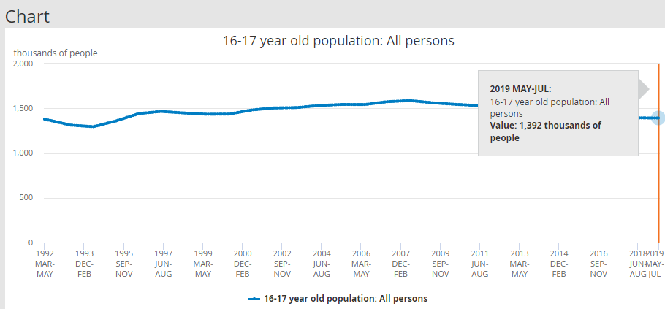
1,394 thousand of 16/17-year olds in the U.K and is slowly increasing every year.
This can have negative impact on the U.K voting as the turn out for elections can be totally differently than expected because the 16- and 17-years olds may not agree with other elder peoples experience and knowledge and can set back the country missing on opportunities and trade deals with other countries because the younger generation may have different thinking such as not negotiating with other countries therefore leading to high prices for out of U.K products such as fruit and veg in the country.
Also, another reason why the voting age should not be lowered is because at the age of 16 you will still be living with your parents and therefore 16-year olds are more easily to get influenced by their parents or whoever is looking after them. So, this means parents to the 16-year olds are basically given extra votes because not all 16-year olds have knowledge or experience in politics and might not even have any interest so their parent or guardian might convince them to vote specific party or person.
The majority of students believe that the voting age should not be lowered and should stay as it is 18, there are many young people age 14-17 who don’t care about politics and world issues however there is fifty percent that might care and want to take part in politics. Another reason why they don’t want take part voting is because they are in school and stressed with their course work and exams as year 11 is not easy for anyone and also considering what steps to take career wise after finishing year 11.

1.3: Overall it seems to be the situation that many students are already decided on the outcome the voting age should stay at 18. Because at the age 18 you start to get more amateur and you have more experience and knowledge of what you are doing and who are going to vote for. I think that voting age needs to reconsidered because under the age of 18 there are lots of rights and responsibility that 16/17 have to follows. As you can see at the ages of 16 and 17 you can drive, have sex legally and lots of these things but not allowed to vote at age 16. Then age restriction for other things should go up for example to drive a car or learn it should then be 18 as well, also the age to have sex legally should also be 18 there are lots things that needs to taken into consideration before taking anyone steps. It can either be the voting age dropped to 16 years or everything you are allowed to do when your 16 and 17 should be restricted to 18 as well from my personal opinion.

1.4: References
- Chandler,D- (2017)- Reasons why voting should be lowered to 16(online) Available at: https://metro.co.uk/2017/11/03/the-voting-age-should-be-lowered-to-16-and-this-is-why-7051099/?ito=cbshare,
acessed-1-10-19

- Leaker, D (2019), 16-17 year old population: All persons (Online) Available at: https://www.ons.gov.uk/employmentandlabourmarket/peopleinwork/employmentandemployeetypes/timeseries/jn5p/lms Accessed on 5th October 2019.

- Johnston.N, Dempsey.N, (2019) U.K election voting age (online) Available at:https://researchbriefings.parliament.uk/ResearchBriefing/Summary/SN01747 accessed- 5th October 2019.

- Oliver. S, Claire.F,(2015)- Whether the voting age should be reduced to 16 years in Great Britain or not. (journal) Issue 230, p24-25, 2 pages. Accessed 5th October 2019.

- Cato m, (2017) “Greens: Elitist rubbish to stop vote for 16 year olds” (online) Available at: www.bbc.co.uk /news/uk-politics-39651786. Accessed 5th October 2019.

- Stone J, (2017) The Prime Minister Theresa May refused to allow younger people to vote. (online) Available at:https://www.independent.co.uk/news/uk/politics/theresa-may-voting-age-16-right-to-vote-engaged-politics-general-election-2017-a7736091.html Accessed- 5th October 2019.

- Lidington D (2019) Should the voting age be lowered to 16? (online) available at: www.independent.co.uk/new/politics/should-the- voting-age-be lowered-to-16-a8882731.html. accessed 12th October 2019.

- Gaberiela. A (2019) “voting age should be lowered to 16 which will encourage civics education and mentions importance of teenagers participation in choosing their lawmakers” (Journal) Vol. 31 Issue 2, p5-5, 1page. Accessed 15 October 2019.

