

Program: BA Business Management
Module: LCBB5001 Entrepreneurship
Student Name: Gina Velicu
Student ID: 2028707

Table of Contents
Introduction 1
Business Description 2
Industry Analysis 3
VRIO Analysis 3
Porter’s Five Forces Analysis 4
Operation and Management Team Plan 6
Marketing Plan and Strategy 6
4P’s Marketing Mix 6
Financial Plan 8
Closing Summary 13
References 14

Introduction
Entrepreneurs across the economy are coming up with exciting ideas and with proper funding and dedication they reach the highest peak of the success tower. Business these days is now full of competition. But with the touch of differences in the products and services, the new business ventures are making places in the hearts of the customers. The economy of the United Kingdom is at pace after being toiled for years after the sudden boom of the COVID-19 pandemic. Currently, the economy is planning to accommodate small and medium enterprises to make a remarkable debut. The competitive market needs effective teamwork for a successful business venture. With the right product, strong HR team, customer segmentation, and strategic decisions the business can surely see the sunlight within a very short period (Dumas et al., 2018). Thus it is time to come up with an effective and exciting business plan to roll in the ground of success race.

Business Description
Foodario is going to set milestones in the food and culinary art industry. The venture will comprise a restaurant where pan-Asian, Thai, continental, and western sections will be available. The availability of a separate bakery section and live kebabs and sushi stations will add value to the restaurants. Primarily it is going to start its business in London which is the heart of the United Kingdom. This prime location will give the restaurant the best opportunity to attract the maximum number of customers. The foods at Buquet restaurants are always expensive and food lovers at times feel that the price shall be brought under the ability of mass consumers. Foodrio has the mission to bring tasty and culinary arts within the ability of the mass consumers. They plan on providing all types of food items under one roof. Foodario is planning to provide quality within the ability of mass consumers. Foodario has a kebab station and sushi station which are now the newest trends among the prominent restaurants. Besides the dining-in facilities, there is a special take-out as well as home delivery services where the first three orders are delivered charge-free as opening promotional offers.

Industry Analysis

VRIO Analysis
For a successful business venture understanding to industry is very important. Proper industrial analysis will help the business to determine what the business organization must do to ensure the proper growth of the business. The VRIO analytical tool described below illustrates the resources of Foodario and its contribution to assessing the market position:
Valuable:
Without Vale resources are useless. According to VRIO analysis, Foodario has kitchen tools in restaurants that help the restaurant to provide the best quality foods. The ingredients used in the kitchen are the property of Foodario. This pushes the organization to stay with comparative advantages (Hernández and Garcia, 2018). The human capital including the chiefs, writers, and staff working here are also assets for the restaurants.
Rare:
Among compatriots, the rare and slightly differentiated products and services give the business advantages over its competitors. Foodario has a special menu, sushi stations, as well as kebab stations, which are quite rare among the local and native restaurants of London (Summa, 2019). These could bring an advantage for Foodario to compete with its rivals.
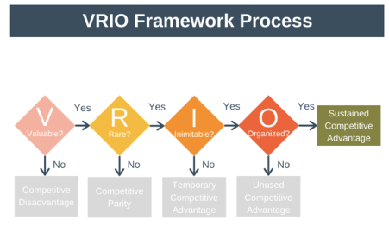
Figure: VRIO Analysis.
Source: Research gate, 2023.
Inimitable:
The restaurants serve the same dishes but the taste varies for the property of inimitability (Ariyani, and Daryanto, 2018). The secrets of the chiefs of Foodario will help the restaurants create unique dishes with special spices and ingredients that they do not share with the people outside the restaurant. This brings a speciality to their dishes. So this will help the business to stand strong among its competitors.
Organized:
Organized frameworks are pre-conditions for success. Foodario has a chain of command in administrations, chiefs, the structure of the kitchen, supply chain are all unique. This gives the business venture the extra advantage of printing before the consumer in the most attractive ways (Knott, 2015).

Porter’s Five Forces Analysis
Foodario as a new business venture must carefully assess the competitors and their threats to the progress of the business organization. The analysis includes the use of Porter’s five forces model. The findings of the model in the context of Foodario are illustrated below:
Threats of New Entrants:
No industry has a limited number of competitors. The food and culinary art industry has a lot of potential. So Foodario is not free from the threat of new entrants. This will increase challenges for the business venture for sure.
Threats of Substitutes:
Foodario serves quality food but there are restaurants in the locality of London that compete with menus serving similar foods. So people could easily substitute the foods if there is any doubt regarding fair price and quality servings. So the threats will make Foodario monitor pricing and quality.
Bargaining Power of Buyers:
The buyers have the preserved bargaining power so they can easily exercise this power and take foods and services from other available options(Metrick, and Yasuda, 2021). Business organizations must assess what their competitors are charging for a respective type of food and must monitor it regularly.
Bargaining Power of Suppliers:
Food and culinary business tends to rely on suppliers for the ingredients and raw materials. The suppliers of these raw materials exercise bargaining power and as the restaurants rely on these organizations they must take necessary actions to keep collecting raw materials at the most affordable rate( Muizu, 2016).

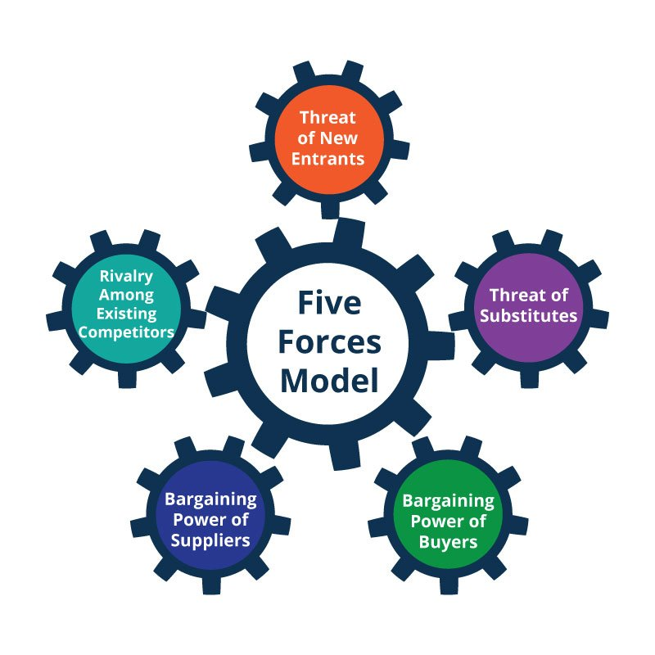
Figure: Porter’s Five Forces Analysis.
Source: Bob Stanke,2023.
Rivalry among Existing Competitors:
Besides new entrants, the existing competitors could act as rivals. This is when the comparative advantages are used to keep up with the competitors. The foundation is prepared to have rival activities from its competitors. They plan on providing quality food and special services to keep up with the competition.

Operation and Management Team Plan
The success of any business regardless of its type depends on the operational strategy as well as the management strategy. Foodario is going to be a restaurant with a difference. The quality of the foods will be assured if the raw materials as well as ingredients used in the kitchen remain fresh. The supply chain management team ensures that only the fresh ingredients reach the kitchen of the venture (Chatzoglou et al., 2018). Besides the technical support, the professionals working under this organization also play a crucial role in the development of the business. The amazing chiefs are appointed accordingly for the different cuisines (Bröcker, 2021). Culinary art is greatly valued here. So the chiefs and culinary artists needed to pass tests and they received the appointment. The Kitchen has a quality monitoring cell to ensure quality and hygiene at its best. These strategic activities are working behind the success of the venture of Foodario.

Marketing Plan and Strategy

4P’s Marketing Mix
For a successful business venture, a proper marketing strategy is one of the preconditions. The more pop strategic decisions will eventually bring success to Foodario. The description below showcases the 4P Marketing mix for Foodario:
Products:
For Foodario, the products are the foods served on the premises and delivered by Foodario. These are unique and specially cooked by the su chiefs at Foodario. The market has many options before the customers but the quality and tasty foods could easily attract customers to the brand (Saunders, and Lewis, 2017).
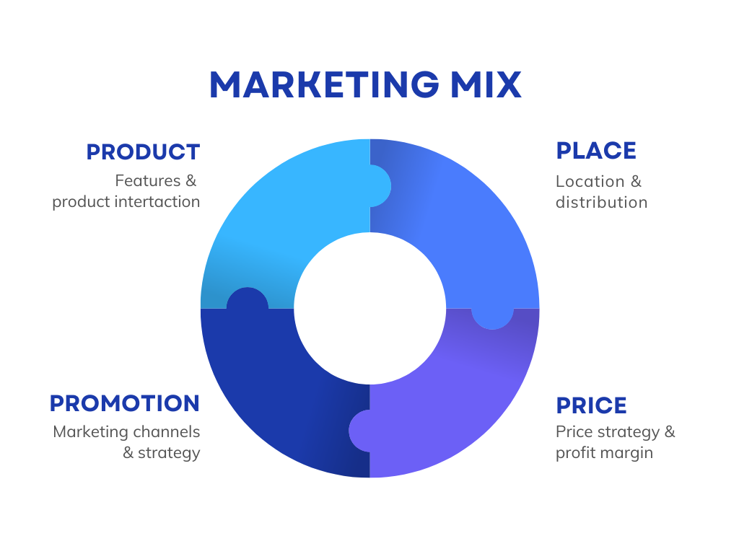
Figure: Marketing Mix.
Source: Business. Org, 2023.

Place:
The success of the venture depends on the locational choices as well. Foodario is planning to start its operation with one premises in London. Being the heart of the area and with special premises along with parking and play zone facility will sure bring success factors for the company.
Price:
Price often becomes an obstacle for businesses to reach the mass of consumers. At Foodario our vision remains to provide the best quality food in the most luxurious environment at the most affordable rate. In comparison with other bouquet restaurants, our target remains to minimize the cost and increase e the volume of sales (Nuseir. and Madanat, 2015).
Promotion:
Without proper promotion and advertisement, the restaurants might not get the reach of the customers. This is why the HR team has hired professionals to make digital promotions (Išoraitė, 2016). In the option of the venture there will be free delivery on the first 3 orders of takeout and dine-in will offer a flat 5% discount along with a 7% discount on the kebab menu.

Financial Plan
For the success of the business financial allocation and calculation of cost benefit is necessary. Business ventures like Foodario need the attention of the investors. The private investor like Dragon’s Den can give a kick-start to the business venture. The successful running of the business will eventually ensure that the business can achieve its required level of revenue and profits. Successful business ventures need to analyze the potential cash flows and determine how the business ventures should behave when it comes to gaining financial sustainability in their operational period (Wallmeroth, Wirtz and Groh, 2018). If there is a balance between its cost and profit the balance will be gained. The financial transaction below can evaluate the project cash flow for six months:
Cost-benefit analysis of Foodario:

Particulars | Jan- Feb | Mar- Apr | May- Jun
 | Amount (£) | Amount (£) | Amount (£)
Sales | 500000 | 1700000 | 2500000
Direct Cost | 100000 | 500000 | 600000
Others | 5000 | 10000 | 15000
Total Cost of Sales | 105000 | 510000 | 750000
Gross Margin | 55000 | 1190000 | 17850000
Gross Margin (%) | 50.00 | 65.56 | 81.167
Expenses
Payroll | 95625 | 165652 | 234783
Depreciation | 0 | 0 | 0
Others | 23400 | 47000 | 80000
R & D | 15000 | 25000 | 80000
Utilities | 600 | 800 | 1000
Insurance | 600 | 800 | 1000
Rent | 2400 | 3000 | 5000
Taxes | 14348 | 24848 | 352783
Others | 0 | 0 | 0
Total Operating Cost | 152000 | 267100 | 397000
Profit before Interest and Tax | - 57000 | 692175 | 103216
EBITDA | -57000 | 692175 | 103216
Internal Expenses | 0 | 0 | 0
Taxes Incurred | 0 | 550960 | 367760
Net Profit | -57000 | 692175 | 1035216
Net Profit/ Sales | -28.50 | 46.15 | 47.06

Projected Cash Flow of Foodario:
Particular | Jan- Feb | Mar- Apr | May- Jun
 | Amount (£) | Amount (£) | Amount (£)
Cash from Operation | - | - | -
Cash Sales | 250000 | 555000 | 559000
Cash from Receivable | 150500 | 563250 | 15478750
Total Cash from Operation | 1705050 | 18056250 | 20945660
Additional Cash Received | - | - | -
Sales of Long-Term Assets | 0 | 0 | 0
New Investment Received | 36000 | 0 | 0
Total Cash Received | 206500 | 130825 | 2096750
Expense | - | - | -
Expenses from Operations | - | - | -
Cash Spending | 95652 | 165652 | 234783
Bill Payments | 147562 | 604177 | 906344
Subtotal Sent on Operations | 243214 | 769829 | 1141127
Cash Spent Additionally | - | - | -
Purchase Long Term Assets | 10000 | - | -
Dividends | 0 | 0 | 0
Total Cash Spent | 253214 | 769829 | 1141127
Net Cash Flow | -36714 | 589621 | 855627
Cash Balance | 5478 | 556307 | 1457930

Balance Sheet of Foodario:
Particular | Jan- Feb | Mar- Apr | May- Jun
 | Amount (£) | Amount (£) | Amount (£)
Assets | - | - | -
Current asset | - | - | -
Cash | 5786 | 544207 | 1499830
Accounts Receivable | 29500 | 221250 | 324500
Other Current Assets | 5000 | 5000 | 5000
Total Current Assets | 40286 | 770457 | 1829330
Long Term Asset | 1000 | 1000 | 1000
Accumulated Depreciation | 0 | 0 | 0
Team Asset | 10000 | 10000 | 10000
Total Asset | 50286 | 7804897 | 1868330
Liabilities and Capital | - | - | -
Current Liabilities | - | - | -
Accounts Payables | 14786 | 52781 | 76438
Current Borrowing | 0 | 0 | 0
Other Current Liabilities | 0 | 0 | 0
Total Current Liabilities | 14786 | 52781 | 76438
Long Term Liabilities | 0 | 0 | 0
Total Liabilities | 14786 | 52781 | 76438
Paid in Capital | 152600 | 152600 | 152600
Retained Earnings | -60100 | -117100 | 575075
Earnings | -57000 | 692175 | 1035216
Total Capital | 355500 | 727675 | 1762892
Total Liabilities and Capital | 50286 | 780457 | 1839330
Net Worth | 475500 | 705875 | 1762892
Break-Even Analysis of Foodario:
Monthly Revenue Break Even | 35450
Assumption | -
Average Variable Cost (%) | 60%
Estimated Monthly Fixed Cost | 11530

Closing Summary
Entrepreneurs have the mindset to bring differentiated products at the most affordable rate to grab the attention of potential customers and with quality products and services they can easily assure the loyalty of the customers as well. Foodario is going to become a name of trust among other diners and bakers for its quality products. People these days prefer healthy as well as tasty foods to satisfy their cravings and Foodario could be the solution. The food and culinary industry has always been full of competitors yet investors are willing to make investments if they are assured of quality services and potential(Thabit, and Raewf, 2018). A business organization that deals with sensitive products such as edibles must never compromise quality in every stage of production till serving the food bowl. As Foodario is going to be something different and the beliefs of the diners are going to be prominent in their field there shall be no confusion regarding the quality of food. The special and exclusive baking item will be a blessing for the business venture (Brovenko, and Antonenko, 2018). The live kebab station will bring an aesthetic view as well as act as one of the successive factors for the business venture for sure.

References
Ariyani, W. and Daryanto, A., 2018. Operationalization of Internal Analysis Using the VRIO Framework: Development of Scale for Resource and Capabilities Organization (Case Study: XYZ Company Animal Feed Business Unit). Asian Business Research Journal, 3, pp.9-14.
Bröcker, F., 2021. Chefs and artists in dialogue–about the use of food as a sensual and conceptual medium in contemporary art and cuisine. International Journal of Gastronomy and Food Science, 24, p.100339.
Brovenko, T. and Antonenko, A., 2018. Food design is the actual direction of interdisciplinary research. Вісник Національної академії керівних кадрів культури і мистецтв, (2), pp.88-91.
Chatzoglou, P., Chatzoudes, D., Sarigiannidis, L. and Theriou, G., 2018. The role of firm-specific factors in the strategy-performance relationship: Revisiting the resource-based view of the firm and the VRIO framework. Management Research Review, 41(1), pp.46-73.
Dumas, M., La Rosa, M., Mendling, J. and Reijers, H.A., 2018. Fundamentals of business process management (Vol. 2). Heidelberg: Springer.
Hernández, J.G.V. and Garcia, F.C., 2018. The link between a firm's internal characteristics and performance: GPTW & VRIO dimension analysis. Revista de Administração IMED, 8(2), pp.222-235.
Išoraitė, M., 2016. Marketing mixes theoretical aspects. International Journal of Research-Granthaalayah, 4(6), pp.25-37.
Knott, P.J., 2015. Does VRIO help managers evaluate a firm’s resources? Management Decision, 53(8), pp.1806-1822.
Metrick, A. and Yasuda, A., 2021. Venture capital and the finance of innovation. John Wiley & Sons.
Muizu, W.O.Z., 2016. Competency development of culinary creative industries. Academy of Strategic Management Journal, 15, pp.67-72.
Nuseir, M.T. and Madanat, H., 2015. 4Ps: A strategy to secure customers' loyalty via customer satisfaction. International Journal of Marketing Studies, 7(4), p.78.
Saunders, M. and Lewis, P., 2017. Doing research in business and management. Pearson.
Summa, R., 2019. Marketing-Mix. Red Universitaria Virtual Internacional, 12.
Thabit, T. and Raewf, M., 2018. The evaluation of marketing mix elements: A case study. International Journal of Social Sciences & Educational Studies, 4(4).
Wallmeroth, J., Wirtz, P. and Groh, A.P., 2018. Venture capital, angel financing, and crowdfunding of entrepreneurial ventures: A literature review. Foundations and Trends® in Entrepreneurship, 14(1), pp.1-129.

