Report about the Hilton hotel and the Hyatt hotels

SYED GOUS UDDIN 2110027
19/10/2021
THE HILTON HOTEL AND RESORT .
The Hilton hotel company was founded by Conrad Hilton in 1919 in Texas, starting from a one hotel and growing to a world-wide company stretching to all major cities.
The HILTON offers a wide range of hotels to appeal to the rich and famous, from the ISTANBUL HILTON where the movie James bond was shot to your local city where you would want to take your girlfriend or wife on a weekend break. One of the most exclusive Hilton hotels is the BEVERLY HILTON in the famous Beverly hills ranging from £235 starting, exclusive rooms cost up to £1151 per night, the HILTON HOTELS that are built are very strategically located from the BEVERLY Hilton being 5 minutes from Miami beach to the Hilton Istanbul Bosphorus where the movie From Russia what is what is basically rather spoiled their policy but it’s the same for china as well we just have with love was filmed.
What does the Hilton offer and who they attract.
The Hilton hotel website (2021) Water skiing, jet ski, tennis, golf, sailing to fitness, spars money exchange, outdoor and indoor pools, and many more to attract the wealthy, the Hilton offers a babysitting service too.
newsroom.hilton.com (2021) the Hilton hotel and resorts are spread across 94 countries and 6 continents and has had the rich and famous like John Lennon and Yoko Ono as guests.
After researching the web and visiting several Hilton hotel websites I have concluded that the Hilton hotel and resort attract the rich and famous, there image is all about elegance and style, it is not about a good night's sleep or and the rest it is a status symbol from spending a weekend with fiancé to meeting business executives to impress.
MARKETING THE HILTON HOTEL
www.xotels.com/glossary (2021) The Hilton hotel company market there hotel to the middle to upper social professional with a high level of income coming from a upper social class.
Hiltonfoundation 20/10/21 at the Hilton hotel websites and there advertising drive, Hilton hotels inspire traveller's to make new memories by staying at there exotic hotel sites and using there own facilities ie spa, pools, tennis and many more of there exclusive attractions.
MCLEANS, VA- has announced that the company will be launching a new campaign to new memories after the covid-19 pandemic, the campaign has been launched after a long survey uncovered that travel memories are some of the happiest memories of costumers, as the covid –19 pandemic comes to an end the survey revealed that 89% of the population in the us would start to plan holidays after the pandemic comes to an end.
Hilton hotels and resorts corporation is worth $40.08B
Shares between $145.21-$146.54 day range and year range at $108.50-$166.33
Looking at the stock figures and the average between the high peak and the low peak and looking at the last five years the stocks of Hilton hotels average is $145.50
Graphis displayed on google.com/finance/quote/05ilon? Shows the effects of covid 19 and the drop in revenue starting in 2017 revenue being at 3.40B with a year on year climb 2018 3.67B and 3.77B in 2019 with a sharp fall in 2019 when covid 19 hit bringing revenue down to 1.60B and a slow climb as rules and laws in different countries eased.
PROFIT AND LOSES MADE BY THE HILTON HOTEL GROUP
Phocuswire.com (12/10/2021) stats that the Hilton hotel group made a loss of $720 million in the year of 2020 due to the covid –19 pandemic, in 2019 the hotel reported $81 million loses in the first quarter, with improvements made and a new campaign launched the hotel group is expecting all of its hotels to be open by the end of 2021 and is expecting a profitable future.

About the Hyatt hotels
Hyatt hotel group was founded in 1957 by Jay Pritzker, he bought the first Hyatt house adjacent to the Los Angels International Airport.in the many years as the website about.Hyatt.com tell the story about the family business and how family members worked together to make Hyatt what it is today.
Hyatt became a public company in 1962 and in 1968 Hyatt international was formed, Hyatt at the start started to branch in to different entities Hyatt corporation, Hyatt international corporation and other smaller Hyatt partners and December 31, 2004 all Hyatt companies were consolidated into one single entity, now Hyatt hotels corporation.
Hyatt has hotels around the world in New York, Hong Kong, Chicago, London and many other major cities and attractions sites.
Hyatt has launched there global responsibility program, corporate responsibility to there staff and guests Hyatts purpose to care for the people that work in all there establishments and to care for there guests by addressing todays environmental and social issues is important to Hyatt and its corporation
Referenceforbusinesss.com 2023 explains the history of the global Hyatt corporation as being one of the leading companies in the world, its owners the PRITZKER FAMILY of Chicago managing and licensing 210 hotels and resorts around the world. Hyatt hotels are luxury hotels specially for the high end customer base with the addition to running six casinos. The company has had its bad time where there skywalks at Kansas city regency hotel col lapsed killing 114 people and injuring 229 one of the most devastating events causing so many deaths in the United States with a law suit that cost the company $120 million in payouts dropping its shares and looking like the company would not bounce back to its peak performance, new management and new operations staff with the help of HR in 1989 the company introduced a program the attracted more family’s giving them the option to to take a second room at half the price with young children and toddlers.
Hyatt corporation and Hyatt casinos are valued at 12.15B USD closing on 07-02-2023
Stokes price ranging from $109.14-$113.77 with a year range $70.12-$113.77
Looking at the stocks and the average to the low and the high peak of stocks the business is stable rounding out around $110,
On the status of running costs and revenue for the last% years from 2017 revenue being 1.45B being contestant and steady through 2018 and 2019 taking in to the fact of covid 19 and the effects that it had to the hotel industry end of 2019 and 2020 a sharp fall in revenue at 780 million with a slow climb in 2021 to 1.45B, taking in to fact with the introduction of safety measures and law changes this fall was certain, as normality started to return and laws in different countries was being eased the revenue at the end of 2021 was reaching a stable position averaging out around 2B.
Looking at wsj.com 2023 at the profit and loss’s made by Hilton hotels over the years from 2017 to 2021 starting revenue 8.131 in 2017 and 2018/19 being rough the same with growth being at 9.53% in 2018 and 6.46 in 2019, due to covid 19 and ristrictions to the hospitality industry a sharp fall in 2020 by -54.27% after covid restrictions lift in 2021 a growth of 34.23% in 2021 for-casted to increase to pre pandemic results in future years.
Hyatt hotels profit and loss’s as explained in wsj.com 2023, starting from 2017 at 4.462 with a small drop in 2018 by -0.18%, 2019 with a 12.71% increase, as covid 19 hit in 2020 a sharp fall -58.84%, after laws on covid 19 are easing a climb by 46.56% in 2021 in sales and revenue looking to climb to pre pandemic figures for casting in 2years.
Looking at graphs and revenue of both hotels over the last five years both companies where effected by covid 19 and the hotel industry was at a very uncertain time with shares and stocks falling with staff reduction and with the introduction to new rules and laws it between 2019 and 2020 both hotels made major losses but y year ending 2020 as laws eased a slow but stable climb in both hotels and 2021 bringing both hotels to full operating standards
MARKET POSITIONS FOR HILTON HOTELS AND HYATT HOTELS
Market position of Hiton hotel as explained in marketing 91.com 2023 84 in the top 100 hotels the brand targets high end guests and corporate employees and upper class society, business class, movie starts, pop stars and many more on the high end earners.
Hyatt hotels and resorts corporation being 1314th most valuable company by market cap according to their data. Guests attraction middle aged to older customers with family orientated business class and high earners.
Hiton hotels and resorts to fill the earth with a light and warmth of hospitality by delivering exceptional experiences -every day hotel, every guest, every time. Moto sounds nice and pleasant with the introduction of saving the planet projects to supporting educational needs in local community’s and the use of local produce all contributes to a long lasting company.
Hyatt hotels and resorts purpose a is to care for people so they can b their best, supporting communities in which they operate by caring for the planet, reducing greenhouse gas’s.
COMPARISONS BETWEEN HILTON HOTELS AND HYATT HOTELS
Looking at comparably.com (2023) Hilton hotels ranks higher then Hyatt hotels and looking at the customer base both attract the same type of customers in the high earners and the business executives but in the market the Hilton hotel group has more of a popular hold on the attraction of movie stars to music artists to politicians as to Hyatt hotel group attract the high earning family base customers with there advertisement more focused on a family thiam.
Revenue and room prices differ as explained above, Hilton hotels market cap being at $32.46B and Hyatt hotels current valuation being $3.38B clearly shows that Hilton hotel is the bigger brand having more of the say in the market function and being able to attract and facilitate the needs of the customer.
RECOMMENDATIONS
After a long search through the world wide web www.hilton.com and www.hyatt.com and other various websites I strongly believe that both hotels could benefit from attracting more people with disabilities, by modifying some parts in the hotel ie putting in lifts and railings and ramps in both the Hilton and the Hyatt hotels would greatly benefit anyone with a disability.
Advertising is key to pushing business to the type of customers that would normally not use the Hilton or the Hyatt hotels would greatly make a difference in revenue, having bathrooms fitted with wheelchair access and rooms on the ground floor, I have found that the only Hilton hotels and Hyatt hotels that serve halal food for Muslim’s are only based in Islamic counties, having the option to order halal food and having hotel members trained to customs of people with different cultural and religious needs would be another attraction and would attract more people with a different diet preference.
Reference list
https://www.referenceforbusiness.com/history2/38/Global-Hyatt-Corporation.html

https://www.google.com/finance/quote/H:NYSE?sa=X&ved=2ahUKEwi30Ibps4T9AhXwQ0EAHQ6TDOYQ3ecFegQIIRAd

https://www.google.com/finance/quote/0J5I:LON?sa=X&ved=2ahUKEwjetvC9t4T9AhVXR0EAHX2BCWIQ3ecFegQIDRAd

https://www.marketing91.com/marketing-strategy-of-hilton-hotels/

https://ir.hilton.com/financial-reporting/annual-reports

https://www.wsj.com/market-data/quotes/HLT/financials/annual/income-statement

https://www.wsj.com/market-data/quotes/H/financials/annual/income-statement

https://companiesmarketcap.com/hyatt/marketcap/

https://brandstruck.co/hilton/

http://tradearabia.com/touch/article/TTN/397564

https://www.hilton.com/en/corporate/

https://about.hyatt.com/content/dam/HyattStories/thrive/HyattEnvironmentalSustainabilityHighlights20192020.pdf

https://youtu.be/sWYVu3E_Ekc 2023

https://www.comparably.com/competitors/hilton-vs-hyatt

https://www.hilton.com/en/

https://about.hyatt.com/en.html

https://www.hospitalitynet.org/organization/17001488/hyatt.html

https://stories.hilton.com/history

https://www.hospitalitynet.org/brand/23000030/hilton.html

https://www.soegjobs.com/top-100-hotel-chains/

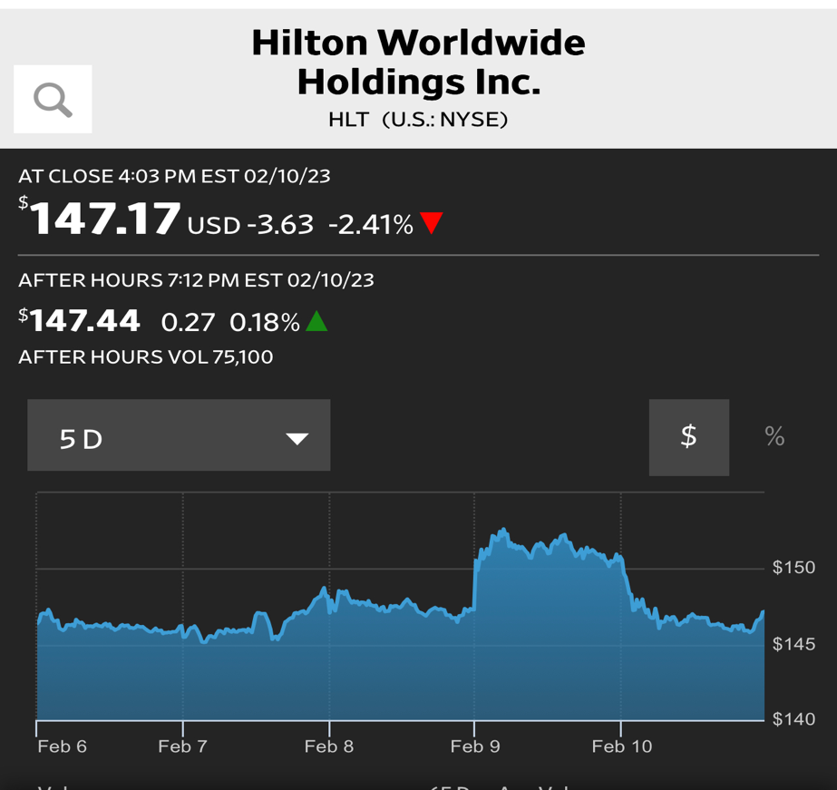
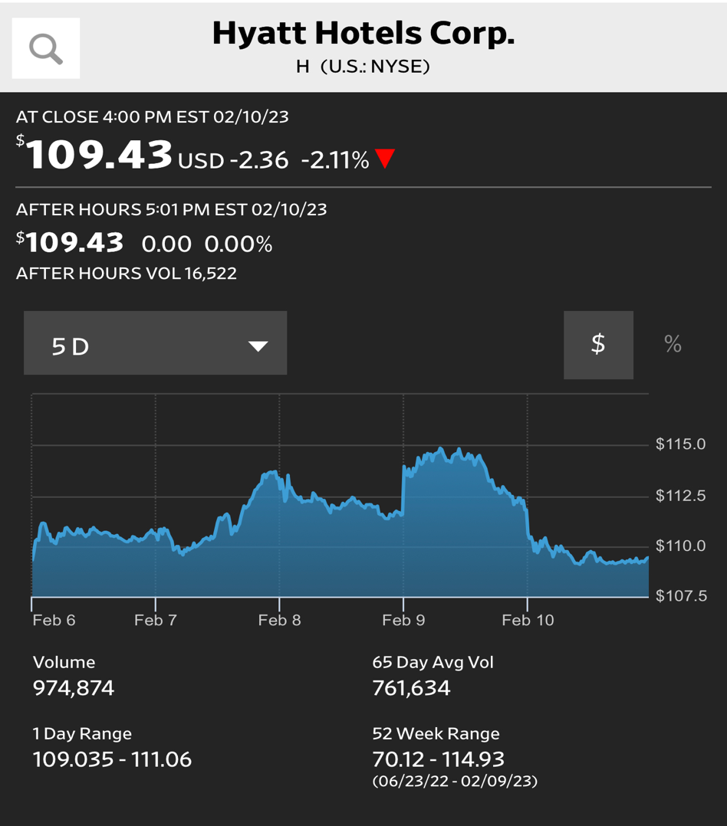
Market stocks and fluctuations

