
APPENDIX GA36a

LEVEL 4 ASSESSMENT SPECIFICATION

Student name: | Wesley Hill | Student ID number: | 141916
Programme: | HNC Electrical and Electronic Engineering
Module: | Design of Electrical Installations
Module code: | PCEE4007 | Contribution to Overall Module Assessment (%): | 50%
Lecturer: | Steven Evans | Internal Verifier: | Nigel Richards
Assignment Title: | Practical Installation. | Word count (or equivalent): | 2000
Submission deadline: | 15th May 2024 | Return date of provisional marks & written feedback: | 22nd May 2024
Submission method: | All written assessments, where practical and possible, must be submitted via Turnitin unless otherwise instructed by the Lecturer. (Please DO NOT put this assessment specification into Turnitin or it will match many similarities with other students’ submissions.)  Alternative submission method (if applicable):  Late submission of the assessment will result in a late penalty mark. Penalties for late submission: Up to one week late, maximum mark of 40%. Over one week late, 0%. Only the Extenuating Circumstances Panel may approve a change to submission dates.
Academic honesty / referencing: | Academic honesty is required. In the main body of your submission you must give credit to authors on whose research and ideas your work is based. Append to your submission a reference list that indicates the books, articles, etc. that you have used, cited or quoted in order to complete this assessment.

Module Learning Outcomes
(from module syllabus)
LO1, LO2

TASK DESCRIPTION

Assignment 2 – 2023-24

This assessment has been designed in TWO parts: Section A and Section B.

Answer all questions

Section A deals with the design, installation and testing of a Ring Final Circuit and requires the student to design and then construct the circuit using the accessories provided.

Section B requires the student to answer ALL the questions with detailed statements and fully labelled diagrams where possible.

Wiring with multicore cables
Multicore cables (commonly referred to as flat twin and earth (FTE) or PVC/PVC cables) used in standard circuit installations are three-core cables consisting of a line, a neutral and an earth conductor. Both the line and neutral conductors are copper insulated with coloured insulation; brown for line and blue for neutral. The earth being a non-insulated bare copper conductor sandwiched between the line and neutral and is known as the C.P.C. – Circuit Protective Conductor. The three conductors are encased in a PVC outer sheathing.
All cables used in electrical installations in the United Kingdom must be BASEC approved.

In this practical exercise you are requested to install and test a PVC/PVC wiring installation which shall comply with good codes of practice and the current IET Wiring Regulations.

The Layout diagram shows a Ring Final Circuit with spurs and a fused spur controlling a two-way switched lighting circuit. From the diagram, estimate the materials required and complete the requisition sheet. You will also need to complete the tools and equipment sheet.

Before carrying out the practical exercise you must complete a circuit diagram and a wiring diagram on the relevant sheets.

On completion of the practical exercise, carry out the required tests in the correct sequence according to the IET Wiring Regulations and record on the test sheet.

Section A

Time Allowed: 120 Minutes

Work Plan/ Method Statement

Tools List

Materials List

Test Results

Continuity of CPC Test Lead Resistance = _____________

(R₁ + R₂₎ = _____________

Insulation Resistance Test Voltage Applied = ______________

Min. Acceptable Value = ______________

Line to Neutral Value = ______________

Line to CPC Value = ______________

Neutral to CPC Value = ______________

Ze measurement = ______________

30mA RCD Test ½ x ______________

1 x ______________

Polarity Test Pass / Fail

Comments

Layout Diagram of a Ring Final Circuit with Spurs

and a Switched Fused Spur controlling a 3-way switched lighting circuit

Circuit Diagram of a Ring Final Circuit with Spurs

and a Switched Fused Spur controlling a 2-way switched lighting circuit

Wiring Diagram of a Final Ring Circuit with Spurs

and a Switched Fused Spur controlling a 2-way switched lighting circuit

Section B

1 a) The fuses in Figure 1 are BS88 Type 2.

- Explain why it is important to achieve discrimination between fuses A and B

- Using the appropriate tables from BS7671:2018 and considering the time-current characteristics of fuses A and B, determine the disconnection times caused by a fault current of 300A and state if discrimination is achieved.

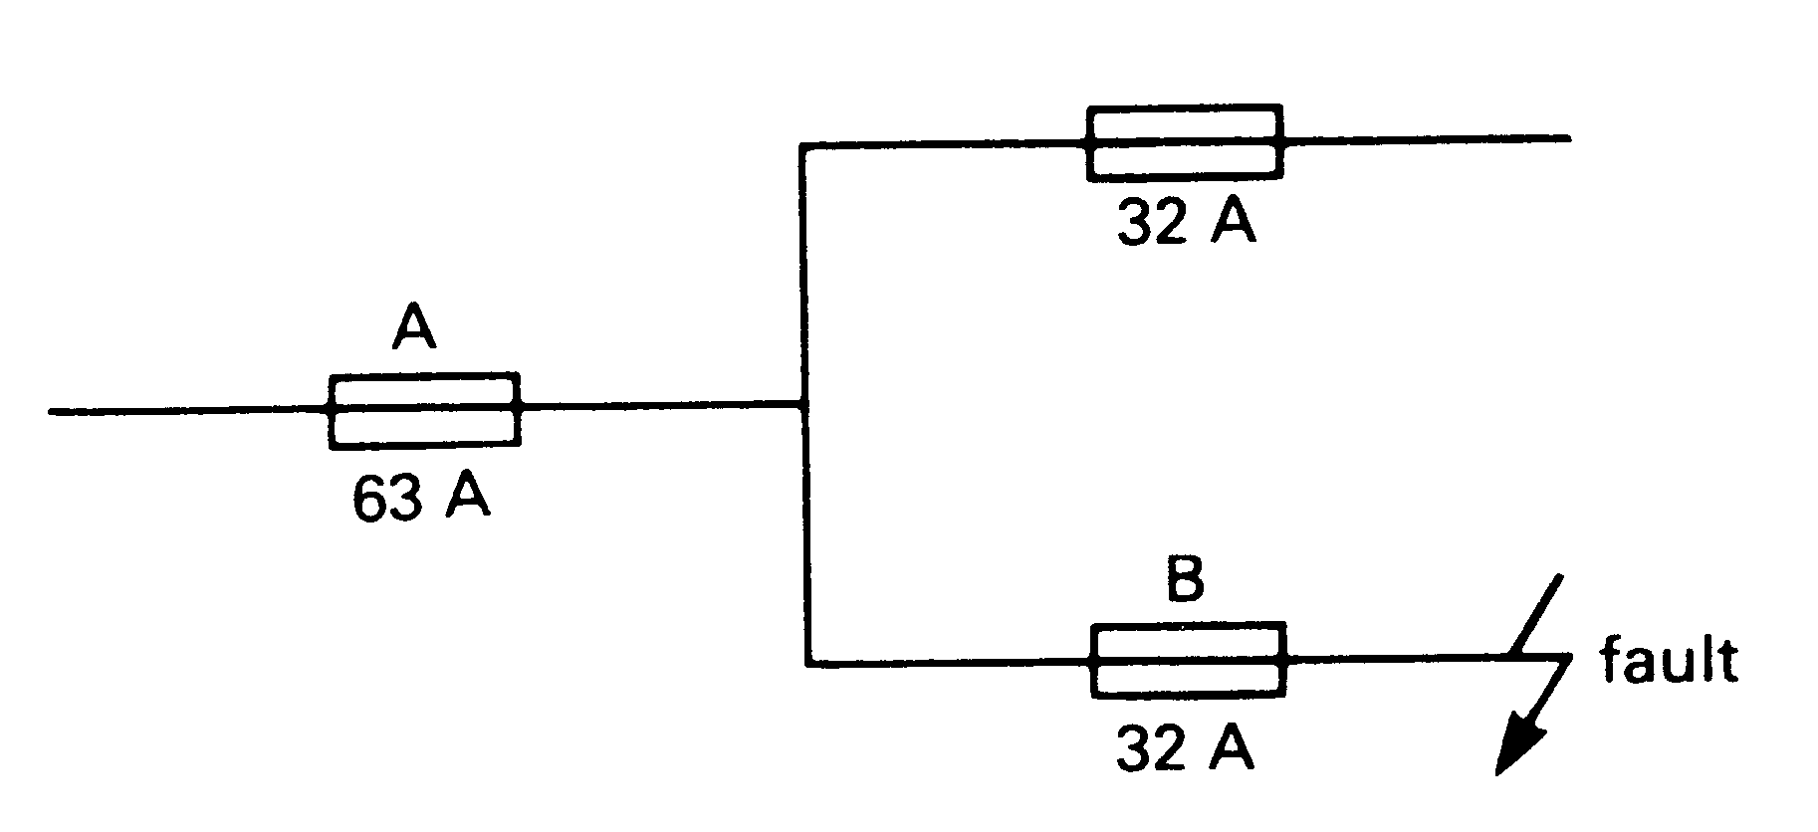

Fig. 1

- Explain what is meant by thermal and magnetic tripping properties with regard to protective devices.

- Figure 2 shows a line diagram that illustrates a typical lighting point controlled by a dimmer switch and protected by a fuse. Make similar line diagrams for the following circuits:
  - Lighting point controlled by two-way switching.
  - Lighting point controlled by two-way and intermediate switching.
  - Six 13 A BS 1363 switched socket outlets wired as a radial final circuit.
  - Thermostatically controlled heater wired from a double-pole switch.

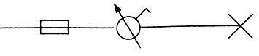

Fig. 2

HNC Electrical Engineering:
Design and installation of electrical circuits

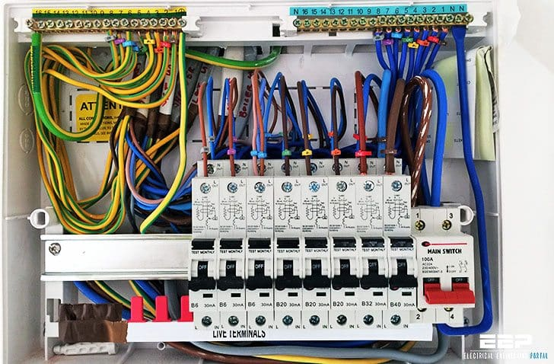

Student Name: Wesley Hill
Student Number: 141916
Tutor Name: Steve Evans

Contents

Section A 11
Section B 15
References 18
Bibliography 19

Introduction

This paper aims to undertake designing and installing an electrical circuit on a board that includes a 2 way switching arrangement, using good codes of practice and ensuring that it complies with BS7671. Testing of the ring final circuit will also be carried out to BS7671 standard, using an insulation resistance test and CPC continuity test.

The safety protective devices that are in place in electrical circuits will also be covered in this paper, specifically looking at the magnetic and thermal tripping properties of safety protective devices. The design and symbols used in circuit will also be looked at in this paper.

Section A

Work Plan/Method statement:
A ring final circuit is to be installed using 2.5 Twin and Earth cabling for multiple sockets and a JB and 1.5mm 4 core cabling for a two way switching arrangement.
- First a layout and wiring diagram will be made to visualize the circuit
- Next the circuit will be copied onto a sheet of plywood, using the components to trace around.
- Then the lines for the cables/cable clips will be drawn on to follow once it is time to install
- The board will then be fitted onto a wall and each component will be screwed in following the markings out already on the board ensuring everything is square.
- Then it is time to wire in each component to the consumer unit ensuring good codes of practice are adhered to.
- 1.5mm 3 core and neutral cable will then be used for the two way switching arrangement, from the switch fused spur onwards and throughout the lighting part of the circuit.

Tools list:
- Flat head screwdriver
- Phillips head screwdriver
- Level
- Square
- Cable Cutters
- Pliers

Materials required:
- 2.5mm flat twin and earth cable
- 1mm 4 core and earth cable
- Cable clips
- Wood screws
- 8 Socket back boxes
- 8 Socket outlets
- Switch fused spur
- 1x Consumer unit
- 1x Junction box
- 2 lights

Visual Inspection | Pass
Continuity of CPC | Test Lead Resistance | = 0$Ω$
Continuity of CPC | (R1 + R2) | = 0.1$Ω$
Insulation Resistance | Test voltage applied | 500v
Insulation Resistance | Minimum acceptable value | = 1 M$Ω$
Insulation Resistance | Line to Neutral value | Greater than 500$Ω$
Insulation Resistance | Line to CPC value | Greater than 500$Ω$
Insulation Resistance | Neutral to CPC value | Greater than 500 $Ω$
30mA RCD test | ½ x | Fail
30mA RCD test | 1 x | 18.8ms
30mA RCD test | 5 x | 19ms
Polarity test |  | Pass

Comments:
BSEN: 61010
Test Leads: HSE GS:38

To carry out the testing on the circuit the outgoing line and incoming neutral in the loop was tested as well as the incoming line and outgoing neutral, this testing method was used at each socket as well as on the consumer unit.

A CPC Continuity test (R1+R2) test was carried out to BS7671 standard. This is achieved by testing the continuity of the CPC and line connected in a figure of 8 and measuring the resistance using the low resistance ohmmeter function in the tester.

Circuit diagram:

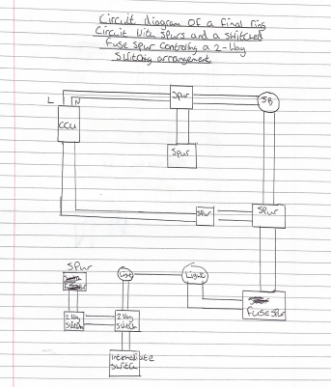

Wiring diagram:
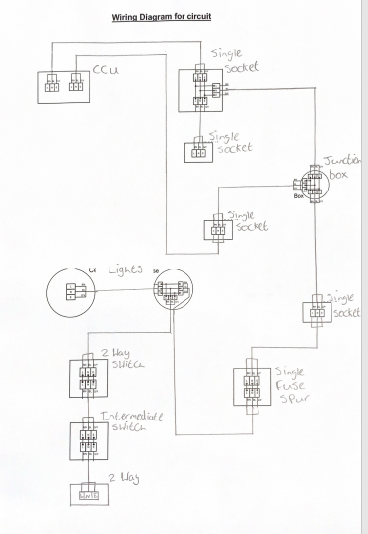

Section B
- Explain why it is important to achieve discrimination between fuses A and B
Discrimination when referring to electrical fuses in a circuit is achieved when a fuse closest to the fault has tripped/blown leaving other fuses/components in the circuit intact. It is very important to achieve this in the electrical circuit shown in fig.1 as the 63A fuse is much higher rated than the 32A fuse, meaning that if both fuses were to operate it would mean a serious fault has occurred and could potentially cause other issues with other parts of the circuit However the 32A fuse should operate first as it is much lower rated.

- Using the appropriate tables from BS7671:2018 and considering the time-current characteristics of fuses A and B, determine the disconnection times caused by a fault current of 300A and state if discrimination is achieved.
Time current characteristics for a 32A fuse according to BS7671: 2018 state that for a fault current of 300A the fuse should disconnect within 0.1 seconds, however for a 63A fuse the disconnection time is stated as being 1 second if there is a fault of 300A. Based on these disconnection times discrimination between the fuses would be achieved as this shows that the 32A fuse would operate before the 63 A fuse in the circuit.

- Explain what is meant by thermal and magnetic tripping properties with regard to protective devices.

Safety devices used in electrical installations sense imbalances in an electrical load and will cut off an electrical supply if the current exceeds the rating of the safety device, there are also different ratings for different type of electrical loads such as inductive, resistive etc. A safety device that has thermal tripping properties means that the current in the electrical circuit will cause a bi-metallic strip to break contact with the electrical circuit. A bi metal strip is essentially a type of memory metal that will return to it’s given shape under certain conditions, in this case the bi metallic strip is activated by heat characteristics. The bi metal strip once broken will not return to it’s original condition due to a latch holding it in place, this can only be reset by hand. Thermal trips are integrated into a circuit breaker for overload protection. A safety device with magnetic tripping properties uses a magnetic actuator, similar to a solenoid coil and it’s magnetic properties, when current flow becomes too large the magnetic field will cause the magnetic actuator will activate and stay open until it is reset.
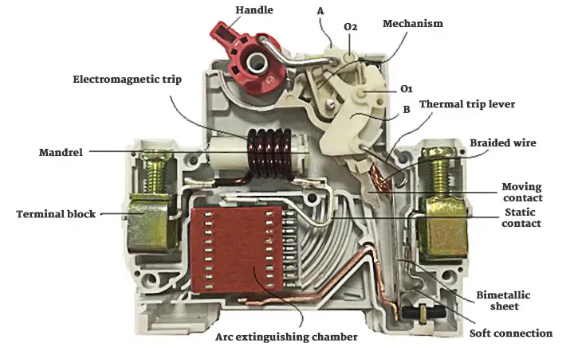

Figure A – Shows the internals of a typical single pole MCB found in a domestic building. The bi metal strip is seen to be used to break contact with the contact, and the electromagnet does the same, this type of circuit breaker has thermal and magnetic tripping properties to protect against overcurrent and overload.

- Figure 2 shows a line diagram that illustrates a typical lighting point controlled by a dimmer switch and protected by a fuse. Make similar line diagrams for the following circuits:
  - Lighting point controlled by two-way switching.
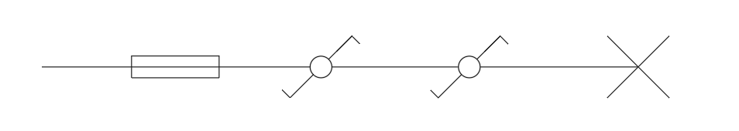

  - Lighting point controlled by two-way and intermediate switching.
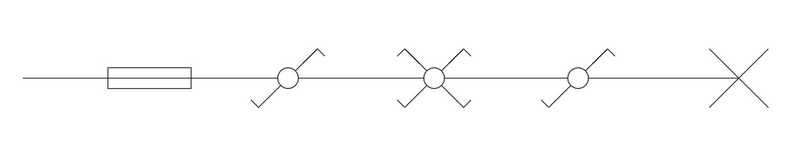

  - Six 13 A BS 1363 switched socket outlets wired as a radial final circuit.
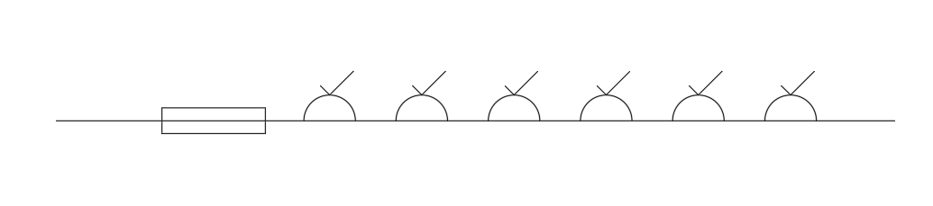

  - Thermostatically controlled heater wired from a double-pole switch.
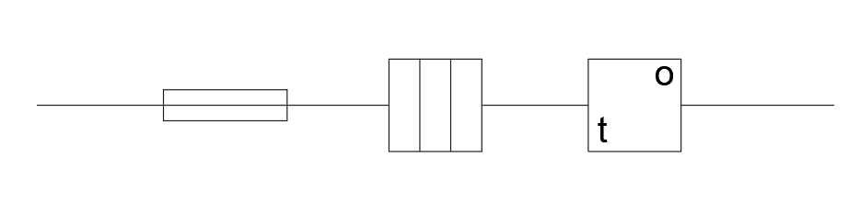

References
Figure A - https://www.google.com/url?sa=i&url=https%3A%2F%2Fwww.quisure.com%2Fblog%2Ffaq%2Fwhat-is-a-miniature-circuit-breaker&psig=AOvVaw16XCKi-KNrjsmuK8BFwqDX&ust=1715969174771000&source=images&cd=vfe&opi=89978449&ved=0CBQQjhxqFwoTCKDCoLrhkoYDFQAAAAAdAAAAABAE
Requirements for electrical installations: IET Wiring Regulations: BS7671:2018 (2022a). London, United Kingdom: The Institution of Engineering and Technology.
MCB (Miniature Circuit breakers) guide (2024) RS. Available at: https://uk.rs-online.com/web/content/discovery/ideas-and-advice/mcb-guide (Accessed: 16 May 2024).

Bibliography

Electric (circuit breaker industries) (no date) CBI. Available at: https://cbi-lowvoltage.co.za/content/thermal-magnetic-principles#:~:text=The%20mechanism%20includes%20a%20bimetal,the%20circuit%20breaker%20to%20trip. (Accessed: 16 May 2024).

Student FEEDBACK FORM

This section details the extent to which the assessment criteria are demonstrated by you, which in turn determines your mark. The marks available for each category of skill are shown. Lecturers will use the space provided to comment on the achievement of the task(s), including those areas in which you have performed well and areas that would benefit from development/improvement.

Generic Assessment Criteria | Marks available | Marks  awarded
1. Engagement with Literature Skills
.
A clear and well-presented assignment. |  | 15
A clear and well-presented assignment. | 25 | 15
2. Knowledge and Understanding Skills

A good knowledge and understanding of electrical technology across the assignment. |  | 15
 | 25 | 15
3. Cognitive and Intellectual Skills

A well thought out assignment. |  | 15
A well thought out assignment. | 20 | 15
4. Practical Application Skills

Transferrable skills are clearly evident and applied across the assignment work. |  | 15
 | 20 | 15
5. Transferable Skills for Life and Professional Practice

The learner has an excellent ‘working’ knowledge of his subject and can transfer his knowledge skills to practical applications very well. |  | 5
 | 10 | 5

Assessment Mark (Assessment marks are subject to ratification at the Exam Board. These comments and marks are to give feedback on module work and are for guidance only until they are confirmed. ) | Late Submission Penalties (tick if appropriate) |  | 65 %
 | Up to 1 week late (40% Max) |  | 65 %
 | Over 1 week late (0%) |  | 65 %

