
Shabana Ali
2326747
BMHP5015 Component 1

Task 1 – Personal Brand
Write about your own person brand and how you could develop this to enable you to reach your employment goals (200 words- 2 referenced sources)
Introduction
Personal branding is all about putting myself on the spot so that my future employees can see my special talents, values and possibilities. Blackett (2004) suggests that a brand conveys an image that will make other people view an individual or organisation. Having a positive and clear personal brand is crucial in the accomplishment of my long-term ambition of becoming a caring and professional Mental Health Support Worker in the NHS.
Body
Compassion, dependability, flexibility, and cultural sensitivity are my pillars in building my personal brand. These attributes would help me to relate well with individuals, express empathy and be composed even in emotionally demanding circumstances. I have been able to build confidence in interacting with people with different backgrounds through volunteering in community mental health awareness programmes and upholding empathy and confidentiality. My peers and tutors also know me due to the hardworking habit, teamwork and reflection on self-improvement.
I however admit that I still require improvement of my assertiveness and leadership competence especially dealing with complex client cases or when presenting the service users. To strengthen my brand, I will consider pursuing ongoing professional development programs, mentorship programs and time-structured introspection. Pawar and Gandhi (2016, pp.840-847) point out that proper personal branding assists people to gain credibility, trust, and pursue their career growth in competitive markets.
Conclusion
Through ongoing enhancement of my confidence, communication, and leadership, I should also be able to present myself as a competent, caring, and trustworthy professional who supports the NHS values and provides quality care.

References
Blackett, T. (2004) What Is Brand. New York: Interbrand.
Pawar, A. and Gandhi, R. (2016) The Power of Personal Branding, International Journal of engineering and management Research, 6(1), pp. 840- 847.
Task 2 - Network Map and Rationale
Create a map of your own network considering career, support, social and community dimensions. Additionally you should provide a supporting rationale explaining and critically assessing this (200 words- 2 referenced sources).
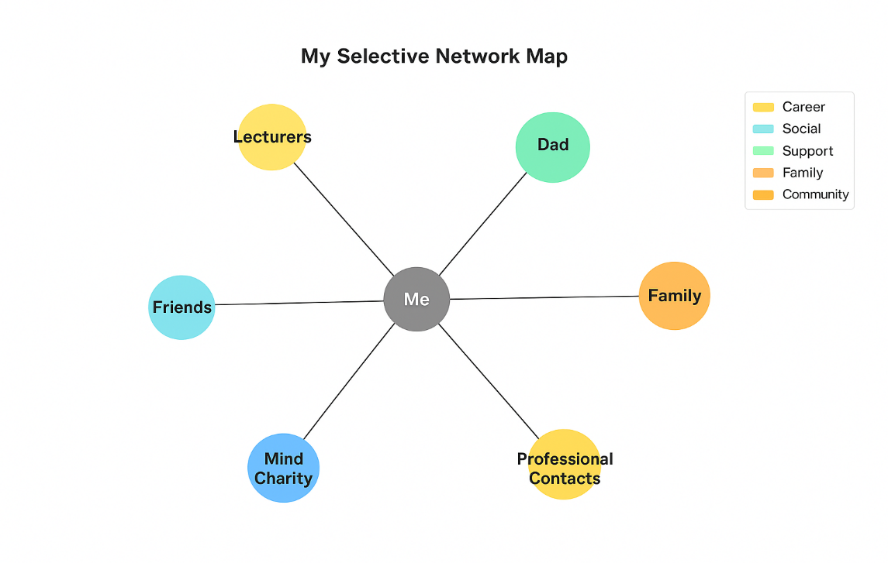
Rationale
My network comprises a wide variety of relationships that are essential in helping me develop personally and professionally. According to Coleman (1990), the social capital is founded on trust, mutual understanding and shared norms, which help people to strive towards achieving a common goal together. Emotional stability, motivation and practical help offered to me by my family enables me to cope with academic, personal, and professional commitments in a well-balanced environment. However, on the contrary, my lecturers and mentors provide guidance and positive feedback that can assist me to move on my way towards becoming a Mental Health Support Worker.
The social interactions like friends help me in my general wellbeing and in my self-confidence as well. They provide support in difficult moments and offer a feeling of belonging which makes one more resilient. Another lesson that has increased my awareness of communities that help individuals in the face of mental health challenges is my volunteer experience with Mind Charity. Working with the individuals who have diverse backgrounds has enhanced my empathy, communication and teamwork skills which are critical attributes in health and social care.
As Phillips and Ellinas (2014) emphasise, going outside the circle of friends and acquaintances and forming bridging relationships, which promote professional advancement, is a possible option. Thus, I will keep widening my contacts via professional social networking tools, like LinkedIn and the NHS Learning Hub, and participate in workshops and other local health-related conferences to enhance my visibility and professional identity.
References
Coleman, J. (1990) The Foundations of Social Theory. Cambridge: Harvard University Press.
Phillips, S. and Ellinas, S. (2014) The Complete Guide to Professional Networking: The Secrets of Online and Offline Success. London: Kogan Page.

Task 3- Blog
Write a blog exploring a current topic or issue of your choice within the health and social care sector in the UK. The purpose of this is to inform a specific target audience of your choosing (300 words)
Empowerment of Mental Health Support Services in the UK
Mental health support is still on the increase in the UK, especially after the COVID-19 pandemic. Increasing cases of anxiety, depression, and stress among adults and the youth have been a result of social isolation, economic uncertainty, and lack of access to face-to-face services. The lack of funding and chronic shortages of the workforce have amplified waiting queues and decreased access to necessary care. Ford et al. (2021) emphasise that people facing ongoing support depended on the continuity of care to leave them without access to it during the time of severe service disruptions due to the pandemic.
Delays and inconsistency of services also pose emotional and practical pressure to the families and carers. According to the findings of Holding et al. (2022), empathy, effective communication, and frequent follow-up are valued by service users of healthcare professionals. Such results indicate the necessity of further cooperation between the NHS mental health teams, local governments, and voluntary organisations to establish a comprehensive, person-focused model in promoting recovery and long-term wellbeing.
Fresh strategies like online therapy sessions, peer-support groups, and well-being community centres are proving to be effective in increasing access to mental health services. The reduction of stigma and earlier seeking of help by individuals may be promoted by encouraging early intervention, awareness raising, and open discussion of mental health.
To be sustainable, appropriate investment in training, workload, and allocation of resources among the staff must be a regular practice. A better and better supported workforce with adequate training can provide more caring and effective care, burnout can be mitigated, and great service can be maintained. Finally, enhancing the mental health in the UK requires the cooperation on all layers of care, creating interconnections between communities, professionals, and families in an attempt to ensure inclusion, comprehension, and resilience.
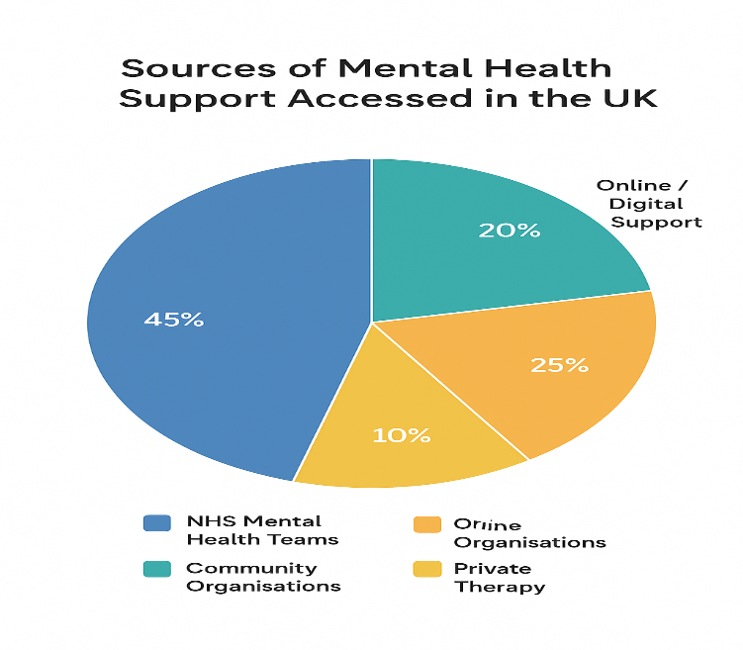
References
Ford, T., John, A. and Gunnell, D. (2021) ‘Mental health of children and young people during pandemic’, BMJ, 372.
Holding, E., Crowder, M., Woodrow, N., Griffin, N., Knights, N., Goyder, E., McKeown, R. and Fairbrother, H. (2022) ‘Exploring young people’s perspectives on mental health support: A qualitative study across three geographical areas in England, UK’, Health & Social Care in the Community, 30(6), pp. e6366–e6375.
Task 4- NHS Equality, Diversity and Inclusion Quiz (250 words equivalent)
- What is the primary goal of the NHS Equality, Diversity, and Inclusion Improvement Plan?
(Answer in one or two sentences.)
This plan is designed to provide a fair inclusive and supportive culture of NHS wherein every employee feels appreciated, respected, and empowered to achieve his or her full potential and lead to better patient care and equal health outcomes in all communities.

- How does the NHS EDI Improvement Plan propose to tackle the gender pay gap?
(Answer in one to two sentences.)
The NHS EDI Improvement Plan embraces openness on pay, systematic mentoring and equal treatment of women throughout recruitments to enable equitable representation of women in senior leadership positions which would help close the gender gap hence establishing lasting equality in careerisation.

- What is meant by the term ‘intersectionality’ as used in the NHS EDI Improvement Plan?
(Answer in one to two sentences.)
Intersectionality acknowledges the interaction of various identities, such as gender, ethnicity, age, and disability, to determine how a person experiences privilege or discrimination in the NHS, which will in turn affect the treatment of the staff and patients.

- Why is it important for the NHS to create a psychologically safe work environment?
(Answer in one to two sentences.)
By establishing a psychologically safe NHS environment, employees can express their concerns and raise innovative ideas and report errors without the fear of judgment, which results in improved teamwork, learning and safer patient outcomes.

- How does the NHS EDI Improvement Plan suggest improving the experience of internationally recruited staff?
(Answer in one to two sentences.)
The plan provides the support of the internationally recruited personnel according to fair treatment, similarity extremities to training, cultural enlightenment programmes which advance it to a sense of inclusion and enables foreign workers to adapt effectively to the NHS setting.

- What role does leadership play in advancing EDI objectives according to the NHS Improvement Plan?
(Answer in one to two sentences.)
Depending on their behaviours, policies, promotion of diversity objectives, and development of a culture of accountability, leaders can be very essential in ensuring equality within the NHS workforce.

- Identify one way the NHS EDI Improvement Plan aims to reduce health inequalities within the workforce.
(Answer in one to two sentences.)
The strategy will help in narrowing the divide by making promotion, support of wellbeing and professional development opportunities fairly accessible to all staff, particularly to the underrepresented and marginalised staff groups within the NHS.

- Why does the NHS EDI Improvement Plan emphasise the importance of collecting and analysing data on protected characteristics?
(Answer in one to two sentences.)
The collection and analysis of equality information on the characteristics that are protected will assist the NHS in identifying equality gaps, monitoring progress and taking evidence-based steps that reinforce equality and inclusion within all departments.

- Explain how flexible working policies can contribute to equality and inclusion in the NHS workforce.
(Answer in one to two sentences.)
Flexible working policies are inclusive as they enable employees to juggle between their personal commitments like caring responsibilities, as well as maintain productivity and wellbeing, which, in the end, increases the morale and retention of the staff.

- What is one strategy mentioned in the NHS EDI Improvement Plan to combat bullying and harassment in the workplace?
(Answer in one to two sentences.)
NHS has zero-tolerance, available reporting systems, and staff training to resolve bullying and harassment to make sure that every employee enjoys a caring and respectful culture at work.
Task 5- A Letter to Yourself
Think of a time in the past when you may have been experiencing issues or difficulties, and after considering what you have learned in this module about emotional intelligence and resilience write a letter to your younger self explaining how these attributes were important at that time and perhaps how developing these areas could have been useful (250 words)

Dear younger me,

I recall how confused and overwhelmed you were in a bid to balance studies, family and emotional health. You would tend to conceal your stress knowing that being quiet or seeming tough would lessen the problem. Now, I can see that building emotional intelligence and resilience would have made you better prepared to handle such situations, making them less dramatic.
According to Serrat (2017), emotional intelligence refers to the skill to identify, comprehend, and control your feelings and those of other people. Had you known this before, then you could have taken a moment to think, express yourself, and get someone to support you rather than taking everything to yourself. Through empathy as well as enhancing your communication, you might have created closer, more trusting relationships with the people surrounding you and could have mitigated on avoidable stress.
According to Skills for Care (2016), resilience refers to the ability to overcome the challenges and respond positively to change. Any challenge that you faced, either in school or in your personal life was a lesson that you could learn and come out even tougher. Had you realised your improvement, rather than perfection, you would have known how able you were.
Never forget that, expressing feeling and seeking assistance is courageous behavior and is not a sign of weakness. Through emotional intelligence, patience, and resilience, you will be able to move on to new experiences confidently, kindly, and willfully.

With care,
Your Future Self

References
Serrat, O. (2017) Understanding and Developing Emotional Intelligence.
Skills for Care (2016) Building your own resilience.

Task 6- GANTT Chart (200 words equivalent)
Compile a Gantt chart which illustrates the tasks you have to complete to achieve your future employment goals
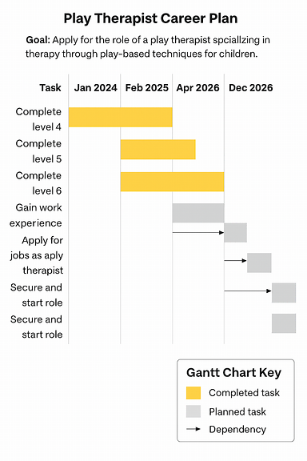
Analysis
This career map indicates precise and attainable targets of my professional objective. Every stage develops practical skills and experience by volunteering, professional training and networking. It will be beneficial to have a monthly review to make sure that progress is consistent. Being able to manage time, adjust and be confident will help me to easily adapt to the NHS environment as an effective and driven Mental Health Support Worker.

Task 7- Making Changes- Report
You are the manager of a care home and want to make changes your workplace. Identify one specific change that you want to implement and write a brief report on how this is going to be achieved considering the necessary skills needed and addressing possible barriers to success. Relevant change models can be highlighted (250 words- 2 referenced sources).
As the supervisor of a care home, I would like to propose the implementation of digital incident reporting to substitute the existing paper-based system. Such an alteration will increase the accuracy of records, communication between employees, and eventually, the safety and responsibility of residents throughout the home.
Application of Kotter (1995) eight-step model of change is a clear way of implementing this transformation. The former can be achieved by creating an issue of urgency by pointing out how manual records might slow down responses and augment the number of mistakes made. A guiding coalition of senior carers will be formed to spearhead the change to serve as role models. The following levels will involve creation and communication of a clear vision that emphasises on the improvement of safety through effective and clear reporting. Employee development courses will be organised to make them confident and accustomed to the digital platform.
Short-term wins (e.g., decreased reporting time) will be celebrated to ensure the engagement, and frequent feedback meetings will allow highlighting the challenges at their very beginning. Limited digital literacy or technology fear can be listed among some barriers; they can be alleviated with the help of mentorship, patience, and continuous support. Leadership and communication are crucial in the implementation of new practices in the workplace culture as indicated by Kotter (2011).
Such a program will contribute to not only the increase of operational efficiency but also the empowerment of employees to assume ownership of quality care and make sure that all incidents are addressed promptly, in a transparent and professional manner.
References
Kotter, J.P. (1995) ‘Leading Change: Why Transformation Efforts Fail’, Harvard Business Review.
Kotter, J.P. (2011) Leading Change. Boston: Harvard Business Press.
Task 8- Self-Reflection
Using one of the highlighted models of reflection, reflect on what you have learned about yourself during this module ,as well as the knowledge you have gained, and explain how this has developed your skills and informed your future practice (250 words- you must reference the model you use)
Embarking on the use of Gibbs Reflective Cycle (1988) has enabled me to be able to analyse my learning experience during this module and how reflection brings about personal and professional development.
Description
In the course, I was engaged in self-awareness, emotional intelligence, networking, and employability activities. These assignments have made me become aware of the ways the theory can be used in actual workplace environments and the way reflection can be used to improve.
Feelings
Initially, I was confused with the process of self-assessment and bare personal experience. In the process, I came to feel more confident in sharing my ideas and realising my strong and weak sides without feeling embarrassed.
Evaluation
The personal branding and resilience exercises were also the most beneficial to me since they led to the enhancement of my self-confidence and the realisation of the ways of managing the challenges in a positive way. The experiences were valuable as they increased my drive and equipped me with the future professional obligations.
Analysis
Reflectively, I have acquired that adaptability, empathy, and communication are the relevant qualities in health and social care. Understanding the necessity of self-control and positive feedback has helped me to be more conscious of my communication with other people.
Conclusion
This module has demonstrated to me that under constant learning, it is important to take self-assessment on a regular basis and be prepared to change.
Action Plan
I will keep using Gibbs model to assess my experiences, track my progress and make realistic goals to ensure that I will continually develop professionally towards achieving the set goals of being a confident and compassionate Mental Health Support Worker.

References
Gibbs, G. (1988) Learning by Doing: A Guide to Teaching and Learning Methods. Oxford: Oxford Polytechnic.

Reference List
Blackett, T. (2004) What Is Brand. New York: Interbrand.
Pawar, A. and Gandhi, R. (2016) ‘The Power of Personal Branding’, International Journal of Engineering and Management Research, 6(1), pp. 840–847.
Coleman, J. (1990) The Foundations of Social Theory. Cambridge: Harvard University Press.
Phillips, S. and Ellinas, S. (2014) The Complete Guide to Professional Networking: The Secrets of Online and Offline Success. London: Kogan Page.
Ford, T., John, A. and Gunnell, D. (2021) ‘Mental health of children and young people during pandemic’, BMJ, 372.
Holding, E., Crowder, M., Woodrow, N., Griffin, N., Knights, N., Goyder, E., McKeown, R. and Fairbrother, H. (2022) ‘Exploring young people’s perspectives on mental health support: A qualitative study across three geographical areas in England, UK’, Health & Social Care in the Community, 30(6), pp. e6366–e6375.
Serrat, O. (2017) Understanding and Developing Emotional Intelligence. Available at: https://www.researchgate.net/publication/318018981_Understanding_and_Developing_Emotional_Intelligence (Accessed: 23 May 2024).
Skills for Care (2016) Building your own resilience. Available at: https://www.workingwellglos.nhs.uk/wp-content/uploads/2019/01/Building-your-own-Personal-Resilience.pdf (Accessed: 23 May 2024).
Kotter, J.P. (1995) ‘Leading Change: Why Transformation Efforts Fail’, Harvard Business Review.
Kotter, J.P. (2011) Leading Change. Boston: Harvard Business Press.
Gibbs, G. (1988) Learning by Doing: A Guide to Teaching and Learning Methods. Oxford: Oxford Polytechnic.

