Material engineering
plastics in civil engineering
Morgan Davies
1910276@student.uwtsd.ac.uk

Table of Contents
Section 1: Introduction/ mechanical, physical and chemical uses of plastics 2
Section 2: Waste plastics in road construction 5
Section 3: plastics practicality and functionality 8
Section 4: Conclusion 9
Section 4: Bibliography 10

Section 1: Introduction/ mechanical, physical and chemical uses of plastics

Plastics has thousands of uses, its versatility, and virtual indestructability, practically unmatched in the world of synthetic materials. An estimated 8.3 billion tons of plastic has been produced since the 1950s, only the 9% of it has been recycled.

Physical properties of plastic within civil engineering projects

The success of plastics as an engineering material all depends on the type of plastic that’s being used. There are some general properties of plastic which are essential for knowing which plastic is best to use within a certain part of a civil engineering project for example, appearance, dimensional stability, durability, electric insulation, finishing, recycling of plastics, strength, weather resistance etc.
Appearance is one of the most important aspects of plastic. There are many available plastics which are transparent, coloured. Pigments are added to the process of manufacturing of the plastic material to obtain these different properties. This then will give good aesthetics to the structure.
Plastics with sufficient surface hardness are very good as they are longer lasting. Sometimes, plastics are affected by termites and rodents especially in the case of thermo-plastic types.
In construction, plastics are used for electrical insulation, this is because plastics are very good electrical insulators, in construction they are usually used for linings of electrical cables and electronic tools.
Recycling of plastics is one of the biggest problems in our society. This is because disposing plastics cause severe pollution. It is not a serious problem thanks to the recycling property, we can use waste disposal consistently to produce drainage pipes, fencing, handrails, benches, etc.
Plastic is a very strong material. But no plastic has been designed for structural purposes yet. Putting fibrous material into plastics will improve the overall strength. If the strength to weight ratio of plastics is the same as metals than we can’t give preference to plastics due to different reasons for instance, heavy cost, creep failure may occur, sensitive against temperature, etc.
A major problem about using plastics within a construction project is its exposure to light and temperature. The ultraviolet rays given off the sunlight make plastic go brittle. The way to avoid this is by adding pigments and fillers which then absorbs or reflects the UV to the surface.

Mechanical properties of plastic within civil engineering projects

Plastics with good mechanical properties
(Plastics with good mechanical properties | Ensinger, 2020)

- strength- measure of the resistance of a material to external stress.
- stiffness- measure of the resistance of a material to deformation.
- Hardness- measure of the resistance of a material of deformation under concentrated compressive load.
- Toughness- measure of an energy absorption of a material during impacts.

Properties can be compared with different products by using different test method. Tensile strength load and tensile strength can be determined accordingly by briefly applying load in one direction with a tensile test. The results and values observed during a test, depending on the materials behaviour as shown in the graph below;
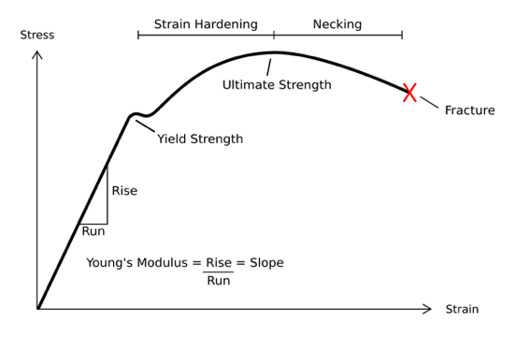 (Kirkby, 2016)

When the stress of the material reaches the yield point, that material is then no longer able to provide the same amount of resistance for the same increase in applied stress. The strain of the material is then increasing very quickly, as it reaches its ultimate strength, that’s where the stress starts to increase again into the material is fractured.

Tensile and flexural strength are the 2 most commonly used values to compare materials.
TECAMID 6 Gf30 black is one of the plastic materials that are used within a construction project. This type of plastic has 30% glass fibre reinforced. This makes is high in strength, rigity, creep strength, also dimensional stability. This is also very beneficial as it can have a bigger load for higher temperatures. (Plastics with good mechanical properties | Ensinger, 2020)

Compressive strength
Compressive strength gives you the indication of the short-term loading capabilities of different plastic materials. This is measured by applying an increasing force on cylindrical and cubical specimens which are held between 2 plates. While measuring both pressure and elongation, properties and application of polymer composites with many different fibres.
The advantages of having polymer composite materials reinforced with continuous fibres have high strength with a low density, this is superior as it makes it possible to replace steel and aluminium alloys within the design of machines and devices. The resistance to attack by aggressive substances, which imparts to articles made of such material’s long life without the use of protective coatings. The low materials-intensiveness of articles made from them, which makes it possible to reduce the mass and increase the fuel economy of mobile equipment.

Thermoset plastics
Thermoset plastics have replaced many engineering materials due to its phenomenal mechanical and physical properties. This is due to the high flexibility design which is more resistant to high temperatures compared to other types of plastic. Using this plastic is also very cost-effective meaning that this is a very popular type of plastic to use within the construction industry as money is everything. Even though thermoset plastics are the preferred material within construction. It has an unfixable problem, and this is that it cannot be recycled. Another issue about using thermoset plastics is that it is difficult to have a clean surface finish and also unlike thermoplastics, it cannot be remoulded or put back into its original shape.

Thermoplastics
Thermoplastics are on the rise through construction as they are very recyclable, has high impact resistance, remoulded or reshaped, chemical resistance etc. several types of thermosetting plastics are used within construction. One of these being ‘phenol formaldehyde’.
These types of synthetic polymers provide a variety of thermosetting plastics. Also used for decorative, electrical, mechanical and thermal applications. Thermoplastics are very good electrical properties and are used within electrical wiring. It’s very strong and hard in weight.

Epoxy and polyester casting resins
Epoxy resin is a thermoplastic polymer. This is used for flooring, tables as a layer on top of a material. This can be transparent, or coloured but coloured resin is more cost-effective.
Polyester resin is a transparent high-density polymer with phenomenal strength and water resistance. These types of resins can be used for electronic parts with delicate components. These are also very good as they are absorbing any thermal and shock. These types of resins are excellent adhesion to materials like;
- Copper
- Steel
- Brass
- Aluminium

Section 2: Waste plastics in road construction

Using waste plastics within road construction is fairly new as laboratory tests having shown positive outcome for when small pieces of plastics is put into bituminous mixes. By putting waste plastics into these mixes, this results in improved stability, strength and durability. As waste plastics within road construction has only been around for around 20 years no long-term effects are clear yet. The most commonly used plastic waste which are used as an oily coat which goes on top of the aggregate are plastic carrier bags and disposable cups. In terms of construction methods for road construction, the two main methods are the, dry process and the wet process. There are many advantages of using waste plastics in within road construction instead of doing the standard road construction methods:
- Stronger roads with increased martial stability value
- Better resistance towards weather (rainwater)
- No stripping or potholes
- Increased binding and better bonding of the mix
- Reduction in pours and aggregate enhancement, unless running and ravelling
- Ultra-violet does not affect the road even though it has plastics within the mix
- The overall road strength in increased by 100%
- Overall costs of road construction are decreased
- Maintenance costs are very low
- Disposal of waste plastics will be less of an issue
There are many different processes for the making of plastics, one which can mass produce different designs of plastic is the injection moulding process.
The injection moulding machine consists of a heated barrel equipped with a reciprocating screw (driven by a hydraulic or electric motor), which feeds the molten polymer into a temperature controlled split mould via a channel system of gates and runners.
(injection moulding, 2020)
Small pieces of polymer plastics are put into the heater where they will be melted down ready to be moulded into the shape. As stated, this type of process has a very high volume of productivity.
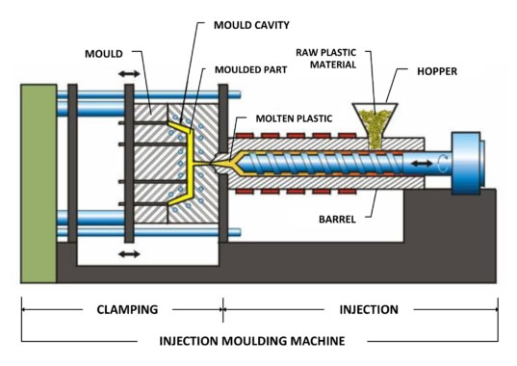
(Automation, 2019)

As you can see from this picture, the plastics would be placed into the ‘hopper’ where it would be heated up within the barrel, once heated the plastic would be pressed into the mould and the product would be finished.

Dry process
In the dry process, processed waste plastic is shredded and then added to a hot aggregate. The Indian road congress indicates that shredded waste plastic size should preferably be 2mm-3mm in spread and coating of an aggregate. Dust and other impurities should not exceed 1%. The shredded plastic waste is then placed within the aggregate which is then heated to around 170 degrees Celsius. Shredded waste plastics soften and melts to form a coasting around the aggregates. Within production, the bitumen is heated to around 160 degrees Celsius and plastic-coated aggregates are mixed within the bitumen and then this would be ready for use within road construction. A lab has stated that the shredded waste plastics within the bitumen mixes are to be between 5%-10%of the weight in the mix, this shows how much plastic is being used within road construction, most of these plastics being thermoplastics due to its recyclability and overall strength. ‘Mishra and Gupta’ saw marked improvements in various parameters such as Marshall stability and indirect tensile strength for the outputs from using the dry process compared to the wet process. The dry process also shows higher resistance to withstand at higher loads and to resist deformation, meaning that the stiffness of the bitumen mix has the ability to resist when cracking or fatigue from the load. Due to the bitumen mix that is used for this method of road construction, this can form flexible pavements. Flexible pavements are the ones that bend and can be shaped to suit the style or shape of the road over a smaller area. UK company MacRebur converts waste plastics into pellets and adds them to an asphalt of bitumen mix before heating the mix between 160 and 180 degrees Celsius, waste plastic pellets melt and fully homogenise to form a part to the bitumen mix.

Wet process
In terms of road construction, the wet process is significantly different to the dry process as there are less steps to the method. The way this type of method is done is by using processed plastic, which is in a powder form, this powder is then added to a hot bituminous mix. The powdered waste plastic is then directly mixed in with the bitumen before adding them to the aggregates. It has to be ensured that they’re in an even mix of plastics and bitumen. The reason for this is that the plastics increase the strength and hardness of the bitumen making it more durable and also more cost effective for the contractors. The temperature range for this method is 155 to 165 degrees Celsius, with a 6%-8% of waste plastic powder within the bitumen mix.

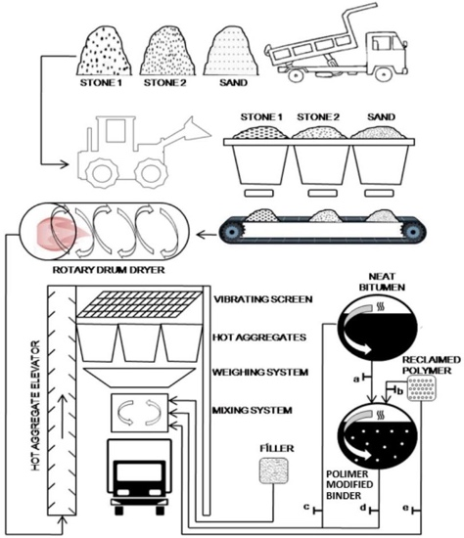 Source: Brasileiro, Luzana; Moreno-Navarro, Fernando; Tauste, Raúl and Rubio-Gámez, Maria. 2019.

This is a diagram of how the wet and dry processes in an asphalt plant, sand and stone are moved from plant, into a rotary drum dryer where the stone and sand would be heated and rotated until dried, after the stone and sand is dried, it is placed into a hot aggregate elevator, one the aggregate has been heated it is placed into a mixing system where bitumen and plastics are then mixed together to form the new aggregate, which is then ready to be used for road construction.

International use of plastics within road construction
Plastics within road construction in somewhere like India is very common. India has promoted the use of waste plastic materials in bituminous mixes for the construction of its national highways and rural roads for many years. It has an approved default mode of periodic renewal with hot mixes with roads within 50km periphery of urban areas with a population of around 500,000. Since the year 2002. Waste plastics have been used to construct more than 2500km of roads which the functionality of the roads was very well, no potholes or ravelling would occur for up to 10 years. on the roads due to its use of waste plastics. The poor binding between the aggregate and the bitumen mix is one of the biggest reasons for such defects in standard road construction but binding between a plastic-coated aggregate and bitumen is significantly stronger compared to a normal standard road construction technique. (Using waste plastics in road construction, n.d.)

Plastic Bike track- Netherlands
In the Netherlands, a company are testing out a road which is made completely from plastics (mostly recycled). This plastic road is put together like pieces of Lego where they would be clicked into place. These roads are manufactured within a factory, so when they are done, it is ready for use. The road is used so that pipelines and cables are installed under the surface so that there would be better internet around the area, the expected lifetime of a plastic road is 3 times longer compared to a normal constructed road. There is only one prototype for this invention, this is in a small town in Holland where a cycle track of around 30 meters is being tested, within this 30-metre road there are sensors which are checking how the road reacts under different circumstances like weather resistance. (Dermentzi, 2018)

Section 3: plastics practicality and functionality

Plastics practicality
Most plastics that are used on a day to day bases are recyclable, this means the reduction in waste, lowering greenhouse gas emissions and also, it’s a material that is used in energy saving when at home, work and on the road. Plastics are used more than any other material as its very easy to manufacture, its cost effective, some plastics are good electrical conductors, resistant to shock, corrosion and chemicals. Its practicality is very useful as they’re so many different types of plastics and work differently as well where you’d have plastics which are stronger than others, you have smart materials like polymers with mould into a shape that’s needed. Most of these materials are recyclable which is very good as it lowers pollution levels.

Functionality of plastics
there are many different functionalities for plastics as there are so many different types. An example is PVC. PVC is used widely across the construction industry but most in housing. This is because of its durability and toughness, it is used within flooring, windows, doors, etc. this type of plastic can be transparent or coloured, it can also be shaped as it is very rigid and flexible, this plastic is a very good electrical insulator and that’s why it’s used widely within housing. What’s the problem with PVC?
The problem with PVC is that it is very damaging against the environment as it gives out toxic gases. This can result in bad health conditions such as cancer.

Section 4: Conclusion

In my opinion I believe that plastics being used within the construction industry wouldn’t work for beams or planks as the plastics would deform under the stress from the weight of the building. Plastic is also not as strong as materials like wood, steel and concrete. Constructing with plastic would also make it very hard to nail, screw and drill as it would break.
On the other hand, I believe that plastic is a very advantageous material within housing. It is more cost effective to use plastics like PVC, it is also light, flexible and a good electrical insulator, etc. I also believe that road construction is the way forward as it would play a massive part in reducing waste disposal, also reducing pollution. There is evidence that proves that using plastics in road construction lowers the risk of potholes, this is whether you add plastic to an aggregate or if the road is entirely constructed out of plastics. Using plastic roads is also safer as the roads are slip-proof.

Section 4: Bibliography

Assets.publishing.service.gov.uk. n.d. Using Waste Plastics In Road Construction. [online] Available at: <https://assets.publishing.service.gov.uk/media/5d41b34040f0b60a86a5e5dc/595_Use_of_Waste_Plastics_in_Road_Construction.pdf>

Automation, R., 2019. Robotics In Injection Moulding - RNA Automation. [online] RNA Automation. Available at: https://www.rnaautomation.com/blog/robotics-in-injection-moulding/

Bpf.co.uk. 2020. Injection Moulding. [online] Available at: <https://www.bpf.co.uk/plastipedia/processes/Injection_Moulding.aspx>

Dermentzi, M., 2018. This Bike Path Paves The Way For Future Roads Made From Recycled Plastic. [online] Mashable. Available at: <https://mashable.com/video/recycled-plastic-road-bike-path-netherlands/?europe=true> [Accessed 19 November 2020].

Ensingerplastics.com. 2020. Plastics With Good Mechanical Properties | Ensinger. [online] Available at: https://www.ensingerplastics.com/en-gb/shapes/plastic-material-selection/mechanical-properties

Kirkby, A., 2016. What Happens After Hooke’S Law Is Not Obeyed?. [online] quora. Available at: <https://www.quora.com/What-happens-after-Hooke’s-Law-is-not-obeyed>
Source: Brasileiro, Luzana; Moreno-Navarro, Fernando; Tauste, Raúl and Rubio-Gámez, Maria. 2019. Reclaimed Polymers as Asphalt Binder Modifiers for More Sustainable Roads: A Review. © 2019 by the authors.
https://www.researchgate.net/publication/330706261_Reclaimed_Polymers_as_Asphalt_Binder_Modifiers_for_More_Sus tainable_Roads_A_Review. Licensee MDPI, Basel, Switzerland. License http://creativecommons.org/licenses/by/4.0/

