Course: masters in business Administration
Marketing Management-Assessment 1(75%)
Module Number: LCMB7001
LECTURER: Tushara Balendran
Student Name: Karishma Vesuwala
Student number:2131314
Submission Date:13/09/22
Contents
1. Introduction 3
2. Company Background – Tesla 3
3. Communication 4
3.1. Definition of Communication 4
3.2. Shannon and Waever’s Communication Model 4
3.3. Integrated Marketing Communication 6
4. Current Marketing Strategies of Tesla 7
5. New Promotional Strategies for Tesla 9
6. Brand and Brand Equity 11
6.1. Brand 11
6.2. Brand Equity 11
6.2.1. Keller’s Brand Equity Model 11
6.2.2. Keller Model applied to Tesla 11
7. Customer Journey 14
8. Customer Touch Points 15
8.1. Pre Purchase Touchpoints 15
8.2. Purchase Touch Points 15
8.3. After Purchase Touch Points 15
9. Customer journey Map of Tesla 16
10. Total Engagement Model 18
11. Conclusion and Recommendations 18
12. References 20

Introduction
The customer satisfaction is the key element for the success of the business and is regarded as the touchpoints that should be aimed to enhance the customer experience. It includes making sure that the customers of the organization are satisfied with the Product, customer support services, retail staff, and marketing content. However, it has been found that the companies overlook some major and key experience of delivering the good while looking only at the customer touchpoint which can also impact the sustainability of the company in the long run (Chylinski and Heller, 2022).
Hence, the report is focused on developing some innovative marketing strategies for the Tesla with the purpose of enhancing its brand awareness and value across the Globe. Further, it focuses on the brand equity of the Tesla along the customer journey through multiple communication channels to make sure that the customers are satisfied with the Brand (Gellert, 2020).

Company Background – Tesla
The Tesla is an American Based company that has its headquarters in the Paulo Alto California. The Tesla is widely known as one of the tech oriented companies that are working on the science, and information and technology combinations. The Company was founded in 2003 in San Carlos, California. The tesla designs and manufactures electric cars, Battery energy storage, Solar panels, Solar roof tiles, and related energy-efficient products and services. Tesla is ranked among the most world’s most valuable companies and is recognized as the most valuable automotive company with abet capitalization of $760 billion (Forbes, 2019). In 2021, the Tesla sold most of the electric and plugin cars to the customers ranging from 21% of electric sold was from Tesla and 14% plugged in cars sold in 2021 were related to the Tesla. The Tesla Energy Subsidiary of the Tesla is one among the top energy storage products and supplied almost 3.99 Giga Watts Hour in 2021. The first electric car production began in 2009 named as roadster that was a sports car followed by Model S, Model X, and Model Y in 2020. Its Model 3 was one of the bestselling car in 2021 with more than 1 million units sold during the year in the category of plug in cars (Tesla, 2022).
The company has retail stores in 665 locations across the countries with more than 664 customer service centers. The key areas of operating of Tesla are North America, Europe, Oceania, East Asia, Middle East, and Southeast Asia. By the end of April 2022, the Tesla was the employer of more than 110,000 employees around the world. In 2021, the Tesla generated revenue of more than $53 billion and its net income was $5.52 billion from the all the markets. The tesla is the parent company of three separate operating brands known as Deep Scale, Tesla Energy, Tesla Grohman Automation (Homepage, Wantara and Tambrin, 2019).

Communication

Definition of Communication
Communication is the word that is derived from the Latin word “communicatio” that has meaning of Sharing or to share. Hence the communication in literal context is the transfer of data and information from one person to another as per Huang, Li and Hsu (2022). According to Kastberg (2022), It is method and channel that is used to convey feelings, values, ideas, thoughts, and facts to the other person. Thus, the communication is defined as the interactive way of exchanging and transferring information from one person to another or from one person to more than two persons that have the awareness of communication and mutual intention of involving in the communication. Hence, the communication system is recognized as the most important element of the human society as it allows the human to be in touch with other people and to exchange words, and speeches (Kitchen and Tourky, 2022).

Shannon and Weaver’s Communication Model
The formal model of communication that was developed in 1949 by Claude Shannon and Warren Weaver. The Communication Model defined by these two people is the basis of some recent and modern theories of communication therefore sometime its referred as the mother of all models of communication as per research study of Li (2022). Hence this model is widely accepted as the main initial model of communication.
In the beginning, it was designed to reflect the functioning of the Telephone and Radio Technology and had four parts including Sender, Message, Channel, and receiver. Where the sender was the part of speaking through the telephone, the message what he was speaking, and channel was the telephone itself and receiver was the part of the telephone through which one can hear the other person as per study of Liang (2022). However, the static background sounds during the communication through telephone was called Noise.
In the modern communication model, the model is based on the concept of signal transmission where the message is encoded to language can be understood by the medium and then the message is decoded into the language that can be understood by the receiver of the message then the receiver provides the responses or feedback to the message and the interruptions in this system are called noise according to Popova et al. (2021), This can be explained with the help of communication more precisely.
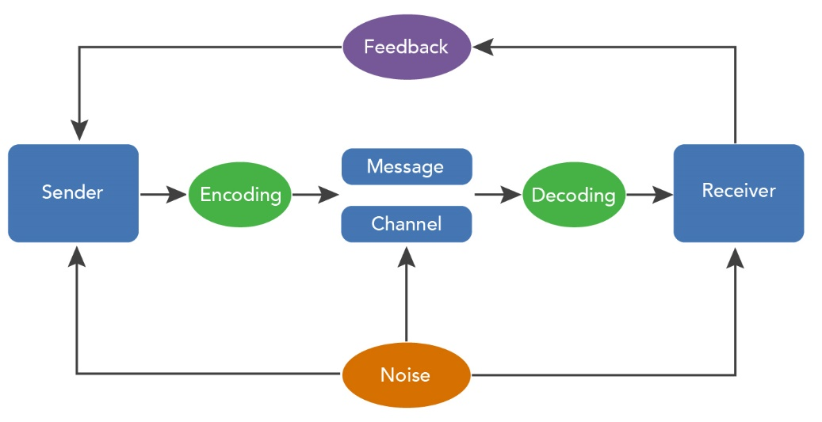
Figure 1: Modern Communication Model
Source: (Kastberg, 2022)
This model can easily be related to the marketing concept of relaying the message to the consumers using this modern communication model linked to Huang, Li and Hsu (2022). The sender are the companies, message is the description of the product, the channel is any communication media such as Social media, smartphones, web interfaces, emails, the receiver is the customer, and customer provides the feedback about the product in negative or positive manner. However, some time the message cannot be relayed to the consumer due to noise in the form of add blockers, and network company’s restrictions over the marketing campaigns as stated by Purani and Jeesha (2021).

Integrated Marketing Communication
The integrated communication is referred to the practices of the marketers that include planning, implementing, controlling, and analyzing the marketing communication contracts, channels, and media that are used to interact with the target audience of the company as per study of Rojas (2020). The days have passed when the companies were bound to use only electronic media and print media to interact with its customers. According to Schweidel et al. (2022),With the advancement in technology, each industry and sector of the economy has affected and communication technology also have evolved into current position where the marketers have multiple options to communicate with the consumers. As per Shen and Zeng (2022), The marketers have become more specialized into interacting with customers through the use of number of communication channels that include smart phones, social media, web marketing with more customized messages and interacting modes as proclaimed by Shen and Zeng (2022). For each segment of customers, there are different communication channels and media is being used to target even the smallest segment of the customers as well as defined by Siddiqui and Ahmad (2022).
As linked to Wodak (2021), this bunch of communication media and channels that are used by the marketers have resulted in the information overloaded which is making the information un clear for the customers to understand and making them confuse about what to do with this large information patterns. Hence, the customer has no choice but to make their own choices and purchase options as referred to Dikanov (2021). To handle this issue, the marketers have come up with the integrated marketing strategies that allow the marketers to use certain content for the certain segment of the customers without leaving them confused and to persuade the customers for making purchasing with confidence as per Pavliv (2021), With the integrated marketing, the companies can streamline their content and media as per the customer values, patterns, and preferences as referred to Kozyubra (2021).

Current Marketing Strategies of Tesla
As per Volgina (2021), It is amazing and surprising to know that the Tesla is one of the largest value holding companies around the world with the market capitalization of $760 billion. In 2021, the Tesla’s model 3 was sold for more than 1 million units around the world. However, it is interesting that the Tesla doesn’t spend on the marketing strategies or any kind of brand endorsement activities of marketing. According to Forbes (2019), The Tesla has adopted Zero Marketing strategy that means it doesn’t spend a penny on the marketing techniques and campaigns endorsed. As per Tesla, the only marketing strategy that is used by the company is the word of mouth and the originator of this word of mouth is Elon Musk who has become the face of the Tesla Company as referred to Homepage, Wantara and Tambrin (2019).
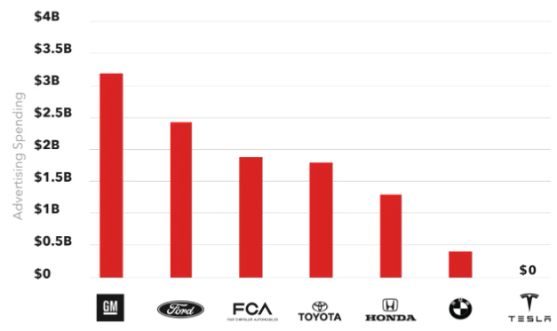
Figure 2: Tesla Advertisement Spend vs Competitors
Source: (Tesla, 2022)
Hence, the Tesla marketing practices are much different from others that are focused on:
Marketing through customer experience – The referral program introduced by Tesla Enables customers to have credit of up to $100,000 and additional accessories and perks. These include “Arachnid Wheels for Model S or 22”, “Turbine Wheels for Model X” and VIP invitation for Tesla events (Wodak, 2021).
Use of Social Media – the Tesla marketing strategy only focused on social media marketing where Elon Musk using his personal account interacts with the Customers and has become the face of the Tesla impacting the brand image and value positively with respect to Shen and Zeng (2022).
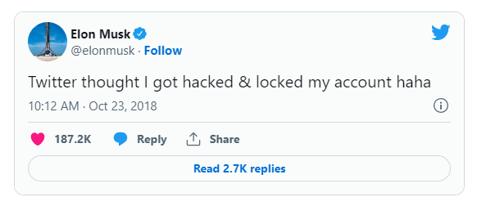
Figure 3: Elon Musk on Twitter
Source: Siddiqui and Ahmad (2022).
Cross Promotional Opportunities – the other companies of the Tesla are also included in the promotional campaigns of the Tesla where the Tesla company SpaceX is often used to promote the products of Tesla Electric Vehicles. The SpaceX launched the Tesla Roadster with dummy driver named “Starman” in 2018 that gained worldwide popularity for the Tesla according to Siddiqui and Ahmad (2022).

New Promotional Strategies for Tesla
The modern promotional methods and techniques have surpassed the benefits and perks of traditional promotion methods with references to Bart and Inman(2022). But as the traditional methods are the basis of modern promotions, the traditional methods cannot be ignored either as described by Stephen (2022). As the tesla is only focused on the word of mouth through social media, there is need to add some more marketing practices into its promotional activities in the form of offline marketing channels explained by Purani and Jeesha (2021).
Business magazines- the customer segment of the Tesla is limited to the people having large income households. Hence, the most of customers fall in the category of business men and women, the Tesla can use business magazine like Business week, and Economists to advertise its new products to the potential customers instead of personal invitations to some existing customers for un veiling of the cars defined by Kitchen and Tourky (2022).
Increasing the stores locations- the Tesla can use the stores for its marketing as well. Although, the Tesla is using its stores and supercharge stations for its marketing but they are limited in numbers like there are only 655 stores are opened in the whole world. The Tesla can partner with agents of different countries having stores to place their Tesla banners and signs across the stores of the potential target market. This can increase the hype of the Tesla before entering into the new market as linked to Li (2022).
The offline promotional methods are best to reach the certain number of customers but In this tech oriented world, the methods arrived that can be used to reach the vast audience in seconds and spending much less. The basis Tesla marketing strategy is the Word of Mouth through the Social Media Channel. But the social media can also be used for further brand awareness to the local countries as well as explained by Kastberg (2022).
Paid Social Media Advertisement- the question arises here why the tesla should spend on Social media when it is already on the top for fan following comparing to other competitors in the market? the answer to increase the brand awareness for the potential markets. There are still some markets that have low awareness of the Electric cars and the name Tesla as proclaimed by Zahay et al. (2022). The Tesla can make sure to advertise its name and purpose through Social Media channels such as Facebook, Instagram, and Twitter. This can help the Tesla to make the Tesla name aware from any corner of the world. Further, a part of investment for future potential markets.
Influencer Marketing – the influencer marketing strategy has become a great tactic to promote the brands products for the niche market. With reference to Tesla (2022), There are multiple influencers of social media and YouTube can be found that has large fan following and using them to advertise and review the products can increase the brand awareness of the Tesla.
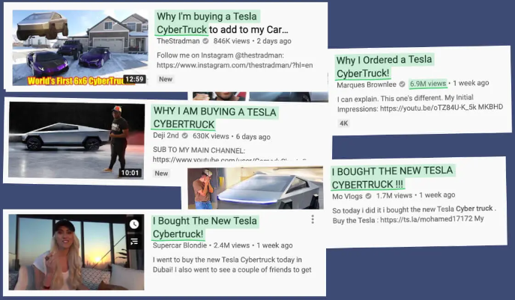
Figure 4: Influencer marketing
Source: (Roberts, 2022)
These influencers have reviewed the Tesla without charging a penny but they have influence on certain customer segment stated by Parker ( 2022). Their services can be obtained to reach the certain customer segment by paying them to review in positive way as some has produced negative opinions about Tesla cars as compared to Competitors that has affected the Tesla brand image.

Brand and Brand Equity

Brand
Brand is referred to name, symbol, element, term, and combination of all to refer to the products and services of one seller than to other sellers in the market as per Barker (2022). The brand of company is one of the valuable assets of the companies and are related to the identification of products and services of a company. The brand is the source of recognition, awareness, and maintaining the business relationships with partners, employees, and customers.

Brand Equity
Brand equity is the brand value and have influence over the relationship of customers with the brand as linked to Chylinski and Heller (2022). The brand equity in other terms is defined as the value of the brand that creates sales based on the brand name irrespective of specifications, features, and benefits of products and services offered by brand as described by Forbes (2019). The brand equity work as marketing for the brand. Customer based brand equity holds the view of high association of brand with the customer and customer can recognize the brand having deep association with it.

Keller’s Brand Equity Model
The American Professor Kevin lane Keller worked on assessing the value the brand holds in the success of the company (Gellert, 2020). Hence, it has developed a resonance model to develop active and loyalty based relationship with the customer using brand.

Keller Model applied to Tesla
The resonance model provided by Keller is based on four elements of branding Brand Identity, Brand Meaning, Brand responses, and Brand relationships as referred to Huang, Li and Hsu (2022).
Brand Identity/Salience
It describes who are you? Tesla brand is known to the world with its core products electric vehicles than any other products offered as referred to Kastberg (2022). The Tesla logo can be identified easily within the industry of Automotive and has unique logo that is also implanted on the Vehicles of the Tesla. Tesla logo is the extraction from the tires.

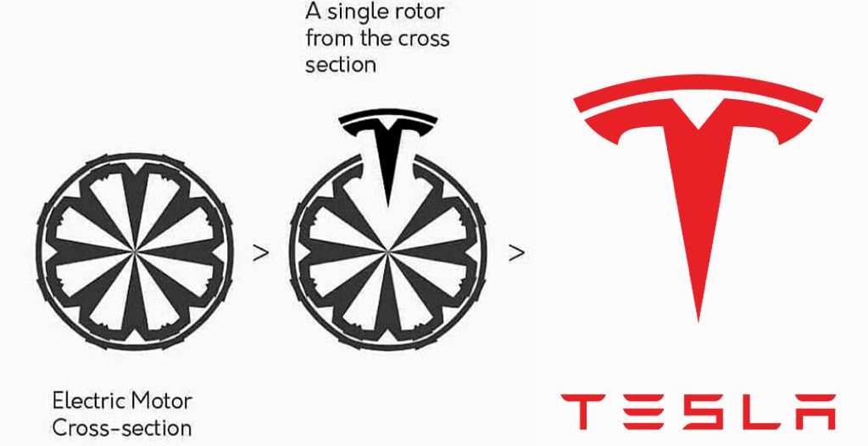
Source: Chylinski and Heller (2022).
Performance/Imagery
Brand performance is referred to what are you? The Tesla products are known to have tech oriented features. The automotive product line is widely recognized for electric and Plugged in cars. further, it is known for environmental friendly products (Kitchen and Tourky, 2022).
Brand Imagery
The elegant design and modern technological integration into the cars is the brand imagery where the auto pilot mode has enhanced the Tesla overall brand imagery worldwide (Huang, Li and Hsu, 2022).
Brand Response
The brand judgements of the customer’s reveal that the products of Tesla are highly appreciated by the consumers for its efficiency in electric vehicles and customer services. it has received positive reviews from the customers. The customers prefer using environmental friendly products hence the electric cars also satisfy the feelings of the customers making the brand responses positive (Liang, 2022).
Brand Relationship
The Tesla has created a profound brand awareness and customer relationships by offering referral programs and interacting with the customers on the social media. The Tesla has highest social media following due to its content and controversy statements. Elon Musk is the face of brand and instead of Tesla the world is more aware of Elon Musk (Rojas, 2020).
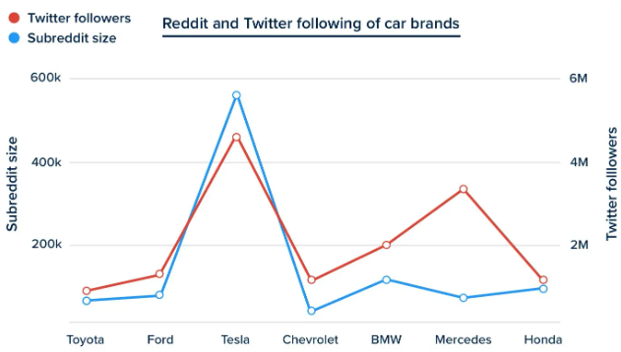
Figure 5: Social media Brand Awareness and Association of Tesla
Source: Chylinski and Heller (2022).
Its space science projects and new electric trucks and yacht projects are creating hype among the customers. Every tweet of Elon Musk is highly shared by the customers and followers.

Customer Journey
The customer journey is defined as the process which the customer follows between identifying a company, and satisfying their need with use of products and services offered by the company. The customer interacts with companies using different channels. However, the customer journey is comprised into 5 stages (Rosario, 2022).
Awareness – the consumer become aware of his/her need of product and service like car. Then they use different channels to get information about the cars brands or cars only such as online or offline channels (Andrews, 2022).
Consideration- after getting information about the products (Cars) offered by different companies, the customer compares the pros and cons and weight them. The features and specifications of one product (Model 3) offered by one brand (Tesla) are compared to other brand products (BMW, Volkswagen).
Decision – at this stage the customer decides to make a purchase from certain brand (Tesla). The customers heavily use (97%) customer reviews of product (Model 3) before making a decision through online channels.
Retention – the critical stage where the customer make inspections of the product delivered and make tests. This is the difficult stage and can be overcome using great customer support service(Libai, 2022)
Advocacy – On declaring the product good to use and excellent, the customer spreads the word of mouth. However, on experiencing the bad experience, the customer spreads the negative word of mouth in the form negative feedback and reviews about the product (Model 3).

Customer Touch Points
The customer touch points are the medium, channels, and ways through which the customer and company interact with each other from stage 1 of customer journey to stage 5. These interactions can be pre purchase, during purchase, and post purchase. The company make extensive efforts to improve the interaction between customer and company by considering the touch points at every stage of purchase (Stephen, 2022). The touch point between Tesla and Customer are as follows:

Pre Purchase Touchpoints
The pre purchase touchpoints are the medium that are used by the customer to get information about the product. For tesla the major source of getting in touch with the company is social media words of mouth and Tesla’s website (Popova et al., 2021). The Words of mouth led the customer to see feature of certain electric car model through Tesla Site and YouTube review of influencers.

Purchase Touch Points
The Tesla stores on 655 locations can be accessed by the customer to experience the physical existence of the brand. Further, staff is expert in making the customer comfortable. The careful test drive is allowed to the customer before making the final purchase decision. After the purchase the customer is asked to subscribe for VIP customers and client membership to get updates regarding maintenance and customer support of car through digital channel (Rojas, 2020).

After Purchase Touch Points
The customer receives email from Tesla about the invitation of new car unveiling. The customer gets some referrals over the purchase of model 3 in the form of turbine wheels. The customer is offered remote truck services in case of problem with the automation of the cars. During the Event of unveiling, the customer can book the car at highest available discounts. (Tesla, 2022).

Customer journey Map of Tesla
This is the best way to understand the customer experience and journey of purchase can be used to touch some touch points of the customer.
Customer Journey | Awareness | Discover | Purchase | Use | Bond
Website |  | 2- Tesla website for more information regarding the Product  Visiting to YouTube influencers to look at their experiences
Magazines
Stores |  |  | 3- Tesla Stores located at 655 locations around the world
Social Media | - Looks for new products, and customer reviews about the product |  |  |  | 5- expressing reviews negative or positive
Web Forum |  |  |  |  | 6- expressing their overall thoughts
The Product |  |  |  | 4- use the product and make tests  Efficiency in electricity use  Quality of the product
Source: (Tesla, 2022)

Critical Evaluation of Customer Map of Tesla

Weaknesses
The Tesla company has Zero Budget for the marketing yet they have high engagement with the customers. The reason is the social media electronic word of mouth and influencer marketing. The scandalous statements made by Elon Musk trigger the debate on the social media sites especially at the Twitter. The Customer Map of tesla has the weak point that customers have only three major source of getting information for the Tesla products; Social Media eWOM, Tesla Site, and vloggers vlog. Two of them are reliable while Tesla Site information is more like Corporate information about their products. Here, it is notable that because there is no other channel that could be utilize to get information, the Customer find it less reliable and effective to make a purchase decision.

Strengths
However, the Positive Points are that the Tesla creates hype of eWOM that itself is most reliable source of getting authentic and reliable information for the products and other services of Tesla. eWOM is not controlled by any corporation and users from all over the world creates and share the information. So, the customers are more likely to rely on users reviews and feedbacks while making decisions. As per reports, the eWOM has 93% conversion rate.

Total Engagement Model
The customer engagement is referred to complete guide to the customer during the customer journey by creating, maintaining, and strengthening the customer relationships. The total engagement model helps the company in their effort to create, maintain, and strengthen the customer relationship by interacting through different elements such as Advertisement, Products, Services, and company culture, etc.
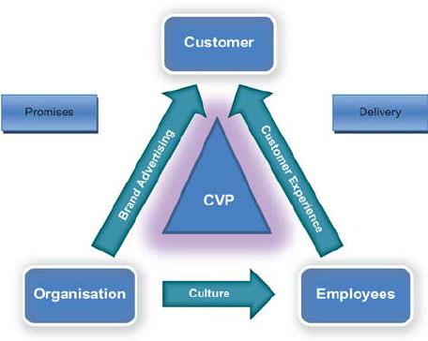
Figure 6: Total Engagement Model
Source: (Thomaz, 2022)
The model provides the key information that the engagement is not only focused on the customer but organizations and employees have crucial role in enhancing the customer engagement (Longoni, 2022). The Tesla offers a premium brand quality and promises to be met at all cost in terms of mileage of the cars and technological durability of its electric vehicles. The employees at the Tesla work their best to improve the customer experience through touch points at the stores of the Tesla. The premium atmosphere and ambiance of the stores enhance the customer experience. Further, the comfortable purchase is the key element where the customer is allowed to make test drives as many as they want before making a final purchase (Kupor and Chen, 2022). The organization uses the social media for electronic word of mouth to reach the customer. Elon Musk uses his personal account for the promotion of company products.

Conclusion and Recommendations
The Tesla has entirely focused on the electronic word of mouth for the promotion of its products ignoring the certain online modern marketing tactics. The company is doing good in terms of marketing area but the certain recommendation can enhance its performance for the potential markets:
- Influencer marketing can be great way to enhance the word of mouth as influencers have great influence over the purchases these days.
- The business magazines can be great tool for the Tesla to introduce their products to the business men and women.

References
Chylinski, M. and Heller, J. (2022). The customer loyalty journey - technology enabled loyalty touchpoints. [online] www.elgaronline.com. Edward Elgar Publishing. Available at: https://www.elgaronline.com/view/book/9781800371637/book-part-9781800371637-9.xml [Accessed 26 Aug. 2022].
Forbes (2019). Tesla on the Forbes World’s Best Employers List. Forbes. [online] Available at: https://www.forbes.com/companies/tesla/.
Gellert, R. (2020). Comparing definitions of data and information in data protection law and machine learning: A useful way forward to meaningfully regulate algorithms? Regulation & Governance. doi:10.1111/rego.12349.
Homepage, J., Wantara, P. and Tambrin, M. (2019). ITHJ International Tourism and Hospitality Journal The Effect of Price and Product Quality Towards Customer Satisfaction and Customer Loyalty on Madura Batik. [online] International Tourism and Hospitality Journal. Available at: https://rpajournals.com/wp-content/uploads/2019/02/ITHJ-2019-01-14.pdf.
Huang, H.Y., Li, H. and Hsu, Y. (2022). Coping, COVID knowledge, communication, and HBCU student’s emotional well‐being: Mediating role of perceived control and social connectedness. Journal of Community Psychology. doi:10.1002/jcop.22824.
Kastberg, P. (2022). Modelling Knowledge Communication as Co-Actional Communication. Perspectives on Knowledge Communication: Concepts and Settings. [online] Available at: https://vbn.aau.dk/en/publications/modelling-knowledge-communication-as-co-actional-communication [Accessed 26 Aug. 2022].
Kitchen, P.J. and Tourky, M.E. (2022). Integrated Communication or Integrated Marketing Communication. Integrated Marketing Communications, pp.69–87. doi:10.1007/978-3-030-76416-6_5.
Li, Z. (2022). Accurate Digital Marketing Communication Based on Intelligent Data Analysis. Scientific Programming, 2022, pp.1–10. doi:10.1155/2022/8294891.
Liang, J. (2022). A Case Study of Marketing at Tesla Based on the 4V Theory. Proceedings of the 2022 7th International Conference on Social Sciences and Economic Development (ICSSED 2022). doi:10.2991/aebmr.k.220405.161.
Popova, T.S., Dikanov, M.Yu., Pavliv, A.I., Kozyubra, T.I. and Volgina, S.V. (2021). Innovative Marketing as a Tool to Improve Sustainable Business Development in a Pandemic. Сooperation and Sustainable Development, pp.1281–1287. doi:10.1007/978-3-030-77000-6_148.
Purani, K. and Jeesha, K. (2021). Community based brand equity as brand culture: advancing brand equity conceptualization for a connected world. AMS Review. doi:10.1007/s13162-020-00189-2.
Rojas, F. (2020). Council Post: Eight Digital Marketing Lessons We Can Learn From Tesla. [online] Forbes. Available at: https://www.forbes.com/sites/forbesagencycouncil/2020/12/10/eight-digital-marketing-lessons-we-can-learn-from-tesla/.
Schweidel, D.A., Bart, Y., Inman, J.J., Stephen, A.T., Libai, B., Andrews, M., Rosario, A.B., Chae, I., Chen, Z., Kupor, D., Longoni, C. and Thomaz, F. (2022). How consumer digital signals are reshaping the customer journey. Journal of the Academy of Marketing Science. doi:10.1007/s11747-022-00839-w.
Shen, C. and Zeng, Q. (2022). Research on the Marketing Communication Strategy of Tesla Motors in China under the Background of New Media. [online] www.atlantis-press.com. doi:10.2991/aebmr.k.220307.155.
Siddiqui, K.A. and Ahmad, S. (2022). Brand equity trend analysis for top auto brands on Interbrand’s 20-year longitudinal data. Journal of Brand Strategy, [online] 10(4), pp.358–376. Available at: https://www.ingentaconnect.com/content/hsp/jbs/2022/00000010/00000004/art00005.
Tesla (2022). About Tesla. [online] Tesla. Available at: https://www.tesla.com/about.
Wodak, R. (2021). Crisis communication and crisis management during COVID-19. Global Discourse. doi:10.1332/204378921x16100431230102.
Zahay, D., Roberts, M.L., Parker, J., Barker, D.I. and Barker, M. (2022). Social Media Marketing: A Strategic Approach. [online] Google Books. Cengage Learning. Available at: https://books.google.com/books?hl=en&lr=&id=iv9UEAAAQBAJ&oi=fnd&pg=PP1&dq=Paid+Social+Media+Advertising+as+marketing+strategy&ots=7EJqydOK3o&sig=v5DYLdCEnQSg2Oz1ZpC8zz3J7EQ [Accessed 26 Aug. 2022].

