Menu
Hotel Trinity
Trinity Restaurant

MIHAELA TEODORESCU
ID NUMBER: 2233479
MODULE TITLE: Food & Beverage Operations BMIH4002
LECTURER: Jaliya De Silva
WORD COUNT : 398

In a restaurant, the menu is a list of food and drinks offered to customers and the prices. A menu can be à la carte – presenting a list of options for customers to choose from – or table d'hôte.
In the present case, the concept of a restaurant with an à la carte menu is introduced in the Trinity hotel chain. A casual concept or family-style restaurant. Prices are higher than fast casual, food is served on regular tableware (as opposed to disposable), and guests get full table service. For this concept, for the Trinity restaurant, the target audience are consumers who serve dinner in the city, prefer fresh and natural ingredients, give importance to the sustainability of the business and the company's values, such as Millenials but also Generation X consumers who value family restaurants or don't have much a lot of experience in the online world.
The importance of the menu in a restaurant is practically the restaurant's business card.
Therefore, a Trinity Restaurant menu must be well structured and take into account some very important aspects such as: the menu must be original, be versatile, the products must have the correct prices, the products presented on the menu must be easy to prepare, the menu must have a format that is easy to read and manipulate and periodically updated, information on the nutrition and weight of the products, including the allergens used.
The reasoning behind choosing this menu is diversification, offering a range of menu options. This increases the likelihood that customers will find a dish to their taste, thus we can address a wider audience, and the chances of customer satisfaction can be improved. Customers rely on environmental impact, especially for restaurants, means a conscious effort to reduce environmental impact by reducing food waste, excess packaging, utility consumption and a commitment to shorten the supply chain, to recycle and support sustainable food production.
Another importance of the restaurant is the location and arrangement of the space. Wall color, lighting, furniture, table setting, music and decor all play an important role in the overall impact of the restaurant, even if the food needs to be the focus.
Considering all the aspects listed, with reference to the target audience, the concept of the restaurant or the sustainability of the business, the a la carte menu of the Trinity restaurant, from the Trinity hotel chain, is presented below.

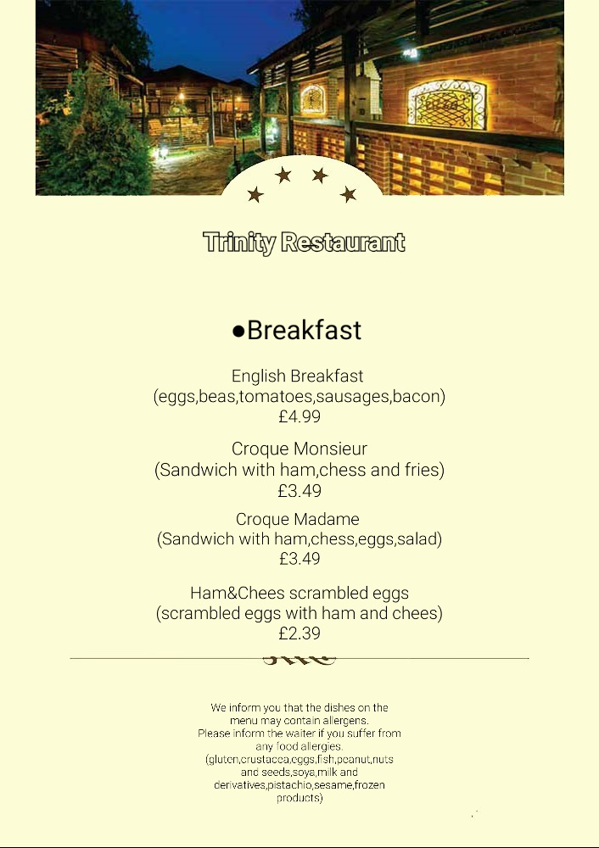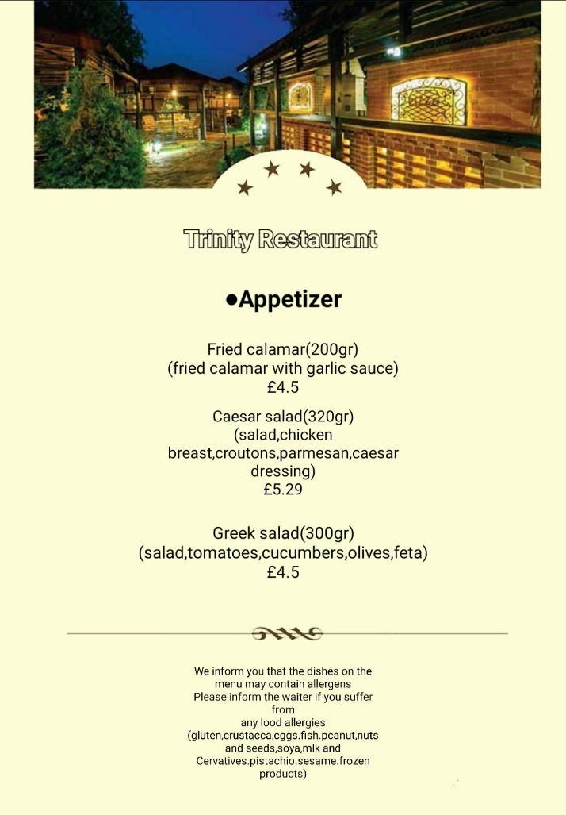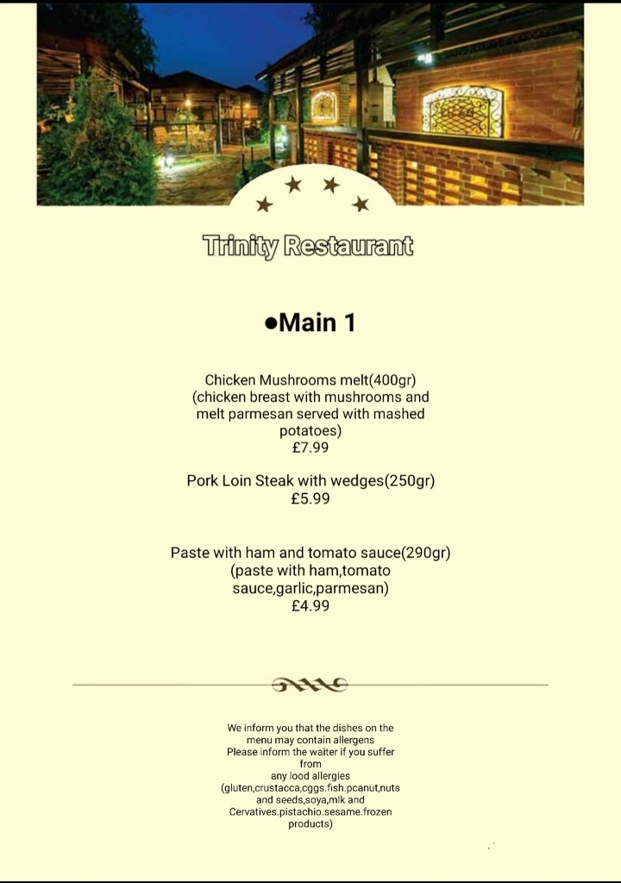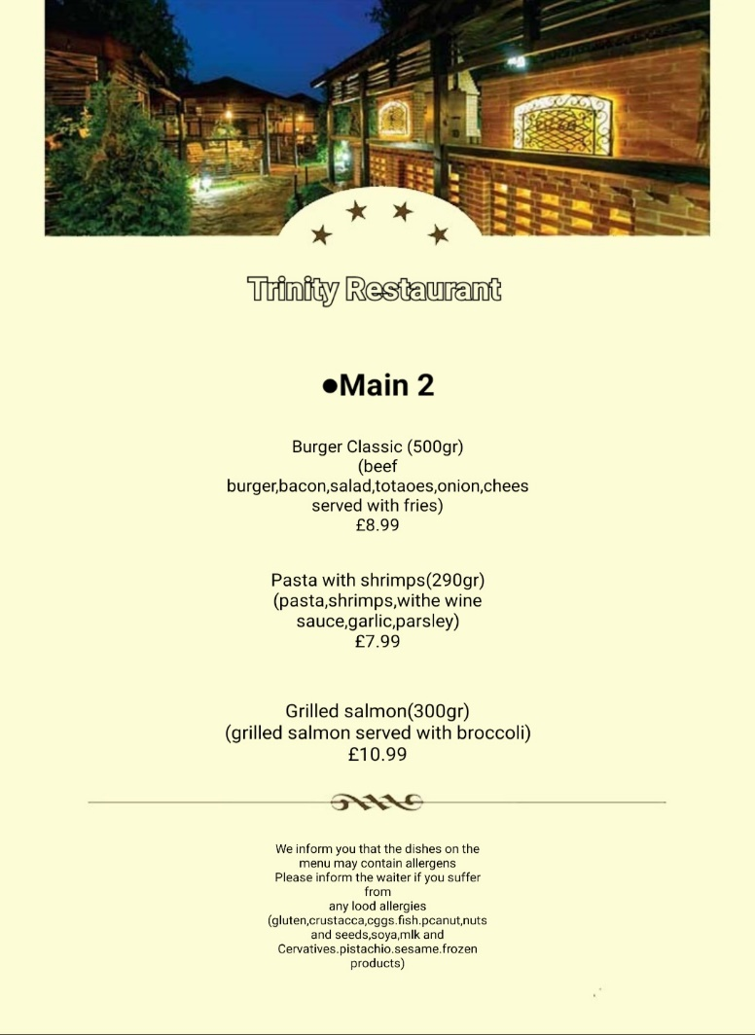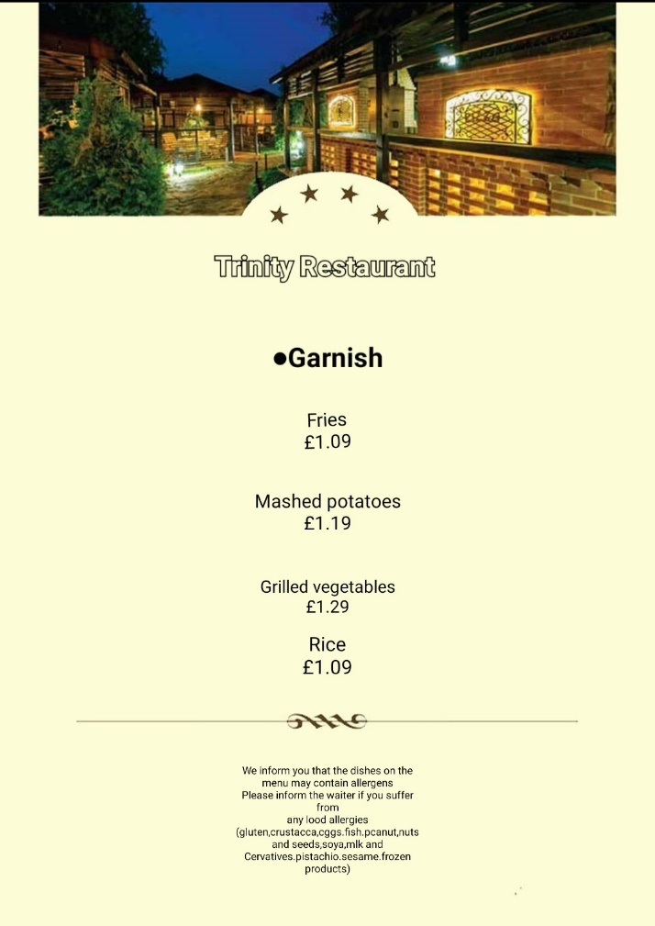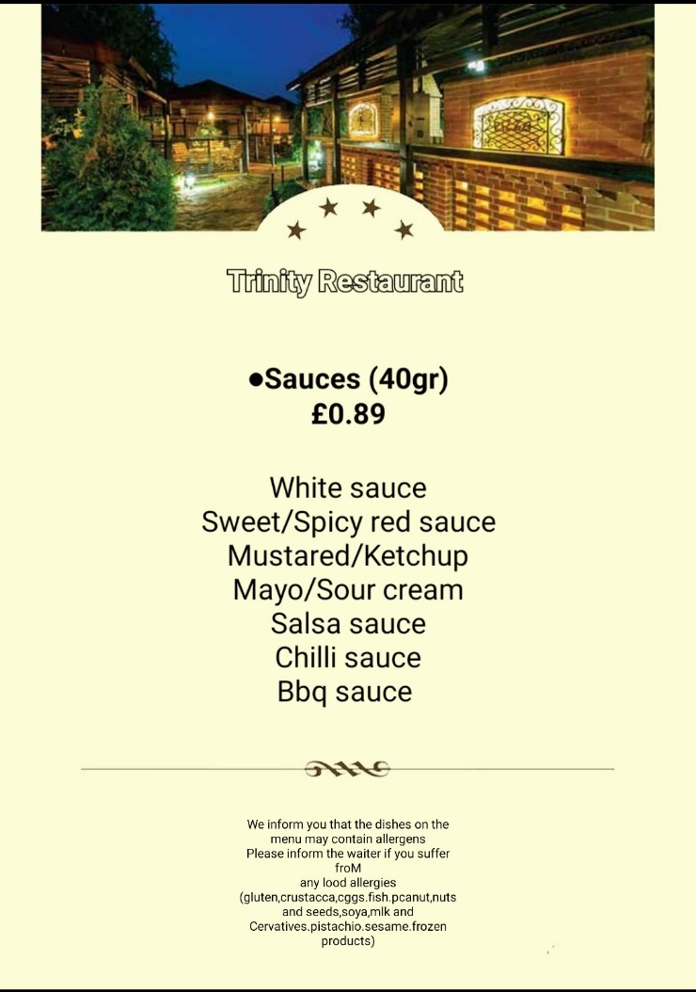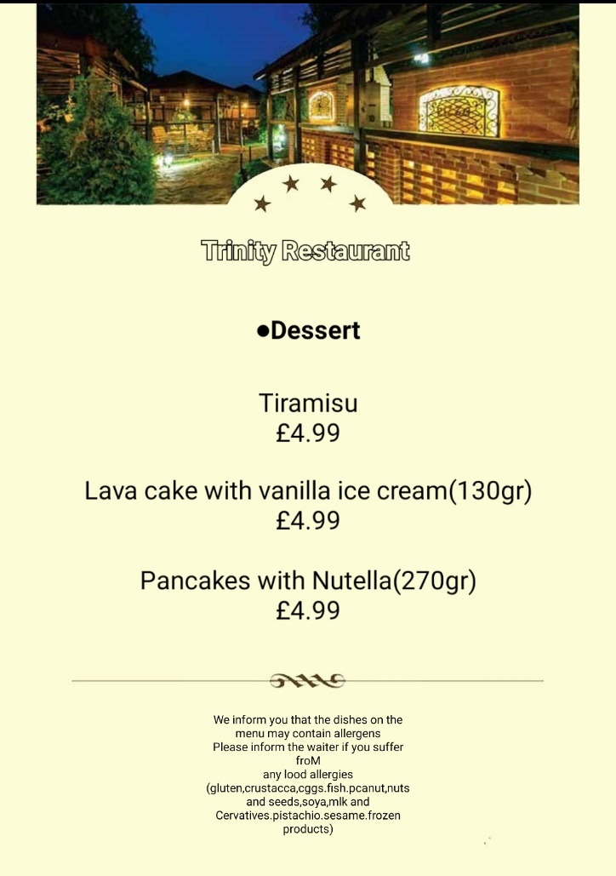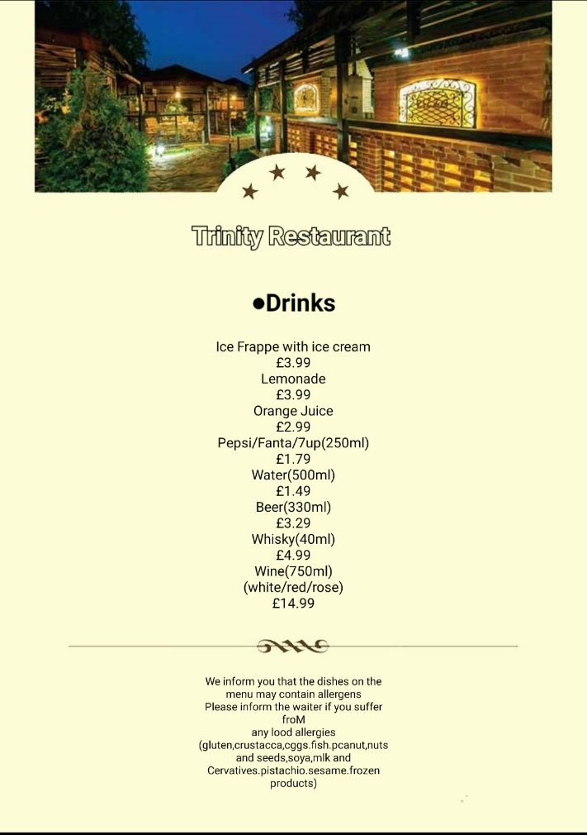

- https://www.7shifts.com/blog/restaurant-concepts/
- https://www.conference-news.co.uk/blogs/why-menu-choice-might-be-important-venue-choice/
- https://www.cordonbleu.edu/news/how-important-is-menu-design/en
- https://eat-marketing.co.uk/3-ways-to-guarantee-the-ultimate-restaurant-dining-experience/
- https://www.pointfranchise.co.uk/articles/understanding-your-target-market-for-your-restaurant-6213/
- https://pointone-epos.co.uk/how-and-why-to-make-your-restaurant-more-sustainable/
- https://www.theresident.co.uk/food-and-drink/21483200.11-londons-unique-new-concept-restaurants/
- https://www.touchbistro.com/blog/defining-your-restaurant-target-market/
- https://trinityhotelgroups.com/about-us
- https://www.waiterio.com/blog/en/types-of-restaurant-customers/

