BMSP 4004


Generating Business Data and Analysis

Assignment 1
Conference Venue Database and Report

Claire Davies 1806680
Dr Roisin Mullins
9th January 2019
Contents

- Introduction
- Rationale for the chosen venue
- Wellbeing of future generations act (Wales 2015)
- Roles – End users vs Database administrator
- Planning and Analysis
- Database Design
- Implementation
- Maintenance
- Comparison between Prosumer file and Venue Database
- Reference Page
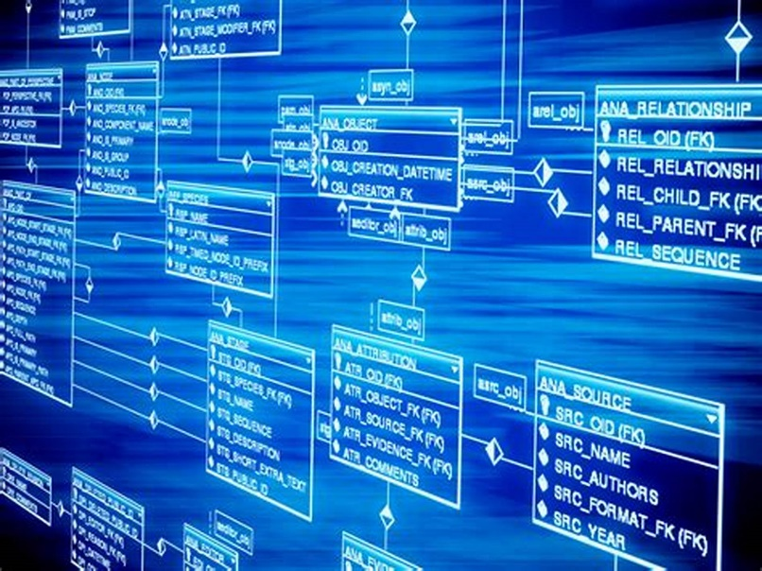

Introduction
For this assignment an Access Database spreadsheet was created to help find a suitable venue in Wales to hold a conference for the Carmarthen Business School. The spreadsheet compared 20 different venues across Wales to enable us to find the ideal place.
Throughout the report we will go into more detail as to what a database is and what information you can get from a database. It will show how a database is created and how it is used to store and find the information needed to find the ideal location for this event.
The venue chosen for the conference to be held is Parc Y Scarlets in Llanelli, it is classed as one of West Wales’ premier meeting and events venues. (Scarlets, 2017).
This report will show you why and how the venue was chosen.



(Bing, n.d.)

What is a Database
Database is a system used on computers to hold information, this making easier to find and store certain information. Databases are used in various different places, like hospitals, schools and many businesses also use them.

Rationale for chosen venue
This assignment was set for us to create a Database on Microsoft Access, on the database we were to find and in put the details for 20 different venues from different counties throughout Wales. The database would hold different information on each venue that was chosen. We were looking to find the best place to hold a conference for the Carmarthen Business School. So when doing so different facilities were looked at with each venue, i.e cost, easily accessible, amenities, size of function rooms.
So after inputting all the information into the database, Parc Y Scarlets was the chosen venue. The reason for choosing this venue was due to may factors on the database and also research into previous functions that had been held there.
“Parc Y Scarlets is the perfect venue for conference and events in West Wales. Situated only 12 mins from Junction 48 on the M4 and with free parking on site, Parc Y scarlets is easily accessible for all.” (Parc Y Scarlets, 2015).
- 82% satisfied with the events at Parc Y Scarlets
- 4.5 * reviews
- 71% retained bookings
- Wi-Fi
- Catering available
- Free parking (2000 spaces)
- Private bar
- Easily accessible
- Disable access
- Transport
Even though Parc y Scarlets is one of the more pricy venues, when all other factors are taken into consideration this seems like the ideal venue for what is needed.

Well-being of future generations act (Wales 2015)
The well-being of future generations act is about improving the social, economic, environmental and cultural well-being of Wales.
The Act will make the public bodies listed in the Act think more about the long term, work better with people and communities and each other, look to prevent problems and take a more joined-up approach.
This new law will mean that, for the first time, public bodies listed in the Act must do what they do in a sustainable way.
Public bodies need to make sure that when making their decisions they take into account the impact they could have on people living their lives in Wales in the future.
It will expect them to:
- work together better
- involve people reflecting the diversity of our communities
- look to the long term as well as focusing on now
- take action to try and stop problems getting worse - or even stop them happening in the first place.
(Welsh Government, 2016).

Below is an image that shows the 7 different goals with-in the well-being act:

Parc Y Scarlets and the Well-Being and Future Generations Act

The training facilities at Parc y Scarlets offer the perfect solution for local clubs to play in all weather conditions and maximise their potential.
At the heart and soul of Parc y Scarlets is rugby and fitness. We thrive on our diversified fitness facilities such as the indoor training centre and athletics track.
We are honoured to be the training home of the Scarlets, Scarlets Ladies, Llanelli RFC, Carmarthen Quins and Llandovery RFC to name a few.
The 70 by 40 metres indoor training centre is equipped with artificial surface is perfect for all sports including rugby, football, hockey and many more. With heating available in the main area and male and female changing rooms both equipped with showers; the indoor training facilities is a haven for sports training, competitive fixtures and coaching courses – you will not have to worry about rain calling off play when holding your event in the Delme Thomas Centre.
In addition to the indoor training centre, Parc y Scarlets also has a 6 lane, 400 metre resi-sports, rubberized track which is highly utilized by Llanelli AAC. (Scarlets P. Y., 2015).
So as we can see here Parc Y Scarlets offer a safe place for girls/boys, men/women to train to help towards a healthier lifestyle, whether it be rugby or athletics, they offer a great range for all to enjoy.


(WCVA, n.d.).

Roles-Database Administrator vs End User
When designing a database you have to not only consider how to store the information, but also how you will use it to find the information needed.
Roles of a database administrator:
- establish the needs of users and monitoring user access and security
- monitor performance and manage parameters in order to provide fast responses to front-end users
- map out the conceptual design for a planned database
- consider both back-end organisation of data and front-end accessibility for end-users
- refine the logical design so that it can be translated into a specific data model
- further refining the physical design to meet system storage requirements
- install and test new versions of the database management system (DBMS)
- maintain data standards, including adherence to the Data Protection Act
- write database documentation, including data standards, procedures and definitions for the data dictionary (metadata)
- control access permissions and privileges
- develop, manage and test back-up and recovery plans
- ensure that storage and archiving procedures are functioning correctly
- carry out capacity planning
- work closely with IT project managers, database programmers and multimedia programmers
- communicate regularly with technical, applications and operational staff to ensure database integrity and security
- commission and install new applications and customise existing applications in order to make them fit for purpose
- manage the security and disaster recovery aspects of a database
Roles of an end user:
- Rename the finished database
- Input any relevant data for their company/business
- Create relationships between the data that’s been inputted
- Create forms
- Alter any ready made forms to benefit their needs
So as we can see the difference between a database administrator and end user is that one creates the database and the other adapts the database to suit their needs.

Planning and Analysis
When you are preparing to design a database, planning is a key part. The aim is to be able to store information and also to be able to find and extract information when making decisions that require the information that you have stored on a database.
When planning and analysing a database it should be done so to make it easy for the person designing it to find out certain information such as:
- What information is required
- The queries and reports the database will need to generate
- Who will need to access the information
- Where to find the information that is stored
- How they will use the information
- What elements will be needed
- Which attributes may be needed
- What relationships may be used
To build a successful database these are some of the questions that will need to be answered and all the relevant information for the organisation/business, this is to make it easily accessible for whoever will be accessing the database.
Database design
The database design consists of tables, forms and queries, the 20 venues chosen are put into the database to enable them to be found and retrieved.
The table is the first part of the database to be created:
- Click on the create tab at the top of the screen
- Select table and press ok
- A new table will show on the database
- Name the table for ease of accessibility at a later date
3 tables were created in the database to store the chosen 20 venues, these tables were:
- County
- Town
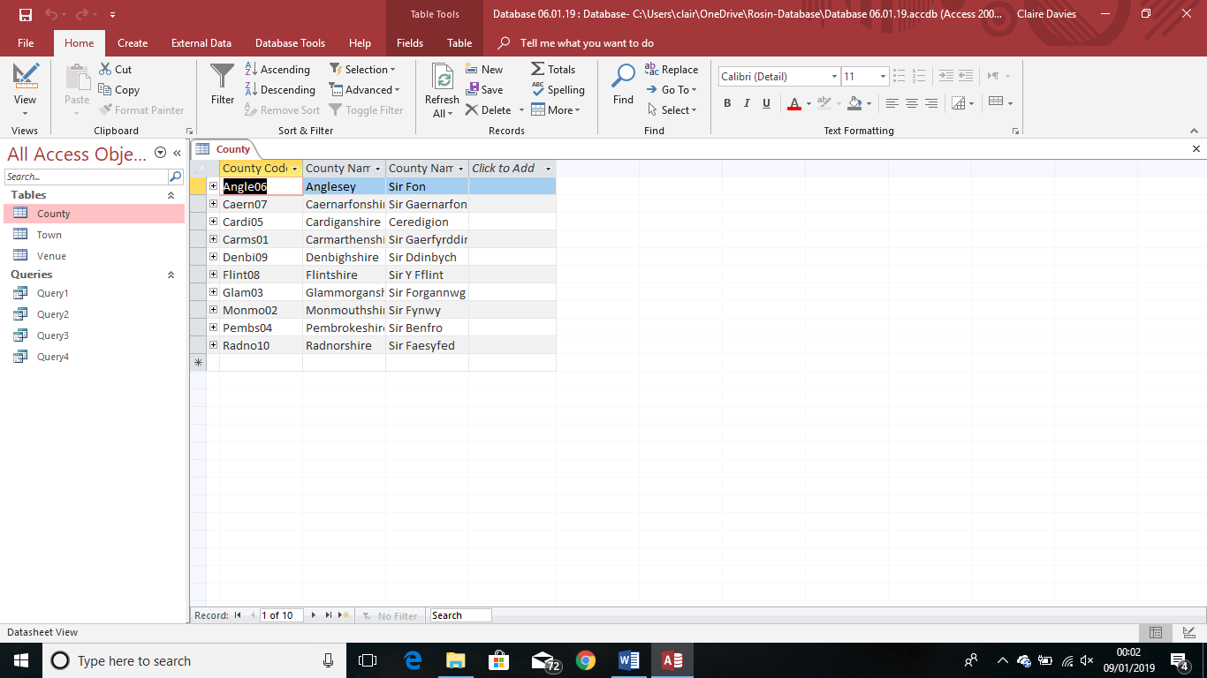
- Venue
Picture 1 is the table with County Name, County Code and County Name in Welsh, 10ndifferent Counties across wales were inputted into this table.

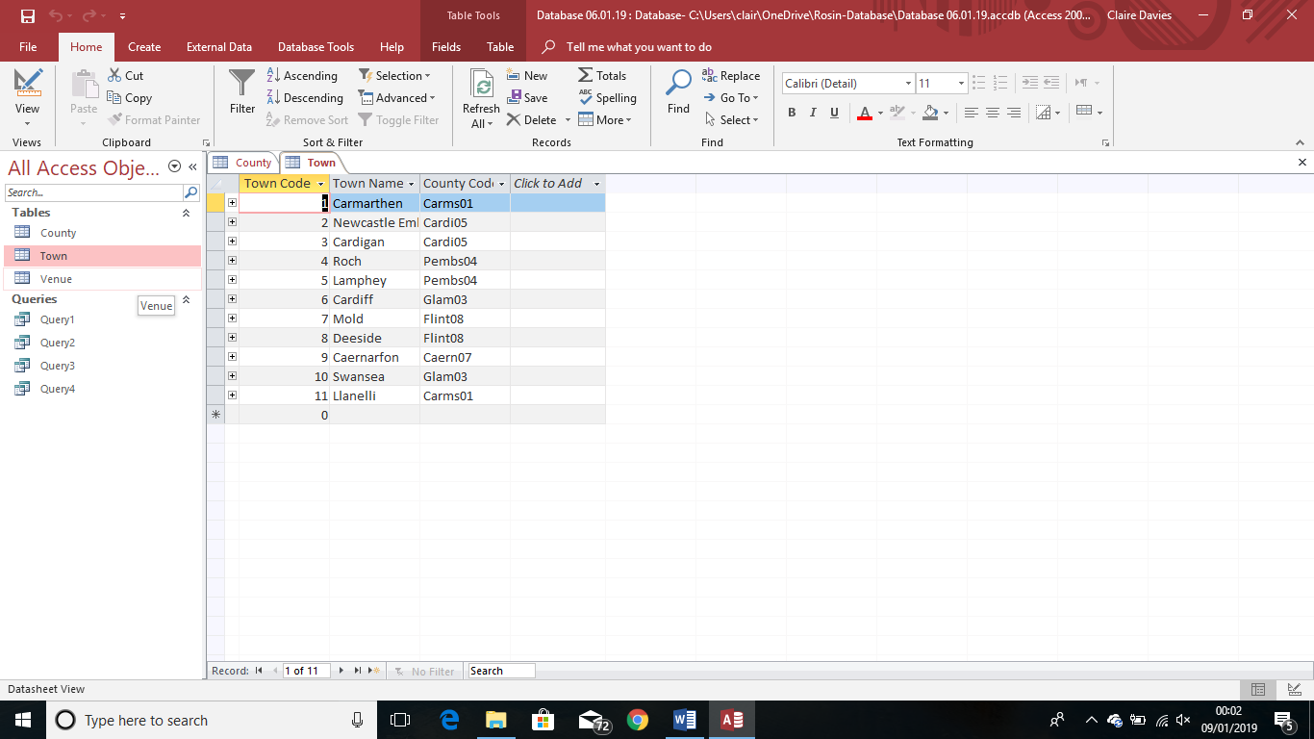
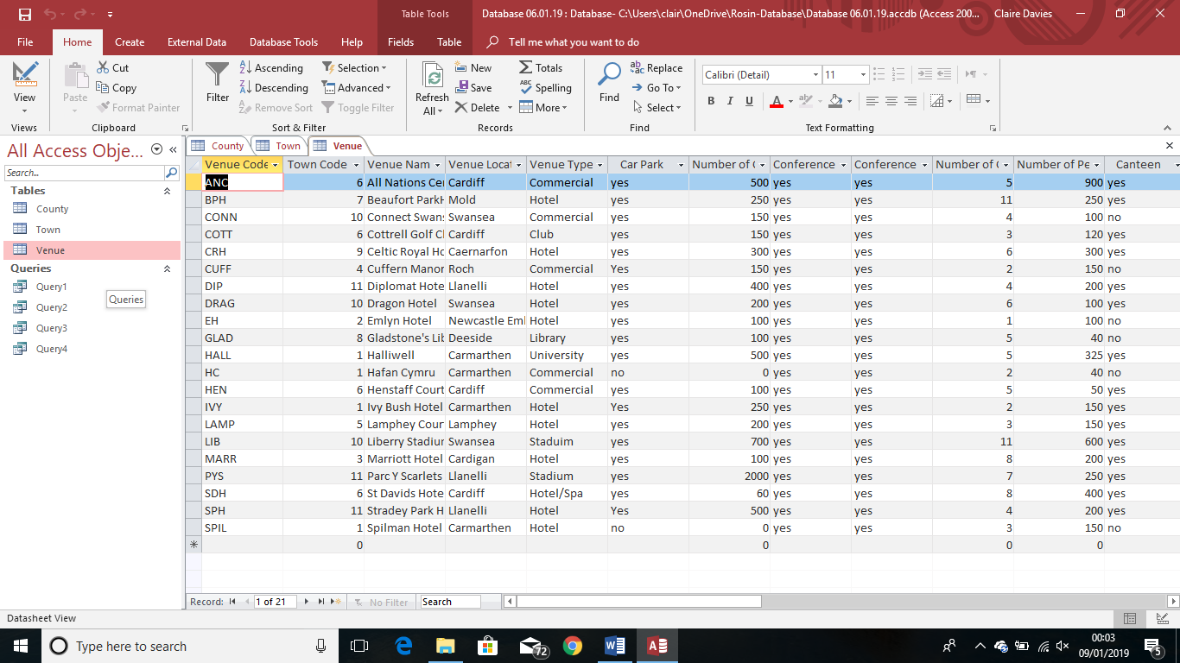
Picture 2 is the Town table, this consists of Town Code, Town Name and County Code, 11 different towns were inputted into this table.

Picture 3 is the Venue table, this is the table used to input all the information that was found for the 20 different venues across Wales.
Create a relationship
A relationship must be created between the tables, hers how it is done:
- Data base tool and select relationships
- Show table option in the relationship tab
- In the database select the tables
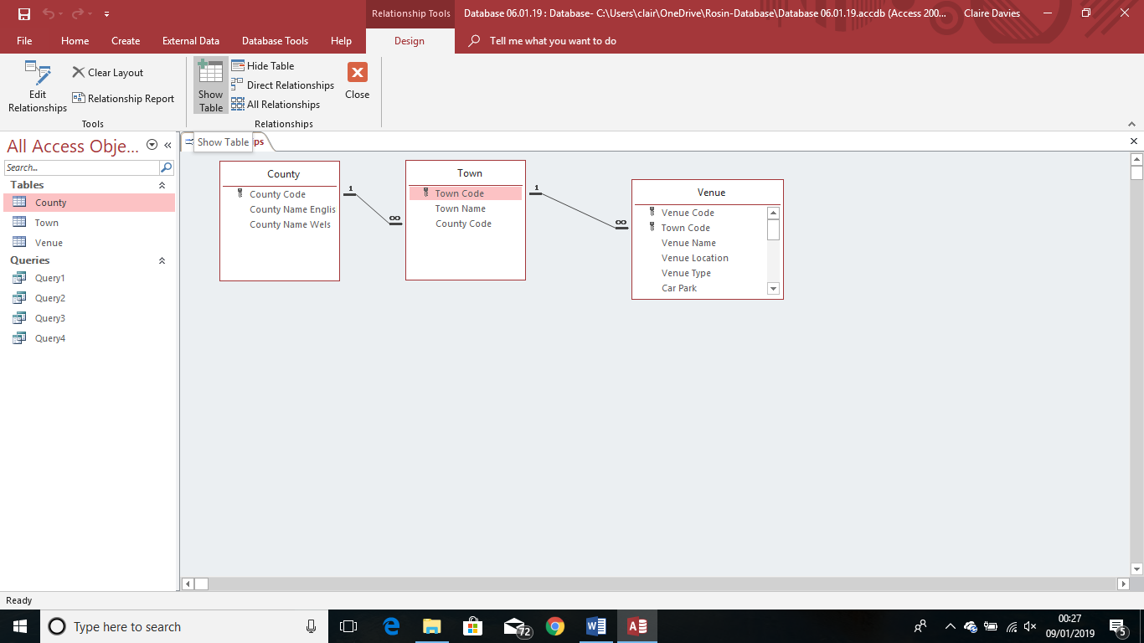
- Click on the boxes you want to create the relationships with

Create a relationship in an Access desktop database
- On the Database Tools tab, in the Relationships group, click Relationships.
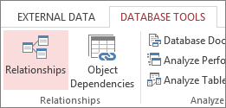
- If you haven't yet defined any relationships, the Show Table dialog box automatically appears. If it doesn't appear, on the Design tab, in the Relationships group, click Show Table.
The Show Table dialog box displays all of the tables and queries in the database. To see only tables, click Tables.
- Select one or more tables, and then click Add. After you have finished adding tables, click Close.
- Drag a field (typically the primary key) from one table to the common field (the foreign key) in the other table. To drag multiple fields, press the Ctrl key, click each field, and then drag them.
The Edit Relationships dialog box appears.
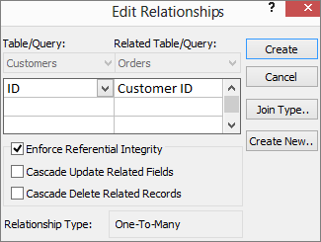
- Verify that the field names shown are the common fields for the relationship. If a field name is incorrect, click on the field name and select the appropriate field from the list.
- To enforce referential integrity for this relationship, select the Enforce Referential Integrity box.
- Click Create.
- When you are finished in the Relationships window, click Save to save your relationship layout changes.
Access draws a relationship line between the two tables. If you selected the Enforce Referential Integrity check box, the line appears thicker at each end. In addition, again only if you selected the Enforce Referential Integrity check box, the number 1 appears over the thick portion on one side of the relationship line, and the infinity symbol (∞) appears over the thick portion on the on the other side of the line. (Microsoft, 2019).
Creating a Query
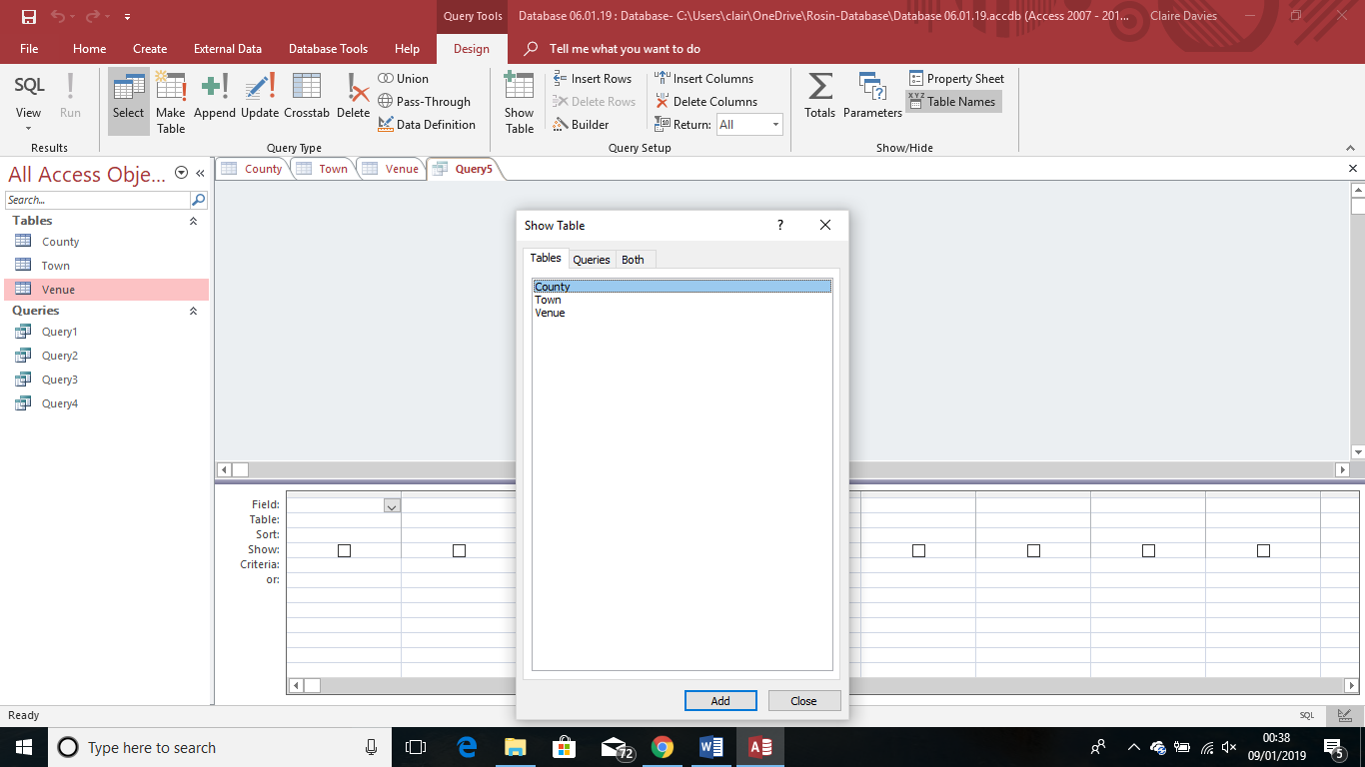
Click on the create tab and then click query design. This will open up a new tab called query 1, you must then select the table that you want to use for the query from the list shown. As in picture below.
Click on the field/fields that you need and click the add button. Once you have done that, close the box. You then need to drag the relevant fields down into the boxes below. In the sort section u can select either ascending or descending, this decides whether your information will be A-Z or Z-A, once you have done that you need to select Run and save the query you have just created.
Implementation

The database implementation or deployment is the process of installation of database software, configuration and customization, running, testing, integrating with applications, and training the users. Its different stages and processes are:
Defining the database project scope
○ Identifying the subdivision of organization
○ Defining about the functions which is utilized by the database
Organizing Database project
○ Design team development
○ Formation of database administrators
Database design
○ Identification of data requirement
○ Determining the structure of data and entire design specifications
○ Review and approval of design specifications
Training about database project
○ Preparation of the training requirement
○ Training to use the data manipulation language
○ Training for database administrator to use data manipulation and control language
Database testing
○ Coding of data manipulation and control language, schema, and subschema
○ Database generation
○ Testing and debugging
○ Review and approval
Periodic review and performance review
○ Evaluating the goals, information, and functional requirements
○ Evaluating the success of the implementation. (Chegg Study, 2019).

Maintenance

The key to a successfully working database is the maintenance.
When creating a database, regular check and maintenance will need to be carried out to make sure it runs smoothly. There may be a time when you will need to add new information into the database, for instance a change of name, price changes etc, this is all part of the checks and maintenance and to make sure that all data is correct and up to date.

Comparison between Venue Database and Prosumer Database

The venue database was created on Microsoft Access and was created by us, making us the Database Administrator. This meaning we had to input all the necessary fields into the tables. The Prosumer Database had already been created and we were required to input data into the already created tables, this making us the end user.

References

Bibliography
Bing. (n.d.). Retrieved from https://www.bing.com/images/search?q=parc+y+scarlets+logo&FORM=HDRSC2
Chegg Study. (2019). Retrieved from https://www.chegg.com/homework-help/definitions/database-implementation-3
Microsoft. (2019). Retrieved from https://support.office.com/en-us/article/create-a-relationship-40c998dd-4875-4da4-98c8-8ac8f109b85b
Parc Y Scarlets. (2015). Retrieved from parcyscarlets.com
Scarlets, P. Y. (2015). Retrieved from http://parcyscarlets.com/training-facilities/
Scarlets, P. y. (2017). Retrieved from www.scarlets.wales
WCVA. (n.d.). Retrieved from https://www.wcva.org.uk/what-we-do/the-future-generations-(wales)-act-all-you-need-to-know
Welsh Government. (2016, August 8th). Retrieved from https://gov.wales/topics/people-and-communities/people/future-generations-act/?lang=en

