University of Wales Trinity Saint David
School of Engineering
Vehicle Optimisation
Jeffrey Elliss
1802644
Motorsport Engineering MSc
3/4/22
Advanced Motorsport Dynamics, ACEA7002

Table of Contents
1.0 Introduction 4
1.1 Vehicle Handling Models 4
2.1 Methodology 5
2.2.1 Tires 5
2.2.2 Tyre models 5
2.3.1 Variable Limits 5
2.4.1 Experiment Design 6
3.1 Results 6
3.1.0 Base Case 7
3.1.1 Tyre Testrig 7
3.1.2 Spring and Damping Rates 10
3.1.2.1 Gauging tests 10
3.1.2.2 Spring and damper tests 10
3.1.3 Wheel Geometry 12
3.1.4 Gear Ratios 13
3.1.5 Differential 13
4 Final Vehicle Parameters 14
5 Final Setup Results and comparison to Base Case 14
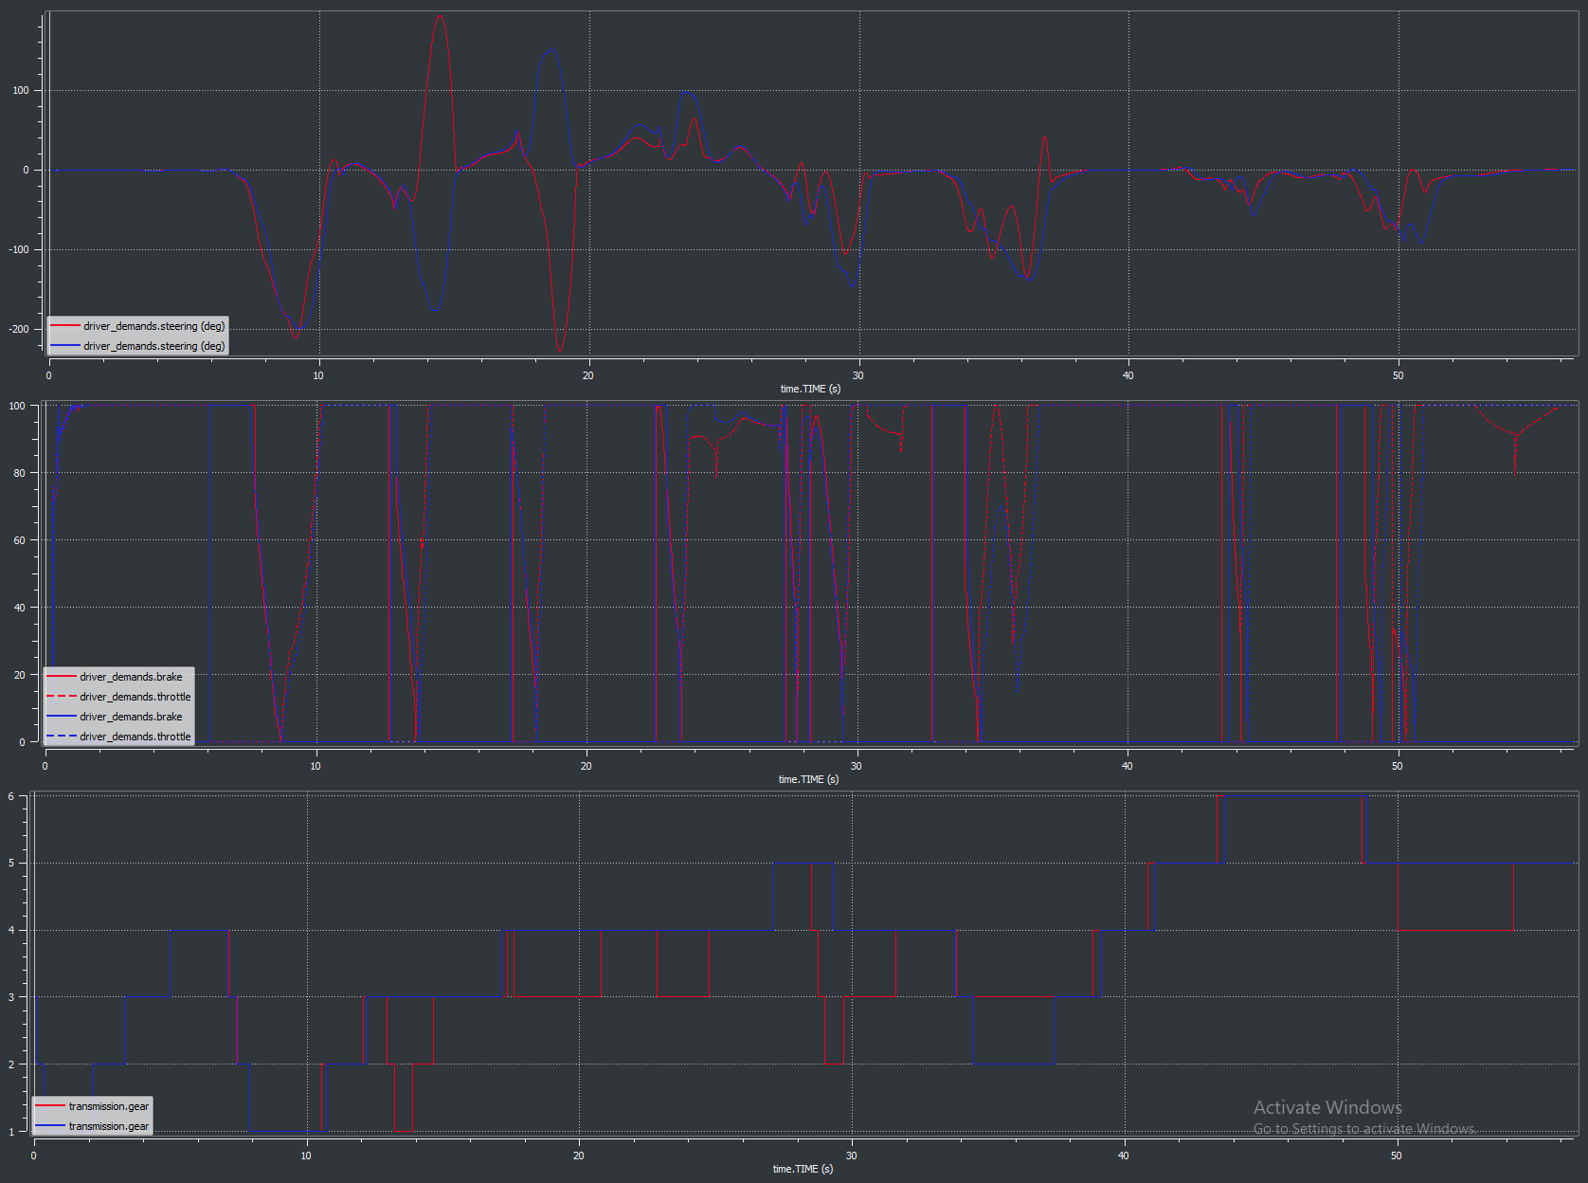 15
Conclusions 16

1.0 Introduction

Optimization of a vehicle in a motorsport setting is always a compromise, the needs of different corners and straights. Pembrey and Llandow are very different circuits, both In terms of average speed, minimum speed and general cornering speeds. Llandow is a much lower speed circuit with tighter corners making low speed maneuverability key to laptime. Pembrey is a much higher speed circuit with less time spent cornering relative to time spent on straights. The contrasting natures of the circuits mean that compromises have to be mae on vehicle setup to ensure that the driver is able to maximize the use of the tyres over both laps.

Vehicle Handling Models

There are a wide range of mathematical methods of modelling a vehicle’s handling characteristics. From extremely simplified methods such as the bicycle model which considers a two wheel model subject to centripetal forces due to cornering and the relative cornering stiffnesses of the front and rear tires to provide a basic analysis of vehicle balance. (Pacejka, 2006, p23). This basic model only considers two degrees of freedom and must assume that the vehicle is not rolling. Another limitation of the model is that due to it being a two wheel model it cannot account for steering geometries such as Ackerman.

Spring mass damper modelling is another component of vehicle modelling, a quarter car model can be used to examine one corner of a vehicles response to an input. These models are usually used to identify the effectiveness of a vehicles damping regime when considering bump responses (Wong, 2001,p272). These models usually consist of one subsystem for the tyre and a second considering the vehicle body and suspension system. This allows a reasonable estimation of the frequencies and effects that will be transmitted to the vehicle body for the purposes of noise vibration and hardness investigations.
This model can be extended by considering two of the model connected by a rigid beam to investigate pitch or roll effects and further extended as was the case in assignment 1 to begin examining load transfer effect and whole vehicle pitch and roll characteristics. A basic whole car model is effectively comprised of four quarter car models connected by four rigid beams which is allowed to rotate about the x y and z axis as well as move vertically on the z axis (Rill, 2020, p318). Previous work demonstrated a number of limitations to this model which can be simply summed up as limitations due to a significant number of simplifications. These included but were not limited to:

- antiroll bars were not included in the model
- all components that were not suspension or tires were considered to be totally rigid
- the entire vehicle mass was considered as one rigid formation centered about a single point. (in some vehicles large masses such as the engine are not rigidly mounted)

Where the bicycle model simply identifies mass distribution and considers only forces acting perpendicular to the normal force generated by the vehicle mass. A 7 degree of freedom spring mass damper model can express to a degree the load transfers across each axle due to the lateral acceleration which a vehicle may be subject to when cornering. Increasing the complexity of the spring mass damper model to include factors such as bump and rebound damping, chassis flexibility and the influence of a range of other components flexibilities and damping characteristics would yield more accurate results. Software packages such as ADAMs car are predominantly based on this principle.

2.1 Methodology

The process of optimizing a vehicle can be sped up by establishing reasonable limits on the range of variables. This can be achieved through analytical methods in many cases. Once reasonable limits have been established a range of experiments can be designed to determine the interactions between variables and determine the optimal setting for each. Further to this due to the nature of vehicle dynamics it is imperative to understand the vehicles tires. VI-Grade contains a software element called tyre testrig. The data from this can be used to determine the ideal operating conditions for the tyre.

2.2.1 Tires

Tires are the primary factor that limits a vehicles ability to accelerate, brake and corner. Optimizing the reaction forces available from the tyre at all points I time is essential to gaining lap time. The job of a racing driver is to ensure that the vehicle is at all times maintaining the vehicle on the limits placed by the tires. Understanding the optimal operating parameters of the vehicles tires is essential in both maximizing vehicle performance and minimizing the time and resources required to do so.

2.2.2 Tyre models

The VI-Grade software uses a tyre model often referred to as the magic formula model. The essence of this model is a curve fitting process aimed at accurately representing the reaction forces created on tyre testing apparatus. This curve fit can be highly complex using dozens of constants to adjust different regions of the curve or be relatively simple with just a few constants (Pacejka, 2006, p84). The tyre data generated through the Vi-Grade Tyre Testrig software is generated by applying the Pacejka magic formula model to some experimental data.

2.3.1 Variable Limits

When considering spring rates one method for determining a reasonable range of values is to consider the ride frequencies at the front and rear of the vehicle. These can be expressed as:
$F=\frac{1}{2π}\sqrt{\frac{k}{m}}$ (Wong, 1978)

Ride frequencies do not necessarily correlate to handling changes in and of themselves but can be considered to have general effects on the characteristics of the axles for which they are calculated. The ride frequency can also be sued as an indicator of the dominant forces involved in a particular vehicles operation. High frequencies above 2.5Hz approximately usually only occur when a vehicles dominant performance factor is its aerodynamic downforce. The vehicle studied has a front ride frequency of 1.45Hz and a rear ride frequency of 0.92Hz.

Dampers have the greatest influence in dynamic situations, for example the rear rebound damping of the vehicle is most effective during the beginning period of braking events. Typically damping settings are sued to help in the control of the vehicle in complex situations. Fast damping rates mostly affect events such as bumps or curb hits. One useful analytical methods for examining basic damping characteristics of a vehicle is to examine the damping ratio. This is a value which examines the mass, spring, and damper of a system. The output is a ratio which describes the overall level of damping of the system. For vehicle suspension systems in almost all cases the system will be under damped to some degree as this allows the swiftest return to the point of equilibrium. The damping ratio can be expressed as:

$Damping Ratio=\frac{c}{\sqrt{2km}}$ (Gillespi, 1992)

 | Damping Ratio | Ride Frequency
Front | 0.790 | 1.45
Rear | 0.68 | 0.92
Table 1-Ride frequencies and slow bump damping ratios
Table 1 shows the damping ratios calculated for the base case. Both front and rear are under damped with the rear being slightly more under damped. As well s this the rear ride frequency is significantly lower than the front. These two factors imply but do not necessarily definitively state that the vehicle is front dominated. That is to say that setup changes will have a greater effect when performed on the front axle than when performed on the rear axle.

2.4.1 Experiment Design

Due to the significant number of variables many of which are coupled in order to explore the interactions between these variables a large amount of data would ordinarily be required. It is possible to use statistical techniques to reduce the number of tests needed to identify the effects of each variable and the interactions between variables. Design of experiment tools have been used inn two manners in this work. First as a general impact analysis concerning the main roll stiffness variables and then in a more detailed analysis of the effects of the spring and damper interactions. Design of experiment has been proved to be a reliable tool for understanding complex systems such as the vehicle to be optimized here and to understand the interactions of ranges of variables which are in coupled systems. It is important when designing an experiment to consider whether two variables are causally linked and therefore whether any assumed interaction is valid (Jiju, 2014).

3.1 Results
 | Llandow | Pembrey
Long Accel | 4 | 4
Long Braking | 3.05 | 2.7
Lateral Accel | 1.3 | 1.15
Table 2-Driver performance factors
Table 2 shows the driver performance factors used to obtain the results in all of the subsequent experiments. The basic driver does not reach the limit of grip at any point and hence vehicle setup changes would not be seen to have any significant effect on lap time. These values provide a reasonable balance between number of iterations required for the driver to complete a single lap and ensuring that the driver is at or near the limit of the vehicle at all times. One improvement that could be made here with more time would be to optimize these values for each setup. It is likely that the results of more extreme setup deviations from the base case will be less performant than is possible as they may allow for a greater range of performance than these performance factors allow the driver. These values produced laptimes which were repeated 5 times for both circuits. Every results was within a margin of +-0.01s. This degree of repeatability is important both for consistency of comparison and for understanding the quality and significance of the design of experiment results produced.

3.1.0 Base Case

To quantify the effects of each setup change it is important to compare results to the base case. Table 3 shows the basic results of the base setup of the vehicle with the driver performance factors adjusted such that the performance of the vehicle is the primary factor effecting lap time rather than the driver.

 | Pembrey | Llandow
Lap Time (S) | 56.57 | 50.24
Top Speed (KM/h) | 216.2 | 207.25
Min speed (KM/h) | 35.86 | 35.87
Lat accel peak (G) | 1.992 | 1.93
Long accel peak (G) | 1.114 | 1.114
Table 3-Base case simple results
The initial results seen in table 3 show a difference in top speeds of 9Km/h and a further look into the driver demands data shows that of the six available gears the driver only ever demanded 4th. The track layouts of Pembrey and Llandow are very different, Pembrey only has 1 truly slow tight corner where llandow has significantly shorter straights and several slow tight corners.

3.1.1 Tyre Testrig

The results of the tyre testrig can be broken down into front and rear as well as lateral and longitudinal. Further to this camber effects have also been examined to provide a basis for further experiments concerning wheel geometry.

Figure 1-Camber Study for front tyre
Figure 1 shows the reaction forces generated by a front tyre at a range of camber angles and through a range of slip angles. The peak force generated at positive slip angles is from the 0 and -2.3 tests. The negative slip angles shown are less important as these will only be experienced when that wheel is on the inside of a corner and therefore unloaded and less dominant in terms of the load it is carrying.

Figure 2-Camber study tyre efficiency
Figure 2 shows the front tyres ratio between the normal force and the peak lateral reaction force generated. This plot shows that past 950N of vertical load the efficiency with which the tyre converts vertical force into lateral force begins to significantly reduce. This is often due to carcass deformation reducing the effective contact patch and therefore reducing the tyres ability to interact with the surface.

Figure 3-Vertiical force Variation tests for front tyre
Figure 3 shows a range of vertical force tests at 0 degrees of camber angle on the front tyre. This establishes that the tyre acts symmetrically when no camber angle is applied and that the asymmetry seen in previous tests is due to camber angle preloading effects.

Figure 4-Rear Tyre Longitudinal efficiency at a range of loads
Figure 4 shows the longitudinal reaction forces generated by a rear tyre as a ratio of the reaction force to the normal force. This demonstrates that the most efficient operating region of the tyre is around 700N vertical load. For the rear tyres then peak efficiency is a relatively flat region over a wide range of loads. As can be seen on figures 1 and 3 the range of reasonably effective slip angles is relatively wide making the tyre likely to be fairly easy to operate from a drivers perspective.

3.1.2 Spring and Damping Rates

The spring and damper test are split into two main sections, first a more basic overall experiment which examines springs dampers and antiroll bars together over a wide range of values to understand the general influences of each component and then a more detailed examination of the springs and dampers without the antiroll bars.

3.1.2.1 Gauging tests

The results shown in this section were used to inform later experiments and show the basic interactions between the various forces resisting the roll forces created by the vehicle.
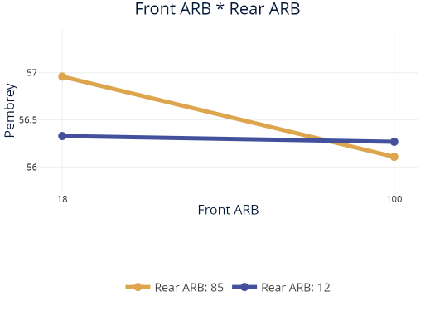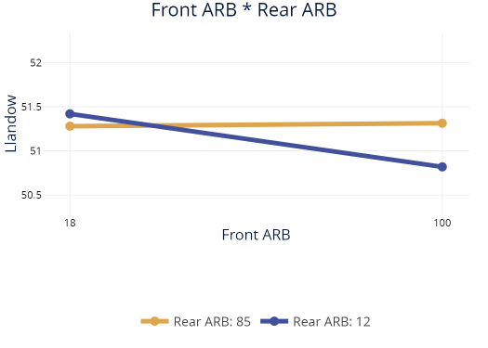
Figure 5-Antiroll bar rates influence on laptime at both circuits.
Figure 5 shows the influence of antiroll bars at both axles and both circuits. A significant difference to observe here is that where the Pembrey results show that with the softer rear antiroll bar setting front antiroll bar changes show very little difference the opposite is seen in the llandow results. Both data sets show that peak performance was reached with the highest possible front antiroll bar setting. When considering the different characteristics of the front a rear tyres, it is apparent that the rear tyres of the vehicle have a significantly lower ability to convert vertical force to lateral forces. This difference in tyres front to rear combined with the vehicles rear biased mass distribution suggests that the vehicle is likely to suffer from significant oversteer. One way to reduce this effect is to increase the load transfer that occur at the front axle which has the effect of moving the tyres to a less efficient operating region losing some peak performance but allowing the driver to better control the vehicle.

3.1.2.2 Spring and damper tests

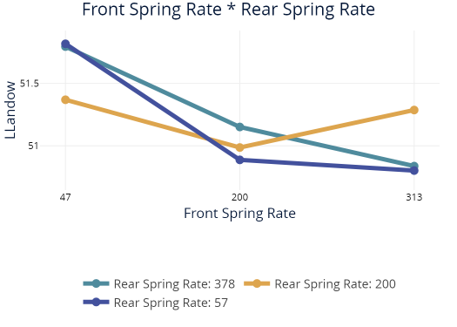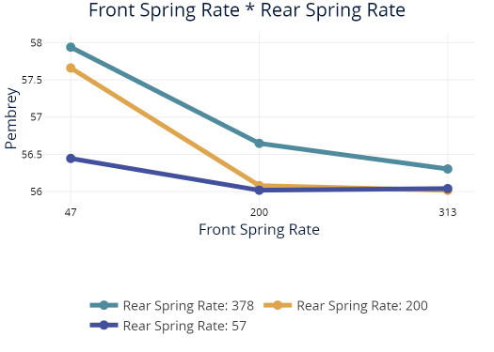
Figure 6-Interactio plots for llandow and Pembrey showing the front and rear spring rate.
Figure 6 uses the data generated in the design of experiment software package to examine the interactions between the front and rear spring rates on lap time at both circuits. Figure 6 (left) shows a minimum lap time at maximum spring rate tested. More interestingly at rear spring rate of 200N/mm the data shows a local minimum lap time at a front spring rate of 200N/mm also. Llandow is a short and tight circuit which is very low speed. A greater rear spring rate will produce more load transfer at the rear of the car and move the tyres past their optimal operating loads for quickly. This is likely to generate more oversteer making the car more nervous to drive. Both circuits show a tendency to reduce lap times with heavily front oriented roll stiffness distributions. Peak lap time for pembrey was achieved at a roll stiff ness distribution of

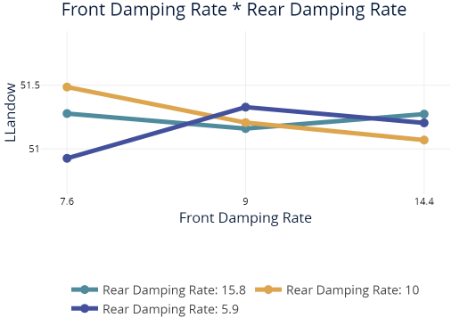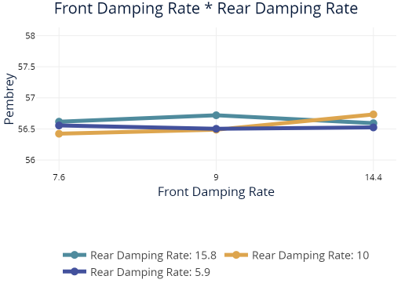
Figure 7-Damping Rate interaction plots for Pembrey and llandow
Figure 7 shows the influence of the damping rate changes at both circuits. The magnitude of the differences and significantly smaller compared with the differences seen concerning the spring rates shown on figure 6. This is due to the nature of the influence of damping on vehicle performance only acting when the vehicle is rolling, pitching or heaving. Steady state corn erring performance for example is influenced very little by damping rates and the rate at which the wheels are moving relative to the vehicle body is very low. Therefore, while spring rates will have a dominant effect on vehicle handling at all times the damping only acts during dynamic periods becoming more dominant in periods such as heavy braking and high frequency direction changes. The general trend shown at the front axle at Pembrey is a reduction in lap time as the damping rate is increased.

3.1.3 Wheel Geometry

Wheel geometry in this context includes static camber and toe angles. Due to the nature of the model and of vehicle suspensions in general the wheel angles relative to the car will dynamically shift as the suspension deflects. Due to this it is often the case the a static camber angle must be set to accommodate this angle change and attempt to keep the tyre in its ideal operating angle.

Figure 8-Camber angle vs suspension displacement
Figure 8 shows the camber angle changes through a sweep of suspension displacements. Both the front and rear of the car show significant changes through the sweep of the suspension. As the vehicle compresses its suspension the amount of camber tends to become more positive. The results shown in figure 9 also confirm this as the more negative camber values produced the best average lap time across the two circuits. In the context of the tyre testrig experiment shown in figure 1 which showed peak reaction forces from a front tyre at -2.3 degrees the static camber angle of -3 degrees producing the best laptimes.

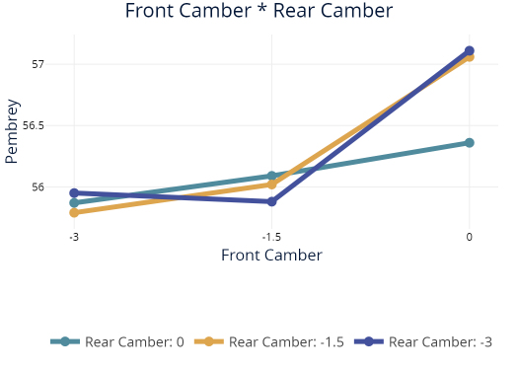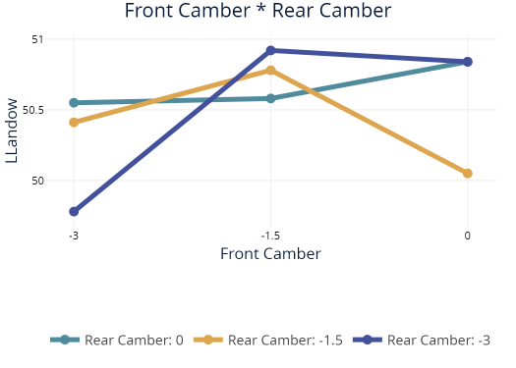
Figure 9-Front and rear camber interactions Pembrey and llandow
Figure 9 shows the laptimes at both circuits at a range of static camber angles. Both circuits show the best overall time at -3 degrees of front camber which is significantly more than the tyre testing suggested produces maximum reaction forces from the front tyres. This is due to the effected stated previously of the changing wheel geometry at different suspension deflections.

3.1.4 Gear Ratios

The gear ratios selected had a significant impact on lap performance. This is due to the nature of internal combustion engines having an ideal operating range where maximum torque is produced.

Figure 10-Torque Curve for Race Car engine
Figure 10 shows the torque curve for the examined car. Thisn has been used to produce a simple optimization of the cars gear ratios in combination with the top speeds reached at both circuits. Table 4 shows the optimized gear ratios. The effect of this was to reduce the laptime at Llandow by 0.2s, the time gained at Pembrey was negligible (less and 0.02s).

Baseline | Simple
3.55 | 10.07
2.68 | 5.03
2.13 | 3.357
1.8 | 2.518
1.58 | 2.01
1.38 | 1.68
Table 4-Base and Optimised gear ratio.
Table 4 shows the optimized gear set, these values were calculated by using the ideal engine rpm range and the top speeds of the vehicle with the rolling radius and final drive ratio. They are evenly split through the speed range and do not account for individual corner speeds.

3.1.5 Differential

The differential of a vehicle controls the deployment of torque from the engine to the driving wheels. By manipulating the drive force that is moved to each tyre it is possible to maximize the use of the available grip. An open differential is limited by the amount of torque which the wheel with the least grip available can deliver. It can also allow the maximum difference in rotation speed meaning that in certain situations where the lap time is dominated by slow speed tight corners and the vehicle is not massively traction limited it may be the case that an open differential is the highest performance option.

 | Pembrey | Llandow
Limited Slip | 56.57 | 50.24
Open | 55.84 | 49.64
Table 5-Differential Setting Results
Table 5 shows that with the standard limited slip settings that an open differential produced significantly quicker laptimes. This suggests that the standard settings for the LSD are not optimized well for the circuits or the setups used.

LSD Settings | Pembrey Time (S) | Llandow Time (S)
5000 | 55.62 | 49.06
2500 | 56.43 | 49.07
7500 | 55.64 | 49.08
Table 6-Differntial locking torque (both directions)
Table 6 shows the results of a further investigation into diff settings. The lower locking settings appear to show a significant decrease in laptime with the best time achieved at 5000Nmm.

4 Final Vehicle Parameters

 | Final Setup
Front Spring (N/mm) | 313
Rear Spring (N/mm) | 57
Front Damping (NS/mm) | 14.4
Rear Damping (NS/mm) | 10
Front ARB (N/mm) | 100
Rear ARB (N/mm) | 33.3
Table 7-Final Suspension settings
The spring and antiroll bar rates used in table 7 show a roll stiffness distribution of 0.825 on the front of the car. Considering the mass distribution of the car is 0.453 on the front of the vehicle

5 Final Setup Results and comparison to Base Case

This section briefly covers the differences seen in the driver demands and reactions as well as the chassis slip angles seen.
Figure 11-Pembrey Compariosn of driver demands from base case (red) and final setup (blue)
Figure 11 shows the driver demands for both final and base cases at Pembrey. The top trace shows the driver steering input the base case shows two significant opposite lock events which correlate with the two huge spikes in lateral acceleration seen in figure 11.
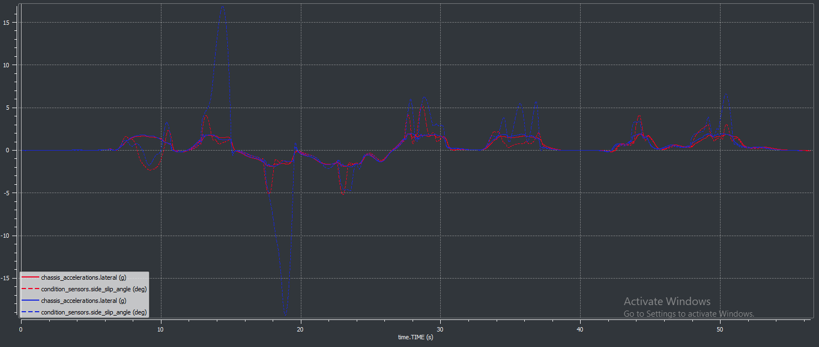
Figure 12-Lateral slip and lateral acceleration at pembrey for base case(blue) and final setup (red)
When considering the chassis slip angles it is important to also consider at what slip angle the tyres produce peak reaction forces. The peak forces generated by the tyres are centered around 5.5 degrees of slip if the chassis slip angle significantly exceeds this it Is likely that the yaw moment is past the limit of grip and therefore not optimal for producing good lap times. This can be seen in figure 12 at two points early in the lap and in figure 14 at three points in the lap both from the base setup. In both cases the vehicle oversteers and exceeds the optimal slip angle by ten degrees or more.

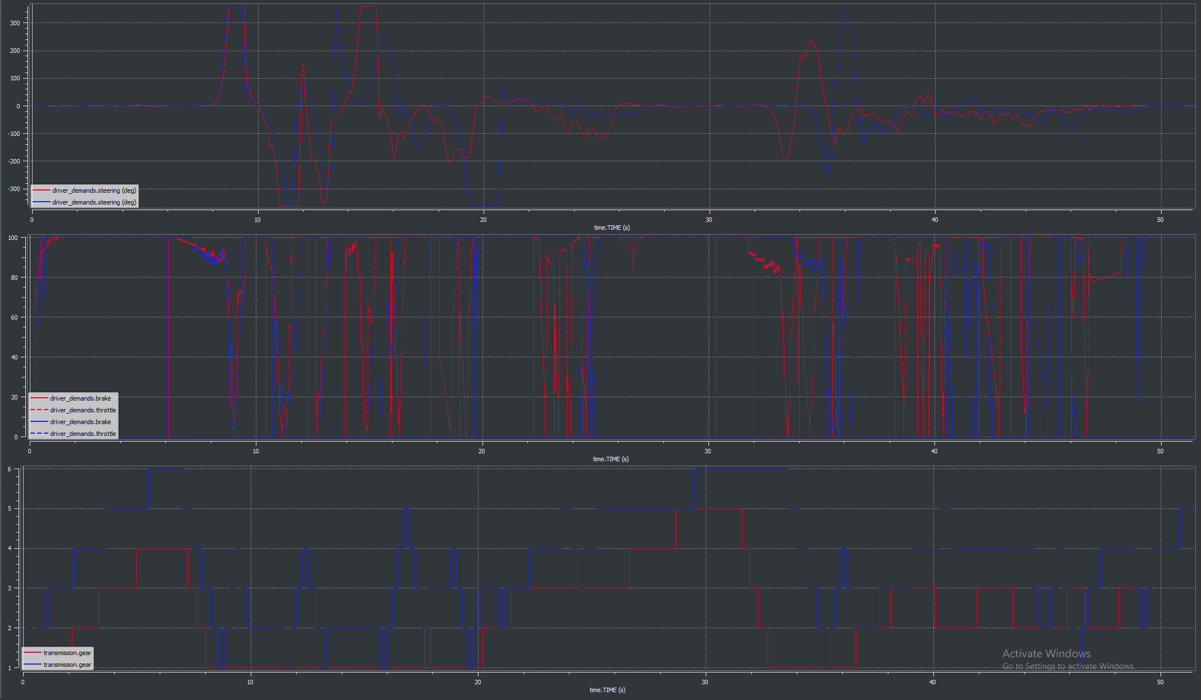
Figure 13-Driver Demands for llandow base case (red) and final setup (blue)
Figure 12 shows the driver demands for both llandow runs. An initial observation concerning the steering demand trace of the base case is that inputs tend not to be definitive. Between 22 and 25 seconds for example the driver appears to correct and re correct the vehicle multiple times where in the final case the driver is able to make a single more continuous input to achieve a better outcome. This type of input induces less variation in the loading of the tyres and ensures that the maximum grip is available for the maximum time.
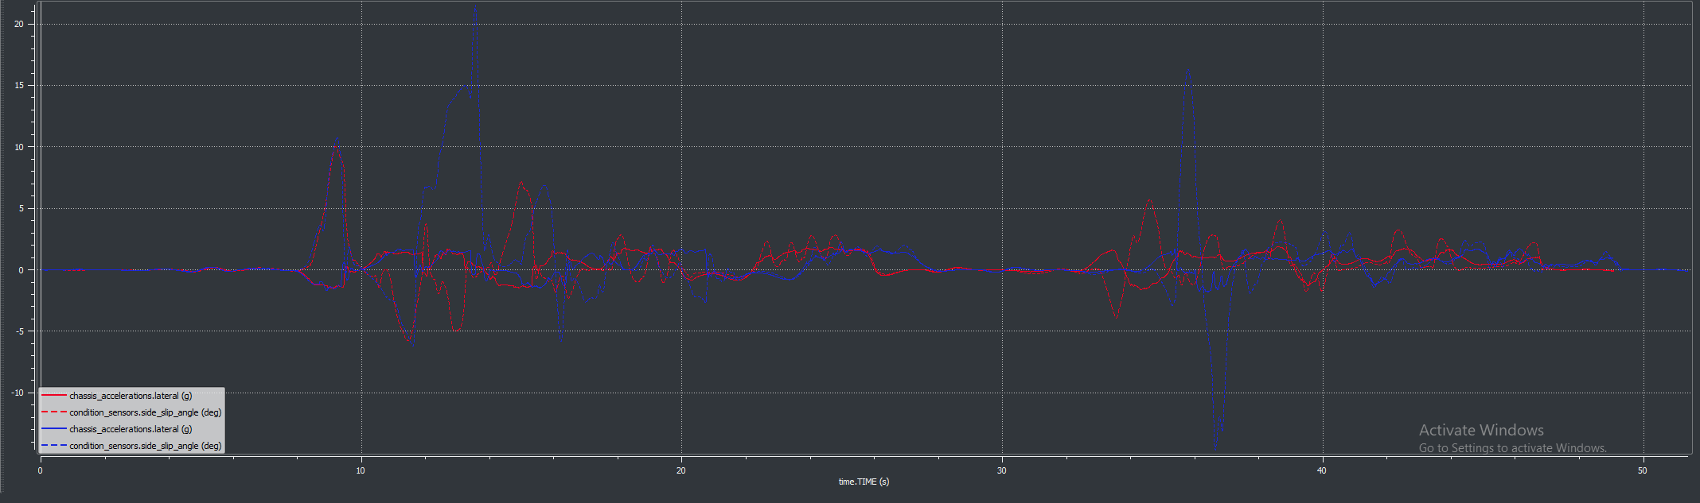
Figure 14-chassis slip angle and lateral accelerations for llandow base case (Blue) and final setup (red)
Figure 14 shows the difference in the two vehicle setups from a drivers perspective the most cleary. Where using the base setup the driver has several instances where and excessively high chassis slip angle happens the final setup greatly reduces the vehicles tendency to do this.

Conclusions

Due to the vehicles mass balance and tyre balance front to rear the vehicle tends to favor a significantly front biased roll stiffness distribution. This phenomena can be seen in both the antiroll bar effects and the spring rate effects. The increased front spring rate significantly increases the front ride frequency to 1.8Hz. This in combination with the reduced rear ride frequency of 0.7Hz. This ride frequency discrepancy will also be seen in the unpsrung natural frequency (Wong, 2001, p271). This effect may mean that the vehicle experiences wo disturbances when hitting a bump due to the front reacting significantly faster than the rear. This may in turn create off-putting driver feel due to the two ends of the vehicle seeming to act seperatley.

Evaluation

The principle methodology used to plan an evolve experiments has been relatively successful, its primary limitation being that it was an iterative approach requiring many designed experiments to arrive at the final few important experiments. The use of analytical approaches reduced the number of experiments required for this evolution but could have been furthered by utilizing a number of basic models to make the predicted values have a smaller range.
The optimization of the vehicle was considered where possible as a whole system as components such as differentials effect are significantly influenced by the way that load transfer is managed in the vehicle. While this approach initially seemed viable after some DOE work was conducted it was evident that consider the vehicle as one system would not be possible in the time frame considered. This led to the splitting into subsystems and treating each individually in a logical order. This approach creates a higher likelihood that the final result is a local minimum and not the overall best setup. Another improvement to the method would be to automate significant chunks of the process(Tey,2020).

References

ANTONY, J., 2014. Design of experiments for engineers and scientists. Amsterdam, Netherlands: Elsevier.
BRUCE P.MINAKER, 2019. Fundaments of Vehicle Dynamics and Modelling. 1st edn. Hoboken New Jersey: John Wiley & Sons.
GEARG RILL, ABEL ARRIETA CASTRO, 2020. Road Vehicle Dynamics Fundamentals and modelling with matlab. 6000 Broken Parkway NW, Boca Raton: CRC Press.
GILLESPIE, T.D.(., 1992. Fundamentals of vehicle dynamics. Warrendale, Pa: Society of Automotive Engineers.
MIKE BLUNDELL, D.H., 2004. The Multibody Systems Approach to Vehicle Dynamics. Kidlington, Oxford, OX51GB: Elsevier Books.
PACEJKA, H.B., 2006. Tyre and vehicle dynamics. 2 edn. Oxford: Butterworth-Heinemann.
SAVARESI, S.M., CIOTTI, D., SOFIA, M., ROSIGNOLI, E. and BINA, E., 2006. GEAR-SET OPTIMIZATION OF A RACE CAR. IFAC Proceedings Volumes, 39(12), pp. 579-584.
TEY, J.Y. and RAHIZAR, R., 2020. Handling performance optimisation for formula vehicle using multi-objectives evolutionary algorithms. Vehicle System Dynamics, 58(12), pp. 1823-1838.
WONG, J.Y.(., 2001. Theory of ground vehicles. 3 edn. New York ;: Wiley.

