Module:
Work-Based Research
Module code:
BMPF7006
ASSESSMENT COMPONENT 2
A Critical Evaluation of Work-Based Research
Name:
Robert Messenger
Student Number:
0053043
Title:
Gwalia Stores
Descriptive Analysis

CONTENTS

Page

INTRODUCTION 3

Nominal data 3

Ordinal Data 3

Scale Data 4

ANALYSIS 5

Gender 5

Newspapers 7

Opinion 10

Distance 13

Spend 15

CONCLUSION 18

INTRODUCTION

Nominal, ordinal and scale (interval and ratio) are levels of statistical measurement which represent a hierarchy of quantitative detail i.e. from nominal, which provides the least detailed information and the least opportunities for manipulation, to scale, which offers the most.

All three are represented in the data collected and recorded here by Gwalia Stores.

Nominal data

Nominal data, also known as categorical data, is so called because it refers to names or categories or groups based on specific characteristics e.g. marital status or blood group. The categories are named or labeled, but the data has no natural order, and it tells us nothing about measurement.

In the Gwalia Stores data set, ‘Gender’ and Newspaper’ are examples of nominal variables.

It is possible that this customer sample is an example of convenience sampling. If these are 20 customers who have an order placed for newspaper delivery or collection, Gwalia Stores will have records of their names, which newspapers they order, and, if delivered, their addresses (for ‘distance’).

Otherwise, the data is most likely to have been collected by Gwalia Stores staff through observation and recording.

Nominal is the lowest form of the statistical hierarchy because although the observations can be grouped or tallied, they cannot be ordered. Nominal data is not measuring the thing itself, but describing the frequency with which that type or category occurs.

Nominal data can answer important questions including, for example: ‘how many?’, ‘how often?’ and ‘what proportion?’.

The appropriate measure of central tendency in nominal data is the mode. The mean, median and standard deviation cannot be calculated.

Ordinal data

Ordinal data is a step up from nominal data in the statistical hierarchy because it can also be ranked. There are still named groups, but they can be arranged in a natural order. Examples include: low/medium/high income, star ratings, football teams’ league positions, and exam grades.

The data can be placed in order, but the differences between adjacent values may not be equal (as in runners coming 1st, 2nd and 3rd in a race).

The variable labeled ‘opinions’ contains ordinal data.

A Likert Scale provides ordinal data, and this is likely to have been the tool used (as part of a very brief questionnaire) by Gwalia Stores to record the customers’ opinions of the local borough council.

Nominal and ordinal data can both be used to calculate frequency of events or the occurrence of items, but ordinal adds greater precision in terms of numerical order.

In ordinal data, the median is the preferred measure of central tendency because it refers to the middle ranked value in a set. The mean may not be an appropriate measure even when the rankings are numeric, because the differences between ranks may differ.

The range can be used to measure dispersion in ordinal data, as well as the onterquartile range or the spread between two percentiles.

Scale data (interval and ratio)

Interval scales are a further step beyond ordinal, and ratio scales are the highest level.

Their data can be ranked as in ordinal, but they also provide information about the degree of difference between values. Examples include measurements of temperature and dates on a calendar.

They can record both integers (whole numbers i.e. discrete data) and numbers with fractions/decimal places (continuous data), and both the order of the values and the distance between any two values are meaningful.

Interval scales do not have a true zero measurement, whereas ratio scales do.

In the Gwalia Stores data set, the variables ‘Distance’ and ‘Spend’ contain ratio scale data. The values are whole numbers in both cases, but they could meaningfully be divided into fractions or decimals, and both variables can have a zero value (zero spend / zero travel).

Data on individual customers’ weekly spending could have been collected by Gwalia staff e.g. by keeping a copy of each receipt and entering figures into an Excel spreadsheet, then obtaining a meaningful average over an agreed period e.g. 6 weeks.

Information on distance from customers’ homes to Gwalia Stores could come from a questionnaire, perhaps also incorporating the Likert Scale on ‘opinion’. If the newspapers are delivered by the Store, addresses will already be known, and distances can be calculated e.g. from Google Maps.

Measures of central tendency (mean, median, mode) – how close data is to ‘the middle’, and, conversely, of spread or dispersion ( range, standard deviation , interquartile range) are useful tools when analysing a set of data.

ANALYSIS

It will be useful to start by looking at each variable in turn (univariate analysis), before turning attention to how they may be related.

Gender

This is nominal data – also called categorical data because it simply names groups or categories into which values for each variable can fall. The distinct groups are based on characteristics, but have no ‘natural order’.

Variables where is only a choice between of two options (as in ‘YES/NO’, ‘PASS/FAIL’ and here MALE/FEMALE are known as binary variables.

This information could be summarized simply in a table, a bar chart, or a pie chart:

Of the total 20 customers, 11 are male and 9 female.

Customer gender | Number of customers
Male | 11
Female | 9

Table: Numbers of male/female customers (n=20)

We could add a column to show these figures as percentages.

Customer gender | Number of customers | % of customers
Male | 11 | 55%
Female | 9 | 45%

Table: Numbers and percentages of male/female customers
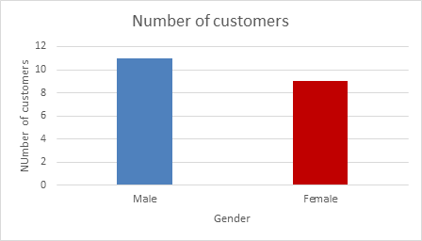
Number of customers by gender

Bar chart: Numbers of male/female customers

The data can be presented as whole numbers, as in this bar chart, or as percentages, as in the pie chart below, and with or without numbers / percentages added to the bars / ‘slices’.

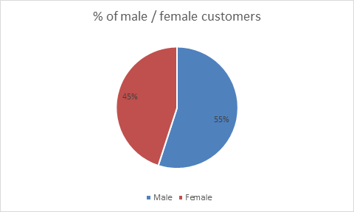
Pie chart: Percentage of male/female customers

Bar and pie charts are visually effective in summarising simple data sets, such as in this case.

The separation of the bars in the bar chart helps visually to convey the discrete nature of the two categories.

How might this data have been gathered?

- Via questionnaire / structured questionnaire– tick box – which could have included an option for ‘non-binary’ / ‘prefer not to say’
- Via observation – staff record – tick box – most likely method

What does this data tell Gwalia management?

They have roughly equal numbers of male and female customers (at least, within this sample).

It is hard to draw any conclusions from this data alone, beyond the observation that there appears to be no significant gender divide in the appeal of the service they are providing currently.

However, when gender data is analysed alongside other variables (below), some useful patterns may emerge.

Newspapers

The data for the variable ‘Newspaper’ indicates which of four daily newspapers are purchased on a regular basis by each of the customers.

The raw data is nominal (categorical).

Such data can be used to evaluate categories’ relative frequencies or proportions.

The mode is the only measure of central tendency appropriate for nominal data.

The Guardian is the most frequently purchased newspaper, and thus, the mode in this distribution (see table below).

The data may be better understood when converted to percentage of total newspaper sales.

Newspaper | Number of customers who regularly purchase each newspaper | % of total newspaper sales
Times | 2 | 10
Western Mail | 5 | 25
Daily Express | 6 | 30  Mode
Guardian | 7 | 35
Total | 20 | 100

Table: Numbers and percentages of customers regularly purchasing each of 4 daily newspapers

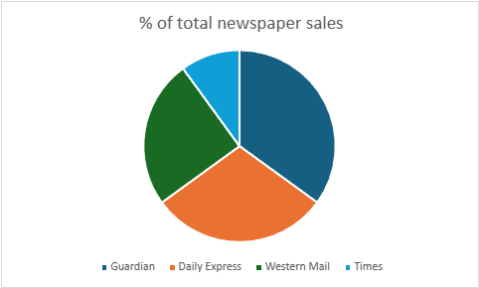
Pie chart: Percentage sales per newspaper

Both bar and pie charts work will work well with small numbers of categories like this. With large numbers they can become too cluttered, and their visual ‘readability’ and impact become limited.

A horizontal bar chart can be useful when there are longer data labels.

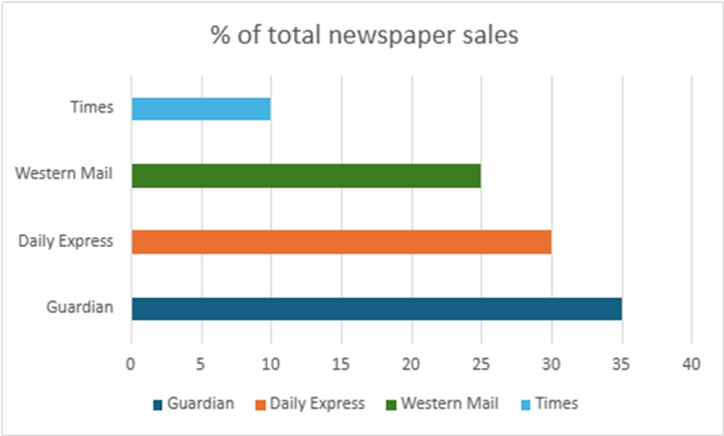

Horizontal bar chart: Percentage sales per newspaper

The raw data was nominal, but by tallying, the total numbers of each newspaper purchased are calculated as while numbers or percentages, and then ranked according to popularity. The data is now ordinal – it can be ranked.

Newspaper | Number of customers who regularly purchase each newspaper | % of total newspaper sales | Rank in terms of popularity
Guardian | 7 | 35 | 1
Daily Express | 6 | 30 | 2
Western Mail | 5 | 25 | 3
Times | 2 | 10 | 4
Total | 20 | 100

Table: Newspapers purchased (number and %), then ranked by popularity

The table below recording Newspapers against Gender, shows a clear preference amongst female customers for the Guardian (exclusively female purchasers) and amongst males for the Daily Express (only bought by men)

Newspaper | Guardian | Times | Western Mail | Daily Express
Female | 7 | 1 | 1 | 0
Male | 0 | 1 | 4 | 6
Total | 7 | 2 | 5 | 6

The same information can be presented graphically using a clustered column graph:

Number of
customers
Newpaper popularity by customer gender

Newspaper

Opinion

This variable contains data on customers’ opinions of the local borough council.

It is likely to have been collected by Gwalia staff using a Likert Scale:

Question: What is your opinion of the Local Borough Council?
Very discontented | Discontented | Contented | Very contented
1 | 2 | 3 | 4

The results can be tallied into a table like this:

Tally of responses
6 | 4 | 6 | 4

or, from the original spreadsheet, like this:

Opinion | Tally
1 | 6
1 | 6
1 | 6
1 | 6
1 | 6
1 | 6
2 | 4
2 | 4
2 | 4
2 | 4
3 | 6
3 | 6
3 | 6
3 | 6
3 | 6
3 | 6
4 | 4
4 | 4
4 | 4
4 | 4

and summarised thus:

Opinion | Tally
Very discontented | 6
Discontented | 4
Contented | 6
Very contented | 4

This is ordinal data.

Measures of central tendency which can be calculated include:

- the mean (arithmetic average) – calculated from the sum of all the Likert scores divided by the number of responses:

48 [(6x1)+(4x2)+(6x3)+(4x4)] / 20 = 2.4

- the median (mid-point) i.e. 10 data entries above and 10 below in this data set of 20 – the median lies at the mid-point between scores 2 and 3 i.e. 2.5

Opinion
1
1
1
1
1
1
2
2
2
2
Median 2.5
3
3
3
3
3
3
4
4
4
4

In this case the mean and median scores are almost identical at approximately 2.5. On the face of it, this suggests that, between them, this group of customers hold a balance of negative and positive opinions about the local borough council.

However, the bi-modal distribution suggest a slight left skew – towards discontent. The ‘very discontented’ outnumber the ‘very contented’.

If so, why? What has that got to do with Gwalia Stores? Why might they be asking this question? It is very non-specific. Is there an issue, the responsibility of the local borough council, which is a common concern to both Gwalia Stores and their customers (e.g.availability of parking outside the shop / reliability or frequency of local bus service giving easier access to Gwalis Stores for those at distance)?

Would it have been more useful to ask customers how satisfied they are with the service provided by Gwalia Stores?

Distance

The data for the ‘Distance’ and ‘Spend’ variables are examples of scale data.

MEAN
MEDIAN
MODE

Graph: Distance travelled by individual customers from their homes to Gwalia Stores with measures of central tendency (mean, median, mode) indicated.

Mean | 259.5
Median | 160
Mode | 50

Table: Distance data – measures of central tendency

There is wide variation between the common measures of central tendency, the mean, median and mode. This is also reflected in the standard deviation.

Standard deviation is a measure of how far values in the variable are spread out from the mean The greater the spread, the larger the standard variation.

Standard deviation | 323.4

Skewed distribution – the mean is of less value as a measure of central tendency because of the outlier effect. In this case 5 customers (25%) travel less than 20m, whilst 2 (10%) travel 1000m or more.

The range = 1,095m (i.e. difference between longest and shortest distance travelled) is striking. The customer who lives furthest away travels 220x the distance of the nearest.

Box and whisker chart for the Distance variable

The box and whisker chart reveals the skewed nature of the distance data.

Box plots and whisker charts display the 5 number summary i.e. :
- minimum (smallest number)
- 1st quartile (25% point)
- median
- 3rd quartile
- Maximum (largest number)

Together, these provide a visual representation of the ‘shape’ of the data’s distribution, its central tendency and spread / dispersion.
The data is broken down into quartiles. The blue box represents the inter-quartile range (middle 50%) and the lower and upper ‘whiskers’ the lowest and highest 25% of the data respectively. The long upper tail reflects the skew in favour of higher distances.
The median is indicated by the horizontal line passing through the blue box (and the mean by the ‘x’).
The data for the ‘long distance’ customers (1000 and 1100m) are identified by the two detached dots. These are clearly outliers which are ‘pulling’ the mean away from the median.
Box and whisker charts generally require a minimum data set of 20, so can be used effectively here.

When the mean and median are recalculated for the interquartile (representing the middle 50% of customers), they move closer together.

The interquartile range is 50-300m (much smaller than the full range of 1095m)

INTERQUARTILE
MEAN | 154.5
MEDIAN | 160

Gwalia Stores could consider the needs of three groups of customers based on the distance they travel to shop there: the ‘average’ customers (blue box), those few who live very close by, and those who are more distant.

Spend

MEDIAN 15.00
MEAN 15.25

Graph: Weekly spend by individual customers

SPEND (£)
Mean | 15.25
Median | 15
Mode | Multi-modal

There is no single mode, but all these values occur twice: 6,11,15,19,33. This multi-modal pattern provides no meaningful information.

However, the mean and median are extremely close.

Customers spend between £6 and £24 per week – a range of £18 with a standard standard deviation of just 5.8.

This more even spread (compared to the pattern in the Distance data above) is reflected in the box and whisker chart below. The box and tails are fairly evenly spread each side of the median.

Box and whisper chart: Weekly spend per customer

Does the distance customers have to travel to shop at Gwalia Stores affect how much they spend?

Scatter graph: Weekly spend against distance travelled

A scatter graph can be used to plot data for Distance against Spend. It suggests there is a strong negative correlation between the two variables i.e. the further the customer lives from the shop, the less they are likely to spend, and the closer they are the more they spend.

Gwalia Stores could consider offering a home delivery service to increase sales amongst customers who live at a distance.

Do men spend more than women?

On average males spend more than females by approximately 16%:

Gender | Average weekly spend
Female | £14.00
Male | £16.27

Gwalia Stores undertake some market research to improve the shopping experience for females – e.g. shop environment and stock items.

CONCLUSION

Some caution is necessary in interpreting this data set because of its small size.

It probably does not record information about all of Gwalia Stores’ customers (20 customers a week and takings of £305 is unlikely to sustain a business).

Presumably, these 20 customers are a sample only. How has the sample been selected? Perhaps the 20 were chosen because they are all the customers who have a daily newspaper delivery, or because they were the ones who were willing to respond to the questionnaire / Likert scale. In what sense are they representative of all the customers? Can lessons learned from it be generalised?

However, it provides some useful preliminary data, suggesting ways in which Gwalia Store might improve the service it provides – for example, by the provision of a home delivery service and working on improving its appeal to female customers.

