University of Wales
Trinity Saint David

Module title: Community Engagement LCBB4002
Student Name: Vasile Penciuc
Student Number: 1916918
BA Business Management
Lecture tutor name: Molly Jack
Community Engagement -Assessment 1

Table of Contents
Introduction 4
1. Organizational Overview and analysis 5
1.1 Industrial overview of Tesla Inc. 5
1.2 Size and structure of Tesla Inc. 5
1.3 Goals, mission and values of Tesla Inc. 6
2. Customers of Tesla Inc. and their expectation from the company 6
2.1 Customer analysis of Tesla Inc. 6
2.2 The expectation of customers 7
3. SWOT analysis of Tesla Inc. 8
4. Role of employees and their support to achieve organizational goals 9
5. Explanation of training and development and importance of this to the organization 9
6. Importance of Chief Financial Officer at Tesla Inc. 10
7. Skills and knowledge needed to carry out the role of a Chief Financial Officer 11
8. Training and development requirement for a CFO 13
Conclusion 15
References 16
Appendices 18

Table of Figures
Figure 1: Organizational Structure of Tesla Inc. Plc 5
Figure 2: Customer segments of Tesla Inc. 7
Figure 3: SWOT analysis on Tesla Inc. 8
Figure 4: Importance of training and developments 10
Figure 5: Activities of CFO in Tesla Inc. 12

Introduction
This report contains several discussion and analysis of a business organization and its different internal and external factors. For completing the report a business organization has been selected. The size, structure, mission and goals of the selected company have been identified and described (Porter and Latham, 2015). Different customers have been identified and explained and SWOT analysis has been included to support the explanation. After that, a particular employee role has been selected and the importance of this role in the organization has been explained (Khalifa, 2018). Finally, training and development requirements for a crucial employee in the organization has been explained.

1. Organizational Overview and analysis

1.1 Industrial overview of Tesla Inc.
Tesla Inc. formerly known as Tesla Motors Inc. is an American company. It’s an electric vehicle and clean energy company. It is specialized in manufacturing of electric vehicles and battery energy storage from home to grid-scale. It was founded on July 1, 2003, by Martin Eberhard and Marc Tarpenning (Tesla.com, 2020). It operates in the automotive, energy storage and energy production industry. The automotive industry includes designing, developing, manufacturing, marketing and selling of motor vehicles. It is one of the largest business segment in the world.

1.2 Size and structure of Tesla Inc.
Tesla has been doing business for more than sixteen years. After eleven years in the market, Tesla was ranked as the best seller of battery electric passenger car. Tesla has a 17% market share of plug-in the segment and more than 23% in the battery-electric segment. In 2019 this company generated $24.75 billion. They have a total asset of more than $34 billion. This publicly-traded company has 48,016 employees working currently. This company has five subsidiaries in the different business segment. This company operates in four industry simultaneously, being such a complex organization Tesla Inc. has to maintain a functional or U-form organizational structure. Their organizational structure is:
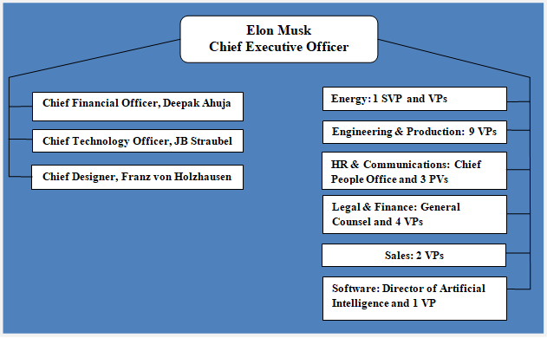
Figure 1: Organizational Structure of Tesla Inc. Plc
Source: (Tesla.com, 2020)
Tesla Inc. Finance, technology, global sales & services, engineering and legal department’s head directly report to the CEO, Mr Elon Mask.

1.3 Goals, mission and values of Tesla Inc.
Tesla’s mission is to accelerate the world’s transition to sustainable energy and sustainable transport. The founders of this company have the objective that people don’t need to compromise with the electric drive as electric vehicles will be quicker, better and more enjoyable to drive than gasoline cars. Tesla Inc. is very serious about their values, they believe values shape their culture. They have established their values after taking suggestions and feedback from their stakeholders (Bayer, 2016). Their organizational values include:
- Respect the environment
- No forecast is perfect, but you must try
- Encourage people to respect each other
- Keep the learning process continue
- Keep the best effort and embrace the challenges

2. Customers of Tesla Inc. and their expectation from the company

2.1 Customer analysis of Tesla Inc.
Tesla Inc. provides several services. Their core business is car manufacturing. The automotive services are provided by the auto & truck manufacturing division of this company. The customers of Tesla falls into different categories, these are:
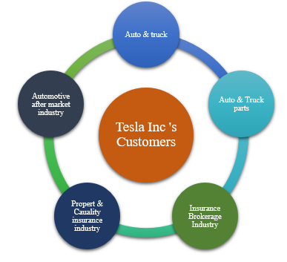
Figure 2: Customer segments of Tesla Inc.
Source: (Carlberg, 2014)
These five industries are current customer segment of Tesla Inc. At present Tesla is selling cars to mostly male customers. Most of them are more than 45 years old income level of $100,000 and Asian (Tesla.com, 2020). Their customers belong to three different industry. In this report, customers of the automotive industry will be highlighted.

2.2 The expectation of customers
Product’s quality is the top of all the expectations of customers from a telecommunication company like Tesla Inc. (Massmann, 2015). Customers expect a stable high-quality product. They want the product of this company to add a social status through their brand value. The customer of Tesla wants this company to be successful. They expect the company to remain honest and transparent to them. Customers always want to be delivered long term experiences from the products of this company. (Porter and Latham, 2015). If something goes wrong customers want to communicate directly with the Company and they want an easier medium of communication with the company.

3. SWOT analysis of Tesla Inc.
Being one of the leading companies in the telecommunication industry Tesla Inc. contains several factors that have a positive impact and negative impact on the company. A SWOT analysis will represent most of these influencing factors:
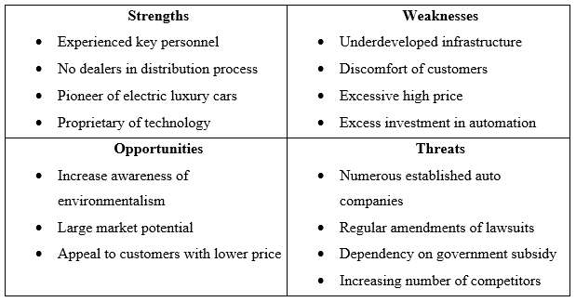
Figure 3: SWOT analysis on Tesla Inc.
Source: (Pugh and Hickson, 2019)
Strengths: Tesla has very experienced key personnel, they have quite a good record in this industry. Tesla has its outlets, they don’t use traditional distribution channel for selling cars. This company is the pioneer producer of luxury electric vehicles. They have established their brand’s name with electric cars in the mind of people (Puranam and Maciejovsky, 2017).
Weaknesses: Their brand is established with electric cars but they haven’t been able to develop the full infrastructure for producing electric cars in a lot (Reid and Barrington, 2014). But they have spent a pretty high amount for establishing automation in the production process, which may be proved unnecessary excess expenses. Customers are still not that much comfortable with the electric vehicles moreover the cost is too high to afford by general people.
Opportunities: They can increase the demand for electric vehicles by increasing awareness of environmentalism among people. They have the opportunity to enter the international market with a strong brand name and can grab the lower-income customers by offering new low price models (Woodard et al., 2017).
Threats: The number of the established auto company is quite high for this industry. Staying ahead of them it’s a challenge for Tesla. The government isn’t certain about the established laws and regulation about electric cars as these are new technologies. The price substantially becomes lower for customers due to government subsidy (Tesla.com, 2020), without government subsidy sales will fall drastically.

4. Role of employees and their support to achieve organizational goals
The organizational goal of Tesla Inc. is to accelerate the world’s transition into sustainable energy (Sheth et al., 2014). To achieve organizational goals employees must willingly accept challenges and try to learn new things regularly. If roles and responsibilities are delegated as per employee’s interest and specializations, employees will have to try hard and perform better than the fellow workers. Employees’ shouldn’t engage in unhealthy competition and exercise of unfair political power (Bayer, 2016). Employees can establish a set of organizational principles and policies that will create a brand image in the organization and make it distinct from its competitors. Employees are the most precious asset for Tesla Inc. their responsibility is to strive hard for delivering the best level effort and achieve the assigned target within a specific time frame (Baker, 2017). Only the employees can contribute effectively toward the achievement of organizational goals.

5. Explanation of training and development and importance of this to the organization
Training and development is the formal process of improving the performance of employees and increasing their job-related knowledge through educational programs and methods. Training involves sharping of knowledge and skills, improving concepts and changing attitude to enhance employees’ performance (Khalifa, 2018).
The organizational structure of Tesla contains employees of different designations. They have separate roles and responsibilities. They must know their duties toward their seniors and responsibilities for their subordinates.
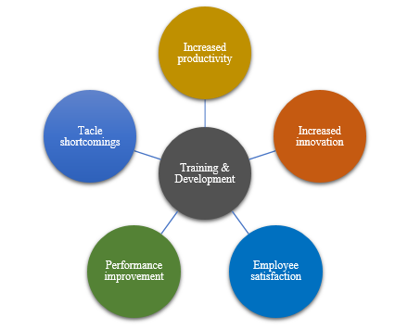
Figure 4: Importance of training and developments
Source: (Porter and Latham, 2015)
A training program contains the assignment of responsibilities and outline of activities for employees of all designations. Training and development programs help the employees of Tesla Inc. to understand their assigned goals and strategies. Structured training program improves employee’s performance, it helps employees to address their weaknesses (Puranam and Maciejovsky, 2017). Training programs improve the productivity of the employees and support them to be more innovative. It teaches them to tackle shortcomings and increase their performance level. The opportunity to increase knowledge base brings satisfaction among employees.

6. Importance of Chief Financial Officer at Tesla Inc.
Chief Financial Officer also known as CFO is the executive who is responsible for directing and managing financial actions of Tesla Inc. (Reid and Barrington, 2014). The basic duties of a CFO in Tesla include:
- Financial planning
- Tracking cash flows
- Analysing Tesla Inc.’s financial strengths and weaknesses &#
- Proposing corrective actions
The duty of a CFO starts from collecting equity or debt for Tesla and ends with the timely collection of revenue. He/she keeps the business fully funded and functional at any point in time. CFO adds value to Tesla Inc. in different ways. He always tries to ensure faster growth of the company and improve real profitability by ensuring improvement in the cash flow of the company (Khalifa, 2018). CFO has a deep knowledge of Tesla Inc.’s business model and its banking relationship. He knows the most efficient ways of working with the auditors, oversee tax planning and setting control and payroll policies for the company.

7. Skills and knowledge needed to carry out the role of a Chief Financial Officer
A chief financial officer needs to handle and direct the financial activities of the whole company. He must possess vast knowledge regarding managerial finance, financial corporate strategy and financial innovation. Knowledge of managerial finance helps CFO to create accurate budgets and make informed decisions with the help of financial insights (Armandi, 2016). Knowledge in financial corporate strategy helps a CFO to understand strategies that affect the future of the business and make better strategic decisions by utilising the strategic framework. Depth knowledge about financial innovation let the CFO in Tesla to handle the money, market and transactions in the most efficient way (Carlberg, 2014). To be a good financial officer one must need to develop three areas of skills, these are:
- Business acumen
- Technical skills
- Behavioural skills
To progress through finance management in the automotive industry a CFO must develop higher technical skills. He should know activity-based costing, forecasting, and data mining and financial modelling. He also needs to upgrade his business acumen (Khalifa, 2018). He should have the skill of business strategy development and managing strategic performance. And finally, he must possess some behavioural skills such as building relationships, communication, influencing and negotiation.

8. Training and development requirement for a CFO
Tesla Inc. is a giant conglomerate. In such an organization the CFO must have different competencies to manage the whole financial sector of the company. The task of CFO in this company is to ensure that the business successfully retains a positive financial outlook. The training and development program for a CFO depends on the key responsibilities he/she will have to perform in this organization (Massmann, 2015). As Tesla Inc. runs the operation in four different industry simultaneously the CFO of this company has to perform numerous activities. Some day to day task of the CFO are:
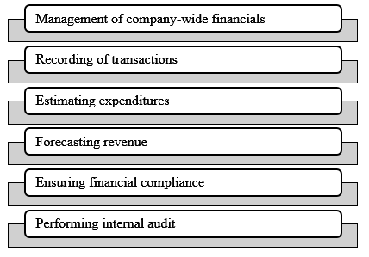
Figure 5: Activities of CFO in Tesla Inc.
Source: (Sheth et al., 2014)
As these are day to day task so the training and development programs are also set to improve the performance of these activities. To perform all these activities efficiently some basic categories of training are:
- Strategic planning
- Financial Modelling
- Risk Management
- Financial Compliance
Strategic planning training helps the CFO in Tesla to create easy and understandable strategies. Such strategies will derive from the team’s strengths and will last longer (Khalifa, 2018). Financial modelling training will help the CFO to perform better financial forecasting, reporting and operational metrics tracking. Risk management training helps to raise basic awareness of risk management concept and mechanisms (Puranam and Maciejovsky, 2017). Financial compliance training will help the CFO of Tesla Inc. to stay compliant with the current rules and regulation regarding the automotive industry, as they have to oversee activities of different industries this training is very significant for them.

Conclusion
Every business operates in a particular sector. Tesla Inc. belongs to the automotive, energy storage and energy production industry. Due to having multiple business lines they have customers of different segments. They have been successfully upholding their business though they are facing some internal and external threats. But the dedicated participation of their employees can take them to the peak of their organizational goals (Khalifa, 2018). Chief Financial Officer is one of their most crucial executives. He is a very experienced and efficient employee for the company. Still, there are scopes to train this employee to bring the best performance out of him.

References
Armandi, B., 2016. Organizational Structure And Efficiency. Lanham [Md.]: University Press of America.
Baker, H., 2017. Employee Training. Chandni Chowk, Delhi: Global Media.
Bayer, J., 2016. Customer segmentation in the telecommunications industry. Journal of Database Marketing & Customer Strategy Management, 17(3-4), pp.247-256.
Biazzo, S., 2015. Approaches to business process analysis: a review. Business Process Management Journal, 6(2), pp.99-112.
Carlberg, C., 2014. Business Analysis. [Place of publication not identified]: Que.
Harrison, R., 2017. Employee Development. London: Chartered Institute of Personnel and Development.
Khalifa, A., 2018. The strategic CFO. Strategic Direction, 20(3), pp.20-22.
Massmann, C., 2015. The evolving role of the CFO. Strategic Direction, 20(3), pp.26-28.
Porter, R. and Latham, G., 2015. The Effect of Employee Learning Goals and Goal Commitment on Departmental Performance. Journal of Leadership & Organizational Studies, 20(1), pp.62-68.
Pugh, D. and Hickson, D., 2019. Organizational Structure In Its Context. Farnborough, Hants: Saxon House.
Puranam, P. and Maciejovsky, B., 2017. Organizational Structure and Organizational Learning. SSRN Electronic Journal,.
Reid, M. and Barrington, H., 2014. Training Interventions. New Delhi: Jaico Publishing.
Sheth, J., Mittal, B. and Newman, B., 2014. Customer Behavior. Fort Worth, TX: Dryden Press.
Tesla.com. 2020. Tesla. [online] Available at: <https://www.tesla.com/> [Accessed 4 May 2020].
Woodard, J., Chiu, L., Power, G., Vedenov, D. and Klose, S., 2017. Factors Affecting Changes in Managerial Decisions. Agribusiness, 33(3), pp.443-465.

Appendices
Skills | Objectives | Resources | Duration
Strategic planning | Financial Officer will be able to build easy, understandable and unique strategies | Strategic planning, Business workshops, Seminars, | 2 months (Starting from July 2020 to July 2020)
Financial modelling | Employees will be able to analyze financial data, forecasting, reporting and create financial models | Case studies, Planned reading, training, mentoring | 3 months (From September 2020 to November 2020)
Risk management | Helps to prepare better quality data for decision making and the budget relies less on guesswork | Simulators, Training, seminars, reading materials | 4 months (From January 2021 to April 2021)
Financial Compliance | This training helps to accomplish all the financial activities complying with current rules | Training, workshops, seminars and group discussions | 2 months (from July 2021 to August 2021)

