Student Name: Mashuda Begum  Student ID: 2119256  Module Title: BMIH  Module Code: 5003  Lecturer: Guilia chifari  Date:31-05-24 | 
ASSIGNMENT 1: PORTFOLIO

Component 1: Professional Reflection (500 words +/- 10%)

Weighting: 25%
Diversity Hotel & Spa London
Having worked at Diversity Hotel & Spa London for the last two years I have encountered different events where I faced cultural misunderstandings. Working as a front house employee, it’s important to have the ability to manage other people from various cultures and languages. Here I get different customers from different ethnic or countries (Margaret Shu-Mei Sass, 2013). So, in dealing to French customers I am offended by the culture and feel embarrassed. In French, the guests are politer and gentle and care about equality. So, here in serving the guests, I feel ashamed of their double kiss greeting cultures where I was unfamiliar with this tradition. Again, I was also unaware that French customers like to have dinner later in the evening. At that time there were not too many guests and I became ashamed and shy after getting the greetings.
Cultural Misunderstanding
Here, I get the cultural misunderstanding with the greeting norms where usually the guests haven’t the culture of gathering with us. In my work experience, I always tried to give my best efforts in understanding the customers and helping them with their needs (Chamberlain, 2019). But such of these kinds of activities make me discomfort which has created a negative impression in front of my customers.
Reflection through using ERA Cycle
Overthrowing the overall scenario, I have realized that I need to improve my communication skills and should be confident with the misunderstanding of different cultures. From these experiences here I gained an of understanding the importance of multilingualism. I have realized that if I were aware of other cultures and traditional norms it would be helpful for me to make better serving. In getting the experience, I may need to be involved in different learning programs or training where that can help me how to serve different guests (Jasper, 2013). Again, the situation taught me about the interaction and diversification of different cultures and influenced me to focus on services-oriented actions.
To avoid this kind of misunderstanding in the future I have planned to acknowledge the different country languages and traditions. I will focus in the beginning on the Spanish, German, French, and Italian languages which may be easier to understand. I will try to know about their cultural background and their norms which will make me able to behave with them politely. Again, I will also focus on a communication strategy where I will care about their expectation and give them customized services according to their needs (Ann Shelby Harris et al., 2010). Moreover, I believe if I ask open-ended questions to them and request them to cooperate with me it will be better to build a good communication bond. I want to get prepared about their gestures and behaviour which will help me to respond to their needs accordingly and help them to have a good experience.
References:
Ann Shelby Harris, Bruster, B., Peterson, B. and Shutt, T. (2010). Examining and Facilitating Reflection to Improve Professional Practice. Rowman & Littlefield Publishers.
Chamberlain, D. (2019). Reflection. London: Macmillan.
Jasper, M. (2013). Beginning Reflective Practice. Cheltenham: Nelson Thornes.
Margaret Shu-Mei Sass (2013). Service Learning Reflection Journal for Kids: Tools and Activities to Help You with Your Service Learning Project from Beginning to End. Purdue University Press.
Component 2: Presentation

Weighting: 25%

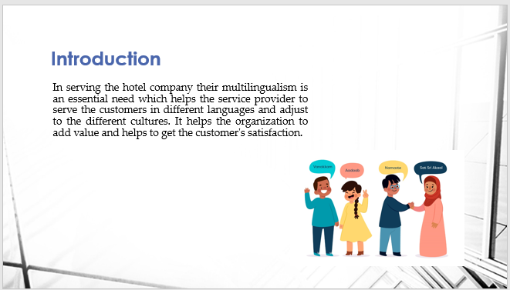
In serving the hotel company their multilingualism is an essential need which helps the service provider to serve the customers in different languages and adjust to the different cultures. It helps the organization to add value and helps to get the customer's satisfaction.
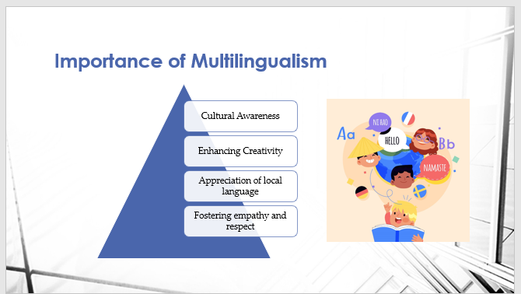
Multilingualism helps in understanding cultural awareness where the service provider gets awake how to treat guests from different cultures. Diversity Hotel & Spa London there it has records of visiting 12 million people in a year. As here it has different countries people including, Spanish, German, Italian, French, Dutch etc. So, here the employees have to be aware of the different cultures and languages (Aronin and Singleton, 2012). Again, knowing about the language and their cultures, the employees may boost their performances which helps in getting creative functions for business. In performing the customers serving the local language or culture get appreciation which helps to promote the local perception to the foreign guests.
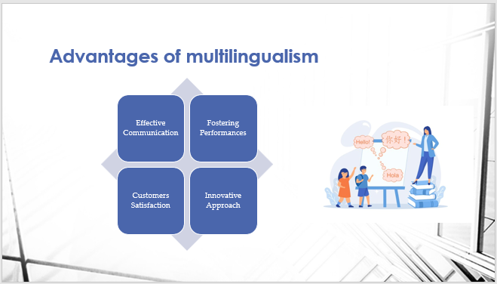
Through getting multilingualism skills there the employees get the ability to make effective performances where they get boosted in their capabilities. Again, it gives the employees the right skills to communicate well where they can make attachments with them and understand their needs. Again, it fosters the capabilities of the employees where the staff can take innovative actions and invent more equipment to engage the customers (Pavlenko, 2011). Diversity Hotel & Spa London has a diversified culture in the UK which has different services including dining, lounges, spas, hotel rooms etc. So, here every year, different types of customers arrive who need to get accurate services. To maintain brand popularity, it is essential to making the using of multilingualism.
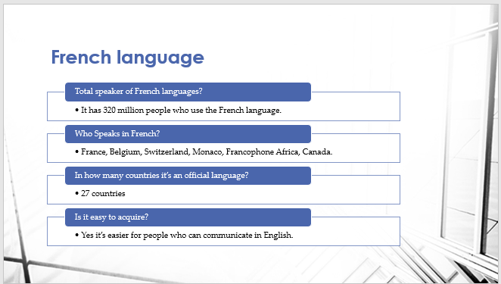
In the European language, this is one of the top languages which has been spoken by 310 million people. It’s being used as the official language in 27 countries and 10 sub-national countries. This language is native to France, Belgium, Switzerland, Monaco, Francophone Africa, and Canada. As in the UK from cultures, there is a large number of people who visit the hotel, so it is one of the essential languages. Again, that’s not so difficult for learning who have a native language English.
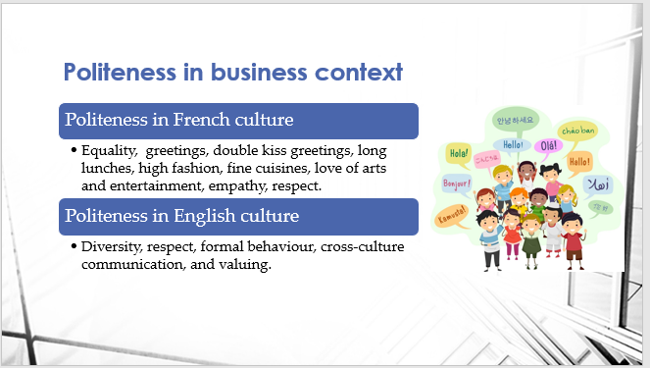
There in different countries, it has different cultures where it has different languages for politeness. In French, they give priority to empathy and equality which helps them show respect for the person. They like to give greetings to the people when they meet and they leave the place. They have the craziest culture of making double kisses in the greetings (Bhatia and Ritchie, 2015). Moreover, they have an addiction to high fashion and cuisines. Again, in comparing the English culture, it has the politeness to showing formal relations with everyone. It has also a culture of cross-culture communication where they try to show respect to the people of every culture.
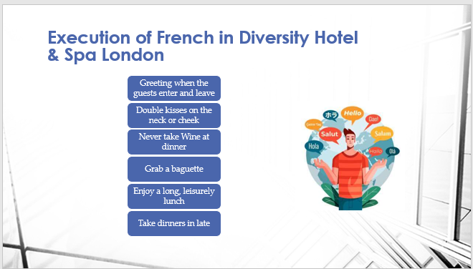
There in serving the French guests the hotel staff have to remember their likes and dislikes. They always prefer to greet whenever they enter and leave. Again, they have a culture of double kissing at the time of greetings which is unusual in the UK culture. Moreover, they have no culture for taking wine at dinner parties and taking late dinner. At lunchtime, they like leisure and a long time to take lunches. At Diversity Hotel & Spa London every year almost 40,000 guests arrive from the countries where they have their mother tongue of French. So, here it will be helpful for the management to make effective engagement with the customers.
References (no screenshots):
Allan, B. (2016). Emerging strategies for supporting student learning. London: Facet Publishing.
Bassot, B. (2020). Reflective journal. 2nd ed. London: Palgrave Macmillan.
Budworth, T. and Hashemi, A. (2014). Reflective Learning. Routledge.
James David Velleman (2017). Practical reflection. Stanford, Calif.: Csli Publications.
Component 4: Student Self-Reflection (500 words +/- 10%)

Weighting: 25%
As a part of working in the hospitality industry where I need to be able to learn continuously which will help me to enhance my performance and access more satisfied performances. Throughout the session, I learned about cultural awareness which has significantly influenced me to make self-development (Allan, 2016). Here I have reflected on my learning through Kolb’s learning cycle which helped me to make real-life experiences and make the plan to improve for further actions.
Concrete Experiences: I encountered a cultural misunderstanding that helped me to find the importance of knowing cultural importance. In my hotel serving experiences, I need to serve different guests who may come from different ethnicities and cultures. So, here I getting encouraged to know about multilingualism which will give visibility to behaving according to the culture of those guests. So, here I getting the French guests who had the culture of kissing in the greetings which makes me discomfort. Here I observed that I need to know how my culture has biased me to satisfy the guests. This experience gives me the sensitivity to giving further cultural intricacy and serving more effectively.
Reflective Observation: After reflecting on the incident I understand I have a lack of knowledge and assumption toward various cultural awareness (James David Velleman, 2017). There I have the consciousness that I have to understand the guests' norms and cultures which will indicate to me how to give them better services. This situation has also awakened me to provide effective services which will help in engaging the customers.
Abstract conceptualization: Here in understanding cultural competency I have tried to include fewer frameworks and theories which helped me to understand the concepts of serving in different cultures. Here I learned the cultural dimensions of Hofstedee’s and Iceberg's theory which helped me to know about the customer's communication strategy and conceptualized how to give them better experiences.
Active experimentation: After knowing about the different cultures and norms here I will make an experiment with the different customers and treat them with confidence. It will help me to provide the right service and adjust to the different cultures of customers (Budworth and Hashemi, 2014).
Self-reflective experiences:
Frem this part I have learned about the surfaces of different languages and being aware of trading with other countries' customers. I have realized that knowing about the multi-language will help me to make more incredible performances. Again, through effective communication, I can interact with them and give them accurate services (Bassot, 2020). In the hospitality sector, customers are fond of new and unique services and I will make them creative and unique services. In their greetings, lunch menu, dinner time and more I will be more aware and try to encourage them to be loyal to this hotel.
References:
Allan, B. (2016). Emerging strategies for supporting student learning. London: Facet Publishing.
Bassot, B. (2020). Reflective journal. 2nd ed. London: Palgrave Macmillan.
Budworth, T. and Hashemi, A. (2014). Reflective Learning. Routledge.
James David Velleman (2017). Practical reflection. Stanford, Calif.: Csli Publications.

