What is ‘Community Heritage’ and how is it practiced in Britain today? Discuss in relation to one project known to you.
Community in the heritage sphere has been said to be hard to define, but Watson and Waterton state, when discussing this topic, simply that: “community heritage is valuable”. The word “Community” refers to a group of people that are drawn together by their beliefs, values, expressions of diversity, and empowerment. The development of heritage as a whole often does not happen in a linear fashion, but this process often creates something of an “official” version of the past. Though, when this heritage is grasped by a community sphere, this can change. The engagement often takes place as an educative leisure activity, linking the communities to a past that they feel connected to, deconstructing a hegemonic perspective of heritage that may have been more pervasive before public interest became prevalent. The preservation of this type of heritage is often in the hands of the local population, so if a certain part of the heritage of an area is seen as insignificant, it may be rejected by the people it relates to. If an aspect of heritage doesn’t relate to the constantly changing sense of self of a group of people, it is easily neglected and no longer attracts community interest.
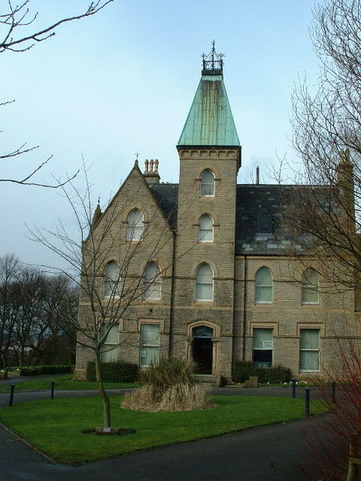
Community heritage strongly relates to the lives and identities of the people presiding in the local community. The linking of communities and heritage is what Watson and Waterton believe to be the building blocks of identity. These identities are layered and embedded in a local area where heritage may lie. Though these identities have the potential to include preconceptions, this does not mean they are to be invalidated. Communities are still able to define themselves through myth even if it is known to not be the full truth. Because these identities are so complex, they are often embedded in aspects of the past, these aspects of the past becoming managed as a type of heritage. Community mythologies and memories become resources for curators to use in the present day. Eventually, if these identities are related to one another, they become ascribed to a place by the local people. Their heritage becomes the outstanding characteristic of a place. It is this community history that has the ability to enhance the sense of community that may otherwise be lost if not preserved in institutions such as museums. When museums are visited in this way, a community heritage is best made sense of though emotional consumption, potentially meaning something different – but equally valid – to the visitors who are able to identify. Local people then have the ability to express a pride in their community and affirm their modern identities, wanting to learn about their past and see the evidence of it happening. Yet, it has to be considered that these identities are fluid and have the capability to change whenever, and be unstable and uncertain. Because of this uncertainty, the engagement with certain aspects of the community heritage may differ depending on what is important at the time. Even when looking at the different perspectives that come into heritage management, the interests of community heritage change; such as the perspectives of the government, the museum sector, and public initiatives.
It is also said by Waterton and Smith that the reasoning behind the increase of community heritage is due to the fact that it allows heritage professionals to “feel good about the work [they] do”. Crooke also suggests that the connection that is seen between communities and their heritage is so natural that there is no need to make an attempt to justify it, as they justify each other. It is so essential that some museums even come into question when the heritage they hold does not have a link to the community, if it has no link to the local population in any way, how viable can it be?
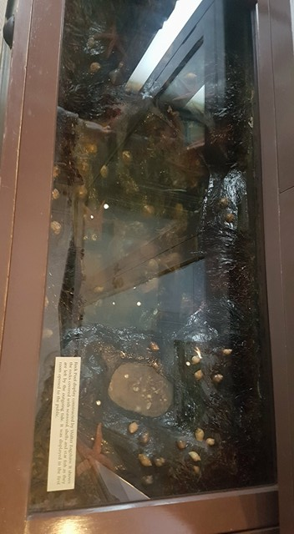
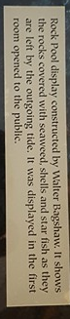
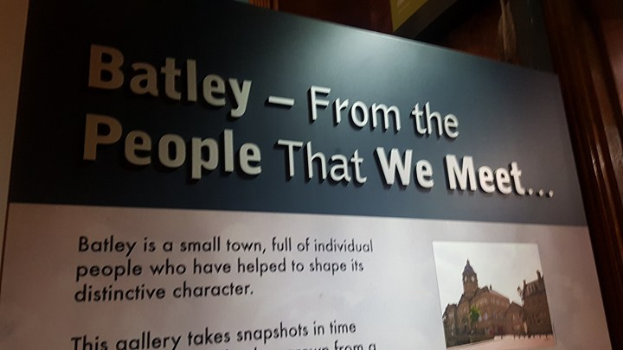
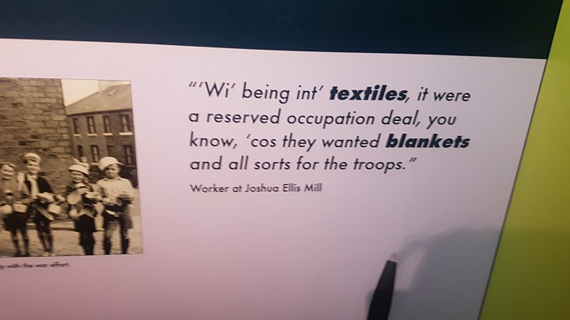
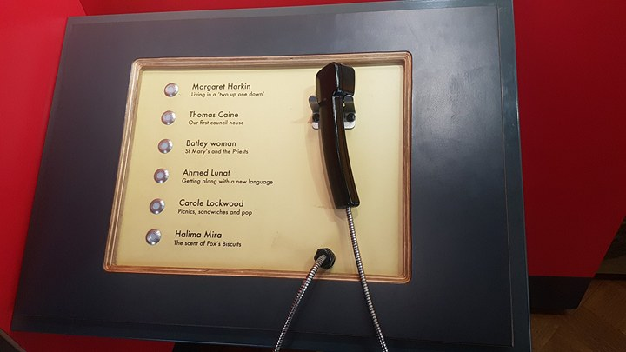
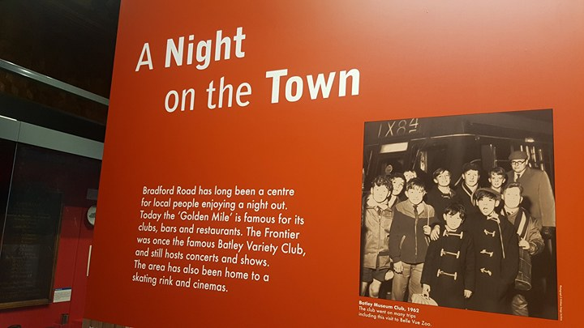
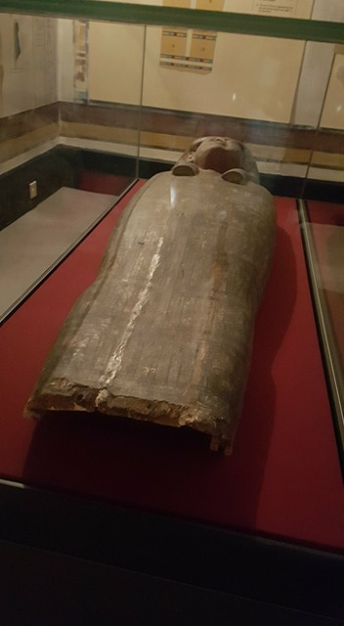
The project that has been chosen to be the case study of this essay is the institution known as Bagshaw Museum (see Fig. 1) in Batley, West Yorkshire. This institution is of a rather large personal importance, it being a place where I have visited throughout my childhood. Batley is a town that has a large amount of personal history, my paternal and maternal families have residing in this area for many generations.
Bagshaw Museum was originally a Victorian mill-owner’s mansion known as ‘The Woodlands’. In the year 1911, Walter Bagshaw converted the mansion into a Museum. The museum is set in 36 acres of farmland and ancient woodland – known to be Wilton Park in the modern day. The exhibits in the museum tell of Walter Bagshaw being an inventor and a prominent figure in the local community, his influence stretching from Batley, to Harrogate, to Leeds, to other areas in Yorkshire. The older objects in the current collection were acquired by Noah and Violet Bagshaw after the death of their father. Noah Bagshaw in particular had an interest in archaeology of ancient civilisations, and the creation of the Egyptology gallery at the museum could be credited to him and his acquisitions which he donated to the museum.
In the modern day, the museum has local history galleries on the ground floor about the Bagshaw family, and the history of Batley. The Bagshaw Gallery contains examples of the first objects that were donated to the museum by the family (See Fig. 2), and information about the life of Walter Bagshaw. The first of the two Batley galleries contains information about immigration of Irish families to Batley, as well as the increasing South Asian immigration that was seen in the mid-twentieth century (See Fig. 3). There are quotes from oral histories in and around the displays, (See Fig. 4) and even an option to hear recorded histories of local people about their experiences growing up in Batley – both credited, and anonymous (See Fig. 5). The second Batley gallery concentrates more on the local infrastructure and institutions that have allowed the local area to receive a certain level of prestige (See Fig.6), such as the stories from the Fox’s Biscuits factory and the Batley Variety Club (locally known as the Frontier, though recently now developed into a gym). Here there are displays of historical objects that come from the local area, such as memrobilia relating to religious institutions, the garb of the Batley Town Crier and reconstructions of horse and carts that once roamed the local streets. As well as historical objects, there is also a display relating to the community’s local rugby team – The Batley Bulldogs – showing the sports uniform and items of regonition from the achievements this team have been able to obtain.
The first floor of the museum has four more galleries, one relating to African history, a “Spirit of South Asia” gallery, a gallery relating to egyptology (perhaps what the museum is best known for) and Victorian seaside gallery. The egyptology exhibits have been of huge local interest, and the museum offers a rare opportunity for local children to have the experience of handling real ancient Egyptian objects – something that can not be found anywhere else in the north of England. Some of the objects in the egyptology gallery include a complete cartonage mask, a mummified human hand, jewelery, cosmetics, a mirror, and canopic jars that have been found in burial sites, and a sarcophagus of a woman known to be Tadianebethen (See Fig.7) among many others. This Egyptology exhbition is of an incredible high standard for the local area, so much so that in 2016, 40 of the ancient Egyptian objects were featured in the exhbition “Beyond Beauty: Transforming the Body in Ancient Egypt” by the British Museum in London.
Fig 1: Bagshaw Museum © Nigel Homer, 2003, Batley
Fig 2: Rock Pool Display by Walter Bagshaw, Hannah Pickering, 2018, Batley
Fig 3: Batley Local History Exhibit, Hannah Pickering, 2018, Batley
Fig 5: Oral Histories, Hannah Pickering, 2018, Batley
Fig 4: Quotes from the Local Population, Hannah Pickering, 2018, Batley
Fig 6: Batley Local History Exhibit II, Hannah Pickering, 2018, Batley
When assessing the impact that community heritage can have, it does have to be considered that it can be a contentious topic. On the surface it does seem to be a wonderful idea, but negatives about the way community heritage is grasped and can change do arise. Because comminity heritage is obviously related to the community, it is a common issue that any advisors from outside of the community who are tasked with improving the heritage may not know how to change places for the better. Seeing as they are not members of, and do not know the community as well as they may assume, it would be wrong to task these people with improving local institutions, though this is a common occurance (even when visiting Bagshaw, the staff member interviewed expressed distaste in how advisors higher up had tried and failed to improve the system in the museum). People such as these advisors seemed to not pay enough attention to the world outside the museum, which is vital when trying to manage such a place. It is commonly known that governments and private funders are massively guided by financial viability and profit, and this could be where a large amount of these issues come from. When a hertiage of a community is popular, many become quickly keen to capitallise. In the UK, there has been an icreased drive to consider financial accountability and efficiency, museums being required to demonstarate their economic viability in order to stay open. At Bagshaw, staff could be seen attempting to count footfall in order to create reports on their popularity, but this is an incredibly blunt measurement. The issue here is that profit (especially when admission is free – which is the case at Bagshaw) and visitor numbers are too simple to encapsulate the complexity of the museum system. What seems to not be considered is the social capital that these museums have the capabilty to produce, rather than their economic capital. The more intangible aspects of musuems are less obvious, but hold an incredible importance. A free environment for personal learning, the opportunity to develop personal perspectives and insight, and relating to the past experiences of local generations are incredibly valuable when undertsanding the attainment of especially younger populations visiting museums, but these are often ignored simply because they cannot be counted.
Fig 7: Sarcophagus of Taditanebethen, Hannah Pickering, 2018, Batley
Another issue that has stood with musuems and community heritage in the past is who this heritage was crafted for. For years, museums have commonly appealed to more educated and affluent groups of people, mainly the white middle classes. For years, the heritage sector has mainly been concerned with this group of people, stereotypes prevailing. Even after the push in the 1830s for the increased accessibility to the broader public, in many museums this rhetoric is still an issue. Communities and their history could even be rejected if they do not fit with this incredibly prejuduced, and racist “ideal”, this being described by Waterton and Smith as “plague” of heritage studies. It is only when a much more personal past is introduced that lower classes take an interest. Because of the systems of power that lay in community heritage, it is incredibly important that diversified voices are heard, in order to deconstruct this rhetoric and open up the histories of marginalised people, whether they be marginalised due to their class or their race. This issue seems to be removed by Bagshaw Museum very well, due to the mix of local history and ancient archaeology, so many groups of people are easily catered for in one institution. A large amount of the cultural value of this institution comes from the importance of the African and South Asian galleries, local ethnic minority groups able to feel a link to an institution in their local area through the acknowledgement and display of the history of their cultures.
Yet, even when this is done well, one should not close their eyes and believe and assume that everything has been clear and with no wrongdoing. Even if a place and its history has been accepted by a local community to the point they strongly identify with it, it still has to be considered that landscapes such as these are still political playgrounds. Heritage and community engagements can be divisive and politically charged. Heritage is contingent on the forces of society and politics, community concerns being related to these factors. Gilman states that heritage even justifies governmental regulation. Local imperatives such as political disputes and who owns certain sites may even have more of an influence on the way in which heritage is treated, more so than the historical and community links. Depending who holds the power, and financies these institutions, history could be warped to a certain group’s advantage, and propaganda used in musuems and institutions that the classes trust. The dominance that a museum has over a community can be supported by institutions of state, populations ever so easily being conditioned depending on what professional levels of society wish them to believe. Manipulation by those who hold power is still possible, so as with most things, this sometimes needs to be taken with a pinch of salt. It is the state in question that has the most amount of power when it comes to the creation of heritage and the practices used to enhance the concerns that may arise when trying to link a community to a heritage site, rather than the community itself, even if it is the local population that are the main beneficiaries.
Community heritage is also not always done correctly, sometimes it is presented as discontinuous with the present (as seen in the UK) and this stops identication with the past, leading to community heritage not being as accepted as one would hope it to be. If projects which include a large amount of community engagement are taken without caution, it is easy for them to become tokenistic. If this is the case, communities are unlikely to engage, and the trust between communities and institutions easily erodes. If this is the case, the development of future community-driven initiatives could be met with a lack of support from the people they are aiming to benefit.
Though there are many reasons to question community heritage and the dangers that come with it, there are many positives that highlighting the heritage of a community can bring. Pearson puts it simply when they state that there has to be one simple reason for the conservation of heritage places – that they are valued by a community, or by society as a whole, and that the conservation of these places is vital to a national or a local self-identity of a population whether it be establishing or maintaining a sense of place or belonging. A community may value a place for a variety of reasons. It may show the remaining links between a long-lost past, local traditions, or simply personal associations in memory. It may also link to the definitions of the customs, langauage, monuments, and even artefacts found in the area. It is then the identity that is constructed from these things that brings both a community and its heritage together. The community then defines itself because of its heritage, the heritage becoming vital.
During the past twenty years, heritage has become more contemporary and part of the cultural landscape in many places over the world. Community heritaige allows for the bringing together of personal memories and family histories about a place, which can then be spread and learned from by the rest of the community. With this knowledge, people are able to change the way their lanscape is viewed, imbuing it with a rich culture and heitage it may have not been seen to have if these stories were not shared.
The uncertain and ever changing aspects of heritage also have the capability to bring in something positive, as mythic histories of local areas are reworked to serve new and developing purposes for new generations, being key in the formation and regeneration of local identities. As well as this, community heritage allows for traditions to be easily remembered, and even bestowed with a rather large amount of presitge. The community then has a focus and can easily be brought together. There is no doubt that because of the creation and introduction of community heritage, that the heritage sector has been able to grow, allowing for individuals to want to engage with the past, and being able to do so in a much broader range of ways.
Specific sites that are deemed as aspects of community heritage often carry a meaning that is unique to each individual site. The meanings of these sites become intrwoven in the lives of the local people, community relationships being able to flourish when these sites are managed properly. When these meanings are handled sensitively, experts find a new way to respond to the community, and it is in this way that the best preservation of culture is made. The value of heritage sites is then once again linked to the community rather than to any higher-up institutions, becoming of a much higher value to the local area. Not only does community-led heritage site management benefit the local area, but lessons can also be learned by the management agencies, who have previously run community projects for the community, when really it should be done with them. This obsession with taking on all of the power often results in it being obvious that these people do not know as much about the community and local area at hand as they should, often using a more nostalgic definition of community than would be appropriate in modern times. When looking at how communities are constructed, it has to be considered that certain representations of realities in cultural histores can have a powerful effect and even do damage, especially if the community identity has not yet been fully developed. Without proper care, these representations could easily lead to misrecognition and discrimination. When these factors have been taken into consideration these community-led dynamics can be used as an example of the socio-political and cultural processes that need to be handled sensitively in order to do no damage to the community. If the responses of the local people are taken into consideration more and more often, communities will be happy to provide insight on how to maintain their sites well, without them feeling pushed away and as if they can no longer access their own history and heritage. Those who have input on community heritage sites often see massive individual benefits, but also benefits to the society as a while, Perkin stating that such roles are even able to enhance personal well-being and community involvement in the future.
Museums are valuable institutions, and should not be neglected in any way. Since their creation, museums in Brtain have been instrumental in improving the health of the public, cohesion within communities, economic developent and educational attainment. To this day, they still hold a position of privilidge in commnunities, as epicentres of authority and education, being respected by the population. Museums are tasked with displaying the diversity of life and how rich it can be. They are a valuable assets to the community, able to share many interpretations about our history, serving the population in the education they are able to supply. Janes likens the role of the musuem in a community to that of “a first nation’s elder telling meaning-laden stories to a grandchild”, the capability of the generation of social capital being hard to be beaten by many other institutions in our society. Personal and shared identities are often enhanced by museum institutions. Because of this community dependence on museums and what they are able to deliver, musuems become powerful institutions in forging public history. Surveys have siggested that 30% of visitors to musuems are attracted by the community history, and thus institutions such as museums are incredibly important. The synergy between heritage spaces and communities is often shown in the displays of exhibits, if community-initaitives in museums are executed correctly.
When a community becomes linked with a museum, it becomes what Crooke deems a “contact zone”, a place where different aspects of the community come into contact, spreading and developing assorted assumptions and aspirations of the local people. When diverse groups of people have a hub where they come into contact, the whole dynamic of the community can change – hopefully for the better! Social inclusion policies are developed, and in turn help develop their audiences. Because this interest and acceptance of the diversity of the local population is enhanced in a museum, it then makes sense for community involvement to be prevalent in the creation of collections, exhbitions, and education programmes – musuems become directly linked to public policy in terms of the social agendas of the local authorities. If a museum has a very direct link with the community, it allows them to evolve with the input of the local populations when needs be. Because of this, it is easy for museums to initiate critical thinking in the population and respond with appropriate shifts in policy. These changes should come in time when social cohesion needs it, reducing exclusion in the community and, in best case scenarios, increasing self-esteem and ecourage learning to continue on in life as the world continues to develop in different ways.
In terms of what the museum does with the community and its engagement with the local people, Bagshaw is able to do a somewhat exceptional job. The education service at the institution holds a Sanford Heritage Education Award for the quality of the younger-years education service that it provides. One of the most notable of these services is one run for key-stage two students, allowing them to handle some of the egyptian artefacts on display and learn about the process of mummification. Throughout the year Bagshaw also offers family activities, some relating to the “Seasonal Bagshaw” theme, changing depending on the time of year (Such as the Easter Crafts and Egghunt activity held on 31/3/2018 and the Easter Holiday Caterpillar Crafts held on 10/4/2018), one notiable activity being that named “Explore the World” where families are introduced to the international exhibits in the museum. As well as this, they offer “Behind the Scenes” days, where free guided tours are taken around the museum in rooms that are not usually open to the public.
The day in which I chose to go back to the museum, was the day of the “Caterpillar Crafts” event, and after interviewing one of the members of staff, it was shown that in the first two hours of the musuem being open, there had already been a footfall of c.300 visitors. When asking about the footfall of local minorities, it showed that they did indeed come for the galleries relating to South Asian and African history and these exhbits had been increasingly popular. Though, the main reason people seemed to visit the instituion was for the egyptology gallery.
Yet, even though the museum was incredibly popular with the local community, and has been for years, this does not mean that there had not been any financial issues. The staff member expressed her distaste at the closure of nearby Red House Museum (where she had worked previously) due to financial problems in the local council, and how Bagshaw had been threatened with the same. If it were not for the public outcry, she believed that the same fate would have become part of Bagshaw’s history.
Overall, it would be shown by the literature surrounding community heritage and the chosen case study of Bagshaw Museum, that the community aspect is a complex part of heritage, but nontheless, incredibly important to modern society. Though heritage places may not be significant on their own, what makes them important is the value placed on them by humans. The value of heritage places rests on the community perception of an institution. This significance is complex, and fluid. Yet, its fluidity could be considered what makes community heritage so vital. Unlike many other kinds of heritage, community heritage is able to morph and change with the means of a local population, and thus, never becomes stale.
Word Count: 3,935

Bibliography
- Crooke. E, 2007, the Politics of Community Heritage: Motivations, Authority, and Control, In: Waterton. E, Watson. S (Eds.), Heritage and Community Engagement: Collaboration or Contestation, London, Routledge
- Gillman. D, 2010, the Idea of Cultural Heritage, Cambridge, Cambridge University Press
- Haigh. M. H, 1978, the History of Batley: 1800-1974, M.H. Haigh, Batley
- Hudson. N, 2016, Yorkshire Nostalgia: The Batley Mansion that Became a Museum, Yorkshire Evening Post
- Janes. R. R, 2007, Museums, Social Responsibility and the Future We Desire, In: Knell. S. J, MacLeod. S, Watson. S (eds.), Museum Revolutions: How Museums Change and are Changed, London, Routledge
- Katina. B, 2002, Asian Textiles in the Bagshaw Museum, Yorkshire, Oxford Asian Textile Group Newsletter, 22
- Kirklees Council, 2018, Ancient Egypt: Bagshaw Museum: The Kingdom of Osiris, Leisure and Culture, http://www.kirklees.gov.uk/beta/museums-galleries-history/bagshaw-ancient-egypt.aspx [Last Accessed: 24/03/2018]
- Kirklees Council, 2018, Bagshaw Museum, Leisure and Culture, http://www.kirklees.gov.uk/beta/museums-galleries-history/bagshaw-museum.aspx [Last Accessed: 24/03/2018]
- Kirklees Council, 2018, It’s Happening: Kirklees Museums and Galleries, April to Sept 2018, Kirklees Council, Huddersfield
- Pearson. M, Sullivan. S, 1995, Looking After Heritage Places: The Basics of Heritage Planning for Managers and Administrators, Carlton, Melbourne University Press.
- Perkin. C, 2007, Beyond the Rhetoric: Negotiating the Politics and Realising the Potential of Community-Driven Heritage Management, In: Waterton. E, Watson. S (Eds.), Heritage and Community Engagement: Collaboration or Contestation, London, Routledge
- Waterton. E, Smith. L, 2007, the Recognition and Misrecognition of Community Heritage, In: Waterton. E, Watson. S (Eds.), Heritage and Community Engagement: Collaboration or Contestation, London, Routledge
- Watson. S, 2007, History Museums, Community Identities, and a Sense of Place, In: Knell. S. J, MacLeod. S, Watson. S (eds.), Museum Revolutions: How Museums Change and are Changed, London, Routledge
- Watson. S, Waterton, E, 2011, Heritage and Community Engagement; finding a new agenda, In: Waterton. E, Watson. S (Eds.), Heritage and Community Engagement: Collaboration or Contestation, London, Routledge

Waterton, Smith, 2007, 12
Watson, Waterton, 2011, 1
Watson, Waterton, 2011, 5
Watson, Waterton, 2011, 3
Watson, Waterton, 2011, 4
Watson, Waterton, 2011, 7
Watson, Waterton, 2011, 9
Watson, Waterton, 2011, 6
Watson, 2007, 160
Watson, 2007, 168
Watson, 2007, 160
Watson, 2007, 161
Watson, 2007, 167
Watson, 2007, 169
Watson, 2007, 170
Pearson, 1995, 18
Waterton, Smith, 2007, 16-17
Crooke, 2007, 24
Crooke, 2007, 24
Waterton, Smith, 2007, 15-16
Crooke, 2007, 25
Crooke, 2007, 25
Kirklees Council, 2018
Haigh, 1978, 99
Hudson, 2016
Kirklees Council, 2018
Katina, 2002, 4-7
Kirklees Council, 2018
Kirklees Council, 2018
Kirklees Council, 2018
Kirklees Council, 2018
Kirklees Council, 2018
Kirklees Council, 2018
Kirklees Council, 2018
Janes, 2007, 134
Janes, 2007, 134
Janes, 2007, 134
Janes, 2007, 139
Gilman, 2010, 1
Perkin, 2007, 116
Perkin, 2007, 116
Janes, 2007, 140
Perkin, 2007, 116
Watson, Waterton, 2011, 6
Waterton, Smith, 2007, 15
Perkin, 2007, 117
Waterton, Smith, 2007, 16
Watson, 2002, 161-162
Watson, Smith, 2007, 16
Pearson, 1995, 18-19
Watson, Waterton, 2011, 6
Gilman, 2010, 1
Watson, Waterton, 2011, 7
Perkin, 2007, 116
Crooke, 200, 26
Watson, Waterton, 2011, 3
Watson, 2002, 170
Watson, Waterton, 10
Watson, Waterton, 2010, 4
Watson, Waterton, 2010, 4
Perkin, 2007, 115
Pearson, 1995, 17
Pearson, 1995 18
Pearson, 1995, 21
Pearson, 1995, 308
Crooke, 2007, 25
Crooke, 2007, 25
Gilman, 2010, 1
Watson, 2007, 161-162
Watson, 2007, 167
Watson, 2007, 170
Watson, 2007, 168
Watson, 2007, 168
Watson, Waterton, 2011, 3
Watson, Waterton, 2011, 7
Watson, Waterton, 2011, 9
Waterton, Smith, 2007, 15
Waterton, Smith, 2007, 16
Waterton, Smith, 2007, 17
Watson, Waterton, 2011, 9
Perkin, 2007, 134
Perkin, 2007, 117
Perkin, 2007,
Janes, 2007, 135
Janes, 2007, 135
Janes, 2007, 139
Janes, 2007, 140
Watson, 2007, 160
Watson, 2007, 170
Gillman, 2010, 1
Crooke, 2007, 35
Crooke, 2007, 24
Crooke, 2007, 24
Crooke, 2007, 26
Crooke, 2007, 25
Perkin, 2007, 116
Perkin, 2007, 116
Kirklees Council, 2018
Kirklees Council, 2018
Kirklees Council, 2018, 7
Kirklees Council, 2018, 8
Kirklees Council, 2018, 8
Kirklees Council, 2018, 9
Pearson, 1995, 21

