Assessment and Evaluation
Educational institutions promote depth and breadth of learning by adopting varying teaching approaches, styles, and learning theories, to create an effective learner (Wortham, 2003). An effective learner will engage in learning processes which permit the student to conceptualise their educational experiences, by reflecting on employed styles of teaching, systems of discipline and processes of assessment (Carnell et al., 2002). According to Wiliam (2013), assessments link teaching and learning by identifying levels of student understanding and engagement following instructional activities. An educational system which aligns assessments with teacher instructions promotes effective student learning in all settings.
Identification of assessment strategies are key to evaluating students’ progress, course content and methods of delivery, for programmes of education (Tosuncuoglu, 2018). Key elements for consideration during assessment design include assessment purpose, identification of domains to be tested and tools of assessment. According to Fuentealba (2011), assessment is fundamentally an educational tool which can be used to enhance learning and education. Furthermore, its process should ensure students’ educational objectives and curricular goals are aligned, via intended learning outcomes. Learning outcomes are fundamentally a building block tool which are used to represent transparency within higher education systems (Adam, 2004).
According to Adam (2004), learning outcomes are utilised by institutes of higher education for programmes of study, qualification frameworks and transparency, locally, nationally, and internationally, for wider recognition. In addition, they should be measurable and specific to explain the learning process in accordance with Bloom’s Taxonomy (Mahajan and Singh, 2017). Learning outcomes should encompass all three of Bloom’s domains – psychomotor, cognitive, and affective. However, universities have previously been criticised for not utilising the affective domain, which relates to students’ attitudes to learning and personal values (Savickienė, 2010).
In addition, Bloom’s Taxonomy encompasses six levels of learning associated with depth of learning and higher order thinking skills. The ability to develop higher order thinking skills is key to a successful education (Anazifa et al. 2018). Adopting the concepts of Bloom’s Taxonomy within the process of learning, is said to aid the development of learning outcomes (Mahajan and Singh, 2017). The University of Wales Trinity Saint David (UWTSD) advocates the use of learning outcomes to align assessment methods and criteria for all assessment taught programmes (UWTSD, 2021) (Appendix 1). According to Derntl et al. (2010), learning outcomes are the focal point of learning, for all outcome-based learning programmes.
Key features of an outcome-based education include a purposeful set of learning outcomes to which the student strives to achieve upon completion of a unit (Akram et al., 2018). To assist with student success, opportunities for attainment must be provided by the institution within an effective timeframe. Furthermore, Spady (1994) suggests each educational system clearly focuses on providing a learning experience which advocates the use of an organised system of learning outcomes, within its curriculum design and development process.
According to Spady (1994), learning outcomes are a clear set of objectives to which the student refers to during their learning journey, as they strive to achieve academic success. In addition, they demonstrate how the student can apply their knowledge via tangible applications which reflect and embody learner competence. In support of this notion Derntl (2010), advocates the use of a learning outcome statement to define student’s learning expectations in terms of acquisition of knowledge, processes of understanding, and how the student applies the knowledge upon completion of the learning process.
In addition, learning outcomes should cover knowledge, skills, and competence (Derntl, 2010). For the purpose of learning outcomes, knowledge is defined as a collection of principles, facts, practices, and theories that relate to the field of study. Skill is the ability to apply acquired knowledge, to complete a given set of tasks or solve problems. Lastly, competence is defined as the ability to apply acquired knowledge and skills to real life situations of personal or professional development. Learning outcomes are said to favour the pragmatist work of John Dewey, encompassing an educational system that is centred around the student (Prøitz, 2010).

According to the Academic Quality Handbook (UWTSD, 2021), learning outcomes are defined and aligned to assessment methods and criteria, for all designated assessment taught programmes. Within each module, the Module Co-ordinator comprises an accompanying handbook, which sets out the module’s aims and objectives (Appendix 2). In addition, a schedule is included to outline each session’s learning outcomes and intended teaching and learning strategies (Appendix 3). Adopting this approach, appears to reinforce the university’s commitment to aligning assessment methods to learning outcomes.
However, several of the Module Handbooks have not been updated to correspond with the implementation of block teaching and learning in 2018 (Appendix 3). This approach potentially contradicts the assessment methods and criteria, as set out in the university’s Academic Quality Handbook (UWTSD, 2021). Adopting this approach, could be considered detrimental to students learning as they are utilised as a guiding tool to success. In their absence, students may experience episodes of increased stress levels (Mahajan and Singh, 2017).
According to Derntl (2010), learning outcomes provide opportunities for lecturers to apply strategies to aid their teaching methods. A teaching method is defined as a set of oriented learning outcome activities, to be executed by students. A unit of learning may adopt several teaching methods aimed at multiple learning outcomes. According to Prøitz (2010), learning outcomes essentially guide what is taught. In addition, they reduce the need for unnecessary teaching, via effective planning and the application of appropriate teaching strategies (Mahajan and Singh, 2017).
Adopting teaching strategies utilising output-focused techniques including the use of learning outcomes, encompasses a student-centred approach to learning (Adam, 2004). Referring to Yilmaz (2009), a learner-centred approach to education encourages students to develop understanding and meaning, throughout all stages of the learning process. Furthermore, a student-centred approach to education encompasses a constructivist approach to education, as credited in the theories of educator and philosopher John Dewey (McMahon and O’Neill, 2005).
According to McMahon and O’Neill (2005), a constructivist approach perceives the lecturer as a facilitator of learning and the student as a constructor of knowledge, who takes responsibility for their own learning. Furthermore, Adam (2004) recognises the need for independent learning outside of the classroom environment in the absence of the facilitator. To reinforce this concept, students at UWTSD are expected to engage in asynchronous and synchronous face-to-face learning sessions.
Referring to Dolan et al. (2007), synchronous learning occurs in real-time with participants engaged in instructor-led learning activities. Synchronous learning enables interaction between students and lecturers, to create a student-centred environment which is engaging and interactive. In addition, it supports the academic and well-being of all students, including those with additional learning needs. Synchronous learning can incorporate an instructor led lecture, student questions and collaborative activities (Coogle and Floyd, 2015). In addition, lecturers can provide immediate feedback and answer student queries (Dolan et al. 2007).
Reflecting on the work of Dolan et al. (2007), synchronous face-to-face learning experiences have been offered by the university, to meet the learning requirements of this course. During on campus sessions, instructor-led activities were aimed at widening students’ understanding of education. Within a student-centred environment, learning activities involved seminars, group work, lectures, study visits, and discussions. Interaction between students and lecturers was pro-active, addressing the academic and well-being needs of all students. In accordance with the Academic Quality Handbook, additional tutorial sessions were freely available to discuss any student concerns or address assignment queries. However, following the impact of COVID-19, asynchronous learning was introduced to limit the spread of the disease.
Asynchronous learning provides students with opportunities to engage in independent learning activities, in the absence of their lecturer and peers. Students engage in a variety of learning activities which promote the development of self-directed study (Coogle and Floyd, 2015). According to Manning (2007) self-directed learning is a process which encompasses student autonomy. Using their own initiative, students acknowledge their learning needs, formulate goals, identify resources, and evaluate learning outcomes. Self-directed learning is a key component of adult learning and is evident in Knowles’ Theory of Andragogy (Hartree, 2006). However, Knowles expressed concerns regarding the use of self-directed study in situations where the learner has no prior knowledge of the subject matter (Manning, 2007).
According to (Hrastinski, 2008), asynchronous learning provides opportunities for students to refine their contributions and reflect upon their work. However, it has attracted criticism for creating an environment in which students felt isolated. To address such concerns, UWTSD implemented ‘breakout rooms’ to assist with the delivery of online lessons via Microsoft Teams (Appendix 5). According to Microsoft Teams (2021), breakout rooms create meaningful connections, to facilitate brainstorming and discussion sessions between students, in smaller sub groups.
Adopting the principles associated with self-directed study, students have been provided with opportunities to engage in independent learning activities following the impact of COVID-19. To assist with the delivery of asynchronous learning, lecturers have implemented the use of digital curations platforms via Wakelet. Wakelet platforms are utilised to create virtual learning classrooms, where teachers and students can collaborate and share ideas. Furthermore, adopting this approach embraces the principles associated with peer and self-assessment (Appendix 6).
Prior to the implementation of Microsoft Teams breakout rooms and Wakelet platforms, asynchronous learning sessions were on occasions less than engaging or interactive. In addition, several students were reporting feelings of isolation, as suggested in the work of Hrastinski (2008). However, following the introduction of breakout rooms and Wakelet platforms, students' perceptions of asynchronous learning sessions have anecdotally improved, with some students suggesting they have seen improvements in their academic and social well-being.
To adopt the principles of synchronous and asynchronous learning, the university in accordance with the Academic Quality Handbook (UWTSD, 2021), utilises a wide range of teaching activities encompassing lectures, group work, discussions, and self-directed study for each module of study (Appendix 4). In addition, to ensure the process of teaching activities is aligned with learning outcomes, students engage in a range of assessment tasks, to ensure academic standards are maintained.

According to Adam (2004), assessments ensure transparency and comparability of standards amongst educational programmes and are utilised as a measure of good practice and quality assurance. Quality assurance within higher education is essential to ensure consistency and equitably, is applied to all assessment processes and standards. Furthermore, assessment processes should be reliable, valid, and fair in accordance with the Quality Assurance Agency (QAA, 2021). To ensure good practice and quality assurance is being adhered to, the UWTSD appear to adopt the guiding principles of assessment as advocated for use as a framework document for providers of higher education (Appendix 1).
Assessments are critical to the role of teaching and processes of education (Tosuncuoglu, 2018). According to Cowie and Bell (1999), the role of assessment in education is considered an essential process which can inform and develop continuous learning. Effectively, they are the link between teaching and learning (Prasanthi and Vijetha Inti, 2019). Diagnostically, assessments identify the strengths and weakness of students, enabling educators to adjust their teaching practices accordingly (Tosuncuoglu, 2018).
Assessment is a form of communication which collaboratively provides feedback to the student on their learning, to the lecturer on their teaching and to the programme designer on course content (McAlpine, 2002). According to Black (1998), assessment in education has three main purposes. Primarily, assessment should support students’ learning, a phrase that Black subsequently labelled ‘formative’, otherwise known as assessment for learning. Secondly, he perceived assessment as a process which aided student’s progression of learning. Lastly, Black identified accountability as the remaining purpose of assessment. Black later referred to the two latter purposes as ‘summative’, otherwise known as assessment of learning. According to Tosuncuoglu (2018) educators should adopt varying styles of assessment when assessing students’ grades
According to the Assessment Reform Group (2002), assessment for learning seeks and interprets evidence which can be utilised by the learners and their teachers to help decide where the individual is with regards to their learning journey. Furthermore, it encompasses the sharing of criteria to students; the development of classroom dialogue and questioning; appropriate feedback provision; and self and peer-assessment. Familiar to all four strategies, is the engagement of the active student in the learning process (Black et al. (2002).
Engaging the active learner is key to assessment for learning. Utilising classroom dialogue, students actively engage with lecturers and peers to initiate debates, discussions, and questioning sessions (Black et al., 2002). Adopting this approach to learning, advocates the principles associated with peer and self-assessment. In addition, access to assessment criteria promotes active learning, as students can formulate their own success criteria, by scrutinising the marking scheme (Appendix 7). Utilisation of both strategies is advocated in the work of John Dewey and his theories on the active learner. According to Boydston et al. (1987), Dewey’s active learning theory is also associated with motivation and meaningful experiences.
According to the Assessment Reform Group (2002), motivation is key to assessment success. Assessment for learning strategies encompass a learning environment that focuses on progress and achievement, utilising a variety of assessment methods. Active leaners who initiate classroom discussions, contribute to debates, and participate fully in classroom dialogue, become partners in the process of learning (Black et al., 2002). In addition, the learner’s autonomy is protected through constructive feedback and opportunities for self-regulation (Assessment Reform Group, 2002).
According to Panadero (2017), self-regulated learning encompasses metacognitive, cognitive, behavioural, motivational, and affective aspects of learning. Within educational psychology, it analyses by what method students set learning goals and how those goals are achieved (Schunk and Zimmerman, 2011). To create an effective learner, students need to understand the role of learning goals and assessment criteria.
According to the Assessment Reform Group (2002), engaging in this process provides students with opportunities to develop learning goals via identification of criteria. To support students, active classroom discussions can be utilised to ensure learners understand the criteria for success. Furthermore, students should receive descriptive, evidence-based feedback that is linked to criteria and learning outcomes (CCSSO, 2012). To aid this process, the lecturer may engage students in self and peer-assessed learning, utilising exemplar material (Assessment Reform Group, 2002).
According to Chin (2016), peer-assessment is a process that entails providing summative or formative feedback on the work of contemporaries and is often referred to a variant of self-assessment. However, both play an active role in the acquisition of meta-cognitive skills (Coombs, 2013) and are an essential element of higher education courses (Ndoye, 2017). Referring to the work of Logan (2009), teaching and learning effectiveness can be enhanced by engaging in peer and self-assessment, leading to the development of critical and reflective thinking. In addition, the process can improve students’ self-confidence.
Peer assessment is a reciprocal process, as students increase their own understanding by providing feedback to fellow students. In addition, it can be utilised to support fellow students during the process of peer learning. According to Chin (2016), collaborative learning advocates the development of self-reflection, transferrable skills, and critical thinking skills. Utilising social interaction, students share insights and ideas, leading to a greater understanding of assessment criteria and processes (Coombs, 2013). Furthermore, peer assessment enables students to monitor their own progress, whilst developing meta-cognitive skills leading to sense of ownership with the task in question. According to Black et al. (2004), peer assessment is a valuable bridging skill to self-assessment.
According to Black and Wiliam (1998), self-assessment is an essential element of assessment for learning. Utilising pre-established criteria, self-assessment is perceived as a qualitative assessment which permits students learn from their successes and errors (Panadero, 2011). Self-assessment is considered a key element of self-regulation as it engages in the act of reflection, making students more aware of the learning process. According to Alonso-Tapia and Panadero (2013), there is empirical evidence to support its relationship with self-assessment in the work of Schunk, D. and Zimmerman, B. (2001).
Self-assessment encompasses all three domains of self-regulated learning: affective, motivational, and cognitive (Paris & Paris, 2001). According to Schunk, D. and Zimmerman, B. (1998), students who are successful at self-regulation work more efficiently compared to those who do not engage with the concept. Self-assessment is effective if engaged from the initial point of learning, as motivation is also key to its success. Utilising self-monitoring, students can monitor and adjust their work, by engaging with the assessment task and criteria (Alonso-Tapia and Panadero, 2013). Utilising a rubric, is an effective strategy to provide students with information regarding the performance expectations of the criteria, in relation to grade outcomes (Bhat and Bhat, 2019) (Appendix 7). Adopting this process, facilitates learning in accordance with self-regulation. However, constructive teacher feedback is considered key to improving students’ work (Gulley, 2012).
Constructive feedback should be sensitive and purely focused on the work, to ensure the learners’ enthusiasm and confidence is not impacted upon (Assessment Reform Group, 2002). According to (Black et al., 2002), providing opportunities for students to evaluate their and others’ work, is essential in identifying students’ strengths and weaknesses. Adopting this approach to learning, provides opportunities for improved student attainment as lecturers can adapt their teaching strategies to meet the learners’ needs (Wiliam and Black, 2001). Furthermore, students are provided with opportunities to become autonomous, self-regulated learners (Swaffield, 2009).
Reflecting upon individual experiences, opportunities to engage with assessment for learning strategies has been pivotal to gaining an understanding on the concepts of education. Prior to Covid-19, synchronous face-to-face learning sessions were facilitated by the lecturer, adopting a student-centred approach to learning. Learning outcomes were utilised in correlation with various teaching strategies, to ensure curricular goals were aligned to assessment.
On campus face-to-face learning sessions were engaging, with opportunities provided for students to interact with fellow peers and lecturers. Effective lecturer planning, incorporated the utilisation of a wide range of teaching strategies, to ensure students gained an understanding on the module’s learning outcomes. During lectures, active student learning was encouraged utilising brainstorming sessions, classroom discussions, questioning sessions and debates. Active learning was utilised as a concept to allow students to build upon their knowledge and understanding of the topic. Furthermore, active learning provided opportunities for the lecturer to engage in the concepts of assessment for learning, and assess students understanding in accordance with the principles of peer and self-assessment.
Following the introduction of Covid-19, there has been a shift in paradigm towards active learning. To continue with the delivery of learning sessions, Microsoft Teams has been adopted for use as a learning platform. Adopting the principles of assessment for learning, opportunities have been provided to engage students in classroom discussions, debates, and questioning sessions, as advocated for use within a student-centred learning environment. However, sessions have on occasions been less than engaging or interactive, due to the reluctance of fellow students.
However, the implementation of breakout rooms has appeared to reinforce the concepts of assessment for learning, as student engagement levels have improved. Break-out rooms provide opportunities for a small number of students to engage in discussions, brainstorming sessions, debates, and group work with fellow peers. To assess students understanding, lecturers pop in and out of each breakout room during synchronous learning sessions. However, in accordance with the principles of assessment for learning, the generation of student feedback during Microsoft Teams sessions, has on occasions been limited. Adopting this approach advocates the principles associated with peer and self-assessment.
To adopt the principles of assessment for learning in asynchronous learning sessions, ‘Kahoot!’ has been adopted for use by lecturers. ‘Kahoot!’ is a learning-based platform which incorporates the utilisation of multiple-choice quizzes to assess students’ understanding. Following personal engagement with the platform, the quiz highlighted areas of concerns regarding an aspect relating to an educational concept. However, the platform was limited in its ability to provide personal feedback on how to improve (Appendix 8).
In contrast, the university is forthcoming with feedback for modular assignments. Reflecting on individual experiences, modular summative assessments in accordance with assessment of learning, have generated purposeful feedback in accordance with the Quality Academic Handbook (UWTSD, 2021). Summative assessments are a formal success measure which are utilised at the end of a module, to assess students’ sole understanding in terms of learning outcomes (Coombs et al., 2013). In addition, summative assessments can be utilised to evaluate teachers following the completion of a module (Qu and Zhang, 2013).
According to Bloom et al. (1971), summative assessment is an evaluation of the course, the course provider’s validity, and the learner’s progress. Furthermore, it leads to the award of a qualification utilising a range of classifications (Coombs et al., 2013). Summative assessments can be utilised for transfer purposes, permitting the student to progress to the next level of study and is often referred to as assessment of learning (Black, 1998).
Given its essential role in students’ futures, assessment of learning should incorporate a range of assessment tools that are aligned to learning outcomes, in outcome-based education. However, suitable assessment techniques must be developed to ensure there is a cascade effect, linking learning outcomes to teaching strategies (Adam, 2004). Assessment criteria statements are key to recognising student performance in respect of modular learning outcomes (Waragh, 2019).
According to (Waragh, 2019), the purpose of assessment criteria is to define a set of requirements to which the quality of the students’ work may be judged. In addition, students’ progress is measured against a set of standards to ensure consistency across institutes. Access to assessment criteria provides opportunities for students to focus on key aspects of cognitive learning, by encompassing subject-specific knowledge and skills, with learning outcomes. Utilising learning outcomes, assessment criteria can be developed to provide opportunities for reflection, improving the design of the course and student experience (Adam (2004). Therefore, assessment criteria are an essential element in the process of assessment of learning (Nusche, 2008).
In accordance with the Academic Quality Handbook, students at UWTSD are provided with opportunities to demonstrate their depth of knowledge and understanding, utilising a range of assessment strategies and methods (Appendix 1). Reflecting upon individual experiences, assessment of learning at UWTSD has encompassed a variety of assessment methods, which have incorporated a wide range of transferable skills, including the ability to work in a team. Using effective written and oratorical skills, assessments have been designed to enable students to make links between theory and practice.
To promote academic success during processes of assessment, students adopt strategies associated with self-regulation to set academic goals and successes (Cleary and Zimmerman, 2004). A key component of self-regulation is the ability to engage in the practice of self-evaluation. According to Meister and Rosenshine (1994), engaging in the practice of self-evaluation provides students with opportunities to evaluate their own learning, before the work is formally assessed. Adopting a student-centred approach to teaching and learning, advocates the principles of self-evaluation. Utilising learning outcomes and assessment criteria, students can identify their strengths and weaknesses using self-evaluation (Smith and Stevenson, 1992).
To adopt the principles of self-evaluation, a variety of evaluation approaches should be implemented to the learning environment, including the use of practical, oral, performance-based presentations, essays, and research projects during summative assessments. Adopting this approach to learning provides opportunities for students to respond to feedback and critique, from peers and assessment verifiers. Responding to critique enables the learner to consider where they are in their learning journey and what remedial action, they can take to improve their attainment levels (Klenowski, 1995).
To develop students’ attainment levels, feedback is essential in assessment for learning and assessment of learning. However, assessment for learning feedback is qualitative in nature for students and lecturers, as it focuses on course content and performance. In contrast, assessment of learning feedback purely focuses on students’ outcomes at the end of a module or programme (Bhat and Bhat, 2019). According to (Coombs et al., 2013), feedback is a reciprocal process informing students of their achievements and what they need to implement to improve their future successes.
In accordance with Kolb’s Learning cycle, effective feedback promotes a change in student’s learning behaviour, in accordance with the principles of self-regulation (Akella, 2010). Incorporating the principles of self-regulation, feedback is utilised to inform students and teachers, of the next learning cycle. Students utilise feedback as a guiding tool to improve their academic success. In contrast, feedback is utilised by teachers as a communicative tool to adjust their teaching strategies according to the needs of the learners (Wiliam, 2009).
Descriptive feedback is an essential component of assessment, as it is a strategy which is utilised by the learner to narrow the gap between their present skills, knowledge and understanding and their intended learning goals (Coombs et al., 2013). According to Hattie and Timperley (2007), feedback should be purposeful, clear, meaningful, and consistent with students’ prior knowledge. Furthermore, effective feedback should be aligned to learning outcomes and assessment criteria, whilst encompassing a student-centred approach to learning (Coombs, et al., 2013).
However, to avoid cognitive overload, feedback should be purposely timed to ensure students are not overwhelmed. In addition, feedback should be specific to avoid superficial learning (Mayer and Moreno, 2002). According to Baird J. et al. (2014), effective feedback should encompass information that informs the student on their ability to transfer material successfully, whilst demonstrating their wider knowledge and understanding on a given topic. Productive feedback should include information on student motivation, in-class contributions, and completion of tasks. Adopting this approach to feedback, encourages the student to positively change their behaviour with regards to their intended future learning outcomes (Hargreaves, 2010). In addition, it encompasses strategies associated with assessment for learning and assessment of learning.
Reflecting on individual experiences, assessment of learning has encompassed a variety of evaluation approaches including the use of essays, research projects, individual and group presentations. To gain a greater understanding of assessment criteria, opportunities have been provided by lecturers to engage in sessions, advocating the principles of peer-assessment. Using social interaction, students have engaged in discussions to share insights and ideas on the impending assignment. To further support the principles of peer-assessment, opportunities have been provided via Moodle to engage in assignment discussion forums and associated assignment questions (Appendix 9).
Moodle has also been utilised by lecturers to provide key information on assessments. The sharing of assessment criteria and corresponding rubric system has provided students with opportunities to engage in the principles of self-regulated learning. Adopting this approach to learning, has provided students with opportunities to monitor and adjust their work in accordance with the assessment criteria. To further support learners with their academic development, feedback has been generated for each assignment by lecturers.
In accordance with the Academic Quality Handbook (UWTSD, 2021), feedback to support students’ learning has been provided in accordance with assessment of learning principles. In addition, feedback has been utilised as a platform to inform students of their strengths and weaknesses. Adopting this approach provides opportunities for students to respond to critique. Encompassing the principles of self-regulation, students can decide on what remedial action can be taken to improve their future attainment levels. However, the style in which feedback has been generated by lecturers has not always been consistent (Appendix 11).
Assessment of learning feedback for individual and group presentations has been consistent and in accordance with the Quality Academic Handbook (UWTSD, 2021). Feedback has been timely and provided students with information regarding their strengths and weaknesses. To improve students’ understanding, knowledge and skills, the feedback was aligned to assessment criteria, methods and learning outcomes (Appendix 10). Furthermore, opportunities had been provided during presentations for fellow students to engage in the principles of peer-assessment. Adopting this approach to feedback, has provided students with opportunities to self-evaluate. Self-evaluation enables the student to assess where they are in their learning journey, and what remedial action they can take to improve their attainment levels (Klenowski, 1995).
In contrast, written assignment feedback has adopted varying approaches, which have addressed the students’ needs in terms of support. In accordance with the Academic Quality Handbook, students’ strengths and weaknesses have been identified. However, the feedback given does not always directly align to assessment criteria, methods and learning outcomes, in the same manner as the feedback is delivered for presentations (Appendix 11). To promote the benefits of self-evaluation and provide consistency to students, lecturers could align all future feedback to assessment criteria, methods and learning outcomes. Adopting this notion could potentially improve students’ overall learning experiences and fully embrace the principles of assessment (Appendix 12).
Assessment is a process which is utilised within educational settings to enhance learning. It links teaching and learning by identifying levels of student understanding and engagement, following instructional led activities. Encompassing a student-centred approach to education, learning occurs in synchronous and asynchronous environments. Indicative to both learning environments, is the role of the active student who takes responsibility for their own learning. Embracing the concepts of self-regulation, the learner will engage in active classroom discussions to ensure they understand the role of learning outcomes and assessment criteria. Furthermore it allows students to engage in the concepts of peer and self-assessment, to increase levels of understanding and to provide feedback to fellow students.
Feedback is an essential element in the processes of assessment for learning and assessment of learning. Feedback is a reciprocal process which informs students of their achievements and what they need to do to improve their future attainment levels. Utilising self-evaluation in collaboration with self-regulation, students can adopt strategies to positively change their behaviour and improve their future attainment levels in processes of assessment. An effective leaner will adopt the principles of assessment to support their processes of learning, throughout their educational journey.

Appendix 1
Aligning Learning Outcomes to Assessment Criteria

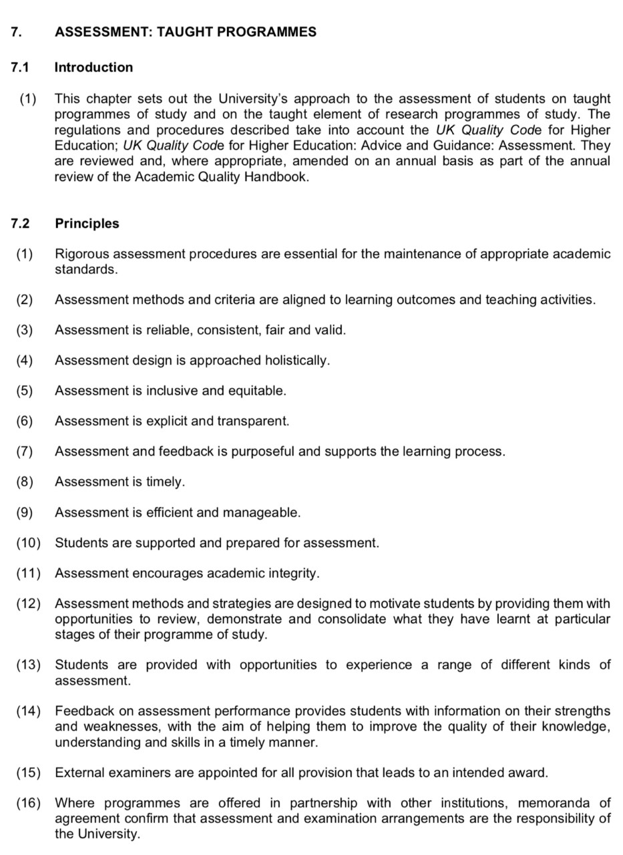
Various assessment methods and strategies are utilised to consolidate students’ learning. Key to academic success is the definition of assessment requirements. Assessment criteria is an essential element in this process.
The UWTSD appear to adopt the QAA’s guiding principles of assessment as a framework document, to ensure good practice and quality assurance for all assessment taught programmes (QAA, 2021).
As outlined within the Academic Quality Handbook, the university advocates the use of learning outcomes to align assessment methods and criteria for all assessment taught programmes. An educational system which aligns assessment with teacher instructions promotes effective student learning (Wiliam, 2013).
In accordance with the Academic Quality Handbook, learning outcomes are utilised by institutes of higher education for programmes of study as suggested by Adam (2004).

Appendix 2
Module Aims and Objectives

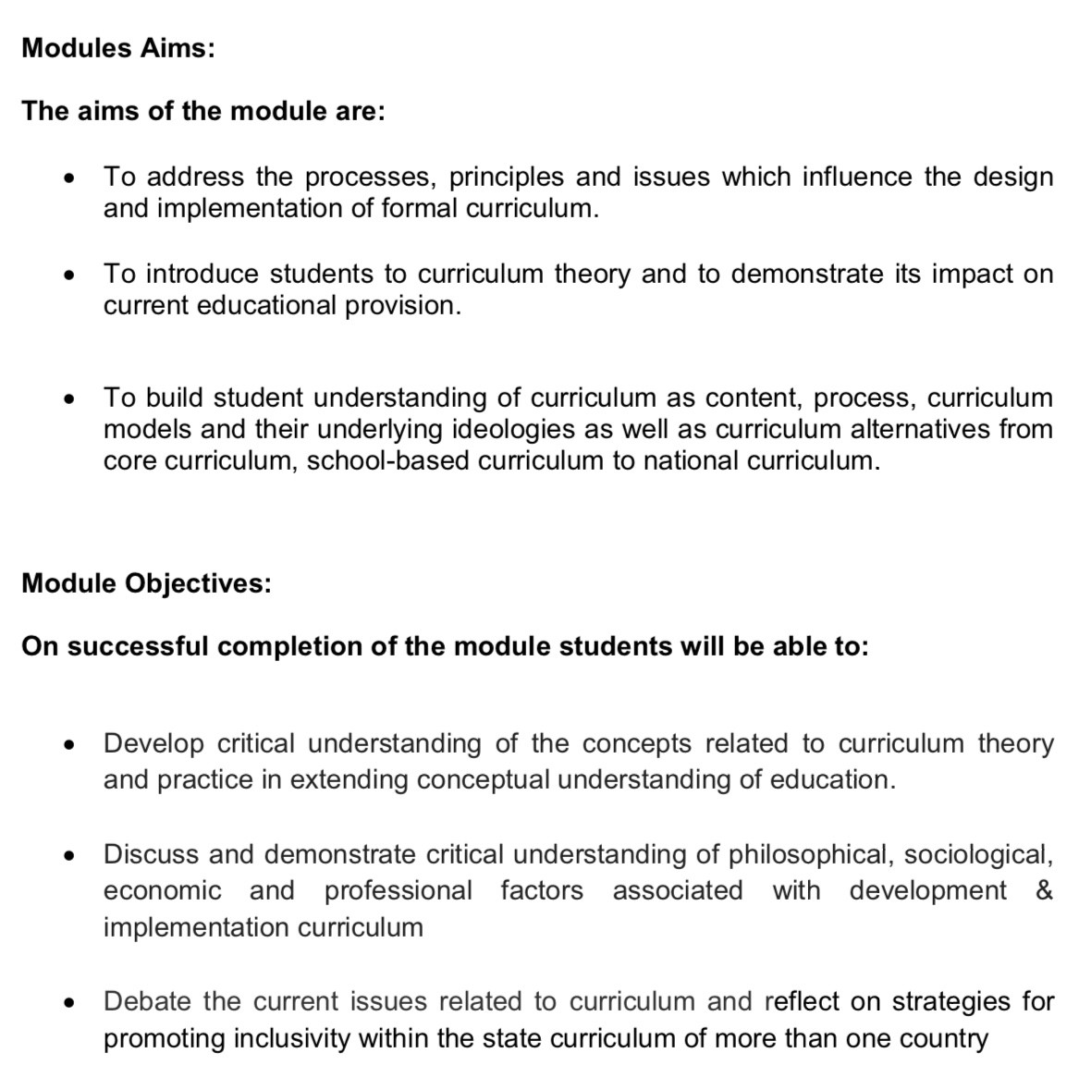
Module objectives are provided by the Module Co-ordinator as a means of reference, for learners to refer to during their learning journey (Derntl, 2010).
Module aims and curricular goals are aligned in accordance with the Academic Quality Handbook to enhance student learning (Fuentealba, 2011).

Appendix 3
Learning Outcomes
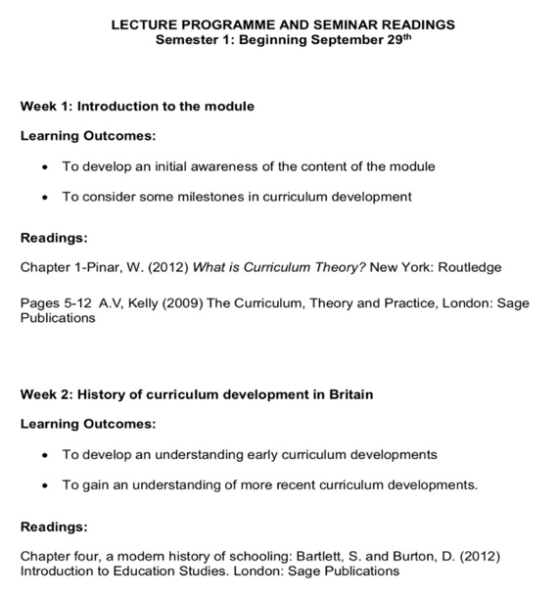
Reflecting upon personal experiences, learning outcomes have been useful in gaining an advance understanding on the session’s topic. Students are able to link the additional source readings to the intended learning outcomes. This approach provides students with a prior knowledge and understanding of the topic. Students can then transfer this knowledge and utilise it to engage in classroom debates and discussions. Adopting this approach to learning, promotes the role of the active student. In addition, it provides opportunities for students to engage in peer assessment.
Learning outcomes are utilised to define student’s learning expectations. In addition, suggested readings are provided as a means of sourcing additional knowledge to reinforce student’s understanding. According to Derntl (2010), application of this strategy aids a student’s understanding transfer of knowledge.

However, with regards to module ECES6013/C the schedule of sessions and learning outcomes are outdated following the implementation of block teaching and learning in 2018. The implementation of block teaching and learning has reduced the module’s timeframe from ten weeks to three. Therefore, the current learning outcomes could be considered to be of no relevance to students and possibly detrimental to their learning.
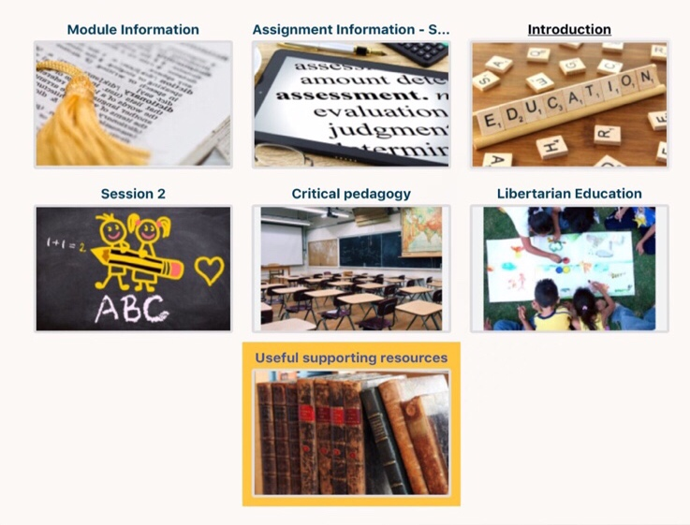
Module ECES6008 was presented and delivered to students with no Module Handbook. Subsequently, students completed the module without access to module aims, objectives and learning outcomes.
Please note – the above modules were delivered during times of great difficulty following the impact of COVID-19. However, strategies could be implemented to avoid a recurrence of such incidences during the new academic year.
Appendix 4
Teaching and Learning Strategy
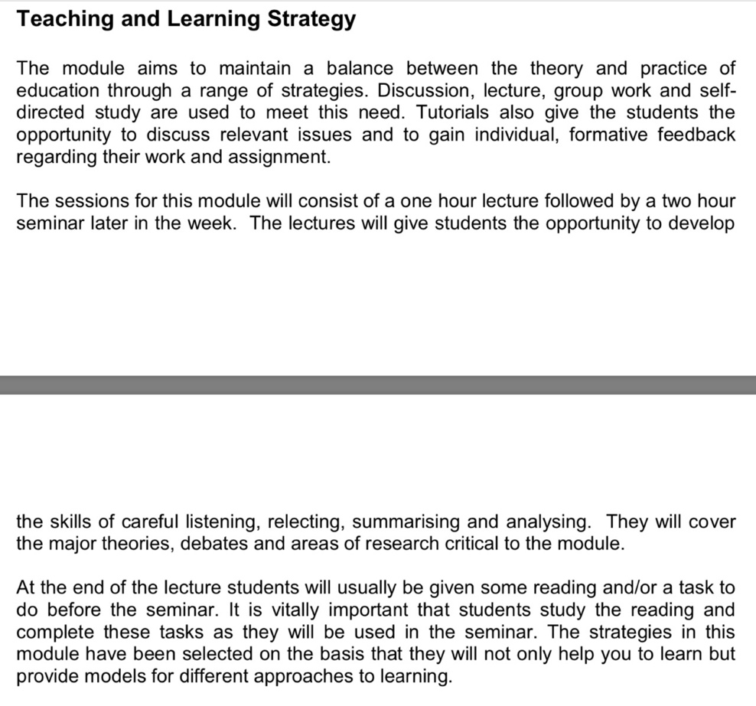
Furthermore, the lecturer reinforces her role as a facilitator by expressing the need for students to engage in self-directed study, taking responsibility for their own learning. Adopting this approach creates a student-centred approach to education.

Lecturer refers to the use of various teaching strategies - discussions, lectures and group work. Furthermore, the lecturer aligns the module’s teaching activities and strategies to the intended learning outcomes.
Strategy for learning encompasses synchronous and asynchronous learning. Students are expected to engage in synchronous learning sessions utilising lectures and seminars. Asynchronous sessions involve additional tasks, readings and self-directed study sessions.

Appendix 5
Asynchronous Learning Sessions

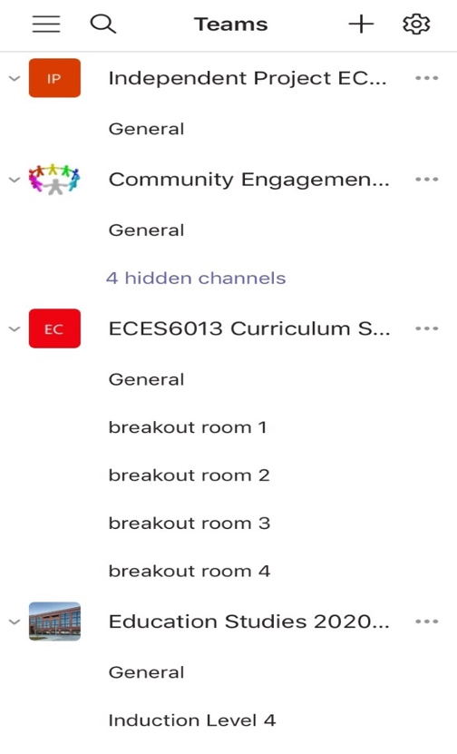
Asynchronous learning sessions have become more inclusive since the introduction of breakout rooms in September 2020. Students are able to breakout into smaller sub-groups, to facilitate the delivery of brainstorming and discussion sessions. Students can informally share and draw upon each others ideas, within a relaxed learning environment. Creating an informal learning environment using breakout rooms has actively engaged students. Students have been able to check in on each other virtually, promoting social interaction and positive feelings of well-being.
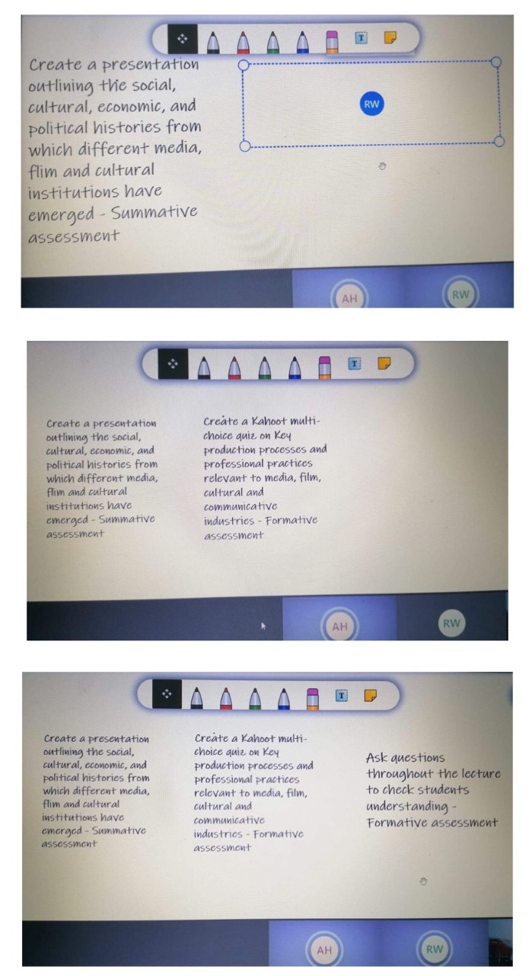
Collaborative working between students can be exemplified during breakout sessions, via utilisation of the whiteboard activity. Students are able to post their ideas utilising post it notes. This approach effectively promotes active discussion and peer learning, providing students with opportunities to build upon their knowledge and understanding of a module topic.
Appendix 6
Wakelet Platforms
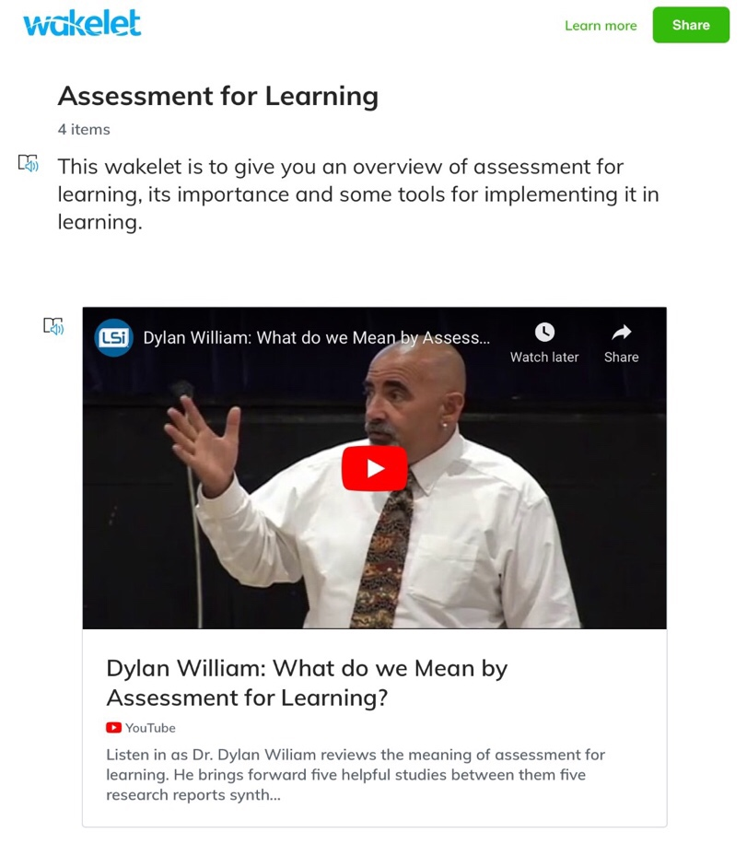
To aid student’s understanding and build upon prior knowledge, students can access additional source materials via Wakelet. Material is easily accessible and accessed when convenient, supporting the work of Coogle and Floyd (2015). Opportunities within Wakelet allow students to add any additional source materials for collaborative usage. Adopting this approach, encourages student reflection (Hrastinski, 2008). However, consideration should be given with regards to the availability of student’s time and asynchronous learning to avoid students becoming overwhelmed with workload.

Appendix 7
Assessment Criteria and Mark Scheme
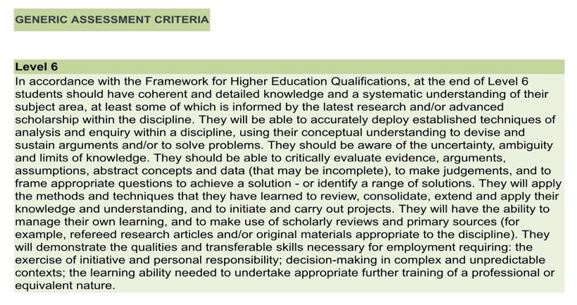
Assessment criteria is encompassed within each module’s assessment specification. Adopting this approach to learning promotes the role of the active learner.
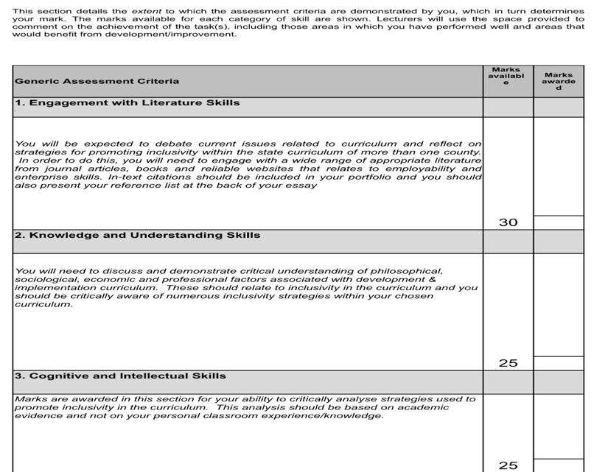
The corresponding mark scheme is incorporated within each module’s assessment criteria. Within each category of skill, the designated available marks are made available to students. Analysis of the assessment criteria provides students with opportunities to ensure they meet the specified determinants. In addition, the criteria identifies the marks available for each skill category.
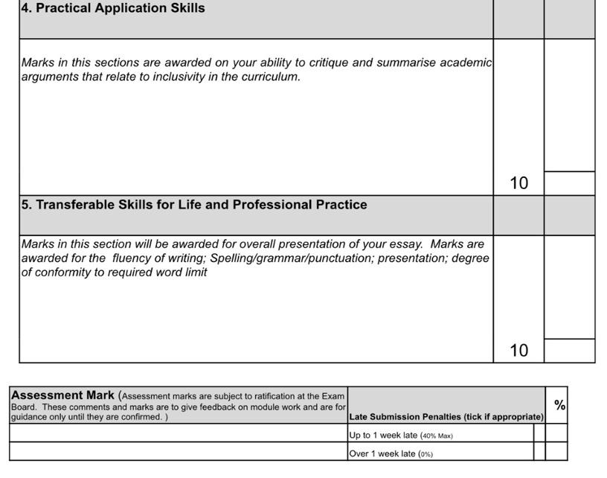
Appendix 8
Kahoot! Challenges

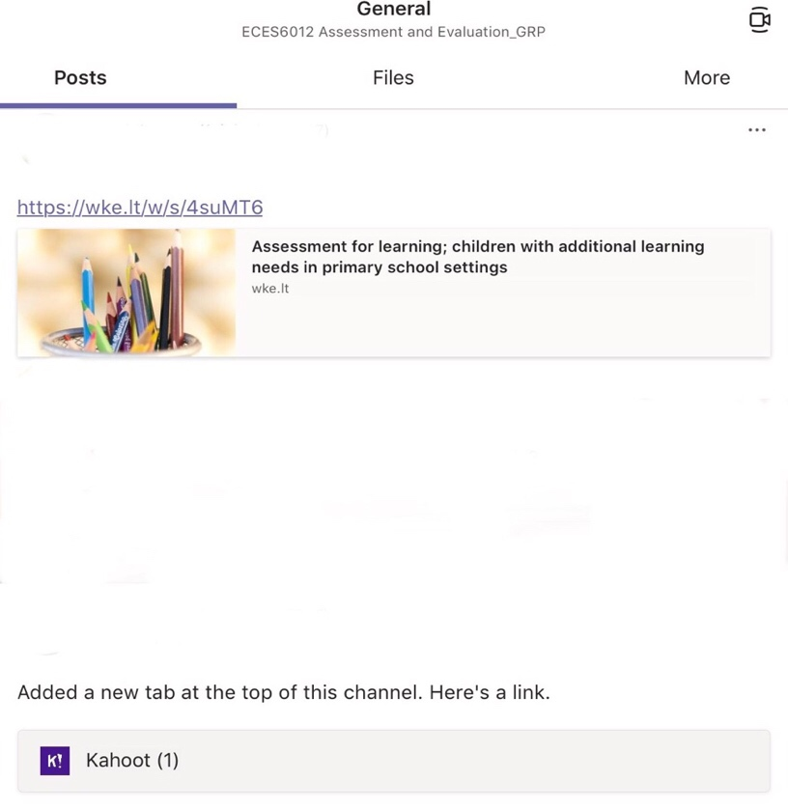
Upon completion of the challenge, students gain access to their score. However, ‘Kahoot!’ appears to not be forthcoming with information regarding student feedback. Therefore, it could be suggested that ‘Kahoot!’ is not meeting the learning requirements of students in terms of assessment for learning.
Utilising Microsoft Teams, access to asynchronous learning sessions is promoted via the use of Wakelet.
‘Kahoot!’ challenges are utilised by lecturers to gain an understanding on students’ knowledge during asynchronous learning sessions. Adopting this approach to learning incorporates the concepts of assessment for learning.
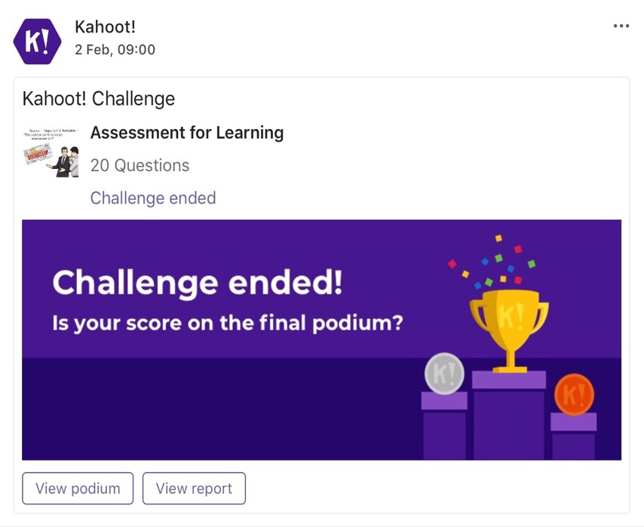
To improve students’ understanding on a concept of education, it could be suggested that the use of ‘Kahoot!’ is correlated to each source of additional reading material.

Appendix 9
Advocating the principles of peer-assessment


Utilising Moodle as a platform to support learning, opportunities have been provided to students to engage in the principles of self-assessment, via discussion forums. Adopting this approach to learning encourages students to share insights and ideas.


In addition, students are able to share queries on assignments, utilising the Moodle platform. Adopting this approach, encompasses the principles associated with self-regulation and self-evaluation.

Appendix 10
Assessment Feedback – Presentations
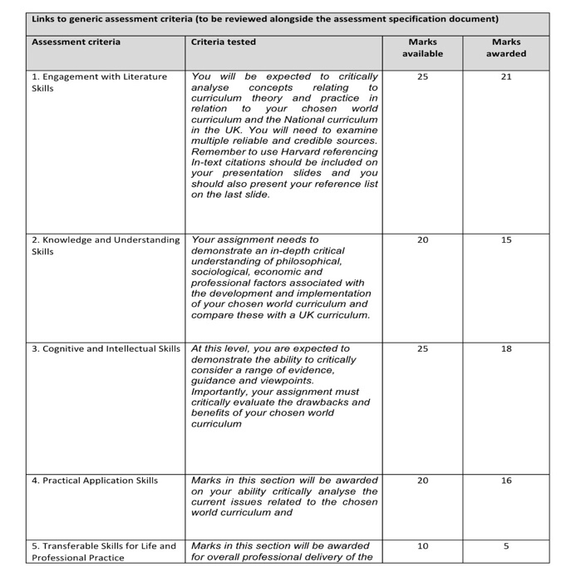
Feedback is aligned to assessment criteria, methods and learning outcomes utilising the corresponding rubric. Adopting this approach provides opportunities for students to engage in the principles of self-evaluation, in accordance with assessment of learning.
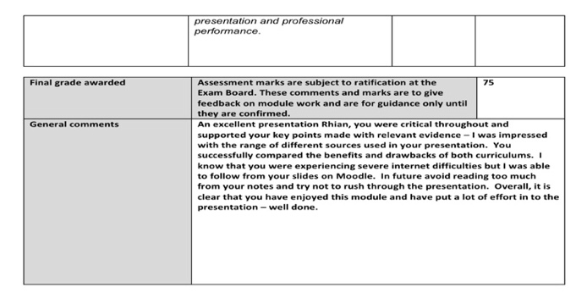
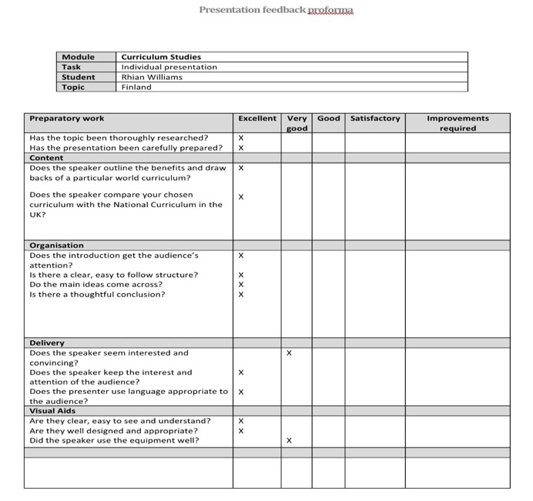
Additional feedback is given to students regarding the content and delivery of work. This style of feedback could aid the student when engaging in the process os self-evaluation.
Appendix 11
Assessment Feedback – Written assignments

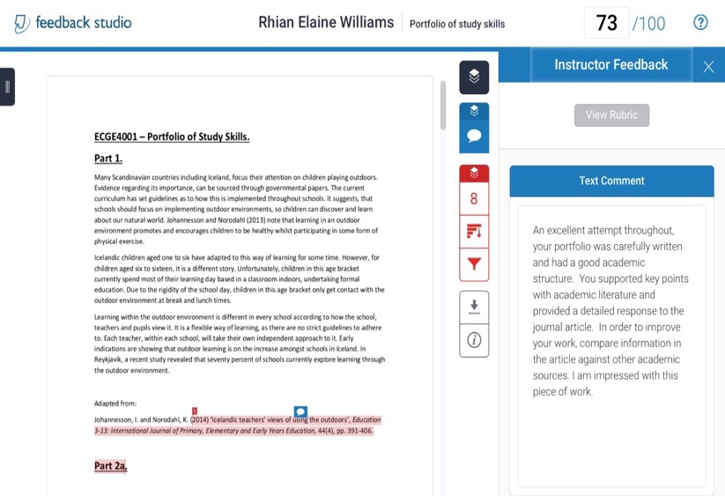
Written assignment feedback is not always consistent with its approach. The feedback given does not appear to be directly aligned to assessment criteria, methods and learning outcomes. Furthermore, it does not incorporate the use of the corresponding rubric system. However, the feedback does identify the student’s strengths and weaknesses. Adopting this approach to feedback, provides the student with opportunities to engage in the principles associated with self-evaluation.
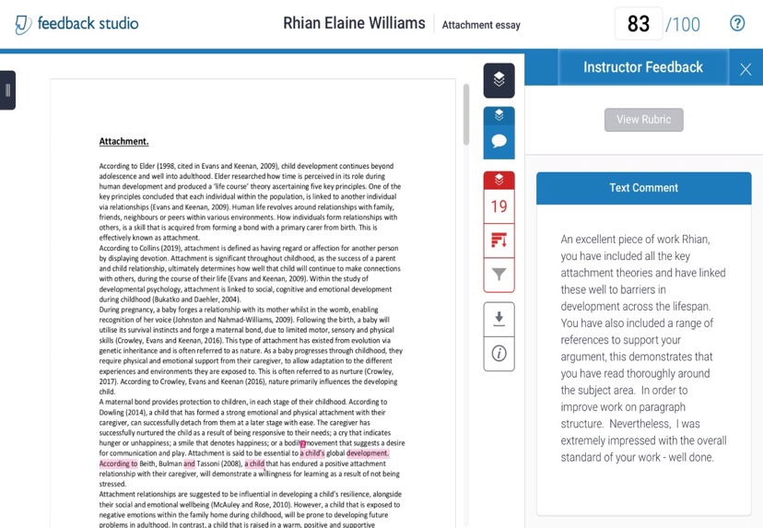

Appendix 12
Assessment Feedback – Written assignments

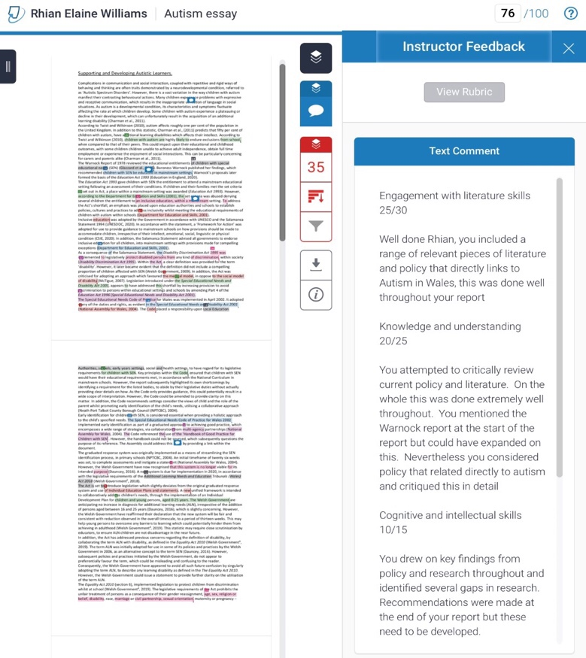
Feedback here is more detailed and appears to be aligned to assessment criteria and methods in accordance with the Academic Quality Handbook (UWTSD, 2021). Furthermore, the feedback has incorporated the use of a rubric system, in accordance with the corresponding assignment mark scheme. Adopting this approach provides the student with opportunities to engage in the principles of self-evaluation, in accordance with assessment of learning principles.
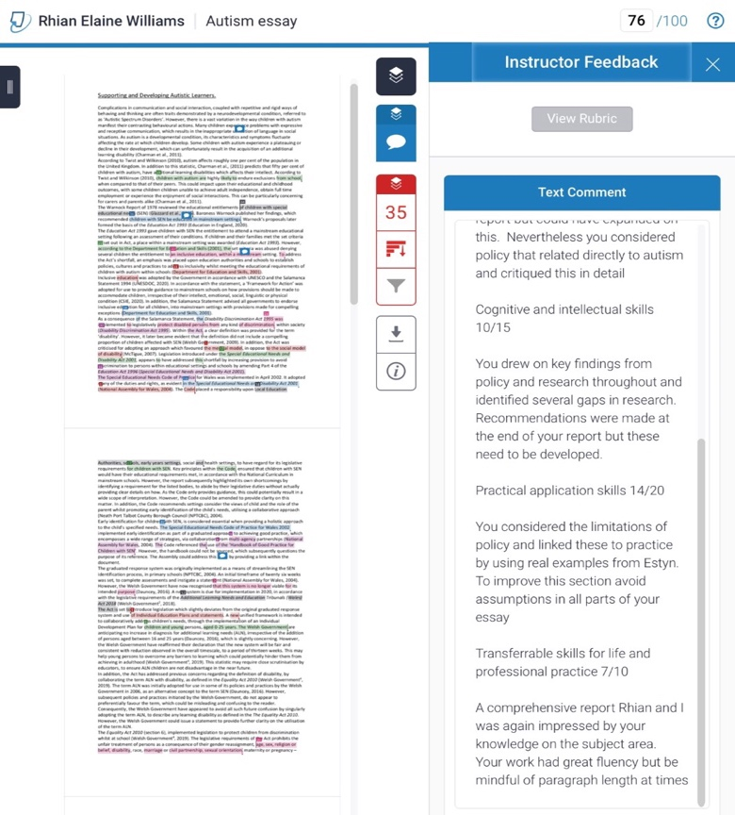
References
Akella, D. (2010) ‘Learning together: Kolb’s experiential theory and its application’, Journal of Management and Organization, 16(1), pp. 100-112. Available at: https://www.researchgate.net/publication/247920250_Learning_together_Kolb's_experiential_theory_and_its_application (Accessed: 18th February 2021).
Alonso-Tapia, J. and Panadero, E. (2013) ‘Self-assessment: Theoretical and Practical Connotations. When it Happens, How it is Acquired and what to do to Develop it in our Students’, Electronic Journal of Research in Educational Psychology, 11(2), pp. 551-576. Available at: https://www.researchgate.net/publication/256354296_Self-assessment_Theoretical_and_Practical_Connotations_When_it_Happens_How_is_it_Acquired_and_what_to_do_to_Develop_it_in_our_Students (Accessed: 17th February 2021).
Anazifa, R. D. et al. (2018) ‘Teachers’ knowledge about higher-order thinking skills and its learning strategy’, Problems of Education in the 21st Century, 76(2), pp. 215-230. Available at: https://www.researchgate.net/publication/324923893_Teachers’_knowledge_about_higher-order_thinking_skills_and_its_learning_strategy (Accessed: 6th February 2021).
Adam, S. (2004) ‘USING LEARNING OUTCOMES’. UNITED KINGDOM BOLOGNA SEMINAR. Heriot-Watt University, Edinburgh, 1-2nd July. Available at: https://www.educacionmedica.net/pdf/documentos/espacio/Outcomes-1.pdf (Accessed: 4th February 2021).
Assessment Reform Group (2002) Assessment for Learning: 10 principles. Research-based principles to guide classroom practice. Available at: (PDF) Assessment for Learning: 10 Principles. Research-based principles to guide classroom practice Assessment for Learning (researchgate.net) (Accessed: 11th February 2021).
Baird J. et al. (2014) ‘State of the Field Review: Assessment and Learning’, Norwegian Centre for Education & Oxford University Centre for Educational Assessment. Available at: Microsoft Word - FINAL MASTER 24Jun14 Baird et al 2014 Assessment and Learning (up.pt) (Accessed: 19th February 2021).
Bhat, A. B. and Bhat, J.B. (2019) ‘Formative and Summative Evaluation Techniques for Improvement of Learning Process’, European Journal of Business & Social Sciences, 7(5), pp. 776-785. Available at: https://www.researchgate.net/publication/333633265_Formative_and_Summative_Evaluation_Techniques_for_Improvement_of_Learning_Process (Accessed: 18th February 2021).
Black, P. (1998) Testing, Friend or Foe?: The Theory and Practice of Assessment and Testing. London: Falmer Press.
Black, P. et al. (2002) Working Inside the Black Box: Assessment for Learning in the Classroom. London: Department of Education and Professional Studies, King’s College.
Bloom, B. S. et al. (1971) Handbook on formative and summative evaluation of student learning. New York: McGraw-Hill.
Boydston, J. A. et al. (1988) ‘The Latter Works of John Dewey 1925-1953: 1938-1939', Experience and Education, Freedom and Culture, Theory of Valuation, and Essays, 13. Carbondale, IL: Southern Illinois University Press.
Carnell, E. et al. (2002) ‘Effective Learning’, NSIS RESEARCH MATTERS, 17, pp. 1-8. Available at: https://core.ac.uk/download/pdf/83041.pdf (Accessed: 1st February 2021).
Chin, P. (2016) ‘Peer assessment’, New Directions in the Teaching of Physical Sciences, 3, pp. 13-18. Available at: https://www.researchgate.net/publication/328340643_Peer_Assessment (Accessed: 16th February 2021).
Cleary. T. J. and Zimmerman, B. J. (2004) ‘SELF-REGULATION EMPOWERMENT PROGRAM: A SCHOOL-BASED PROGRAM TO ENHANCE SELF-REGULATED AND SELF-MOTIVATED CYCLES OF STUDENT LEARNING’, Psychology in the Schools, 41(5), pp. 537-550. Available at: https://www.unityoga.org/uploads/2/5/7/4/25747040/cleary__zimmerman_-_self-regulation_and_empowerment_program_-_a_school-based_program_to_enh.pdf (Accessed: 18th February 2021).

Coogle, C. and Floyd, K. (2015) ‘Synchronous and Asynchronous Learning Environments of Rural Graduate Early Childhood Special Educators Utilizing Wimba© and Ecampus’, MERLOT Journal of Online Learning and Teaching, 11(2), pp. 173-187. Available at: https://jolt.merlot.org/Vol11no2/Coogle_0615.pdf (Accessed: 7th February 2021).
Coombs, S. J. et al. (2013) Key Concepts in Educational Assessment. London: SAGE Publications Ltd.
Council of Chief School State Officers (CCSSO) (2012). DISTINGUISHING FORMATIVE ASSESSMENT FROM OTHER EDUCATIONAL ASSESSMENT LABELS. Available at: DISTINGUISHING FORMATIVE ASSESSMENT FROM OTHER EDUCATIONAL ASSESSMENT LABELS (michigan.gov) (Accessed: 14th February 2021).
Cowie, B. and Bell, B. (1999) ‘A Model of Formative Assessment in Science’, Assessment in Education: Principles, Policy & Practice, 6(1), pp. 101-116. Available at: Search results | Taylor & Francis Online (tandfonline.com) (Accessed: 9th February 2021).
Derntl, M. et al (2010) ‘Aligning assessment with learning outcomes in outcome-based education’, IEEE EDUCON Education Engineering 2010 – The Future of Global Learning Engineering Education. Madrid, 14-16th May. Available at: https://www.researchgate.net/publication/224148655_Aligning_assessment_with_learning_outcomes_in_outcome-based_education (Accessed: 3rd February 2021).
Dolan, D. et al. (2007) Synchronous-Learning: Three Perspectives. Available at: https://www.researchgate.net/publication/251181403_Synchronous_e-Learning_Three_Perspectives (Accessed: 7th February 2021).
Fuentealba, A. (2011) ‘The role of assessment in the student learning process’, J Vet Med Educ., 38(2), pp. 157-62. Available at: https://pubmed.ncbi.nlm.nih.gov/22023924/ (Accessed: 1st February 2021).
Gulley, B. (2012) ‘Feedback on Developmental Writing Students’ First Drafts’, Journal of Developmental Education, 20(1), pp. 16-36. Available at: JDE 36-1_130107_FINAL_TIFS2.indd (ed.gov) (Accessed: 17th February 2021).
Hargreaves, E. (2010) ‘Teachers’ classroom feedback: still trying to get it right’, Pedagogies: An International Journal, 7(1), pp. 1-15. Available at: Teachers' classroom feedback: still trying to get it right: Pedagogies: An International Journal: Vol 7, No 1 (tandfonline.com) Accessed: 20th February 2021).
Hartree, A. (2006) ‘Malcolm Knowles’ Theory of Andragogy: A Critique’, INTERNATIONAL JOURNAL OF LIFELONG EDUCATION, 3(3), pp. 203-210. Available at: https://www.tandfonline.com/doi/abs/10.1080/0260137840030304?journalCode=tled20 (Accessed: 12th February 2021).
Hattie, J. and Timperley, H. (2007) ‘The power of feedback', Review of Educational Research, 77(1), pp. 81-112. Available at: Feedback.pdf (columbia.edu) (Accessed: 18th February 2021).
Klenowski, V. (1995) AN INVESTIGATION OF STUDENT SELF-EVALUATION AS AN AUTHENTIC PEDAGOGICAL PRACTICE: PROCESSES, POSSIBILITIES AND REALITIES. Available at: https://core.ac/download/pdf/111068805.pdf (Accessed: 18th February 2021).
Logan, E. (2009) ‘Self and peer assessment in action’, Practitioner Research in Higher Education, 3(1), pp. 29-35. Available at: https://files.eric.ed.gov/fulltext/EJ1130670.pdf (Accessed: 16th February 2021).
Mahajan, M. and Singh, M. K. S. (2017) ‘Importance and Benefits of Learning Outcomes’, IOSR Journal of Humanities and Social Science, 22(3), pp. 65-67. Available at: https://www.researchgate.net/publication/315637432_Importance_and_Benefits_of_Learning_Outcomes (Accessed: 4th February 2021).
Manning, G. (2007) ‘Self-Directed Learning: A Key Component of Adult Learning Theory’, Journal of the Washington Institute of China Studies’, 2(2), pp. 201-115. Available at: https://core.ac.uk/download/pdf/235986555.pdf (Accessed: 12th February 2021).
Mayer, R. E. and Moreno, R. (2002) ‘Aids to computer-based multimedia learning’, Learning and Instruction, (12)1, pp. 107-119. Available at: PII: S0959-4752(01)00018-4 (typepad.com) (Accessed: 19th February 2021).
McAlpine (2002) Principles of Assessment. Glasgow University: Robert Clark Centre for Technological Education. Available at: https://citeseerx.ist.psu.edu/viewdoc/download?doi=10.1.1.137.3942&rep=rep1&type=pdf (Accessed: 8th February 2021).
McMahon, T. and O’Neill, G. (2005) ‘STUDENT-CENTRED LEARNING: WHAT DOES IT MEAN FOR STUDENTS AND LECTURERS?’, Emerging Issues in the Practice of University Learning and Teaching. Available at: https://www.eprints.teachingandlearning.ie/3345/1/O’Neill%20and%20McMahon%202005.pdf (Accessed: 7th February 2021).
Meister and Rosenshine (1994) ‘Reciprocal Teaching: A Review of the Research’, Review of Educational Research, 64(4), pp. 479-530. Available at: https://www.researchgate.net/publication/243782308_Reciprocal_Teaching_A_Review_of_the_Research (Accessed: 18th February 2021).
Microsoft (2021) ‘Breakout rooms generally available today in Microsoft Teams’, Microsoft Teams [blog]. 12th September. Available at: https://techcommunity.microsoft.com/t5/microsoft-teams-blog/breakout-rooms-generally-available-today-in-microsoft-teams/ba-p/1968481 (Accessed: 10th February 2021).
Ndoye, A. (2017) ‘Peer / Self Assessment and Student Learning’, International Journal of Teaching and Learning in Higher Education, 29(2), pp. 255-269. Available at: https://files.eric.ed.gov/fulltext/EJ1146193.pdf (Accessed: 16th February 2021).
Nusche, D. (2008) ‘Assessment of Learning Outcomes in Higher Education’, OECD Education Working Papers, 15. Available at: https://files.eric.ed.gov/fulltext/ED503834.pdf (Accessed: 15th February 2021).
Panadero, E. (2011) Instructional help for self-assessment and self-regulation: Evaluation of the efficacy of self-assessment scripts vs. Rubrics. Available at: (PDF) Instructional Help for Self-assessment and Self-regulation: Evaluation of the Efficacy of Self-assessment Scripts vs. Rubrics (researchgate.net) (Accessed: 17th February 2021).
Panadero, E. (2017) ‘A Review of Self-Regulated Learning: Six Models and Four Directions for Research’, Front Psychol., 8(422), pp.1-89. Available at: https://www.ncbi.nlm.nih.gov/pmc/articles/PMC5408091/#_ffn_sectitle (Accessed: 14th February 2021).
Paris, S. G. and Paris, A. H. (2001) ‘Classroom applications of research on self-regulated learning’, Educational Psychologist, 36(2), pp.89-101. Available at: Classroom applications of research on self-regulated learning | Request PDF (researchgate.net) (Accessed: 17th February 2021).
Prasanthi, B. V. and Vijetha Inti, V.V. (2019) ‘CLASSROOM ASSESSMENT METHODS AND TOOLS: A REVIEW’, International Journal of Research and Analytical Reviews, 6(2), pp. 94-97. Available at: https://researchgate.net/publication/333378035_CLASSROOM_ASSESSMENT_METHODS_AND_TOOLSA_REVIEW (Accessed: 8th February 2020).
Prøitz, T. S. (2010) ‘Learning outcomes: What are they? Who defines them? When and where are they defined?,’ Educ Asse Eval Acc, 22, pp. 119-137. Available at: https://www.researchgate.net/profile/Tine_Proitz2/publication/226454599_Learning_outcomes_What_are_they_Who_defines_them_When_and_where_are_they_defined/links/5f6b7c5792851c14bc91a8e3/Learning-outcomes-What-are-they-Who-defines-them-When-and-where-are-they-defined.pdf (Accessed: 3rd February 2021).
Qu, W. and Zhang, C. (2013) ‘The Analysis of Summative Assessment and Formative Assessment and Their Roles in College English Assessment System’, Journal of Language Teaching and Research, 4(2), pp. 335-339. Available at: https://www.academypublication.com/issues/past/jltr/vol04/02/14.pdf (Accessed: 15th February 2021).
Quality Assurance Agency (2021) UK Quality Code for Higher Education: Advice and Guidance: Assessment. Available at: https://www.qaa.ac.uk/docs/qaa/quality-code/advice-and-guidance-assessment.pdf?sfvrsn=ca29c181_4 (Accessed: 13th February 2021).

Savickienė, I. (2010) ‘CONCEPTION OF LEARNING OUTCOMES IN BLOOM’S TAXONOMY AFFECTIVE DOMAIN’, The Quality of Education. Vytautas Magnus University, Lithuania, February 2010. Available at: https://files.eric.ed.gov/fulltext/EJ900258.pdf (Accessed: 5th February 2021).
Schunk, D. and Zimmerman, B. (1998) Self-regulated learning: From teaching to self-reflective practice. New York: Guilford Press.
Schunk, D. and Zimmerman, B. (2001) Self-regulated learning and academic achievement. New York: Lawrence Erlbaum Associates Publishers.
Schunk, D. and Zimmerman, B. (2011) Handbook of self-regulation of learning and performances. New York: Routledge.
Smith, F.L. and Stevenson, Z. (1992) ‘A student-centred approach to assessment’, NASSP Bulletin, 76(545), pp. 389-395.
Spady, W.G. (1994) Outcome-Based Education: Critical Issues and Answers. Arlington: American Association of School Administrators. Available at: https://files.eric.ed.gov/fulltext/ED380910 (Accessed: 4th February 2021).
Swaffield, S. (2009) ‘The misrepresentation of Assessment for Learning – and the woeful waste of a wonderful opportunity’, AIAA National Conference. Bournemouth, UK. Available at: Microsoft Word - The _mis_rep of AfL Oct 09.doc (aaia.org.uk)(Accessed: 11th February 2021).
Tosuncuoglu, I. (2018) ‘Importance of Assessment’, Journal of Education and Training Studies, 6(9), pp. 163-167. Available at: https://www.researchgate.net/publication/327042964_Importance_of_Assessment_in_ELT (Accessed: 8th February 2021).
Wiliam, D. (2009) Assessment for Learning: Why, What and How? London: Institute of Education.
Wiliam, D. (2013) ‘Assessment: The Bridge between Teaching and Learning’, Voices from the Middle, 21(2), pp. 15-20. Available at: (PDF) Assessment: The bridge between teaching and learning (researchgate.net) (Accessed: 1st February 2021).
Waragh, I. (2019) ‘Assessment Criteria in EFL Writing Skills’, Libyan bulletin for studies, (13), pp. 239-249. Available at: https://www.researchgate.net/publication/332465100_Assessment_Criteria_in_EFL_Writing_Skills (Accessed: 15th February 2021).
University of Wales Trinity Saint David (2021) Academic Quality Handbook 2020-21. Available at: https://www.uwtsd.ac.uk/acedmic-office/academic-quality-handbook/ (Accessed: 2nd February 2021).

Wortham, S. (2003) ‘Learning in Education’, Encyclopaedia of Cognitive Science, 1 (563), pp. 1079-1082. Available at: https://www.researchgate.net/publication/304049716_Learning_in_Education (Accessed: 1st February 2021).
Yilmaz, K. (2009) ‘DEMOCRACY THROUGH LEARNER-CENTERED EDUCATION: A TURKISH PERSPECTIVE’, International Review of Education, 55, pp. 21-37. Available at: https://www.researchgate.net/profile/Kaya_Yilmaz/publication/225647925_Democracy_Through_Learner-Centered_Education_a_Turkish_Perspective/links/02bfe50f7d1f6cbac6000000.pdf (Accessed: 6th February 2021).

