

Module Code: ECAD5015

Assignment Title: Deepening Practice
ALN – Part 1 Journal
Student Name: Abby Hughes
Student Number: 2305307
BA Primary Education (QTS)

AI Acknowledgement

I acknowledge the use of [Chat GPTl] (on [18.5.25] to [support my research]. I used the prompt(s):
1. can you give me a theory that supports using visual learning in the classroom?
2. who disagrees with the support children with ALN receive?
3. what are the limitations to sensory rooms?
I confirm that I have not presented any AI generated text as my own work.
I confirm that I have copies of my drafts, notes, and other resources I used before and after the use of AI tools which I may be asked to provide in evidence.

Targets from previous module | How I have worked on these? | An example can be seen on…
I appreciate you are working on your targets of deepening critical engagement and synthesis of literature. Continue to develop these skills. | I have developed these throughout and tried to use tentative lanauge where appropriate | An example can be seen throughout where i have used multiple authors to back up one point. I have also used critical enegament when talking about the Welsh Goverment
Use your professional standards and relevant literature to guide next steps. What impact will your findings have on your own future teaching practice? | I have talked about my experince throughout but have used the QTS standards to also supporrt my next steps | In the conclsuion asn my exerpince throughout
Ensure you proof-read for clarity of expression and please avoid contractions in academic writing. | I have proof read my work before submitting | Throughout

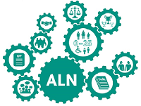
Additional learning needs is a term used worldwide for individuals who have a disability or learning difficulty which requires additional provision (Swansea council, 2023). It is crucial to recognise ALN to ensure individuals receive early support, an inclusive education and it’s the legal and ethical responsibility under the United Nations rights of the child (Unicef, 2022, Welsh Government, 2024). The Welsh curriculum allows all schools within Wales to design an individual curriculum that support all learners to progress at their own pace whilst developing towards the four purposes (Welsh Government, 2024). However, evidence suggests that children with additional learning needs are not being supported adequately due to limited provision, the quality of guidance and the negative stain on families causing children with ALN not to receive an education they are entitled to (Blake, 2024, Welsh Government, 2024). These issues have been recognised and the Welsh Government (2022) identifies that there is a need for change within the curriculum to support children with additional learning needs such as by providing more flexibility, support for all learners and reducing barriers. The Additional Learning Needs and Education Tribunal (Wales) Act 2018 represents a fundamental change in Welsh legislation and how to support children with ALN (Welsh Government, 2024). This act has replaced the term special educational needs and has since been replaced with the term ALN due to it being a more inclusive term that allows all individuals to feel supported and valued (Welsh Government, 2024). Alongside this, the act introduces individual development plans and extends support for individuals with ALN from 0 to 25 years whilst creating a more person-centred approach (Welsh Government, 2024).
(Powys county council, 2025)
The term inclusion is described as the act of being included (Cambridge dictionary, 2019). This is identified within the curriculum as an essential part of education due to its effects on educational achievement (Welsh Government, 2024). The ALN Act (2018) supports these points and promotes an inclusive approach by offering a more individualised approach, increasing the amount of participation from families and setting clear guidance to what support children are entitled to (Welsh Government, 2024). However, it has been identified within an Estyn report (2025) that there are possible challenges that need to be considered when implementing this act into the Welsh curriculum. The report states that budget for resources and the need for consistent staff training can cause education inequality therefore affecting the outcome for the individuals (Estyn, 2025). Although, this act has already supported schools to make changes to their curriculum with one school creating a panel to be able to address the needs of all children within the school to ensure support is consistent, appropriate and co-ordinated alongside the Additional Learning Needs and Education Tribunal (Wales) Act 2018 (Estyn, 2023).
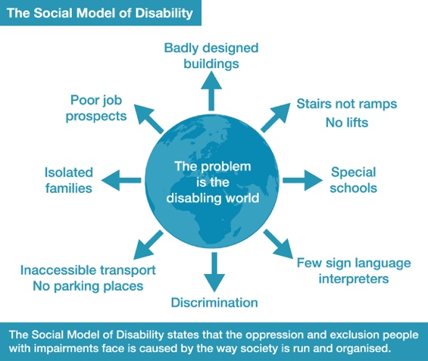
The theory social model of disability also reinforces the idea of inclusion the ALN act (2018) by emphasizing that the challenges faced by children with disabilities arise from societal barriers rather than the disability itself, (Mcourt, 2015, Goering, 2015). This, theory indicates there is a need to prioritize inclusion and remove the barriers within society (Mcourt, 2015, Goering, 2015). To support this discussion, I will be reflecting on my own practice whilst in my PTE2 school placement which will be referred to as school A in line with BERA (2024) guidelines to keep confidentiality.
(Inclusion London, 2015)
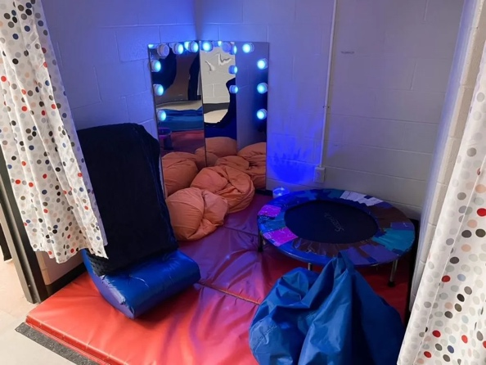
Within the Welsh curriculum the classroom environment should provide the opportunity for exploration whilst also providing an inclusive space with integrated inclusive strategies that ensures all learners are valued and included within the decisions that are being made (Welsh Government, 2023). An inclusive strategy is described as an approach to ensure equal opportunities and involves adapting teaching methods, resources or the classroom environment (Losberg, Zwozdiak-Myers, 2021, Yale university, 2010).
(Simply special ED, 2025)
A sensory room is a space that is designed to cater to the specific needs of individuals within the class (Main, 2022). Some spaces may include bean bags, sensory toys, headphones and LED lights (Main, 2022). Jean Ayer (1970) supports the idea of a sensory room emphasising the importance of sensory integration to promote learning, behaviour and self-regulation (Guardado, Sergent, 2023). This is further supported by Bandura ‘s social cognitive theory which states that self-regulation allows individuals to control their behaviour, set and achieve goals and enhance wellbeing which can be achieved within a sensory room due to the ability to adapt to the individuals needs depending on behaviour and interests (Bandura, 1991). This theory aligns with my experience during school A as I have been able to observe the sensory room being utilised with a child with ALN to regulate their emotions between lessons. It is also recognised by various authors that a sensory room is seen as crucial aspect of the classroom particularly for children with ALN due to the positive effect on their engagement, reducing the feeling of anxiety and decreases negative behaviours such as hitting or kicking (Unwin, Powell, Jones, 2021, Scottish Government, unknown date). This is recognised as a key priority for the Welsh Government to improve on due to new funding being allocated to provide children with ALN a safe and sensory focused environment (Welsh Government, 2023).
Although, sensory rooms can provide crucial for support for children with ALN it is also key to identify that it can also be an inclusive strategy for all individuals. An Estyn report highlights the importance of a safe space for all children to regulate their emotions and support their wellbeing (Estyn, 2024). On the other hand, there can be limitations to this strategy due to some practitioners using the room to distract or restrict the children rather than creating a meaningful experience (Bozic, 1997). One way to limit these barriers is to ensure staff have clear training on the purpose of inclusive strategies and how to support diverse needs correctly as stated within the ALN act (2018) (Welsh Government, 2024). Within school A to ensure the children had a meaningful experience during the sensory room their IDP’s and goals where clearly displayed to ensure staff understood what the children were working towards and set clear expectations for staff to follow whilst also supporting the diverse needs of the individuals (Welsh Government, 2024).
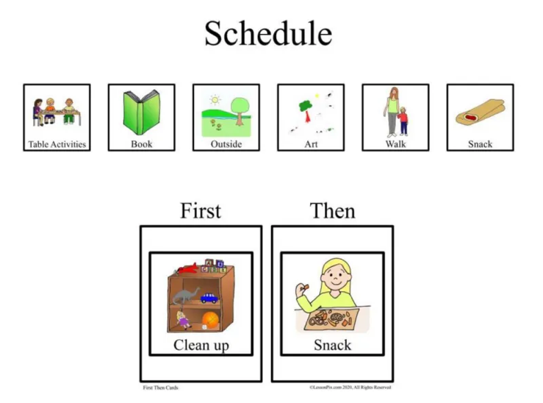
Visual support is an inclusive strategy that promotes an inclusive environment by increasing opportunities for individual’s diverse needs (Welsh Government, 2024). It is a strategy that uses pictures, gestures or signs to support children with change and communication (Welsh Government, 2019, Speech and Language UK, 2024). This strategy was used in school A with the implementation of visual timetables, choice boards and labelled areas. This strategy is supported by the dual learning theory which emphasises the importance of all children being exposed to both verbal and visual representations that promote motivation, achievement and memory (Clark, Paivio, 1991). Although this strategy can support all individuals within a class due to the holistic approach this strategy offers its crucial to identify that this strategy is suggested to promote the sense of belonging for children with ALN and allow them to engage in the curriculum whilst also providing structure that can be used within multiple scenarios (Foster-Cohen, Mirfin-Veitch, 2017).
BEBE Marin, 2025)
Although it’s been suggested that this strategy promotes an inclusive environments and supports the individual learners within the classroom there are limitations to this strategy such as lack of staff training and understanding, the child may struggle to understand the use of visual support as a strategy on its own and the importance of consistency (Foster-Cohen, Mirfin-Veitch, 2017, Cohen, Demchak, 2018). It is highlighted that children with ALN thrive on consistency due to the lack of change. However, when implementing a strategy like visual support consistency increases the effectiveness therefore supporting the child’s progression (Foster-Cohen, Mirfin-Veitch, 2017, Cohen, Demchak, 2018). One way to overcome the limitation of consistency is to set clear expectations and goals for the teachers to reflect and engage with and reduces confusion, stress and the feeling of being overwhelmed (Strength scope, 2025). An Estyn case study also empathises the importance of consistency when implanting visual support for children with hearing impairments (Estyn,2018). The case study outlines that once the strategy was implemented correctly with a clear focus and guide the progression and effectiveness promoted the sense of inclusion and supported the children to move to the mainstream classroom (Estyn, 2018).
This module has enhanced my understanding of additional learning needs and the importance of policies and legislation in creating an inclusive environment such as the curriculum and ALN act (2018) (Welsh Government, 2024). Which has also allowed me to work towards the QTS standard, emphasizing the value of teachers conducting wider research (Welsh Government, 2019). Additionally, it has deepened my awareness of inclusion in schools, highlighting benefits such as educational achievement and a sense of belonging (Welsh Government, 2024). Reflecting on my placement, I recognized areas for improvement, such as clearly using visual support alongside the sensory room in the school. This journal demonstrates my commitment to professional development following the QTS standards (Welsh Government, 2019) and the importance of creating an inclusive environment.
Reference list:
Blake, A. (2024). Wales’ education system is failing many disabled children, Senedd members have found - Learning Disability Wales. [online] Learning Disability Wales. Available at: https://www.ldw.org.uk/wales-education-system-failing-disabled-children/?utm_source=chatgpt.com [Accessed 16 May 2025].
Bozic, N. (1997). Constructing the room: multi‐sensory rooms in educational contexts. European Journal of Special Needs Education, [online] 12(1), pp.54–70. doi:https://doi.org/10.1080/0885625970120106.
British Educational Research Association (2024). Ethical Guidelines for Educational Research, Fifth Edition (2024). [online] www.bera.ac.uk. Available at: https://www.bera.ac.uk/publication/ethical-guidelines-for-educational-research-fifth-edition-2024 [Accessed 18 May 2025].
Cambridge Dictionary (2019). INCLUSION | meaning in the Cambridge English dictionary. [online] Cambridge.org. Available at: https://dictionary.cambridge.org/dictionary/english/inclusion [Accessed 12 May 2025].
Clark, J. and Paivio, A. (1991). (PDF) Dual Coding Theory and Education. [online] ResearchGate. Available at: https://www.researchgate.net/publication/225249172_Dual_Coding_Theory_and_Education [Accessed 19 May 2025].
Cohen, A. and Demchak, M. (2018). Use of Visual Supports to Increase Task Independence in Students with Severe Disabilities in Inclusive Educational Settings. Education and Training in Autism and Developmental Disabilities, [online] 53(1), pp.84–99. Available at: https://www.jstor.org/stable/26420429 [Accessed 19 May 2025].
ESTYN (2023). A report on St Christopher’s School Stockwell Grove Wrexham LL13 7BW Date of inspection: March 2023 by Estyn, His Majesty’s Inspectorate for Education and Training in Wales. [online] Available at: https://www.estyn.gov.wales/system/files/2023-03/Inspection%20report%20St%20Christopher%27s%20School%202023.pdf?utm_source=chatgpt.com [Accessed 16 May 2025].
ESTYN (2024). A whole school approach to well-being using a scientific model - Estyn. [online] Estyn. Available at: https://estyn.gov.wales/improvement-resources/a-whole-school-approach-to-well-being-using-a-scientific-model/?utm_source=chatgpt.com [Accessed 18 May 2025].
ESTYN (2025). Thematic report - The additional learning needs system - Estyn. [online] Estyn. Available at: https://estyn.gov.wales/improvement-resources/thematic-report-the-additional-learning-needs-system/?utm_source=chatgpt.com [Accessed 16 May 2025].
Estyn (2018). School develops innovative learning experience for pupils - Estyn. [online] Estyn. Available at: https://estyn.gov.wales/improvement-resources/school-develops-innovative-learning-experience-for-pupils/?utm_source=chatgpt.com [Accessed 19 May 2025].
Foster-Cohen, S. and Mirfin-Veitch, B. (2017). Evidence for the effectiveness of visual supports in helping children with disabilities access the mainstream primary school curriculum. Journal of Research in Special Educational Needs, [online] 17(2), pp.79–86. doi:https://doi.org/10.1111/1471-3802.12105.
Goering, S. (2015). Rethinking Disability: the Social Model of Disability and Chronic Disease. Current Reviews in Musculoskeletal Medicine, [online] 8(2), pp.134–138. Available at: https://www.ncbi.nlm.nih.gov/pmc/articles/PMC4596173/ [Accessed 16 May 2025].
Guardado, K.E. and Sergent, S.R. (2023). Sensory Integration. [online] PubMed. Available at: https://www.ncbi.nlm.nih.gov/books/NBK559155/ [Accessed 18 May 2025].
Losberg, J. and Zwozdiak-Myers, P. (2021). Inclusive Pedagogy through the Lens of Primary Teachers and Teaching Assistants in England. International Journal of Inclusive Education, [online] 1(4), pp.1–21. doi:https://doi.org/10.1080/13603116.2021.1946722.
Main, P. (2022). Sensory Rooms: A School Guide. [online] www.structural-learning.com. Available at: https://www.structural-learning.com/post/sensory-rooms [Accessed 18 May 2025].
McCourt, D. (2015). The Social Model of Disability. [online] Inclusion London. Available at: https://www.inclusionlondon.org.uk/about-us/disability-in-london/social-model/the-social-model-of-disability-and-the-cultural-model-of-deafness/ [Accessed 16 May 2025].
Scottish Goverment (n.d.). Inspiring Learning Spaces. [online] Available at: https://www.scottishfuturestrust.org.uk/storage/uploads/inspiringlearningspaces.pdf?utm_source=chatgpt.com [Accessed 18 May 2025].
Speech and Language UK (2024). Visual supports - Speech and Language UK. [online] Speech and Language UK: Changing young lives. Available at: https://speechandlanguage.org.uk/educators-and-professionals/resource-library-for-educators/visual-supports/ [Accessed 19 May 2025].
Strengthscope (2025). Why setting clear expectations is important and how to do it. [online] Strengthscope. Available at: https://www.strengthscope.com/blog/why-setting-clear-expectations-is-important-and-how-to-do-it [Accessed 19 May 2025].
Swansea council (2023). ALN - Definition of ALN. [online] Swansea. Available at: https://www.swansea.gov.uk/article/1965/ALN---Definition-of-ALN [Accessed 16 May 2025].
UNICEF (2022). UN Convention on the Rights of the Child (UNCRC). [online] UNICEF. Available at: https://www.unicef.org.uk/what-we-do/un-convention-child-rights/ [Accessed 16 May 2025].
Unwin, K.L., Powell, G. and Jones, C.R. (2021). The Use of Multi-Sensory Environments with Autistic children: Exploring the Effect of Having Control of Sensory Changes. Autism, [online] 26(6), p.136236132110501. doi:https://doi.org/10.1177/13623613211050176.
Welsh Goverment (2024). Implementing the Additional Learning Needs and Education Tribunal (Wales) Act 2018: practitioner guide [HTML]. [online] GOV.WALES. Available at: https://www.gov.wales/implementing-additional-learning-needs-and-education-tribunal-wales-act-2018-practitioner-guide-0 [Accessed 18 May 2025].
Welsh Government (2019). Professional Standards for Teaching and Leadership. [online] Hwb. Welsh Government. Available at: https://hwb.gov.wales/api/storage/19bc948b-8a3f-41e0-944a-7bf2cadf7d18/professional-standards-for-teaching-and-leadership-interactive-pdf-for-pc.pdf [Accessed 19 May 2025].
Welsh Government (2022). Education Is changing: Additional Learning Needs | GOV.WALES. [online] www.gov.wales. Available at: https://www.gov.wales/education-changing-additional-learning-needs [Accessed 16 May 2025].
Welsh Government (2023). Enabling learning - Hwb. [online] hwb.gov.wales. Available at: https://hwb.gov.wales/curriculum-for-wales/designing-your-curriculum/enabling-learning [Accessed 18 May 2025].
Welsh Government (2024a). Additional Learning Needs and Education Tribunal (Wales) Act 2018 | Law Wales. [online] law.gov.wales. Available at: https://law.gov.wales/additional-learning-needs-and-education-tribunal-wales-act-2018 [Accessed 16 May 2025].
Welsh Government (2024b). Introduction to Curriculum for Wales guidance - Hwb. [online] hwb.gov.wales. Available at: https://hwb.gov.wales/curriculum-for-wales/introduction-to-curriculum-for-wales-guidance/ [Accessed 16 May 2025].
Welsh Government (2024c). Moving to the Additional Learning Needs (ALN) system: parents guide [HTML] | GOV.WALES. [online] GOV.WALES. Available at: https://www.gov.wales/moving-additional-learning-needs-aln-system-parents-guide-html?utm_source=chatgpt.com [Accessed 16 May 2025].
Welsh Government (2019). Learners’ well-being, equity and inclusion - Hwb. [online] Gov.wales. Available at: https://hwb.gov.wales/evaluation-improvement-and-accountability/evaluation-and-improvement-resource-nrei/learners-well-being-equity-and-inclusion?utm_source=chatgpt.com [Accessed 19 May 2025].
Welsh Government (2023). £20m to improve learning spaces for learners with additional learning needs | GOV.WALES. [online] www.gov.wales. Available at: https://www.gov.wales/20m-improve-learning-spaces-learners-additional-learning-needs [Accessed 18 May 2025].
Welsh Government (2024a). Supporting learners with additional learning needs (ALN). Education Wales. Available at: https://educationwales.blog.gov.wales/2024/12/12/supporting-learners-with-additional-learning-needs-aln/ [Accessed 16 May 2025].
Welsh Government (2024b). Written Statement: Publication of Estyn’s second Thematic Review: Implementation of ALN reforms (11 December 2024) | GOV.WALES. [online] GOV.WALES. Available at: https://www.gov.wales/written-statement-publication-estyns-second-thematic-review-implementation-aln-reforms?utm_source=chatgpt.com [Accessed 16 May 2025].
Yale University (2010). Inclusive Teaching Strategies | Poorvu Center for Teaching and Learning. [online] Yale.edu. Available at: https://poorvucenter.yale.edu/InclusiveTeachingStrategies [Accessed 18 May 2025].

