Ewan James Richards (1802187)
university of wales trinity st david Software Engineering Principles & Practice (BSc Computing - School of Applied Computing)
Software Engineering

Contents
Introduction 3
Design 4
User Stories 6
The stories 6
User story map 6
Acceptance Criteria 7
Evaluation 7
CRC Cards 8
Cards 8
Card Design approach 10
Evaluation 10
Wireframe Diagram 11
Evaluation 13
Sequence Diagram 14
Diagram 14
Significance 15
Sequence diagram evaluation 15
Design Evaluation 15
Idea discussion and refining the design. 16
Software Testing 16
White Box Testing 17
Advantages 17
Disadvantages 17
Demonstration 18
Black Box Testing 18
Advantages 19
Disadvantages 19
Demonstration 19
Testable Code 21
Importance and relevance to software engineering 21
Version control software 21
Code implementation and testing 25
Implementation 25
Testing 31
Test 1 31
Test 2 32
Test 3 33
Test 4 33
Test 5 33
Test 6 34
Implementation Evaluation 34
Conclusion 36
References 37
Table of Figures 38
Appendix 40
Appendix 1: version control using Git. 40
Appendix 2: Group discussions 40
Appendix 3: user stories 42
Appendix 4: CRC card collaborators 44
Appendix 5: connect 4 program code 44
Appendix 6: board class code (connect 4 game) 48

Document word count | 7,861
Word count (not including front page, table of contents, word count table, references, table of figures and appendix) | 5,000

Introduction
This report details the software design and implementation for a Connect 4 game. The design will be discussed and initiated in a team environment and further refined individually. Appropriate class descriptions will be generated using CRC (class, responsibility, collaboration) cards and they will be evaluated. The overall design will also be evaluated.

User stories will be used to illustrate discussions relating to design evaluations including a developed user story map.

The importance of software testing shall be evaluated including discussion of the difference between black box and white box testing. The advantages of using version control software will also be discussed.

Design
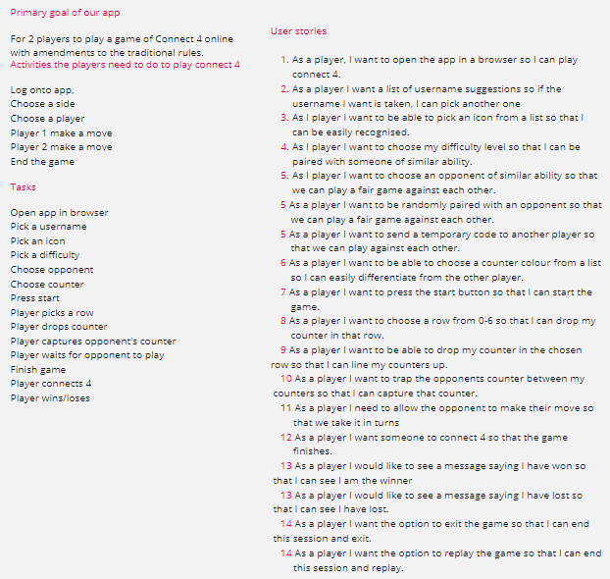
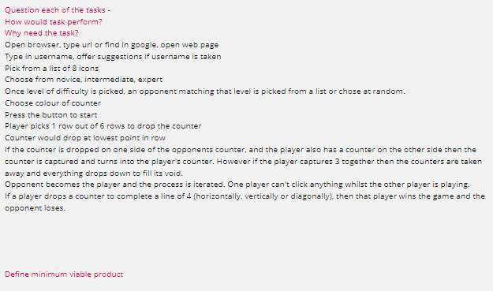
Figure 1: Initial Ideas
The group discussed the actions and processes of a game of connect 4 so we could start to build our stories and diagrams from the set of instructions. We questioned each user task so we could explore possible user stories. The primary goal of our app was ‘for players to play a game of connect 4 online with amendments to the traditional rues’. Some of the traditional rules shall remain the same but there are amendments such as players being able to capture an opponent’s counter by catching it among two of their own counters and a player trapping 3 opponents counters, they can be destroyed.

User Stories

The stories
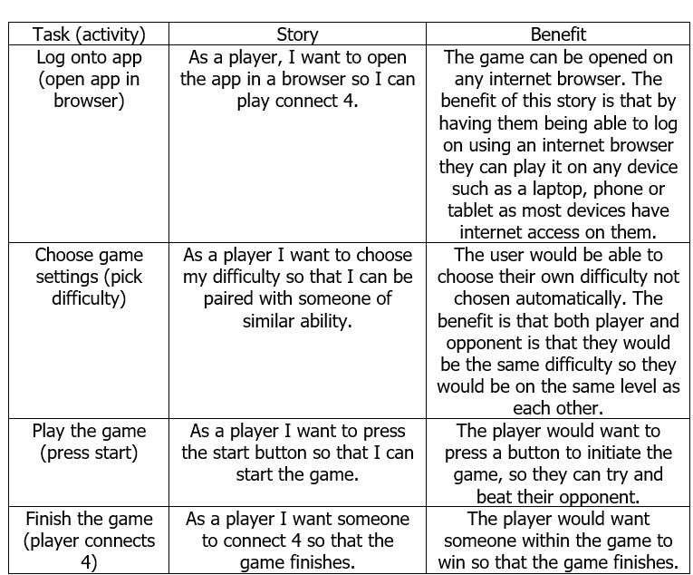
Figure 2: User story benefits

User story map
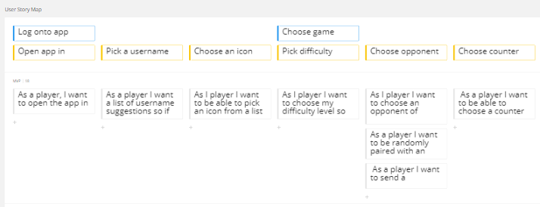
Figure 3: log onto app and choose game.
Users are logging onto the app and choose the settings such as entering their name and choosing an icon, difficulty level, opponent, and counter. Many activities were created in relation to the tasks alongside with the user stories.

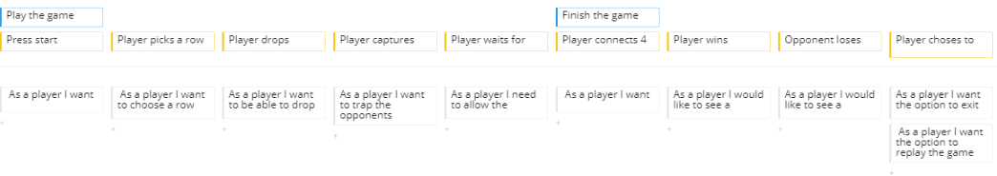
Figure 4: the game
When users click on the start button, they would want to initiate a game of connect 4 and see an empty grid. They would want to pick a row so then they are in control of their own counters and can place them where they wish to. When the player drops the counter into the board, they want to attempt to capture the opponent’s counter. When the player captures the counters, they feel rewarded because the counter trapped some of the opponent’s counters in and they are near to the end of the game and winning it. The player waits for the opponent to place their counter to make it a fair game of connect 4 and they can plan where they are going to place their counters to try and beat their opponent and win. When the user finishes the game, they want to connect 4 counters together so that they can win. The user can replay or quit the game.

Acceptance Criteria
Whilst creating the user stories we had to take into consideration the main objective of the game. The group discussed an outline of the procedures were deliberated and recorded the criteria in the user activities and tasks. This was then detailed within the user stories we created. We feel that we have met the requirements of the traditional and amended rules of the game because the user stories explain the activities and tasks and what the player wants to achieve from it such a player wants to choose their difficulty so that they can be paired with someone of similar ability. The CRC cards also expand what are the processes of each class, what their responsibilities are and what other classes can assist them in achieving various tasks.

Evaluation
After completing the user stories, we discussed their strengths and weaknesses, and we feel that we could have done more stories and could have gone deeper with future versions of the game such as things we could add such as additional functionality.

We felt that the user stories had been successful. Prior to starting this part of the design aspect of the game we revised over the lecture notes and discussed the topic, so we all understood what user stories are and how they are meant to be formatted. User stories are beneficial because it can help with the user’s expectations of what they want to do during specific sections of an application. It can also help with the steps required to use the application such as logging on, playing the game, and finishing it. It helps understand the flow of the program and the order in which it should work.

CRC Cards

Cards

Player class card
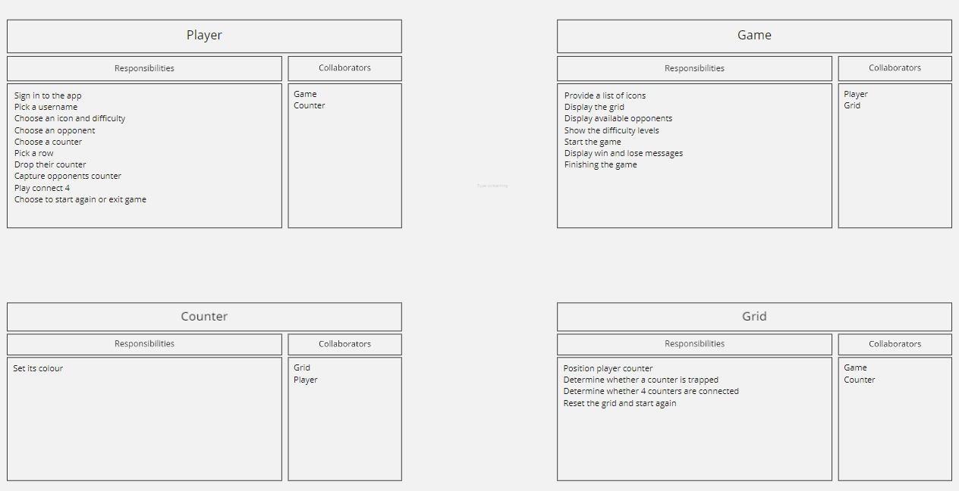
Figure 7: Player card
The player is the part of the game who is in the most control as they make all the decisions regarding the game settings and how they play it. They would sign into the app and be able to enter in their username. They would also be able to choose their own icon and difficulty level. They can either choose an opponent or have one randomly picked for them. The opponent would match the difficulty chosen by the player so if the player picked easy, the opponent would be the same ability. Once they have entered their own settings, drop their counters into the grid. By being able to pick where they are attempting to capture the opponents counter. At the end of the game, they have the option to either start a new game session or exit the game.

Game class card
Figure 8: Game card
A list of icons will be provided for the player to choose from at the start of the game so they can have something unique to identify themselves. Once the game set up has been completed, an empty grid is shown. The available opponents will then appear and depending on if the player has decided to select or have the opponent randomly selected.

Counter class card
Figure 9: Counter card
The counter does not have massive responsibility throughout the game apart from when the player chooses its colour for when the game begins so that the player knows which counters are theirs and which counters are the opponents.

Grid class card
Figure 10: Grid card
For this card, it would position the player counters. It would be based upon where the player positions it and then it gets placed. It would be required to determine whether a counter is trapped such as 2 opponents around 1 players’ counter. Once the game has been finished and the game restarted the grid would be required to be reset for the next game.

Refer to appendix 4 to see the collaborators.

Card Design approach
CRC cards is the main method for creating systems. The planned CRC method involves coordinating the CRC team, instructing appropriate people, and completing the process of CRC modelling such as discovering the classes, getting the responsibilities, and identifying collaborators [2]. They are a compilation of universal index cards. A class signifies a compilation of parallel entities, a responsibility is an object that a class understands, and a collaborator is an additional class which a class cooperates with to accomplish its obligations [3].

Evaluation
They contain sufficient detail to enable the code to be implemented and tested as we created reasonable tasks which can be performed easily. We looked at other online games of connect 4 and the responsibilities, despite some amended rules to our game, are the same in the other online games available. The responsibilities describe what classes need to do what activity or task such as saving the game settings for just that individual session of connect 4 and the collaborators, which are other classes, to assist them achieve the completion of the tasks. When we did the group work, it is a good approach as we could collaborate our ideas of what we required for each class and discuss potential attributes and expected outcomes of the game. The classes discussed could be implemented into the game as it would make reading the code simpler and it would break code into each individual area rather than just 1 main program class. It also assists with understanding what each part of the game is meant to do. We felt that the CRC cards met the acceptance criteria as it follows the traditional and amended rules of the game. CRC cards would be used in the future because they are useful to visualise the classes, helping with being able to look at each class, and see what it would do and be responsible for.

Wireframe Diagram
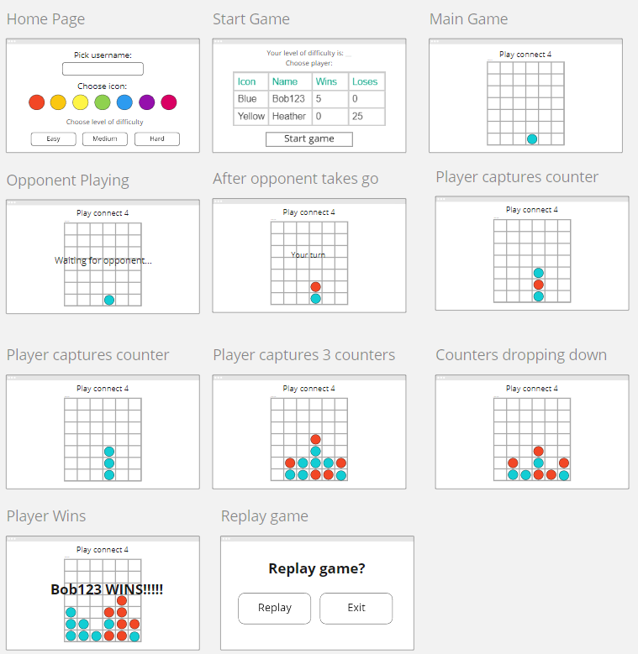
Figure 5: diagram
A wireframe diagram is a valuable tool to help developers discuss about the architecture of the program what you are constructing. Wireframe diagrams are useful for making designs clear [1].

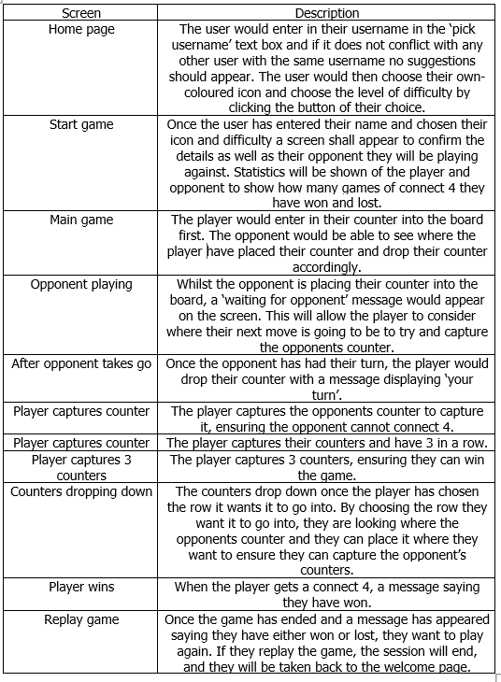
Figure 6: Game interfaces
The above table explains what each screen within the wireframe diagram signifies. We decided to create the wireframe diagrams because it would give the group ideas of what we would want the program to look like and how the messages appear saying whether it is the opponents or players turn and whether the player has won or lost the game.

Evaluation
The implementation of the diagrams went well as we successfully created suitable interfaces for the different aspects of the game, based on the brief, and our developed user stories and CRC cards. We constantly referred to the areas to ensure that we were creating a suitable game based on the rules and stories created. Wireframe diagrams are a useful approach to designing a program as you can capture what the interface could look like in the game.

Sequence Diagram

Diagram
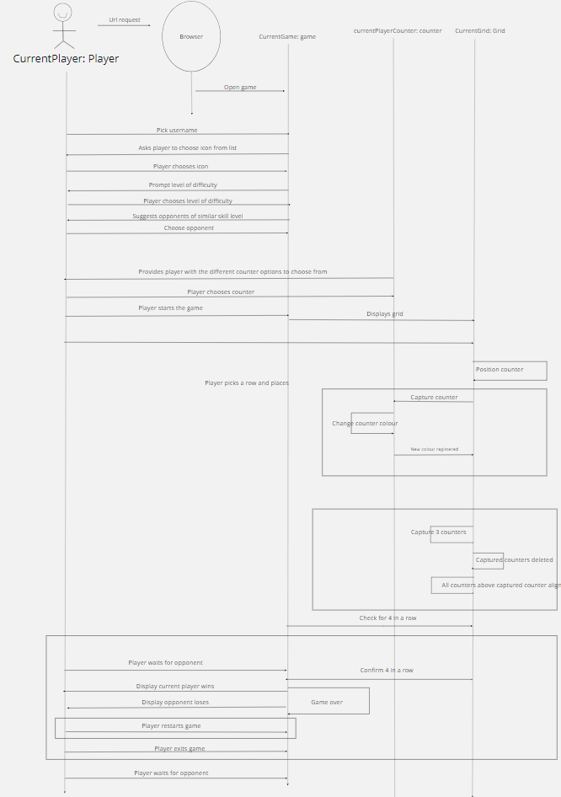
Figure 11: sequence diagram

Significance
Sequence diagrams are interaction diagrams that detail how operations are carried out. They capture the interaction between objects in the context of a collaboration [4]. The significance of the sequence diagram is that, based on the user stories, tasks and activities, the group were able to determine what activity would happen at certain points of the game and when the player interacted with the game. We used the classes thought of whilst completing the CRC cards and based the user activities and processes from those. The operation of the game has been highlighted as well as IF statements in case a certain event occurs such as winning or losing the game.

Sequence diagram evaluation
As a group, we are pleased with the way the sequence diagram was created. We found some of the sections rather difficult to implement, particularly the IF statements of the game and we were not able to complete the relevant parts of the diagram straight away and we decided to end our discussions for the day, refer to the lecture notes and improve our knowledge for the diagrams. We then met again and was able to complete the IF statements with the assistance of other examples and illustrations. We used all 4 classes created within the CRC cards and used those as a base to start creating the diagram which helped the group discover the various processes required. We found that sequence diagrams are beneficial because they can assist with the way the game operates and can help with coding each class, understanding what is happening within the coding.

Design Evaluation
The design discussions went well, and productive work was completed during the meetings. The tasks were completed within 3 weeks. Whilst conducting the group tasks we reviewed the work to ensure that all our work reflected what we did in the diagrams and CRC cards. We discussed every section of the work before completing it. We would discuss our understanding of each topic and revised the design aspects and revised over lecture notes so then when we came onto completing the tasks, we have a much better understanding of what we were completing. When we came onto implementing the game, we had a clear set of rules and user requirements we wanted to put into the game alongside with the scenario we had as a group so a game could be played by all.

Idea discussion and refining the design.
Whilst making the game, a group was formed to discuss the design of the application as well as the user stories and map. We met a few times a week and used Miro to create a collaborative board to share ideas. The discussions can be found in appendix 2.

We then discussed what should be in the game such as going onto it and registering and then logging on, inviting friends to be your opponent, and then playing the game. We discussed activities for all the tasks and discussed user stories to go alongside with them.

We then did the CRC cards for 4 different classes which are player, game, counter, and grid. We discussed what their responsibilities are and what their collaborators could be. The collaborators were determined to gather which classes would help all other classes such as for the player it could be counter and game.

We then created a sequence diagram. We played different versions of the game and established what the processes take place in the game, which aided us to complete the diagram. We discussed IF statements and the order of activities in each of the classes and decided the directions such as if it was player to game such as a counter going into a grid or game to player such as requesting them to enter their name.

We finally created a sequence diagram which showed what the different interfaces would look like for different parts of the game such as settings and playing the game.

Software Testing
Software Testing is the act of checking if the software meets the anticipated targets to guarantee that the software product is working correctly. It includes execution of software modules using either manual or programmed tools to assess at least a single property of curiosity. The objective of the analysis is to discover issues compared to the real requirements. Software testing means the Verification of Application Under Test (AUT) [5].

Quality assurance (QA) is a methodical approach of deciding if a system follows precise conditions. It creates and follows requirements for creating verifiable software. QA improves client satisfaction and a company’s reliability, while also increasing work practices and productivity, and it allows a company to compare with other organisations [6].

Software testing and quality assurance are important in a software development cycle. Both procedures improve the whole development and try to ensure that exceptional standards are met in the system. It decreases upkeep costs and offers improved usability and greater functionality [7].

Another reason software testing is important is that if there are any issues discovered in the software, it can be found straight away and can be resolved prior to distribution of the program. Sufficiently tested software guarantees consistency, security and it can run smoothly which can cause time being spared, cost efficiency and client gratification [5].

White Box Testing
White box testing approaches involve tests such as every single line of source code is performed once or needing all the events to be independently verified. Few white box tests can be completed without changing the system or altering the amount to push a separate implementation path [8]. White box testing is an approach which tests and confirms a system’s functionality, inside framework, items, and elements. This method of testing discovered an application’s susceptibilities as well as test code according to the project requirements [9].

Advantages
The advantages of using white box testing is that it gives code optimisation by showing unseen errors, there is clearness of the internal coding architecture which assists in originating the input data type required to test a system efficiently. The other advantages are that test cases can be created and it provides engineering-based rules to halt testing a system [9].

Disadvantages
The disadvantages of using white box testing is that it is a hard and costly procedure which involves the ability of an expert developer to understanding of inside architecture of a system. It requires updated test script when the software is altering regularly, it is extensive testing, and some circumstances could be untested as it is not practical to test every single system area which could mean that some errors may not be discovered [9].

Demonstration
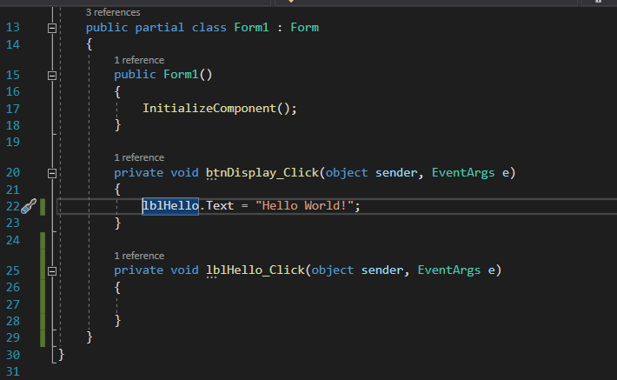
Figure 12: Code to be tested.
The code will be tested to see if a message should appear once a button has been pressed, displaying “Hello World!” as white box testing mostly investigates the inside architecture of the software.

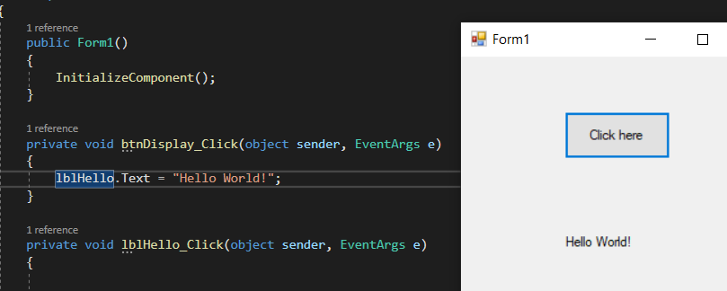
Figure 13: Result.
As visible in the above image “Hello World!” appears in the form. The code was shown on one side of the screen with the form on the other side following the progress of the software to ensure that all the code gets read and works correctly. This test was successful [10].

Black Box Testing
Black box testing tests if a product works as it is expected to operate. It is usually completed by evaluating an application’s authentic functionality with the expected functionality defined in a requirement article [8]. It is a testing technique which is utilized to scrutinize application functionality without understanding its inside code architecture. It can be utilized to all software testing quantities, but it is mainly used for the greater-level recognition [11].

Advantages
Black box tests are impartial because the developer and tester typically works by themselves, the tester is unrestricted from any burden of information of specific programming languages to test the dependability and effectiveness of a system. Black box testing is completed from a user’s perspective and not of the developers and test cases can be created straight after the requirements have been done [11].

Disadvantages
The disadvantages of using black box testing is that the tests can be unrequired if they have been done by the developer, test cases are hard to be make without vibrant requirements and testing every input method is not possible because it is timely, and this would leave many software areas unverified. The other limitations are that the results might be overemphasized, and it cannot be used for testing complicated code [11].

Demonstration
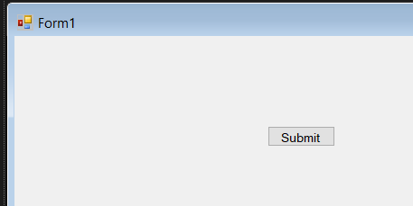

Figure 14: Designing the addition calculator.
To demonstrate black box testing, a form has been created to add 2 integers which are in the code.

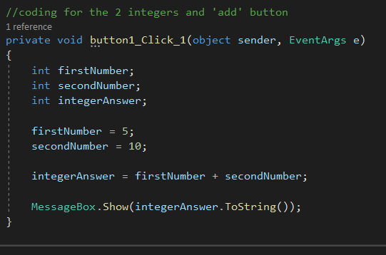
Figure 15: Program code.
Above is the calculator code. ‘firstNumber’, ’secondNumber’ and ‘integerAnswer’ variables are set as integer data types as these are going to be including numbers. As shown above, the 2 integers to be calculated are 5 & 10. The expected result is 15 [12].

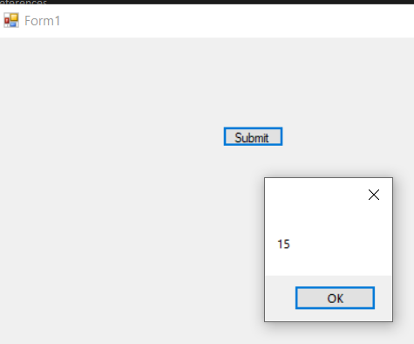
Figure 16: Testing
Because of black box testing being commonly used for functional testing, the method to show the result is clicking the ‘Submit’ button to show the result. As expected, the result is 15. This test was successful as the code works and the number 15 is appearing.

Testable Code
Testable code is code created to a high standard. It is loosely coupled, and it is encapsulated. It is code that can be tested programmatically. When a test fails, developers need to know the reasons why it has failed so that they can discover the problems and how to fix them. By using this process, it can be beneficial on a project as it could save expenses and save making mistakes and fixing them [13].

When writing testable code, it requires control and effort from the developer. The most important benefit of having testable code is that it can be easily grasped by a team of developers, be maintainable and extend the code for future development [14].

By having the code understandable, if new developers work on the software, they become aware of what it is and what the expected outcomes are as well as being able to understand and appreciate the code.

Importance and relevance to software engineering
One of the important factors of testable code is that developers can computerize the testing stages so that developers can watch the progress of their implementation in a set to be delivered state. It also generates late adjustments, changes that are significant on a development, it could essentially save money as there could be no or very few errors within the software, so the project will be finished quicker. Testable code is important because it can maintain the software in an always ready to release stage as it can computerize the testing method [13].

By having testable code, it improves speed and quality. Good unit tests create testable code, which improves quality [14].

Version control software
Version control systems allows developers to evaluate files, find discrepancies and collate the modifications if required. Version control is a useful method to keep the system builds updated to be able to distinguish which version is presently being implemented. If new developers manage the implementation, they can download the current system version to their local working area using the version control software and can keep updated with the version they are utilizing. When the project has been finished, developers can combine the files together to produce a final working version ready for users to use [15].

When fixing a problem, developers can evaluate distinct versions of files to follow the changes. Developers can assess the last running file with the incorrect file, reducing the time devoted discovering the cause of a problem. If the user wanted to roll back the modifications, the developer can execute the last functional file [15].

Based on the research discovered, it is concluded that the quote is agreed. It is a key tool in the software development process as it is useful because if there are any errors with the current version of software being used it can be easily reversed to show the last successfully built software, such as if a system were currently on version 5 and this did not work, and the previous successful version was 4.5 it would go to this version.

By keeping track of the different versions, it produces a comprehensive log of all changes. The modifications include the establishment, changes, and removal of documents [16].

Git is an open source delivered version control system. Git can be utilized to store information and it is mostly used to keep code. The code, which is kept in Git, gets updated as extra code is added. Developers can increase code in parallel [17].

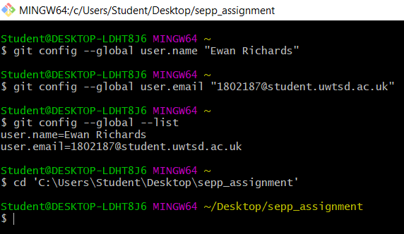
Figure 17: Configuration and directory
The configuration has been completed.

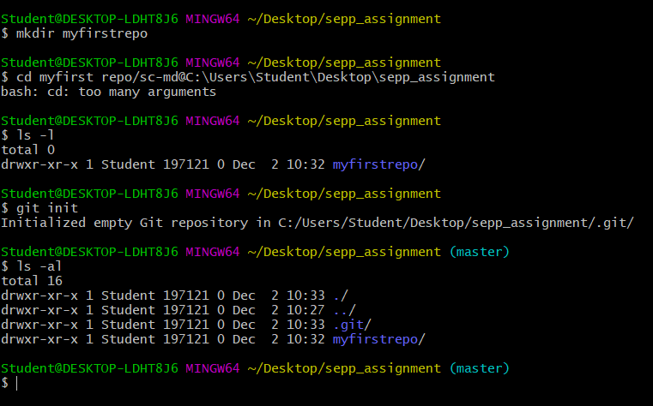
Figure 18: Creating an empty local repository.

A new repository has been created. Any files needed will be in the ‘sepp_assignment’ repository.

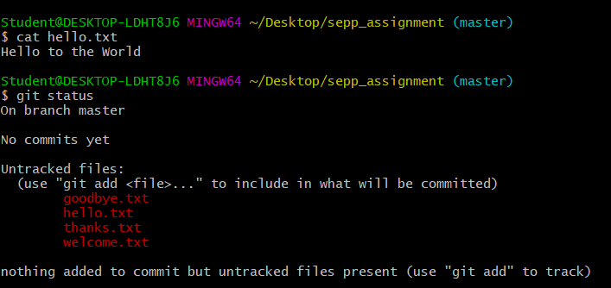
Figure 19: Staging artefacts
All files are in the repository.

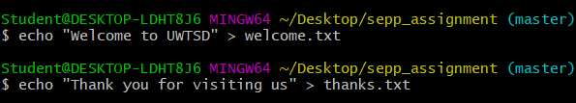
Figure 20: Staging artefacts
2 files have been edited which will be added to the repository.

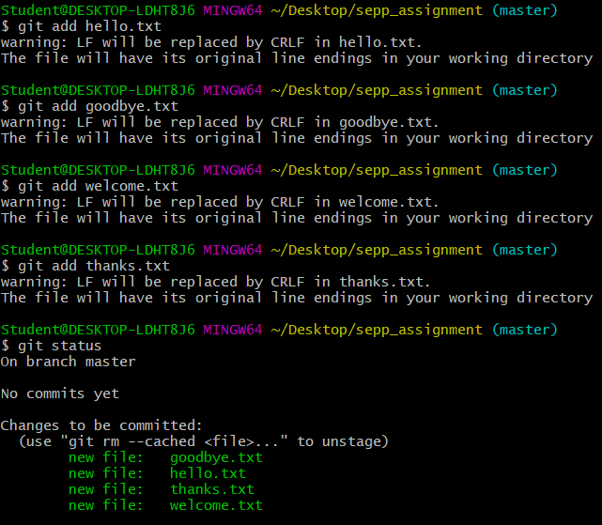
Figure 21: Adding the files to be tracked.
All files are in the repository.

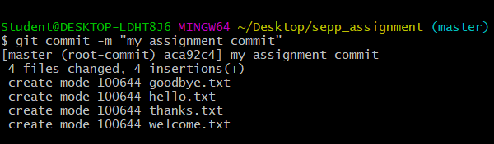
Figure 22: Commit
All files have been committed.

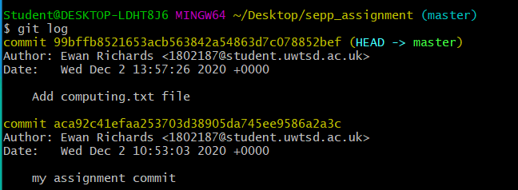
Figure 23: Git logs
The 2 commit logs have been created.

Code implementation and testing

Implementation
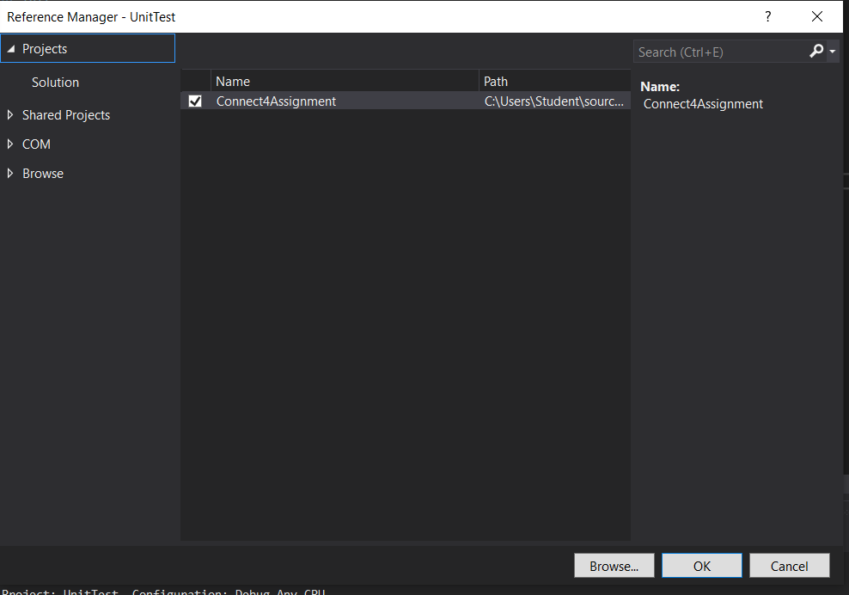
Figure 24: Dependency (adding reference)
A unit test (Xunit) solution was created to perform tests to ensure that the code is working. To ensure that it reads the full program, a reference requires to be added. Due to time constraints and workload, not all the unit testing was completed. However, tests have been done by the developer.

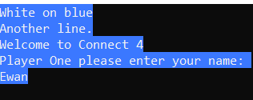
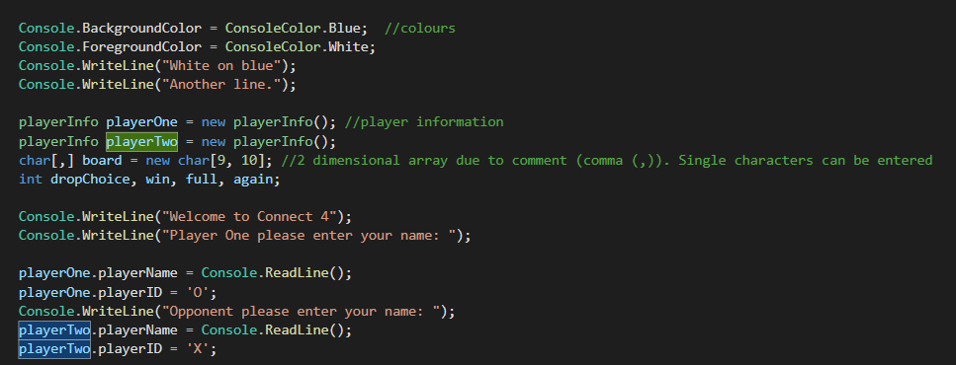
Figure 25: Player enters name (including code)
The user story for the above illustration is ‘As a player, I want to open the app in a browser so I can play connect 4’. For this part of the game the player comes onto the welcome screen of the game and they can enter in their name.

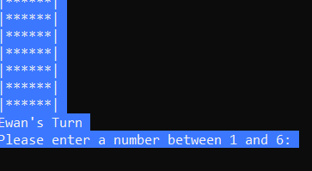
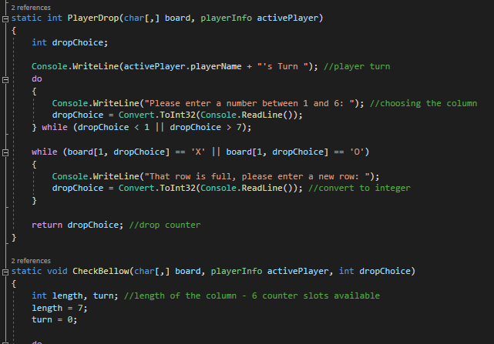
Figure 26: Players turn (including code)
The game has now started. The player plays first to enter in their counter. The main user story for this part of the game as that ‘As a player I want to press the start button so that I can start the game’. For this game, it is the enter button on the keyboard. The other user story includes ‘As a player I want to choose a row from 0 -6 so that I can drop my counter in that row’. In this game the numbers are 1 – 6, the functionality remains the same. Code is being demonstrated, showing the turn of the player and the decision of what column to drop the counter into.

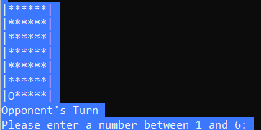
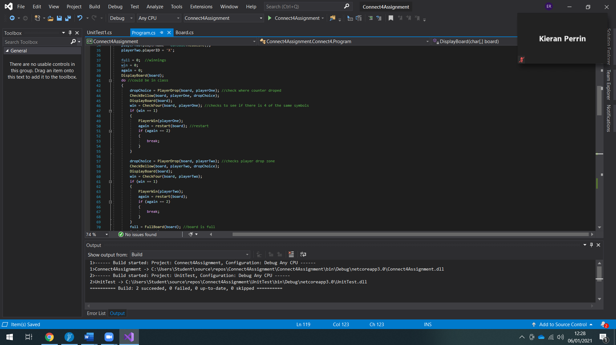
Figure 27: Opponent’s turn (including code)
The player has placed their counter into the grid. The player is now waiting for the opponent to place their counter into the grid. For this section of the game the user story decided in the group was ‘As a player I need to allow the opponent to make their move so that we take it in turns’. This story has been achieved within the game as the opponent will take their turn and place their counter (X) on the grid. This allows the player opportunity to consider their next steps about playing the game whist the opponent is taking their turn. The code shows where the player has dropped their counter and to see whether they have connected 4.

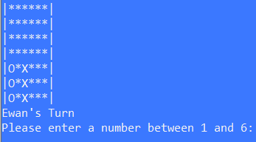
Figure 28: 3 in a row (including code)
Both the player and opponent have 3 counters in a row on the grid. The player could either place their counter onto column 1 and secure a win and get a connect 4 or they could trap the opponent’s counters and destroy the counters. The code shows where the opponent has dropped their counter and to see whether they have connected 4.

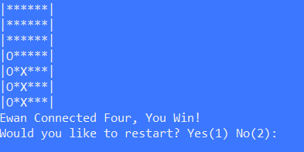
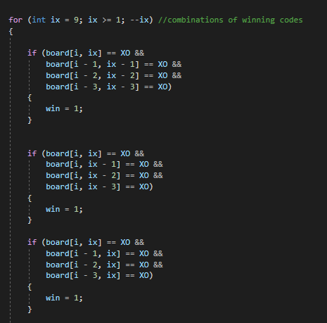
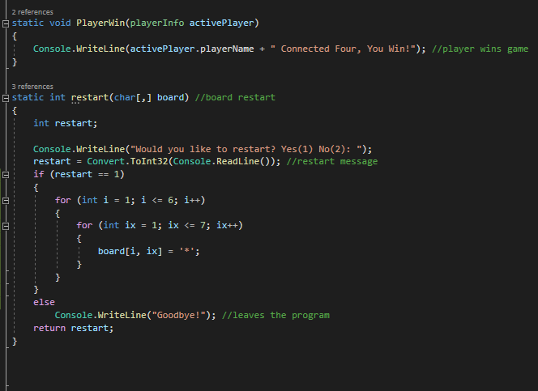
Figure 29: End of game message (including code)
The main user stories here are ‘As a player I would like to see a message saying I have won so that I can see I am the winner’, ‘As a player I want the option to exit the game so that I can end this session and exit.’ and ‘As a player I want the option to replay the game so that I can end this session and replay’. The player has decided to put their counter onto column 1 and secure a victory. The screenshot demonstrates that 4 of the players counters (O) are connecting. All the user stories have been successful as a message has appeared show that the player has connected 4 so the player has won. Another message also appears asking the player whether they wish to play the game again. If the player says yes, the grid gets reset and a new game begins. If the player says no, the application closes. This code is demonstrating the different messages for winning and restarting the game as well as some of the potential winning combinations (refer to appendix 6 to read all combinations).

Testing

Test 1
The expected result of the test is that the player will have the option to enter in their name as well as the opponent and press the enter button on the keyboard to initiate the game. The test has been successful as the names have been entered and the game has initiated.
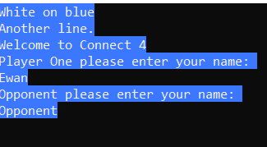
Figure 30: The player and opponents have entered in their names.
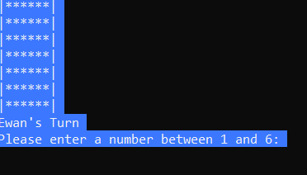
Figure 31: The game has successfully been initiated.

Test 2
The expected result is that after the player takes their turn and their counter has been dropped, a message should appear saying opponent it is your turn, they take their turn and then the turn is back to the player. The test has been successful as the player has dropped their counter.
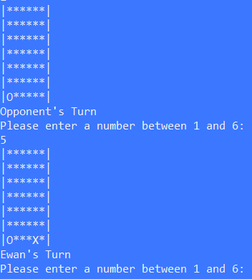
Figure 32: The player and opponent dropping their counters into the grid.

Test 3
The expectation of the test is that the play will achieve an outcome of connecting 4 counters together and win the game. The test has been successful as the player has been able to achieve a connect 4 and win the game.

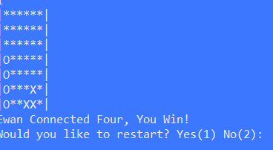
Figure 33: Player wins connect 4.

Test 4
The purpose of the test is to determine what the player wants to do at the end of the game. The expected result is that the player should receive a message saying that they have won the game and have the option to restart the game if they want to. For this test, the player wants to restart the same, so they need to select the yes option, number 1. The test has been successful as the grid resets.
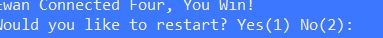
Figure 34: End message.
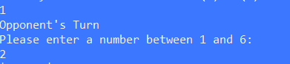
Figure 35: Game restart.

Test 5
The purpose of this test is to exit the application. The player has successfully received their end of game message saying that they have won the game, but they decided to end the application. The expectation is that they player will need to press 2 on their keyboard to end the game and the application should end. The test has been successful as the application has shut down.

Figure 36: End of game message.
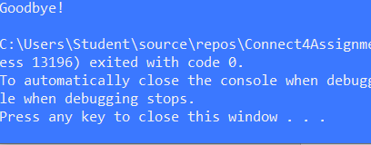
Figure 37: Closing the application.
The enter button was pressed and the application closed.

Test 6
The expectation is to run a unit test through the program and discover if these tests work. The actual result is that the unit test shows that the program is fully functional, the test has been successful.

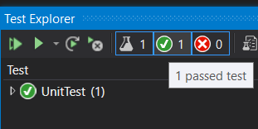
Figure 38: Unit testing

Implementation Evaluation
Overall, the implementation went well, however a few errors were discovered. This was because the board class had not been linked with the main program class where most of the code was stored. The grid class was made public. However, further errors were discovered as the classes were not accessible. The ‘CheckFour’ and ‘FullBoard’ parts of the code were made public and it resolved the errors.

Future implementation would include changing names when the game restarts in case the opponent changes and have a variety of background colours available to improve accessibility.

Conclusion
The details the development of a software design for a Connect 4 game have been reviewed. The design was discussed in a team environment and refined individually. Appropriate class descriptions have been generated using CRC Cards and user stories have been created and discussed alongside with a user story map. The design has also been evaluated.

User stories have been used to illustrate discussions relating to design evaluations including a user story map that has been developed. User story benefits have also been evaluated.

Software testing has been discussed as well as its advantages and disadvantages.

References

[1] | L. Hvam, J. Riis and B. L. Hansen, “CRC cards for product modelling,” Computers in Industry, vol. 50, no. 1, pp. 57-70, 2003.
[2] | S. W. Ambler, “Class Responsibility Collaborator (CRC) Models: An Agile Introduction,” Agile Modelling, 2020. [Online]. Available: http://agilemodeling.com/artifacts/crcModel.htm. [Accessed 4 December 2020].
[3] | P. Guilizzoni, “What Are Wireframes,” Balsamiq Wireframing Academy, 2020. [Online]. Available: https://balsamiq.com/learn/articles/what-are-wireframes/. [Accessed 22 December 2020].
[4] | Visual Paradigm, “What is Sequence Diagram,” Visual Paradigm, 2020. [Online]. Available: https://www.visual-paradigm.com/guide/uml-unified-modeling-language/what-is-sequence-diagram/. [Accessed 22 December 2020].
[5] | Guru99, “What is Software Testing? Definition, Basics & Types,” Guru 99, 2020. [Online]. Available: https://www.guru99.com/software-testing-introduction-importance.html#2. [Accessed 18 November 2020].
[6] | M. Rouse, “Quality Assurance (QA),” SearchSoftwareQuality, July 2019. [Online]. Available: https://searchsoftwarequality.techtarget.com/definition/quality-assurance. [Accessed 23 November 2020].
[7] | S. Sameer, “Why Is Software Testing and Quality Assurance Important for Any Business,” West Agile Labs, 2019. [Online]. Available: https://www.westagilelabs.com/blog/why-is-software-testing-and-qa-important-for-any-business/#:~:text=The%20importance%20of%20software%20testing%20and%20quality%20assurance%20is%20of,better%20usability%20and%20enhanced%20functionality.. [Accessed 18 November 2020].
[8] | S. R. Ahamed, “Studying The Feasibility And Importance of Software Testing: An Analysis,” International Journal of Engineering Sicence and Technolog, vol. 1, no. 3, pp. 119-128, 2009.
[9] | W. Moore, “What is White Box Software Testing: Advantages and Disadvantages,” Invensis Global Outsourcing Services, 20 August 2020. [Online]. Available: https://www.invensis.net/blog/white-box-software-testing-advantages-disadvantages/#Advantages_Pros_of_White_Box_Testing. [Accessed 24 November 2020].
[10] | O. Altunyan, D. Coulter, T. G. Lee, G. Hogenson, G. Warren, tglee, N. Schonning and T. Petersen, “Createa Windows Forms app in Visual Studio with Visual Basic,” Microsoft, 27 September 2019. [Online]. Available: https://docs.microsoft.com/en-us/visualstudio/ide/create-a-visual-basic-winform-in-visual-studio?view=vs-2019. [Accessed 9 December 2020].
[11] | W. Moore, “What is Black Box Testing: Advantages and Disadvantages,” Invensis Global Outsourcing Services, 20 August 2020. [Online]. Available: https://www.invensis.net/blog/black-box-testing-advantages-disadvantages/#Advantages_Pros_of_Black_Box_Testing. [Accessed 24 November 2020].
[12] | Home and Learn, “Addition In C# .Net,” Home and Learn, 2020. [Online]. Available: https://www.homeandlearn.co.uk/csharp/csharp_s2p8.html. [Accessed 8 December 2020].
[13] | D. Bernstein, “Writing Testable Code,” DZone, 7 June 2019. [Online]. Available: https://dzone.com/articles/write-testable-code#:~:text=Writing%20testable%20code%20means%20that,singletons%20or%20service%20locators%2C%20etc.. [Accessed 24 November 2020].
[14] | S. Kolodiy, “Unit Tests, How to Write Testable Code and Why it Matters,” Toptal, 2021. [Online]. Available: https://www.toptal.com/qa/how-to-write-testable-code-and-why-it-matters. [Accessed 5 January 2021].
[15] | M. Heusser, “Why is unit testing important for developers,” SearchSoftwareQuality, 12 November 2020. [Online]. Available: https://searchsoftwarequality.techtarget.com/answer/Is-unit-testing-an-important-aspect-of-software-development. [Accessed 8 December 2020].
[16] | I. Azarian, “A Review of Software Versin Control: Systems, Benefits, and Why it Matters,” Segue Technologies, 14 June 2013. [Online]. Available: https://www.seguetech.com/a-review-of-software-version-control-systems-benefits-and-why-it-matters/#:~:text=Version%20Control%20Benefits,development%2C%20QA%2C%20and%20production.. [Accessed 18 November 2020].
[17] | Atlassian Bitbucket, “Whaat is version control?,” Atlassian Bitbucket, 2020. [Online]. Available: https://www.atlassian.com/git/tutorials/what-is-version-control. [Accessed 4 December 2020].
[18] | A. Sridhar, “An introduction to Git: what it is, and how to use it,” FreeCode Camp, 12 August 2018. [Online]. Available: https://www.freecodecamp.org/news/what-is-git-and-how-to-use-it-c341b049ae61/. [Accessed 2 December 2020].

Table of Figures
Figure 1: Initial Ideas 5
Figure 2: User story benefits 6
Figure 3: log onto app and choose game. 6
Figure 4: the game 7
Figure 7: Player card 8
Figure 8: Game card 9
Figure 9: Counter card 9
Figure 10: Grid card 10
Figure 5: diagram 11
Figure 6: Game interfaces 12
Figure 11: sequence diagram 14
Figure 12: Code to be tested. 18
Figure 13: Result. 18
Figure 14: Designing the addition calculator. 19
Figure 15: Program code. 20
Figure 16: Testing 20
Figure 17: Configuration and directory 22
Figure 18: Creating an empty local repository. 23
Figure 19: Staging artefacts 23
Figure 20: Staging artefacts 23
Figure 21: Adding the files to be tracked. 24
Figure 22: Commit 24
Figure 23: Git logs 25
Figure 24: Dependency (adding reference) 25
Figure 25: Player enters name (including code) 26
Figure 26: Players turn (including code) 27
Figure 27: Opponent’s turn (including code) 28
Figure 28: 3 in a row (including code) 29
Figure 29: End of game message (including code) 30
Figure 30: The player and opponents have entered in their names. 31
Figure 31: The game has successfully been initiated. 32
Figure 32: The player and opponent dropping their counters into the grid. 32
Figure 33: Player wins connect 4. 33
Figure 34: End message. 33
Figure 35: Game restart. 33
Figure 36: End of game message. 34
Figure 37: Closing the application. 34
Figure 38: Unit testing 34

Appendix

Appendix 1: version control using Git.
commit 99bffb8521653acb563842a54863d7c078852bef (HEAD -> master)
Author: Ewan Richards <1802187@student.uwtsd.ac.uk>
Date: Wed Dec 2 13:57:26 2020 +0000

Add computing.txt file

commit aca92c41efaa253703d38905da745ee9586a2a3c
Author: Ewan Richards <1802187@student.uwtsd.ac.uk>
Date: Wed Dec 2 10:53:03 2020 +0000

my assignment commit

Appendix 2: Group discussions
Meeting date
Monday 30th November
Members attended
All members present
Discussed
- We started developing our user story map.
- Thought of the main goal: To create a two-player game of connect 4 as well as the main goal for the users: To be the first to get 4 in a row.
Questions
- Are you looking for the design to be web application or console?
- If you capture 3 in one go is there a hole?
- The counter drops into the hole, or does it stay empty to be filled by next dropped counter?
- If there are 2 counters above, do both counters drop down?
Plan of action
Come up with a list of what we think we need to do and compare next week to come up with a group list.
Next meeting
4th December

Meeting date
Friday 4th December
Members present
3 members were present, 1 was absent.
Discussed
- Plan was developed for the user tasks and activities
- Primary goal was amended: For 2 players to play a game of Connect 4 online with amendments to the traditional rules
Plan of action
- To look back over the plan created during the meeting and see if there is other information to be included
- Start creating the user stories
Next meeting
Monday 7th December

Meeting date
Monday 7th December
Members attended
All members present
Discussed
- Revised over the developed plan.
- Start the user stories.
Plan of action
- To revise the user stories to see if there is other information to be included.
- Start creating the CRC cards.
Next meeting
9th December.

Meeting date
Wednesday 9th December
Members attended
All members present.
Discussed
- Revised the developed user stories.
- Started the CRC cards (picked out the identified classes, started developing the cards, completed most of them by the end of the meeting)
Plan of action
- Finished creating the CRC cards.
- Revise over the cards to see if any other information needs to be included.
Next meeting
Thursday 10th December

Meeting date
Thursday 10th December
Members attended
All members present
Discussed
- Revised / finished the CRC cards.
- Alter some of the collaborators on the cards as they were not all suitable.
- Discussed the sequence diagrams making sure we all understood what they are before starting them. We then started the diagrams.
Plan of action
- Complete the sequence diagram.
- Start the wireframe diagrams
Next meeting
Monday 14th December

Meeting date
Monday 14th December
Members attended
All members present
Discussed
- Reviewed work ensure it met requirements and we were happy with the work to date.
- We finished the sequence diagrams.
- Started the wireframe diagrams
Plan of action
- Finish the wireframe diagrams.
- Revise all work completed
Next meeting
Tuesday 15th December

Date of meeting
Tuesday 15th December
Members attended
All members present
Discussed
- Finished the wireframe diagrams.
- Revised the entire design created and discussed the next steps form this point and concluded that all work had been completed.
- No further meetings.

Appendix 3: user stories
Task (activity) | User story
Log onto app (open app in browser) | As a player, I want to open the app in a browser so I can play connect 4.
Log onto app (pick a username) | As a player I want a list of username suggestions so that if the username I want is taken, I can pick another one.
Log onto app (choose an icon) | As a player I want to be able to pick an icon from a list so that I can be easily recognised.
Choose game settings (pick difficulty) | As a player I want to choose my difficulty so that I can be paired with someone of similar ability.
Choose game settings (choose opponent) | As a player I want to choose an opponent of similar ability so that we can play a fair game against each other.
Choose game settings (choose opponent) | As a player I want to be randomly paired with an opponent so that we can play a fair game against each other
Choose game settings (choose opponent) | As a player I want to send a temporary code to another player so that we can play against each other
Choose game settings (choose counter) | As a player I want to be able to choose a counter colour from a list so that I can easily differentiate from the other player
Play the game (press start) | As a player I want to press the start button so that I can start the game.
Play the game (player picks a row) | As a player I want to choose a row from 0-6 so that I can drop my counter in that row.
Play the game (player drops counter) | As a player I want to be able to drop my counter in the chosen row so that I can line up my counters up.
Play the game (player captures opponent’s counter) | As a player I want to trap the opponents counter between my counters so that I can capture that counter.
Play the game (player waits for opponent to play) | As a player I need to allow the opponent to make their move so that we take it in turns
Finish the game (player connects 4) | As a player I want someone to connect 4 so that the game finishes.
Finish the game (player wins) | As a player I would like to see a message saying I have won so that I can see I am the winner
Finish the game (opponent loses) | As a player I would like to see a message saying I have lost so that I can see who has lost
Finish the game (player choses to exit or replay the game) | As a player I want the option to exit the game so that I can end this session and exit.
Finish the game (player choses to exit or replay the game) | As a player I want the option to replay the game so that I can end this session and replay.

Appendix 4: CRC card collaborators
Card | Collaborators
Player class | The collaborators are the game, counter, and grid classes as the player would be playing the game and they would be dropping their counters into the grid.
Game class | The collaborators are the player and grid classes as the player would be playing the game and the grid would be available throughout the game to drop counters.
Counter class | The collaborators for are the game and player classes as the player would be in control of where the counter is places on the grid.
Grid class | The collaborators are the game and counter classes as the grid is an important part of connect 4 because it revolves around what goes on in the grid and the player drops their counters into the grid.

Appendix 5: connect 4 program code
using System;

namespace Connect4Assignment
{
public struct playerInfo //struct means structure
{
public String playerName; //able to be seen by the user playing the game
public char playerID;
};

namespace Connect4
{
public class Program : Board
{
static void Main(string[] args)
{

Console.BackgroundColor = ConsoleColor.Blue; //colours
Console.ForegroundColor = ConsoleColor.White;
Console.WriteLine("White on blue");
Console.WriteLine("Another line.");

playerInfo playerOne = new playerInfo(); //player information
playerInfo playerTwo = new playerInfo();
char[,] board = new char[9, 10]; //2 dimensional array due to comment (comma (,)). Single characters can be entered
int dropChoice, win, full, again;

Console.WriteLine("Welcome to Connect 4");
Console.WriteLine("Player One please enter your name: ");

playerOne.playerName = Console.ReadLine();
playerOne.playerID = 'O';
Console.WriteLine("Opponent please enter your name: ");
playerTwo.playerName = Console.ReadLine();
playerTwo.playerID = 'X';

full = 0; //winnings
win = 0;
again = 0;
DisplayBoard(board);
do //could be in class
{
dropChoice = PlayerDrop(board, playerOne); //check where counter droped
CheckBellow(board, playerOne, dropChoice);
DisplayBoard(board);
win = CheckFour(board, playerOne); //checks to see if there is 4 of the same symbols
if (win == 1)
{
PlayerWin(playerOne);
again = restart(board); //restart
if (again == 2)
{
break;
}
}

dropChoice = PlayerDrop(board, playerTwo); //checks player drop zone
CheckBellow(board, playerTwo, dropChoice);
DisplayBoard(board);
win = CheckFour(board, playerTwo);
if (win == 1)
{
PlayerWin(playerTwo);
again = restart(board);
if (again == 2)
{
break;
}
}
full = FullBoard(board); //board is full
if (full == 7)
{
Console.WriteLine("The board is full, it is a draw!");
again = restart(board);
}

} while (again != 2);
}
static int PlayerDrop(char[,] board, playerInfo activePlayer)
{
int dropChoice;

Console.WriteLine(activePlayer.playerName + "'s Turn "); //player turn
do
{
Console.WriteLine("Please enter a number between 1 and 6: "); //choosing the column
dropChoice = Convert.ToInt32(Console.ReadLine());
} while (dropChoice < 1 || dropChoice > 7);

while (board[1, dropChoice] == 'X' || board[1, dropChoice] == 'O')
{
Console.WriteLine("That row is full, please enter a new row: ");
dropChoice = Convert.ToInt32(Console.ReadLine()); //convert to integer
}

return dropChoice; //drop counter
}

static void CheckBellow(char[,] board, playerInfo activePlayer, int dropChoice)
{
int length, turn; //length of the column - 6 counter slots available
length = 7;
turn = 0;

do
{
if (board[length, dropChoice] != 'X' && board[length, dropChoice] != 'O')
{
board[length, dropChoice] = activePlayer.playerID;
turn = 1;
}
else
--length;
} while (turn != 1);

}

static void DisplayBoard(char[,] board) //array called 'board' using char consisting of assignment rows and column requirements
{
int rows = 7, columns = 6, i, ix; //this declares how many rows and columns ithere will be in the game

for (i = 1; i <= rows; i++)
{
Console.Write("|"); //set-up for the columns
for (ix = 1; ix <= columns; ix++)
{
if (board[i, ix] != 'X' && board[i, ix] != 'O')
board[i, ix] = '*';

Console.Write(board[i, ix]);

}

Console.Write("| \n");
}

}

static void PlayerWin(playerInfo activePlayer)
{
Console.WriteLine(activePlayer.playerName + " Connected Four, You Win!"); //player wins game
}

static int restart(char[,] board) //board restart
{
int restart;

Console.WriteLine("Would you like to restart? Yes(1) No(2): ");
restart = Convert.ToInt32(Console.ReadLine()); //restart message
if (restart == 1)
{
for (int i = 1; i <= 6; i++)
{
for (int ix = 1; ix <= 7; ix++)
{
board[i, ix] = '*';
}
}
}
else
Console.WriteLine("Goodbye!"); //leaves the program
return restart;
}

}
}
}

Appendix 6: board class code (connect 4 game)
namespace Connect4Assignment
{
public class Board
{
public static int CheckFour(char[,] board, playerInfo activePlayer)
{
char XO;
int win;

XO = activePlayer.playerID; //calculates if there's a win
win = 0;

for (int i = 8; i >= 1; --i) //nested if loops
{

for (int ix = 9; ix >= 1; --ix) //combinations of winning codes
{

if (board[i, ix] == XO &&
board[i - 1, ix - 1] == XO &&
board[i - 2, ix - 2] == XO &&
board[i - 3, ix - 3] == XO)
{
win = 1;
}

if (board[i, ix] == XO &&
board[i, ix - 1] == XO &&
board[i, ix - 2] == XO &&
board[i, ix - 3] == XO)
{
win = 1;
}

if (board[i, ix] == XO &&
board[i - 1, ix] == XO &&
board[i - 2, ix] == XO &&
board[i - 3, ix] == XO)
{
win = 1;
}

if (board[i, ix] == XO &&
board[i - 1, ix + 1] == XO &&
board[i - 2, ix + 2] == XO &&
board[i - 3, ix + 3] == XO)
{
win = 1;
}

if (board[i, ix] == XO &&
board[i, ix + 1] == XO &&
board[i, ix + 2] == XO &&
board[i, ix + 3] == XO)
{
win = 1;
}
}

}

return win;
}

public static int FullBoard(char[,] board) //full board
{
int full;
full = 0;
for (int i = 1; i <= 6; ++i)
{
if (board[1, i] != '*')
++full;
}

return full;
}
}
}

