
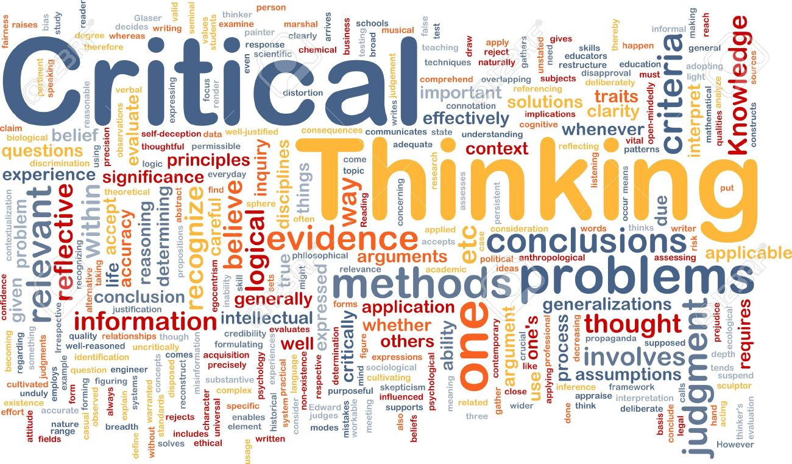
Development in the Workplace Critical Thinking McDonalds

By Nicola Bennett Student:1905849
[Company name]
[Date]
Contents

Introduction …………………………………………….……Page 2
Organisation Background ………………………….….Page 3
Values, Beliefs, Attitude and Cultures …………..Page 4
Classic Theorist Models..………………………..…....Page 6
Critical Thinking on classic management .…….Page 8
Advantages and Disadvantages using
Dilts Model………………………………………..……..…Page 10
How McDonalds has enhanced……………..…....Page 11
What is holding back the organisation…..…….Page 12
Modern management theory……..……..….…….Page 13
Critical thinking on modern management …..Page 14
How working conditions have enhanced….….Page 15
How employees feel…………………………….………Page 16
Personal evaluation & Barrett’s model….…….Page 17
Conclusion…………………………………………….…….Page 18
References………………………………………….……….Page 19

Intro
This report is evaluating McDonalds Corporation, researching classic management and modern theories and critically analysing them. Management theories are a collection of ideas from professional backgrounds who recommend general rules on how to manage an organization with many employees.
Training and developing staff effectively is vital for McDonalds, without it, the demands of a fast-paced outlet would suffer (McDonalds, 2020).
Employees are the primary source of progress in the field of quality and productivity. Looking into classic theorists throughout management training, Max Weber (1905), Frederick Taylor (1909) and Henri Fayol (1916) and modern theorists, Bruce Tuckman (1965) and John Adair (1973) and Meredith Belbin (1981), show how they managed employees to help companies become successful, whilst showing their values, beliefs, attitude and cultures around the globe. Using Models such as Barrett’s Model (1998) and Dilts Model (1996), will demonstrate how to bring all of these theorists together and show just how effective they may or may not be (Indeed, 2020).

Organisation Background
McDonald brothers (1948) opened their first ever restaurant in Chicago, Illinois in 1948. Maurice and Richard sold popular and tasty hamburgers and milkshakes. Businessman named Ray Kroc (1954) joined the company as an agent and brought McDonald’s from its founders and subsequently founded the McDonald’s corporation headquarters also in Chicago, Illinois (Who Invented, 2020).
Kroc (1954) started out selling small appliances to the brothers when he discovered a simple, efficient formula that assisted the brothers in producing huge quantities of food at low prices. Kroc (1954) helped McDonalds to expand internationally which effectively helped it to become one of the most popular restaurants that families enjoyed visiting. It was an affordable meal, with vibrancy, fun, and delicious flavours that appealed to children and adults alike (Brittanica, 2020).
McDonalds is the biggest fast-food cooperation and franchise in the world. (McDonalds, 2020). With employee statistics reaching 205,000 in 2019, the organisation invests £43 million each year to train their staff, keeping up with modern developments, sufficient training and reputable service (Macrotrends, 2020) McDonalds train an average of over fifty-five thousand employees on an annual basis. Becoming part of management and using developed skills such as, planning, organizing, staffing, leading, and controlling techniques will help bring success to a company (Olum, 2004).

Values, Beliefs, Attitudes and Cultures
McDonalds Values,
“The Backbone of our brand is, and always has been, a commitment to a set of core values that define who we are and how we run our business and restaurants. We live our values every day and use them to make decisions, big or small, we define McDonalds as a brand, our people and the people we serve, can trust” (McDonalds, 2020).
According to McDonalds Steel Corporation (2020), McDonalds core values are “to be our customers favourite place and way to eat and drink”
(McDonalds Steel, 2020) by providing:
- Teamwork – Supporting a diverse, unified team.
- Respect – Honouring the rights and beliefs with everyone.
- Accountability – Accepting individual and team responsibilities by meeting commitments.
- Serve – Putting our customers and people first.
- Inclusion – The door is open to everyone
- Family – We get better together
- Integrity – Employing the highest ethical standards.
- Innovation – Creative in delivering value and anticipate change.
- Diversity – Value diversity in stockholders and employees.
- Employees - Welfare, quality of life, security, empowerment and teamwork are important.
- Community – Committed to being active and responsible in the communities (McDonald steel, 2020), (McDonalds, 2019).

Values, Beliefs, Attitudes and Cultures
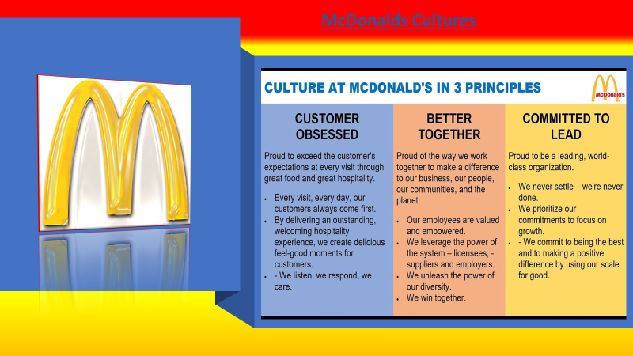
Fig 1, McDonalds, (2020)

Classic Theory Models
From the 1700’s – late 1800’s Industry work became popular, machinery, power and innovations were developing and new ways of doing and thinking were being tested and tried everywhere. Transportation was evolving at a fast pace, meaning larger amounts of employees, factory machinery and equipment were used. Employers needed to spark an industrial organisation to help manage the employees.
According to Alex Lyon (2018), Management theory models from the late 1890’s demonstrates that Webber (1905), Taylor (1909) and Fayol (1916) using slightly different management theories to one another, however they do have some common traits.
Max Webber (1905), used bureaucracy and legal systems in his theories, a rational approach, he was particular and non-traditional with his leadership, he didn’t care that you had charisma or a based leadership skill, he wanted rules and regulations to be authoritative and own responsibility to that specific job. Weber (1905) liked to separate work life from family life, he would separate man and wife at work to make sure no favouritism was given (Lyon, 2018).
Frederick Taylor (1909) used Micro-management as a custom approach to management and work productivity. He studied profusely a ‘One right way’ to reduce time and motions, he developed a way to break each task into small steps. Taylor studies machinery and found it was quicker and better in factory/ production line types of work, so he implemented that employees work this way just like they were machines, he also separated the managerial and employees as he felt, managers were the thinkers and the disciplinarians and the employees do the work instructed (Lyon 2016).

Henri Fayol (1916) was a French mining engineer and had a mid- level systematic approach of how to manage employees. Fayol (1916) set industrial activities for mangers as follows:
- Technical – Production and Manufacturing
- Commercial – Buying and Selling
- Financial – Searching for products and using capital
- Security – Protecting property and people (Employees)
- Accounting – Balance, sheets and cost (salary)
- Managerial – Planning, organising, command and control
He brought in a ‘principle of Management’ for employees to follow, employees would put their concerns or request to a manager and therefore the manager would take the order to hierarchy, using a ‘chain of superior’, but Fayol (1909) had a fair quality and wanted everyone to be treated as equals with pay, discipline and kindness (Lyon 2017).
McDonalds have used classic theories to an extent when it comes to fast food service, in 1950 the McDonald brothers used production line machinery to help with the fast production of burgers, this production was based on Henry Ford’s (1903) assembly-line machine he used in his automobiles, using Fayol’s (1909) way to speed up the process (Ford, 1903).
Every McDonalds worker had their own job, within that role became their responsibility. The brothers used Weber’s (1905) theory to keep the jobs specific and perfected, with only 9 items on the list at McDonalds in the 1950’s it was a much easier production line to keep up with and with less staff, fast forward 50 years with 205.000 employees around the world, adaptions to ‘One right way’ and micromanagement (Taylor, 1909) may be needed (McDowell, 2020).

Critique the models
Without any of these classical theories, management, production, industrial and technical evolution wouldn’t be the way it is today. There are a few common tendencies the theorists have which are:
- Clear hierarchy
- Fair pay
- Standardized approach to production
Fayol (1916) had a better example of quality and even though most principles are used as common sense today, Fayol (1916), Weber (1905) and Taylor (1909), displayed no empathy to employees, no favouritism or any kind of personal relationship with their employees, they did not like team work in-case of socialization and work production being reduced.
Where Taylorism separates manual from mental work, scientific management focuses too much on the mechanics and fails to value the employees as a person or individual, there is a lack of motivation and workplace satisfaction which are key elements in an efficient and productive organisation (Mind Tools, 2020). According to PTSD Journal (2020), not having socialized connections may have a negative impact of a person’s life, it can cause:
- social dis-connections
- poor self-esteem
- loss of reality
- decreased motivation in themselves
- reduced psychological stimulation
- tiredness
- lack of empathy
- selfishness
With all of these having a negative result on an employee’s life with depression and stress related issues (PTSD Journal, 2020). It is a possibility that obesity may have been caused at this point due to depression, stress, working at one production point and not moving far from a station and keeping within that proximity, exercise and regular movement may not have been an option. Having a fear of management and potential loss of a job, had seen many employees become stressed and fearful if performances weren’t demonstrated (Emerald Works Ltd, 2020).
Weber (1905) weren’t fond on new ideas or traditional family run business ventures so made sure that all relations worked unconnectedly from one another. Where Taylorism separates manual from mental work, scientific management emphases too much on the mechanics and fails to value the employees as a person or individual, there is lack of motivation and workplace satisfaction and socialisation which are key elements in an efficient and productive organisation (Emerald works Ltd, 2020).

Advantages and Disadvantages
Advantages of having classic theories established that, production was tight and working structures were efficient. Using methods of ‘One Right Way’ found that if communication was given from one manager, clear rules and instructions would have been transferred correctly.
The disadvantage is that it lacked personal care and attention or any consideration to individuals with personal circumstances or health and safety, no teamwork or group dynamics were tolerated. Employees were not allowed to have a sociable network or eligible to share new ideas they may have had. Management were already selected, which meant that career progression was very rare.

Dilts Model, (1996)
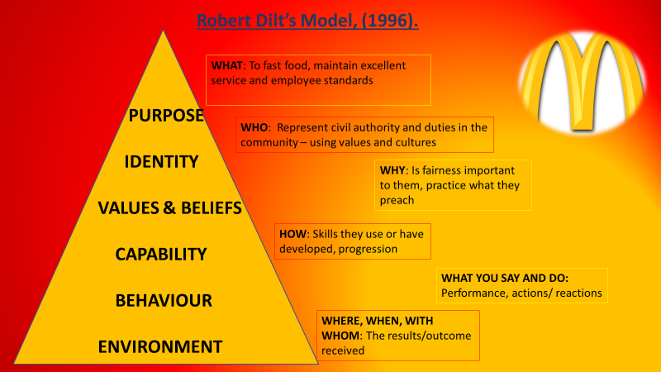
Fig 2, Dilts, (1996), Bennett, (2020).

How McDonalds has enhanced
McDonalds use wide varieties of skills, multi preparation and customer interaction stations to fully maintain their tasks well. McDonalds believe in hands on learning and continued to use a production line training in classic management, but as time went by, McDonalds wanted to give more to their employees, using the Hawthorne Experiment conducted by Elton Mayo (1924) helped managers change their ways in how they see their employees. The Hawthorn study (1924) demonstrated that employees are not motivated to their full potential with having a regular income alone, they needed primary factors to help improve performance. McDonalds offered benefits scheme with:
- Payed holiday
- Bank holiday’s off
- Extra pay for over time or Bank Holidays
- Insurance schemes
- Employee recognition and rewards
Showing a sense of appreciation for performances in employees productivity enhances employees working satisfaction and encourages worker's ideas, experience and knowledge (UK Essays, 2010).

What is holding back the organisation
The success of McDonald’s brought increased criticism and a global increase in obesity. In 1950’s, McDonalds had 9 items on the menu, now they sell over 145 items, Bloomberg (2013).
McDonalds continue to advertise and produce larger meals, with hefty calories, but forget the importance of vegetarian and healthier options. According to the Dominik Lemanski, (2020), McDonalds are ignoring all warning signs with diabetes and cholesterol rising, choosing to ignore government advice on obesity (Lemanski, 2020).
This goes against their values and integrity of ‘doing the right thing’. If portions are too big and meals are unhealthy, showing signs of increased obesity is not demonstrating ‘the right thing’ to the community.
Spencer (2020), the Daily Mail’s medical correspondent proved that within recent research, that food is consumed more than double compared to the 19050’s. Statistic show that Burgers have increase to 223% of its original size , fizzy soda pop has increased its size by 500% and chocolate bars have increased 1,233% since the 1900’s.
Men have a new average weight which has increased by 28 pounds from 50 years ago and women by 24.5 pounds (Spencer, 2020).
What can be done better?
Raising awareness for healthy eating, can always be better achieved, McDonalds should show ingredients and what is not suitable for diabetics or people with higher cholesterols, advertising healthier options and price cuts in healthier meals would help promote healthier choices and reducing portion sizes for all meals served (Quora, 2020).

Modern management theory
Management has moved forward a great distance over the last 50 years, through development and human civilization and based on psychological needs.
Tuckman’s Theory (1965), focuses on team building and working together in unity. Connecting a team of diverse individuals, creating ideas and discuss their own views and values, progresses onto norming stage where they focused and engaged to task at hand, the outcome is to perform better as they work together as a team (The Team Building Company, 2020).
Adair’s leadership model (1973) adapts enormously to busy modern businesses. Adair (1973) believed that distributing work and resources, defining the tasks at hand and making plans represents Task Needs, setting standards, maintain discipline and building team spirit is Team Needs and attending to personal problems, valuing individuals and recognising individual abilities shows Individual Needs.
Belbin (1981) believed individuals possessed unique and diverse behaviours. He invented self-perception tests so that each person could show their preferences for nine different roles in working life. Belbin communicated that individuals demonstrate wide variety of strengths and weaknesses, so high performing teams will be achieved (Belbin Associates, 2020).
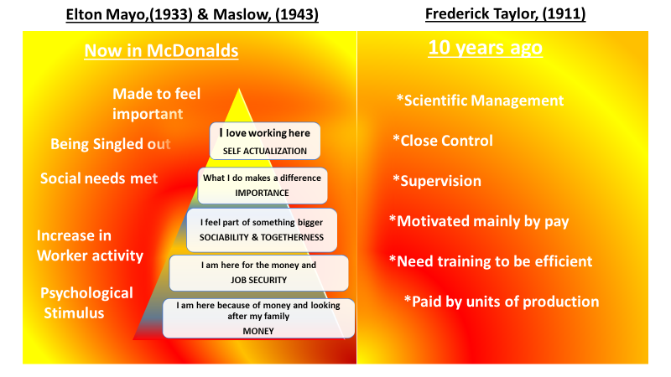
Fig 3, Mayo (1933), Maslow, (1943) and Taylor, (1911), Bennett, (2020).
Critique the models
Tuckman (1965), Adair (1973) and Belbin (1981) are very similar in their teamwork and performance achievements. According to Norton (2017) many companies tried and failed at using Tuckman (1965) and Belbin (1981) theories, mostly due to individuals leaving, maternity and sickness with teams unable to keep its original form, new members were temporarily taking place and this ruined structures of great original teams (Norton, 2017).
With so many sickness benefits, holidays and family leave entitlements, this is affecting performances and team unity.
Cross (2017) stated that excessive competitiveness, no individual recognition may cause a sense of resentment and disputes, this could have detrimental outcomes to performances and the company (Cross, 2017).
Pearson’s Red Model
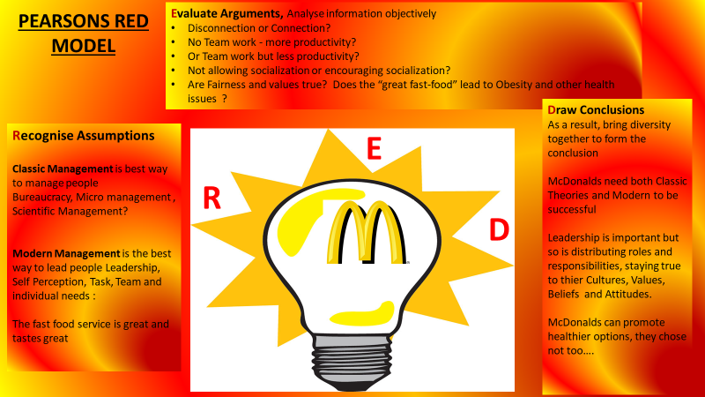
Fig 4, Pearson-Talent Lens, (2009)

How working conditions have enhanced
Having great relationships with clients, customers and suppliers, enhances the working environment. It improves motivation and working conditions for employees, which leads to increased labour productivity, market resilience and overall business competitiveness (European Commission, 2020). Technological advancement with apps and new ways to order meals in an efficient manner will encourage customers to purchase and customise orders.

Adair Leadership Model (1973)
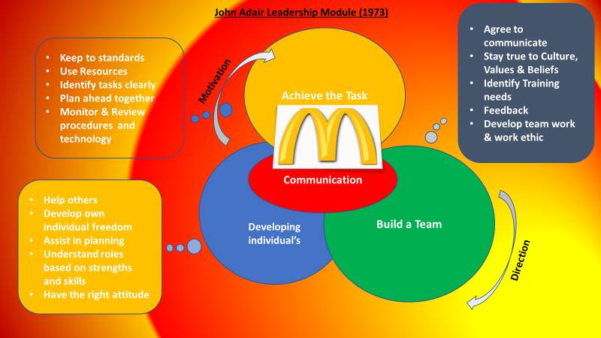
Fig 5, Adair, (1973), Bennett, (2020)

How employees feel working at McDonalds
According to Blair at the Independent (2015), rewards and recognition is vital for employees, most employees feel they have great training at work and are rewarded for excellent levels of work and commitment to their role.
McDonalds is said to be very organised and have many protocols to follow, but customer service experience is a highlight and the fast-actioned production makes the days go faster (Blair, 2015).
However, though profit was generated well, bonuses given and self- esteem climbing , the health effects on employees in other areas were having a negative impact on mental and physical health due to demands of fast service and staff shortage (sickness and holidays) .

Personal Evaluation
To stay at a competitive edge, McDonalds (2020) need to invest not only in technological innovation but also in non-technological practices.
Finding ways to tackle obesity and work with the Government to find healthier choices of food and reducing portion and meal sizes, would encourage younger generations to enjoy eating healthily and maintain positive eating habits to reduce health risks in their future.

The Barrett’s Model, (1998)
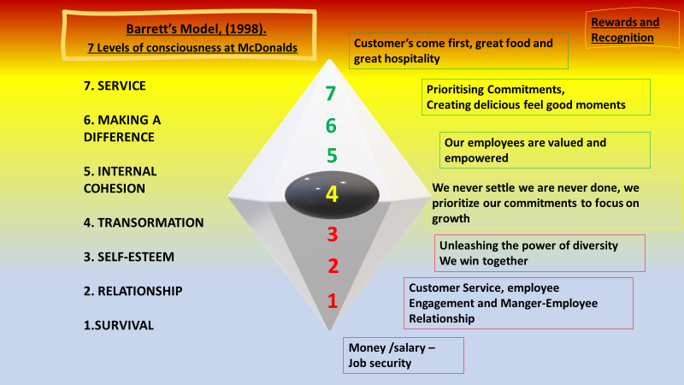
Fig 6, Barrett, (1998), Bennett, (2020)

Conclusion
Reflecting on all sources and information found within this report, McDonalds (2020) will always be recognised for the world’s biggest fast-food service.
Regardless of health reviews, government warnings and obesity levels rising, the franchise will continue to produce unhealthy choices on their menu. Families and younger generations will remain loyal to the service due to their reasonable prices, fast meal service and convenient locations.
The values and cultures of the business are set extremely high in McDonalds, (2020), but criticism and contradiction heavily linger, regarding their unhealthy choices of food.
McDonalds (2020) use of classic models is evident in their ways of working, maintaining production line techniques and micro-management subtly used to keep the working stations organised and closely monitored.
Employees are treated fairly with the use of modern management theories in the workplace, psychological needs, recognition, values and beliefs are significant to management, they believe if the employees are satisfied, they will expand their knowledge and diversity in particular skills, McDonalds (2020) say they prioritize commitment and focus on growth.
Having a mix of both theories, classic and modern demonstrates that McDonalds evaluate different ways to get the correct service for their customers and the right workplace for their employees, but not displaying the satisfactory and reasonably healthy food choices in their branches, may have negative outlooks in the future.

References
Bennett. N, (2020) ‘Team working at Google’, BMSW4002: Effective Team Working and Communication. University of Wales Trinity Saint David University. Unpublished Essay.
Blair. O, (2015) What People in McDonalds Really Think About Their Job ‘Independent’. Available at: https://www.independent.co.uk/life-style/food-and-drink/what-people-who-work-mcdonalds-really-think-their-job-a6716216.html (Accessed:15 December 2020).
Britannica (2020) McDonalds Cooperation. Available at: https://www.britannica.com/topic/McDonalds (Accessed: 07 December 2020).
Business Balls (2018) Leadership Models. Available at: https://www.businessballs.com/leadership-models/action-centred-leadership-john-adair/#:~:text=John%20Adair%20%27s%20simple%20Action-Centred%20Leadership%20model%20provides,remember%2C%20apply%20and%20adapt%20to%20your%20own%20situation. (Accessed: 13 December 2020).
Chappell. J, (2020) Natural Philosophy Society, Critical Thinking. Available at: http://www.naturalphilosophy.org/site/critical-thinking/ (Accessed: 07 December 2020).
Clayton. M, (2020) Victor Vroom and Expectancy Theory: Process of Model of Motivation. Available at: https://www.youtube.com/watch?v=WDgF7Avijlc (Accessed: 12 December 2020).
Cross, S (2017) Negative Aspects of Teamwork. Available at: https://bizfluent.com/info-8156056-weaknesses-brainstorming.html (Accessed: 14 December 2020).
Emerald Works Ltd (2020) Mind Tools,’ Essential Skills for an Excellent Career’. Available at: https://www.mindtools.com/pages/article/newTMM_Taylor.htm (Accessed 11 December 2020).
European Commission (2020) ‘Internal market, Industry, Entrepreneurship and SME’s’ - Workplace Innovation. Available at: https://ec.europa.eu/growth/industry/policy/innovation/workplace_en#:~:text=Workplace%20innovation%20can%20mean%20many%20things%20such%20as,and%20suppliers%2C%20or%20in%20the%20work%20environment%20itself (Accessed:09 December 2020).
Lemanski, D (2020) ‘McDonalds Has Been Accused of Ignoring Government Advice on Obesity’ Daily Star, 5 December. Available at: https://www.dailystar.co.uk/news/latest-news/mcdonalds-ignores-obesity-advice-chain-21438306 (Accessed 13 December 2020).
Lyon. A, (2016) Douglas McGregor’s Theory X and Theory Y. Available at: https://www.youtube.com/watch?v=CXAzZRnJo2o (Accessed 12 December 2020).
Lyon. A, (2016) Frederick Taylor Scientific Management. Available at: https://www.youtube.com/watch?v=vNfy_AHG-MU (Accessed: 09 December 2020).
Lyon. A, (2017) Henri Fayol’s Principles of Management. Available at: https://www.youtube.com/watch?v=90qpziPNRnY (Accessed: 11 December 2020).
Lyon. A, (2018) Max Webber Bureaucracy Available at: https://www.youtube.com/watch?v=zp554tcdWO8 (Accessed: 09 December 2020).
McDonald Steel Corporation (2020) Mission, Vision and Values. Available at: https://mcdonaldsteel.com/mission-vision-values/ ( Accessed: 09 December 2020).
McDonalds (2017-2019) Our Mission and Values. Available at https://corporate.mcdonalds.com/corpmcd/our-company/who-we-are/our-values.html (Accessed 09 December 2020).
McDonalds (2020) (Available at: http://gofasteats.com/mcdonalds/ (Accessed: 07 December 2020).
McDonalds (2020) A great Place to Work. Available at: https://people.mcdonalds.co.uk/why-mcdonalds/great-place-work/ (Accessed 07 December (2020).
McDowell. E, (2020) McDonalds in the 1950’s ‘Insider Inc’ Available at: https://www.businessinsider.com/what-mcdonalds-was-like-1950s-2020-7?r=US&IR=T#back-in-1955-there-were-no-dining-rooms-or-drive-thrus-but-mcdonalds-thrived-on-its-drive-up-model-10 (Accessed: 14 December 2020).
Norton. D, (2020) Tuckman Was Wrong Available at: https://onbelay.co/articles/2017/5/5/tuckman-was-wrong ( Accessed: 14 December 2020).
Olum, Y. (2004) ‘Modern Management Theories and Practices’ 15th East African Central Banking Course. 12 July 2004. Kenya: School of Monetary Studies. pp.0-24.
Patton. L (2013) McDonalds Seen Overhauling U.S Menu from 145 Choices, ‘Bloomberg’, Available at: https://www.bloomberg.com/news/articles/2013-05-17/mcdonald-s-seen-overhauling-u-s-menu-from-145-choices (Accessed 14 December 2020).
Pearson Talent Lens (2010) Better Decisions Everyday, Everywhere. Think About It! Available at:https://downloads.pearsonassessments.com/images/assets/talentlens/CriticalThinking-eBook.pdf (Accessed: 15 December 2020).
Quora (2020) How Can McDonalds Be Improved. Available at: https://www.quora.com/How-can-McDonalds-be-improved (Accessed:13 December 2020).
Silberman. J, (2013) Training Station- Be a Training Management Hero Available at: https://trainingstation.walkme.com/what-we-can-learn-from-mcdonalds-employee-training/ (Accessed 08 December 2020).
Spencer. B, (2020) Take Portion sizes back to the 1950’s, ‘Daily Mail Online’ Available at: https://www.dailymail.co.uk/health/article-3343129/Take-portion-sizes-1950s-beat-obesity-say-scientists-warn-portions-20-years-ballooned.html (Accessed:14 December 2020).
The Team Building Company (2020) Team Building Theory. Available at: https://www.teambuilding.co.uk/theory/Forming-Storming-Norming-Performing.html#:~:text=Tuckman%27s%20theory%20focuses%20on%20the%20way%20in%20which,Transforming%20to%20cover%20the%20finishing%20of%20a%20task. (Accessed 13 December 2020).
UK Essays (2020) McDonalds Approach to Employee Motivation. Available at https://www.ukessays.com/essays/business/employee-motivation-the-integrated-approach-at-mcdonalds-business-essay.php (Accessed 13 December 2020).
Who invented (2020) Inventions and Discoveries. Available at https://www.whoinvent.com/who-founded-mcdonalds/ (Accessed: 07 December 2020).

