NAME | JOSE SEDEHI- OBADIARU
STUDENT NUMBER | 1913206
MODULE CODE | BMSW 4005
MODULE TITLE | PROFESSIONAL CAREER DEVELOPMENT
LECTURER`S NAME | CHARLES NIMOH
ASSESSMENT TITLE | PORTFOLIO OF WORK

TABLE OF CONTENT

INTRODUCTION 1
RATIONALE OF THE STUDY 1
ANALYSIS (I) 1-6
ANALYSIS (II) 6-12
ANALYSIS (III) 13-14
CONCLUSION 14
REFERENCES 14-15

INTRODUCTION
This report analyses the portfolio of work. Portfolios may allow students to make correlations between the substantive aspects of the curriculum and the practice. They can also be used to scale up success in a single course or as an exit criterion (Coleman, Rogers, and King, 2002).
I will be using Personal Development Planning (PDP) as an analysis tool to identify the required skills that could supercharge the career of my choice. I will also evaluate my skills in comparison to my chosen profession within the PDP table.
In this paper, I will be assessing the learning and development training methods for new employees that are to start work in our organisation. I will be doing this in my position as an assistant manager. I will be using theories such as. (I) Kolb’s Learning Cycle (II) The VARK model (III) Honey and Mumford’s Learning Styles Cycle (IV) Dunn, and Dunn Learning Style Model.
I will be explaining and evaluating my reasons for the selection of these theories and methods.
I have learnt a lot from the start of this course, a lot of topics, tools, and exercise. I will be reflecting on some of these things that I learnt till now, analysing experience to remember where I was before I start the course and now.

RATIONALE OF THE REPORT
The rationale of this report is to reflect on what the course thoughts and to demonstrate my understanding.

ANALYSIS 1
Personal development is a continuous lifelong method that involves cultivating, structuring, and developing skills and knowledge to optimal productivity and continued employability (CMI, 2020).
PDP is the process for.
1. setting goals, targets, or objectives of your intended plans or your intended position in the short, medium, or long term of your career.
2. choosing significant planning activities to fulfil these perceived needs.
3. identification of required skills, experiences and ability, and evaluation of existing realities. (CMI, 2020)
My goal is to become a top social care worker. Social care work is my chosen career. However, I am presently working as a mental health support worker.

SKILLS AND COMPENTENCIES | CURRENT PROFICIENCY | DESIRE PROFICIENCY | ACTION TO BE TAKEN FOR IMPROVEMENT | CRITERIA FOR JUDGING SUCCESS | TIME FRAME | EVIDENCE OF IMPROVEMENT
Communication | An adequate level of communication but talk too fast, I need improvement. | To be able to communicate more clearly, both verbally and nor verbally. Able to control my speaking speed, pitch, and tone. | I will be reading about communication, watching TED talks, practice and record the exercise as a mock scenario. | I want to be speaking clearly at the right speed so that I can be easily understood when I speak. | By the end of my academic year | Feedback from peers, friends, and family
Organisation | I can organise myself to a certain level when it comes to one patient at once | I want to be more organised when attending to multiple persons at once, so, I can be able to pay attention to the most prioritised client, to avoid adverse outcomes. | I Will go for internship, I will learn more about time-management, I will go for job practice. | Able to handle multiple tasks successfully in real job scenario, e.g. at internship or job practice | Before I complete my social care worker course | Review and feedback from shift managers and supervisors.
Empathy | I do empathise as human but need to develop professional empathy to be able to efficiently carry-out my professional task. | Develop professional empathy that is balanced enough to be able to understand genuine cases as a professional | Read and listen to case studies and story about people with genuine cases and false cases. Study more about social psychology. | When I can handle a complicated case study and solve it without wrong empath | Before I complete my social care worker course | Lectures and senior social care leaders’ feedbacks
Active listening | I am good at listening to people and understanding what they are trying to say. | Improve on my listening skill to be able to attend to sensitive matters. | Study more on listening skill by reading books and watching videos. | Able to listen and understand people that talk in all manner of ways. | End of January 2020 | Feedback from managers and supervisors of social care centres.
Critical thinking | Not good enough, according to my lecturer.  Need to have an excellent critical thinking skill.  More studies and practices  Re-Assessment | Need to have an outstanding critical thinking skill. | More studies and practices. I will read more books. | Re-Assessment | End of March 2020 | Feedback from the lecturer.
Self-care | I lack in my level of self-care skill. | I need a high level of self-care skill to operate as a professional. It is a necessity. (Newell and Nelson-Gardell, 2014) | Learn more about self-care skill from books and videos | Perform a task or assessment under the instruction of lecturer. | End of March 2020 | Feedback from Lecturer.
Patience | I have enough patience skill to manage in my present job. | I need an adequate level of patience to manage professionally as a social care worker. | Study more about stress management and stress control by reading books. | Undergo test during job placement | Before I complete my social care worker course | Feedback from Managers and supervisors of social care centres.
Cultural competence | I understand and maintain the skill of cultural competence. | To maintain this skill always. | Involve more in working with people of all races, religions, varying cultural, gender, sexual orientation, religion, age, or disability. | I will judge by the absence of complaints and negative feedback from patients and clients. | always | Feedback from Managers and supervisors of social care centres.
Advocacy | I posse’s good skill of advocacy | To maintain this skill always | Advocate for my patients and clients at my internship centres | Clients/patients and family satisfaction | always | Clients/patients and family feedback
Professional Commitment | I am skilled in my current profession. | I need to improve my level of this skill. | Learn and master social work value and ethics | Undergo triers and test | By the end of March 2020 | Feedback from Managers, supervisors of social care centres. And lecturer.

My PDP above reflects my current skills and competencies and the skills and competencies needed for my chosen career, which is a social care worker. Some of my existing skills are the same skills needed for my future career. However, there are some that need an upgrade of improvement. The steps to match-up my skills are listed in column 4 in the PDP table, 'ACTION TO BE TAKEN FOR IMPROVEMENT'.
I lack in the skill of self-care, which is one of the skills needed for my chosen career, it is essential to care for oneself to be able to care for others. Newell and Nelson-Gardell (2014). Quotes. Social workers or social workers should follow self-care strategies to preserve health and balance while in operation.
Another important one that I do not have for my chosen career is Professional Commitment; this is like the touch light that lights up the way. Reamer (2013). Quotes. Social work is deeply rooted in the essential collection of principles that fundamentally form the mission of the practice and the goals of its practitioners.
I need Critical thinking skill to succeed in my chosen career; presently, I lack this skill. Critical thinking is an essential capacity for social workers to possess, partly, so clients deserve to be shielded from non-helpful, non-substantiated, or adverse activities. Customers must therefore be confident that the services they receive are based on the most substantial facts, experience, and procedure in each situation (Booley, 1997; Gibbs & Gambrill, 1999, quoted in Coleman, Rogers & King, 2002)

ANALYSIS 2
It is essential to adopt a method of learning and development when it comes to training. Before we look at the best method to be chosen among various methods, theories and learning styles, let us look at the meaning and differences between learning, training and development. Training could be defined as a process for optimising work efficiency and strengthening existing or unique personal expertise, skills and behaviours so that work is carried out correctly, efficiently and guarantees continual progress in the quality of work (Romanowska, 1993 quoted in Neugebauer and Evans-Brain, 2016).
Learning is an intention to bring about a qualitative and reasonably everlasting change in the way a person sees understands, experiences, or sees something in the real world (Marton and Ramsden, 1988, quoted in Neugebauer and Evans-Brain, 2016). Nadler and Wiggs (1986, quoted in Neugebauer and Evans-Brain, 2016) see development as equipment of employees against an uncertain future. It could include connecting the strategy of the organisation and the strategy for employee's retention and linking the profession with learning plans.
In the aspect of employability, development could also involve learning and experience beyond the boundaries of the organisation. We can see that learning right is vital for employees to get adequate development training to guarantee a brighter future. To go about this concept of learning, we most chose an excellent learning style.
Pashler, H. et al. (2008) declared that the word "learning style" refers to the idea that individuals vary as to what form of teaching or study is more appropriate for them. Academies have developed many theories about learning styles by great authors. Some of them are.

- Kolb's Learning Cycle
Kolb hypothesises is that learning is successful as individuals move through each stage of the cycle. Accordingly, after a substantial experience, it is crucial to focus on that experience and to draw conclusions with new ideas that can then be applied. Bringing us new perspectives from which we can replicate the cycle all over again. Kolb saw this as a critical phase where the complete execution of each stage was crucial for successful learning (Kotecha, 2019). See fig below.

Hawk and Shah (2007)

- The VARK model
the model name comes from the acronym VARK which stands for Visual (V), Aural (A), Read/Write (R), and Kinaesthetic
According to Hawk and Shah (2007), Fleming (2001) Defines this learning style as a person's characteristics and choice of thinking, arranging, and collecting information. VARK belongs to the class of instructional preferences since it deals with perceptual modes; it reflects on the various ways in which we give out and take in information. However, this theory does not address perceptual methods or senses for smell and taste. The VARK inventory offers metrics in every one of the four perceptual modes; each one has preferences for anyplace from one to all four. See fig below.

Hawk and Shah (2007)

- Honey and Mumford's Learning Styles Cycle
Honey and Mumford's learning style is another popular theory. Swailes and Senior (1999) manifested that. Honey and Mumford (1986) followed Kolb's fundamental idea of a learning cycle of various learning types but suggested a new method, which is the Learning Styles Questionnaire (LSQ), they believe that this one has more meaning than that of Kolb's for the management's and managers tasks. While not precisely following the bipolar structure for their LSQ, the parallels in the learning stages of Kolb and Honey and Mumford, and the terms used, it will be resealable to conclude that the LSQ describes the similar bipolar structure.
It is about knowing the suitable style from (I) Activist (II) Reflector (III)Theorist (IV)Pragmatist and then take advantage of using it in learning.

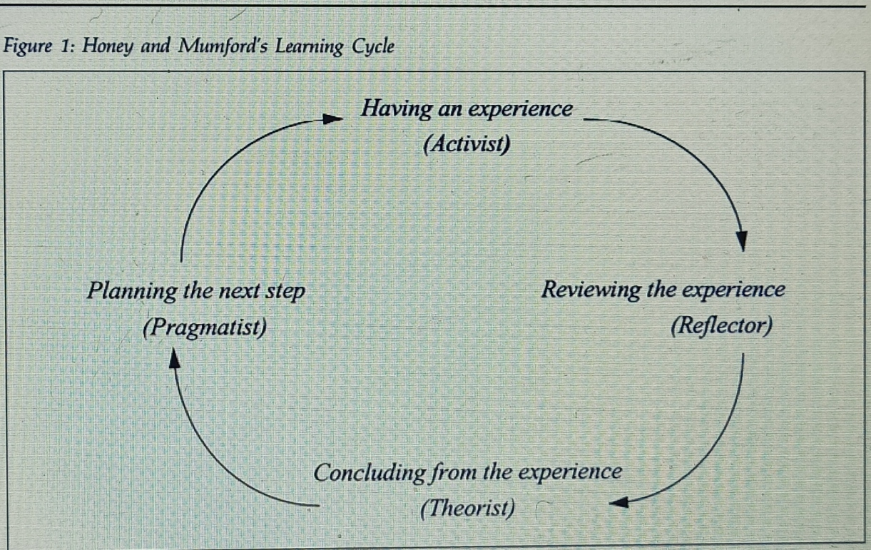
Swailes and Senior (1999)

- Dunn and Dunn Learning Style Model
Hawk and Shah (2007) described this model as follow. Dunn and Dunn learning styles suggested that this model has five learning style stimuli and several components incorporated in each stimulus. The five stimuli and their correspondent elements are the following.
- Environmental: room design, temperature, light, and sound
- Emotional: responsibility, structure, persistence, and motivation
- Sociological: learning alone, with peers, in a pair, mixed, and with a teacher
- Physiological: perceptual, mobility needs, chronological energy pattern, and intake while learning,
- Psychological Processing: hemispheric, impulsive, or reflective and global, or analytic.

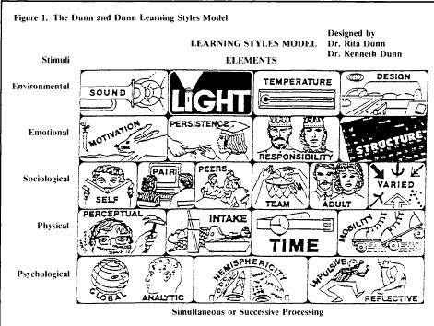
Dunn et al (1995)

As an assistance's manager of this organisation, I would choose the Dunn and Dunn learning style model for our new employees as a preferred and more effective learning styles. Other models analysed above are good; hence, I chose to analyse them. Honey and Mumford's Learning Styles Cycle and Kolb's Learning Cycle are quite similar. Many people commonly use them, that shows their importance and effectiveness. VARK model is a unique style of learning; the writer declared that it belongs to the class of instructional preferences since it deals with perceptual modes. The importance and effectiveness of these styles is the reason for explaining these theories above.
I chose Dunn and Dunn learning style because it touches almost all aspect of our life. Physical, psychological, emotional, sociological, and environmental, including all the elements that go with them. Meaning our employees can be learning with everything and anything both visible and invisible.
The model is about the learners knowing which of the elements from the stimuli that best suit them. E.g.
Psychological- this is about how they respond and process ideas and information.
Physical- is how do we physically engage when learning, like, movement, intake, the energy involved, time factor.
Environmental- this is about the environmental circumstances of learning, like, if the leaner prefers the quiet or noisy environment, if bright light is preferred or dim light, if the colder environment is preferred or wormer. See figure below for more examples.

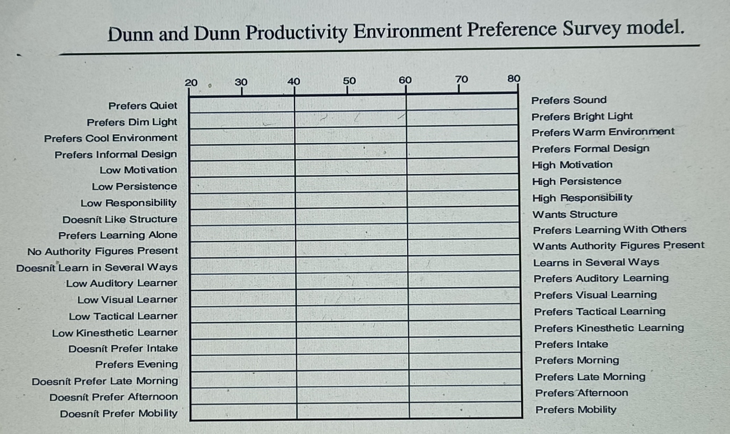
Hawk and Shah (2007)

ANALYSIS 3
Reflection on My Before and After the Course
I started this course imagining which kind of topics it will contain. I soon realise the wonderful new things that I learnt; they were things that I never expected.
1. We learnt about personal development plans (PDP). We learnt about PDP in our previous module (Academic and Employability skills), but I did not understand it as I do now. We search for and study five different PDP templates; we were to identify the differences and similarities. This exercise broads my understanding of what PDP is, as it serves for many purposes towards developing whatever we want to improve on or achieve in the short- or long-term future.
2. We learnt about self-awareness. This topic is one of the topics that surprised me. I realised that many people are not aware of themselves as they though they are. We learnt that according to Eurich, T. (2017), Though 95 % of people believe they are self-aware, the actual figure shows that it is closer to 10–15 per cent. In the self-awareness quiz I did, I found out that I am not aware of myself the way I thought I do. The Johari window theory that we studied made me realised that there is a great need to understand that there is some aspect of our life that we do not know or that people do not know about us. We do not open up about what we do not like about ourselves, and people do not feel free to tell us what we are like because they do not want to offend us (Morgan, 2017). I surely realise now that there are areas that I need to open to people to enlarge my open self. I never know that there are things that people know about me that I do not know. All these facts are useful to know through this course.
3. We learnt about learning style. We completed a quiz to know our learning style. The result of my learning style shows that I am a visual learner, being 45% visual learner, 35% tactile learner and 20% auditory learner. I think this could be accurate because I learn more from what I see or imagine. Before I started this course, I did not know if someone can be a visual learner or tactile learner, I now understand the difference in learning style. Just as Bernard, Chang, Popescu and Graf, (2017) suggested, the Identification of student learning styles has a range of advantages, such as making students aware of their strengths and limitations in learning and the ability to customise their learning environment to their learning styles.
4. We learnt about exploring employment opportunity. Before undergoing this course, I never knew that there are vital steps to follow to gain desired employment successfully. This course has thought me the steps to follow toward achieving this goal. I did a test on career motivation. The result shows financial reword with 73%, which means I am motivated by the financial reward involved in a job. I believe it is nice to know what motivates me in a job. I used a tool called personal Holland code to detect what could be my favourite types of job, the result of this exercise shows that my favourite types of job are, social 25%, investigation 20%, conventional 18%, enterprising 15%, realistic 13% and artistic 8%. This result makes me happy, knowing that social work is my preferred type of job.
5. We learnt about a job interview, and we did conduct a mock interview. Before this course, I thought I understood how to stand out on a job interview, but after I attended a mock interview in this course, I realise that I needed to learn more. The feedback that I got from the mock interview gave me more understanding about the job interview. I can say that I am more prepared for any job interview now.

CONCLUSION
Portfolio of work allows students to make correlations between the substantive aspects of the curriculum and the practice. They can also be used to scale up success in a single course or as an exit criterion (Coleman, Rogers, and King, 2002). There is a need for a continues personal development. Personal development is a continuous lifelong method that involves cultivating, shaping, and develop skills and knowledge to ensure optimal productivity and continued employability (CMI, 2020). PDP is the tool that one needs to organise and plan out the goals and how to achieve them.
Training is a necessity if one should develop to advance. Therefore, it is essential to adopt a method of learning and development when it comes to training. We have analysed different theories and methods about learning styles, which includes Kolb's Learning Cycle, The VARK model, Honey and Mumford's Learning Styles Cycle, and the Dunn and Dunn Learning Style Model. I have reflected on my journey through this course. Before this course, I was short of a wide range of knowledge that I posse now. Those includes. Personal development plans (PDP), self-awareness, learning style, exploring employment opportunity and interview.
At this moment, I believe I am well prepared to go forward to employment or further studies.

REFERENCES
Bernard, J., Chang, T., Popescu, E. and Graf, S., (2017). Learning style Identifier: Improving the precision of learning style identification through computational intelligence algorithms. Expert Systems with Applications, 75, pp.94-108.
CMI, (2020). Personal Development Planning - CMI. [online] CMI. Available at: <https://www.managers.org.uk/knowledge-and-insights/research/personal-development-planning/> [Accessed 4 November 2020].
Coleman, H., Rogers, G. and King, J., (2002). Using portfolios to stimulate critical thinking in social work education. Social Work Education, 21(5), pp.583-595.
Dunn, et al. (1995). A Meta-Analytic Validation of the Dunn and Dunn Model of Learning-Style Preferences. The Journal of Educational Research, [online] 88(6), pp.353-362. Available at: <https://ezproxy.uwtsd.ac.uk/login?url=https://www.jstor.org/stable/27541998> [Accessed 11 November 2020].
Hawk, T. and Shah, A., (2007). Using Learning Style Instruments to Enhance Student Learning. Decision Sciences Journal of Innovative Education, 5(1), pp.1-19.
Kotecha, A., (2019). Learning styles. InnovAiT: Education and inspiration for general practice, 12(5), pp.276-280. doi: 10.1177/1755738018814278.
Morgan, P., (2017). Business Student's Guide To Study And Employability. Los Angeles: SAGE, pp.29-32.
Neugebauer, J. and Evans-Brain, J., (2016). Employability : Making The Most Of Your Career Development. London ; Thousand Oaks ; New Delhi ; Singapore: SAGE, pp.94-110.
Newell, J. and Nelson-Gardell, D., (2014). A Competency-Based Approach to Teaching Professional Self-Care: An Ethical Consideration for Social Work Educators. Journal of Social Work Education, 50(3), pp.427-439.
PashleH. et al. (2008) ‘Learning Styles: Concepts and Evidence’, Psychological Science in the Public Interest, 9(3), pp. 105–119. doi: 10.1111/j.1539-6053.2009.01038.x.
Reamer, F., (2013). Social Work Values And Ethics. 4th ed. New York: Columbia university press, p.3.
Swailes, S. and Senior, B., (1999). The Dimensionality of Honey and Mumford’s Learning Styles Questionnaire. International Journal of Selection and Assessment, 7(1), pp.1-11.

