

Information Security, Governance and Compliance Design for AeroLink Logistics (ALL)

A Framework-Based Approach to Cloud, IoT and AI Security Risk in a Global Logistics Enterprise

Module: ACCA7028 – Data Security, Governance and Compliance

MSc Data and Artificial Intelligence

University of Wales Trinity Saint David

Lecturer: Dr Vijeyananthan Thayananthan

ASSIGNMENT- CASE STUDY

STUDENT NAME: VIVEK NELAPATI
STUDENT ID NUMBER: 2511594

Contents:
Executive Summary: 3
1.Introduction: 4
2. Research into Security Frameworks and Models: 5
2.1 ITIL 4: 5
2.2 NIST Cybersecurity Framework (CSF) 2.0: 5
2.3 COBIT 2019: 6
2.4 ISO/IEC 27000 Series: 7
3. Proposed Design: An Integrated Approach for AeroLink Logistics: 8
3.1 Governance and Strategic Planning for Security: 8
3.2 Compliance (Laws and Ethics): 9
3.3 Security Policies and Procedures: 9
3.4 Risk Management and Assessment: 9
3.5 Security Management Models and Practices: 9
3.6 Contingency and Business Continuity Planning: 10
3.7 Protection Mechanisms and Access Controls: 10
3.8 Vendor and Service Level Agreement (SLA) Management: 10
4. Critical Discussion: Why Continuous Updates to Regulations and Standards Matter: 12
5. Assumptions: 13
6. Conclusion: 14
7.References: 15

Executive Summary:

AeroLink Logistics (ALL) is a global supply chain provider whose attack surface has grown more quickly than its governance structures have developed due to its reliance on outsourced Infrastructure-as-a-Service (IaaS) and Software-as-a-Service (SaaS), Internet of Things (IoT) tracking sensors, and artificial intelligence (AI) analytics. ALL lacks a centralised risk procedure, a single security framework, and formal compliance auditing against standards like ISO/IEC 27001 and the GDPR, according to recent breaches affecting shipping data and personally identifiable information (PII).
This study examines four well-known frameworks—ITIL 4, NIST CSF 2.0, COBIT 2019, and the ISO/IEC 27000 series—and combines them into a unified, multi-layered governance model specifically designed for ALL. All secondary evidence is cited in IEEE numbered style and comes from publications that were published in 2023 or later. Before closely examining the significance of ongoing regulatory and standards updates in a threat landscape created by cloud, IoT, and AI, the design covers governance, compliance, policy, risk management, protection mechanisms, business continuity, and vendor/SLA oversight. In Section 5, assumptions are made clear.

1.Introduction:

Logistics companies like ALL can now provide real-time tracking and predictive analytics thanks to digital transformation, but it has also dispersed data and decision-making across cloud platforms, sensor networks, and other vendors that the company does not directly control. Approximately 88% of ALL's IT infrastructure is outsourced, and partners, suppliers, and remote workers connect from unmanaged devices spread across several time zones. This combination makes it more likely than possible for unauthorised access to PII and shipping data: In 2024, 38% of organisations worldwide reported an increase in cyberattacks year over year, with the most common attack methods being malware, social engineering, and unpatched-system exploitation [5].
This report develops an integrated security, governance, and compliance approach for ALL after first researching established IT security and governance frameworks to find practices appropriate for ALL's context. Finally, it critically examines why it is important to keep standards and regulations up to date as threats and technology change. Compliance, governance and strategic planning, policies and procedures, risk management, security management models, contingency planning, protection methods, and vendor/SLA management are all covered in the paper.

2. Research into Security Frameworks and Models:

This section examines four complimentary frameworks before comparing them in Table 1 since no single framework adequately addresses governance, risk management, operational controls, and service delivery.

2.1 ITIL 4:

ITIL 4 is a service management framework based on a Service Value System (SVS) that uses 34 management practices, governance, guiding principles, and continuous improvement to transform organisational inputs into value. The framework is extended to procurement and vendor evaluation via the 2023 Sustainability in Digital & IT extension module, which mandates that suppliers be evaluated based on operational and environmental resilience standards in addition to cost [8]. ITIL is useful less as a security control set and more as the discipline that governs how services are requested, modified, incident-managed, and continuously improved for ALL, where the majority of infrastructure is provided by outside vendors. These processes must function securely for IaaS/SaaS relationships to be reliable.

2.2 NIST Cybersecurity Framework (CSF) 2.0:

In February 2024, NIST released CSF 2.0, the first significant update to the framework since 2014. It reorganises cybersecurity outcomes around six functions, which include 22 categories and 106 subcategories: Govern, Identify, Protect, Detect, Respond, and Recover [1]. The Govern function is important because it lays the groundwork for risk management strategy, roles, duties, policy, and oversight. It specifically addresses supply chain risk management, which is supported by NIST's own guidelines, which were last updated in November 2024 [2]. CSF 2.0 is intended to be used in conjunction with standards like ISO/IEC 27001 and has expanded its reach beyond critical infrastructure to organisations of any size.

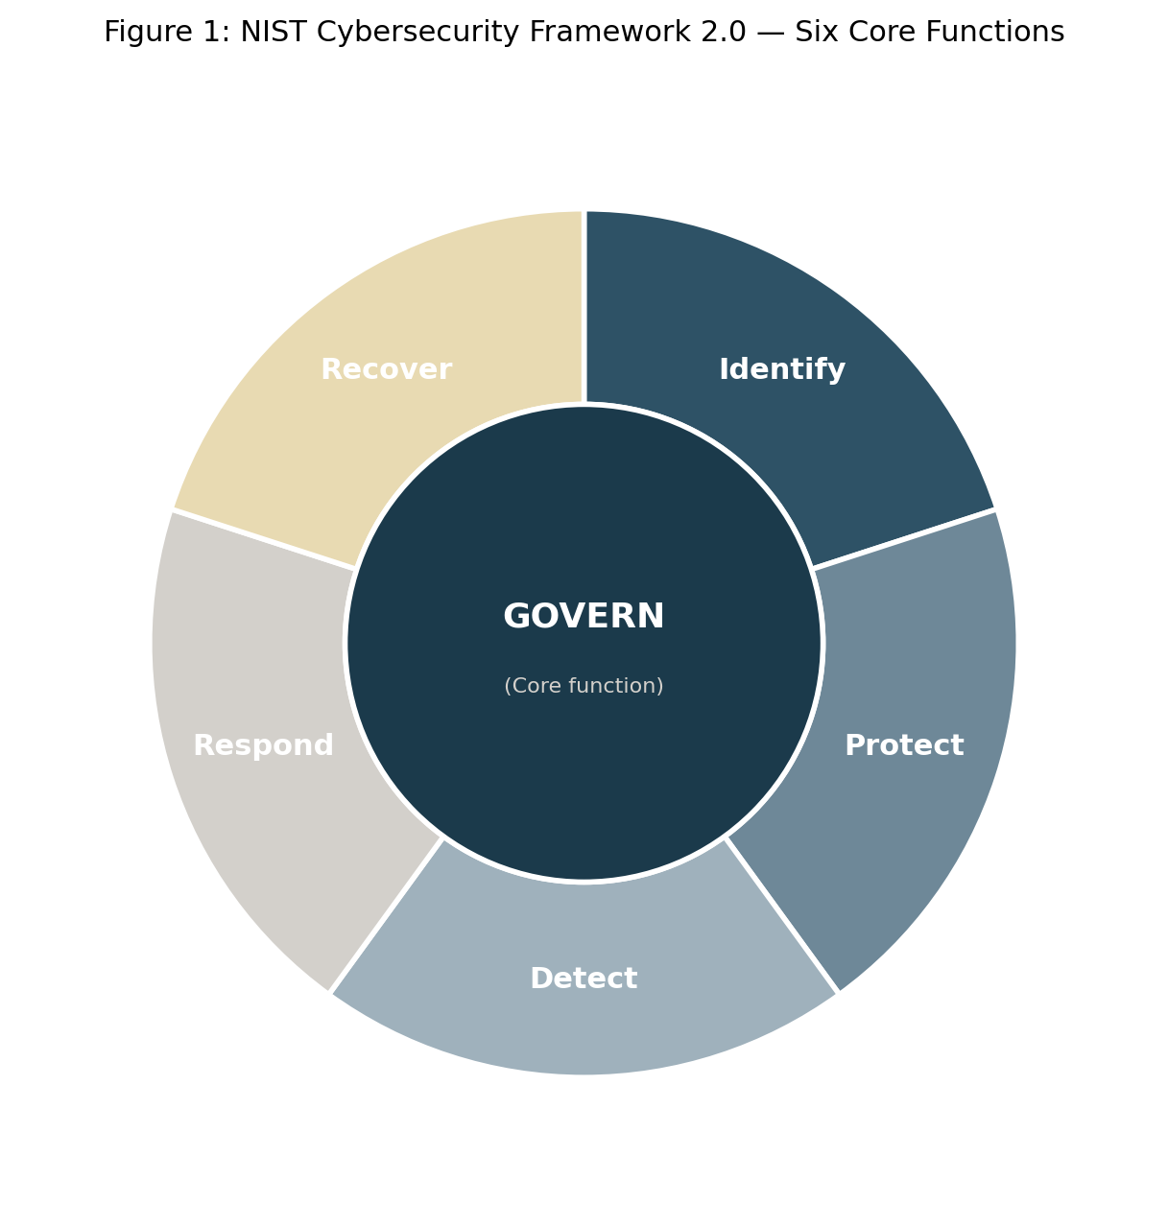
Figure 1: NIST Cybersecurity Framework 2.0 — Six Core Functions (Govern, Identify, Protect, Detect, Respond, Recover) [1]
Identify and Protect map naturally onto IoT sensor asset inventories and data encryption, while Detect/Respond/Recover map onto the incident response gaps highlighted in the case. For ALL, CSF 2.0's Govern function directly targets the assignment scenario's primary weakness—the lack of coordinated risk ownership.

2.3 COBIT 2019:

The enterprise governance of information and technology (EGIT) framework COBIT 2019, issued by ISACA, divides management (Align/Plan/Organize, Build/Acquire/Implement, Deliver/Service/Support, and Monitor/Evaluate/Assess) from governance (Evaluate, Direct, and Monitor). Instead of using a one-size-fits-all methodology, its design-factor approach enables an organization to customise governance goals to its risk profile, strategy, and threat scenario. Extending the same goals-cascade reasoning to AI-driven analytics oversight, ISACA's 2025 recommendation on applying COBIT to AI system governance is especially pertinent to ALL. It recommends that AI use cases be strategically aligned, risk-assessed, and monitored like any other IT operation [10]. The case's lack of coordination and ambiguous assignment of security tasks are directly addressed by this distinct separation of operational management and board-level governance.

2.4 ISO/IEC 27000 Series:

Information security management system (ISMS) requirements and guidelines are specified in the ISO/IEC 27000 series. Analysts have directly linked the emergence of cloud-dependent and hybrid operating models to the 2022 revision of ISO/IEC 27001, which reorganised Annex A, reducing the control set from 114 to 93 and adding 11 new controls covering threat intelligence, cloud security, and ICT readiness for business continuity [9]. The case's worry about the lack of a formalised compliance audit would be directly addressed by certification, which would provide ALL's clients and regulators with independent assurance that its ISMS is successful.

Framework | Primary Focus | Structure | Relevance to AeroLink
ITIL 4 | IT service management and value co-creation | Service Value System with 34 management practices; extension modules (e.g. Sustainability) | Standardises outsourced IaaS/SaaS service delivery
NIST CSF 2.0 | Cybersecurity risk management and governance | Six functions: Govern, Identify, Protect, Detect, Respond, Recover (22 categories, 106 subcategories) | Risk-based lifecycle for protecting IoT and PII assets
COBIT 2019 | Enterprise governance of information and technology | Governance (EDM) and Management (APO, BAI, DSS, MEA) domains with 11 tailorable design factors | Clarifies board-level accountability ALL currently lacks, including for AI oversight
ISO/IEC 27000 series (27001:2022) | Information security management system (ISMS) and controls | Clauses 4-10 (management requirements) plus Annex A: 93 controls in 4 themes | Gives ALL a certifiable baseline that supports GDPR accountability
Table 1: Comparison of Candidate Frameworks and Their Relevance to AeroLink Logistics

3. Proposed Design: An Integrated Approach for AeroLink Logistics:

This design layers the four frameworks discussed above—COBIT 2019 for board-level governance, NIST CSF 2.0 for risk-driven cybersecurity management, ISO/IEC 27001 for certifiable operational controls, and ITIL 4 for day-to-day service and vendor delivery—so that each functions at the level of the organization that best suits it.
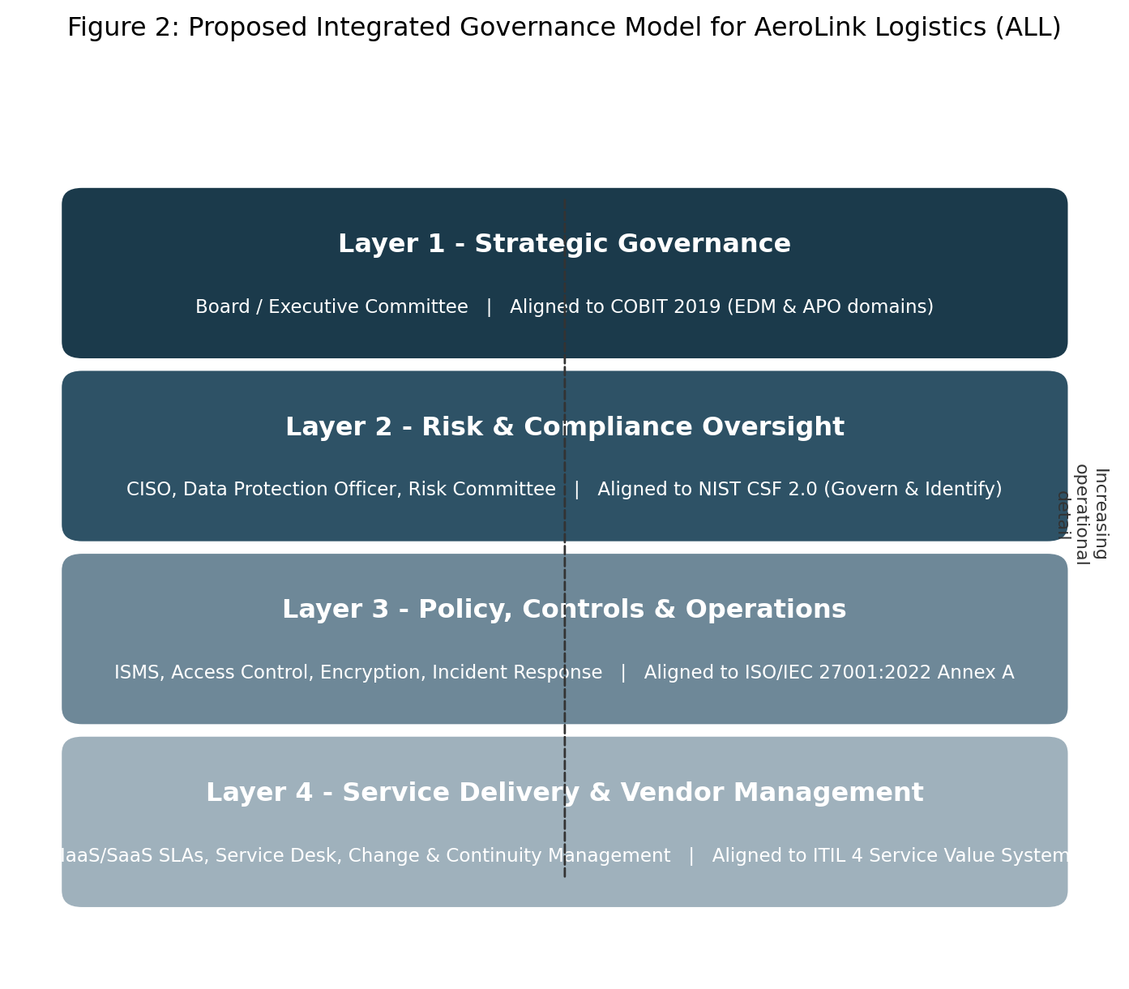
Figure 2: Proposed Integrated Governance Model for AeroLink Logistics

3.1 Governance and Strategic Planning for Security:

A Board-level Information Security and Risk Committee that oversees resource allocation, assesses strategy, and tracks performance on a quarterly basis should be established by ALL using COBIT 2019's EDM domain. The coordination gap mentioned in the case should be closed by a CISO reporting directly to this committee with the help of a DPO. A three-year plan for ISO/IEC 27001 certification should be established by strategic planning, with NIST CSF 2.0 profiles serving as interim benchmarks. This investment is necessary since understaffed teams are closely linked to slower detection and response, and 52% of firms polled report having insufficient cybersecurity budgets [5].

3.2 Compliance (Laws and Ethics):

Everywhere it handles the personal data of EU/UK citizens, ALL must abide by the GDPR in addition to comparable data protection regulations in other jurisdictions. The European Data Protection Board reported about €1.15 billion in cumulative GDPR fines issued in 2025 alone [6], and independent tracking reveals fines issued for failures spanning inadequate technical measures, insufficient transparency, and unlawful surveillance across sectors, including transport [7]. This indicates that enforcement in this area has intensified rather than eased. A compliance unit in the CISO's office should conduct Data Protection Impact Assessments (DPIAs) for new AI analytics use cases, keep a regulatory registry that links relevant legislation to particular business operations, and record legal justifications for processing. Instead of gathering data just because it is technically possible, ALL should ethically adopt data minimisation and purpose limiting for its IoT devices and AI models.

3.3 Security Policies and Procedures:

A Board-approved information security policy should be at the top of the hierarchy, followed by operating procedures that are in line with ISO/IEC 27001 Annex A, supporting requirements for encryption, access control, permitted usage, and remote/unmanaged-device access. A BYOD standard that requires baseline endpoint protection, required MFA, and conditional access before any unmanaged device can access internal apps is crucial given the case's focus on unmanaged devices.

3.4 Risk Management and Assessment:

Everyone should use NIST CSF 2.0. Determine how to create an asset inventory that includes cloud workloads, IoT sensors, and third-party data flows. Then, use a recognised approach to rate each asset's impact and likelihood. Supply chain risk should be evaluated as a separate category because 88% of infrastructure is outsourced. This is in line with NIST's specific recommendation, which calls for ongoing supplier relationship monitoring as opposed to a one-time onboarding check [2]. Supply chain compromise was listed as one of the top cybersecurity risks confronting the EU in 2024 [4], so this makes sense. Decisions about contract renewal and procurement should be directly influenced by vendor risk scores.

3.5 Security Management Models and Practices:

Given ALL's remote and multi-vendor operational style, a defense-in-depth approach that combines network segmentation, encryption in transit and at rest, and a Zero Trust access philosophy (verify explicitly, least-privilege access, presume breach) is advised. Identity, devices, networks, applications and workloads, and data are the five pillars that make up CISA's Zero Trust Maturity Model, version 2.0, which is evaluated at conventional, initial, advanced, and optimal maturity stages [3]. Since it eliminates the presumption that anything inside the perimeter can be trusted by default, Zero Trust is especially well-suited to an organization where partners, suppliers, and employees connect from unmanaged devices across time zones. ALL should start by focusing on the identity and device pillars since they are most directly related to the case's description of unauthorised access.

3.6 Contingency and Business Continuity Planning:

With agreed-upon Recovery Time and Point Objectives for every crucial logistics service, ALL should create a Business Continuity Plan (BCP) and Disaster Recovery Plan (DRP) that addresses ransomware situations, vendor outages, and cloud connectivity loss. According to the ISO/IEC 27001 continuity requirement and the Recover function of NIST CSF 2.0 [1], annual tabletop exercises and at least one live failover test should confirm that recovery assumptions are valid.

3.7 Protection Mechanisms and Access Controls:

Baseline controls should include encryption of PII and shipping data both in transit and at rest, role-based access control, and MFA for all remote and privileged access. IoT sensor communication should be separated from corporate IT networks and authenticated at the device level to lessen the possibility that a compromised tracking sensor may find its way into vital systems.

3.8 Vendor and Service Level Agreement (SLA) Management:

Vendor governance is essential to ALL's design because the majority of its infrastructure is outsourced. In accordance with current guidelines treating third-party dependencies as a continuously monitored risk category rather than a one-time procurement checkbox, contracts should specify security SLAs (patching timescales, breach notification windows, right-to-audit clauses), and vendors should be tiered by criticality and data sensitivity, with higher tiers subject to independent assurance evidence such as ISO/IEC 27001 or SOC 2 reports [2], [4]. In order to address the case's concern with vendor accountability, Table 2 suggests a RACI (Responsible, Accountable, Consulted, Informed) matrix that clarifies ownership across the Board, CISO/DPO, IT/SOC teams, and suppliers.

Security Activity | Board / Exec | CISO / DPO | IT / SOC Team | Vendors
Set risk appetite & security strategy | A | R | C | I
GDPR / ISO 27001 compliance audits | A | R | C | C
Access control & identity management | I | A | R | C
Incident detection & response | I | A | R | R
Vendor SLA & sub-processor oversight | C | A | R | R
Business continuity & disaster recovery testing | A | R | R | C
Table 2: Proposed RACI Matrix for Key Security Responsibilities at AeroLink Logistics

4. Critical Discussion: Why Continuous Updates to Regulations and Standards Matter:

Three interrelated factors make it a good idea to keep security standards and laws up to date: the rate of technical advancement, the growth of the threat landscape, and the globalisation of compliance duties.
First, technology alters the risk surface more quickly than static frameworks can predict. NIST's decision to update its Cybersecurity Framework for the first time in ten years, adding a full Govern function and broadening its scope to include all types of organisations, demonstrates that even well-known frameworks need to be periodically and significantly revised once cloud computing, IoT, and AI change how organisations generate and expose risk [1]. The governance and supply-chain concerns that are currently seen as fundamental, as well as the AI-specific guidelines ISACA has since added to COBIT, would not be reflected in a framework that ALL accepted in 2020 without further evaluation [10].
Second, even if the underlying technology remains same, threat actors always adapt, and outdated control mechanisms gradually lose their efficacy. The need for control catalogues to be periodically pruned and expanded is reflected in the 2022 restructuring of ISO/IEC 27001 Annex A, which added controls for threat intelligence and cloud security [9]. ENISA's 2024 reporting demonstrates why, with over 19,700 vulnerabilities catalogued in the twelve months leading up to mid-2024, supply-chain compromise and credential-based intrusion—both of which were identified as escalating rather than static [4]. Within two years of its initial publication, CISA revised its maturity model in accordance with Zero Trust advice [3].
Third, cross-border compliance is becoming more and more necessary. As ALL operates across time zones and jurisdictions, a logistics firm is subject to several, independently changing legal frameworks. The scope is demonstrated by GDPR enforcement, which has resulted in fines of more than €6 billion since 2018—roughly €1.15 billion in 2025 alone—and is extending into industries including transportation [6], [7]. Regulatory databases and DPIIf they are not reviewed everytime a law is changed or a new data flow is added, they become stale rather than dynamic controls. The immaturity that has already led to ALL's violations would be replicated if regulatory currency were seen as a one-time event rather than an ongoing board-owned endeavour.
One plausible counterargument is that ongoing modification results in expense and change fatigue; cybersecurity experts themselves are reporting higher levels of stress due to a changing threat picture [5]. This is a reasonable trade-off, which is one of the reasons NIST created CSF 2.0 to be customisable through Organisational Profiles rather than requiring complete adoption of each update [1]. Using the design-factor logic already present in COBIT 2019, ALL can treat framework updates as a trigger for a scoped gap assessment.

5. Assumptions:

Since the case scenario does not describe every organisational parameter, the following assumptions were established to provide a specified framework for the design:
- It is believed that ALL is a sizable, international company with enough funding to provide a dedicated CISO/DPO role and a phased ISO/IEC 27001 certification over a period of about 24 to 36 months.

- Since there is no single framework, risk procedure, or compliance audits, it is assumed that ALL's present security maturity is low (reactive rather than proactive).

- Considering ALL's European clientele, the GDPR is thought to be the main external regulatory driver, along with other comparable legislation in other operational countries.

- New SLA and audit conditions can be added to current IaaS/SaaS vendor contracts without requiring an immediate provider switch because they are presumed to be renewable within a reasonable timeframe.
- Device-level authentication and vendor risk-tiering are justified as complimentary procedures because it is believed that IoT tracking sensors are a combination of ALL-owned and vendor-owned devices.

- The design is preventative and risk-based rather than a reaction to a single identifiable breach because no specific prior incidences beyond those in the case are envisaged.

6. Conclusion:

The lack of a cohesive framework linking board-level governance, risk-based cybersecurity management, certifiable operational controls, and disciplined vendor/service management is the main cause of AeroLink Logistics's vulnerability rather than any one missing control. Instead of choosing one framework alone, ALL may handle governance, compliance, policy, risk assessment, protection measures, continuity, and vendor monitoring as a single system by overlaying COBIT 2019, NIST CSF 2.0, ISO/IEC 27001, and ITIL 4. Growing GDPR enforcement, an expanding supply-chain threat landscape, and the expansion of frameworks like COBIT into AI oversight all suggest that cloud, IoT, and AI technologies, adversary tactics, and cross-border regulation will continue to evolve [4], [6], [10]. This structure has to be examined on a regular basis, with modifications like the Govern function in CSF 2.0 and the updated Annex A of ISO/IEC 27001:2022 serving as natural catalysts for scoped reevaluation.

7.References:

[1] National Institute of Standards and Technology, "The NIST Cybersecurity Framework (CSF) 2.0," NIST Cybersecurity White Paper (CSWP) 29, Gaithersburg, MD, USA, Feb. 2024.
[2] National Institute of Standards and Technology, "Cybersecurity Supply Chain Risk Management Practices for Systems and Organizations," NIST Special Publication 800-161r1, Gaithersburg, MD, USA, May 2022, updated Nov. 2024.
[3] Cybersecurity and Infrastructure Security Agency, "Zero Trust Maturity Model," version 2.0, Washington, DC, USA, Apr. 2023.
[4] European Union Agency for Cybersecurity, "ENISA Threat Landscape 2024," Publications Office of the European Union, Athens, Greece, Sep. 2024.
[5] ISACA, "State of Cybersecurity 2024," Schaumburg, IL, USA, Oct. 2024.
[6] European Data Protection Board, "EDPB 2025 Annual Report," Brussels, Belgium, Apr. 2026.
[7] CMS Legal Services EEIG, "GDPR Enforcement Tracker Report," 6th ed., May 2025.
[8] PeopleCert / AXELOS, "ITIL 4 Specialist: Sustainability in Digital and IT," London, U.K., 2023.
[9] A-LIGN, "Unveiling ISO 27001:2022: The 9 Critical Updates You Need to Know," Tampa, FL, USA, 2023.
[10] ISACA, "Leveraging COBIT for Effective AI System Governance," white paper, Schaumburg, IL, USA, 2025.

