

‘Updated Long Term Population Projections in Welsh Local Authorities Using Multiple Machine Learning Models’

Jonathan Lesmond (2300728)
BSc (Hons) Applied Computing

Preferred Supervisor(s): Dr Seena Joseph, Gaynor Thomas

Table of Contents
1. Introduction 3
2. Background to the Proposed Research 3
2.1 Predictive Analytics and Machine Learning 3
2.2 Geographic Information Systems 4
3. Research Problem statement 4
4. Research Aim & Objectives 4
5. Methodology 5
5.1 Methods 5
5.2 Materials 5
5.2.1 Data Collection and Sources 5
5.2.2 Technologies 5
6. Project Plan 5

Table of Figures
Figure 1 - Proposed Timeline for the Project 7

1. Introduction
According to the StatsWales which is a service owned by the Welsh government to publish datasets to the public, the most recent data that showed population projections by local authority were based on 2018’s population estimate.[1] although there are more recent projections of the UK population that include Wales such as the 2022 based projection from the Office for National Statistics (ONS), it does not provide details on specific Welsh local authority populations, section 8 of that publication also states that the ONS are planning to release a 2022 based projection on local authorities in England only.[2]
Now that there is data from the Welsh government providing population estimates from 2019-2024,[3][4] this project aims to give an updated version of population projection which would help give a more accurate depiction of the Welsh Population in the future, it will also evaluate the accuracy of the 2018 based projections. This report will outline the motivation behind the project, the objectives, the methods and tools that will be utilised to achieve those objectives and the justification of the choices.

2. Background to the Proposed Research

2.1 Predictive Analytics (PA) and Machine Learning (ML)
An early account of PA in the 1980s mentions an American company called the Fair Isaac Company (FICO) using mathematical equations to calculate the likelihood that a person will pay back their loan, this likelihood was represented as a numerical score which was named the FICO score, the increasing use of the FICO score in other companies may have inspired how companies outside of the USA calculate credit scores.[5][6]
PA branches from data analytics and focuses on leveraging historical data to make predictions for the future, in more recent years these predictions have increasingly incorporated ML.[7] PA has a lot of applications in fields such as healthcare where monitoring devices worn by patients incorporate algorithms to help staff be aware of risks before an incident occurs.[8] Transportation is another application of PA, for example, the London North Eastern Railway (LNER) who are using ML models trained from data on train journey performance, quantity of passengers, weather conditions etc. to predict delays in train journeys.[9]
Governments use PA and ML in a variety of departments, for example, the NHS uses ML to predict patient demands across hospitals to inform resource allocation.[10] The ONS in one of their publications about national population projections mentioned that they produce these reports to be given to the governments of the constituent countries of the UK to assist with planning in education, health, pensions and economic forecasts.[2]

2.2 Geographic Information Systems (GIS)
GISs allows the visualisation, management and analysis of spatial data,[11][12] GISs are usually used to study a population and their characteristics in specific areas, also known as geodemography.[13] GISs are also used to understand the geographical characteristics or infrastructure of an area.
The origins of GISs date to the 1960s where the first GIS was believed to be the Canada Geographic Information System (CGIS)[11][14] which was created in collaboration with IBM during a Canadian government funded program called the Canada Land Inventory to reduce their difficulty managing natural resources due to the size of the country.[15] Esri, a reputed GIS software company was founded using early advancements in technology.[14] from the 1990s to modern day more major advancements in satellite imagery and observation, and hardware made GISs more powerful and popular in everyday life through systems such as Google Maps and Uber. GISs have more frequent usage in environmental sciences and urban design to assist construction projects, research on air quality, predictive analytics on crime etc.[14]

3. Project Design

3.1. Research Aim & Objectives
The aim of the project is to create an updated projection of the Welsh population, including the population of each local authority that will be visualised through a geographic information system, the project also aims to compare the accuracy of predictions from various types of machine learning models.
The key objectives of the project are as follows:
- To produce an updated projection of the Welsh population by local authority with multiple different machine learning models
- To produce a visualisation that allows easy understanding of the projections
- To compare the accuracy of the model’s predictions with each other and with historical projection data

3.2 Methods
An experiment will be the research method of this project. The reasoning behind this being that project will make evaluations and draw comparisons between different machine learning algorithms and historical data from government publications

Data Collection and Sources
Collecting quantitative data from publicly available repositories is the main method of data collection for this project, the sources that data will be collected will include StatsWales, DataMapsWales, Digital Health and Care Wales etc.
The data collected will relate to housing, education, health and social care, mortality, migration etc.

Technologies
The development of the machine learning models will be done in Python, The Python programming language has the most support for machine learning operations through libraries such as Scikit-learn, TensorFlow, Keras etc. Python also has libraries for reading data from CSV or SQL files through polars and pandas, SQLAlchemy is another popular library within Python used for inserting data through Python code.[16]
For storing historical data and the new data that will be produced, MySQL will be used, this is due to its compatibility with Python through MySQL Connector, through polars and MySQL Connector, the MySQL database will allow querying of data via Python code.[17]
Quantum GIS (QGIS) will be the GIS of choice for the project, QGIS is a widely used free and open source GIS used by various authorities around the world for case studies in countries such as Saint Lucia, Nigeria, Portugal etc. [18]

3.3 Project Timeline
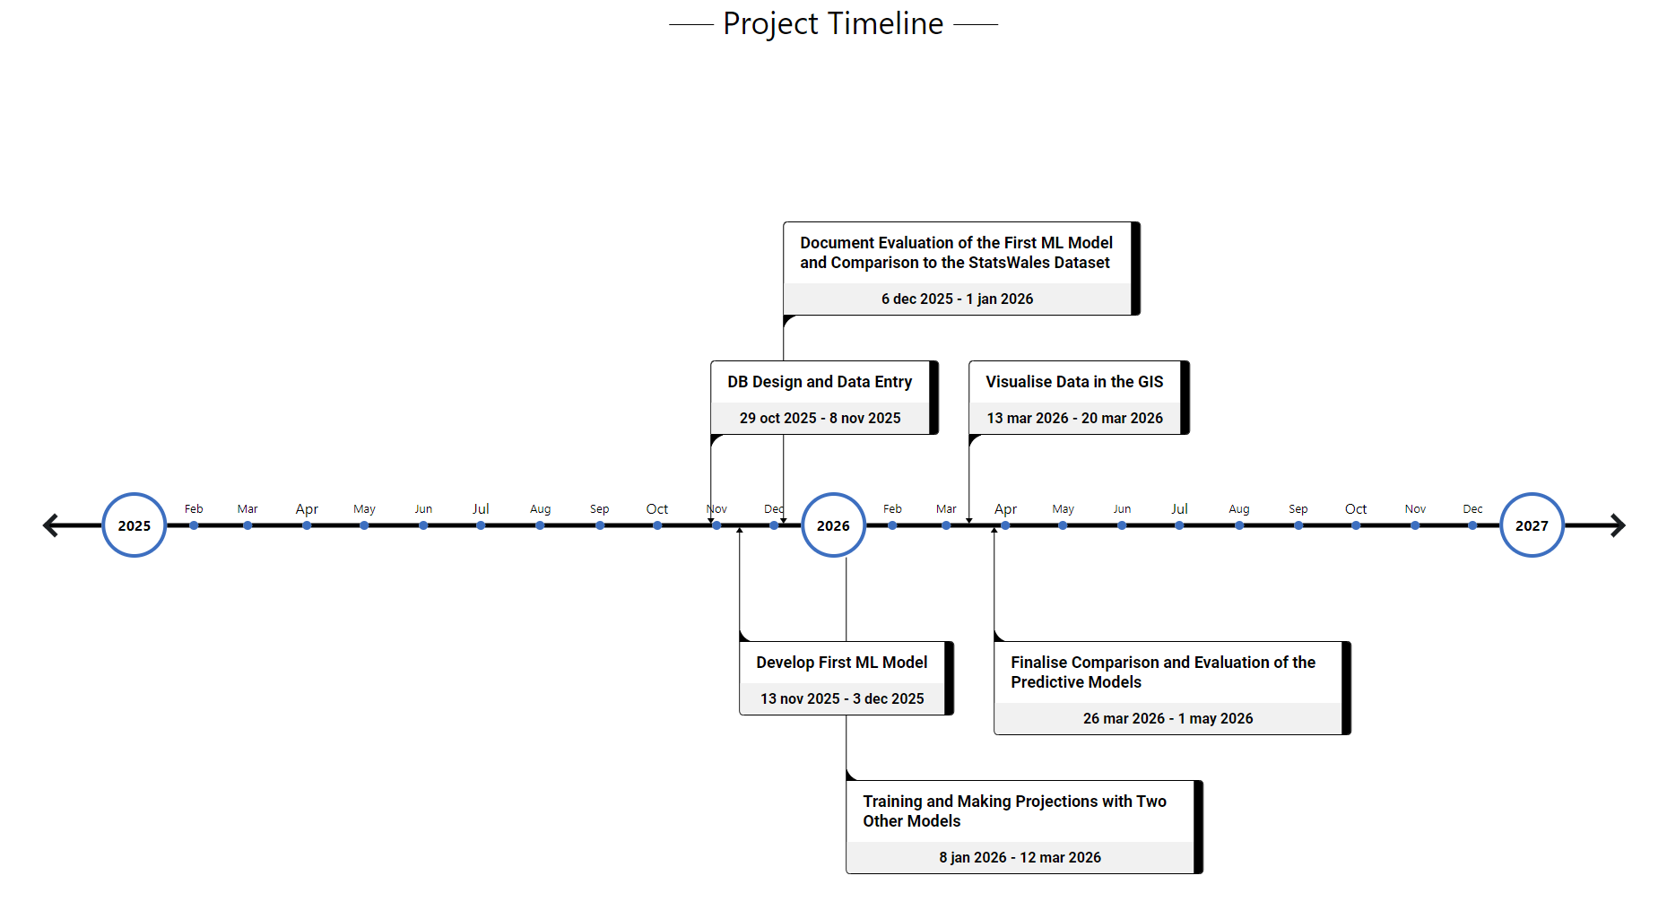
Figure 1 - Proposed Timeline for the Project

References
[1] Welsh Government. (August). Population projections by local authority and year. Available: https://statswales.gov.wales/Catalogue/Population-and-Migration/Population/Projections/Local-Authority/2018-based/populationprojections-by-localauthority-year.
[2] Office for National Statistics. (January). National population projections: 2022-based. Available: https://www.ons.gov.uk/peoplepopulationandcommunity/populationandmigration/populationprojections/bulletins/nationalpopulationprojections/2022based.
[3] Office for National Statistics. (Sept 25). Population estimates by local authority, year, sex and age. Available: https://stats.gov.wales/en-GB/82d9faea-b515-41cd-aedb-8f4594f66ce5#about_dataset.
[4] Welsh Government. (July). Population estimates by local authority and year. Available: https://statswales.gov.wales/Catalogue/Population-and-Migration/Population/Estimates/Local-Authority/populationestimates-by-localauthority-year.
[5] G. Hagler. G. Hagler. Credit score. Credit score. EBSCO EBSCO 2022. Available: https://www.ebsco.com/research-starters/business-and-management/credit-score.
[6] R. Sheposh. R. Sheposh. Predictive analytics. Predictive analytics. EBSCO EBSCO 2024. Available: https://www.ebsco.com/research-starters/science/predictive-analytics#full-article.
[7] P. Ongsulee, V. Chotchaung, E. Bamrungsi and T. Rodcheewit. P. Ongsulee, V. Chotchaung, E. Bamrungsi and T. Rodcheewit. Big data, predictive analytics and machine learning. Big data, predictive analytics and machine learning. Presented at 2018 16th International Conference on ICT and Knowledge Engineering (ICT&KE). Presented at 2018 16th International Conference on ICT and Knowledge Engineering (ICT&KE). 2018, . DOI: 10.1109/ICTKE.2018.8612393.
[8] M. S. Supriya and K. Sasidaran. M. S. Supriya and K. Sasidaran. "Machine learning for big data," in Applications of Big Data in Large- and Small-Scale Systems, S. Goundar and P. K. Rayani, Eds. 2021, Available: https://services-igi-global-com.ezproxy.uwtsd.ac.uk/resolvedoi/resolve.aspx?doi=10.4018/978-1-7998-6673-2.ch004. DOI: 10.4018/978-1-7998-6673-2.ch004.
[9] London North Eastern Railway (LNER). London North Eastern Railway (LNER). The tech keeping A watch on train times. The tech keeping A watch on train times. 2025. Available: https://www.lner.co.uk/news/the-tech-keeping-a-watch-on-train-times/.
[10] I. P. S. Sethi, O. P. Gupta, R. K. Dwivedi, M. Kapoor, S. Bhaisare, V. K. Chaudhari and S. Varma. I. P. S. Sethi, O. P. Gupta, R. K. Dwivedi, M. Kapoor, S. Bhaisare, V. K. Chaudhari and S. Varma. Machine learning in government applications: A review. Machine learning in government applications: A review. Procedia Computer Science Procedia Computer Science 258258pp. 1365–1371. pp. 1365–1371. 2025. Available: https://www-sciencedirect-com.ezproxy.uwtsd.ac.uk/science/article/pii/S1877050925014711. DOI: 10.1016/j.procs.2025.04.369.
[11] X. Li, J. Yue, S. Wang, Y. Luo, S. Cheng, J. Zhou, D. Xu and H. Lu. X. Li, J. Yue, S. Wang, Y. Luo, S. Cheng, J. Zhou, D. Xu and H. Lu. Development of geographic information system architecture feature analysis and evolution trend research. Development of geographic information system architecture feature analysis and evolution trend research. Sustainability Sustainability 1616(1), 2024. Available: https://www.proquest.com/scholarly-journals/development-geographic-information-system/docview/2912828553/se-2?accountid=130472 https://libkey.io/libraries/1422/openurl?ctx_ver=Z39.88-2004&ctx_enc=info:ofi/enc:UTF-8&rfr_id=info:sid/ProQuest&rft_val_fmt=journal&rft.genre=article&rft.jtitle=Sustainability&rft.atitle=Development+of+Geographic+Information+System+Architecture+Feature+Analysis+and+Evolution+Trend+Research&rft.au=Li%252C+Xiao%253BYue%252C+Jianwei%253BWang%252C+Shaohua%253BLuo%252C+Yifei%253BCheng%252C+Su%253BZhou%252C+Junyuan%253BXu%252C+Dachuan%253BLu%252C+Hao.&rft.aulast=Li&rft.aufirst=Xiao&rft.date=2024-01-01&rft.volume=16&rft.issue=1&rft.spage=137&rft.isbn=&rft.btitle=&rft.title=Sustainability&rft.issn=&rft_id=info:doi/10.3390%252Fsu16010137 https://doi.org/10.3390/su16010137. DOI: 10.3390/su16010137.
[12] A. L. Franklin, T. Mott and T. H. L. Williams. A. L. Franklin, T. Mott and T. H. L. Williams. Coproduction in the U.S. department of defense: Examining how the evolution of geographic information systems (GIS) expands non-traditional partner engagement. Coproduction in the U.S. department of defense: Examining how the evolution of geographic information systems (GIS) expands non-traditional partner engagement. Policy & Internet Policy & Internet 55(4), pp. 387–401. pp. 387–401. 2013. Available: https://doi.org/10.1002/1944-2866.POI345. DOI: 10.1002/1944-2866.POI345.
[13] A. Hetmanenko, V. Khomutov, O. Nikolaieva and S. Kudelina. A. Hetmanenko, V. Khomutov, O. Nikolaieva and S. Kudelina. Geodemography as a component of population geography. Geodemography as a component of population geography. J Educ Health Sport J Educ Health Sport 1313(5), pp. 161. pp. 161. 2023. . DOI: 10.12775/jehs.2023.13.05.021.
[14] R. Steenson. R. Steenson. The history of geographic information systems (GIS). The history of geographic information systems (GIS). 2019. Available: https://www.bcs.org/articles-opinion-and-research/the-history-of-geographic-information-systems-gis/.
[15] M. M. Castron. M. M. Castron. Colonialism, computerized the canada land inventory and the canada geographic information system at library and archives canada. Colonialism, computerized the canada land inventory and the canada geographic information system at library and archives canada. Archivaria Archivaria 93932022. Available: https://www.proquest.com/scholarly-journals/colonialism-computerized-canada-land-inventory/docview/2770087481/se-2?accountid=130472 https://libkey.io/libraries/1422/openurl?ctx_ver=Z39.88-2004&ctx_enc=info:ofi/enc:UTF-8&rfr_id=info:sid/ProQuest&rft_val_fmt=journal&rft.genre=article&rft.jtitle=Archivaria&rft.atitle=Colonialism%252C+Computerized+The+Canada+Land+Inventory+and+the+Canada+Geographic+Information+System+at+Library+and+Archives+Canada&rft.au=Castron%252C+Melissa+M.&rft.aulast=Castron&rft.aufirst=Melissa&rft.date=2022-04-01&rft.volume=93&rft.issue=&rft.spage=136&rft.isbn=&rft.btitle=&rft.title=Archivaria&rft.issn=03186954&rft_id=info:doi/.
[16] A. Géron. A. Géron. Hands-on Machine Learning with Scikit-Learn, Keras, and TensorFlow Hands-on Machine Learning with Scikit-Learn, Keras, and TensorFlow 2022Available: http://ebookcentral.proquest.com/lib/trinity/detail.action?docID=30168989.
[17] Oracle. Chapter 1 Introduction to MySQL Connector/Python. Available: https://dev.mysql.com/doc/connector-python/en/connector-python-introduction.html.
[18] QGIS Foundation. Case Studies. Available: https://qgis.org/project/case-studies/.

