

LCMB7035
Dissertation

Dissertation Proposal

Sustainable Fashion and the Circular Economy: Reducing Waste in the UK Fast Fashion Industry with Insights from ASOS PLC

Submitted by-
Student Name- MD Ashik Mahmud Reshat
Student ID- 2412813

Submission deadline
Table of Contents
1. Introduction 3
1.1 Research Title 4
1.2 Study Background 4
1.3 Problem Statement 4
1.4 Research Rationale 5
1.5 Aim, Objectives, and Questions of the research. 5
2. Literature Review 7
2.1 Introduction 7
2.2 Theoretical Frameworks 7
2.3 Circular Economy in Fashion 7
2.4 Quick Fashion and Sustainability Pressures. 8
2.5 “ASOS PLC” and Sustainable Strategies. 8
2.6 Comparative Studies and Industry Benchmarks. 9
2.7 Gaps in the Literature 9
2.8 UK Policy Frameworks and the UK context. 9
3. Methodology 11
3.1 Research Onion Layer 11
3.3 Data Analysis Method 12
3.4 Ethical Problems and Reasonableness. 12
4. Timeframe 13
4.1 Work Breakdown Structure (WBS) 13
4.2 Gantt Chart 14
5. Conclusion 15
References 16

1. Introduction

1.1 Research Title

Sustainable Fashion and the Circular Economy: Reducing Waste in the UK Fast Fashion Industry with Insights from ASOS PLC

1.2 Study Background
The emergence of fast fashion has changed the way clothes are produced and consumed in the world, and has devastating environmental, ethical, and social effects. The United Kingdom being among the prominent markets of fast fashion is under a growing pressure to extract waste produced by textile and move towards a model of the circular economy. The Waste and Resources Action Programme (WRAP) showed that the UK disposes of around 1.7 million tonnes of textile waste every year with only a minor portion being recycled (WRAP, 2023). “ASOS PLC”, Boohoo, and PrettyLittleThing dominate the UK market; these fast fashion brands are based on low-cost production, turnover speed, and the needs of customers to be supplied with something new every day (Joy et al., 2020).

Figure: “ASOS PLC” (WRAP, 2023).
The fashion business has now turned into a pillar of the contemporary consumer culture as well as a great contributor to the deterioration of the environment. Rapid production and low cost consumption, which are the pillars of fast fashion, create too much waste of textiles, and drain the resources. This dissertation will examine how the circular economy as a regenerative model that emphasises on reuse, recycling, and minimization of waste can help to deal with challenges of sustainability in the UK fast fashion industry.
Based on the corporate strategies, policies and practises of “ASOS PLC”, which are used as the case study, a critical analysis of the corporate strategies is presented with the view to minimise waste and therefore enhancing long-term sustainability of the production and consumption cycle. The resulting endless production and consumption process leads to unsustainable business, such as carbon emission, water pollution, micro plastic, and overconsumption of landfill.
Fashion industry contributes approximately 10 percent to the total carbon emission in the world, surpassing even the transport of the air and seas. Therefore, the industry is facing increased scrutiny among policy-makers, NGOs, and even consumers. Circular economy offers a crucial conceptual response to such challenges by no longer focusing on linear modes of take-make-dispose, but instead aiming to offer systems of repair, reuse, recycling, and using resources efficiently (Ellen MacArthur Foundation, 2021).

1.3 Problem Statement
Although the world is becoming more conscious of the issue of sustainability, the industry of fast fashion in the UK remains deeply dependent on a linear manufacturing process in which alternative factors such as speed and low cost are given precedence over the issue of environmental responsibility. The negative impact of this take-make-dispose model has resulted in gross depleted resources, defilement, and social injustices in world supply chains. The absence of uniform accountability systems has enabled most brands to partake in greenwashing- advertising sustainability in rhetoric without making significant changes in their operations (Delmas and Burbano, 2019).
Although the ASOS and its competitors have implemented sustainability programmes, they are still applied in a fragmented fashion. The main areas of problems are excess dependence on synthetic fibres, inadequate investment in recycling facilities, and absence of disclosure in the supply of materials (Bick et al., 2018). Besides, the problem is exacerbated by consumer behaviour, which promotes excessive consumption and the limited lifecycle of garments of fast fashion due to their affordability.

1.4 Research Rationale
This research comes at the right time and place when the issue of sustainability is becoming a challenge to the fashion industry. First, it deals with the urgent environmental implication of the current textile waste crisis in UK by exploring practical frames through which the change can be initiated to measurable change. Secondly, it adds to the scholarly discourses on how business innovation and environmental responsibility can intersect, specifically within the framework of the uptake of circular economics.
Moreover, this study complies with the sustainability policies of the UK such as the Waste Prevention Programme by DEFRA (2021) and WRAP targets of Textiles 2030. The examination of how ASOS has reacted to these structures creates knowledge that is useful to policymakers and other industry leaders who aim to have scalable circular systems. Finally, the study generates a gap in scholarly literature and applied corporate sustainability, which represents a blueprint to assist fast fashion businesses in achieving sustainability on the environment and profitability (H&M Foundation, 2021).
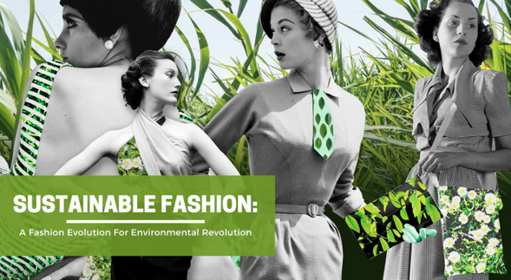
Figure: Sustainable Fashion (Bryman & Bell, 2021).

1.5 Aim, Objectives, and Questions of the research.
Aim:
To investigate the way in which concepts of atomized economy can help in minimising waste in the fast fashion sector in the UK, especially in “ASOS PLC”.
Objectives:
- To examine the connexion of sustainable fashion and the circular economy.
- To assess the plans of “ASOS PLC” to adopt circular practise.
- To determine obstacles and opportunities of reducing waste in the fast fashion sector.
- To offer sustainable performance suggestions on UK fast fashion.
Research Questions:
- What are the opportunities to implement the principles of the circular economy to minimise waste in the UK fast fashion industry?
- What should sustainability and circularity efforts by “ASOS PLC” entail?
- What are some of the issues that ASOS can face in rolling out these strategies successfully?
- What are some of the policy and strategic suggestions that may facilitate a circular transformation?

2. Literature Review

2.1 Introduction
According to the literature on sustainable fashion and the circular economy, there exists a shift in paradigm with the linear model of production to the regenerative and closed-loop models. Researchers and players in the fashion industry realise the need to move away from the fast production and disposal approach of fast fashion towards environmental sustainability. This review is a synthesis of both theoretical and empirical literatures in order to examine how the principles in the circular economy can be functionalised to minimise wastes and enhance the sustainability performance in the fast fashion sector in the UK.

2.2 Theoretical Frameworks
The paper will be rooted in two theories, the Circular Economy (CE) theory and Triple Bottom Line (TBL) framework. The Circular Economy encourages the restorative utilisation of materials by retaining products and resources in circulation as long as conceivable by reusing them, recycling them, and remaking those (Geissdoerfer et al., 2017). It does not subscribe to the linear approach based on take-make-dispose and is rather centred on regenerative design, life-cycle thinking, and systemic innovation (Ellen MacArthur Foundation, 2021).
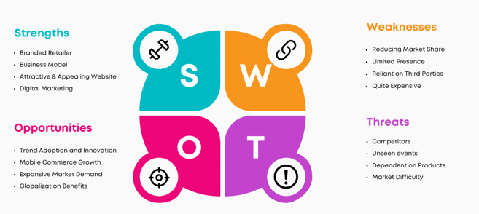
Figure: issues (H&M Foundation, 2021).

TBL, designed by Elkington (2018), expands the meaning of corporate performance to three aspects people, planet, and profit. The model can be used to undertake an integrated assessment of the environmental, economic, and social impacts. The TBL and the CE frameworks in the fashion context are mutually reinforcing the circular economy offers the pragmatic solutions to sustainability, whereas the TBL implies the social and economic concerns are taken into account as well as the environmental destinations.

2.3 Circular Economy in Fashion
The world fashion industry is among the most resource intensive industries with high rates of carbon emissions, water-consumption, and wastes on the textile industry. The volume of textile waste that is produced per year all at about 92 million tonnes in the world of which a significant portion is deposited in landfills or incinerators (Niinimaki et al., 2020). Circular economy as an alternative has advanced innovations like product life cycle, material recycling and disassembly design.
Such brands as Patagonia, Stella McCartney, and Eileen Fisher have also led the way in so-called circular initiatives, including resale platforms, repair programmes, and zero-waste production (Fletcher and Tham, 2019). These programmes show that a cyclical practise does not have to be opposite to profitability and brand loyalty. But in the case of major mass-scale fast fashion retailers, it is difficult to change these practises without interfering with the speed and pricing that they serve as keystones to their business (Moorhouse & Moorhouse, 2017).
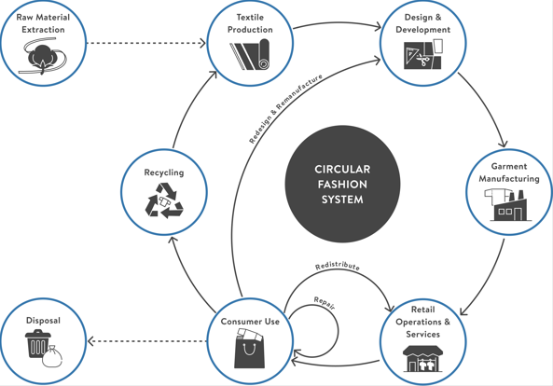
Figure: Circular economy (Geissdoerfer et al., 2017).

2.4 Quick Fashion and Sustainability Pressures.
The fashion industry is being driven around a plan of excessive production, cheapness, and consumption that resulted in an endemic crisis of waste and overconsumption. According to House of Commons Environmental Audit Committee (2019), consumers in the UK today buy five times fewer garments than they bought at the beginning of the 2000s. The result of such behaviour is product lifecycles are reduced as well as the culture of throwaway perpetuates.
Although more awareness has been created, there is still a discrepancy in the attitudes and behaviour of consumers. According to Henninger et al. (2019), the consumers of the UK also serve as an expression of environmental concern, yet they rarely put it into practise, as they tend to think that more sustainable fashion is more expensive. This behaviour is called the attitude-behaviour gap by scholars. Additionally, micro plastic contamination is enhanced by excessive dependence on synthetic fibres, which are the product of fossil fuel (Norris and Kingston, 2020).

2.5 ASOS PLC Sustainable Strategies.
“ASOS PLC” is among the leading online companies dealing with fashion in the UK, and it has gone a long way in using sustainability in its corporate strategy. ASOS has a Fashion with Integrity 2030 programme that sets long-term goals that are dedicated to four pillars, which include circular design, ethical partnerships, responsible sourcing, and carbon reduction (ASOS, 2022).
ASOS has also introduced such product philtres as Responsible Edit, to allow consumers to select those garments that align to certain standards as defined by sustainability. In addition, the company has made commitments to reach net-zero carbon emissions target of 2030 and get rid of virgin plastics in packaging. Regardless of these efforts, the observers claim that the store is too dependent on cheap overseas manufacturers and unnatural materials and that reduces its sustainability efforts (Clark, 2021).

2.6 Comparative Studies and Industry Benchmarks.
The comparative literature indicates that the result of sustainability performance in ASOS is average as compared to its global counterparts, including H&M, Zara, and Primark. The Garment Collecting Programme of H&M as well as the Join Life collection of Zara have launched recycling and eco-material sourcing at this level, but both brands encounter the same issue with the questions of full supply chain transparency (Norris & Kingston, 2020).
The distinguishing feature of ASOS is digital leadership - the utilisation of data analytics to predict demand and reduce overproduction. Research by Morgan (2022) points out the efficiency of AI systems in ASOS to enhance inventory control to prevent wastage in non-sold items.

2.7 Gaps in the Literature
Even though a lot of research has been conducted on the topic of sustainability in fashion, there are still gaps in knowledge about how digital-first companies such as ASOS introduce and assess the concepts of a circular economy. Most of the literature out there looks at consumer behaviour or supply chain ethics individually.
Moreover, there is not much empirical evidence regarding fast fashion brands based in the UK in comparison with European ones. The study thus plays its part in putting ASOS in the context of the UK regulation framework and in investigating how corporate sustainability practises can be coordinated with national interests of the circular economy. This gap will add value to the body of knowledge and to the managerial knowledge of sustainable change in online fashion retail.
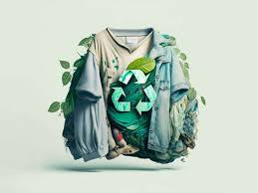
Figure: Sustainable Fashion (Bryman & Bell, 2021).

2.8 UK Policy Frameworks and the UK context.
The UK government is actively involved in the agenda setting of sustainability by using policy tools and collaborations. Textiles, 2030, which is a WRAP initiative, brings together large retailers, such as ASOS, H&M and Next, to have a common environmental goal to cut carbon and water footprint by 50 percent by 2030 (WRAP, 2023). On the same note, the Waste Prevention Programme by DEFRA (2021) also supports the idea of extended producer responsibility (EPR), mandating brands to be responsible of the post-consumer waste.
The strong involvement in WRAP by ASOS and its adherence to the goals of the DEFRA also makes it a leader among the UK online-based fashion companies. However, to realise the real change, circular principles should be obligatory throughout the sector, and economic incentives on innovation and penalties in case of environmental carelessness should be enacted.

3. Methodology

3.1 Research Onion Layer
According to Saunders et al. (2019), this research is carried out within the scope of the research onion model that offers a rigorous tool to utilise to design and conduct academic research.
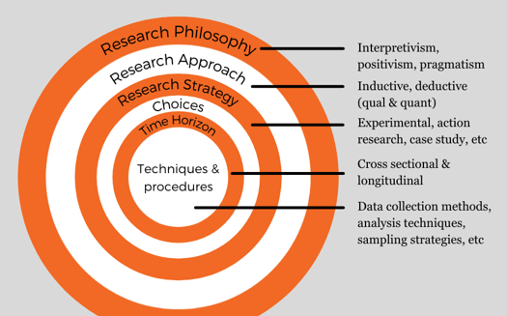
Figure: Research Onion Layer (Saunders et al. 2019),
Concept Philosophy- Interpretivism.
This paper follows an interpretation approach that considers social values and meanings of sustainability and a cellular economy in its practises in ASOS PLC. Interpretivism is appropriate since it investigates the manner in which organisations make ethical choices, encourage responsible production, and define environmental behaviour. It appreciates that sustainability entails human values, cultural views, and organisational ethics, but not quantitative results.
Research Approach - Inductive.
An inductive approach is used because the proposed study only seeks to create insights and recommendations in regards to observed patterns and not in testing an existing theory. Through the discussion of the sustainability practises at ASOS, the study aims to generate a conceptual knowledge on the implementation of the principles of the circular economy in the fashion sector.
Research Strategy Case Study.
The research approach is the case study approach, whereby an example of an ASOS PLC, which is one of the most successful digital-first fashion retailers and moving towards being a circle, will be considered. It gives a chance to deepen the analysis of the sustainability reports of ASOS and its business models and environmental performance and to obtain a context-purpose view of the direction of sustainable business activities of this company (Yin, 2018).
Research as Type - qualitative.
The research is designed under a qualitative research option, which coincides with the interpretivist philosophy. This will allow the researcher to do an analysis of non-numerical data including text information of reports, policies, and publications to understand more about sustainability of ASOS and they are making decisions (Braun and Clarke, 2019)
Time Horizon- Cross Sectional.
The time horizon is cross sectional, as the current study will focus on the sustainability and circular economy initiatives applied by ASOS within a specific time frame-2016 to 2024. This period reflects the latest sustainability practises and reaction to the environmental issues in the UK fashion industry of the company.
Secondary Data and method of data collection Secondary Data.
The study is based entirely on the secondary data retrieved through publicly available and reliable sources such as ASOS annual sustainability reports, government policy documents, academic journals, and industry analyses. These information sources give genuine data regarding sustainability activities at ASOS, and one can analyse it thoroughly, without the inquiry with primary sources (Bryman &amp; Bell, 2021).
Data Analysis Methods Thematic Analysis.
The research uses the thematic analysis approach to understand and group data of secondary sources. Sustainable supply chain management, recycling initiatives, eco-design strategies and stakeholder engagement are the identified and analysed themes that are used to understand how ASOS incorporates the principles of the circular economy in its functioning.

3.3 Data Analysis Method
In this research, the analysis of data is organised solely based on secondary data collected by using quality and open sources, including annual sustainability reports of ASOS PLC (2016-2024), government documents, scholarly articles, and industry reports. The study will use the qualitative thematic analysis to make sense of the gathered data and find significant patterns, trends, and themes concerning the circular economy practises of ASOS.
Based on the six steps used by Braun and Clarke (2019), an analysis will include being familiar with the data, creating initial codes, searching for patterns, revising and defining themes, and interpreting their meaning. The central themes are sustainable sourcing, innovation in recycling, reduction of waste, engaging the stakeholders, and ethical fashion practises. This method of analysis enables the profound insight into the way ASOS can implement the principle of a circular economy in functioning and how this project can harmonies with the wider framework of sustainability conservation-
The study will be based on numerous source s, guaranteeing it data triangulation to enhance credibility and reliability. The kind of analysis made through the interpretation assists to identify the reasons, plans, and organisational culture behind the sustainability process of ASOS. The results obtained after thematic analysis will be synthesised to make conclusions and give suggestions about the further improvement of the terms of adopting a circular economy in the fashion industry (Bryman & Bell, 2021).

3.4 Ethical Problems and Reasonableness.
The sustainability research revolves around ethical integrity. The research maintains the relevance of honesty, transparency, and academic integrity whereby all data gathered are utilised in a sound manner and referenced using the Harvard referencing style. Since no primary data is going to be collected, the question of participant consent and confidentiality does not exist. Nevertheless, the research does not disrespect the intellectual property of organisations and writers in the research.
Moreover, the study considers possible biases of corporate sustainability reporting in which corporations are prone to selectively report data to improve brand image (Bryman & Bell, 2021). To do this several independent and academic sources are consulted as a way of validating findings in order to limit interpretive bias. This method ensures that the findings of the research are credible and objective.
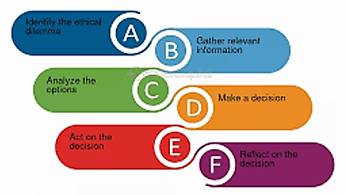
Figure: Ethical issues (Clark, 2021).

4. Timeframe

4.1 Work Breakdown Structure (WBS)
The work breakdown Structure (WBS) represents a hierarchical system to subdivide the key and essential tasks to be performed during the entirety of the production process. The work breakdown Structure (WBS) is one of the hierarchical systems to divide the main and the most important activities to be carried out throughout the production process.
The table below represents major phases of the research project.
Task | Description | Duration | Deliverables
1. Topic Selection & Proposal | Define goals, identification of research area, proposal | Week 1 | Research proposal
2. Literature Review | Survey journals, reports and industry data | Weeks 2–4 | Literature synthesis.
3. Methodology Design | Choose approach, approaches, and frameworks | Week 5 | Methodology section
4. Data Collection | Data secondary and case material collection | Weeks 6–8 | Data repository
5. Data Analysis | Thematic and comparative analysis | Weeks 9–10 | Analytical summary
6. Draft Writing | Complete dissertation draught | Weeks 11–13 | Full draft
7. Review & Editing | Proofreading, citation checking | Week 14 | Final manuscript
8. Submission | Dissertation submission | Week 15 | Final submission

4.2 Gantt Chart
Activity | Week 1 | 2–4 | 5 | 6–8 | 9–10 | 11–13 | 14 | 15
Topic Selection | ███
Literature Review |  | ██████
Methodology Design |  |  | ███
Data Collection |  |  |  | ██████
Data Analysis |  |  |  |  | ████
Draft Writing |  |  |  |  |  | ███████
Review & Editing |  |  |  |  |  |  | ███
Submission |  |  |  |  |  |  |  | █

5. Conclusion
The paper observes that the circular economy offers a revolutionary avenue through which sustainability in the UK fast fashion industry can be attained. The existing linear strategy of production maintains waste, ineffectiveness, and environmental damage. The Fashion with Integrity strategy and its focus on sustainable sourcing, circular design, and reducing carbon are the encouraging steps of the “ASOS PLC”. Nevertheless, there is still a problem when it comes to scaling circular initiatives, transparency of complex supply chains, and influencing consumers to change behaviour. Every brand focused on fast fashion has to incorporate the idea of circularity into its design and business decision-making placing the emphasis on its lifecycle, reuse, and the level of material intensity.

References
ASOS. (2022). Fashion with Integrity 2030. [Online] Available at: https://www.asosplc.com/sustainability (Accessed: 11 Nov 2025).
Bick, R., Halsey, E. and Ekenga, C.C. (2018). 'The global environmental injustice of fast fashion'. Environmental Health, 17(1), p.92.
Braun, V. and Clarke, V. (2019). 'Reflecting on reflexive thematic analysis'. Qualitative Research in Sport, Exercise and Health, 11(4), pp.589-597. MU
Bryman, A. and Bell, E. (2021). Business Research Methods. 6th edn. Oxford: Oxford University Press.
Clark, L. (2021). The Sustainability Gap: ASOS and the Challenge of Fast Fashion. London: Ethical Consumer Research Association.
DEFRA. (2021). Waste Prevention Programme for England: Towards a Resource-Efficient Economy. London: Department for Environment, Food & Rural Affairs.
Delmas, M.A. and Burbano, V.C. (2019). 'The drivers of greenwashing'. California Management Review, 54(1), pp.64-87.
Ellen MacArthur Foundation. (2021). Circular Economy Introduction. [Online] Available at: https://www.ellenmacarthurfoundation.org/topics/circular-economy-introduction/overview (Accessed: 11 Nov 2025).
Elkington, J. (2018). '25 Years Ago I Coined the Phrase "Triple Bottom Line." Here’s Why It’s Time to Rethink It'. Harvard Business Review, 25(June).
Fletcher, K. and Tham, M. (2019). Earth Logic: Fashion Action Research Plan. London: The JJ Charitable Trust.
Geissdoerfer, M., Savaget, P., Bocken, N.M.P. and Hultink, E.J. (2017). 'The Circular Economy – A new sustainability paradigm?'. Journal of Cleaner Production, 143, pp.757-768.
H&M Foundation. (2021). The Green Machine: A Circular Ecosystem for Textile Recycling. Stockholm: H&M Foundation.
Henninger, C.E., Alevizou, P.J. and Goworek, H. (2019). 'Sustainability in Fashion: A Cradle to Upcycle Approach'. In: Green Fashion. Singapore: Springer, pp. 1-28.
House of Commons Environmental Audit Committee. (2019). Fixing fashion: clothing consumption and sustainability. Fifteenth Report of Session 2017–19. HC 1952. London: Parliament UK.
Joy, A., Sherry Jr, J.F., Venkatesh, A., Wang, J. and Chan, R. (2020). 'Fast fashion, sustainability, and the ethical appeal of luxury brands'. Fashion Theory, 16(3), pp.273-296.
Moorhouse, D. and Moorhouse, D. (2017). 'Sustainable Design: Circular Economy in Fashion and Textiles'. The Design Journal, 20(sup1), S1968-S1981.
Morgan, L. (2022). 'AI and Inventory: How Data Analytics is Reducing Waste in Fast Fashion'. Journal of Fashion Technology & Textile Engineering, 10(2), p.1000204.
Norris, L. and Kingston, S. (2020). 'The hidden environmental costs of synthetic fibres: A life cycle perspective'. In: Sustainable Fashion in a Circular Economy. Helsinki: Aalto University, pp. 56-72.
Saunders, M.N.K., Lewis, P. and Thornhill, A. (2019). Research Methods for Business Students. 8th edn. Harlow: Pearson.
WRAP. (2023). Textiles 2030: Annual Progress Report 2022/23. Banbury: Waste and Resources Action Programme.
Yin, R.K. (2018). Case Study Research and Applications: Design and Methods. 6th edn. Thousand Oaks, CA: Sage Publications.

