Topic name: How social and digital media can be used to reach a wider
customer base
Module Name: Digital Skills
Module Code: LCLM 4002
Student’s Name: Anna Chausheva
Student’s ID:2335868 Group: 6
Lecturer’s name: Koushik Modak
University: University of Wales Trinity Saint David (London Campus)
Executive summary
This report has explained the effectiveness of using social and digital media channels to expand brand awareness with a better customer reach. The study has also mentioned several statistical evidence and research-based articles to support the findings. It has examined the advantages and disadvantages of using social media channels as a marketing tool with relevant examples.

Table of Contents

Introduction 4
Social and digital media tools largely used by businesses in the UK 4
Justification of social and digital media tools in reaching a wider customer base 5
Advantages of different social and digital media tools 7
Disadvantages of different social and digital media tools 7
Conclusion 8
References 9

Introduction
Social media is an excellent collaborative medium that allows people to interact actively with a larger community pool through internet connectivity. It allows businesses to create and exchange effective marketing campaigns about their offerings by expanding their global reach. However, social and digital media tools require continuous monetary investments which can pressurise small businesses. This report primarily aims to justify the effectiveness of social and digital media tools in reaching a wider consumer base for successful business activities. It will further assess the advantages and concerns of social media channels in the business context along with supportive resource materials.

Social and digital media tools largely used by businesses in the UK
Social media is an interactive technology that facilitates content creation, sharing, and equal participation by virtual communities through Internet networking. YouTube, Instagram, Snapchat, Whatsapp, TikTok, Twitter and Quora are the most popular social media channels used for worldwide commercial activities. Digital content with detailed information about new launches attracts millions of active followers on Instagram and YouTube. Statistical reports showed that the majority of audiences in the UK spent almost 44 minutes daily watching business content from YouTube (Ceci, 2024). Additionally, more than 200 million businesses in the UK promote their services and goods through Instagram channels for better customer reach. The recorded survey report further postulated that almost 80% of professional market experts in the UK prefer Instagram as an effective digital media platform (Bagadiya, 2024). Besides this, around 160 million business organisations in the UK use Facebook for active communication with existing followers. It helps more than 73%% of business-to-consumer advertisements to reach a larger variety of customers globally (Dixon, 2024).
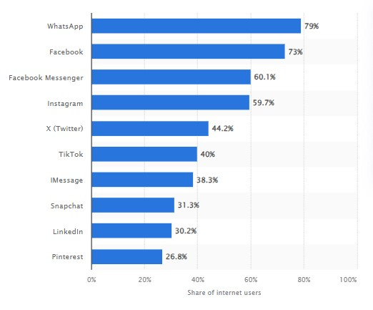
Figure 1: Social media channels according to their reach index in the UK
(Source: Dixon, 2024)

Justification of social and digital media tools in reaching a wider customer base
Role of WhatsApp: WhatsApp, as one of the major social media network systems, spreads commercial content to more than 79% of the British audience through the share option (Dixon, 2024).
Role of Facebook Messenger: Facebook Messenger also plays a significant role by connecting over 60.1% of people with businesses for a successful marketing campaign (Dixon, 2024). Role of Instagram ads: As per statistical reports, Instagram ads lead to more than 38% more audience engagement than manual marketing content. A newspaper article has stated that the viewer penetration rate on Instagram is measured at 58.2% in the UK (Dean, 2024). It helps to elevate the brand identity, brand specification and informative facts about promotional content.
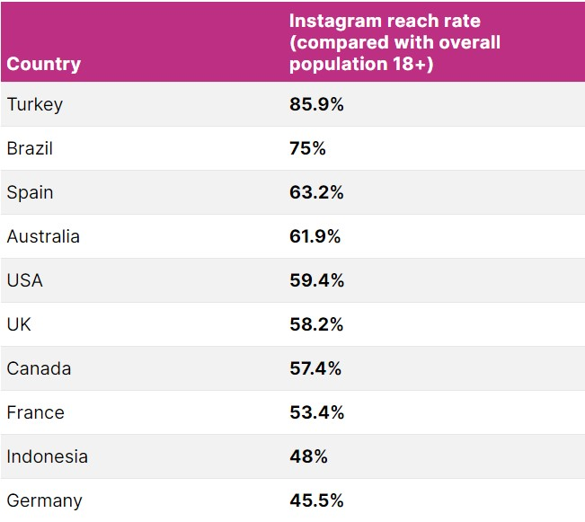
Figure 2: Instagram reach index worldwide
(Source: Dean, 2024)
Role of YouTube: It has been studied that almost 57% of the British audience supports brand content through YouTube ads (Ceci, 2024). It is further shown by statistical survey reports that YouTube is responsible for spreading commercial brand awareness among more than 95% of UK viewers (Ceci, 2024).
Therefore, the above discussion shows the way active customer engagement is driven by social and digital media tools across the nation along with valid evidence.

Advantages of different social and digital media tools
Direct connection: One of the major advantages of using social and digital media tools for brand promotion involves direct relationship development with customers. Customers follow the social media channels of their preferred brand which actively informs them about newly launched products or services. As an example, a direct connection with virtual community members has supported M&S International in operating their business in more than 70 foreign markets globally (M&S International, 2024).
Sustainability: Social media content helps large and small-sized companies in protecting the environmental balance by restricting the excessive consumption of natural resources. Manual advertisements such as billboard advertisements may cause a direct contribution to pollution. Inversely, SEO marketing and email marketing build brand awareness among potential customer base by strengthening brand loyalty precisely. As an example, YouTube visual brand promotion helps to connect more than 95% of UK customers naturally (Ceci, 2024).
A larger variety of audience: It has been observed that social media channel is not limited to national boundaries which supports small and medium-sized organisations in growing their foreign investment probabilities. The internationalisation of business ventures is driven by YouTube video content and Instagram ads in a precise manner. Presence in social media increases the chances of getting foreign orders which boosts profitable business growth in a shorter span. Studies have shown that BP, HSBC, Shell, Boohoo, NEXT and BBC are the most social media active organisations in the UK (Herrmann, 2018).

Disadvantages of different social and digital media tools
Negative feedback and rumours: A journal has stated that fraudulent reviews and negative feedback alone can cause £50 million to £312 million annual harm to UK businesses during social marketing campaigns (Gov.UK, 2024). Additionally, almost 48% of UK business ventures have been criticised in markets due to fake negative compliments on social media channels (Trim, 2021). Most of the local sole trading businesses in the UK are currently suffering from fake negative reviews during their business promotions.
Security and privacy: Several news articles have shown that there is a strong concern for security and privacy while promoting social media brand awareness campaigns. Cybersecurity concern is one of the major disadvantages of social media advertisement which is growing bigger on a daily basis. Cyber attacks on Tesco Bank stole £2.5 million from over 9,000 customers which caused the organisation to lose £16.4 million as a fine (Palmer, 2018). In addition to this, breaches in privacy control in Morrisons caused the organisation to suffer from identity theft of almost 5.518 employees by driving a negative reputation (BBC, 2017).

Conclusion
This report has enlisted the most used social media channels by mentioning the proper rationale for their effectiveness in reaching a larger group of customers. The study has further analysed the advantages and disadvantages of using social media channels as a promotional method by including statistical evidence.

References
Bagadiya, (2024). 75+ Instagram Statistics Marketers Need to Know in 2024. Available at: https://www.socialpilot.co/instagram-marketing/instagram-stats [Accessed: 28th July, 2024] BBC, (2017). Morrisons data leak: Supermarket liable for staff details breach. Available at:
https://www.bbc.com/news/uk-england-42193502 [Accessed: 28th July, 2024]
Ceci, L., (2024). YouTube in the United Kingdom - statistics & facts. Available at: https://www.statista.com/topics/11253/youtube-in-the-uk/#topicOverview [Accessed: 30th July, 2024]
Dean, B., (2024). Instagram Statistics: Key Demographic and User Numbers. Available at: https://backlinko.com/instagram-users [Accessed: 28th July, 2024]
Dixon, S. J., (2024). Most popular social media platforms in the United Kingdom (UK) as of
the third quarter 2023, by usage reach. Available at:
https://www.statista.com/statistics/284506/united-kingdom-social-network-penetration/ [Accessed: 27th July, 2024]
Gov.UK, (2024). Fake Online Reviews Research. Available at:
https://assets.publishing.service.gov.uk/media/6447c00c529eda000c3b03c5/fake-onlinereviews-research.pdf [Accessed: 28th July, 2024]
Herrmann, N., (2018). 20 Most Valuable UK Brands on Social Media. Available at: https://www.quintly.com/blog/uk-brands-on-social-media-report [Accessed: 30th July, 2024]
M&S International, (2024). International. Available at:
https://corporate.marksandspencer.com/about-us/our-businesses/ms-international [Accessed:
28th July, 2024]
Palmer, D., (2018). This is how cyber attackers stole £2.26m from Tesco Bank customers.
Available at:https://www.zdnet.com/article/this-is-how-cyber-attackers-were-able-to-steal-2-
26m-from-tesco-bank-customers/ [Accessed: 28th July, 2024]

Trim, N., (2021). 48% of uk businesses impacted by fake reviews and negative social media posts in the last year. Available at: https://businessinfomag.uk/B2B-Technology/48-of-ukbusinesses-impacted-by-fake-reviews-and-negative-social-media-posts-in-the-last-year/ [Accessed: 28th July, 2024]

Page

