THE SAGRADA FAMILIA

Prepared for
ACBA4027
Skills for Professional Practice
University of Wales Trinity St David
Swansea

Prepared by
Emma Mackay
2410357

December 12, 2024

TABLE OF CONTENTS
TABLE OF CONTENTS ii
List of Figures ii
INTRODUCTION 1
DESCRIPTION 1
Location and Size 1
Purpose 1
Architects 1
Funding 2
DESIGN AND ENGINEERING 2
Style 2
Materials 2
Structures and Design Elements 3
CONSTRUCTION PROCESS 4
Timelines of the Sagrada Familia 4
5
Methods and Techniques 5
Challenges 6
CONCLUSION 7
REFERENCES 8

List of Figures
Figure 1: The Sagrada Familia’s final spire under construction in August 2024. 2
Figure 2: The right-hand side view of the cathedral outside of the underground Metro in August 2024. 2
Figure 3: Image of Antoni Gaudi aged 26 in 1878 by Pau Audouard (Gaudi Club, n.d.). 2
Figure 4: Internal view of the structure looking at the roof. 3
Figure 5: The double twist internal columns of the cathedral. 3
Figure 6: The use of stone on the exterior walls. 3
Figure 7: Organic shapes inspired by nature. 4
Figure 8: Grand stained-glass windows inside the Sagrada Familia. 4
Figure 9: A General Timeline of the Sagrada Familia (adapted from Barcelona Tickets, n.d.) 4
Figure 10: A construction timeline of the Sagrada Familia (adapted from Barcelona Tickets, n.d.) 5
Figure 12: Prefabricated concrete panels being lowered into place (ARUP, n.d.). 6
Figure 11: Gaudi’s Suspended Chains Model (Blog Sagrada Familia, 2018). 6
Figure 13: The Sagrada Familia tower under construction (ARUP, n.d.). 6

INTRODUCTION
The Sagrada Familia is the world’s largest Catholic church, located in Barcelona, Spain. It is an outstanding architectural landmark that remains under construction to this day, as it has been since 1882. It is a significant landmark due to its architectural features and deep cultural, historical, and religious meaning. This report will discuss the architecture, symbolism, and engineering in the design and construction of the Sagrada Familia, focusing on Antoni Gaudi’s design principles and how they reflect his vision and the harmony between nature, religion, and architecture.

DESCRIPTION

Location and Size
The Sagrada Familia is a Roman Catholic minor basilica in the Eixample district of Barcelona, Catalonia, and is known for its bold organic design, in Figure 1 and Figure 2. Planned to be the tallest church in the world, once completed in 2026, it will have a capacity of 14,000 people and span 90 metres in length and 60 metres in width, and the spire height will reach 170 metres (Barcelona Tickets, n.d.).

Purpose
The construction was driven broadly by religious enthusiasm due to the Reformation, as Shaw (2024) states, “many Catholics wanted to reassert their faith”. This resulted in a collective decision of Barcelonian citizens to build an enormous Gothic cathedral in honour of the Holy Family (Shaw, 2024).

Architects
The chief architect of the project, Figure 3, became the Catalan architect Antoni Gaudi in 1883, although originally envisioned by Francisco de Paula del Villar (Middleton, et al., 2024). However, Gaudi died suddenly in 1926, leaving more than three-quarters of the structure incomplete, where it is finally scheduled for completion in 2026, after 144 years, and the centenary of Gaudi’s death.
The production continued under Domenec Sugranes I Gras and nine other architects, adding their ideas and respecting Gaudi’s plans. However, in 1936, Gaudi’s workshop including his models and parts of the unfinished basilica was demolished and burnt during the Spanish Civil War by Catalan anarchists. Therefore, according to Art Media (2024), the current ideas are “based on reconstructed versions and modern adaptations of the plans” (Art Media, 2024).

Funding
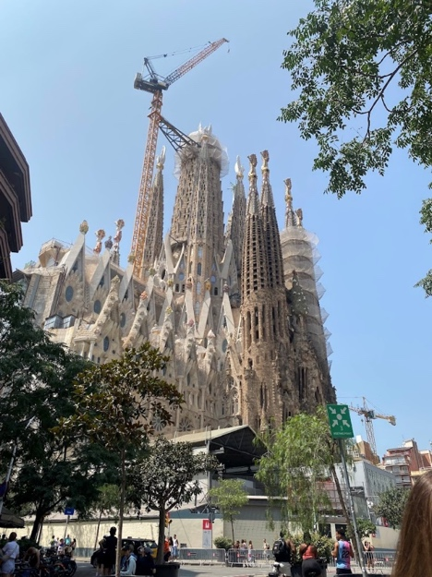
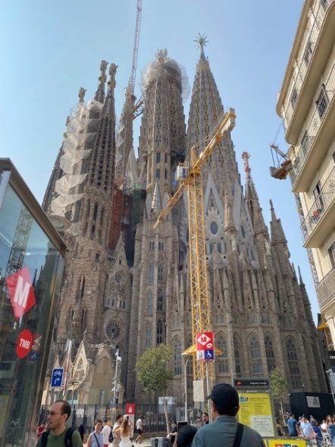
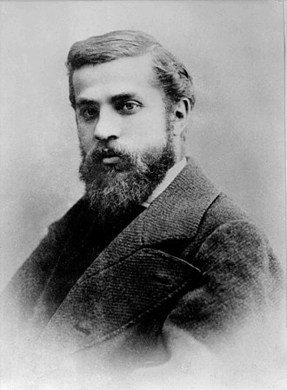
By attracting millions of tourists every single year, many ticket sales and generous donations fund the costs of the construction project. The development of the Sagrada Familia costs around 25 million euros every year (Check Out Sam, n.d.).
Figure 1: The Sagrada Familia’s final spire under construction in August 2024.

Figure 2: The right-hand side view of the cathedral outside of the underground Metro in August 2024.

Figure 3: Image of Antoni Gaudi aged 26 in 1878 by Pau Audouard (Gaudi Club, n.d.).

DESIGN AND ENGINEERING
When the project landed in Gaudi’s hands, he revolutionised its design with innovative architecture and engineering ideas.

Style
The church combines several styles, including Catalan Modernism, Art Nouveau, Noucentisme, and Spanish Late Gothic architecture (Barcelona Tickets, n.d.). The structure is to be standing with no internal bracing or external buttressing. The abnormal design of the church is what it’s well-known for, such as having no right angles and a few straight lines – attributing the organic shapes in nature (Barcelona Tickets, n.d.). As seen in Figure 4 and Figure 5.

Materials
According to Shaw, H (2024), Gaudi utilised modern techniques and materials like steel and reinforced concrete, stone (Figure 7), wood, ceramic, marble, and intricate mosaic and carved details. He added dynamic features to the structure through asymmetrical designs, curvy walls, and porticos (Shaw, 2024).

Structures and Design Elements
Barcelona Tickets (n.d.) discusses how the cathedral has many peculiar architectural elements, such as an enormous tower in the centre, shown to be under construction in Figure 1. Also, Gaudi’s focus on natural forms is evident in elements like palm tree-inspired spires and flowers – where he incorporates traditional Catalan art, in Figure 6.
Despite being the tallest church in the world, it is shorter than the Barcelona hill of Montjuïc because Gaudi did not want his creation to exceed God’s. The structure includes multiple towers, double aisles, an ambulatory with seven apsidal chapels, and three unique portals. Unlike other Spanish cathedrals, Sagrada Familia has a covered passage crossing each portal’s narthex. Eighteen spires symbolise the hierarchy of religious figures.
The Walls
The basilica’s external walls are designed to support its own weight, with internal columns, Figure 4 and Figure 5, transferring pressure from the vaults. The walls consist of grand windows and ogives to reduce the weight of the walls.
The Columns
Materials were chosen for both structural and aesthetic purposes, with volcanic rock for the tallest and sturdiest internal columns, basalt for smaller external columns, and Montjuïc granite for the smallest ones.
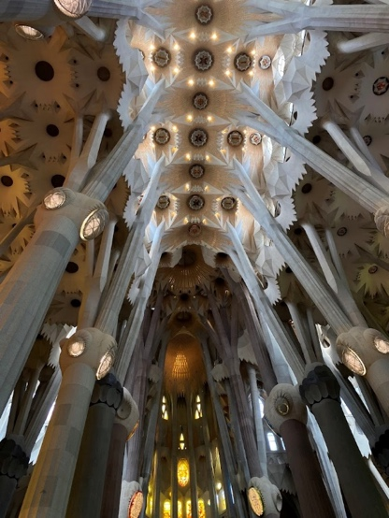
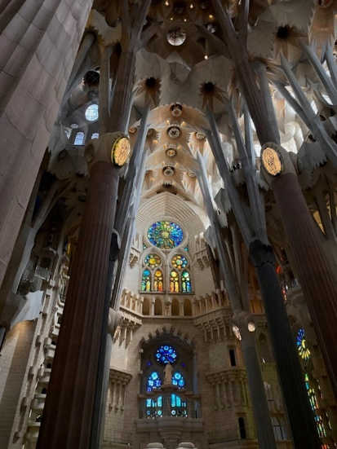
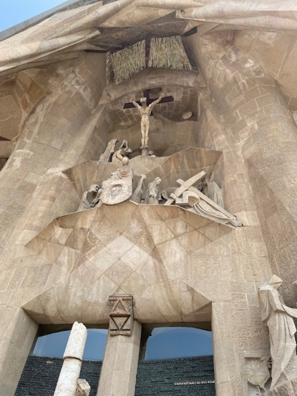
The altar and crypt are where Gaudi and other notable figures of architecture are buried. The apse, which features seven chapels and a throne where Jesus Christ sits while on the cross, is surrounded by grand stained-glass windows (Figure 8) (Barcelona Tickets, n.d.).
Figure 4: Internal view of the structure looking at the roof.
Figure 5: The double twist internal columns of the cathedral.

Figure 6: The use of stone on the exterior walls.
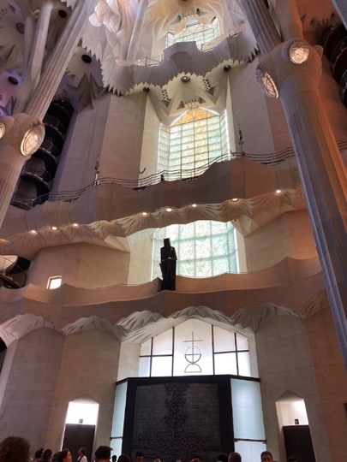
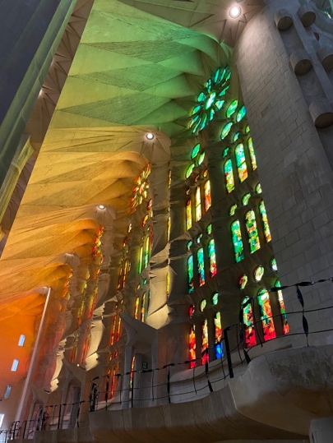
Figure 7: Organic shapes inspired by nature.
Figure 8: Grand stained-glass windows inside the Sagrada Familia.

CONSTRUCTION PROCESS

Timelines of the Sagrada Familia
(Figure 9 and Figure 10)
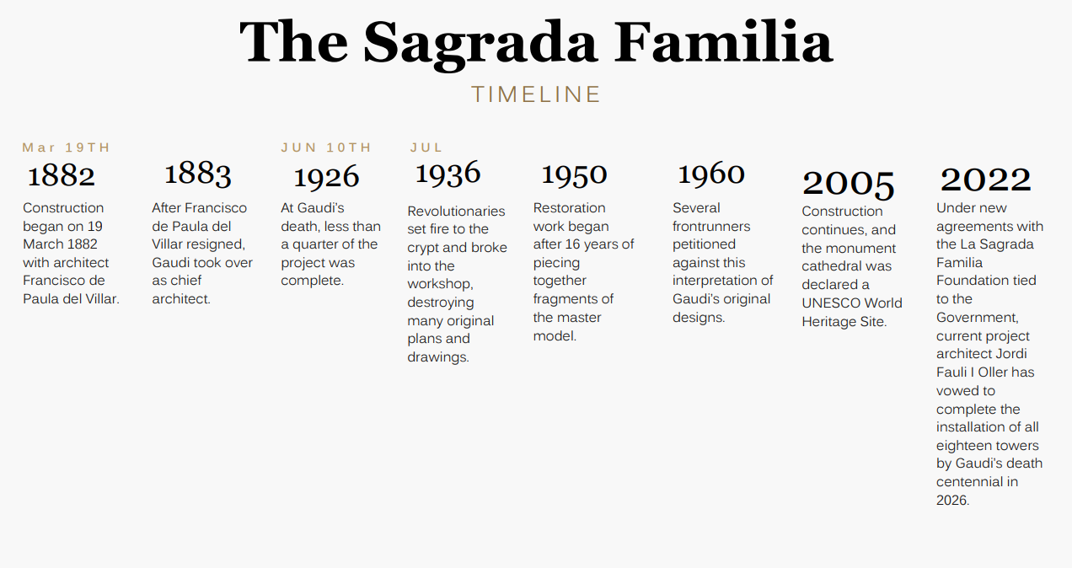
Figure 9: A General Timeline of the Sagrada Familia (adapted from Barcelona Tickets, n.d.)

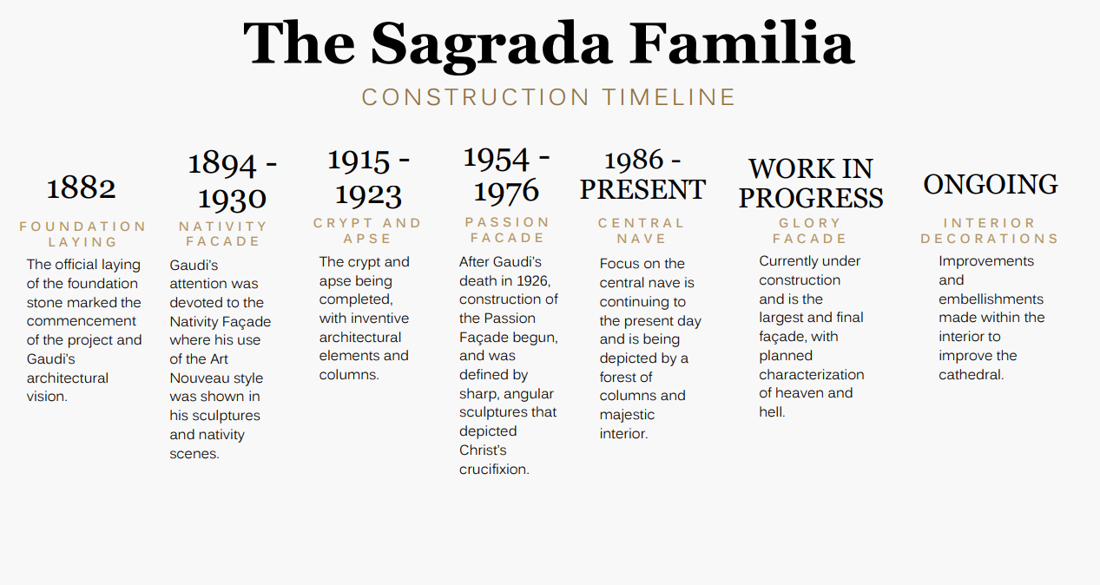
Figure 10: A construction timeline of the Sagrada Familia (adapted from Barcelona Tickets, n.d.)

Methods and Techniques
Blog Sagrada Familia (2018) mentions how Gaudi’s approach to architecture was highly innovative, particularly through his use of suspended chains to model the geometry of the structure, in Figure 11. By inverting the chain models, he was able to visualise the optimal angles for columns and walls, which allowed them to better resist compression forces. Along with this, he used a dynamometer to measure the force on each chain or string being pulled, determining the dimensions of the columns and walls. The chains also allowed him to observe how arches and vaults would behave under varying weights.
However, with all his attention on the structural behaviour through weights of materials, the permanent vertical and gravitational loads, the wind loads, and seismic forces were forgotten, and led to an oversight in the structural stability of the building under horizontal and dynamic loads, so the strings and weights method didn’t work.
In modern structural engineering, a more comprehensive understanding of both vertical and horizontal forces is essential and is more regulated. Horizontal forces, such as wind and earthquake loads, affect the building’s foundation and cause vibrations, with taller buildings prone to movement at their higher levels, like when a rope is being shaken. Gaudi’s chain model accounted for the vertical forces, such as weight, but newer methods of structural calculation address both vertical and dynamic forces (Blog Sagrada Familia, 2018).
ARUP (n.d.) highlights those advancements in Finite Element Analysis, computer modelling and 3D design have significantly improved the construction progress of the Sagrada Familia, enabling more accurate and detailed planning. Additionally, modern techniques like pre-stressed stone panels and off-site manufacturing have improved quality and safety during construction, Figure 12 and Figure 13 (ARUP, n.d.).

Challenges
The project’s funding was initially slow, causing frequent delays. A major donation eventually came and allowed Gaudi to proceed with his bold ideas, and his final designs for the basilica were finished in 1923. However, after his death, funding issues and the loss of original designs further prolonged the construction, which continues today, with ongoing work and adjustments based on modern engineering standards (Check Out Sam, n.d.).
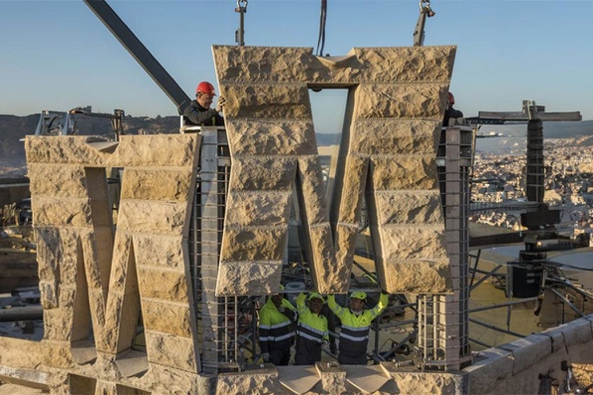
Figure 12: Prefabricated concrete panels being lowered into place (ARUP, n.d.).

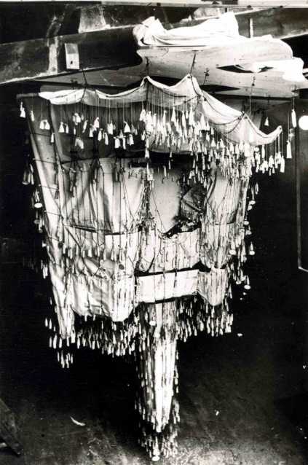
Figure 11: Gaudi’s Suspended Chains Model (Blog Sagrada Familia, 2018).

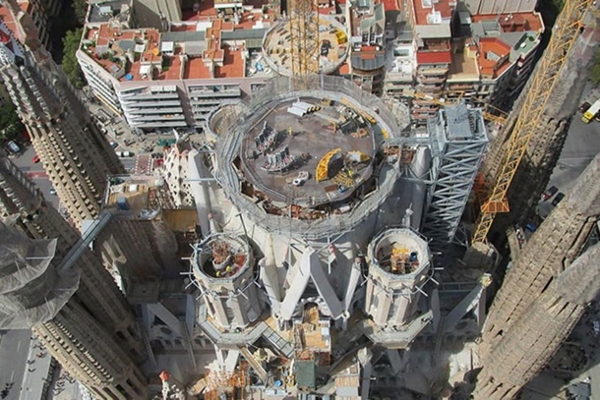
Figure 13: The Sagrada Familia tower under construction (ARUP, n.d.).

CONCLUSION
In conclusion, the Sagrada Familia stands as a testament to Gaudi’s genius and innovative engineering and architecture. It is not only an architectural wonder but is a symbol of human creativity, spiritual devotion, and cultural pride. Its deep religious representation, Catalonian cultural significance, and its ongoing construction make it a global icon. It is an extraordinary landmark that has allowed multiple generations to appreciate the wonder of its construction over the past 142 years and for future generations to enjoy it finally complete after 2026.

REFERENCES
Art Media, 2024. Sagrada Familia by Antonio Gaudi. [Online]
Available at: https://artmedia.bg/en/architecture/sagrada-familia-by-antonio-gaudi/
ARUP, n.d. Completing La Sagrada Familia: a collaboration in digital and stone. [Online]
Available at: https://www.arup.com/projects/sagrada-familia/
[Accessed November 2024].
Barcelona Tickets, n.d. Architecture & design of Sagrada Familia. [Online]
Available at: https://www.barcelona-tickets.com/sagrada-familia-tickets/sagrada-familia-tower-architecture/
[Accessed November 2024].
Blog Sagrada Familia, 2018. Is the Sagrada Familia prepared to withstand an earthquake?. [Online]
Available at: https://blog.sagradafamilia.org/en/divulgation/seismic-activity-sagrada-familia/#:~:text=We%20can%20see,%20then,%20that
Check Out Sam, n.d. A visit to the Sagrada Familia. [Online]
Available at: https://www.checkoutsam.com/visit-sagrada-familia-skip-the-line-tickets-photos-tips/
[Accessed November 2024].
Gaudi Club, n.d. Pictures of Antoni Gaudi. [Online]
Available at: https://www.gaudiclub.com/ingles/i_vida/pictures.asp
[Accessed December 2024].
Middleton, J., Petruzzello, M. & Lotha, G., 2024. Sagrada Familia. [Online]
Available at: https://www.britannica.com/topic/Sagrada-Familia
Shaw, H., 2024. Why Was Sagrada Familia Built. [Online]
Available at: https://www.monumentsandsights.com/why-was-sagrada-familia-built/

