

Module: Leading and Implementing Workplace Change
(BMSW6103_LON)
Lecturer: Nadeem Mirza
Student: Nevyana Nikolova (2111481)

Barclays Bank
A Change Management Plan

ⅠIntroduction

Definition of change management
Change management is a crucial aspect of any organization's success. It refers to the process through which organizations manage and lead employees through changes, ensuring a smooth transition and adoption of new strategies or initiatives.

Barclays Bank background

Barclays Bank is a British multinational investment bank and financial services company, founded in London in 1690 by John Freame and Thomas Gould. The company expanded its operations and became a leading financial institution in the United Kingdom. In the 19th century, Barclays expanded its operations overseas, establishing branches in various countries, with a global presence. Barclays operates across various sectors, including retail banking, investment banking, wealth management, and credit cards. The bank offers a range of products and services, including savings accounts, loans, mortgages, credit cards, investment services, and insurance products.

Figure 1: Old Barclays Bank building in Liverpool


Source: ( https://www.shieldsgazette.com, 2024)

The Current State of Barclays Bank Regarding a Change Management Plan in 2024
Barclays Bank, a leading financial institution, is currently in the process of implementing a change management plan in 2024. This plan is designed to align the organization's objectives, strategies, and capabilities with evolving market conditions and technological advancements.

Objective
The primary objective of the change management plan is to ensure the bank remains competitive and adapts to changing customer needs and regulatory requirements. By implementing these changes, Barclays aims to drive growth, enhance operational efficiency, and capitalize on emerging opportunities.

Key Challenges and Opportunities

Challenges
- Lack of Digital Transformation: Barclays Bank has struggled to keep pace with the digital revolution, which poses a significant threat to its market position.

- Competition from Fintech Startups: The bank's traditional business model is being challenged by innovative fintech startups, which are disrupting the financial services landscape.

- Regulatory Compliance: Barclays Bank must comply with constantly evolving regulations, which adds complexity and cost to its business operations.

Opportunities
- Digital Transformation: By embracing digital technologies, Barclays Bank can enhance customer experiences, improve operational efficiency, and attract a younger customer base.

- Collaboration with Fintech Startups: The bank can leverage partnerships with Fintech startups to access cutting-edge technologies, innovative solutions, and new markets.

- Regulatory Compliance: Barclays Bank can utilize its expertise and experience in compliance to provide advisory services to its clients, generating additional revenue streams.

Change Management Strategy

Barclays Bank's change management strategy

1. Assessment and Diagnosis: The bank will conduct a comprehensive assessment of its current state and identify areas of improvement. This assessment will include analyzing market trends, customer preferences, and internal capabilities.

2. Developing Change Strategies: Based on the assessment findings, Barclays will develop detailed change strategies that align with its business objectives and customer needs. These strategies may include process reengineering, technology upgrades, and employee training.

3. Implementing and Sustaining Change: Barclays will implement the identified changes swiftly and efficiently, ensuring that employees are well-informed and equipped to adapt to the new environment. The bank will provide ongoing support and resources to employees to sustain the change over the long term.

Ⅱ. Main body
SWOT Analysis
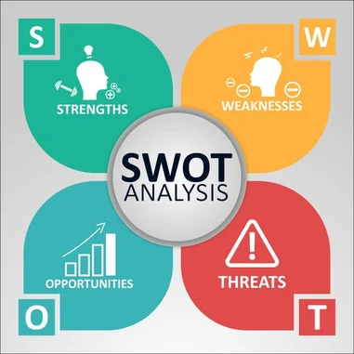
Figure 2: SWOT Analysis diagram

Source (https://www.rhythmsystems.com,2024)

Strengths

1. Strong Leadership: Barclays Bank has an experienced and capable management team that has been instrumental in developing and implementing effective change management strategies.

2. Extensive Resources: The bank possesses significant resources, both in terms of financial capital and human capital, which enables it to invest in change initiatives and allocate the necessary resources for their successful implementation.

3. Global Reach: With operations in over 50 countries, Barclays Bank can leverage its global presence and knowledge to implement change initiatives across various regions and adapt to diverse cultural and operational contexts.

4. Collaboration and Communication: The bank has a strong emphasis on collaboration and communication, ensuring effective communication between key stakeholders and employees during the change process.

5. Continuous Improvement: Barclays Bank commits to continuous improvement, allowing it to identify areas for improvement and proactively implement changes to enhance its competitiveness and operational efficiency.

Weaknesses

1. Resistance from Employees: Resistance to change is a common challenge faced by any organization, and Barclays Bank is no exception. Some employees may resist change due to fear of the unknown, resistance to change, or resistance to change agents.

2. Cultural Resistance: Different cultural aspects within Barclays Bank may pose challenges when implementing change. Different countries and regions may have unique cultural norms and values that influence attitudes towards change.

3. Complexity and Scope: Implementing change within a large and complex organization like Barclays Bank can be a complex task. The bank has diverse business units, product lines, and systems, which may require significant changes.

4. Resource Constraints: Limited resources, such as time, budget, or skilled personnel, can hinder the implementation of change initiatives. Barclays Bank may have to allocate resources from other areas to support the change efforts.

5. Time Constraints: The pace of change can be critical, especially when external market pressures or regulatory requirements necessitate immediate adjustments. Barclays Bank may have limited time to implement changes effectively.

Opportunities

1. Digital Transformation: The increasing adoption of digital banking services presents significant opportunities for Barclays Bank. By leveraging cutting-edge technology, the bank can enhance customer experiences, improve operational efficiency, and gain a competitive edge.

2. Global Expansion: Barclays Bank can explore new markets and geographies to expand its presence and gain additional revenue streams. This can be achieved through acquisitions, joint ventures, or direct entry into new markets.

3. Sustainable Banking: The bank can seize the opportunity to shift towards sustainable banking and incorporate environmental, social, and governance (ESG) considerations into its operations and products. This can attract socially conscious customers and support the bank's reputation.

4. Risk Management: Barclays Bank can explore opportunities to enhance its risk management practices, particularly in areas such as cybersecurity, data privacy, and regulatory compliance. Investing in robust risk management systems can protect the bank from potential threats.

5. Innovation and Disruption: Barclays Bank can foster a culture of innovation and embrace disruptive technologies to stay ahead in the rapidly changing financial services landscape. This can involve partnering with fintech companies or investing in research and development.

Threats

1. Regulatory Changes: The financial services industry is highly regulated, and any changes in regulations or compliance requirements can pose threats to Barclays Bank's operations. The bank may need to adapt to the evolving regulatory environment and maintain compliance.

2. Competitive Landscape: The financial services industry is highly competitive, and new entrants and disruptive technologies can challenge Barclays Bank's position. The bank needs to stay agile and adapt to changing market dynamics to maintain its competitive advantage.

3. Financial Stability: Financial instability, such as economic downturns or financial crises, can significantly impact the banking sector. Barclays Bank needs to maintain a strong financial position and contingency measures to mitigate risks and ensure its financial stability.

4. Cybersecurity Risks: Cyberattacks have become a major concern for financial institutions, and Barclays Bank is exposed to cyber threats. The bank needs to invest in robust cybersecurity measures to protect customer data and prevent unauthorized access.

5. Customer Trust: Maintaining trust with customers is crucial in the banking industry. Barclays Bank needs to maintain its reputation for reliability and transparency, as data breaches or scandals can erode customer trust and impact the bank's reputation.

PESTEL Analysis

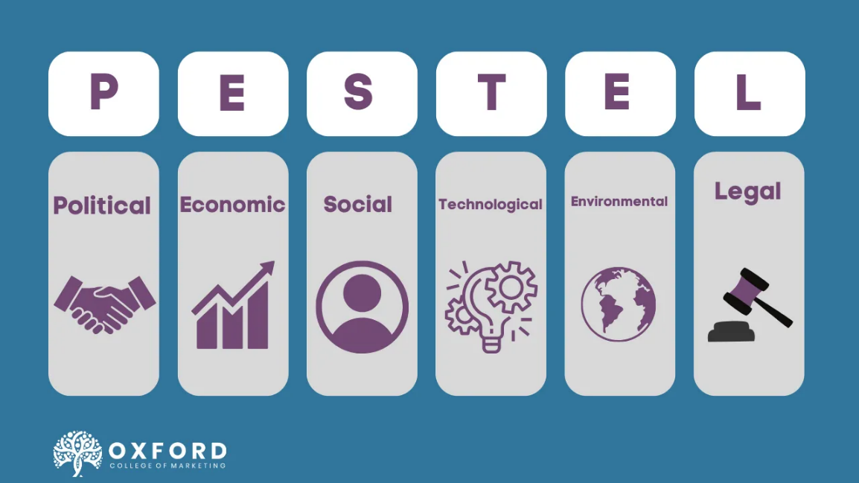
Figure 3: PESTEL Analysis diagram

Source: (https://blog.oxfordcollegeofmarketing.com, 2024)

Political Factors

Recent History

Barclays Bank, one of the largest financial institutions in the United Kingdom, has experienced significant changes in its recent history. In 2008, the global financial crisis caused significant disruptions to the banking system, resulting in losses for Barclays. The bank received government bailout funds to support its financial stability and survived the crisis.

Economic Uncertainty

Economic uncertainty has been a pressing concern for Barclays Bank. The ongoing Brexit process, which threatens to disrupt trade relations and financial stability, has posed significant challenges for the bank. Uncertainty surrounding the UK's future economic relationship with the European Union has raised concerns about the bank's ability to navigate changing market conditions.

Economic Factors

Digital Disruption

Digital disruption has significantly impacted the banking industry, including Barclays. The rise of online banking and mobile banking has challenged traditional business models. Barclays has responded by investing in digital technologies to enhance customer experience and provide innovative banking services.

Ongoing Economic Uncertainty

Economic uncertainty continues to pose challenges for the industry and Barclays Bank. The impact of Brexit, coupled with global macroeconomic factors, has subdued economic growth, affecting both businesses and individuals. This has had a ripple effect on the banking industry, including reduced lending activity and subdued demand for financial services.

Social Factors

Changing Customer Preferences

Customer preferences and behaviours have evolved, influenced by factors such as urbanization, the ageing population, and changing demographics. Barclays Bank has had to adapt to these changes to remain relevant and competitive. The bank has prioritized personalized customer experiences, including mobile banking and digital tools, to cater to changing customer preferences.

Ethical Concerns

Ethical concerns have gained prominence in recent years, with customers demanding more socially responsible business practices. Barclays Bank has faced criticism for its involvement in controversial transactions and has faced scrutiny from regulators and stakeholders. The bank has responded with measures to enhance transparency and increase its commitment to ethical practices.

Technological Factors

Digital Transformation

Technological advancements have transformed the banking industry, and Barclays is no exception. The bank has invested heavily in digital platforms and technologies to enhance customer experience, improve operational efficiency, and stay competitive. This includes mobile banking, online banking, data analytics, and artificial intelligence.

Data Privacy and Security

Data privacy and security have become increasingly important in the digital era. Barclays Bank has had to grapple with challenges such as data breaches, cyber threats, and regulatory requirements to protect customer data. The bank has invested heavily in cybersecurity measures and is developing new technologies to safeguard sensitive information.

Environmental Factors

Sustainable Banking

Environmental sustainability has become a priority for the banking industry, including Barclays Bank. The bank has recognized the importance of reducing its environmental footprint and has committed to sustainable banking practices. This includes promoting renewable energy, reducing carbon emissions, and supporting sustainable initiatives.

Regulatory Compliance

The regulatory environment continues to evolve, driven by factors such as evolving industry standards, regulatory requirements, and changes in consumer behaviour. Barclays Bank has had to adapt to these changes to remain compliant and avoid regulatory penalties. The bank has invested heavily in compliance infrastructure and resources to ensure adherence to regulatory requirements.

Legal Factors

Regulatory Compliance

Barclays Bank operates in a highly regulated environment, subject to various laws and regulations. The bank must comply with regulatory requirements such as capital adequacy standards, anti-money laundering measures, and consumer protection regulations. Failure to do so can result in legal consequences and financial penalties.

Litigation and Legal Risks

Barclays Bank is exposed to legal risks arising from various sources, including customer disputes, regulatory investigations, and litigation. The bank has risk management processes in place to mitigate legal risks and ensure fair treatment of customers.

Conclusion PESTEL Analysis
Barclays Bank has faced numerous challenges in its recent history due to external factors such as digital disruption and ongoing economic uncertainty. The company has responded by investing in digital technologies, adapting to changing customer preferences and addressing ethical concerns. Barclays Bank has also recognized the importance of environmental sustainability and regulatory compliance. While the bank has navigated these challenges successfully, the ever-evolving external environment will continue to impact its operations and require ongoing monitoring and adaptation.

Change management models

Change management models provide frameworks and guidelines to help organizations navigate complex changes effectively. By examining various models and incorporating issues related to strategic change, we can gain insights into how Barclays Bank managed change and what leadership styles were utilized in the process.

Lewin's model

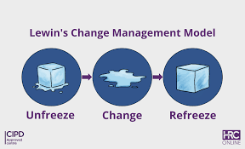
Figure 4: Lewin’s model diagram
Source: (https://hrcoursesonline.com, 2024)

Lewin's model is a comprehensive framework that aims to guide organizations through the change process, ensuring a smooth transition and maximizing the likelihood of success. Applying Lewin's Change Management Model to Barclays Bank's transformation can provide a structured approach to driving change within the organization. By effectively unfreezing the existing mindsets, moving the organization towards the desired future state, and freezing the new behaviours, Barclays Bank can navigate the challenges of change and position itself for long-term success.

Unfreezing Stage

The first step in Lewin's model is the unfreezing stage. During this stage, the existing behaviours and mindsets of employees are challenged and disrupted. Barclays Bank can utilize various strategies to achieve this unfreezing, including:

1. Communication: Communicate the need for change and its potential benefits to all employees. Use various channels, such as town hall meetings, emails, and posters, to ensure widespread understanding.

2. Empathy and Understanding: Show empathy towards employees' fears and concerns. By acknowledging their resistance and providing support, you can create a sense of trust and encourage open dialogue.

3. Training and Education: Offer training and development programs to enhance employees' skills and knowledge required for the change. This can help them transition more easily and adapt to new ways of working.

Moving Stage

Once the existing mindsets and behaviours have been unfrozen, the moving stage begins. During this stage, Barclays Bank can facilitate the implementation and adoption of new processes, systems, or behaviours. Strategies to facilitate this include:

1. Role Models: Identify and highlight successful individuals who have embraced change within the organization. Their examples can serve as inspiration and role models for others.

2. Training and Support: Provide ongoing training and support to help employees navigate the change effectively. Offer resources, such as user manuals, workshops, and coaching, to ensure a smooth transition.

3. Feedback and Recognition: Encourage employees to provide feedback on the change process. Recognize and reward those who embrace the change and contribute positively.

Freezing Stage

The final stage of Lewin's model is freezing. During this stage, Barclays Bank solidifies the new behaviours, attitudes, and mindsets that have been adopted during the change process. Strategies to achieve this include:

1. Supervisory Support: Ensure that supervisors and managers are aligned with the change and provide the necessary support and guidance to employees. Foster a culture of continuous learning and improvement.

2. Regular Review: Regularly assess the change's effectiveness and make necessary adjustments. This can help identify any areas that need further attention or reinforcement.

3. Celebration and Recognition: Celebrate milestones and achievements associated with the change. Recognize and acknowledge the contributions of individuals and teams who have played a crucial role in the transformation.

Kotter's Eight-Step Change Model
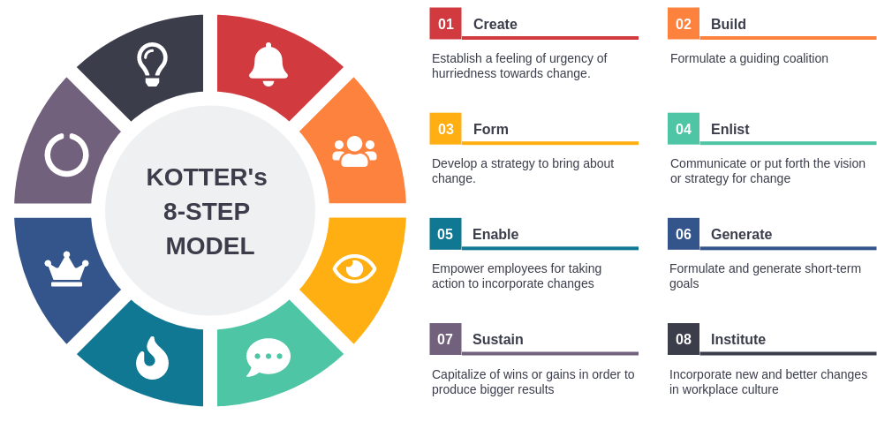
Figure 5: Kotter's Eight-Step Change Model Diagram
Source: (https://www.inkstrategy.com, 2024)

Kotter's Eight-Step Change Model is a popular framework for change management. Developed by John Kotter, a renowned leadership expert, this model provides a systematic approach to leading and managing change within organizations. It outlines the key steps involved in initiating, implementing, and sustaining change. Applying Kotter's eight-step change model for Barclays Bank can guide the institution through successful transformations. By implementing each step effectively, the bank can create urgency, build a coalition, develop a vision, establish a guiding coalition, effectively communicate the vision, empower action and create short-term wins.

Step 1: Create Urgency
The first step in Kotter's model involves creating a sense of urgency. Barclays Bank needs to communicate the urgency for change by highlighting the current state's limitations and the potential risks associated with not addressing them. By emphasizing the negative consequences of the status quo, the bank can motivate its staff and stakeholders to take action.
Step 2: Build a Coalition
To bring about change effectively, it is crucial to build a coalition. Barclays Bank should identify key stakeholders, such as employees, customers, and suppliers, who can contribute to and support the transformation. Engaging these stakeholders early on ensures that they have a voice in the process and are invested in the outcomes.
Step 3: Develop a Vision
A clear and compelling vision is essential for guiding change efforts. Barclays Bank should define its desired future state and articulate a compelling vision that resonates with its stakeholders. This vision should inspire employees, customers, and investors to embrace change and align their efforts towards a common purpose.
Step 4: Create a Guiding Coalition
To lead the change effectively, Barclays Bank needs to establish a guiding coalition. This involves selecting and delegating responsibility to a group of individuals who possess the necessary skills and experience to guide the transformation. The guiding coalition is responsible for overseeing the implementation of change and addressing any challenges that arise.
Step 5: Communicate the Vision
Effective communication is key to ensuring the success of any change initiative. Barclays Bank should communicate the vision and the changes it intends to make to its stakeholders. This communication should be clear, consistent, and tailored to different audiences. By providing regular updates and feedback, the bank can ensure that everyone understands the purpose and direction of the transformation.
Step 6: Empower Action
To drive change, Barclays Bank needs to empower its employees to take action. This can be achieved by providing the necessary resources, training, and support to enable staff to execute change initiatives. By removing obstacles and creating a supportive environment, the bank can foster innovation and encourage employees to contribute their ideas and suggestions.
Step 7: Create Short-Term Wins
To sustain momentum and create a sense of progress, Barclays Bank needs to create short-term wins. These wins can be small victories that serve as stepping stones towards the overall transformation. By celebrating these wins, the bank can build morale and demonstrate the effectiveness of the change process.
Step 8: Anchor the Changes in the Culture
To ensure that change is sustained, Barclays Bank needs to embed it in the culture of the organization. This can be done through ongoing communication, reinforcement of the desired behaviours, and recognizing and rewarding employees who embrace the transformation. By anchoring changes in the culture, Barclays Bank can create an environment that encourages continuous improvement and innovation.
Critical analysis / Barclays’s management plan
While different change management models offer valuable insights, it is important to acknowledge and address potential issues that can arise during the implementation of strategic change in Barclays Bank. These issues may include:

1. Resistance and Resistance Management: Resistance to change is a natural reaction, and Barclays Bank needed to manage this resistance effectively. This involved addressing concerns, providing support, and offering training to ensure a smooth transition.

2. Communication Challenges: Effective communication is crucial during organizational change. Barclays Bank needed to ensure clear and consistent messaging, addressing any concerns or doubts employees may have.

3. Organizational Culture: Barclays Bank needed to adapt its organizational culture to support the strategic change. This involved fostering a culture of adaptability, collaboration, and innovation.

4. Leadership Styles: Leaders play a significant role in driving change. Barclays Bank employed a range of leadership styles, including transformational, transactional, and servant leadership, to ensure effective change leadership.

Evaluation of Organisational Culture on Change Management Programme

Organisational culture plays a significant role in the success of change management programmes within organizations. The impact of organizational culture on the change management program at Barclays Bank and develop a suitable change management plan to address any challenges or opportunities that arise from this cultural influence.

Analysis of Impact:

1. Resistance: Organisational culture can influence the level of resistance to change among employees. If Barclays Bank's culture is characterized by resistance to change and resistance to new ideas, implementing change may face significant challenges.

2. Communication: The culture of Barclays Bank can impact the effectiveness of communication during change management initiatives. A culture of open and transparent communication can facilitate successful change management while one that is closed and hierarchical may hinder it.

3. Employee Engagement: Organisational culture influences the level of employee engagement during change. If Barclays Bank's culture promotes employee engagement and empowerment, it can facilitate positive change management. Conversely, a culture that does not value employee engagement may hinder change.

4. Leadership Support: The support provided by leaders within the organization can significantly impact the success of change management. If Barclays Bank's leaders exhibit a strong commitment to change and actively support initiatives, it can enhance change management practices.

5. Innovation and Risk Tolerance: Organisational culture can also influence an organization's willingness to embrace innovation and tolerate risks during change. If Barclays Bank's culture encourages innovation and risk-taking, it can facilitate successful change management initiatives.

Change Management Plan / Barclays Bank

Proposed Change
1. Enhanced Customer Relationship Management: The bank will invest in upgrading its CRM system to improve customer interaction and streamline processes. This will enable the bank to better understand customer needs and provide personalized products and services.

2. Digital Transformation: Barclays Bank will focus heavily on digital transformation initiatives to enhance customer experience and introduce innovative banking solutions. This will involve upgrading the bank's digital platforms and integrating new technologies like artificial intelligence and blockchain.

3. Enhanced Risk Management: The bank will implement enhanced risk management practices to identify and mitigate potential risks. This will involve implementing robust internal controls, conducting regular risk assessments, and fostering a culture of risk management throughout the organization.

4. Global Expansion: Barclays Bank will explore opportunities for global expansion by targeting new markets and customer bases. This will involve conducting market research, establishing strategic partnerships, and tailoring products and services to meet the unique needs of international customers.

Financial Plan
1. Investment in Technology: The bank will invest a significant amount in upgrading its IT infrastructure, including CRM systems, digital platforms, and data analytics tools. This investment will be funded through a combination of internal resources and external financing.
2. Staff Training and Skill Development: Barclays Bank will allocate resources to conduct training programs for its employees to enhance their skills and knowledge in areas such as customer relationship management, digital transformation, and risk management. These training programs will be funded through salaries and training budgets.

3. Marketing and Advertising: To drive awareness and adoption of the enhanced products and services, Barclays Bank will invest in marketing and advertising campaigns. This will involve both online and offline initiatives, including social media, targeted email campaigns, and traditional media channels.

4. Operational Costs: The bank will incur additional costs related to the implementation and operation of the proposed changes. These costs will include additional staff salaries, consultants, software licenses, and IT infrastructure upgrades. These expenses will be carefully planned and managed to ensure they do not exceed allocated budgets.

Evaluation Plan

1. Assessment: To assess the impact of the change on Barclays, a thorough assessment will be conducted. This will involve analyzing key performance indicators, conducting employee surveys, and reviewing customer feedback.

2. Feedback: Employees and stakeholders will be allowed to provide feedback on the changes. This feedback will be collected through surveys, focus groups, and one-on-one interviews.

3. Evaluation: The evaluation team will review the feedback received and assess the impact on the organization. Key performance indicators will be compared before and after the change to identify any positive or negative outcomes.

4. Lessons Learned: Lessons learned from each evaluation will be documented and shared within the organization. This will help inform future change initiatives and ensure that best practices are followed.

Communication Plan

Internal Communication

1. Upfront Communication: Senior management will provide initial communication about the change, its purpose, and the expected outcomes.

2. Departmental Briefings: Department heads and team leaders will conduct briefings to their teams to explain the changes, their roles, and any associated responsibilities.

3. Training: Training sessions will be organized to provide employees with the necessary knowledge and skills to adapt to the changes effectively.

4. Support Resources: Support resources such as FAQs, toolkits, and helplines will be created to address any questions or concerns employees may have.

External Communication

1. Customer Announcement: Barclays Bank will publish an announcement on its website, social media, and other channels to inform customers about the change and its impact on their services.

2. Customer Support: Dedicated customer support teams will be in place to assist customers with any queries or concerns regarding the change.

3. Customer Feedback: Barclays Bank will actively seek feedback from customers to understand the impact of the change on their experiences.

4. Partnerships: The bank will maintain open lines of communication with partners, suppliers, and other stakeholders affected by the change to ensure a smooth implementation.

Ⅲ. Conclusion

Barclays Bank is embarking on an ambitious change management plan in 2024 to position itself for long-term success in the dynamic financial services industry. The proposed change, financial plan, communication plan, and evaluation plan provide a comprehensive approach to implementing a successful change management system at Barclays Bank. By addressing key challenges, leveraging opportunities, and executing comprehensive change management strategies, Barclays aims to drive growth, enhance customer experiences, and stay ahead of the competition.

References
(Firm), M., 2014. Power generation in Kuwait : MarketLine industry profile, London, England: MarketLine.
Anderson, D., 2010. Beyond change management [electronic resource] : how to achieve breakthrough results through conscious change leadership. San Francisso : Pfeiffer.
Anon., 2014. Power generation in Kuwait : MarketLine industry profile, London, England: MarketLine.
Anon., 2015. Leading sustainable change : an organizational perspective. Oxford: Oxford University Press.
Anon., 2023. Our strategy. [Online]
Available at: https://home.barclays/
Anon., 2024. Managing Turbulence. [Online]
Available at: https://www.exed.hbs.edu
[Accessed 1 December 2024].
Anon., n.d. MarketLine Advantage. MarketLine Advantage, p. Database.
Cameron, E., 2020. Making sense of change management : a complete guide to the models, tools and techniques of organizational change. London ; New York, New York: Kogan Page.
Carnall, C. A., 2014. Managing change in organizations. Harlow, England : Pearson.
Huff, R., 2024. Organizational culture. [Online]
Available at: https://www.britannica.com
[Accessed 1 December 2024].
Kotter, J. P., 2012. Leading change. Boston, Massachusetts: Harvard Business Review Press.
Ralph, S. M. a. O., 2024. Barclays to return £10bn to shareholders. [Online]
Available at: https://www.ft.com
Watkins, M. D., 2023. What Is Organizational Culture? And Why Should We Care?. [Online]
Available at: https://hbr.org
[Accessed 1 December 2024].

