

BA Business Management

Managing people
LCBB5004
Flexible working strategies
INDIVIDUAL REPORT


Baciu Severina 2022009
Lecturer: Efua Adams

Contents
Introduction 1
Flexible working strategies into the organisation 2
Conclusion: 8
Reference list 8

List of Figures
Figure 1.CIPD FLEXIBLE ARRANGEMENTS 2
Figure 2. Labor Force Survey, 2017 4
Figure 3. Flexible and homeworking ONS dataset 4
Figure 4. Datasets about flexible working( moorepay,2022) 7

Introduction
“The COVID-19 epidemic has caused enterprises all around the world to strike a balance between safeguarding their employees' health and safety and continuing to operate” (forum, 2020). Because the pandemic's rapid spread of breakthrough technology and other advancements has quickly brought broad movements into spectacular and essential attention, a global shape change plan is more important than ever. Although COVID-19 functioned as a visible impetus for the implementation of flexible working practises, the fact is that the global economy was already unstable and dated. According to Panetta, half of CEOs anticipated and prepared for an economic slump in 2018 and 2019 (Panetta, 2020). One of the most significant developments in working career since Covid-19 has been the widespread adoption and extension of working remotely for most employees. Flexitime, part-time, and home working are all examples of flexible work tactics, and there are many additional ways to work that do not entail a 9-5 weekday. The option to request flexible working patterns has the potential to encompass a wide range of settings, altering the workplace and how employees are managed. If flexible working is agreed upon, HR must be prepared to adjust. “Human Resource Management is concerned with managerial activities such as planning, organising, directing, and controlling. It is concerned with the acquisition of human resources, their training and development, and their upkeep. It aids in the achievement of personal, organisational, and social goals “(whatishumanresource.com, 2011).

Flexible working strategies into the organisation
CIPD defines flexible working as “Flexibility in where, when, and how many hours individuals work is in high demand, but the quantity of quality flexible employment falls well short of that need. Employers have a chance to do more to provide flexibility for the benefit of all employees and organisations” (CIPD, 2021).
Workplace flexibility can be official or casual. If new operating accommodations are implemented, some corporations prefer to change the formal employment agreement and/or incorporate flexible employment rules in the employer's manual. Other sorts of flexible working, such as residence employment, are more likely to be provided informally, with the agreement of a staff member's direct supervisor, for example.
In CIPD report of megatrends for flexible working patterns it reviews the flexible work which deviates from usual nine to five contract (CIPD, 2019).
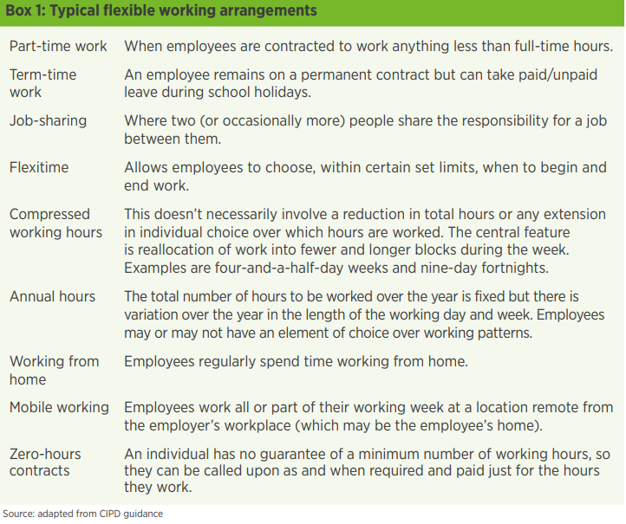
Figure 1.CIPD FLEXIBLE ARRANGEMENTS
According to the CIPD research and figure 1, a mobile/hybrid technique was recently implemented following the pandemic (CIPD, 2019), allowing individuals the benefits of working from home as well as a mobile working method effectively incorporated by some organisations such as DHL Consulting.
According to the megatrends CIPD report study, the UK appears to have a high percentage of its workers working part-time or with some control over their working hours, and the rationale offered is that the number of 'involuntary' part-time growth is expected to increase amid global recession. However, weak economic conditions may discourage businesses from providing, or employees from demanding, flexible working hours (CIPD, 2019). According to Casey Panetta from Gartner, changes in working accommodations began in 2018 when many firms began to perceive the flexible or work from home approach as a method to cut organisational expenditures (Panetta, 2020). "The COVID-19 epidemic struck at a time when economies were already on the verge of collapse," says Mark Raskino, Distinguished Vice President Analyst and companies had to provide a healthy working environment for their employees meaning that effectiveness may be deteriorated.
Andrew Willshire in a recent article defined the problem for companies that consent to remote/hybrid working (to varying degrees) is how to properly supervise the performance of employees who are not in the office five days a week (Andrew Willshire, 2022). Many businesses face difficulties when it comes to effective performance management. Employment law requires that all employees grasp the necessary benchmarks and goals for their role. If there are performance targets involved, a committee will want to be satisfied that personnel may be expected to be aware of them. Periodic one-on-one discussions and assessments are one of the most efficacious strategies to manage effectiveness. A comprehensive assessment can give critical information of deficient performance that can be used to justify additional action, whether casual or official. In the case of termination, an organization is better positioned to demonstrate that opportunities for improvement were provided if frequent assessments were conducted. It also enables the company to identify areas where the individual requires more assistance or changes.
DHL Consulting Division for example has presented a distinctive strategy in reference to mobile working as a standing example of managing people for flexible working techniques.
DHL Consulting offered a mobile office option for all workers at its Bonn office, allowing employees to work from any place for six days each month. The goal was to provide people more freedom at work while also allowing them to manage things in their personal life that required focus, attention, or time. This policy has been revised after the COVID-19 epidemic began, and any employee can work an infinite number of remote days. Even once the pandemic lockdowns are lifted, this approach will remain the norm explains HR Marketing Expert at DHL Consulting (Werner, 2020).
In 2017, Labour Force conducted a poll to determine how many respondents had any flexible working pattern, and the results are shown in the figure below.
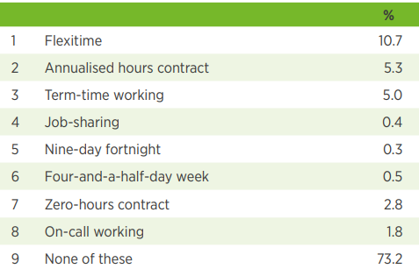
Figure 2. Labor Force Survey, 2017
Office for national statistics has not been able to redo the same survey for 2022 but other datasets such families and the labour market: flexible and homeworking are able to offer such an insight of how much changed working pattern after pandemic.

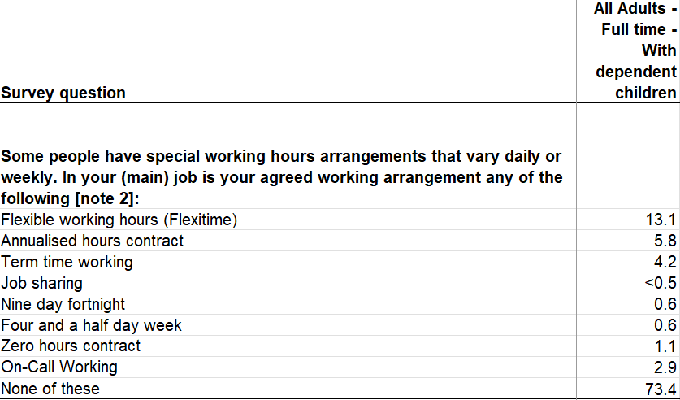
Figure 3. Flexible and homeworking ONS dataset
From figure 3 the dataset is offering an insight for question of any working agreements for adults with children. Comparing figure 2 with figure 3 Flexitime working pattern has increased by ~2% and none of these slightly 0.02% regarding contract stable working pattern meaning that people still work a fixed working pattern as they did back in 2017.
There may be a reason after pandemic the percentage of flexible working has slightly increased but still fixed contract is chosen by employees. Employers who use flexible employment methods may face a number of challenges in effectively implementing such techniques. Most common reasons identified by CIPD (CIPD, 2021) are:
- Overcoming worries about operational constraints and satisfying client demands.
- The present views of line managers about flexible working.
- Managing co-workers’ fears about the impact of flexible working on them.
- Organizational culture that exists.
- A lack of senior-level support.
- Inability to assess employee success based on outputs rather than hours worked.
CIPD has advice for organizations to properly adopt flexible working (CIPD, 2021):
- Clarify the advantages of flexible working for both the organisation and the person.
- Find a compelling hook or business necessity that will get momentum inside your organisation.
- Dispel myths about what flexible working is and who it is for, share accomplishments, and establish communities through communication.
- Create a clear procedure for flexible working that includes clearly defined roles and duties for workers, line managers, and HR.
- Find unique methods to support a variety of flexible working practises for all employees, both in terms of innovative flexible working programmes and inventive ways to embed flexibility into job functions that have historically not been viewed as fit for flexible working.
- Hire flexibly and develop employment to fit the flexible pattern.

The employee's legal situation is also a consideration that occasionally prevents workers from requesting flexible working hours. In the United Kingdom, a 2003 rule applies to all workers who have worked for at least 26 weeks in a straight, regardless of parental or care responsibilities. “Employers are obligated to conduct a fair examination of requests for flexible working and can only deny a request for flexible working if they can establish that one of a restricted number of factors apply. Acas has supplied companies with guidelines and a Code of Practice to help them deal with such requests fairly” (ACAS, 2019).
“Progressive firms are turning away from an employee-centred value proposition and toward a human-centred value proposition that respects employees as individuals rather than as employees” (Gartner, 2021). The digital revolution has established a super competitive environment for vital talent, and its greater openness has transformed the behaviours and expectations of that expertise. Because of the internet revolution, it is now easier to deploy flexible methods than it was 30 years ago. Many tasks, such as office work, may be done from home. Many programmes and internet optimization traffic allow businesses to recruit remote work personnel. Now how can a firm evaluate employee value as to implement a payment structure?
Most businesses do evaluations on a routine basis, usually once a weekly. The assessment often consists of a review of the employee's various job tasks and tendencies to requirements. Companies must have a consistent assessment framework in place and analyse each individual employee against those standard measures to successfully evaluate an employee. Promotions, incentives, and increases are frequently based on evaluation outcomes. Regular assessments assist employees in better understanding what is required of them, increase communication between management and staff, and provide employees with appropriate appreciation for their efforts. Workers might quickly get disengaged if their employer does not provide a compelling value offer.
HRM is often approaching an EVP strategy which symbolises the value that workers are expected to offer as well as the value that they may anticipate receiving in return. HR experts believe recruiting is becoming more like marketing. A business invests in its workers for them to invest in firm. It is the offer that underpins whole employer brand. Creating an EVP necessitates time engagement from all levels of the firm.

The flexible working position is challenged by the measures of payment. According to Dawn Nicholson, HR consulting partner at PricewaterhouseCoopers, the usual way of apportioning compensation may need to be revisited and replaced by organisations paying flexible workers more closely based on their outputs and productivity levels (PWC) (Paterson, 2012). Flexible working primarily assists parents and caregivers by allowing individuals to balance employment and other responsibilities and boosting the UK labour market by creating more diversified working patterns was the topic discussed in a parliament meeting. Employees working compressed hours or flexitime can be regarded the same as full-time employees for payroll reasons, which means their salary and holiday entitlement remain the same.
Moore pay gathered some datasets from CIPD, business wire and wildgoose UK then calculated the percentages for surveys. Results are presented below figure 4
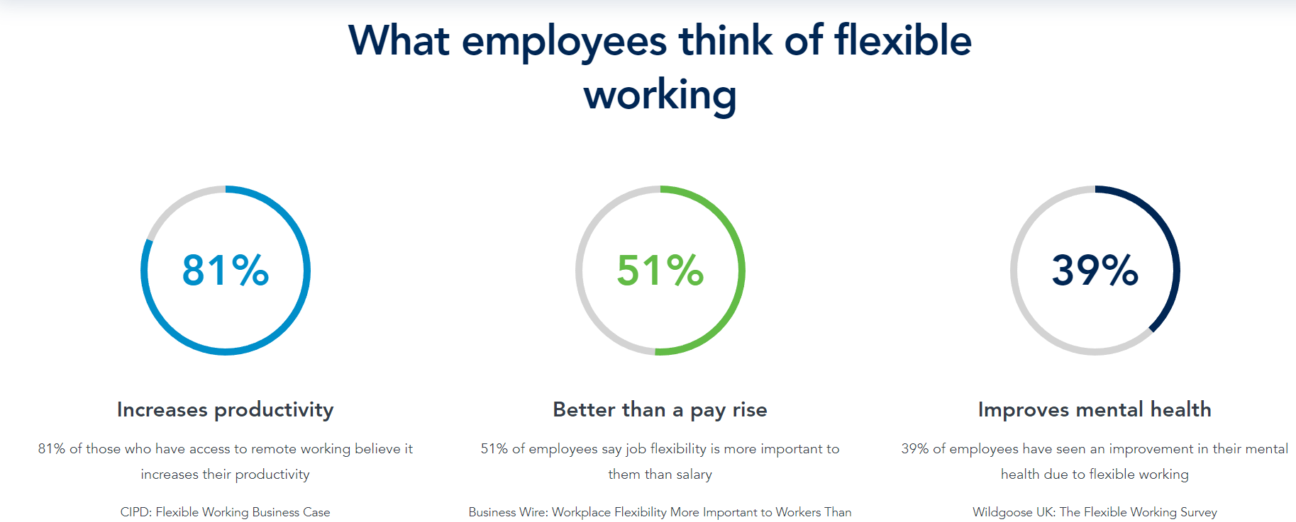
Figure 4. Datasets about flexible working(moorepay,2022)
From Business Wire dataset it was found that people are better on flexible job with lower pay rate that on fixed contract with a little pay rise. Wildgoose UK dataset showed the importance of mental health has improved due to flexible working.

Conclusion:

Before the Covid 19 epidemic, flexible working patterns and ways for implementing them were available. Companies had to adjust to this trend as global economies began to weaken in 2018, and with them, working flexible requests began to rise. During pandemic shutdowns, remote flexible working strategies were used internationally as the primary pivot point for many businesses. Companies such as DHL pioneered the mobile/hybrid flexi work approach. Employers are adopting remote working models because technology allows them to manage some jobs, such as office clerks or IT assistance. The payment approach has stayed the same, with pay for hours worked and holiday entitlement modified based on working hours. Recent studies revealed a minor increase in flexible employment demands, but the mass of the public still prefers permanent contracts. Laws are being passed to assist families in finding flexible work arrangements. According to various polls, persons who work flexible/remotely/mobile/hybrid hours are mentally healthier, happier, and prefer to work for less money but on their desired work schedules.

Reference list
ACAS (2019). Making a flexible working request | Acas. [online] Acas.org.uk. Available at: https://www.acas.org.uk/making-a-flexible-working-request [Accessed 3 Aug. 2022].
Andrew Willshire (2022). How to best manage performance with remote and hybrid workers. [online] www.peoplemanagement.co.uk. Available at: https://www.peoplemanagement.co.uk/article/1794205/best-manage-performance-remote-hybrid-workers [Accessed 3 Aug. 2022].
CIPD (2021). Flexible Working Practices | Factsheets | CIPD. [online] CIPD. Available at: https://www.cipd.co.uk/knowledge/fundamentals/relations/flexible-working/factsheet [Accessed 3 Aug. 2022].
CIPD, C. (2019). FLEXIBLE WORKING. [online] Available at: https://www.cipd.co.uk/Images/megatrends-report-flexible-working-1_tcm18-52769.pdf [Accessed 4 Aug. 2022].
Citizens Advice (2019). Flexible working - what is it. [online] Citizensadvice.org.uk. Available at: https://www.citizensadvice.org.uk/work/rights-at-work/flexible-working/flexible-working-what-is-it/ [Accessed 3 Aug. 2022].
Drucker, P. (2020). Future of Work: 8 Megatrends Shaping Change | Future Careers | GetSmarter Blog %. [online] GetSmarter Blog. Available at: https://www.getsmarter.com/blog/market-trends/future-of-work-8-megatrends-shaping-change/ [Accessed 3 Aug. 2022].
forum, E. (2020). How the post-COVID workplace will change business for the better. [online] World Economic Forum. Available at: https://www.weforum.org/agenda/2020/07/how-the-post-covid-workplace-will-change-business-for-the-better/ [Accessed 3 Aug. 2022].
Gartner, G. (2021). Strengthen Your Employee Value Proposition. [online] Gartner. Available at: https://www.gartner.com/en/human-resources/insights/employee-engagement-performance/employee-value-proposition [Accessed 4 Aug. 2022].
HRSUPPORT, H. (2019). The HR Booth | How are Flexible Working Patterns Changing the Role of HR. [online] The HR Booth. Available at: https://www.thehrbooth.co.uk/blog/hr-support/how-are-flexible-working-patterns-changing-the-role-of-hr/ [Accessed 3 Aug. 2022].
national (2022). Flexible working | Working patterns. [online] UNISON National. Available at: https://www.unison.org.uk/get-help/knowledge/working-patterns/flexible-working/ [Accessed 3 Aug. 2022].
Panetta, K. (2020). 7 Macro Factors That Will Shape Business in the 2020s. [online] Gartner. Available at: https://www.gartner.com/smarterwithgartner/8-macro-factors-that-will-shape-the-2020s [Accessed 3 Aug. 2022].
Paterson, J. (2012). Flexible working could challenge pay strategy. [online] Employee Benefits. Available at: https://employeebenefits.co.uk/issues/november-2012-online/flexible-working-could-challenge-pay-strategy/ [Accessed 5 Aug. 2022].
pay (2022). The ultimate guide to flexible working. [online] Moorepay. Available at: https://www.moorepay.co.uk/the-ultimate-guide-to-flexible-working/ [Accessed 5 Aug. 2022].
Universumglobal, U. (2017). What Makes the EVP So Important to Your Employer Brand? | Blog. [online] Universum. Available at: https://universumglobal.com/blog/makes-evp-important-employer-brand/ [Accessed 4 Aug. 2022].
Werner, M. (2020). Mobile Working – Flexibility and Trust DHL Consulting. [online] DHL Consulting. Available at: https://dhl-consulting.com/insights/blog/mobile-working/ [Accessed 4 Aug. 2022].
whatishumanresource.com (2011). What is Human Resource? (Defined) Human Resource Management Topics - Labour Laws - High Courts & Supreme Court Citation - Case Laws - Human Resource Management - What is HRM? - Definitions - Functions - Objectives - Importance - Evolution of HRM from Personnel management. [online] www.whatishumanresource.com. Available at: https://www.whatishumanresource.com/human-resource-management [Accessed 3 Aug. 2022].

