Steel frame vs
Concrete core construction
(Empire State Building (New York) Vs Aqua building(Chicago))
By Al David Ikete
Student number: 1902411
Material Science and Building Services

Table of Contents
Introduction………Pg3
The Empire State (steel frame)………Pg6,7,9
The Aqua tower ……Pg10,11,12,13,14
Bibliography and referencing ……15

Introduction:

In a modern age where faster construction is always on-demand, as well as the need to build taller more structurally stable buildings in the world’s cities and the ever-growing demand for them to adapt with climatic changes and booming city populations and every day practical uses. Engineers and architects alike have two different methods of constructing skyscrapers, and those two methods are steel framing and concrete core. These are the methods report will carefully explore; however, it will be taking a look at two buildings that have used these methods in their construction. The report will analyse; the time frame in which the two buildings where put up, whether they are deemed structural stable and any issue they design team may have faced during and after their construction.

Empire state
(Steel frame)

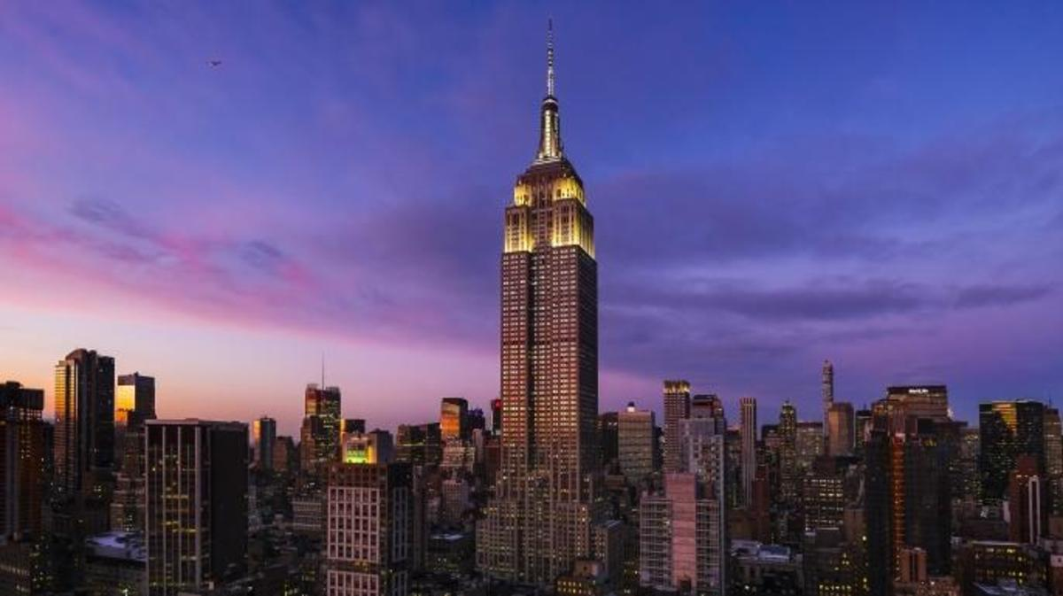
Figure 2 The Empire state

Development and Planning

- The empire state building was built during a period where there was an urge to make the worlds tallest building. As New York saw an economic boom like never before and the main competition for the building was the 40 Wall street bank of Manhattan building and the Chrysler Building, therefore General Motors executive John j. Raskob and former New York Governor Al Smith announced plans for the empire state building.

- In 1929 plans were finally drawn for the building. However, Chrysler changed his plans one final time and fixed a stainless-steel spire to his structure at a soaring 1049 feet upon finding out that the Empire State would be 1000 feet high. However, Raskob and Smith went back to the drawing broad and returned, presenting a taller empire state.

- Upon its completion, the empire state building stood at soaring 1250 feet tall claiming the title of worlds tallest building and held the title for 40 years until the construction of the twin towers in 1970.

Construction of the building

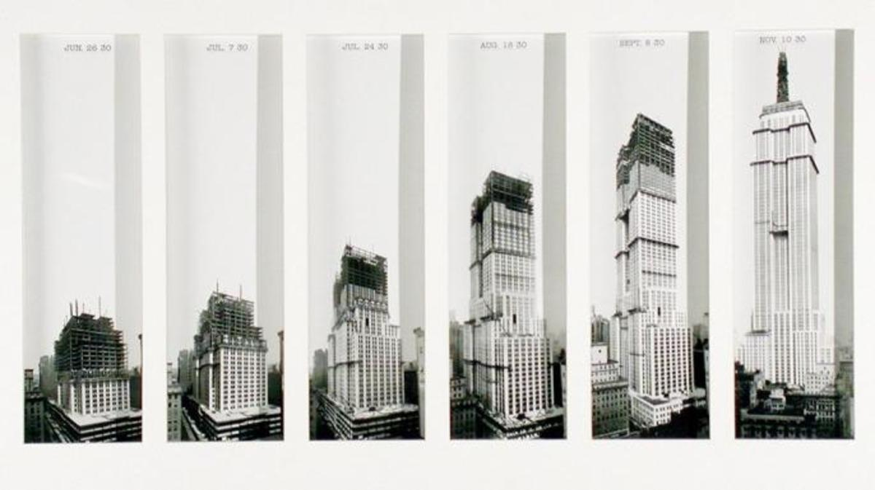

Figure(shows the construction of the building)

The building was constructed using a steel frame inner skeleton, that has been encased by brickwork as well as a granite cladding giving it exceptional resistance to weathering and also giving the building a great exterior finish.

The construction of the building took a year and 45 days to complete this included Sundays and holidays, and this was record time during 1930 as building a skyscraper of such nature would usually take longer.

The fast construction of the empire state was due to it being a steel-framed building, and steel frame constructions are quicker to put together as the majority of the sections and components can be prefabricated and assembled on-site. In contrast, concrete core-based skyscrapers require for the concrete to be mixed off-site and then it would have to be poured on-site. Whereas, concrete core buildings in 21st century ‘take on average two years to complete” according to the journal (concrete quarterly), so, therefore, proving that steel framing is a faster mode of construction.

Due to the period in which the construction took place, the building was completed using a workforce of 3000 people according to (CNN Info). However, this enabled the building to be completed in the time frame in which it built in.

However, steel framing is costly and has a high carbon footprint as a result of the transportation and production methods. The empire state was completed at the cost of 41 million US dollars, however, the concrete quarterly states that concrete core framing is “economically advantageous” in comparison to the steel framing method, especially in today’s economic climate. Even during the period of its construction, the empire state was still expensive as it was constructed during the period of the great depression.

Framing of a building

Steel frame constructions are used mainly used for large simple structures, such as garages, large agricultural buildings and warehouses, as well as high-rise buildings.
Steel framing offered the designers of the Empire three main advantages which were, durability, affordability and sustainability:
Durability-
Structural steel sections are lighter and stronger than weight-bearing concrete. Weight-bearing steel fabrication is 30% to 50% lighter than a concrete equivalent; this is because steel is tensile.
This makes steel-framed constructions stronger and increasingly more durable than of a concrete frame alternative. Additions of bracings to the steel frame increases its stability against loads such as seismic pressure and wind loadings.
This offered the designers of the empire state a material which durable and cheap. This made sense because, during the great depression, the New York and American financial sector had been affected.
Steel frame constructions are highly resistant to fire. However, this can only be achieved if a flame retardant is sprayed on to the building as steel has a melting point of 500 degrees Celsius (930 degrees F). In the case of mild steel which is used in a majority of constructions, it can lose almost half its strength, just like in the collapse of the world trade centres in 2001. The fire-retardant coating helps increase the structural integrity of the steel, whereas concrete buildings do not require a fire-retardant coat due to the chemical properties of the concrete.

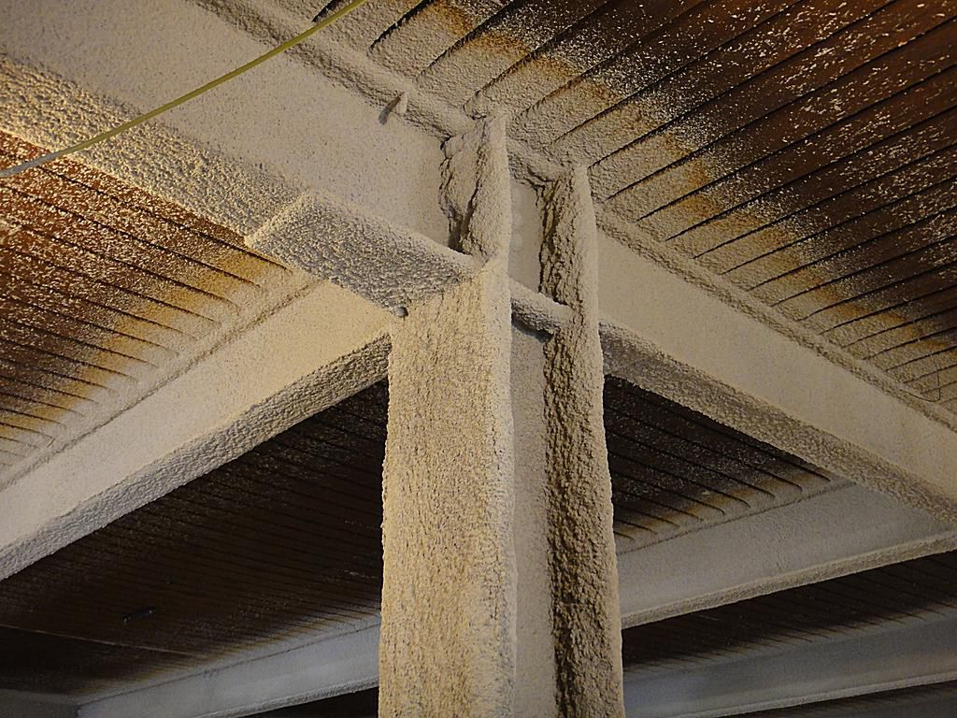
Figure 2 ( shows how in this instance concrete spray has been used as a fire retardant.)

Climatic resistance-
Structural steel has higher moisture resistant properties compared to concrete; however, this depends on its carbon content. A hot zinc coating and powder treatment can enhance the steels rust-resistant and make it immune to the effects of acid rain.
Due to steels molecular properties making it tensile and flexible, steel can withstand seismic forces and withstand gale-force winds. This allowed the designers of the empire state to build high than ever at the time of construction, whereas if it were a concrete building the winds would sway the building and slowly reduce the structural integrity of the building.

Sustainability (environmental impact)-
As a result, of the Empire state being a steel core structure, this allows the possibility for the building to be adapted to, therefore increasing the life span of the building. In the case of the Empire state building, there were planned proposals in the early 70s to add an 11th floor to the building. However, it required the demolition of the building’s 16 story tower to be conducted and be replaced by a new top; however, plans were promptly dropped due to cost concerns.
Due to a high carbon footprint during the buildings active use the owners made the decision to renovate the building to reduce the use of energy by “40% reducing its emissions to 105000 metric tonnes a year” (Pilkington, The Guardian). By adding an extra layer of insulation by secreting a layer coated film in between the two windowpanes. This increases the building's capacity to retain heat, therefore, lower its carbon footprint. A well-maintained steel building has a life span of 30yr plus.

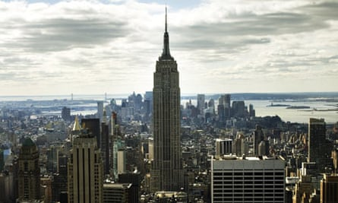
The Empire State Building in New York is getting a $20m environmental makeover Photograph: Murdo Macleod/Murdo MacleodPhotograph: Murdo Macleod.

The Aqua Building
(Concrete)

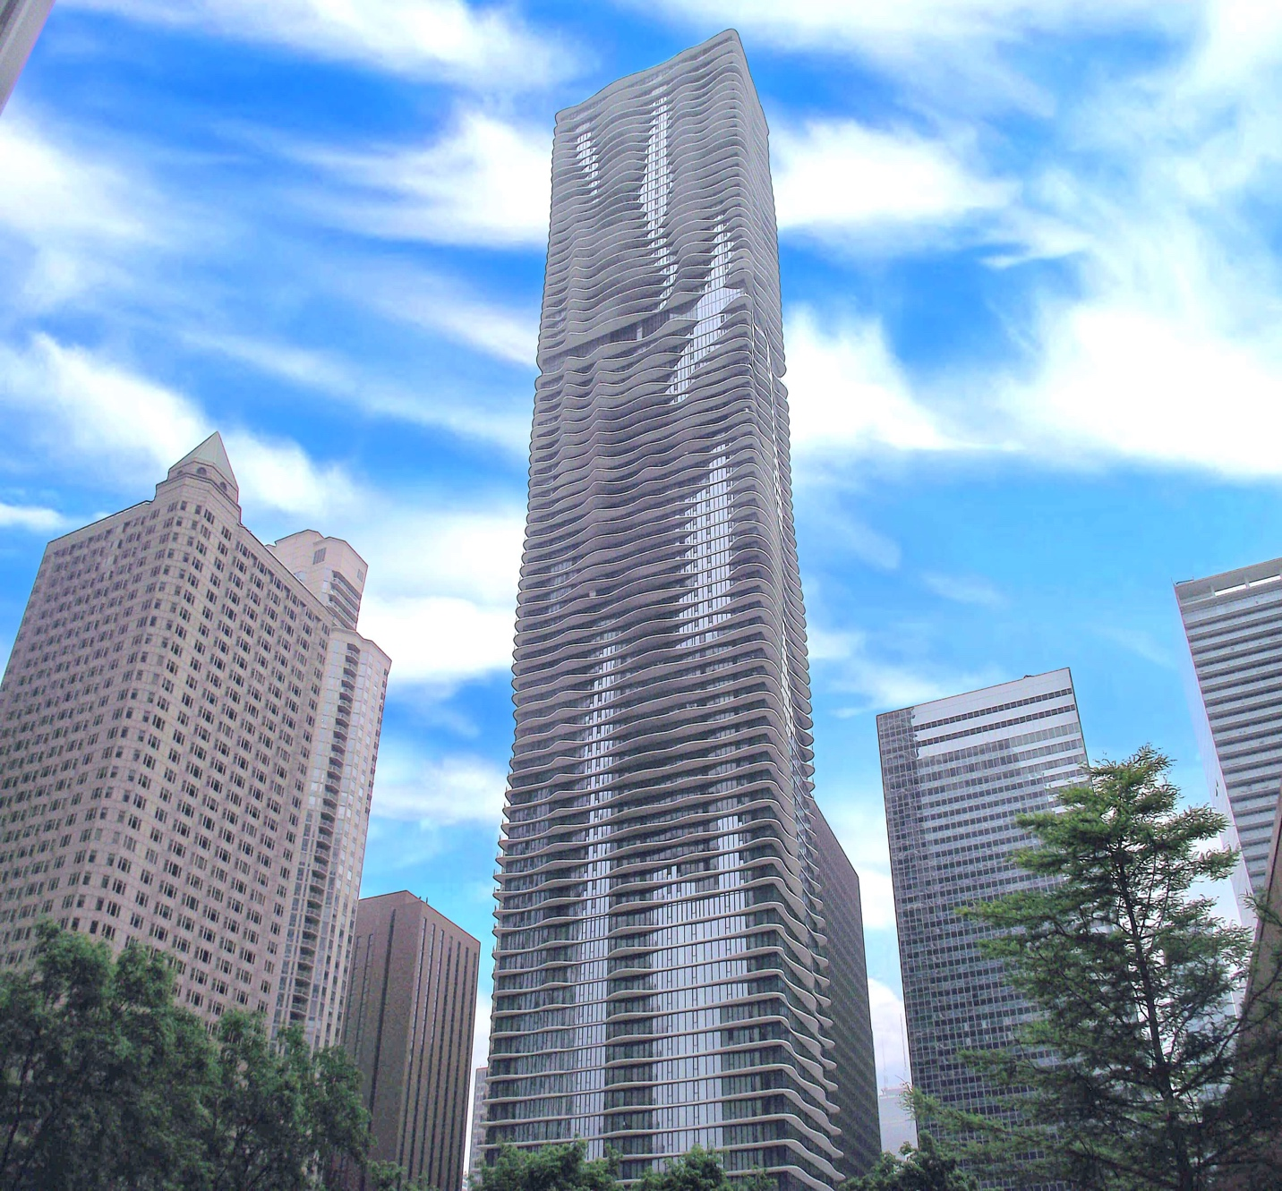
Figure 3 The Aqua tower

Why was it built?
The Aqua Tower is an 87storey skyscraper that combines both domestic and leisure use in one. A Building erect in 2009, its futuristic design was thought of and brought to life by architect Jeanne Gang. It contains 750 residential units; the Aqua Tower serves as a multipurpose building that serves the local Chicago population. Costing at $308m (£188m) is proven to be an addition to Chicago’s skyline. The aqua tower took two years to build is a concrete structure whereas the empire state took one year 45 days and is taller in height.
The project became effective in 2006 and work began on March 12, 2007.

Built by concrete works company McHugh, the construction of the Aqua was faced with challenges such as the use of five types of different glass in its windows, its size and pedestal, to multiple site issues.
Description | Technical data
The tower has a podium of 13,000 m2 on three floors, structurally separate from the tower. The facade, with its irregular curves and opaque glass designed to prevent bird collisions.  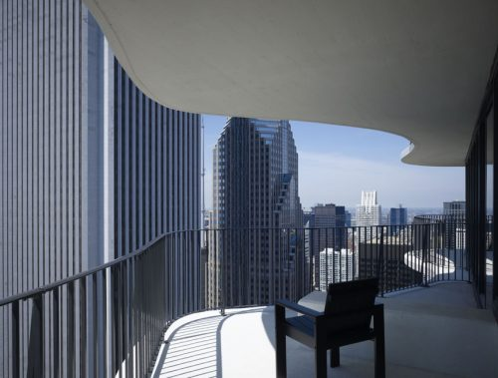  The balconies are rippled, slightly varying forms in each plant and creating a surface similar to a curtain. Its depth has been calculated to maximise the sun protection and the views beyond the perimeter of the building. In the bedroom area fly approximately 3.7 meters, reducing or varying their surface as they travel along the glass, thus allowing them to have a changing facade on all four sides of the building. | - Height 249.74 m  - 82 apartments on surface  - Floor area 1.9 million meters square  - Structural Concrete Materials  - Material concrete facade  - System structure exposed façade  - Colour White facade

Framing of the building
The Aqua tower designers have used a concrete frame; this is a form of structure, comprising a network of columns and connecting beams that form the structural skeleton of a building. This grid of beams and columns is usually constructed onto a concrete foundation and is use the floor above. In the case of the Aqua tower, the engineers used a concrete core with every floor taking a unique shape.
Durability- Concretes durability allows for concrete structures to achieve a long life and maximise their performance, keeping their whole-life environmental impact to a minimum, therefore reducing the life-time carbon footprint of the building, this appealed to the designers of the Aqua Tower as it takes into consideration biophilic design and the liquid form of the concrete allowed Gang the architect to sculpture each floor of the building shape of waves, therefore, giving the building a free-flowing look and this is something you cannot do with a steel frame building. With the majority of buildings in Chicago being of a concrete frame; therefore, this impacted the material choice of the aqua building.
The durability of concrete structures means that once built. They are rarely out of use for maintenance whereas with a steel-framed building such as the empire state building they may be the need to replace a structural beam and this may cause social disruption, affecting the everyday use of the building.
Concrete is a very durable and stable material with a long life span. As a result of this, the building maintenance cost is low.
Construction
The reinforced concrete structure is supported by 31 drawers drilled into the rock 110 meters below ground and placed six meters in a layer of dolomite. These are supplemented with 274 bells of compressed air, smaller and sunken clay.
Although the Aqua Tower is a building whose structure is concrete, levels 1, 2 and 3 were constructed of steel, creating a metal tray on which to spread the concrete.
The steep walls tower used to transfer loads of the columns, instead of downloading on the flagstones of the floor slabs.
A global positioning system guided the construction of curved shuttering at the edges of the balconies. Each floor plate has a unique curve on the side of the slab and had to be created individually.

Climatic Resistance- Concrete is resistant to humidity, one of the main factors that concrete last so long in humid conditions is its lack of organic compound, as none of the elements used to make concrete do not decompose. Unlike materials like steel, concrete can breathe; therefore, moisture can easily escape, which prevents water from causing long term damage to the structural integrity of the concrete.
Although being immune to almost every weather condition, the cold still poses as a threat to concrete as the exposure of fresh concrete to the cold will not just only affect its physical properties but also its mechanical properties. A decrease in the temperature in which the concrete is exposed too, the compressive and tensile strength values, static modulus of elasticity values are also decreased whereas the compressive and tensile strength of the structural steel is not affected by the cold, however, by extremely high temperatures (Yan Yao, 2015).

Sustainability (environmental impact)- Concrete sustainability does not come in the direction of it is a reusable material. However, that it has a long life span and the building can serve a different purpose just by changing the interior décor yet the change in MEP and building services would demand the floorboard and disrupt the social use of the building.

The Co2 emission for the construction of the Aqua tower was 104,000m3 of concrete used x 1.840, which equal 191,360tonnes x 780, which equalled 149,260,800,0 cubic tons of co2 emitted during the construction process.
Calculations show that the embodied carbon content of a concrete structure is lass than that of a steel structure, according to David Bennett’s, RIBA publishing 2010. The publishing states that “steel-framed buildings have three times the embodied carbon of a concrete framed building.”

 | Unit | Bennett ECO2 factor | Adjusted ECO2 factor | Comment on adjusted factor (from ICE v2)
Concrete | kgCO2/m3 | 156.4 | 326 | C32/40 with 25% GBBs ( 133kgCO2/t) *
Steel | kgCO2/t | 5,216 | 1,530 | UK average
Reinforcement | kgCO2/t | 485 | 770
Steel decking | kgCO2/m2 | 29.1 | 21.5 | Based on UK ave steel
* 50% GGBs is not typically used in concrete mixes in buildings due to the extended time to gain strength. For a fairer comparison of the steel and concrete buildings, a 25% GGBs mix was assumed for the adjusted calculation.

Referencing

(Bradley, 2013 ) (Anon., n.d.) (Razzi, 2013) (WHITE, 2017) (Anon., 2019)
(http://www.understandconstruction.com/steel-frame-structures.html)
(Bennett, 2010) (York, 2009) (GANG, 2013)
(https://edition.cnn.com/2013/07/11/us/empire-state-building-fast-facts/index.html)
(https://edition.cnn.com/2013/07/11/us/empire-state-building-fast-facts/index.html)
(Minson, 2016)
(https://www.sciencedirect.com/science/article/pii/S0008884615001581)
(Yan Yao, 2015)

Bibliography
Anon., 2019. Steel frame. Designing Buildings Wiki.
Anon., n.d. Aqua tower. [Online]
Available at: https://en.wikiarquitectura.com/building/aqua-tower/#
[Accessed 5 1 2020].
Anon., n.d. st. [Online].
Bennett, D., 2010. sustainable concrete Architecture. s.l.:Riba publishings .
Bradley, D. C. &. D., 2013 . Embodied carbon of steel versus concrete buildings. cundall, Issue 1.0, pp. 3,4,5.
GANG, S., 2013. STUDIO GANG ARCHITECTUAL REVEALS. NEW YORK : PRISTON ARCHITECTAL PRESS NEW YORK.
Minson, A., 2016. Secrets of a long life, london: mpa The concrete centre .
Razzi, E., 2013. Water and Concrete: Looking at Chicago’s Aqua Tower. Urbanland.
WHITE, G., 2017. The Advantages & Disadvantages Of Steel Frame Construction. GLW Engineering & cConstruction Ltd.
Yan Yao, C. S. ed., 2015. Recent durability studies on concrete structure. In: cement and concrete research . s.l.:Keynote papers from 14th International Congress on the Chemistry of Cement (ICCC 2015) , pp. 143-154.
York, E. P. i. N., 2009. This article is more than 10 ye. Green buildng.

