Nikisha Talbot
Student number: 2113109
Joyful play nursery project management plan.

Table of contents.
- Executive summary
- Introduction
2.a. project description.
- Scope and Gannt chart
- Quad chart
- Work breakdown structure
- Allocation of resources and financial breakdown
- Risk analysis

Executive summary.
Included in this business proposal is a detailed description of the project, the project scope including any objectives and deliverables. A Gannt chart has been developed to aid the efficiency of the time keeping aspects of the project. A quad chart has been created to pinpoint the KPI’s of the project and clarify the desired result of this project. The work break down structure gives a detailed account of the work required and the steps that will be taken to fulfil the requirements of the project. There is an allocation of resource chart with a detailed financial breakdown, and most importantly a risk analysis.

Introduction
This project is a detailed management plan for a nursery proposal. Project management is a tool designed with realistic set goals and a timeframe. It is a business management tool (Galante, 2023). In this project management plan all aspects of a nursery proposal will be covered, with a full breakdown of work required, finances needed and charts to illustrate figures and time frames. A nursery is required to comply by certain regulations and throughout the project their will be checks to ensure that all regulations are complied with.

Project description

The idea for joyful play nursery arose when 4 parents found common ground with each other, in the fact that they could not find childcare to suit their needs. And with that connection came Joyful Play Nursery. As a nursery they are committed to giving the best possible care to the children, and much reassurance of safety for parents. It was decided by joyful play nursery group after much research and deliberation that there was a gap in the market for a nursery with longer operating hours as working hours tend to be longer than the hours of childcare. Joyful play nursery will have operating hours from 7am till 8pm. The project has a budget of £100,000 which will need to be delegated appropriately and efficiently. Joyful play nursery will be the leading nursery in Birmingham with some of the best special needs services and also serving healthy and nutritious halal meals to their children. The nursery will employ 1 caretaker, 2 admin assistants to take care of general enquiries, 1 caterer, at least 1 teacher per 3 under 2year olds, at least 1 teacher per each 5 two-year-olds and at least 1 teacher per each 13 three-year-olds. These are the lawful requirements of the nursery. in line with regulations from Birmingham city council, all teachers will require a clean DBS record and to be health and safety trained regarding under 5-year-olds. An Ofsted inspection will be required before the Nursery can officially open, and the Nursery group will aim to get an outstanding report. An independent security firm will be required to secure the building and ensure an efficient and safe system is in place to take care of staff and children.

Scope and Gannt chart
Need: Birmingham parents need a nursery that supports their working hours and their Childrens’ needs. A nursery serving nutritious meals and have enough variation to cater to special eating requirements. A nursery following all lawful requirements with outstanding Ofsted reports.
Project scope/requirements: Joyful play nursery group have decided to open a nursery that runs from 7am till 8pm. This nursery will have a leading special needs department with 2 fully trained and well experienced SENco staff running that department. This nursery will also be serving healthy and nutritious halal hot meals to children every day. Each child enrolled at this nursery will have individual childcare plans created by the nursery manager catering specifically to the Childs’ needs. This nursery will also offer payment plans for parents struggling to pay all fees at once. Playful Joy nursery will pride themselves on putting the customer first. This project will cost no more than £100,000 to get up and running. This nursery will not only benefit the parents and children but also the city of Birmingham.
The building that is chosen to facilitate the nursery will be safety checked and risk assessed thoroughly. This project has a timeframe of 3 months. The nursery building will be required to have a main reception/office area with a security door leading into the nursery where children can be let in. 3 additional rooms will be required the main nursery room, the main hall used for activities and a sensory room, the building will also contain a kitchen and 3 toilets.
Project Objectives:
- Select a suitable location that fits all location requirements.
- Employ and correctly train all staff required (health and safety training, childcare training etc)
- To efficiently comply with all Ofsted, Birmingham city council and UK education law requirements
- Complete a marketing plan based on research conducted around this nursery.
- Have an efficient financial plan that suits the needs of the project.
Deliverables: A successful open day resulting in a minimum of 25 parents completing admission forms
A fully furnished running nursery with an advanced SENco department, A fully stocked halal kitchen, 2 Nursery managers and 2 chefs, the correct number of teachers required for the children enrolled as required by law.
An outstanding Ofsted inspection.
Good reviews from parents.
Resources:
- £100,000
- Project manager – One person (needed throughout duration of project)
- Design manager – one person (needed for 5 days of the project)
- Marketing and recruitment manager – 2 people (needed for duration of the project)
- Researcher – 1 person needed (for duration of the project)
Constraints:
- Must be within the central Birmingham Area
- Budget of £100,000
- Project must be completed by March 2024.
- All staff must have a clean DBS record.
- Must comply with all Ofsted regulations.
- Must employ the correct number of teachers for the amount of children enrolled (regulations must be complied with).
Assumptions:
- Will be within budget of £100,000.
- Will be finished before March 31st, 2024.
- Will be situated in central Birmingham.

Gannt chart
(figure1.)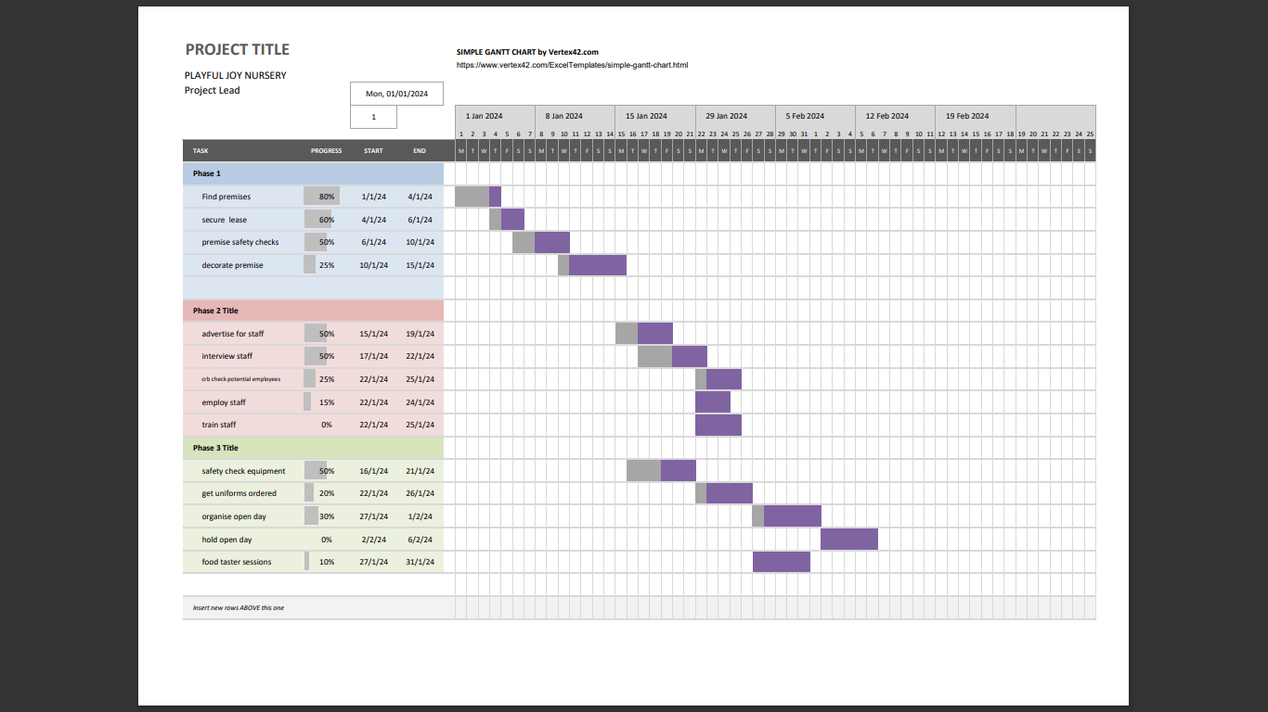
(Figure 2.)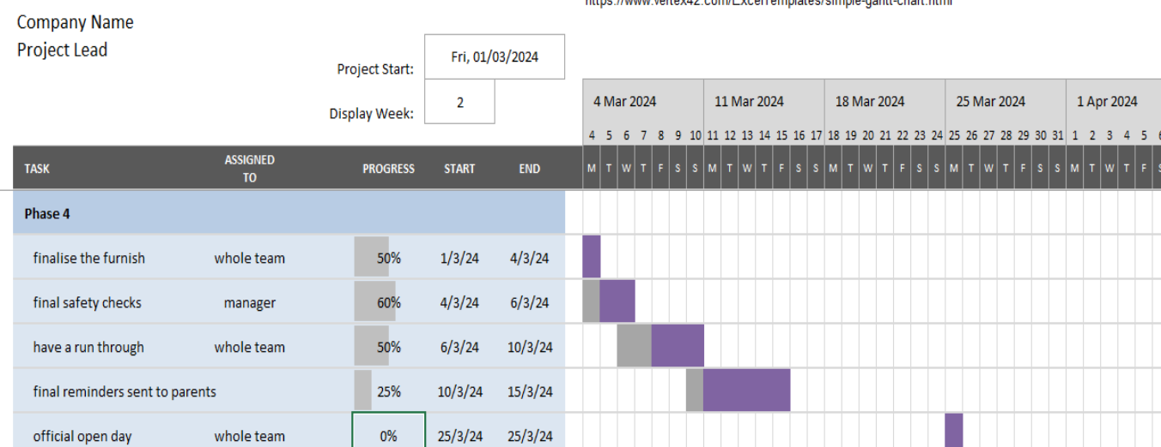
Displayed here is a Gannt chart created for the purpose of the joyful play nursery project. The timescales mentioned are from 1st January 2024 start date. phase 1-3 are estimated to be completed by 19th February 2024 when phase 4 will then be completed bringing the team to a finish date of March 25th, 2024, And the final finished product the official opening of Joyful Play Nursery. A Gannt chart is required to give a visual representation of the timescale the team should follow. This is to aid efficiency of the project. A Gannt chart is a visual project management tool (Shweta, 2022)

Quad chart

Purpose  - Developing & learning essential life skills.  - Generating income  - Independence  - Supporting working parents  - Supplying childcare for longer hours  - Providing healthy halal meals and fresh organic fruit to children  - Improve childcare in Birmingham.  - Provide more jobs for residents of Birmingham. | Customers  - Families  - Working parents of Birmingham  - Employers  - Children with special needs
Desired result  - Children happily developing in a safe environment.  - Outstanding Ofsted report  - Fully furnished and operating, Birmingham city council and Ofsted approved nursery.  - Reach full capacity once open. | Measure of success  - Increase of the demand for our services  - Working with full capacity(full)  - Professionally trained and accredited staff  - Correct fees charged.  - Fees paid on time.  - Positive reviews  - Possibility of more nurseries if successful
(figure 3.)
to further aid the efficiency of the project a quad chart is inserted above see (figure 3). The quad chart gives a detailed overview of the desired result and the success factors. The purpose of this quad chart is to highlight KPI’s for this project to establish a clear route to success. One of the main KPI’s highlighted is a nursery running at full capacity. Operating at full capacity would mean that all spaces were filled, and the nursery was fully booked, this is a good indicator of success. A key purpose highlighted here is the improvement of childcare in Birmingham, the team have a personal passion for improving the quality of childcare with extended hours and nutritious food. This will provide a lot more support for working parents. The desired result has many aspects, most importantly the goal is to provide a safe and happy environment with the best early years education and services.

Work breakdown structure
A work breakdown structure is a project management tool that is used to aid the success of a project by breaking down the large goal into smaller goals which reach the same desired result and help provide structure for the team (Organ, 2023). Another visual tool.
(figure 4.)
If the work breakdown structure is followed accurately and cross referenced with the Gannt chart (see figures 1 & 2) to ensure that timescales are adhered to, upon approval from regulating bodies such as Birmingham city council and Ofsted then Joyful Play group will open Joyful Play Nursery. as seen above (Figure 4) the nursery group will first have to get the building approved for use as a nursery before continuing the project. If this step is unsuccessful a new building will have to be located. Once the lease for the premise has been secured security checks will be completed and a design will be chosen for the nursery. phase 2 entails the securing of staff. During this phase the team will need to advertise for staff, interview people that fit the criteria and also train any suitable staff. All staff members will need to be DBS checked and cleared. This is to ensure the safety of all children staff and parents. Upon completion of training successful candidates will be officially employed. Phase 3 involves the arrival of all the equipment needed. All specialist equipment will need to be safety checked, this will include all sensory items and kitchen equipment. Before the official opening of the nursery an open day is required, this will be meticulously planned to make sure that the correct amount of people will be invited. An Ofsted and a Birmingham city council representative will be invited to the open day event. Upon success of the open day a minimum of 25 children will be enrolled. This is a key performance indicator that if not met will require an improvement on the marketing strategy. The final phase includes the finalising of the furnishings within the nursery building and a run through day for the staff. This is a day where staff will act as though they are having their first official working day everybody will be required to turn up on time and complete a full shift day, from 7:30 am till 8:30pm. The purpose of this is to make sure each staff member is familiar with their role and allows for the training to be put into practice, this also gives time before opening to correct any issues or complications.

Allocation of resources and financial breakdown
Resources allocation Is the way in which resources are used for successful and positive outcomes (390, 2017). For this project the most relied upon resource is money. £100,000 has been allocated to facilitate this project this comes from the members of joyful play nursery group. A financial analysis and breakdown has been completed.
Budget £100,000 | allocation
32,000 | Staffing (wages and also training i.e. first aid, health and safety, SENco.)
18,000 | Premise lease (the cost of the lease for 1 year)
15,000 | Equipment (all senco equipment, kitchen equipment, tables chairs etc.)
10,000 | Suppliers and delivery
17,000 | Decoration and accessories (for the asthetic purpose. The décor of the nursery)
Total =92,000 | £8000 left over for the purpose of equipment replacement initially.
(figure 5)
Displayed in this allocation of resource chart (figure 5) is the breakdown of how the resource of money will be distributed. Other resources available are physical resources. At the dispense of Joyful Play Nursery group will be a designer, allocated 17,000, which includes the designers fee and also funding for the decorative equipment and supplies. Another resource available to Joyful Play Nursery group is the team itself. Being experienced parents, all with different experiences the team are the most important resource. There is a project manager, a design manager, a risk analyser and also the team leader helping support each group member and also keeping team morale high while the project is underway. If the allocation of resource chart is followed efficiently the group will be left with £8000 which will be used for the purpose of equipment replacement within the first 2 months, a nursery being an institution that teaches the youngest of children can expect some accidents with equipment and will keep a budget for replacement purposes to avoid loss of profit.

Risk analysis
The team have conducted a risk analysis for all areas of the project, below findings are discussed and recommendations have been given to mitigate any risks that may be incurred.
Risks;
- requirements of regulating bodies not being met.
- Fixtures and fittings in approved building not being secure.
- Safety security gates failing/security issues.
- All staff to have clean DBS records.
- Accidents with children or staff
- Healthcare issues/emergencies
Recommendations/solutions
- Read and discuss the criteria for the nursery as set by the regulating bodies (Birmingham city council and Ofsted), at regular intervals during the selection of the building, the decoration of the nursery and the employment of any staff, checks must be made to ensure the nursery remains compliant with laws and regulations.
- An independent safety advisor for schools and nurseries to be hired to safety check the finished building before the open day.
- Electronic ID badges for all permanent staff which must be tapped to enter or to leave the nursery and visitor badges must be worn by any visitors to ensure safety and confidentiality. Electronic gates will be fitted around the perimeter of the nursery and in case of a power cut or electricity fail on the gate a backup generator will be in place. the gate will be operated by a code or a release button from inside the nursery, the code will only be given to the manager on site.
- DBS checks to be done on all staff members including the caterers and the caretaker.
- Accident book will be on site with all accidents to be reported at the first possible instance. 5 first aid kits will be available, and all staff will be first aid trained with certificates. There will be 3 portable telephones on site for the purpose of making emergency calls. A defibrillator will be on site with all staff having training using the equipment.
- Upon enrolment all parents will be required to state any ongoing health conditions their child may have and hand in any medication they may need to take. An extra health care assistant trained in administering medication will be employed by the nursery group.

References
390 (2017) Allocating resources to improve student learning, The Edvocate. Available at: https://www.theedadvocate.org/allocating-resources-to-improve-student-learning/ (Accessed: 28 October 2023).
Galante, M. (2023). What Is Project Management? Definitions, Examples & More. Forbes. [online] 12 Jul. Available at: https://www.forbes.com/advisor/business/what-is-project-management/ [Accessed 9 Nov. 2023].
Organ, C. (2023). Work Breakdown Structure (WBS) In Project Management. Forbes. [online] 23 Mar. Available at: https://www.forbes.com/advisor/business/what-is-work-breakdown-structure/#:~:text=A%20work%20breakdown%20structure%20(WBS,deliverables%20into%20a%20single%20tool. [Accessed 13 Nov. 2023].
Shweta (2022) What is a Gantt chart? The Ultimate Guide, Forbes. Available at: https://www.forbes.com/advisor/business/software/what-is-a-gantt-chart/ (Accessed: 28 October 2023).

