

Programme: Master of Business Administration

Module: Dissertation

Module code: LCMB7035

Lecturer: Hoang Nguyen (London)
Masud Ibrahim (Birmingham)

Supervisor: Simon Chatterton

Topic: The Impact of Social Media Marketing on Consumer Purchase Intention: A Case Study of ASOS in the UK Retail Industry

Student Name: Manikandan Gopalakrishnan

Student ID: 2507423
Table of Contents
1.0 Introduction / Background / Research Problem 3
2.0 Research Aims and Objectives and Research Question 5
2.2 Research Objectives 5
2.3 Research Questions 5
3.0 Literature Review 5
3.1 ASOS' Social Media Marketing Strategies in the UK Retail Market 5
3.2 Influencer Marketing, Brand Engagement, Online Content and Customer Interaction 7
3.3 Social media presence of ASOS and consumers' attitudes towards purchasing fashion products 8
3.4 Effectiveness of Social Media Marketing for the promotion of purchase intention 9
3.5 Research Gap 10
4.0 Research Methodology 10
4.1 Research Philosophy: Interpretivism 10
4.2 Research Approach: Deductive 10
4.3 Research Strategy: Case Study 11
4.4 Methodological Choice 11
4.5 Time Horizon: Cross-Sectional 11
4.6 Data Collection 12
4.7 Data Analysis 12
4.8 Ethics 12
5.0 Risks 12
6.0 Gantt Chart 13
References 15

List of Figure
Figure 1: Social Buyer Numbers have surged in the UK 4
Figure 2: ASOS Using Instagram for Managing Fashion 6
Figure 3: Influencer Marketing by Asos 7
List of Table

Table 1: Risk Table 13
Table 2: Gantt Chart 14

1.0 Introduction / Background / Research Problem
Social media marketing has grown to be a vital component of the UK retail industry as users have come to rely on digital platforms to find, compare and assess fashion products prior to buying. In 2025 January, 79.0% of the UK population, which was 54.8M, had an active social media user identity, meaning social media is becoming a mainstream communication channel for UK consumers (Kemp, 2025). This is important because in a market where consumers are heavily exposed to online content, influencers, brand campaigns and digital advertising like ASOS do, it is crucial for them to be aware of the topic.
ASOS is an appropriate case study as it is a UK online fashion retailer which relies heavily on digital marketing to attract and retain customers. ASOS revealed in its 2024 Annual Report that it had expanded its influencer program to approximately 1,500 influencers per month at the end of the reporting period (Asos Plc, 2025).
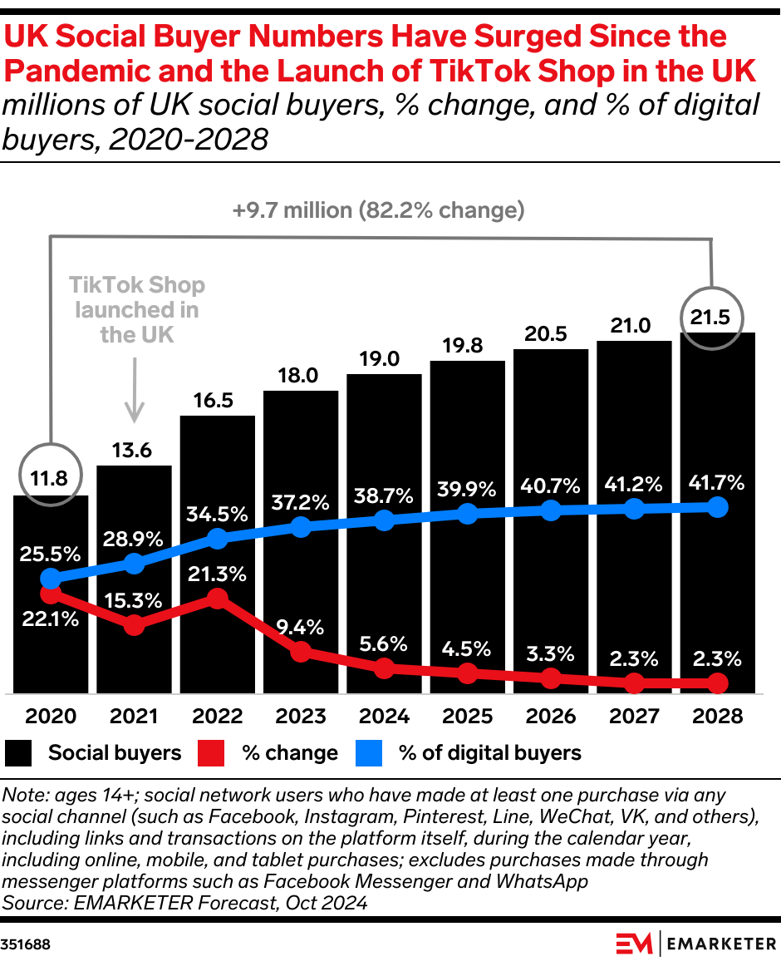
Figure 1: Social Buyer Numbers have surged in the UK
Source: (Perkins, 2024)
In 2025, the UK social commerce market got 39.9% digital consumers and is forecasted to expand by 21.5% to approximately US $49.21 billion. This indicates that social media is not just for communication, but it has also become linked with direct shoplifting and consumer purchase decisions (Perkins, 2024).
The research problem is that although the company ASOS spends a huge amount of money on social media and influencer marketing, it is still important to understand the impact of these activities on purchase intention. Social media content can help to raise awareness, improve brand trust and engagement, which can drive purchases (Huang et al., 2022). But, consumers can also get suspicious if the promotions from influencers are unrealistic, over-commercialised, or not transparent (Retail Week, 2025). Thus, this study will employ secondary data to explore the effect of ASOS's social media marketing on the UK online fashion retail market towards consumers' attitudes and purchase intention.

2.0 Research Aims and Objectives and Research Question
2.1 Research Aim
To examine how ASOS’s social media marketing activities influence consumer purchase intention in the UK retail industry.

2.2 Research Objectives
1. To identify the key social media marketing strategies used by ASOS in the UK retail market.
2. To examine how influencer marketing, brand engagement, online content and customer interaction affect consumer purchase intention.
3. To analyse the relationship between ASOS’s social media presence and consumers’ attitudes towards buying fashion products.
4. To evaluate the effectiveness of ASOS’s social media marketing in encouraging purchase intention among UK consumers.

2.3 Research Questions
- How does social media marketing influence consumer purchase intention towards ASOS in the UK retail industry?
- What impact does influencer marketing, brand engagement, online content and customer interaction have on consumers' attitudes towards ASOS?
- To what extent is ASOS effective in influencing UK fashion consumers' purchase intention through social media marketing?

3.0 Literature Review

3.1 ASOS' Social Media Marketing Strategies in the UK Retail Market
The first theme is related to the social media marketing strategies adopted by ASOS in the UK retail sector. ASOS is an appropriate case as it is a digital-first fashion retailer; visibility online is key to attracting consumers. ASOS also said it was expanding its influencer programmes, with the average of around 1,500 influencers active every month by the end of the year, in its 2024 Annual Report.
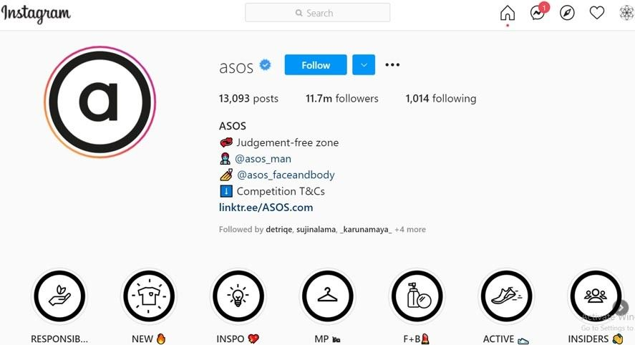
Figure 2: ASOS Using Instagram for Managing Fashion
Source: (Shastri, 2021)
ASOS also said that its adjusted gross margin rose 110 bps year-on-year to 6.6%, while other operating costs declined by £48.9 million, or 12.2%, year-on-year. It indicates the company's marketing efforts to be more efficient and its investment in customer-facing internet marketing (WorldFootwear, 2026). This makes social media marketing essential, as it can help promote your brand without relying solely on costly traditional advertising methods. The above image helped to know that Asos uses Instagram to improve its social media presence (Shastri, 2021).
However, Schott (2023) argued that having a high number of influencers does not necessarily mean that consumers are more likely to buy. While a high number of influencers can help increase reach, consumers' trust in the content and its relevance, plus their transition from viewing the post to considering a purchase, is what matters. ASOS should be investigated in the context of social media literature; therefore, it is relevant to explore both what ASOS does on social media and whether these strategies will have an impact on consumer behaviour.

3.2 Influencer Marketing, Brand Engagement, Online Content and Customer Interaction
The second aspect is based on the influence of influencer marketing, brand engagement, online content, and consumer interaction upon consumer purchase intention. Consumer social proof plays a key role in fashion ecommerce before making an online purchase, which is why influencer marketing is important. When online shoppers use influencers to demonstrate the styling, fit, body shape, trends and lifestyle applications, it can decrease uncertainty during the shopping process.
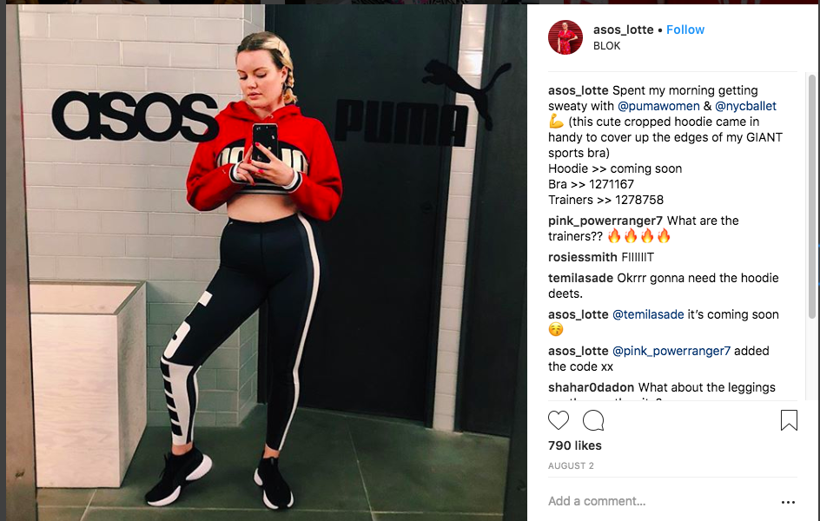
Figure 3: Influencer Marketing by Asos
Source: (The Creative Store, 2022)
The aspects are relevant in the UK social media landscape. The UK's total population social media user identities were 54.8 million in January 2025, representing 79.0% of the population (Kahwaji et al., 2026). This is a sign of a huge customer base that can be tapped by fashion retailers using social media. Styling videos, interactive posts and user-generated content, as well as influencer campaigns, can help boost awareness and engagement for digitally active consumers for ASOS (The Creative Store, 2022).
However, as Sabrin et al. (2025) argued that there are also trust and transparency issues with influencer marketing. According to the Advertising Standards Authority, advertising posts by influencers should be easily recognisable as ads, without requiring consumers to be aware of the influencer's business ties (Dijana Vuković and Tatjana Pavković, 2025).

3.3 Social media presence of ASOS and consumers' attitudes towards purchasing fashion products
The third objective explores the effect of ASOS's social media on consumer attitudes toward purchasing fashion products. Consumer attitudes are significant due to the fact that they shape the way a consumer perceives a brand as being fashionable, trustworthy, relevant to the consumer and affordable. Positive attitudes can motivate customers to visit an online fashion retailer's website, to view products and think about purchasing them.
This is a big issue in the UK online retail landscape. The UK social commerce market was projected to reach the value of nearly US$49.21 billion in 2025, expanding by 22.7% (Research and Markets.com, 2025). This demonstrates that social media is no longer only for brand communication, but is increasingly related to shopping behaviour. This isn't just a space to promote for ASOS, it could be a place that impacts the initial part of a consumer's purchase journey on platforms like Instagram, TikTok and Facebook.
ASOS' social media activity can foster positive attitudes through its fashion-forward imagery, influencer styling, brand partnerships and visual diversity. Such exercises can assist the brand in being seen as modern and approachable (Minal Uprety et al., 2025).

3.4 Effectiveness of Social Media Marketing for the promotion of purchase intention
The fourth theme assesses the effectiveness of social media marketing as a means to influence purchase intention. Purchase intention is the probability that a consumer will think of buying a product in the future. In e-commerce, this may be affected by product visibility, the credibility of the influencers, quality of the content, perceived value, trust and ease of online shopping (Virdi, 2026).
Social media marketing is effective because it reduces the gap between the discovery of a product and the consideration of buying it. As opined by Emini and Zeqiri (2021), product visibility in the post and the ability to click through to the retailer's website, where they can compare products quickly. It is crucial for ASOS as they depend on the conversion of digital attention to visits to their online store and then the conversion of those visits into sales (Ali and Naushad, 2023). Social commerce is also seeing growth, with consumers getting more accustomed to shopping from social media sites.
However, as opined by Osasumwen et al. (2022), it is not just about the social activity in a company's online community, but it needs to be effective. The aim of a large influencer programme, the content it provides and the engagement it creates might also lead to an increase in awareness, but may not always result in purchase intent. Even with the above, consumers can still put products aside due to price, size, delivery, return or trust issues (Zulqarnain, Iqbal and Muneer, 2023).

3.5 Research Gap
Research in the literature has revealed that social media marketing, influencer marketing, brand engagement and online content have an effect on purchase intention among consumers. But, there remains a clear lack of research specifically on the online fashion retail industry in the UK and ASOS. The existing literature tends to analyse social media marketing in a general manner, whereas this study is based on one fashion retailer and one national market.
There is also a disconnect between social media engagement and intent to purchase. While there are many companies that count likes, comments, and followers, or influencer reach, these don't always indicate consumer intent to purchase (Hassan, 2025).
Another drawback is the lack of a cross-examination of influencer marketing, brand engagement, online content and customer interaction. In the actual process of a consumer's decision-making, however, these factors operate together (Hassan, 2025).

3.6 Theoretical Foundation- Theory of Planned Behavior
Theory of Planned Behaviour (TPB) is appropriate for this study as it is one of the theories that explain the role of attitude, social influence and perceived control in the purchase intention and purchasing behavior. The attitude in online reviews is defined as the feelings consumers have about the review information. For Instance, whether reviews are beneficial, credible and relevant. Positive reviews can foster a positive attitude towards a product, and negative reviews can deter people from buying the product.
Subjective norms are also relevant as consumers could be influenced by the opinions, ratings and experiences shared by other online consumers. When a lot of consumers endorse a product, potential consumers may be more confident in their choice. Perceived behavioural control is about how easy consumers find it to evaluate reviews, compare products and buy online. Hence, TPB aligns itself with this research since it connects e-reviews, consumers' attitudes, intention to buy and actual buying behavior.

3.7 Conceptual Framework
The conceptual framework for this study has been explained in such a way that it explains the relationship between the Social Media marketing activities of ASOS with the consumers' purchase intention in the UK retail sector. It is derived from the connection between the factors of social media marketing and consumer behavior. The major independent variables in this study are influencer marketing, brand engagement, online content quality and customer interaction.
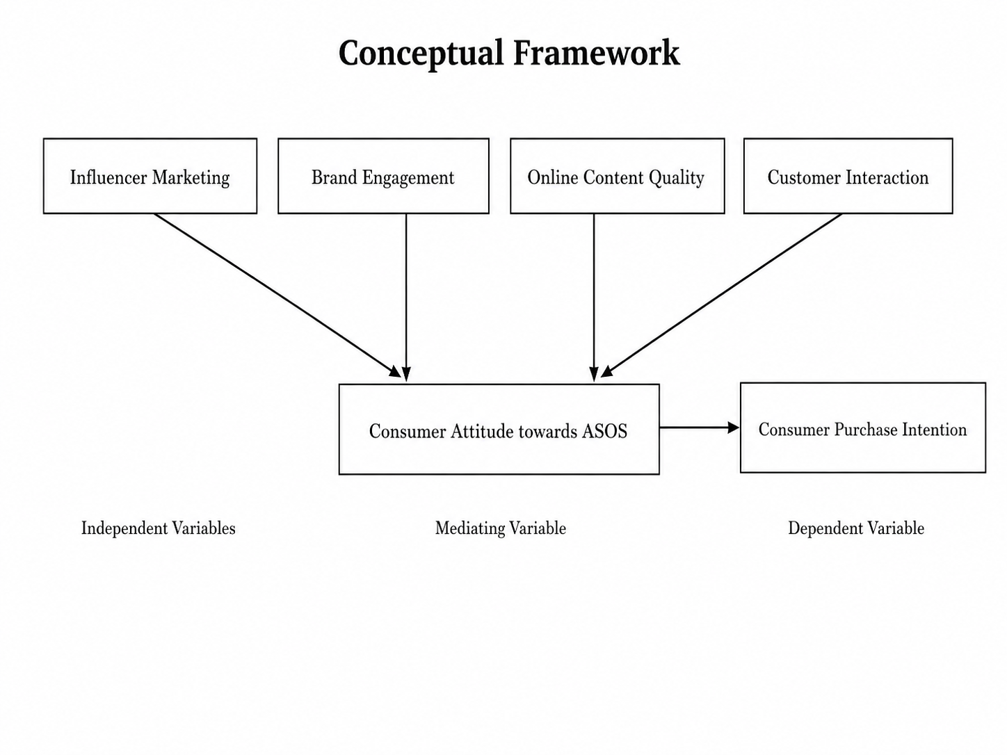
Figure 04: Conceptual Framework
Source: (Self-Created)
These factors can influence consumer attitudes, enhancing their awareness, trust, interest and perceived relevance of ASOS fashion products. Consumer attitude will serve as a connecting element as positive attitudes towards ASOS will be creating higher chances for a consumer to consider, select and buy a product from ASOS. The dependent variable is consumer purchase intention which is the willingness of consumers to purchase ASOS products after being exposed to social media marketing activities.

4.0 Research Methodology

4.1 Research Philosophy: Interpretivism
The study will follow interpretivism as it will seek to understand the possible effect of social media marketing on the attitudes of consumers and their intention to buy based on the published evidence that has been available (Pervin and Mokhtar, 2022). This will be appropriate as this study will not gather primary evidence but will interpret academic literature, ASOS reports, industry and public social media content.

4.2 Research Approach: Deductive
The method of research will be deductive. The study will start with theories and concepts on social media marketing, influencer marketing, brand engagement, and consumer purchase intention (Robinson and Bailey-Rodriguez, 2025). The concepts will then be applied to ASOS with a view to studying the impact the social media marketing of ASOS has on the intention to purchase of the consumers in the UK.

4.3 Research Strategy: Case Study
The research strategy will be by using the case study of ASOS. This will be suitable as the study will be based on one particular organisation in the UK retail industry (Mtisi, 2022). ASOS will be suitable as it is a digital-first fashion retailer that relies on social media, influencers, online content and customer engagement as a part of its marketing strategy.

4.4 Methodological Choice- Systematic Literature Review Using Prisma
Systematic Literature Review (SLR) design with the PRISMA process will be used in this study. This is appropriate as the study will involve secondary data, not surveys or interviews. Academic articles, ASOS reports, industry reports, official websites, public social media evidence and market data will be reviewed to gain understanding of social media marketing and the consumers' purchase intention.

PRISMA will help clarify and structure the source selection process. Sources will be identified by using the Google Scholar, ScienceDirect, Emerald Insight, ASOS reports and industry sources. Duplicate, out-of-date and irrelevant research will be retrieved. The final result of the sources selected will be conducted for literature review and thematic analysis.

4.5 Time Horizon: Cross-Sectional
The time horizon will be cross-sectional, as the study will investigate the attitude of consumers towards the purchase intention of ASOS in social media marketing within the time frame of the study. Evidence from the recent sources (2021-2026) will be given priority due to the fact that there are frequent changes that happen in the field of social media marketing, and current evidence will be required (Maier et al., 2023).

4.6 Data Collection
Data will be collected through a secondary literature and document review. Journal articles on social media marketing, influencer marketing, brand engagement and purchase intention will be identified through the academic databases, including Google Scholar, ScienceDirect and Emerald Insight). Other sources of data that will be analysed to gain an understanding of ASOS's current digital marketing strategy and context in the UK retail market include their annual reports, information found on the ASOS official website and recognised industry reports and data available via public social media.
The data collection process will follow four PRISMA stages. First, during identification, relevant sources will be searched using keywords such as “social media marketing”, “ASOS”, “UK fashion retail”, “influencer marketing”, “brand engagement”, “consumer attitude” and “purchase intention” (Wickham, 2020). Academic databases such as Google Scholar, ScienceDirect and Emerald Insight will be used, along with ASOS reports and reliable industry sources. Second, during screening, duplicate, outdated and unrelated sources will be removed. Third, during eligibility, the remaining studies will be checked to ensure they directly relate to social media marketing and consumer purchase intention.
Inclusion and Exclusion Criteria
Inclusion Criteria | Exclusion Criteria
Empirical studies on social media marketing | Purely theoretical or unrelated studies
Studies on influencer marketing and brand engagement | Studies not linked to consumer behaviour
Studies on purchase intention in retail/fashion | Studies from non-retail sectors
UK, fashion, e-commerce or ASOS-related studies | Studies outside the research context
Peer-reviewed journal articles and credible reports | Blogs, opinion articles and weak sources
English studies published between 2021–2026 | Non-English or outdated studies

4.7 Data Analysis
Themes will be used to analyse the collected secondary data. The themes will be developed from the research objectives, such as influencer marketing, brand engagement, online content quality, customer interaction, consumer attitudes and purchase intention (Pederson et al., 2020).

4.8 Ethics
There will be no direct involvement of human participants in the study, as the study will be conducted with secondary data. But ethical considerations will still be a factor. Proper referencing of all sources will be done to avoid plagiarism. The researcher will ensure the use of reliable and contemporary sources, not misrepresent any statistics, and cross-reference with independent academic or industry sources in order to minimise bias. Private customer information will not be collected, quoted or identified if the public content of ASOS' social media is used.

5.0 Risks
Potential Dissertation Risk | Way to Overcome the Risk
Limited recent academic sources | Use databases such as Google Scholar, ScienceDirect and Emerald Insight to find sources from 2021–2026.
Over-reliance on ASOS reports | Compare ASOS information with academic journals, industry reports and independent market data.
Outdated social media evidence | Prioritise recent evidence because social media marketing and consumer behaviour change quickly.
Lack of primary data | Use published studies, public social media content and reliable industry data to understand consumer attitudes.
Difficulty developing themes | Use the research objectives to create themes such as influencer marketing, brand engagement and purchase intention.
Researcher interpretation bias | Compare evidence from different sources before making conclusions.
Ethical issues with social media content | Avoid using private data, usernames or identifiable customer comments.
Referencing or plagiarism risk | Reference all journals, websites, reports and statistics correctly.

Table 1: Risk Table
Source: (Self Made)

6.0 Gantt Chart
Research Activity | W1 | W2 | W3 | W4 | W5 | W6 | W7 | W8
Topic approval
Background writing
Supervisor Meeting 1
Feedback Revision 1
Aim/Objectives
Literature search
Supervisor Meeting 2
Feedback Revision 2
SLR/PRISMA
Methodology
Supervisor Meeting 3
Feedback Revision 3
Ethics/Risks
Proposal Presentation
Final Revision
Submission

Table 2: Gantt chart
Source: (Self Made)

References
Ali, İ. and Naushad, M. (2023). Examining the influence of social media marketing on purchase intention: The mediating role of brand image. Innovative marketing, 19(4), pp.145–157. doi:https://doi.org/10.21511/im.19(4).2023.12.
Asos Plc (2025). ASOS Plc Annual Report and Accounts 2025. [online] Available at: https://www.asosplc.com/media/buijobcn/49775_asos_ar25_text_int_031225-final.pdf.
Dijana Vuković and Tatjana Pavković (2025). The eThics of influencer MarkeTing: an analysis of Transparency and accounTabiliTy in digiTal adverTising. MAP Social Sciences, [online] 6(2025), pp.40–52. doi:https://doi.org/10.53880/2744-2454.2025.6.40.
Emini, A. and Zeqiri, J. (2021). SOCIAL MEDIA MARKETING AND PURCHASE INTENTION: EVIDENCE FROM KOSOVO. Ekonomska misao i praksa, [online] 30(2), pp.475–492. doi:https://doi.org/10.17818/EMIP/2021/2.8.
Hassan, M. (2025). Identifying and Addressing Research Gaps: a Comprehensive Guide Definition of Research Gap. [online] Research Gate. Available at: https://www.researchgate.net/publication/387770690_Identifying_and_Addressing_Research_Gaps_A_Comprehensive_Guide_Definition_of_Research_Gap.
Huang, X., You, A.T. and Zhou, X. (2022). Research on the Online Marketing Strategy of ASOS’s Young Customer Market. BCP Business & Management, [online] 32(1), pp.277–283. doi:https://doi.org/10.54691/bcpbm.v32i.2900.
Kahwaji, A., Ismael, R., Arnouk, T., Alhomsy, A. and Alsuliman, T. (2026). Adoption rates and knowledge of generative artificial intelligence in pharmacy practice: A comparative study in an internet-restricted country. DIGITAL HEALTH, 12. doi:https://doi.org/10.1177/20552076261432730.
Kemp, S. (2025). DataReportal – Global Digital Insights. [online] DataReportal – Global Digital Insights. Available at: https://datareportal.com/reports/digital-2025-united-kingdom.
Maier, C., Thatcher, J.B., Grover, V. and Dwivedi, Y.K. (2023). Cross-sectional research: a Critical perspective, Use cases, and Recommendations for IS Research. International Journal of Information Management, 70(70), p.102625.
Minal Uprety, Pratibha Barik and Nim, D. (2025). Social Media and Sustainable Fashion : Mediating Roles of Awareness and Attitude Among Young Indian Consumers. Prabandhan Indian Journal of Management, [online] pp.49–71. doi:https://doi.org/10.17010/pijom/2025/v18i12/175033.
Mtisi, S. (2022). The Qualitative Case Study Research Strategy as Applied on a Rural Enterprise Development Doctoral Research Project. International Journal of Qualitative Methods, [online] 21, pp.1–13. doi:https://doi.org/10.1177/16094069221145849.
Ndhlovu, P. and Notice Pasipamire (2022). Use of the Secondary Data Analysis Method in Library and Information Science Research: An Analysis of Research Articles from Selected Journal Databases. [online] 2021(1), pp.34–48. Available at: https://www.researchgate.net/publication/367021324_Use_of_the_Secondary_Data_Analysis_Method_in_Library_and_Information_Science_Research_An_Analysis_of_Research_Articles_from_Selected_Journal_Databases.
Osasumwen, P., Oriakhi, Amin, A. and Safdar, S. (2022). Negative Impact of Social Media Advertisements on Branding in Digital Marketing. [online] Available at: https://pure.port.ac.uk/ws/portalfiles/portal/78542892/Negative_Impact_of_Social_Media_Advertisements.pdf.
Pederson, L., Vingilis, E., Wickens, C.M. and Koval, J. (2020). Use of secondary data analyses in research: Pros and Cons. [online] ResearchGate. Available at: https://www.researchgate.net/publication/343551750_Use_of_secondary_data_analyses_in_research_Pros_and_Cons.
Perkins, C. (2024). UK Social Commerce 2024. [online] EMARKETER. Available at: https://www.emarketer.com/content/uk-social-commerce-2024.
Pervin, N. and Mokhtar, M. (2022). The Interpretivist Research Paradigm: A Subjective Notion of a Social Context. [online] ResearchGate. doi:https://doi.org/10.6007/IJARPED/v11-i2/12938.
Research And Markets.com (2025). United Kingdom Social Commerce Market Intelligence Report 2025-2030 Featuring Key Players and New Entrants Such as Facebook, Instagram, TikTok, Whatnot, LOOKK, Depop, AGORA - ResearchAndMarkets.com. [online] Businesswire.com. Available at: https://www.businesswire.com/news/home/20250509759072/en/United-Kingdom-Social-Commerce-Market-Intelligence-Report-2025-2030-Featuring-Key-Players-and-New-Entrants-Such-as-Facebook-Instagram-TikTok-Whatnot-LOOKK-Depop-AGORA---ResearchAndMarkets.com.
Retail Week (2025). Digital marketing’s new rules: Inside Asos, New Look and Urban Decay’s social strategies. [online] Retail Week. Available at: https://www.retail-week.com/customer/digital-marketings-new-rules-inside-asos-new-look-and-urban-decays-social-strategies/7047941.article.
Robinson, O.C. and Bailey-Rodriguez, D. (2025). Deductive qualitative research: an integrative approach to designing studies. Qualitative Research in Psychology, pp.1–16. doi:https://doi.org/10.1080/14780887.2025.2604773.
Sabrin, A., Alviansyah, A. and Anca, A. (2025). The Ethics of Influencer Marketing: Transparency, Trust, and Consumer Perceptions. [online] doi:https://doi.org/10.2139/ssrn.5112872.
Schott, R. (2023). Online Fashion Retailer ASOS Hit Hard by Drop in Search Performance. [online] Pure SEO. Available at: https://pureseo.com/blog/online-fashion-retailer-asos-hit-hard-by-drop-in-search-performance [Accessed 1 Jun. 2026].
Shastri, A. (2021). Marketing Strategies of ASOS- An Exclusive Case Study [2023]. [online] IIDE. Available at: https://iide.co/case-studies/marketing-strategies-of-asos/.
The Creative Store (2022). The Creative Store UK | Great Jobs. Great People. [online] Thecreativestore.uk. Available at: https://thecreativestore.uk/creative-talk/ideas/micro-influencers-and-how-brands-use-them/ [Accessed 1 Jun. 2026].
Virdi, A. (2026). Asos’ top marketer on bringing the brand ‘back to growth’. [online] Marketing Week. Available at: https://www.marketingweek.com/asos-growth-transformation/ [Accessed 1 Jun. 2026].
Wickham, R. (2020). Secondary Analysis research. Journal of the Advanced Practitioner in Oncology, [online] 10(4), pp.395–400. doi:https://doi.org/10.6004/jadpro.2019.10.4.7.
WorldFootwear (2026). Asos confirms sharp underlying profitability growth in the H1. [online] World Footwear. Available at: https://www.worldfootwear.com/news/asos-confirms-sharp-underlying-profitability-growth-in-the-h1/11444.html.
Zulqarnain, M., Iqbal, M. and Muneer, S. (2023). Impact of Social Media Marketing on Purchase Intention: The Moderating Role of Perceived Enjoyment. Journal of Social Media Marketing, 2(2), pp.35–48. doi:https://doi.org/10.33422/jsmm.v2i2.1171.

