The Shard
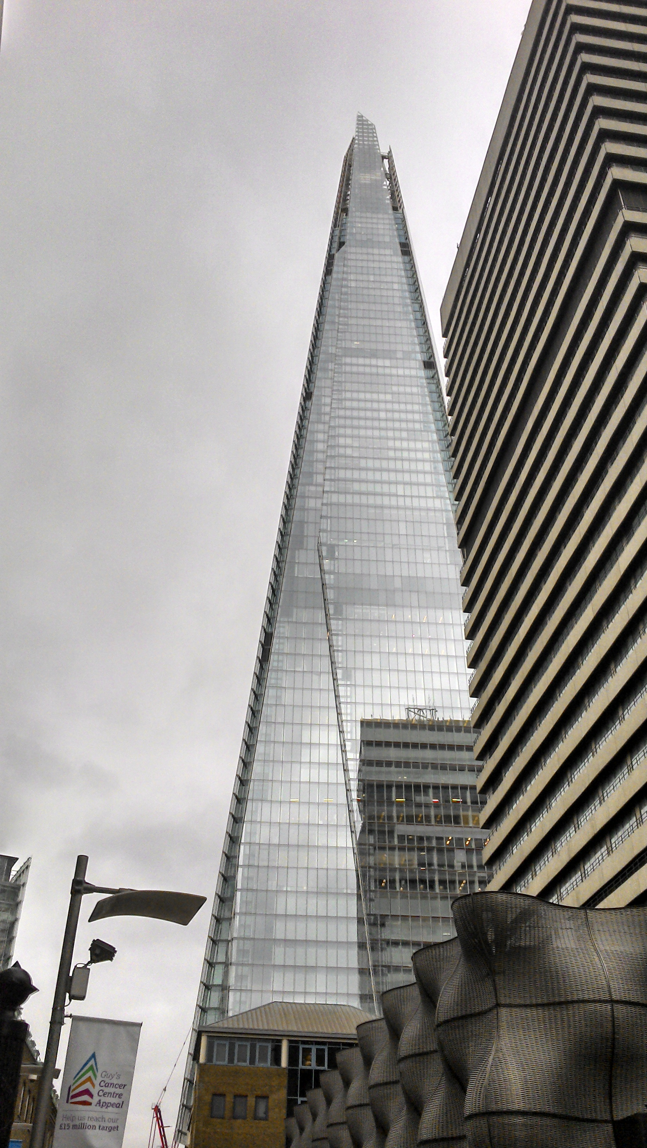

Contents

- 1 Introduction
- 2 Design and construction
- 3 Completion
- 4 Project data:
- 5 Find out more
  - 5.1 Related articles on Designing Buildings Wiki

Introduction
The Shard was one of the most ambitious projects of the London South Bank regeneration and since its inauguration in July 2012 it has become one of the most recognizable and iconic buildings of the London skyline.
Standing at 309.6 m (1,016 ft) high, the Shard is amongst the 100 tallest buildings in the world, is the fourth tallest building in Europe, and the second tallest free-standing structure in the UK.
The initial vision on the part of Irvine Sellar, the developer and joint owner, was to create a ‘vertical city’ that would be capable of incorporating retail, offices, hotel accommodation, apartments, restaurants and a public viewing gallery. The site is in the busy transport hub of London Bridge, where Sellar acquired Southwark Towers in 1998. After meeting in 2000, the architect Renzo Piano began work on designing a church spire-like structure that would appear to emerge ‘like a shard of glass’ from the River Thames.
A planning inquiry was launched in 2002 following opposition from the Commission for Architecture and the Built Environment (CABE) and heritage bodies such as English Heritage (now Historic England). In 2003, Deputy Prime Minister John Prescott announced that planning consent had been approved.
In 2007, building contractor Mace were awarded the contract for a fixed price of £350 million, a figure that would increase to almost £435 million in 2008. The global economic recession threatened the viability of the project, until the State of Qatar agreed to buy out the original stakeholders, in the process consolidating their ownership of the London Bridge Quarter developments.

Design and construction
Renzo Piano’s tapered design was inspired by the geometry of the railway lines running past the site, London’s church spires and the masts of sailing ships. A sophisticated form of glazing was proposed which would feature facades of angled glass panes to reflect sunlight and the sky above, so the building would appear to blend into the sky and change with the seasons and weather.
In a pioneering step, the foundations were excavated according to a top-down method that allowed for the core of the first 23 storeys to be built upward simultaneously. This was necessary due to the challenge faced of constructing a skyscraper in a built-up area adjacent to a major transport hub and was instrumental in the developer completing the project so quickly. In addition to the top-down method, structural engineers and contractors secured several notable achievements for UK construction:
- The UK’s largest concrete pour.
- The first use of jump-lift construction.
- The first inclined hoist in the world.
- The first crane to be supported on a slipform.
The distinctive tapered form consists of the following structues:
- First 40 floors: Composite steel frame.
- Up to 60th floor: Post-tension concrete frame.
- Up to 72nd floor: Traditional reinforced concrete frame.
- Spire to 87th floor: Pre-fabricated steel.
The building features 11,000 panes of glass, with a total surface area of 56,000 sq. m (600,000 sq. ft).

Completion
The Shard was inaugurated on 5 July 2012 by the Prime Minister of Qatar in a ceremony attended by Prince Andrew, Duke of York and featuring a spectacular laser light show.
In accordance with the original idea of a mixed-use ‘vertical city’, the building includes the following accommodation:
- More than 55,000 sq. m of office space over 25 floors.
- Three floors of restaurants.
- A 17-storey hotel.
- 13 floors of apartments.
- ‘The Sky Boutique’ on the 68th floor, the highest shop in London.
- The View from the Shard: a tourist attraction incorporating a triple-level indoor gallery on the 69th floor as well as an open-air observation deck on the 72nd floor.
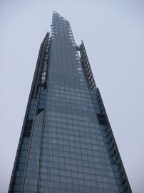

Project data:
- Address: 32 London Bridge Street, London, SE1 9SG
- Construction period: 2009 – 2012
- Height: 309.6 m (1,016 ft)
- Floor count: 95
- Floor area: 110,000 m2 (1,200,000 sq ft)
- Architect: Renzo Piano
- Developer: Sellar Property Group
- Main contractor: Mace
- Owner: State of Qatar (95%), Sellar Property Group (5%)
- Contract cost: £435 million
- Notable prizes: First prize – Emporis Skyscraper Awards

The LeadenHall.
Dimensional
Office finished floor to ceiling height of 2.75m with 150mm raised floor. 1.5m planning module with structural bays of 10.5m x 16m.
Environmental
‘Excellent’ BREEAM rating.
Electrical
Office light levels of 400 Lux average (achieved as part of CAT A fit-out).
Electrical Loading
Office small power 15 W/m2.
Office lighting 12 W/m2.
Supplementary small power available in on-floor riser 25 W/m2.
Landlords & Tenants Standby Power System
4 x HV generators.
Generator (capacity 2,500 kVA each). 100% building load backup.
Lifts
8 x mid level 21 person passenger lifts 5.0 m/s.
8 x high level 21 person passenger lifts 8.0 m/s.
2 x public space access, 17 person passenger lifts 1.0 m/s.
2 x firefighting lifts of 800kg.
2 x goods lifts 3,600kg 2.5 m/s.
Passenger lifts have an average peak waiting time of less than 25 seconds and an average time to destination of less than 90 seconds. 10m2/person mid-rise,
12m2/person high-rise
Mechanical
Office cooling and outside air quantity. Design density 10m2/person.
Population Density
Means of escape 220 persons per floor.
Technical
The Leadenhall Building has achieved a platinum rating from WiredScore. The Wired Certification distinguishes The Leadenhall Building as ‘best-in-class’ for internet connectivity and infrastructure.
Complimentary Wi-Fi throughout the building and in the public space.
Wi-Fi radios instead of two way radios.
Innovise Servicetrac system to manage the Quality Audits and PPM’s frequencies. This is managed via a dedicated Wi-Fi enabled tablet and makes use of the buildings Wi-Fi.
Smart Task, which works using smartphones/PDAs & NFC (near field communications). This can be used to monitor when planned or reactive cleaning tasks have been completed with feedback to the administration system in real-time.
The smartphone units can also be used to allow the user access to important information such as the site risk assessments, method statements, PPM’s, manufacturer safety data sheets, floor plans, local area maps and communications using Push To Talk technology on the building’s Wi-Fi.
Toilets
Average population density 10m2/person. 60:60 male to female ratio.

Prefabricated Construction
The construction of The Leadenhall Building began in autumn 2011 and used cutting edge construction techniques incorporating some of the most advanced technologies available.
More than 80% of the components were prefabricated off-site and then delivered and assembled on-site by the construction team led by Laing O’Rourke.
Using off-site manufacture makes the building process safer, less wasteful and more accurate, especially in such a constricted area. It also helps to minimise noise and disruption.
The megaframe was made at specialist steelworks in northern England, Scotland and Northern Ireland. It is divided into eight sections, each 28 metres high and comprising seven floors (apart from the first section, which contains five). The steel columns and beams are connected by nodes that transfer forces of up to 6,000 tonnes, while nearly 3,000 ‘megabolts’ (threaded steel rods) connect all the steel parts together.


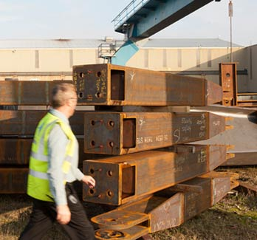
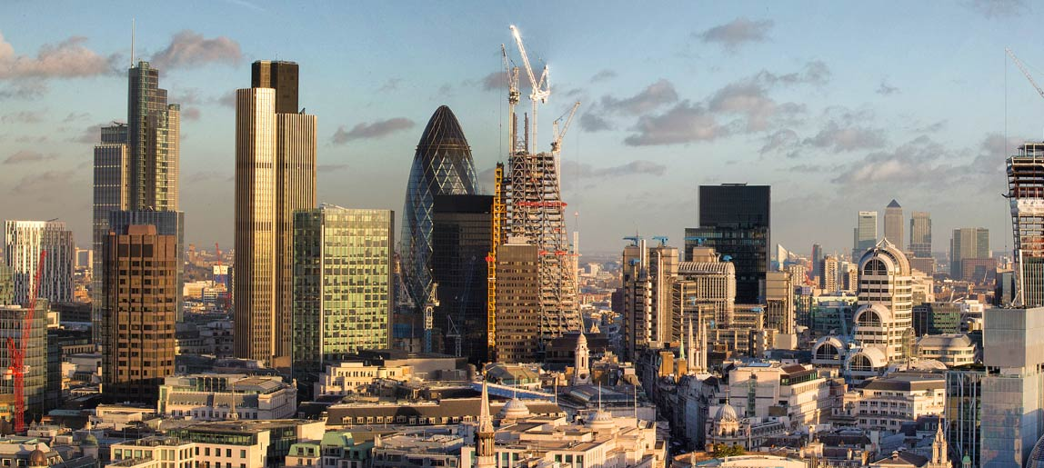
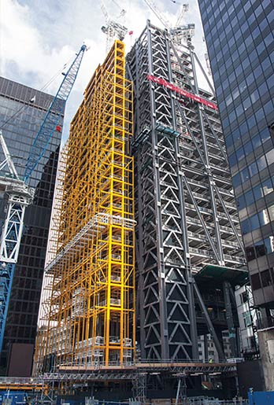
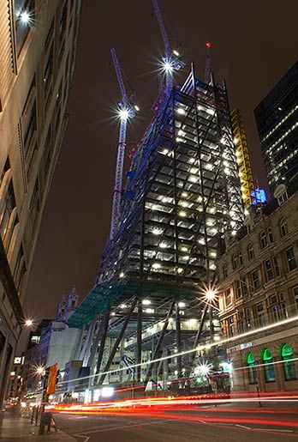
These megabolts are stretched (‘pre-stressed’) before being installed, so that they create completely rigid joints. This type of construction is more commonly used for bridges and offshore oil rigs.
Lifting the steel frame sections into position required cranes that could lift up to 45 tonnes. The heaviest-duty crane available, however, had a maximum load of 32 tonnes, so two new ones were made especially to construct The Leadenhall Building.
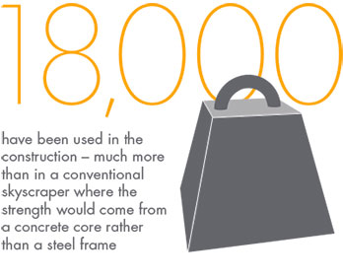

Sustainable Operation
The Leadenhall Building is designed and built to British Land and Oxford Properties’ guiding principle: that a sustainable approach is essential to delivering high quality buildings. Design and engineering elements have been deliberately chosen to make efficient use of energy and resources.
Key to the building’s sustainability is its triple-layer glass ‘skin’. The outer layer of glass is separated from an inner layer of double-glazing by a cavity containing blinds that
respond to the sun’s movement, keeping the office space comfortably cool throughout the working day.
The external glazing incorporates vents every seventh storey, allowing air to flow freely around the cavity. This minimises the need for artificial cooling – typically the highest single source of energy use in an office building.
While the construction process cuts waste to near zero by designing and manufacturing most parts off-site, systems have been put in place to ensure resources are managed efficiently on an ongoing basis. These include nearly 300 energy meters installed throughout the building to monitor usage, along with low-flow water fixtures and fittings.
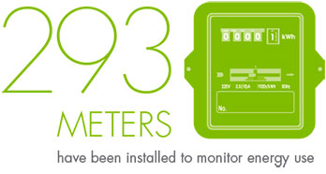
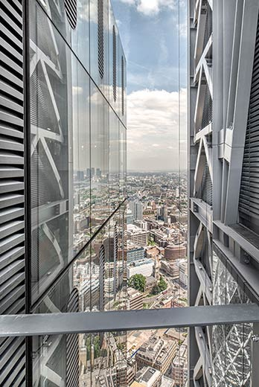
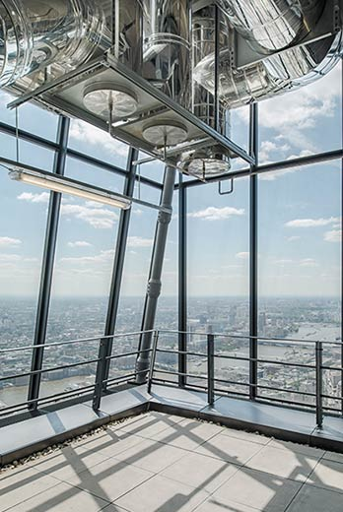
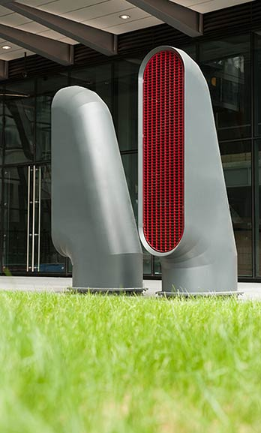
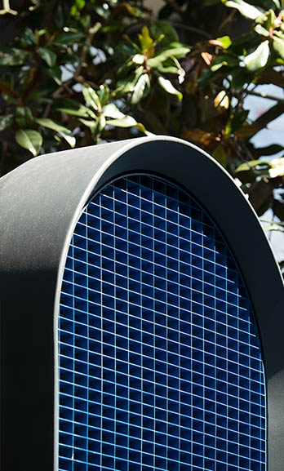
The construction process emphasised eliminating waste at source through efficient procurement, design, manufacturing and engineering methodologies. This was principally through the application of Design for Manufacture and Assembly (DfMA), where products are designed and manufactured offsite. This approach increases the quality of materials and installations, reduces waste to almost zero, and significantly decreases deliveries to site, avoiding air pollution and congestion. Evidence from environmental monitoring suggests the carbon footprint of projects constructed using a significant percentage of DfMA components is typically half that of projects built using traditional methods.
Great time and detail has been taken to ensure the design of the building complements the surrounding architecture, particularly with regard to London’s viewing corridors. Seen from the west looking towards St Paul’s Cathedral, The Leadenhall Building will appear to ‘lean away’ from the historic monument.
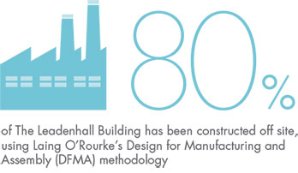

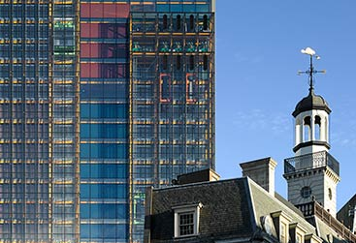

122 Leadenhall Street
From Wikipedia, the free encyclopedia
Jump to: navigation, search
Leadenhall Building
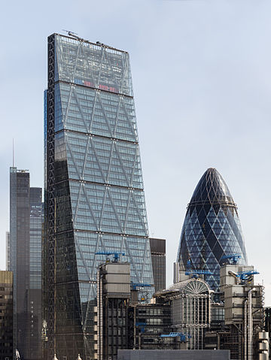
The Leadenhall Building (with the Heron Tower and 30 St Mary Axe in the background and the Lloyd's building in front), viewed from the Monument in 2014
Alternative names | The Cheesegrater
General information
Status | Complete
Type | Office
Architectural style | Post-modern; High-tech
Location | London, EC3  United Kingdom
Completed | June 2013
Opened | July 2014
Cost | £286 million
Height
Roof | 225 metres (738 ft)^{[1]}
Technical details
Floor count | 48
Floor area | 84,424 m² (908,730 sq ft)
Design and construction
Architect | Rogers Stirk Harbour + Partners
Structural engineer | Arup Group
Website
www.theleadenhallbuilding.com
References
^{[2]}
122 Leadenhall Street, or the Leadenhall Building, is a 225 m (737 ft) tall building on Leadenhall Street in London. The commercial skyscraper, opened in July 2014, was designed by Rogers Stirk Harbour + Partners and is informally known as "The Cheesegrater" because of its distinctive wedge shape.^{[3]} It is one of a number of new tall buildings recently completed or currently under construction in the City of London financial area, including 20 Fenchurch Street, 22 Bishopsgate, and The Scalpel.
The building is opposite the Lloyd's building, also designed by Rogers, which is the home of the insurance market Lloyd's of London.^{[3]} Until 2007 the Leadenhall site was occupied by the P&O Tower (Peninsular and Oriental), a building owned by the developer British Land and designed by Gollins Melvin Ward Partnership that was completed in 1968 as a brother to the still existing Commercial Union tower, now called St. Helen's.^{[4][5]} That building was demolished in preparation for redevelopment of the site. The project, initially delayed due to the financial crisis, was revived in 2010 and Oxford Properties co-developed the property in partnership with British Land.^{[6]}

Contents
1 Site history
2 Previous building
3 The Leadenhall Building
4 Tenancy
5 See also
6 References
7 External links

Site history
Prior to the site's previous redevelopment in the 1960s, it had been used as the head office of the Peninsular and Oriental Steam Navigation Company (P&O) for over a century. Since 1840, P&O had worked in the rent-free offices of Willcox & Anderson. However, business east of the Gulf of Suez increased in the late-1840s resulting in the company needing newer and larger offices. It was the P&O directors' obligation to provide new space. In November 1845, the King's Arms inn and hotel at 122 Leadenhall Street was put up for sale. The freehold was bought by P&O for £7,250, which then commissioned an architect, Beachcroft, to design a new building. The cost of the new building was estimated at £8,000. In March 1848, P&O moved into the new office.^{[7]}
In 1854, P&O unsuccessfully attempted to purchase the neighbouring building at 121 Leadenhall Street, however they were eventually able to take a lease from the charity which held it. They also bought leases of 80 years from St. Thomas's Hospital on the residential properties at Nos. 123, 124 and 125 Leadenhall Street which were demolished to create a new frontage at No. 122. The new building provided more office space, some of which was for rent, and a spacious new courtyard.^{[7]}
By the mid-1960s P&O needed to redevelop the site to provide increased office space again. At the same time, the Commercial Union Assurance Company was also planning a redevelopment on an adjacent site on the corner of St. Mary Axe. However, due to a number of issues affecting both sites, notably poor access to the Commercial Union site and the restricted width of the P&O site, it was not possible to obtain planning consents that would optimise the amount of floor space desired by either company. As a result, the two companies decided to participate in a joint development that would involve the reallocation of site boundaries and the creation of an open concourse area at the junction of Leadenhall Street and St. Mary Axe. Both companies would have frontages to the new concourse and would retain site areas equivalent to those enclosed by the original boundaries.

Previous building
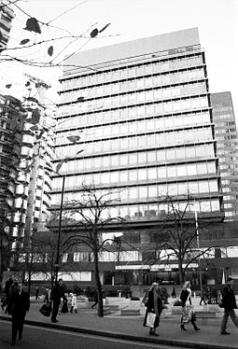
The 1969 building at 122 Leadenhall Street in a black and white photograph taken in 2007
When completed in 1969, the building at 122 Leadenhall Street was 54 m (177 ft) tall with 14 storeys above and three storeys under ground.^{[8]} It was originally designed as a pair with the Commercial Union headquarters (now called St. Helen's) by the architects Gollins Melvin Ward Partnership. The two buildings have a central compressional concrete core and have suspended floors which hang using the steel 'chords' visible on the exterior of the building, which are hung from power trusses at the top of the building (and in the case of No. 1 Undershaft, a further central power-truss). It is an example of a tension structure; at the time, it was considered one of the most complex glass-fronted buildings in the United Kingdom. The architect acknowledged the influence of Mies van der Rohe.
The building was extensively damaged by an IRA bomb in the early-1990s and subsequently had to be reclad. It was occupied by various tenants until November 2006, including the Italian International Bank and Calyon.
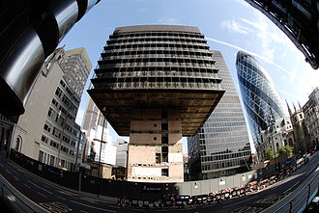
The 1969 building undergoing demolition in 2007
In 2007–08, the building was demolished to make way for a new development. The demolition was undertaken by McGee Group Ltd, with Bovis Lend Lease acting as construction manager. The contract value was £16 million. The first phase of demolition was conventional: after securing the site, the contractors performed a soft strip of the interior and an asbestos survey prior to demolishing the low level structures up to podium level. After this, the suspended structure of the building required an unconventional demolition approach that successively dismantled each office floor from the lowest upwards. To achieve this, the contractors installed a structural deck that acted both as a work platform for the demolition work and as a safety barrier. This was jacked upwards as each successive office floor was removed. When all the office floors and upper support trusses had been removed, the concrete core was de-stressed and demolished. Concurrently, the 25,000 cubic metre basement was propped and excavated. The contract took just over two years to complete.^{[9]}

The Leadenhall Building
Built by Laing O'Rourke, designed by Graham Stirk of Rogers Stirk Harbour + Partners and developed by British Land and Oxford Properties,^{[10]} the new Leadenhall Building is 225 m (737 ft) tall, with 48 floors. With its distinctive wedge-shaped profile it has been nicknamed the Cheesegrater,^{[11][12]} a name originally given to it by the City of London Corporation's chief planning officer, Peter Rees, who upon seeing a model of the concept "told Richard Rogers I could imagine his wife using it to grate parmesan. [The name] stuck."^{[13]}
The planning application was submitted to the City of London Corporation in February 2004 and was approved in May 2005.^{[14]} In 2006 Scheme Design (RIBA Stage D) started. In a statement made to the London Stock Exchange on 14 August 2008, British Land said it was delaying the project, which was due to start in October 2010.^{[15]} On 22 December 2010, the developer announced the project was moving forward with contracts being signed for the 50/50 joint venture with Oxford Properties.^{[12]}
The new tower features a tapered glass façade on one side which reveals steel bracings, along with a ladder frame to emphasize the vertical appearance of the building. It also appears to anchor the tower to the ground, giving a sense of strength. Unlike other tall buildings, which typically use a concrete core to provide stability, the steel megaframe, engineered by Arup, provides stability to the entire structure and is the world's tallest of its kind. The base features a 30 m high atrium. This will be open to the public and will extend the adjacent plaza. The flat side of the building is also encased in glass, and houses the mechanical services – in particular the elevator shafts. These have been turned into an architectural feature in a vein similar to the neighboring Lloyd's building – they deliberately show off the elevator machinery with bright orange painted counterweights and the actual elevator motors themselves.
This unusual design's main drawback is the building's relatively small floorspace (84,424 m²) for a building of its height. However, it is hoped that the slanting wedge-shaped design will have less impact on the protected sightline of St Paul's Cathedral when viewed from Fleet Street and the west.
The development is expected to cost approximately £286 million.^{[16]}
In July 2011, British Land and Oxford Properties announced that Laing O'Rourke was the main contractor for the works of the new Leadenhall Building. Throughout 2011, construction began with the basement floors. By December 2012, the steelwork had progressed up to the fifth mega-level, with topping out expected in February or March. The glass cladding had also begun to rise. By June 2013, the steelwork of the building was completely topped out with the glass cladding covering almost half the building.
The construction of the building was the subject of an episode of the Super Skyscrapers documentary series by the American television channel PBS in February 2014.^{[17]}
In November 2014 two bolts on the fifth floor failed in-service and dropped to ground level.^{[18]} Following this, the bolts were tied to prevent bolt loss. A third bolt failed in January 2015, but was retained by the installed ties. The bolts were determined to have failed by a process known as hydrogen embrittlement.^{[19]} Subsequently, further at-risk bolts were to be replaced ^{[20]}

Tenancy
The development has succeeded in attracting tenants, especially in contrast to the nearby part-built Pinnacle and completed Heron Tower. In May 2011, it was announced that the lower 10 floors of the Leadenhall Building have been pre-let to insurance broker Aon, which moved its global headquarters to London from Chicago.^{[21]} Insurance group Amlin has also agreed terms on a 20-year lease of the 18th to 24th floors as well as the top floor — the 45th — from March 2015, for a total of 111,000 sq ft of office space.^{[22]} The designers of the building, Rogers Stirk Harbour + Partners signed a 15-year lease on level 14, which will become their new head office. They will move in during 2015, having spent more than thirty years at Thames Wharf Studios, Hammersmith.^{[10]}

Reference

^ "Planning Applications". City of London. 04/00111/FULEIA – Documents > South Elevation. Retrieved 6 December 2013.
  - ^ "The Leadenhall Building, London". skyscrapernews.com. 4 May 2014. Retrieved 4 July 2014.
  - ^ to: ª ^{b} Booth, Robert (13 August 2014). "Inside the Cheesegrater – London's latest skyscraper". The Guardian. Retrieved 18 August 2014.
  - ^ GMW Architects projects chronology 1960-1969
  - ^ GMW Architects projects P&O Tower
  - ^ "British Land and Oxford Properties Announce Completion of Joint Venture Agreement to Develop 610,000 sq ft Leadenhall Building". British Land. 22 December 2010. Retrieved 6 December 2010.
  - ^ to: ª ^{b} Freda Harcourt; Edward Harcourt, Sarah Palmer (2006). Flagships of Imperialism: the P&O Company and the politics of empire from its origins to 1867. Manchester University Press. ISBN 0-7190-7393-6.
  - ^ 122 Leadenhall Street at Emporis
  - ^ Case study McGee
  - ^ to: ª ^{b} "The Leadenhall Building to be RSHP's new home". Rogers Stirk Harbour + Partners. Retrieved 7 June 2015.
  - ^ "Building 49 – The Leadenhall Building". SkyscraperNews.com. 11 July 2007. Archived from the original on 5 August 2007. Retrieved 3 August 2007.
  - ^ to: ª ^{b} "British Land and Oxford Properties Announce Completion of Joint Venture Agreement to Develop 610,000 sq ft Leadenhall Building". Retrieved 23 September 2011.
  - ^ The Cheesegrater: Richard Rogers sprinkles the Square Mile | Art and design. The Guardian. Retrieved on 26 July 2013.
  - ^ "Planning Applications". City of London. 04/00111/FULEIA. Retrieved 6 December 2013.
  - ^ Hipwell, Deirdre (23 October 2010). "Canadians join British Land to build the 'Cheese Grater'". The Independent. London. Archived from the original on 24 October 2010. Retrieved 23 October 2010.
  - ^ E-architect: 122 Leadenhall Street
  - ^ Building the Future PBS. Retrieved: 12 February 2014.
  - ^ https://www.theguardian.com/business/2014/nov/05/cheesegrater-steel-bolts-fall-from-building
  - ^ "Cheesegrater to undergo repair work for 'embrittlement' after third huge steel bolt breaks off one of London's tallest skyscrapers".
  - ^ "cheesgrater bolts to be replaced".
  - ^ British Land pre-lets 10 floors of office space to Aon in the Cheese Grater building
  - ^ Insurer Amlin rents space in the Cheesegrater. Telegraph. Retrieved on 26 July 2013.

