Nathan J Morris

The following letter will aim highlight the BIM maturity for this project giving details on how information will be shared, coordinated and managed through the appropriate international standards and the use of a BEP. Appended to this letter is an overview of the level of information need examples and the RIBA stages of a project overview.

Design for Life Ltd
Contents
Letter 2
Level of information need 6
Strategic definition 7
Preparation and briefing 7
Concept design 7
Spatial co-ordination 8
Technical design 8
Manufacturing and construction 8
Handover 8
Use 8
EIR 8
Examples 10
References 12

Word count - 2718

Letter

Design for life Ltd
Federated with Welsh government under the 21st Century School programme
Parker Road, Derby. DE34 5NL
(t) 01322 760598
Admin@DFL.sch.uk
www.Designforlife.co.uk

Project Number: 5010
Project title: Ysgol Glangwili
Description: 1 form entry infant school for 90 pupils, with 48 PT Nursery provision.

Dear Mrs L Fisher and associates
Following our recent appointment as the lead consultant tasked with delivering the above mentioned project in conjunction with Welsh government, Design for life ltd would like to provide you with an overview of how information will be shared throughout this project. It will also outline how the information will be coordinated and managed through the appropriate international standards, BIM maturity stages and explain what is included in the BIM Execution plan (BEP).
As requested by yourselves we will also aim to outline measures that will be taken to show competency of the project team in reaching the BIM maturity requirements and explain from researched examples the Level of Information need for the project throughout the RIBA Stages so you can make an assessment on what you may include in your Exchange information requirements (EIR).
BIM which stands for Building information management, can be summarised as a method or a common way of working throughout the lifecycle of a construction project. It is defined as “a collaborative way of working underpinned by digital technologies” and one that “uses a shared digital representation of an asset to facilitate design, construction, and operation processes to form a reliable basis for decisions” (bsigroup.com,2020).
A BIM model is generally used to improve a projects overall efficiency, this is mainly due to the fact that a BIM model will capture all of the design, construction, pre planning and final handover in one place. This centralised information will make sharing it much easier between all interested parties. (thenbs.com,2022). Figure 1 below illustrates this process nicely.
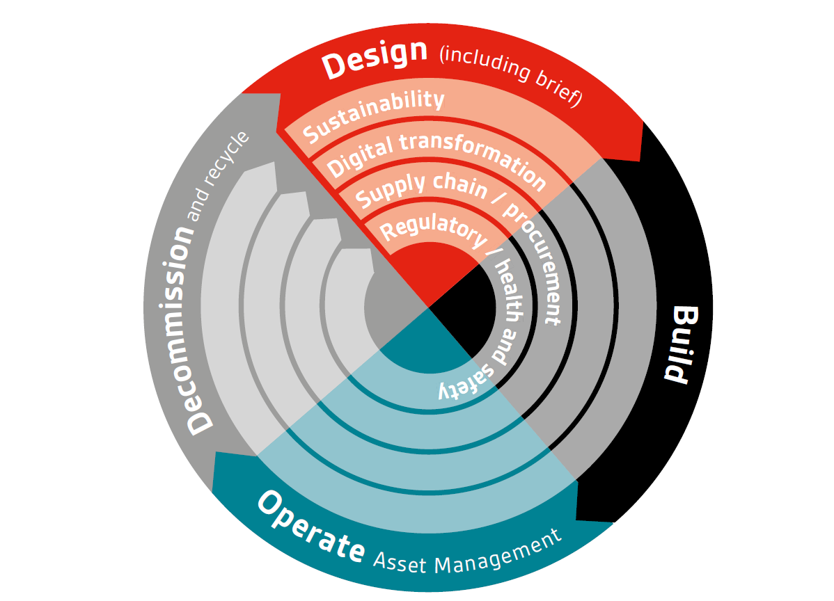
Figure 1 – Little book of BIM (bsigroup.com,2020).
As you have specified a need for whole of life monitoring of the asset through a computer aided facility management system it would be sensible to adopt a level 3 BIM Maturity level which can be summarised in figure 2 below.
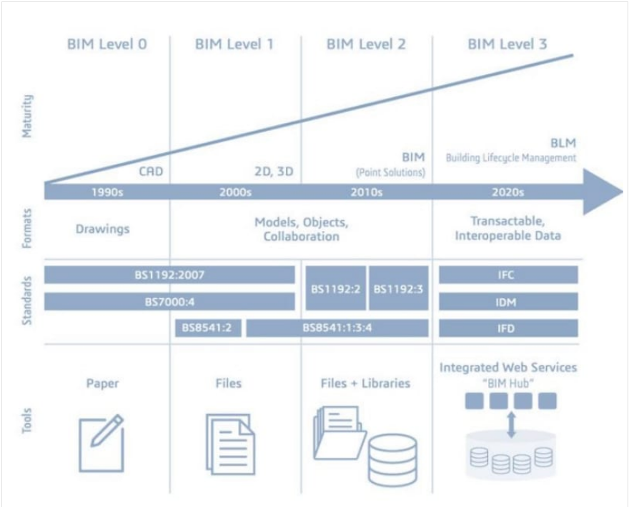

Figure 2 – 4 Maturity levels of BIM (Biblus.com,2022)
A Level 3 BIM maturity model allows real time data allowing not only the design and construction stages of the project to be populated with information but also the operational / full life cycle of the asset to have maintenance / real time information added to it also.
For this type of BIM maturity you will need a full cloud based model to be created allowing all project members access via a common data environment. ISO 19650 – 1:2018 is the specific standard related to BIM maturity which will need to be adhered to throughout the whole of life of the asset. This information should be followed to assist with things such as organizing information, asset information, project information, versioning, exchanging information and asset and model project information (Thenbs.com,2022).
The delivery of the project is outlined in the Bim execution plan (BEP) of which there are two stages, a pre-BEP which occurs prior to the contract being set up, and a post BEP which takes place after winning the contract. The pre-BEP outlines the things which were addressed in the EIR and sets out various things like the project information plan / project goals, key milestones, as well as the project programme (McPartland and Hamil, 2022). The post BEP is centred around the tender documentation, this sets out who is accountable for things such as the project deliverables, key milestones, objectives, and procedures within the delivery team. The BEP is set out in PAS 1192-2:2013 where it is defined as “a plan prepared by the suppliers to explain how the information modelling aspects of a project will be carried out” (McPartland and Hamil, 2022.
The BEP includes things such as file naming conventions, detailed working procedures, construction tolerances, the software to be used and the data exchange management systems required, whilst also specifying who will manage the database. (McPartland and Hamil, 2022).
BIM has a British standard code BS EN ISO 19650 with many different sub categories, some of these can be found below, these are some important standards that will need to be adhered to throughout the project and a summary of what each standard entails can be found next to that standard in the table below taken from the BSIgroup website.
BS EN ISO 19650 | Organization and digitization of information about buildings and civil engineering works, including building information modelling -- Information management using building information modelling: Concepts and principles.
BS EN ISO 19650-2 | Organization and digitization of information about buildings and civil engineering works, including building information modelling -- Information management using building information modelling: Delivery phase of the assets.
BS EN ISO 19650-3:2020 | Organization and digitization of information about buildings and civil engineering works, including building information modelling (BIM). Information management using building information modelling. Operational phase of the assets.
BS EN ISO 19650-5:2020 | Organization and digitization of information about buildings and civil engineering works, including building information modelling (BIM). Information management using building information modelling. Security-minded approach to information management.

Table 1 – ISO 19650 (Bsigroup,2022)

All data and ownership of information should remain with the originator of that information, this will avoid liabilities being changed when the model becomes incorporated into the federated model. The common data environment (CDE) should enable owners of that information to have control over it only allowing the originators to make changes. The models will also have status levels assigned to them such as “work in progress” “published” or “shared”. More information and naming standards can be found within the following standar BS 1192:2007.
The information above is designed to assist with the whole of life monitoring of the school and will make the asset complete with real time data which will not only assist during the construction phase but cover its entire lifecycle. A BIM level 3 maturity will enable all participants to work side by side on the same model reducing information conflicts whilst improving the quality of the asset.
Hopefully the above information is of help to yourselves, and any queries are most welcome.
Thank you for choosing Design for life ltd
Yours faithfully
Designforlife

Level of information need

Level of information need is designed to get all parties to think about what they want and what does the information that they are requesting relate to. It helps identify why are they requesting that information, why is it needed and when is the information needed. It helps identify whether the information is only needed once or at regular intervals, who is this information for, and who will it be shared with (Tekla,2020).
The final part is identifying how we want that information, which is set out in BS EN 17412-1:2020 and this breaks it down into three separate parts.
- Geometrical information – How detailed is the required information, what stage of the project is it needed for? How the information should be presented? Is it 2D,3D etc. How is the location of the data set up, i.e what co ordinate system is used. Appearance of the data, is it realistic or simplistic. Does the data have its own information associated with it, i.e its own intelligence.
- Alphanumerical information – How is the information uniquely identified? What detail of information is required for each object, the metadata that is accompanying the geographical information.
- Documentation – what additional information is required to assist with the project, i.e maintenance schedules, frequency of servicing etc.
All the above information should be identified in your BIM execution Plan and follow what is known as the RIBA plan of works.
The RIBA plan of works was originally introduced in 1963 as a framework for Architects to use on projects (TheBNS.com,2022) this has now developed into a tool used throughout the industry and explains various outcomes, information exchanges and other core tasks associated with the key stages of a construction project.
The plan of works has evolved into what is referred to as the RIBA plan of works 2020 and is published by the Royal institute of British architects, the 2020 version is also endorsed by various professional bodies within the industry.
An example of the RIBA plan of works 2020 can be seen in figure 3 below and I will aim to summarise each in the following section and provide some real life examples following on from this.

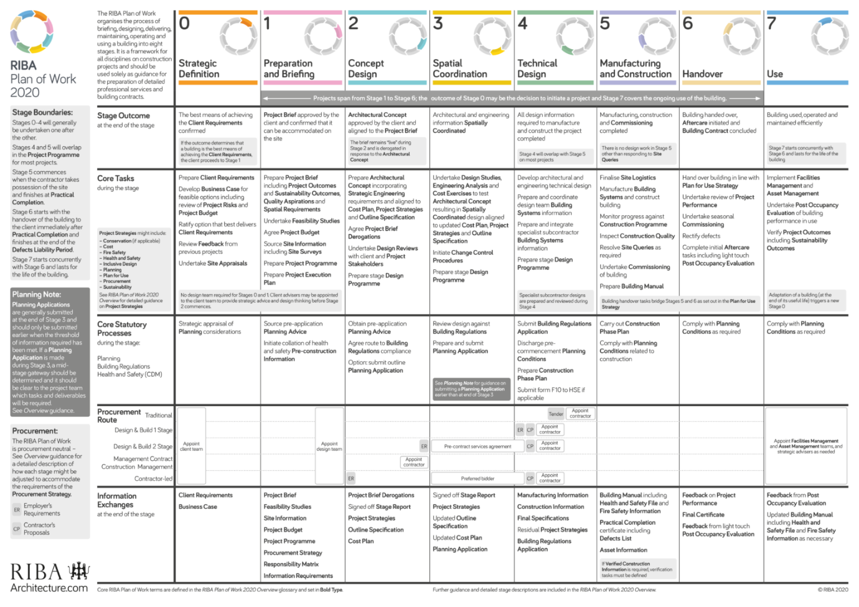
Figure 3 – RIBA plan of works 2020 (Architectsjournal,2022)

The various work stages in the image above will be summarised below and the level of information need that is required for each stage will be explained.

Strategic definition
The first stage in the RIBA 2020 plan of work is what is known as the strategic definition stage, this is where the scope of works is defined along with the clients brief. This stage assesses the projects risks and budget as well as undertaking any site surveys, planning applications and identifying best options for delivering the required outcomes.

Preparation and briefing
This stage involves expanding on the initial design process by carrying out feasibility studies and developing the information that the design team will need for the concept design stage

Concept design
This is the first proper design stage of the project. This stage involves outlining specifications, costs, procurement options, programme of works. The BIM model will start to be developed in greater depth with information added to the model such is zoning, floor and wall information, facilities etc.

Spatial co-ordination
This is where the design and construction of the building is divided into stages and key milestones established, it is set up to assist with the completion of the design stage. This stage assists with progress reports, payment stages and information approval points etc.

Technical design
This is where certain project activities can begin after detailed design but before construction starts, such as the utilisation of specialist contractors and initial meetings with them, i.e fire safety sprinkler installations. There are some ambiguities amongst certain stages of the project so it is important these are identified in the appointment documents as to which activities fall into which stage.

Manufacturing and construction
This stage involves the actual construction of the project, where all agreed stages of the construction programme are followed. This stage also allows the updates to be added into the BIM model to show the progression of the project and the completion of various construction activities. The completion and handover certificates are also handed over to the client at this stage.

Handover
This is the process of the completion of construction, where on site handover training is provided and any defects rectified before the client takes full control of the site and any final certificates are signed, documentation handed over and full control is handed back to the client.

Use
This stage is where the consultants may provide some advice to the client on the buildings use regarding maintenance, facilities management etc but the client now has full control of the site and the project is now complete.

EIR
The EIR can be described as the Exchange information requirements and was previously referred to as the Employers information requirements. These requirements specify the information that will be required by the appointed person for that contract
The EIR will have information such as timescales, who is responsible for what, the level of information needed specific to that project and the format the data is required to be displayed in. (Bsigroup,2022).
The EIR should also include asset information requirements (AIR) which includes the information that is needed to build, maintain, and run a BIM process with a specific asset management strategy. The requirements for this can be found in PAS 1192-3 but in summary include, managerial, commercial, technical, financial and legal requirements.
The information required will depend on how complicated the project is, but the general requirements should include some standardised methods and procedures these should outline things like naming conventions, sharing of information and how this information should be created, whilst providing a clearly defined specification on all roles and their respective responsibilities. Deliverables and detailed plan of who and by when information should be delivered and as well as an asset database detailing all specifications of things like doors, windows, roofs etc and when these will be delivered and by who should also be included (designingbuildings,2022).
The following standard PAS 1192-2:2013 describes the information needed to be included and an example of how an EIR fits into the larger client information model can be found in figure 4 below.
The EIR can be split into three parts, Technical, Management and commercial.
The technical part should identify what software platforms are used, i.e the BIM systems or CAD software that is being used. This is to ensure the correct use of a standardised co ordinate system, this will ensure that everyone is working off the same system ensuring standardization throughout the project.
The management section is where all standards are adopted, i.e roles and responsibilities assigned and all affected parties are fully aware of the deliverables, data security etc.
The commercial part sets out what the clients strategic purpose is, this is identified in the clients plan of works and what the expected purpose of that work undertaken is and how the information is going to be displayed (3d models or in CAD for example) (PlanBI,2022)

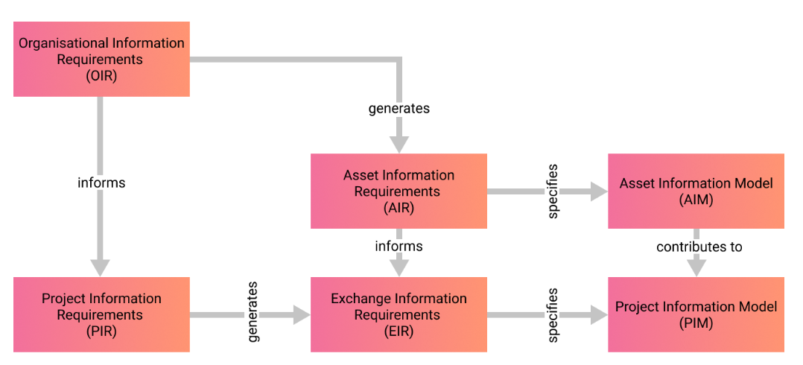
Figure 4 - flow chart of requirements - ISO 19650-1 chart

Examples

Most UK based projects follow the old PAS1192 standard to define the level of information need (LOI) from the client, however the new 19650 international standard mentioned above allows the method of choice to be agreed with the client allowing more flexibility. Outlined below I will aim to give a few examples of this hopefully enabling you to make a choice on the type of LOI and LOD (levels of model detail) you require and what to include in your EIR.

Level of information detail and level of model detail

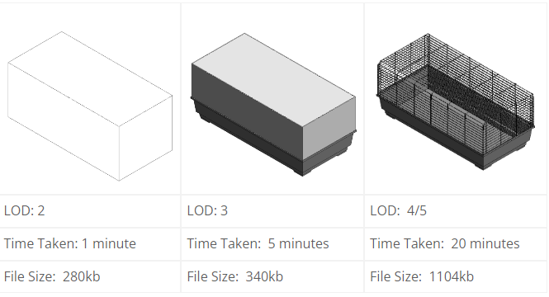
Figure 5 – level of model detail (Bimbloghouse, 2016)
Figure 5 above outlines the difference in level of information detail vs model detail, this is an example of a rabbit’s hutch which has been modelled for a project. Each image above provides the same level of information (the rabbits hutch), but each has a different graphical detail, the LOD4/5 version taking longer to produce and significantly increasing the models size compared to LOD2 version. These are key issues that need to be defined prior to the model build (Concept design stage) as a model built to the LOD 4/5 spec will take a lot longer, use much more memory and cost a lot more than the LOD2 model and if this visualization was not defined in the model purpose or required at all, then the effort to produce the rabbits hutch at an LOD 4/5 standard will be ultimately wasted.
The rabbit hutch is only one small example but in the EIR these requirements for level of detail need to be specified, this level of information need can be applied to doors (do you need screws and hinges modelled or just dimensions) trunking for electrics (do you need cables, costs and all wiring mapped out or just a rough location within the room), the Boiler for the school (Is it a simple shape or will it require how its powered, how its maintained its running costs etc). These are key pieces of information and both LOD and LOI are critical for project success from the outset.
Levels of model detail are defined for the key stages of the project where information exchanges also take place, allowing the customer a chance to verify that they are getting what they require and enabling them to decide if the project should progress to the next stage. There are no definitive timings for these data exchanges but should be aligned to employer decision points, a brief overview is given in PAS 1192-2 but it does not specify exact timings. (Deigning buildings.com, 2022).
BS EN ISO 19650-1 aims to use a range of different metrics to determine the levels of information need ensuring only the minimal relevant information is requested and provided. These metrics include geometrical and alphanumerical type data ensuring quality and quantity and granularity is sufficient (Wityk J, 2022).
Hopefully the above information should provide you with all that you require to identify what you need to include in your EIR and provides a good overview of the level of information need and the RIBA stages of a project. It is important to note that the amount of information will change during the RIBA stages as the complexity of the project develops.

References

Bim maturity levels: BIM Level 3 - biblus (no date). Available at: https://biblus.accasoftware.com/en/bim-maturity-levels-bim-level-3/ (Accessed: December 30, 2022).
BIMicon. 2022. A Simple BIM Naming Convention Based on ISO 19650 Part 1 - BIMicon. [online] Available at: <https://www.bimicon.com/bim-naming-convention-based-on-iso19650-part1/> [Accessed 8 April 2022].
BS EN ISO 19650-1:2018 organization and digitization of information ... (2018). Available at: https://www.thenbs.com/PublicationIndex/documents/details?DocID=324869 (Accessed: December 30, 2022).
Bsigroup.com. 2022. Download your copy of the Little book of BIM (2021 edition). [online] Available at: <https://www.bsigroup.com/en-GB/Building-Information-Modelling-BIM/bim-design-and-construction/little-book-of-bim/> [Accessed 30th Dec 2022].
Designingbuildings.co.uk. 2022. Latham Report. [online] Available at: <https://www.designingbuildings.co.uk/wiki/Latham_Report> [Accessed 30th Dec 2022].
Lod - from level of detail to level of information need | tekla (2020). Available at: https://www.tekla.com/uk/resources/blog/level-of-information-need (Accessed: December 30, 2022).
McPartland, R., McPartland, R. and Hamil, D., 2022. What is a BIM Execution Plan (BEP)?. [online] NBS. Available at: <https://www.thenbs.com/knowledge/what-is-a-bim-execution-plan-bep> [Accessed 21st Dec 2022].
PlanBIM. 2022. Exchange Information Requirements - planBIM. [online] Available at: <https://www.planbim.io/blog/2020/06/01/exchange-information-requirements/#:~:text=The%20Exchange%20Information%20Requirements%20(EIR,of%20the%20completed%20built%20asset.> [Accessed 30th Dec 2022].
PLQ1.5 – level of definition – there's no bim like home (2016) Bimblog. Available at: https://bimblog.house/2016/05/09/plq1-5-lod/ (Accessed: January 10, 2023).
RIBA Plan of Work 2020 released with New Focus on Sustainability (no date). Available at: https://www.architectsjournal.co.uk/news/riba-plan-of-work-2020-released-with-new-focus-on-sustainability (Accessed: December 30, 2022).
Shop.bsigroup.com. 2022. Bisgroup [online] Available at: <https://shop.bsigroup.com/products/transition-guidance-to-bs-en-iso-19650/standard> [Accessed 21st Dec 2022].
Wityk, J. (2022) The level of and Progression Management Systems, integrated project design. Available at: https://integratedprojectdesign.com/the-level-of-and-progression-management-systems/ (Accessed: January 10, 2023).

