Feasibility Study of Electric Vehicles to reduce Carbon Impact.

Programme: BSc Automotive Engineering
Module: Sustainability Through Technology
Lecturer: Kerry Tudor
By: Miguel Clemente (P131083)

Contents

1.0 Introduction 3
2.0 Emissions 4
2.1 Batteries 6
3.0 Problems 7
3.1Availability 7
3.2 Cost 8
3.3 Range 9
3.3.1 Charge time 9
3.3.2 Petrol / Diesel Filling 9
4.0 Analysis/ Comparison 10
4.1 ICE vehicles 10
4.2 Electric Vehicles 10
5.0 Bibliography 11

1.0 Introduction

This report will look upon the employment of electric vehicles towards the urban automotive side along with the problems both sides can sustain being electric or petrol driven.
This paper will consider various aspects of the introduction of EV’s and the current in production ICE cars, emissions will be taken into consideration from both sides, they construction of battery and how the process for an EV vehicle isn’t totally carbon free and the problems that comes with it, current availably of EV vehicles compared to petrol, cost comparison between the two.

The comparison will be made between current new electric production cars and already in production petrol cars.

2.0 Emissions

Emissions, here lies a great trivial pursuit into cleaner pollutants given by the widely used and well known ICE engines, there are many pollutants given out from ICE engines with the main corporate being CO₂, this gas in particular has been closely watched in the last few years and with a great demand to reduce its production the introduction of EV’s seems to be the long dreamed solution to the problem, being that when an electric vehicle is being driven on urban, country roads or motorways it is said to produce ‘zero’ emissions, but with fossils fuels being burnt at power plants to accommodate such demand when charging these electric vehicles aren’t as clean as people might think.

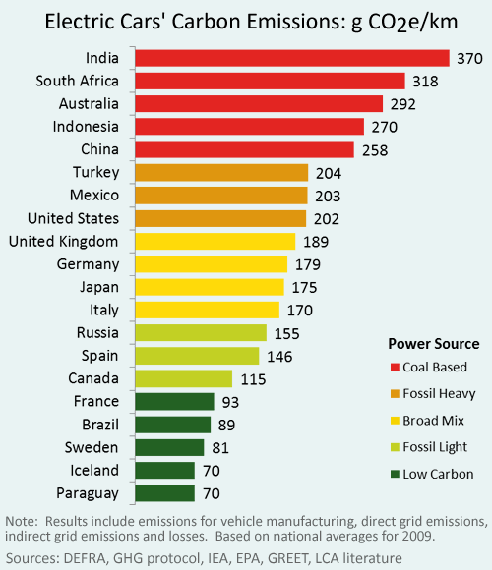
Figure 1: Carbon emissions in coal dominated places to those with low carbon power. (shrinkthatfootprint.com)

By considering the full scope of emissions both in electricity supply and vehicle manufacturing this analysis compares the carbon of electric vehicles in twenty of the world’s leading countries based on national average for 2009. (shrinkthatfootrink.com)

This is showing the entire process between manufacturing and charging, this does not consider when the vehicle is being driven. Off course the ICE vehicle will keep on producing CO₂ when still being driven, but the production process between these two have shown that it takes less CO₂ to produce a petrol car than it does to produce an electric vehicle. Petrol 40g CO₂e/Km and 70g CO₂e/Km for electric estimates taking from different countries across the world.

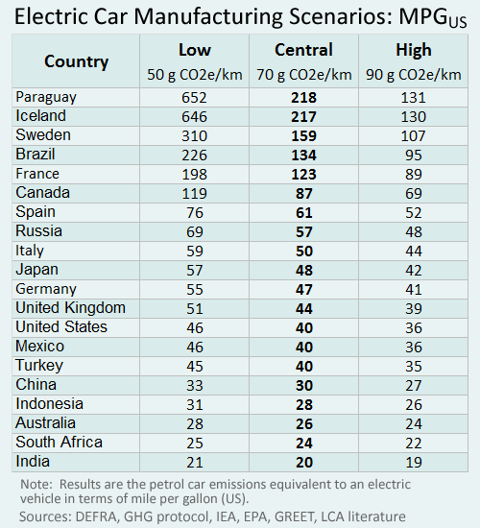
Figure 2: Manufacturing Carbon Scenarios. (shrinkthatfootprint.com)

2.1 Batteries

When it comes to electric vehicles it’s main source of power is as the name states electricity and how is electricity stored? Through a battery, saying this there are diverse types of batteries some types such as Lithium-ion are already in use both for vehicles and other electronics and some other options are being considered like;

- Solid State Battery:
This type of battery has some advantages with no worry of leaking electrolytes or fires, providing a flame-resistant electrolyte is used and extended lifetime with decrease for major cooling mechanisms and with the ability to operate in extended temperature range. Manufactures like Toyota and Volkswagen are considering solid-state batteries to possibly power their electric vehicles. (Jack Karsten, Darrell M. West, Elsie Bjarnason from bookings.edu)

- Aluminium-ion batteries:
These are similar to LIBs with an aluminium anode, it promises to have an increase in safety and a decrease is cost to LIBs. With not much information to go on from minimal research it is still in its initial stages of development. (Jack Karsten, Darrell M. West, Elsie Bjarnason from bookings.edu)

- Lithium-sulfur batteries:
Typically, with a lithium anode and a sulfur-carbon cathode this battery offers a higher theoretical energy density and lower cost to LIBs, with its cyclability being improved NASA as invested in solid-state Li/S batteries to power space exploration. (Jack Karsten, Darrell M. West, Elsie Bjarnason from bookings.edu)

These are just some of the battery technology being worked on and being developed along the way with Lithium-ion being at the top of the list for now and with the most research and information known about it, it is most likely it will still lead the way for some years to come and to aid the development of other technologies with done with diverse types of batteries.

3.0 Problems

When dealing with electric vehicles and ICE powered vehicles problems are inevitable to happen when discussing the two, which is better, which costs less, how long will it take to charge, how long can one drive in a single charge and how available these vehicles are to the public in comparison to ICE vehicles.

3.1Availability

When looking for the availability of these vehicles, it seems that between plug-in hybrids are more viable to own compared to a battery powered electric vehicle, the number of hybrids now are greater than those solely run on batteries.

With this chart from the US it shows the availability of EV’s in selected areas from January -June 2016
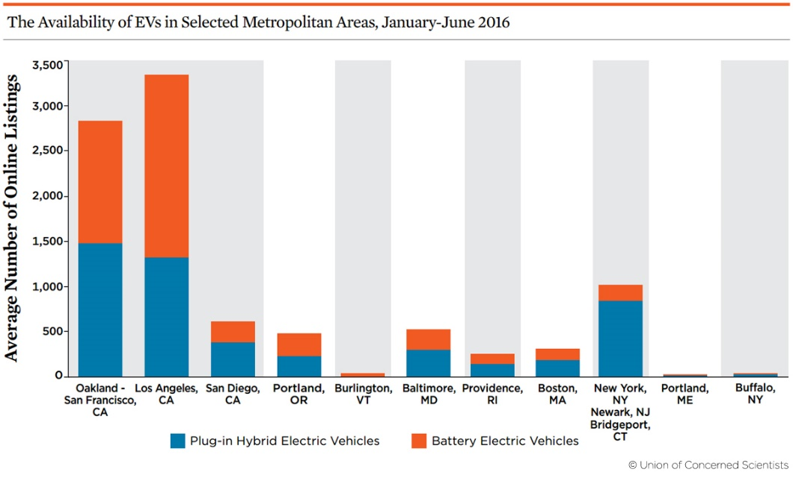
Figure 3: Availability of EV’s. (ucsusa.org)

There is not much out there for the consumer to choose from and when something finds something they like it can cost an arm and a leg or go for the usual and buy and ICE car for sometimes a third or half the price of an EV.

3.2 Cost

A price comparison was made by Chris Lloyd from (motors.co.uk) back in 2014 comparing the annual cost between a petrol, diesel and electric vehicle for a typical driver covering around 10,000 miles, those covering less will have a longer to recoup the additional cost of the electric vehicle, but for those coving more mile they will have a greater saving in fuel.
Ford Focus Electric
Purchase cost: £28,580 (after £5,000 government grant)
Cost to charge: £1.38 – £4.83 (dependent upon tariff)
Range provided per charge: 100 miles
Cost to cover 10,000 miles: £138 – £483
Car tax: £0
Annual cost of fuel and car tax: £138 – £483
Petrol: Ford Focus 1.0 125 Titanium X
Purchase cost: £22,295
Fuel economy: 60.1mpg
Cost to cover 10,000 miles: £938.90
Car tax: £20
Annual cost of fuel and car tax: £958.90
Time before electric car pays for itself: 7.7 – 13.2 years

Diesel: Ford Focus 1.5 120 TDCi Titanium X
Purchase cost: £22,995
Fuel economy: 74.3mpg
Cost to cover 10,000 miles: £785.98
Car tax: £0
Annual cost of fuel and car tax: £785.98
Time before electric car pays for itself: 8.6 – 18.4 years

Annual cost covered by Chris Lloyd (motors.co.uk)
Good comparison for what the consumer might be interested in off course it all depends on how much you can afford and how much the vehicle gets used.

3.3 Range

When talking about how far the consumer can travel with petrol compared to a electric vehicle there is no doubt that a petrol driven vehicle will outlast an electric vehicle is that aspect so why should consumers care for buying an electric vehicle when they are limited to mileage, charging time and sometimes cost of vehicle and choice…

With most electric vehicles today having a short range of travel that only allows the consumer to have short trips to weekend shopping and possible going to work and back if not living too far this doesn’t appeal to a lot of people to not have the freedom to travel for over 500km with petrol or diesel cards from a full tank to a 200km average from a single charge before having to make a stop and waiting a while before setting off again.

3.3.1 Charge time

When owing a petrol or diesel car can give you a freedom of ‘unlimited’ travel without having to wait for you car to charge up, this can be a hassle for a lot of people having to make long trips daily.
Without a doubt the consumer will be saving the environment and money on a long-term basis when opting to have an electric vehicle, but these advantages can quickly be overshadowed by the problems mentioned above.
According to BMW the i3 can charge 80% of its capacity in around 40 minutes to give the consumer and extra ‘180km’ range before having to be charged again, these days to most this is not acceptable. (BMW)

3.3.2 Petrol / Diesel Filling

When in need to fill up its much simpler and no need to wait for hours for a lot of people this brings a lot of convenience and freedom to be anywhere they choose at any given time and not have to wait, once on red just spend a fill seconds filling up and done, back on the road.

4.0 Analysis/ Comparison

4.1 ICE vehicles

When choosing an ICE vehicle is very straight forward there are a lot of options out there as you can imagine from hatch backs to 4x4 to saloon cars and others, the price also varies a lot being the car used (cheaper) or brand new (some what cheap) the consumer can really take its pick and price range as they can afford, also with mileage range is not much of an issue as the consumer can stop at any nearby petrol station and fill up the can in seconds and get on it way very quickly, short or long range travel doesn’t matter its all possible. The carbon foot print is indeed larger than that of an electric vehicle, but there’s less hassle to deal with for most consumers petrol or diesel is still the way to go.

4.2 Electric Vehicles

Well, when choosing this type of vehicle, the consumer can for sure have less carbon foot print in comparison to petrol and diesel and have a great saving in the long run, but now there are some ‘problems’ a lot of consumer are still not ready to deal with or understand. When choosing an electric vehicle it can be hard as there are not many options within a certain price range, most of the cheaper cars will be small and enough for two people , but it a bigger vehicle is needed then you are looking to spend a bit more despite the fact that a lot of these cars have come down on price and there are a lot of expensive cars still on the market despite the Government scheme to help the purchase of an electric vehicle price go from £15,000 for a Smart 2 door car to more expensive Mercedes B-class electric drive b250 at £28,790 to even more expensive Tesla model S £70,000+ it all depends on the consumers’ needs and affordability, again the wait to charge time can put a lot of people off from buying one of these, the wait time can be anywhere from 4 hours to 8+ hours to charge and the consumer only gets a limited amount of range before having to re-charge again.

Having said this the electric vehicle craze can indeed help to regulate the amount of carbon footprint being produce and it can have a long-term saving, but the technology of the batteries is yet to be fully understandable or capable to having these cars being used regularly on a day to day basis without the need to wait hours for a charge. Once more research and development are done, and the technology keeps on improving it could indeed be the future.

5.0 Bibliography

[Online] Shades of Green: Electric Cars’ Carbon Emissions Around the Globe
Read more at http://shrinkthatfootprint.com/electric-car-emissions#jpHRYTA1bqqAhhxV.99
[Accessed 29th November 2017

Five emerging battery technologies for electric vehicles.
Jack Karsten and Darrell M. West, September 2015 [Online]
https://www.brookings.edu/blog/techtank/2015/09/15/five-emerging-battery-technologies-for-electric-vehicles/
[Accessed 1st December 2017]

Electrifying the Vehicle market (2016)
[Online] https://www.ucsusa.org/clean-vehicles/electric-vehicles/ev-availability#.Wi7q8Epl-Uk
[Accessed 2nd December 2017]

Which is cheaper: petrol, diesel or electric?
Chris Lloyd, November 5, 2014. [Online] https://news.motors.co.uk/news/which-is-cheaper-petrol-diesel-or-electric/
[Accessed 3rd December 2017]

Next green car comparison
http://www.nextgreencar.com/electric-cars/available-models/
[Accessed 3rd December 2017

