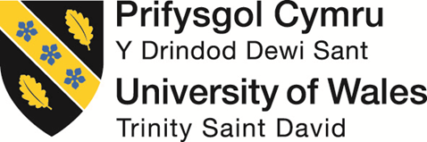

LEVEL 6

SEMESTER 1

MODULE CODE: BMOE6003
Landscape and Sustainable Recreation
aSSESSMENT TYPE: assignment
Assessment: 2

COMPONENT WEIGHTING: 50%

WORD COUNT: 2,500 WORDS

MODULE TUTOR: Anthony Burns

Reflective Fieldwork Journal
As part of this module there will be a number of virtual/physical site visits as fieldwork. As you visit each site you will need to keep detailed notes relating to the following issues:

• Landscape Character
• Landscape Quality
• Designations
• Use
• Access
• Future Potential

You should choose two sites of your choice from those visited (whether virtual or physical) and the notes you took should subsequently form the basis of a reflective and critical account of the landscape at each location, including relevant academic and policy related literature also providing suggestions for sustainable approaches to recreational development at each site. Maps, sketches and photographic evidence should be used as appropriate.

SUBMISSION DETAILS:

Submit by Turnitin on or before 22nd January Friday 2021
Feedback to be returned to student: on or before19th February 2021

School of Sport, Health & Outdoor Education

Assessment Feedback Sheet

Student No./Name: Harry Bowler
Module: Landscapes and Sustainable Recreation
Module Code: BMOE6003

Personal Evaluation – to support your academic progress please complete the section below BEFORE submitting your work.
What do you consider to be the best aspects of this work? |  |  | Knowledge of the area for Blaenavon
Which aspects do you consider could have been improved in this piece of work? |  |  | I could have expanded more about Lundy
What have you found most satisfying whilst undertaking this submission? |  |  | Re-purposing an area I am familiar with.
ASSESSMENT CRITERIA | Learning  Outcomes |  | GRADE
ASSESSMENT CRITERIA |  |  | Poor  < 20% | Weak  20-29% | Unsatisfactory  30-39% |  | Satisfactory  40 – 49% | Good  50 – 59% | Very Good  60 – 69% | Excellent  70 – 84% |  | Exceptional  85– 100% | %
Your discussion of the nature of landscape within the context of the fieldwork locations | 1 |  |  |  |  |  |  |  |  |  |  |  | 20%
Your critical evaluation of external and internal influences that affect the perception, interpretation and use of landscape at the fieldwork sites. | 2 |  |  |  |  |  |  |  |  |  |  |  | 20%
Your critical discussion of the relationship between landscape and recreation and your suggestion of sustainable approaches to the interpretation and use of landscape for recreation. | 3 |  |  |  |  |  |  |  |  |  |  |  | 40%
Your identification and use of relevant academic and other material to help inform and develop your argument | 1,2,3 |  |  |  |  |  |  |  |  |  |  |  | 20%
It is expected that students will present work that is proof read, correctly referenced and adheres to the Assessment Checklist. Therefore a range of 0 – 10 marks will be deducted for non-completion of any of the points on the checklist below.
TUTOR COMMENTS:

Submission date:  via Turnitin |  | Return date:  (at least within 4 weeks) |  |  |  | Tutor: |  |  |  |  | Mark:

Assignment Checklist

- Please complete the Personal Evaluation section of the Assessment Feedback sheet, add your name and details, and paste the whole of this assignment document into the front of your assignment

- Submission is a single word file, clearly labelled with your name and module code
- Font style - Times New Roman, size -12 for text and 14 for headings
- Ink colour – black only
- Line spacing – 1.5 line spacing and 2cm- 2.5cm page margins
- Quotations more than three lines to be indented 1 line spacing
- One line space between paragraphs, paragraphs must be left aligned
- Pagination (your assignment should have page numbers)
- All tables and figures are internally referenced and have a title
- Word count checked and written at end of text (before references and any appendix)
- Assignment is within 10% of the word limit (excluding references and any appendices)
- All references in the text are included in the reference list
- Correct referencing following the Harvard style, as described in the Palgrave study skills book ‘Cite them Right’.
- Correct spelling using UK English
- Correct use of punctuation
- Grammar and syntax correct- double check anything that has a green line under it
- I have read my assignment out loud to myself and it makes sense and is easy to read
- Somebody else has read my work and it makes sense to him or her!
- I have checked and I have not plagiarised
Failure to follow these guidelines will cost you marks!
In this field-trip journal I have written my accounts on two contrasting landscapes. Due to the pandemic I was only able to visit one of the locations in person and for the other I did a virtual visit. I have studied the history, landscape and communities of these areas, and laid down my thoughts of what I would like to see for the places in the future.

Blaenavon
Blaenavon is a town based in the Torfaen county borough of south Wales; full of rich history. Blaenavon is home to a world heritage site the ‘Big Pit’ designated by UNESCO in 2000. This hillside town would once have had an incredible landscape which would ignite all of your senses due to its industrial iron/steel works. The valley would have been a noisy environment with sounds of explosions from the pit and metals being smashed against each-other. Now the town sits quietly with only the sounds of car alarms and traffic of tourists by passing to get to the Brecon Beacons or the ‘Big Pit’. Stood in the town, the rows of workers’ terraced houses block the view of the surrounding countryside. The town offers limited opportunity for its youth, forcing many to migrate to nearby cities. Although the ‘Big Pit’ offers employment now as a museum, a lot of the staff are people who used to work down the mines and when the jobs come up there were not enough vacancies for the unemployed in the area. The local council invested in building an industrial estate but many of the units still sit empty. “Officially, Blaenavon’s population peaked was at 12,469 in 1921, according to the census. However, by this point the town was entering into the post-war economic slump so may have already experienced some outward migration.” (Blaenavon Town Council, 2021). The most recent census in 2011 showed the population of Blaenavon sitting at 6,055 which is a huge drop.
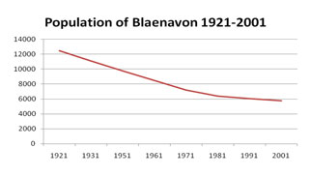(Visit Blaenavon, 2021).

Although the decline in population has slowed in the last decade, the local community are working on a regeneration programme. However, the population drop has left many properties, including the Ty Mawr (Former Iron Masters house) empty. Public transport to Blaenavon is fairly restricted; with the increase of cars and the closure of the mines, Blaenavon would lose its trainline. To access the area you would either need to come by car or bus. Unfortunately, the stagecoach busses which run are expensive and restrictive, making the town less appealing to stay in, particularly for the younger generation of Blaenavon making the town less appealing to stay in. The local community have been working hard to change this direction and utilise the outdoors.
“Ranger schemes have been implemented, allowing for local people to have a role in caring for the surrounding environment. Such initiatives have encouraged repeat visits to the town and have promoted healthy lifestyles. The Forgotten Landscapes Programme will also help conserve and interpret the countryside around the town.” (Visit Blaenavon, 2021).

The urbanised area of Blaenavon sits on the east facing hill, facing the backside of the treeless hill of Blorange. Like Blorange, Blaenavon’s hillside now sits feeling lifeless as apart from than industrial ruins, there isn’t much to see. On the West facing side of Blaenavon however is a completely different story. “Tirpentwys used to be an old tipping site, but has recently been reclaimed and is now made up of a number of different habitats including ponds, woodland and streams.” (Torfaen County Borough, 2021). This biodiverse area has a completely different wilderness setting compared to the town. I truly believe this area could help Blaenavon achieve the building future prospects for the town using outdoor recreational activities. Tirpentwys recently won a battle against an opencast mine being created in the beauty spot. On the 15th of January 2019 Torfaen council's denied permission to remove to quarry. “Torfaen council's decision, which was due to an "unacceptable loss" of ancient woodland.” (BBC, 2019).
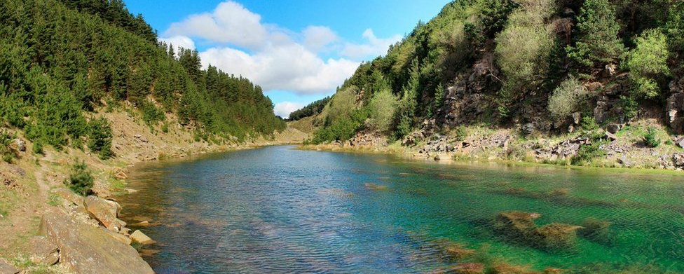
(BBC, 2019).
The Canyon, which was originally created by quarrying, has turned itself into a completely new landscape. “The area, known locally as "the canyons", was left largely as it was when the machines stopped, and a small lake formed in the middle of narrow, steep-sided valleys bordering Blaenau Gwent.” (BBC, 2019). The steep banks either side of the quarry have seen a growth of trees and locals state: “The area has been “Reclaimed by Nature” since opencast mining stopped in 1962, and is now used regularly.” (BBC, 2018). Now “the canyons” have been saved it would be a great time to re-purpose the area to safe-guard it from future destruction.
This area is currently home to a few local recreational activities and these could be a key part to the regeneration of the area. I personally believe if we are to see a successful future for Blaenavon it will be need to be created in a sustainable way so that it does not become obsolete like we saw with the Iron/Steel/Coal industries which previously let down Blaenavon. Following Brundtland’s model of the Three Pillar Paradigm from 2002, I believe this would be achievable. The Three Pillar system ensures that there is a holistic approach and helps to minimise any impact on each area. All should help support each other to create a good foundation.

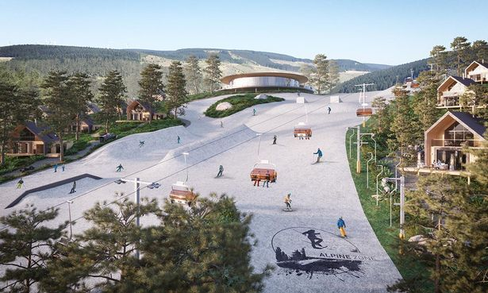
(BBC, 2020).
With Covid-19 creating a huge surge in outdoor activity and the need for more areas dedicated to recreation outdoors, I would look at creating the Tirpentwys outdoor education centre. With the current climate it is important that we give the local community something they can enjoy but at the same time something that will also create jobs. As seen above, this is the Ski resort proposed for Afan Argoed created by the creator of Centre-parks. Taking this concept of a resort but scaling it down is what I see possible for the future of Blaenavon. Instead of ripping through a tree-line to create a slope, my resort would use the existing affordances there, creating as little damage to the environment as possible.
(Tirpentwys Trails, 2021).
As seen here, local rider/trail-builder, the late Ryan Buillimore. He took advantage of an area of felled trees in the forest. This clearing provided Ryan the affordances to carve the mountain into a playground for mountain bikers. My plan would see the trails evolve and cover the entire area of Tirpentwys. It would create employment for the local youth who have picked up Ryan’s shovel and taken over since his passing. The natural landscape of this area is super lumpy; Ryan had an eye to use this to his advantage to create what is known as a “flowy” trail. This is when minimal effort is needed to maintain speed, but also gives a floating sensation when riding the trail (similar to surfing). This method of building would be used to continue the flow feeling and really connect the rider with the landscape.
As mountain biking has now grown into such a huge sport, it promises to be a profitable venture for the area. Not only would the expansion create new jobs but it would also link up Pontypool and Blaenavon with a healthier and fun way to travel between the two towns. There will be a bike rental service creating the opportunity for anyone to get involved without the need to invest thousands on a mountain bike.
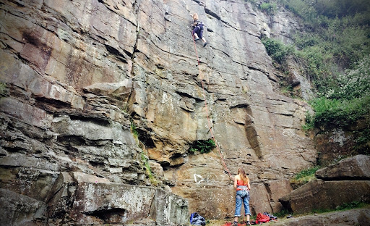
(Bristol Climbing Scene, 2015).
Another hidden gem of this woodland is the new affordances of the sheer cliffs created by the previous open cast mining that took place here. This area can easily be transformed into a climbing centre at an affordable cost. Once again using the landscape provided at its rawest form to provide activities for locals and to bring in more tourism. Locals and tourists can enjoy the landscape in its rawest form, as part of the Tirpentwys outdoor centre this would create specialised jobs for the town of Blaenavon.

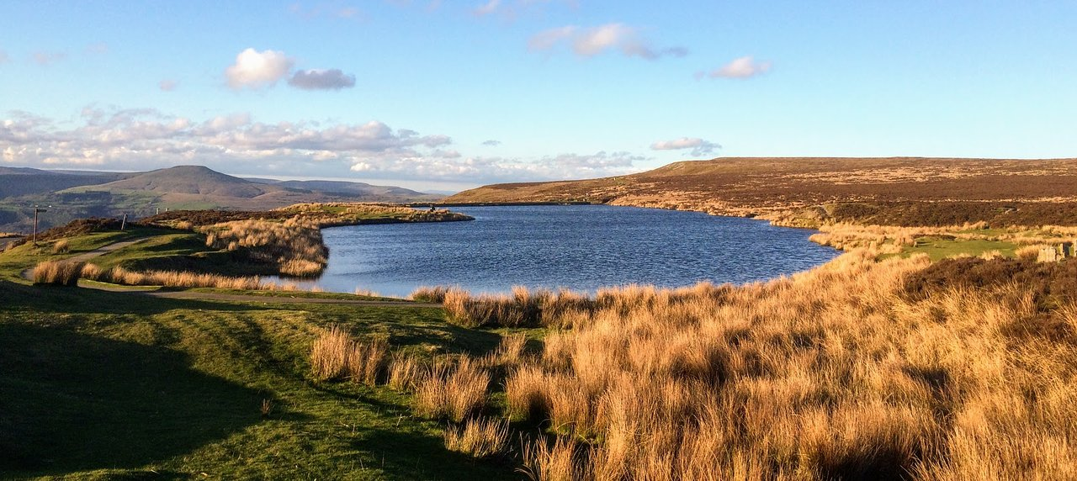
(Trip Advisor, 2020).
With a clear-out of the water in “The Canyon” it could be made safe for water-sports and swimming. Due to the unknown mining equipment which may lurk under the water. In this transition period close by Keepers pond (Seen Above) can be used as an alternative venue. Once again this will create specialist jobs in the area, with minimal disruption to the environment, create local jobs and give the local demographic new opportunities.

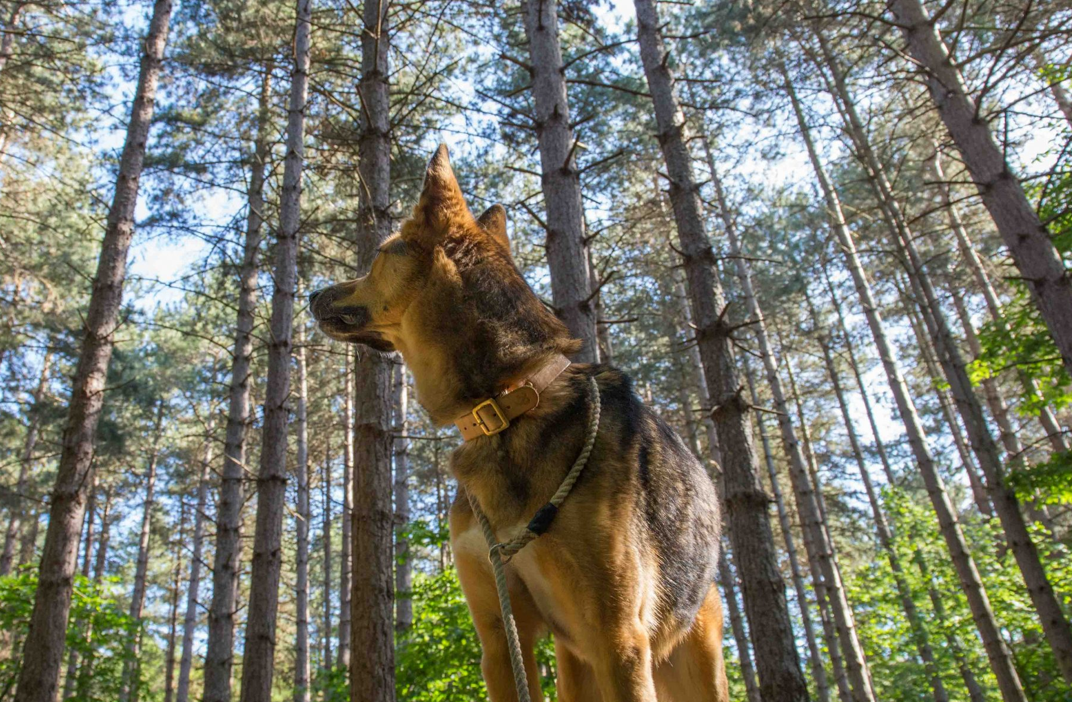
(BBC, 2021).
I recognise that not everyone in the area will be looking for a thrilling adventure, this is why I have also thought about a re-wilding walk. This walk will be through the tree-plantation around Tirpentwys with multiple length options. It will be secured by a fence all the way along the walk but with a 50 metre distance between wall to wall. There will be a one way system to avoid any spreading of infectious dieses. This will give the ability for dog walkers to let their dogs off the lead in a safe environment. Dogs will have to wear bells to warn the local wildlife. This walk will include boards about the local history/wildlife and be open to all. Due to the secure gate, it will need to be manned at the entrances and exits. This will create more jobs for the centre and the local community. However will be run with donation pots with no charge for entry.
Blaenavon is currently a poor town, in economic terms, and the cost of adventure sports at the centre might not be affordable for all. There will be a postcode scheme where local people will have access to the centre. There will be a fleet of rental bikes; a percentage of bikes will be reserved for locals who will have access 3 days a week during winter and 1.5 days during summer free of charge! There will also be community days where they can take part in guided activities funded by the profits of the centre and any government gran. A lot of outdoor centres focus on schools traveling from all over the UK to use them, whereas Tirpentwys will differ because it will be reserved for nearby Welsh Schools only and be subsidised by government grants available; it will work in conjunction with the URDD. Being a new project it will be easy for the centre to abide by the 2015 Well-being of Future Generations Act Wales. This legislation is designed to create a more resilient Wales and help prevention of the destruction of the nation. And work towards creating a more sustainable Wales in the 21st Century. This project can help with placemaking for Blaenavon and really give the people of the town a new sense of connection with their home.

Lundy Island
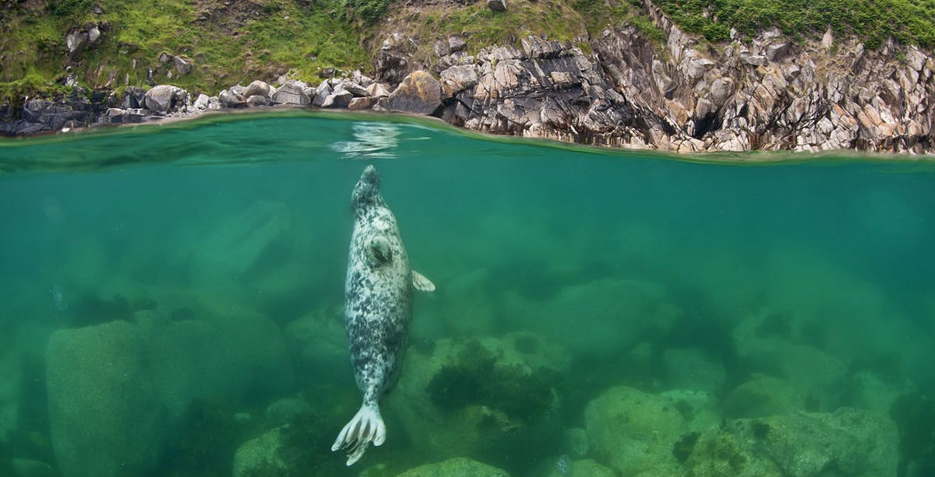

On a small bit of land off the Devon coast surrounded by water you will find Lundy Island. Its steep sides lead to an open landscape up top. The island is owned the National Trust and managed by the Landmark Trust. “The two charities have worked together since 1969 to restore and protect all that is cherished and special about Lundy” (Landmark Trust, 2021). "Above and below the water a huge abundance of wildlife can be found, including 300 sheep, ponies, cattle, puffins, feral goats and much more? Being completely surrounded by water, Lundy is a place which can really connect you to the landscape. Being isolated the island has full experience of the weather fronts which come in and it has total exposure to weather in each season. As the seasons change so does the landscape, with different flora crossing the island and with a range of species which migrate.
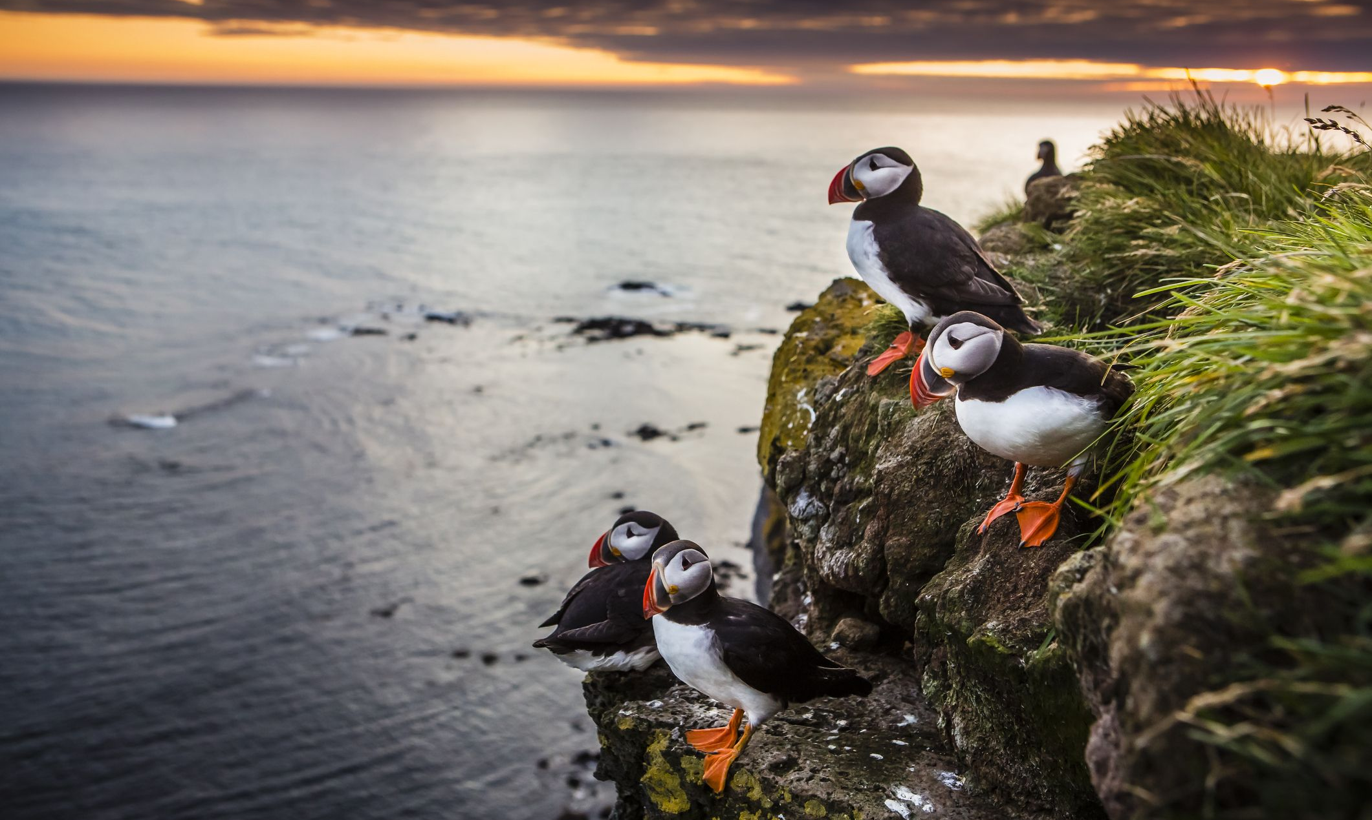
(Country Living, 2019).
This landscape offers great beauty to look at and affordances for wildlife, however it does not provide a suitable place for mass urbanised human settlement. The only access to the island is by boat or aviation so arrivals completely reliant on the current weather conditions. It’s not uncommon for people to get stranded on Lundy island, on BBC’s inside out documentary Sîan Scott came to visit Lundy and, on the day, she was meant to leave, a storm hit and she was stranded on the island for 8 days. Her experience was so amazing that when she got home, she applied for an assistant warden role on Lundy has lived there ever since. (BBC, 2018).
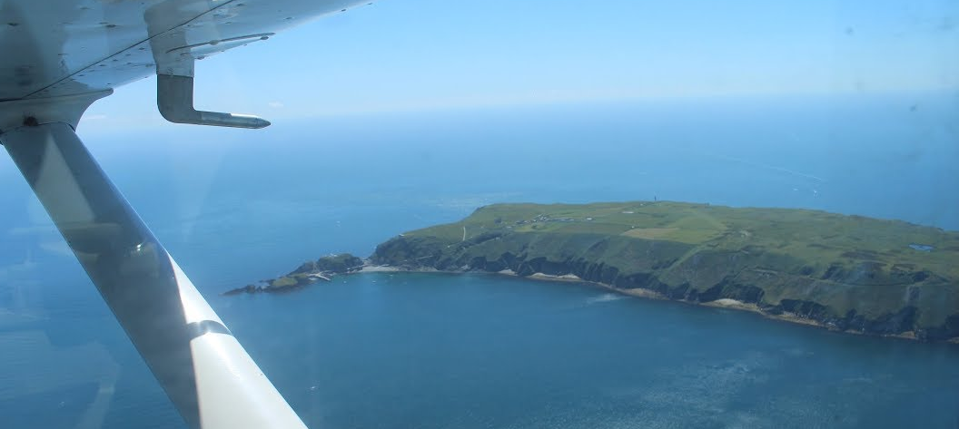
(BBC, 2021).
“Lundy’s spectacular marine life has been protected since 1973, initially as a voluntary Marine Nature Reserve” (Landmark Trust, 2021). In 1976 Lundy was designated a Site of Special Scientific Interest (SSSI). Lundy would continue to be protected, “In 1986, the voluntary Marine Nature Reserve became Britain’s first statutory Marine Nature Reserve and in 2010 the area was designated as the UK’s first Marine Conservation Zone” (Landmark Trust, 2021). The Marine Conservation Zone has brought in a strict code of conduct that applies to all visitors and residents of the island. The code of conduct is not just a set of rules to follow but also works as a huge educational tool for visitors of the island. By following this code of conduct it creates a greater awareness for the users of the landscape and connects them to their surroundings. Although there is scope for a lot of recreation activities on the island, its main focus is the wildlife. The island currently provides, diving, climbing, drinking, fishing and more in terms of entertainment. The current management of Lundy island has proved itself successful so far. “Every day visit and overnight stay helps to secure the future of the island and its landscape, buildings and wildlife” (Landmark Trust, 2021). This has been a vital part of creating an economical successful and environmentally friendly island using the three pillars of sustainability. With the uncertainty of the covid-19 pandemic which has seen the world, and more specifically tourism halted, the island has faced financial hardship, placing its future was in jeopardy. Due to their support and awareness of past and future visitors, the island was able to raise and safeguard £214,000 to ensure the reopening of the island in the future. Along with this Lundy received two grants from the local government. The Cultural Recovery Fund from the governments Department for digital, culture, media, sport (DCMS) also awarded a grant of a staggering £500,000.
“The £500,000 grant will ensure the island can survive by protecting 45 jobs for staff directly employed by Lundy through the coming 2020/2021 winter. It will ensure the island can remain open and accessible to visitors in a safe way, by building on the existing extensive Covid-control measures the Lundy team has already put in in place. The fund will also cover fuel costs for heat, light and power” (Landmark Trust, 2021).
The future of Lundy is looking positive as it prepares for the future, the rest from tourists arriving means that nature has time to restore itself and have a rest from human traffic. I think it is extremely important that when the island is ready to accept visitors again, it is done in a cautious manner, so the introduction of people back onto the island doesn’t leave a trail of destruction.
Wordcount: 2515
Appendix

A Brief History of Blaenavon
In 1788 Lord Abergavenny leased the common lands to Hill, Hopkins and Pratt. Using the new technology from the industrial revolution they constructed a new Ironworks in Blaenavon, now known as the ‘Big Pit’. It would be the first multi-furnace in Wales made for dephosphorization iron for steel making. By 1796 Blaenavon was producing around 5,400 tons of iron per year. This saw the population of the town raise as houses were built beside the ironworks for the workers, also a dense railway connection to transport the produce. This would see the landscape change, with new railways, forges, brickworks, quarries and more. By 1864 The Blaenavon Iron and Coal Company went bust, in 1870 however, the rights were bought by the Blaenavon Iron and Steel Company and the Iron works had a huge makeover to make it suitable to produce steel. By the end of the Victorian era Steel had become a huge demand. However, this would be short lived as in 1878 the Blaenavon Iron and Steel Company would go into liquidation due to the huge cost of the conversion to steel production. In 1880 it would see the site purchased by Blaenavon company LTD. As we reached the 20th Centenary the boom of the industrial revolution saw an increase in demand for coal due to the new steam powered engines. This would impact the local industry of Steel making and after 116 years in 1904 the iron works would finally stop production in Blaenavon. Steel making would continue at the site until 1938. During world war two the site produced alloys and aluminium’s for the aircrafts used in the war. After world war II in 1947 the Coal industry was nationalised meaning the company would lose its interest in coal mining in Blaenavon. The ironworks site would close in the 1960’s and was planned to be demolished in 1970 however, “the site was taken into a state of care in 1974 and was saved for the nation.” (visit Blaenavon). The Big Pit finally closed in 1980 but would be re-opened as a mining museum in 1983 which is still open until today. In November 2000 the wider Blaenavon area, including the town, the ironworks, big pit national coal museum, Pwll du and Thomas hills tram work was designated a world heritage site by UNESCO. Since 2008 the Big Pit has been part of CADW and is now free for everyone to take part in an underground tour.
(Burns, 2020).

CADW

CADW means to keep or to protect. Cadw works to protect the historic buildings and structures, the landscapes and heritage sites of Wales, so that the public can visit them, enjoy them and understand their significance. Cadw manages 127 state-owned properties and sites.

Sustainability Three Pillars

The three pillars of sustainability are a powerful tool for defining the complete sustainability problem. This consists of at least the economic, social, and environmental pillars. If any-one pillar is weak then the system as a whole is unsustainable. Two popular ways to visualize the three pillars are shown.

The goal of three strong pillars of sustainability is a sustainable world. But what exactly is that goal? How well has it been defined?

Unfortunately it's not been correctly defined, which makes it very hard to achieve. The world has been pursuing a goal that was flawed from the start, as described in the glossary entry for sustainability.

Social sustainability is the ability of a social system, such as a country, family, or organization, to function at a defined level of social well-being and harmony indefinitely. Problems like war, endemic poverty, widespread injustice, and low education rates are symptoms a system is socially unsustainable.

Environmental sustainability is the ability of the environment to support a defined level of environmental quality and natural resource extraction rates indefinitely. This is the world's biggest actual problem, though since the consequences of not solving the problem now are delayed, the problem receives too low a priority to solve.
Economic sustainability is the ability of an economy to support a defined level of economic production indefinitely. Since the Great Recession of 2008 this is the world's biggest apparent problem, which endangers progress on the environmental sustainability problem.
(Thwink, 2021).

The National Trust
The National Trust for Places of Historic Interest or Natural Beauty, commonly known as the National Trust, is a charity and membership organisation for heritage conservation in England, Wales and Northern Ireland. In Scotland, there is a separate and independent National Trust for Scotland.
The Trust was founded in 1895 to "promote the permanent preservation for the benefit of the Nation of lands and tenements (including buildings) of beauty or historic interest". It was given statutory powers, starting with the National Trust Act 1907. Historically, the Trust acquired land by gift and sometimes by public subscription and appeal, but after World War II the loss of country houses resulted in many such properties being acquired either by gift from the former owners, or through the National Land Fund. Country houses and estates still make up a significant part of its holdings, but it is also known for its protection of wild landscapes such as in the Lake District and Peak District.
One of the largest landowners in the United Kingdom, the Trust owns over 248,000 hectares (610,000 acres; 2,480 km²; 960 sq mi) of land and 780 miles of coast. Its properties include over 500 historic houses, castles, archaeological and industrial monuments, gardens, parks and nature reserves. Most properties are open to the public for a charge (members have free entry), while open spaces are free to all. The Trust has an annual income of over £630 million, largely from membership subscriptions, donations and legacies, investments, entrance fees to properties, and profits from its shops and restaurants. It also receives grants from a variety of organisations including other charities, government departments, local authorities and the National Lottery Heritage Fund.

UNESCO

UNESCO is the United Nations Educational, Scientific and Cultural Organization. It seeks to build peace through international cooperation in Education, the Sciences and Culture. UNESCO's programmes contribute to the achievement of the Sustainable Development Goals defined in Agenda 2030, adopted by the UN General Assembly in 2015.
Political and economic arrangements of governments are not enough to secure the lasting and sincere support of the peoples. Peace must be founded upon dialogue and mutual understanding. Peace must be built upon the intellectual and moral solidarity of humanity.
In this spirit, UNESCO develops educational tools to help people live as global citizens free of hate and intolerance. UNESCO works so that each child and citizen has access to quality education. By promoting cultural heritage and the equal dignity of all cultures, UNESCO strengthens bonds among nations. UNESCO fosters scientific programmes and policies as platforms for development and cooperation. UNESCO stands up for freedom of expression, as a fundamental right and a key condition for democracy and development. Serving as a laboratory of ideas, UNESCO helps countries adopt international standards and manages programmes that foster the free flow of ideas and knowledge sharing.
UNESCO's founding vision was born in response to a world war that was marked by racist and anti-Semitic violence. Seventy years on and many liberation struggles later, UNESCO’s mandate is as relevant as ever. Cultural diversity is under attack and new forms of intolerance, rejection of scientific facts and threats to freedom of expression challenge peace and human rights. In response, UNESCO's duty remains to reaffirm the humanist missions of education, science and culture.
As early as 1942, in wartime, the governments of the European countries, which were confronting Nazi Germany and its allies, met in the United Kingdom for the Conference of Allied Ministers of Education (CAME). The Second World War was far from over, yet those countries were looking for ways and means to reconstruct their systems of education once peace was restored. Very quickly, the project gained momentum and soon took on a universal note. New governments, including that of the United States, decided to join in. Upon the proposal of CAME, a United Nations Conference for the establishment of an educational and cultural organization (ECO/CONF) was convened in London from 1 to 16 November 1945. Scarcely had the war ended when the conference opened. It gathered together the representatives of forty-four countries who decided to create an organization that would embody a genuine culture of peace. In their eyes, the new organization must establish the “intellectual and moral solidarity of mankind” and, in so doing, prevent the outbreak of another world war.
(UNESCO, 2021).

World Heritage Site

World Heritage is the designation for places on Earth that are of outstanding universal value to humanity and as such, have been inscribed on the World Heritage List to be protected for future generations to appreciate and enjoy. Places as diverse and unique as the Pyramids of Egypt, the Great Barrier Reef in Australia, Galápagos Islands in Ecuador, the Taj Mahal in India, the Grand Canyon in the USA, or the Acropolis in Greece are examples of the 1007 natural and cultural places inscribed on the World Heritage list to date.

The United Nations Educational, Scientific and Cultural Organization (UNESCO) seeks to encourage the identification, protection and preservation of cultural and natural heritage around the world considered to be of outstanding value to humanity. This is embodied in an international treaty called the Convention concerning the Protection of the World Cultural and Natural Heritage, adopted by UNESCO in 1972.

UNESCO's World Heritage mission is to:
Encourage countries to sign the World Heritage Convention and to ensure the protection of their natural and cultural heritage;
Encourage States Parties to the Convention to nominate sites within their national territory for inclusion on the World Heritage List;
Encourage States Parties to establish management plans and set up reporting systems on the state of conservation of their World Heritage sites;
Help States Parties Safeguard World Heritage properties by providing technical assistance and professional training;
Provide emergency assistance for World Heritage sites in immediate danger;
Support States Parties' public awareness-building activities for World Heritage conservation;
Encourage participation of the local population in the preservation of their cultural and natural heritage;
Encourage international cooperation in the conservation of our world's cultural and natural heritage.
(UNESCO, 2021)

Well-being of Future Generations Act
The Well-being of Future Generations (Wales) Act is about improving the social, economic, environmental and cultural well-being of Wales. It will make the public bodies listed in the Act think more about the long-term, work better with people and communities and each other, look to prevent problems and take a more joined-up approach. This will help us to create a Wales that we all want to live in, now and in the future. To make sure we are all working towards the same vision, the Act puts in place seven well-being goals.

Wales faces a number of challenges now and in the future, such as climate change, poverty, health inequalities and jobs and growth. To tackle these we need to work together. To give current and future generations a good quality of life we need to think about the long term impact of the decisions we make. This law will make sure that our public sector does this.

The act gives Wales 7 well-being goals, to make sure we are all working towards the same purpose, the act puts in place seven well-being goals. The Act makes it clear the listed public bodies must work to achieve all of the goal, not just one or two.

They are:

A Prosperous Wales; An innovative, productive and low carbon society which recognises the limits of the global environment and therefore uses recourses efficiently and proportionately (Including acting on climate change); and which develops a skilled and well-educated population in an economy which generates wealth and provides employment opportunities, allowing people to take advantage of wealth generated through securing decent work.

A Resilient Wales; A nation which maintains and enhances a biodiverse natural environment with healthy functioning ecosystem that support social, economic and ecological resilience and the capacity to adapt and change.

A More Equal Wales; A society that enables people to fulfil their potential no matter what their background or circumstances (including their socio economic circumstances).

A Healthier Wales; A Society in which people’s physical and mental well-being is maximised and in which choices and behaviours that benefit future health are understood.

A Wales of Cohesive Communities; Attractive, safe, viable and well-connected.

A wales of Vibrant Culture and Thriving Welsh Language; A society that promotes and protects culture, heritage and the Welsh Language, and which encourages people to participate in the arts, and sports and recreation.

A Globally Responsible Wales; A nation which, when doing anything to improve the economic, social, environmental and cultural well-being of Wales, takes account of whether doing such a thing may make a positive contribution to the global well-being.
(Future Generations Act, 2015)

Reference List:
BBC (2018). Mining beauty spot at Tirpentwys, Pontypool, 'could be ruined'. Available at: https://www.bbc.co.uk/news/uk-wales-south-east-wales-44969962 (Accessed: 23rd January, 2021).

BBC (2019). Quarry at Tirpentwys 'would restore' local beauty spot. Available at: https://www.bbc.co.uk/news/uk-wales-46884417 (Accessed: 25th January, 2021).

Blaenavon Town Council (2021) Our Town. Available at: https://www.blaenavontowncouncil.co.uk/our-town (Accessed: 23rd January, 2021).

Bristol Climbing Scene (2015). Tirpentwys. Available at: http://bristolclimbingscene.co.uk/?p=5886 (Accessed: 23rd January, 2021).

Country Living (2019). Puffins Lundy Island. Available at: https://www.countryliving.com/uk/wildlife/countryside/a27714581/puffins-lundy-island-birds/ (Accessed: 27th January, 2021).

CV Library (2021). Vacancies in Blaenavon. Available at: https://www.cv-library.co.uk/job/211944565/Trainee-Video-Games-and-Software-Tester?sid=69c9d3df-dfcc-486b-ab4c-d7b32a02a6d8 (Accessed: 23rd January, 2021).

Future Generations Act (2021). Guide to future generations Act. Available at: https://www.futuregenerations.wales/wp-content/uploads/2017/02/150623-guide-to-the-fg-act-en.pdf (Accessed: 23rd January, 2021).

Landmark Trust (2021). Lundy Island. Available at: https://www.landmarktrust.org.uk/lundyisland/ (Accessed: 23rd January, 2021).
Landmark Trust (2021). Lundy Island/Conservation. Available at: https://www.landmarktrust.org.uk/lundyisland/discovering-lundy/conservation1/ (Accessed: 27th January, 2021).

Torfaen County Borough (2021). Well-being of Blaenavon and its communities. Available at:
http://www.torfaenpublicservicesboard.co.uk/en/Documents/Assessment-of-Well-being/Part-2-Well-being-of-Blaenavon-and-its-communities.pdf (Accessed: 25th January, 2021).

The Chartered Institution of Water and Environmental Management (2013). Re-framing Sustainable Development. Available at: https://www.ciwem.org/assets/pdf/Policy/Reports/Reframing-Sustainability.pdf (Accessed: 25th January, 2021).

Thwink (2021). Three Pillars of Sustainability. Available at:
https://www.thwink.org/sustain/glossary/ThreePillarsOfSustainability.htm (Accessed: 25th January, 2021).

Tirpentwys Trails (2018). Gallery. Available at: https://tirpentwys-trails.co.uk/gallery/ (Accessed: 3rd May, 2018).

Right Move (2021) Blaenavon Properties. Available at: https://www.rightmove.co.uk/properties/72890975#/(Accessed: 25th January, 2021).

South Wales Argus (2019). Councils balancing economic environmental obligations debated. Available at: https://www.southwalesargus.co.uk/news/17367356.councils-balancing-economic-environmental-obligations-debated-tirpentwys-inquiry/ (Accessed: 25th January, 2021).

Torfaen County Borough (2021). Local Nature Reserves. https://www.torfaen.gov.uk/lgsl/en/Countryside/Localnaturereserves/Local-Nature-Reserves.aspx (Accessed: 23rd January, 2021).

UNESCO (2021). World Heritage Sites. Available at: https://whc.unesco.org/pg.cfm?cid=160 (Accessed: 23rd January, 2021).

UNESCO (2021). Introducing UNESCO. Available at: https://en.unesco.org/about-us/introducing-unesco (Accessed: 23rd January, 2021).

Visit Blaenavon (2021) Blaenavon Story. Available at: https://www.visitblaenavon.co.uk/en/Publications/Blaenavon-Story/Blaenavon-Ironworks.pdf (Accessed: 23rd January, 2021).

Visit Blaenavon (2021). Townscape Story. Available at: https://www.visitblaenavon.co.uk/en/Publications/Education/The-Blaenavon-Townscape-Story.pdf (Accessed: 23rd January, 2021).

Visit Blaenavon (2021). Regeneration. Available at: https://www.visitblaenavon.co.uk/en/WorldHeritageSite/LookingAfterBlaenavon/Regeneration.aspx (Accessed: 23rd January, 2021).

Woodland Trust (2021). Habitats. Available at: https://www.woodlandtrust.org.uk/trees-woods-and-wildlife/habitats/ (Accessed: 25th January, 2021).

